

Application Decision
Site visit made on 22 July 2026.
by Helen O'Connor LLB MA MRTPI
an Inspector appointed by the Secretary of State for Environment, Food and Rural Affairs
Decision date: 29 October 2026

Application Ref: COM/3377610
Stithians Playing Field, Church Road, Stithians, Truro TR3 7DH
Register Unit: VG696
Registration Authority: Cornwall Council

- The application is made under Section 16 of the Commons Act 2006 (“the 2006 Act”) to deregister and exchange land registered as a village green.
- The application is made by Stithians Parish Council (owner of both the release and replacement land).
- The release land comprises approximately 614.43m² of land known as Stithians Playing Field, Church Road, Stithians.
- The replacement land comprises approximately 4504.61m² of land lying to the north-east of Foundry Lane, Stithians, known locally as Crellow Fields Amenity Area.

Decision
- The application to deregister and exchange village green at Stithians Playing Field, Church Road, Stithians, Truro TR3 7DH is granted in accordance with the terms of the application (Ref: COM/3377610) dated 17 January 2026.

Procedural Matters
- Concerns regarding the accuracy of the application plans have been raised. There is some discrepancy between the extent of VG696 as shown on the submitted plans with the registration map. The submitted plan shows a greater area to the north of the bowling green. For the purposes of my determination, I have relied upon the registration mapping to accurately denote the present extent of VG696.
- The applicant has confirmed that the red line area of the release land as shown on the map is accurate and deliberately drawn to exclude a gap in the boundary Cornish hedge and an existing group of trees.
- The light green edge of the replacement land on the map originally submitted in some places strayed slightly away from existing physical boundaries on the ground (stream and residential boundaries). This was inconsistent with the written description in the application and appeared to be a question of draughtsmanship. The applicant has subsequently provided a revised map of the replacement land that makes minor adjustments to adhere to the physical features on the ground, and this assists clarity and consistency. I have made my determination in relation to the corrected map for the replacement land. Given the very minor amendments made, I am satisfied that no one would be prejudiced by this clarification.

Main Issues
- I am required by section 16 of the 2006 Act to have regard to the following in determining this application:

(a) the interests of persons having rights in relation to, or occupying, the release land (and in particular persons exercising rights of common over it);

(b) the interests of the neighbourhood;

(c) the public interest (section 16(8) of the 2006 Act provides that the public interest includes the public interest in: nature conservation; the conservation of the landscape; the protection of public rights of access to any area of land; and the protection of archaeological remains and features of historic interest);

(d) any other matter considered to be relevant.

The Application
- The application is sought to release an area of village green that currently accommodates an existing sports pavilion in poor condition, and the land to its east. This is to facilitate the construction of a larger, replacement community hub which has been granted planning permission. This would serve the local community as well as enhance sporting facilities both at the registered village green and on other land close by. Replacement land is proposed some distance to the east, which lies adjacent to residential development at Crellow Fields.

The Release Land
- The release land is a broadly rectangular parcel of land amounting to about 614.43m². It forms part of VG696 which amounts to approximately 1.696ha overall and includes various sports and recreation facilities such as a tennis court, part bowling green, play equipment, paths and grass. The application lies along the northern edge of registered unit VG696 and accommodates an existing aging pavilion structure which is currently fenced off and disused. The remainder of the application land mostly comprises grass. For the purposes of identification, a copy of the application plan is attached to this decision at Appendix A. The release land is edged in red.

The Replacement Land
- The replacement land is a separate parcel of land located to the east of the village green, with several intervening fields. It comprises approximately 4504.61m². It has a linear configuration and runs adjacent to the rear boundaries of residential properties in Crellow Fields and is bounded to the north by a stream. It is presently an area of open green space with accesses from Crellow Fields. The replacement land is edged in green on the attached application plan at Appendix B.

Representations
- Two representations were made in response to the notice of the application. Natural England (NE) refer to the planning application for the replacement community hub. They point out that the replacement land is already available for public access and is used for recreational purposes. It is also situated away from the centre of the village and that the replacement building approved on the release land is larger than the existing pavilion. However, they recognise the application would enable development that seeks to support recreational use, including the continued use of the replacement land by the local community. Subject to legally binding provisions being in place to ensure continued public use of the new community facilities, they raise no objection.
- Similarly, the Open Spaces Society (OSS) raise no objection in principle. Nevertheless, they raise concerns regarding the accuracy of the plans (which are addressed in the procedural matters above), assert that the public already have a right of access to the replacement land and suggest that an understanding of other options considered would assist the decision maker.

Reasons
- In determining the application, I have had regard to the Department for Environment, Food and Rural Affairs Common Land consents policy, November 2015 (the 2015 policy) published for the guidance of both the Planning Inspectorate and applicants. Paragraph 3.2 sets out overall policy objectives to protect commons and greens which includes the outcome that the stock of such land is not diminished so that any deregistration of registered land is balanced by the registration of other land of at least equal benefit.

The interests of those occupying or having rights over the land
- No rights are registered over the village green. There is nothing before me to indicate that anyone occupying or having rights over the release land will be adversely affected by the exchange.

The interests of the neighbourhood
- There is no definition of the term ‘neighbourhood’ in the 2006 Act, but in this instance, I have taken this to mean the residents of Stithians. The 2015 policy indicates that the issues to be considered in this context include whether the exchange would prevent local people from using the village green in the way they are used to, and whether or not there would be an interference with the future use and enjoyment of the land as a whole. Positive benefits can also be taken into account.
- The applicants explain that the current pavilion building at the village green, and sited on the release land, is no longer fit for purpose and is unsafe. This was consistent with my observations of its condition. Planning permission for a larger community hub building has been secured on the release land. It is also confirmed that legally binding provisions exist to use the land in perpetuity as a public recreation ground for the inhabitants of the parish. As such, even if deregistered as village green, other land law mechanisms are in place to secure the use of the release land and future building for the neighbourhood. Consequently, the neighbourhood are likely to derive considerable benefit from the improved community facilities, which in turn are likely to support continued and enhanced usage of the remaining registered village green for sport and recreation.
- In addition, the replacement land is considerably more extensive in size than the land to be deregistered. Despite it already being used as amenity land, its registration would provide stronger long-term protection by conferring village green status. It provides a pleasant, usable area of green open space conveniently situated close to many residents of Stithians.
- Accordingly, I am satisfied that the proposed exchange would not prevent local people from using the village green in the way they are used to. Rather, it would facilitate development likely to be beneficial to the interests of the neighbourhood as well as support and protect the future recreational use of registered village green across the village.

The public interest

Nature conservation
- Neither the release or replacement land are subject to national or local designations for nature conservation.
- The release land accommodates a poor-quality pavilion but is otherwise a mown grassed area and path. As such, it is unlikely to possess any notable nature conservation interest. It is confirmed that the Cornish hedge and trees along the northern boundary will remain in place and were deliberately excluded from the release land.
- The replacement land is an open green area mainly comprising grass, but with mature trees and hedgerows along the boundaries, and a stream along the northern boundary. This represents both a more mixed habitat and a greater area than the land to be released. Although no works or planting are identified as part of the exchange, these factors mean that the nature conservation potential of VG696 overall would be increased.
- Moreover, the effect on biodiversity would have been a consideration in the planning permission granted for the replacement community hub building. This is alluded to in the comments of NE, who refer to additional planting that would result from that development on the replacement land.
- Therefore, I am satisfied that the proposed exchange would not have an adverse impact upon biodiversity or nature conservation in relation to the registered village green.

Conservation of the landscape
- The release land forms part of the village green core at Stithians, where there is a collection of sports pitches, play equipment, open grass and associated buildings. It has an open, green and managed appearance consistent with its role in the rural settlement. Aside from the poor quality of the pavilion building, the release land makes a positive contribution within this context.
- The replacement land is larger, contains mature hedgerows and situated adjacent to a stream. It is also devoid of built form. As such, it has a more natural appearance with a stronger countryside character. It makes a valuable contribution to the rural qualities of the settlement.
- No works are proposed to the replacement land as part of the exchange. The increased status afforded by the exchange would assist in safeguarding its positive landscape contribution. In terms of the release land, the effect of the replacement community hub building on the character and appearance of the area would have been considered as part of the planning application process.
- Overall, I am satisfied that the impact on the landscape character of the area resulting from the proposed exchange would be generally neutral.

The protection of public rights of access
- The consideration of this criterion contains some overlap with matters considered under the effect on the interests of the neighbourhood. Nevertheless, Paragraph 4.5 of the 2015 policy states that consent will not normally be granted where the replacement land is already subject to some form of public access, as overall this would diminish the total stock access land available to the public. It goes on to say that it will be assumed that the release land will cease to be available for recreation and access, unless a legally binding provision is intended to be made to assure continued use.
- In this instance, the replacement land is already in use as amenity land and is readily accessible to the public. However, assurance is given that there are legally binding provisions to maintain public accessibility to the release land (and community hub) in perpetuity. The release land and future community building would effectively remain central to the village facilities and would be likely to enhance the recreation and social use of the remaining village green adjacent.
- Moreover, given the relative size of the replacement land, there would be an extensive increase in the quantum of land given the strong, long-term protection conferred by village green status as a result of the exchange.
- Overall, I find that the proposal would have a beneficial effect on those wishing to use the village green for recreation and access. The circumstances in this case, which are closely linked to the delivery of an improved community building, would avoid diminishing the total stock access land available to the public. I am satisfied that it aligns with the policy objectives set out in the 2015 policy.

Archaeological remains and features of historic interest
- No archaeological remains or features of historic interest have been brought to my attention either on the release or replacement land. No objections have been made with respect to those matters. Consequently, I have no reason to find that any adverse effects would arise on this basis.

Other relevant matters
- The proposed exchange would enable the development of the replacement community hub building to proceed. This is a matter I have already taken account of when considering the interests of the neighbourhood and the public interest.
- Paragraph 4.3 of the 2015 policy states that the Secretary of State will wish to know what alternatives have been considered to the application proposal. In this instance, it is relevant to consider whether any land contiguous with VG696 was available that might have provided more immediate or suitable replacement land. The applicant has confirmed that, prior to the application being made, a review of the Parish was undertaken. They explain that matters of ownership hindered their preferred option of registering the adjoining playing field to VG696, as attempts to purchase this land have been unsuccessful. I have seen nothing that would undermine this explanation, and no other specific alternatives have been put to me.

Conclusions
- The 2015 guidance confirms that the primary objective in determining applications under section 16(1) is to ensure the adequacy of the exchange land in terms of the statutory criteria. The proposal would increase the stock of land registered as village green. Furthermore, for the reasons outlined above, I am satisfied that the replacement land would be of at least equal benefit to the release land and considerable benefit would result to the interests of the neighbourhood and public by facilitating the replacement community hub building. I do not find that there are any relevant matters which indicate that the application should be refused.
- Therefore, having regard to all matters raised in the application and written representations, I find that consent for an exchange of land should be granted, and an Order of Exchange given in respect of the application.

Helen O’Connor

INSPECTOR

Order

On behalf of the Secretary of State for Environment, Food and Rural Affairs and pursuant to section 17(1) and (2) of the Commons Act 2006, I HEREBY ORDER Cornwall Council, as commons registration authority for the area in which the release land and the replacement land are situated:
- to remove the release land from its register of town and village greens, by amending register unit VG 696 to exclude the release land;
- to register the replacement land as town and village green, by amending register unit VG 696 to include the replacement land.
- to register as exercisable over the replacement land (in addition to remaining exercisable over the remainder of the land comprised in register unit VG 696) any rights of common which, immediately before the date on which the release land is removed from the register, are registered as exercisable over the release land and the remainder of the land comprised in register unit VG 696.

First Schedule – the release land

Colour On Plan  (Appendix A) | Description | Extent
Edged in red | Area forming part of land known as Stithians Playing Field, Church Road, Stithians TR3 7DH. | 614.43m²

Second Schedule – the replacement land

Colour On Plan  (Appendix B) | Description | Extent
Edged in green | Land lying to the North East of Foundry Lane, Stithians, known locally as Crellow Fields Amenity Area, Crellow Fields, Stithians TR3 7RE. | 4504.61m²

Helen O’Connor

INSPECTOR

Appendix A - Release land

Not to scale

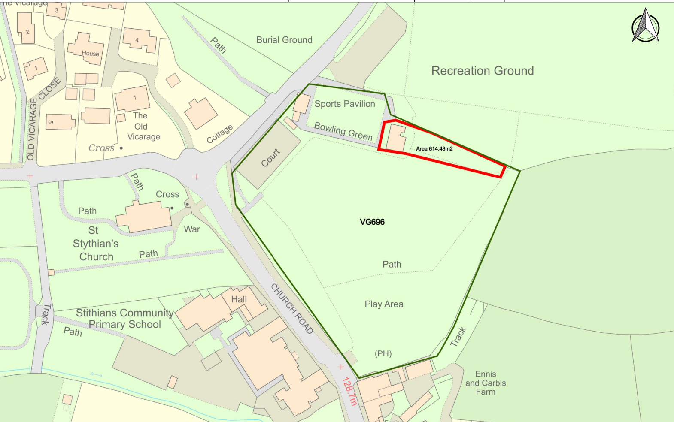

Appendix B – Replacement land

Not to scale

