OFFICIAL: SENSITIVE-COMMERCIAL

Handling instructions: The information and attachments within this e-mail contain information which is commercially sensitive and is currently not within the public domain. Please treat this accordingly and do not distribute any further.

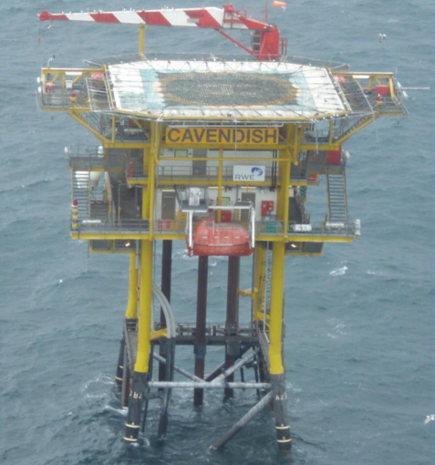



Cavendish Field
Decommissioning Close Out Report

UNCOSTED VERSION

March 2026
Version B05

DOCUMENT CONTROL TABLE:

Revision | Date | Description | By
A01 | 18/03/2025 | For JV Partner Review | NH
A02 | 02/04/2025 | Draft for OPRED Review | NH
B01 | 11/07/2025 | Incorporating OPRED Comments | NH
B02 | 21/08/2025 | Incorporating further OPRED Comments | NH
B03 | 05/09/2025 | Updated total in Table 5.1 | NH
B04 | 10/10/2025 | Incorporating further OPRED Comments | NH
B05 | 20/03/2026 | Final Submission | NH

Contents

 |  | Page
1.1  1.2  1.3  1.4  2  2.1  2.2  2.3  2.4  2.5  2.6  2.7  2.8  2.9  2.10  2.11  3  3.1  3.2  4  4.1  5  6  7  8  9 | Summary  Summary of Decommissioning Programme  Schematic of Installation(s)/Pipeline(s) Being Decommissioned  Gantt Chart  Associated Decommissioning Approvals  Decommissioning Activities  Contracts Awarded  Platform Operations  Well P&A  Subsea Installations  Subsea Stabilisation features  Pipelines/Umbilicals & Jumpers  Pipeline Stabilisation features  Drill Cuttings  Results of Post Decommissioning & Environmental Surveys & Debris Clearance  Detail All Variance from the Approved Decommissioning Programme  Stakeholder Engagement  Impact On Environment  Activities  Future Monitoring & Management Planning  Impact on HSE  Details of any Incidents/Accidents During Project Execution  Waste/Waste Inventory  Lessons learned  Cost Summary  Photographs  Appendices | 4  8  13  14  15  16  17  17  17

Terms and Abbreviations

Abbreviation | Explanation
BSO | Bluestream Offshore
BSL | Benthic Solutions Ltd
DPs | Decommissioning Programmes
DSV | Diving Support Vessel
EPRD | Engineering, Procurement, Removal & Disposal
HLV | Heavy Lift Vessel
HSE | Health & Safety Executive
km | kilometres
KP | Kilometre Point
m | metres
NFFO | National Federation of Fishermen’s Organisations
NORM | Naturally Occurring Radioactive Material
NSTA | North Sea Transition Authority
OPPC | Oil Pollution Prevention and Control
OPRED | Offshore Petroleum Regulator for Environment and Decommissioning
P&A | Plug and Abandon (wells)
PL | Pipeline
PWA | Pipeline Works Authorisation
ROV | Remotely Operated Vehicle
SHE | Safety, Health & Environmental
SNS | Southern North Sea
Te | Metric ton
UKCS | United Kingdom Continental Shelf
URS | Utility ROV Services Ltd.

summary

1.1 Summary of Decommissioning Programme

The Cavendish Field is located approximately 125km east of the UK coastline at Flamborough Head and 65km west of the UK-Netherlands median line, with a water depth of 18 metres. The Cavendish Platform is a NUI design, tied back to the Murdoch MD platform, 44km to the south-east. Produced gas and condensate from three wells at Cavendish was exported via a 47.35km long 10” export pipeline, to Murdoch. A 3” methanol line is piggybacked onto the 10” export pipeline which supplied methanol from the Murdoch platform back to Cavendish. A 1.25” fibre optic cable is also laid in the same trench as the pipeline bundle.

Cavendish production ceased in August 2018 due to the closure of the export route to shore via Murdoch. The two pipelines are out of use and reside in a cleaned, water-filled condition. Field layout of the Cavendish facilities is shown in Figure 1-2.
- Production formally ceased on 15th August 2018
- The Decommissioning Programmes (DPs) were formally approved by OPRED on 1st June 2020; being Rev 7, doc. no RD-CAV-ZPL004
- The Schedule of the DPs was formally revised in August 2022 by letter agreement, to extend by one further year the timeline to complete platform removal works, subsea scope (both by end Q3 2023) and associated surveys (by end Q3 2024).
- In January 2024, a further revision to the Decommissioning Programmes was formally accepted by OPRED, which further extended the removal schedule to end Q2 2024, the survey schedule to end Q3 2025, and confirmed a change to the ‘Selected Option’ for Decommissioning at the Pipeline ends.
A summary of the infrastructure that was to be decommissioned, and the approved decommissioning options, is outlined in the tables below.

Table 1.1: Overview of the Decommissioned Installation(s) In The Approved DP
Installation Type | Number | Weight
Steel Platform and Jacket | 1 | 1054
Subsea Installation Type
N/A | None | N/A

Table 1.2: Overview of the Decommissioned Pipelines & Umbilicals in The Approved DP
Number of Pipeline(s) to be decommissioned | 2
Number of Umbilical(s) to be decommissioned | 1
Total KM of Pipeline(s) & Umbilcal(s) to be decommissioned | 142.0KM
Total KM of Pipeline(s) & Umbilcal(s) left in situ | 140.0KM

Table 1.3: Overview of the Stabilisation Features In The Approved DP
Type | Number
Concrete Mattresses | 105
Grout Bags | N/A
Sand Bags | N/A

Table 1.4: Overview of the Wells in The Approved DP
Type | Number
Wells (Platform) | 3
Wells (Subsea) | N/A
Appraisal Wells | N/A

Table 1.5: Overview of the Drill Cuttings in The Approved DP
Number of Piles & Volume (m³) | 0

Table 1.6: Summary of the Approved Decommissioning Option(s) In the Approved DP
Type | Selected Option
1. Topsides | Complete removal for re-use where possible
2. Substructures | Complete removal for re-use where possible
3. Subsea Installation(s) | N/A
4. Subsea Installation(s) stabilisation features | N/A
5. Pipelines, Flowlines & Umbilicals & Riser Sections | The gas (PL2284) and methanol (PL2285) pipelines and fibre optic cable (PL4612) will be partially removed. The two lines have been flushed and cleaned. Buried sections of pipelines and fibre optic cable will be left buried in-situ.
6. Pipeline and related infrastructure stabilisation Features | Mattresses & Grout bags will be removed
7. Pipeline Crossings | Not specified in DP
8. Wells | Abandoned in accordance with Oil and Gas UK Guidelines for Decommissioning of Wells
9. Drill Cuttings | N/A

1.2 Schematic of Installation(s)/Pipeline(s) Being Decommissioned
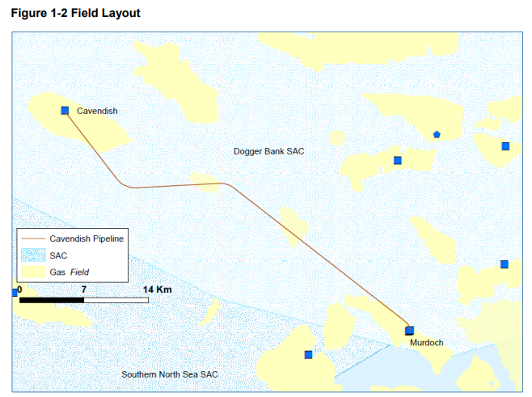

1.3 Project Delivery against the Approved Schedule (from the approved DP or from a revision to the DP)
The revised Schedule, as formally amended in January 2024, is given below.

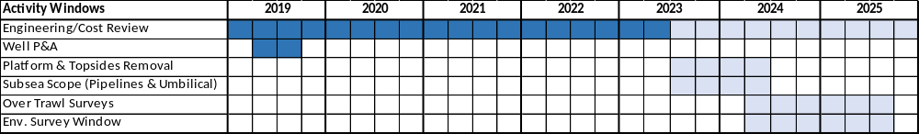

As described in the following sections, all activities are now complete.

Accordingly, the Operator has prepared this report as requested, within 1 year of completion of offshore work, to satisfy OPRED that the approved programme has been fully implemented.

1.4 Associated Decommissioning Approvals

Table 1.7: Associated Decommissioning Approvals
Platform well P&A | Completed September 2019
Topside removal | Approved by OPRED June 2020
Pipeline Preparatory works | Flush and disconnect pipeline and umbilical, completed in July 2019. Approval from NSTA via the PWA process and OPRED via the OPPC/environmental permitting process. Cavendish Pipelines placed in Interim Pipelines Regime by OPRED.
PWA | Up to date for works on Cavendish
Amendment of the approved DPs | The schedule was first revised in August 2022 to extend the schedule by 1 year, to allow completion of platform removal works & subsea scope by end Q3 2023, and associated surveys completion by end Q3 2024.  In January 2024, a second revision to the Decommissioning Programmes was formally accepted by OPRED, which extended the schedule for topsides and subsea scope to end Q2 2024, and surveys by end Q3 2025. The amendment also confirmed a change to the ‘Selected Option’ for Decommissioning at the Pipeline ends
Decommissioning Consent for removal of the Platform | DCA/193 was approved by OPRED in October 2023 to provide consent for the removal of the platform including: Consent to locate for the heavy lift vessel; Marine licence for seabed disturbance and deposits; Survey notification for the use of the ROV; and Disturbance licence for removal with nesting birds present

DECOMMISSIONING ACTIVITIES
2.1 Contracts Awarded

Table 2.1: Contracts Awarded
Seajacks were awarded the contract for the supply of a jack up barge to undertake the 2019 Pipeline Cleaning activities and P&A work in May 2019. For the majority of associated services (e.g. cementing etc.), INEOS was able to utilise existing contracts.

In April 2023, INEOS awarded the contract for the next phase of activity, i.e. the ‘EPRD’ for the removal of the facilities at Cavendish and another INEOS-operated SNS platform, to Scaldis Salvage & Marine Contractors (“Scaldis”). This was done following a tender process and detailed negotiation, with support from JV Partners. This contract also governs the subsea disconnection of the pipelines from the jacket, via Scaldis’ subcontractors, Bluestream Offshore (“BSO”). This work scope, taking place within 20m of the platform, was referred to as the ‘close proximity work.’

In May 2023, INEOS awarded a contract for Subsea Remediation work to Utility ROV Services Ltd. (“URS”), on the basis of its market-leading position and that a campaign of work involving 2 other INEOS-operated SNS assets could be undertaken in summer 2023.

The contract for the post-decommissioning surveys was awarded to XOCEAN in July 2024. A tender was carried out and XOCEAN was deemed to have the required technical capability, whilst the unique solution of uncrewed vessels stood out amongst the tenderers for its SHE risk being as low as reasonably practicable, with lowest possible emissions.

2.2 Platform Operations

Table 2.2: Platform Decommissioning
To avoid committing any offence relating to protected species, it was agreed with Scaldis not to attempt platform removal prior to 1st October 2023, deemed to be comfortably beyond the end of the nesting season.
The offshore campaign for the Cavendish platform decommissioning was carried out between 9th October 2023 and 13th April 2024. Between 5th December 2023 and 2nd March 2024 operations were paused due to expected adverse weather conditions, severely restricting the capability of the Gulliver Heavy Lift Vessel (HLV).
Working days for the Cavendish platform were discontinuously spread across October & November 2023, and March & April 2024. A small crew boarded the platform from the Gulliver HLV when conditions were suitable to do so, to carry out preparation work scopes such as non-destructive testing of padeyes, welding lifting support beams, and installing access scaffolding on the jacket. Each time the platform was de-manned due to bad weather, a make safe campaign was performed upon return. The Cavendish topside was eventually lifted and brought to shore at Sagro’s Decommissioning facilities in Vlissingen, Netherlands, on 7th March 2024, where dismantlement was completed in April 2024.
The jacket was lifted and brought to shore on 13th April 2024 following completion of dredging and cutting activities.

2.3 Well P&A

Table 2.3: Well Decommissioning
Well | Designation | Status and Date of Abandonment | Category of Well
43/19a-C1 | Gas Production | Fully Abandoned Q3 2019 | PL 1.1.1
43/19a-C2y | Gas Production | Fully Abandoned Q3 2019 | PL 1.1.1
43/19a-C3 | Gas Production | Fully Abandoned Q3 2019 | PL 1.1.1

2.4 Subsea Installations

Table 2.4: Subsea Installations Decommissioning
Description | Agreed Decom Solution | Total Removed (Actual)  and Date of Removal | Status
N/A | N/A | N/A | N/A

2.5 Subsea Installations Stabilisation Features

Table 2.5: Subsea Installations Decommissioning
Description | Agreed Decom Solution | Total Removed (Actual)  and Date of Removal | Status
N/A | N/A | N/A | N/A

2.6 Pipelines/Umbilicals & Jumpers

Table 2.6: Pipelines/Umbilicals & Jumpers Decommissioning
PL Number | Description | Agreed Decom Solution  and Date of Removal | Current Status  (Please state the length in kms, left in situ/removed)
PL2284 | 10” gas export line | A 2m section was cut and recovered by Harbour Energy’s operation at CMS Pigging Skid in 2021. In 2023, ~560m in aggregate was recovered by URS operation at Cavendish Platform, Murdoch MD and Trent-Tyne PL crossing. A further 27m was recovered in Aug 2023 via BSO campaign at Cavendish Platform. | 0.6km removed; 46.7km remaining in situ
PL2285 | 3” Methanol line | A 4m section was cut and recovered by Harbour Energy’s operation at CMS Pigging Skid in 2021. In 2023, ~560m in aggregate was recovered by URS operation at Cavendish Platform, Murdoch MD and Trent-Tyne PL crossing. A further 31m was recovered in Aug 2023 via BSO campaign at Cavendish Platform. | 0.6km removed; 46.7km remaining in situ
PL4612 | Fibre Optic Umbilical | A 11.4m section was cut and recovered by Harbour Energy’s operation at CMS Pigging Skid in 2021. In 2023, ~550m in aggregate was recovered by URS operation at Cavendish Platform, Murdoch MD and Trent/Tyne PL crossing. | ~0.6km removed; ~46.7km remaining in situ
Trent-Tyne PL Crossing (PLs 1220/1221) | The Cavendish Pipeline bundle crosses the Trent to Tyne 20” & 3” bundle at KP27.654 | Cuts were performed on the Cavendish PL bundle and sections totalling ~250m were removed via URS campaign in 2023. PL1220/1211 remained untouched as the responsibility for decommissioning is with the Trent & Tyne owners Perenco UK Limited. | ~0.2km of Cavendish PL bundle removed at Trent-Tyne PL crossing
Norsea Com 1 Cable Crossing | The Cavendish Pipeline bundle crosses the Norsea Com 1 Fibre Optic Cable at KP47.158 | The Cavendish PL bundle was removed and recovered in this vicinity (within the ‘Murdoch MD’ 500m safety zone) via URS campaign in 2023. The Norsea Com fibre optic cable remained untouched and is the responsibility of owners Tampnet AS. | ~0.2km of Cavendish PL bundle removed in Murdoch 500m zone. Norse Cable left in-situ
Cygnus PL Crossing | The Cavendish pipeline bundle is crossed at KP14.178 by the Cygnus 24” export pipeline PL3088 | PL3088 is a live gas export line operated by Ithaca Energy. Responsibility for Decommissioning is with the Cygnus owners Ithaca (NE) E&P Limited and Spirit Energy Southern North Sea Limited. | Left in-situ
Rita-Hunter PL Crossing | The Cavendish pipeline bundle is crossed at KP44.034 by the Rita to Hunter 8” pipeline and control/injection umbilical (KP44.060) | Cavendish’s Comparative Assessment document RD-CAV-ZPL005 assumed that the gravel used to cover the crossing points would remain in-situ. Decommissioning of PLs 2137, 3005, 2528 & 2529 and PLU2138 remain the responsibility of the Rita & Hunter owners Premier Oil E&P UK Limited, Premier Oil PLC, Neptune E&P UKCS Limited and Neptune Energy International. | Left in-situ

2.7 Pipeline Stabilisation Features

Table 2.7: Pipeline Stabilisation Features Decommissioning
Description | Agreed Decom Solution and Date of Removal | Status
Concrete Mattresses | 134 in total: 27/07/23 – 16/08/23  132 mats removed via URS campaign at 3 locations: Cavendish Platform, Murdoch MD and Trent/Tyne PL crossing. This included some mats discovered in ‘As-found’ surveys that were not included on drawings.  In addition to the above, 2 mats were recovered via the BSO diving operation at the Cavendish platform. | 134 Removed

2.8 Drill Cuttings

Table 2.8: Drill Cuttings Decommissioning
Description & Volume (m3) | Agreed Decom Solution and Date of Removal | Status
N/A | N/A | N/A

2.9 Results of Post Decommissioning & Environmental Surveys & Debris Clearance
– Also include evidence of clear seabed

Table 2.9: Environmental Surveys & Debris Clearance
A post-decommissioning survey conducted by XOCEAN in July 2024 is provided alongside this report as evidence of clear seabed. See reference 9.1 in the Appendices.
This survey covered the 100m corridor of piggybacked PL2284, PL2885 and PL4612 and the previous location of Cavendish 500m zone. The survey showed there was no change in burial status of Cavendish Pipelines. There was no significant debris found which would be considered a hazard to the integrity of the Pipelines and Fibre Optic Cable. There was no significant debris found in the Cavendish 500m Zone.
In 2025, a further post-decommissioning survey was carried out by BSL, specifically an “Environmental Baseline & Habitat Assessment Report” or simply hereafter, an “Environmental Survey”. See reference 9.2 in the Appendices.
In this survey, an agreed set of locations (or ‘stations’) were visited to take ‘grab samples’ of seabed sediment for laboratory analysis. This Environmental Survey concluded that the available data do not indicate any discernible environmental impact associated with either the former presence of the Cavendish platform or the decommissioning activities, and that that there is no clear indication of a need for additional environmental investigations in the area.

2.10 Detail All Variance from the Approved Decommissioning Programme

Table 2.10: Detail All Variance from the Approved Decommissioning Programme
The Schedule of the DPs was formally revised in August 2022 by letter agreement, to extend by one further year the timeline to complete platform removal works, subsea scope (both by end Q3 2023) and associated surveys (by end Q3 2024).

In January 2024, a further revision to the Decommissioning Programmes was formally accepted by OPRED, which further extended the decommissioning schedule to 31 December 2025, and confirmed a change to the ‘Selected Option’ for Decommissioning at the Pipeline ends. The original version of the DPs specified that backfilling with seabed sediment would be deployed to remediate the cut ends of the pipeline, however the DP was amended to enable INEOS’ Contractors URS to deploy rock placement instead, due to its much higher effectiveness.

The estimated amount of mattresses in the DPs was 105, whereas in practice, 134 were located and removed. This figure is an aggregate total of the mattresses recovered from Cavendish platform approach, Murdoch platform approach, and the Trent-Tyne pipeline crossing.

The measured tonnage figures for platform disposal as waste were higher than those estimated in the DPs.

2.11 Stakeholder Engagement

Table 2.11: Stakeholder Engagement
INEOS has had some contact from Third Parties to express an interest in reuse of the Cavendish Facilities, but no viable option was found.

Prior to signing the contract for the EPRD scope, INEOS undertook nesting bird surveys to establish the likelihood that colonies of the protected black-legged kittiwake would nest on the installation. Specialist ornithologists were consulted and their input and advice was key to the engagement with OPRED and JNCC, influencing the timing of the removal programme. In March 2023, when it became clear that the agreed deterrent measures could not be implemented, the removal works were scheduled outside of the expected nesting season, to avoid disturbance to nesting kittiwakes.

Post removal surveys were planned and conducted in accordance with all relevant guidelines and in consultation with regulatory bodies.

3 IMPACT ON ENVIRONMENT
3.1 Activities

There have been no releases/discharges during the reporting period.

After major offshore works are concluded, ‘As-left’ surveys were conducted to confirm no adverse impact or physical disturbance of seabed.

Table 3.1: ‘As-left’ Surveys
Description | Date | Performed by | Comments
Post-Pipeline disconnection ROV survey at Murdoch | June 2021 | Boskalis, for Harbour Energy | All project equipment removed from worksite. Mattress protection reinstated over cut ends
Post-Subsea Remediation ROV Survey | August 2023 | OceanInfinity for URS | All grout bags, mattresses and debris recovered
Post-Jacket Removal ROV survey | April 2023 | BSO for Scaldis | Debris Targets too small (<1m) for recovery
Post-decommissioning seabed clearance verification survey | July 2024 | XOCEAN | No change in burial status of Cavendish Pipelines, no significant debris found

3.2 Future Monitoring

Table 3.2: Future Surveys and Monitoring Proposals
1. Substructures
N/A – the substructure has been removed, as evidenced by Scaldis’ “As-removed – Decommissioning Cavendish” report RD – XDRY – SCA – CH – PR - 00101
2. Pipelines, Flowlines & Umbilicals
The XOCEAN survey referred to in 2.9 confirmed that “there was no change in burial status of Cavendish Pipelines” and “There was no significant debris found which would be considered a hazard to the integrity of the Pipelines and Fibre Optic Cable.”
The next physical inspection is proposed in 2034. This follows the recommendation of Jee Ltd. in its ‘Risk Based Inspection’ report “JEE-INE40-TN-001 Rev B01”, which was commissioned to verify the post-decommissioning seabed clearance. The report states: “Inspection data from 2012, 2015, 2019, and 2024 was reviewed to analyse the trends in exposures and spans... The majority of the exposures and all of the spans identified in the historical survey data were no longer observed during the 2024 survey. Additionally, several spans reported in historical inspections were located within a section of the pipeline system that was removed during the decommissioning operation... As such, these spans are no longer a concern for the pipeline system that remains in-situ.”
3. Pipeline Stabilisation Features
N/A – these have been removed. Confirmed by seabed clearance verification survey.
4. Drill Cuttings
N/A
5. Environmental Surveys
Following the conclusions and recommendation of the BSL Environmental Survey carried out in 2025, it is not proposed to carry out any further post-decommissioning Environmental Surveys. The BSL Survey confirmed that the sampled stations did not show evidence of significant contamination or notable changes in macrofaunal communities between the pre- and post-decommissioning surveys. The available data do not indicate any discernible environmental impact associated with either the former presence of the Cavendish platform or the decommissioning activities, and therefore the risk is not considered sufficiently high to warrant the further cost and emissions incurred by additional survey work.

Management Planning

N/A: Cavendish is not an "Approved Derogation DP".

4 IMPACT ON HSE
4.1 Details of any Incidents / Accidents during Project Execution
No reportable incidents or accidents have occurred during the Decommissioning Programme. The following ‘incidents’ relating to the Cavendish topsides and jacket are noted:

- Scaffolding around the platform jacket suffered damage during the winter storms when lifting was paused in December 2023. It was replaced prior to resumption of operations in March 2024.
- During transit of the Cavendish topsides to Vlissingen via the HLV, the port-side steering wire parted. The broken section was retrieved and replaced.
- Once the topsides structure was lifted free of the jacket, an inclination of approx. 3.5 degrees of the load was observed. The load was always under full control.

In each case, an incident investigation has been carried out to establish cause, potential consequences and Lessons Learned. All are considered closed.

5 WASTE

Table 5.1: Materials/Waste Returned to Shore
Material/Waste | Total Weight (t) – as per the approved DP | Tonnage In situ | Tonnage to shore (including date) | Disposal Method
Steel | 8201 | 7082 | 1119 (Aug 2023, Apr 2024) | Recycled
Plastics/Rubber | 28 | 26 | 2 (Aug 2023) | Recycled
Non-ferrous Metals | 41 | 14 | 27 (April 2024) | Recycled
Concrete | 604 | 0 | 710 returned to shore Aug 2023 following URS campaign* | Recycled
Other | 7 | 0 | 5 (April 2024) | Recycled
Grout bags | 0 | 0 | 0 | N/A
TOTAL | 8,881 | 7,122 | 1,863

*See Section 2.7 for explanation.

Note that the ‘Tonnage to shore’ figures come from actual measured weight by the responsible contractors for each work scope and differs from the estimated figure in the original DPs.
Because the waste was taken from UK waters and brought ashore to a disposal yard in Netherlands, a Transfrontier Shipment of Waste Process was followed. This involved liaisons with the Environment Agency on the UK side to prepare the necessary application paperwork, and put in place a Financial Guarantee. This paperwork was then required to be reviewed and accepted by the equivalent in Netherlands, the ‘Inspectie Leefomgeving en Transport’ (Human Environment and Transport Inspectorate).

6 LESSONS LEARNED

The well P&A was conducted using a jack-up barge rather than a rig, which although could offer greater operational capabilities, was not considered to be worth the incremental cost. INEOS was able to secure a highly competitive rate spread rate for the vessel and services via a ‘campaign’ approach, i.e. scheduling sequential Pipeline flushing operations, P&A operations at Cavendish followed by P&A at another operated SNS asset. The through-tubing methodology was also employed, which allowed time and therefore cost to be saved on the P&A operation.

BSO’s ‘close proximity’ operations were diver-based, and therefore had significant limitations on working time due to weather and tidal conditions in the relatively shallow water depth of the Cavendish installation. It would be difficult to avoid this in future, however, due to those unique conditions and the positioning of the infrastructure proving unworkable for larger craft to execute the workscope.

Having subcontractors (BSO were working as part of the Scaldis agreement) execute this scope also made it more challenging for INEOS to optimise the work scope, particularly in relation to cutting methodology, as the shear cutters were unable to meet performance standards, leading to the adoption of saw cutting. Greater emphasis should therefore be placed on onshore testing of shear cutters on equivalent pipeline material and wall thickness.

The subsea remediation campaign via URS benefitted greatly from the ‘campaign’ approach adopted, with URS able to optimise the schedule of work across 6 worksites at 3 different INEOS-operated SNS assets. Through daily planning meetings and sharing ‘lookahead’ data with each other, INEOS and URS were able to minimise efficiency losses, despite access restrictions being imposed by the BSO work programme taking place in parallel.

Similarly, there were significant financial and practical benefits to the ‘campaign’ approach adopted for the EPRD scope, which was almost identical for 2 INEOS-operated assets. The contractual price was significantly reduced vs. a ‘standalone’ campaign, and the overheads incurred during preparation, execution and close-out phases are shared between the assets.

The timing of the lifting operations was dictated by avoiding disturbance to nesting birds, which increased the operational weather risk considerably. Although this increased risk was reflected in a higher price paid to the contractor, the ‘lump-sum’ arrangement benefitted the asset owners as limited the cost exposure due to weather delays.

The Transfrontier Shipment of Waste Process referred to in Section 5 proved to be somewhat longer than expected to obtain approval from all regulatory bodies. INEOS would recommend to other Operators that where this process cannot be avoided, it be taken off the ‘critical path’ where possible by an earliest possible commencement.

Using the uncrewed vessel solution provided by XOCEAN resulted in extremely favourable outcomes for the project, and INEOS would encourage the use of similar technology to other operators. As well as the significant cost savings vs. larger, crewed vessels, INEOS and its JV Partners were able to minimise risk to personnel by removing the need to have an offshore crew, and vastly reduced CO₂ emissions.

7 COST SUMMARY

Decommissioning costs WILL BE provided to OPRED out with this report.

8 PHOTOGRAPHS

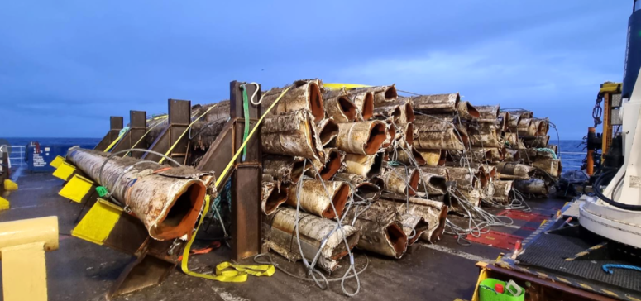
Fig. 8.1: cut lengths of pipe on board the Normand Superior

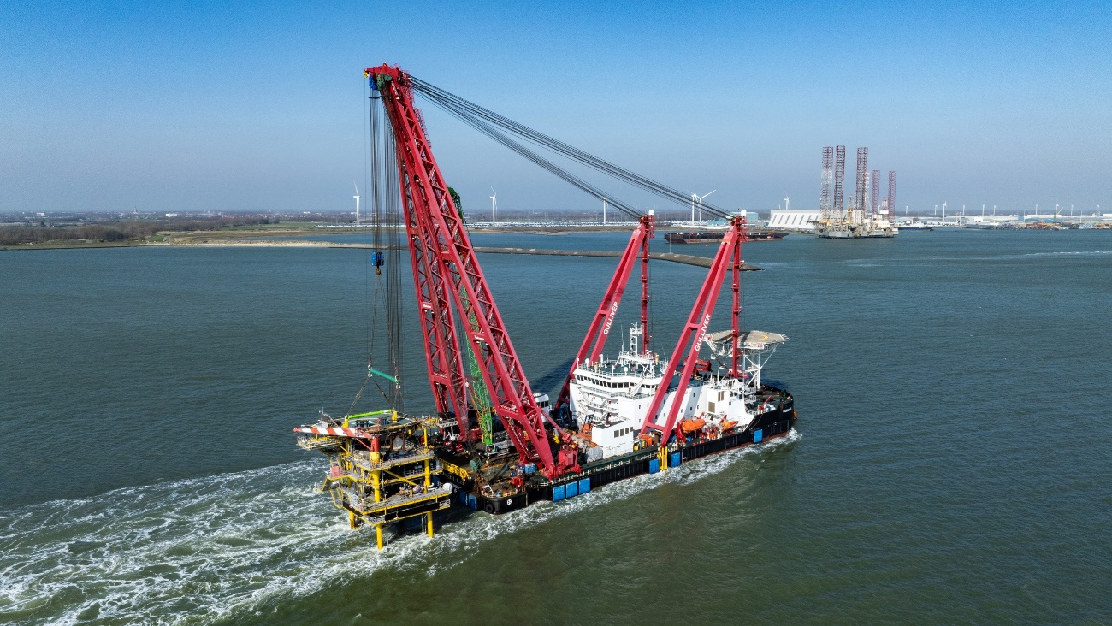
Fig. 8.2: The Gulliver HLV carrying the Cavendish topsides structure back to shore

9 APPENDICES
9.1 01193-INE-UKX-DECM – 2024 Post Decommissioning Cavendish PL2284, PL2285 and PLU4612 Survey Results Report, XOCEAN, issued 23/09/24
9.2 Cavendish Post-decommissioning Survey; Environmental Baseline & Habitat Assessment Report – Benthic Solutions Ltd. for INEOS, issued 20/01/26

