OFFICIAL: SENSITIVE-COMMERCIAL

Handling instructions: The information and attachments within this e-mail contain information which is commercially sensitive and is currently not within the public domain. Please treat this accordingly and do not distribute any further.


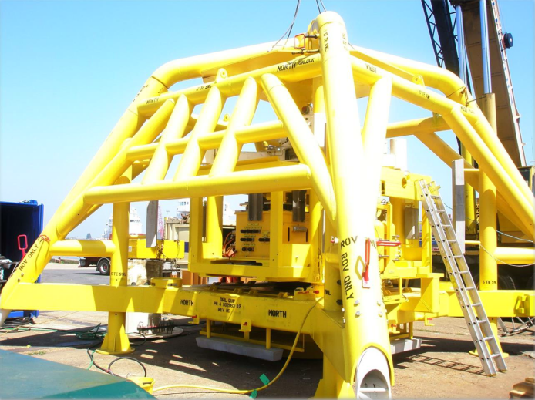

Decommissioning Close Out Report
TOPAZ Field

UNCOSTED VERSION
Rev B02 – Final

DOCUMENT CONTROL TABLE:

Revision | Date | Description | By
A01 | 14/11/2025 | For JV Partner Review | NH
A02 | 03/12/2025 | Draft for OPRED Review | NH
B01 | 20/03/2026 | To incorporate Env Survey results | NH
B02 | 24/07/2026 | To incorporate OPRED comments shared 24/06/26 | NH

Contents

 |  | Page
1.1  1.2  1.3  1.4  2  2.1  2.2  2.3  2.4  2.5  2.6  2.7  2.8  2.9  2.10  2.11  3  3.1  3.2  4  4.1  5  6  7  8  9 | Summary  Summary of Decommissioning Programme  Schematic of Installation(s)/Pipeline(s) Being Decommissioned  Gantt Chart  Associated Decommissioning Approvals  Decommissioning Activities  Contracts Awarded  Platform Operations  Well P&A  Subsea Installations  Subsea Stabilisation features  Pipelines/Umbilicals & Jumpers  Pipeline Stabilisation features  Drill Cuttings  Results of Post Decommissioning & Environmental Surveys & Debris Clearance  Variance From the Approved Decommissioning Programme  Stakeholder Engagement  Impact On the Environment  Activities  Future Monitoring & Management Planning  Impact on HSE  Details of any Incidents/Accidents During Project Execution  Waste/Waste Inventory  Lessons learned  Cost Summary  Photographs  Appendices | 4  7  11  13  13  14  14  15  16

Terms and Abbreviations

Abbreviation | Explanation
BSL | Benthic Solutions Ltd.
DPs | Decommissioning Programmes
DSV | Diving Support Vessel
CSV | Construction Support Vessel
EPRD | Engineering, Procurement, Removal & Disposal
HSE | Health & Safety Executive
km | kilometres
KP | Kilometre Point
LWIV | Light Well Intervention Vessel
m | metres
NFFO | National Federation of Fishermen’s Organisations
NORM | Naturally Occurring Radioactive Material
NSTA | North Sea Transition Authority
OPPC | Oil Pollution Prevention and Control
OPRED | Offshore Petroleum Regulator for Environment and Decommissioning
P&A | Plug and Abandon (wells)
PL | Pipeline
PWA | Pipeline Works Authorisation
ROV | Remotely Operated Vehicle
SHE | Safety, Health & Environmental
SNS | Southern North Sea
Te | Metric ton
TGT | Theddlethorpe Gas Terminal
UKCS | United Kingdom Continental Shelf
URS | Utility ROV Services Ltd.
WHPS | Wellhead Protection Structure
WONS | Well Operations Notification System

summary

1.1 Summary of Decommissioning Programme
The Topaz Field is located in the southern basin of the UKCS (see Figure 1.2) in Block 49/02, approximately 15.5km to the south-east of the DNO North Sea (ROGB) Limited owned Schooner platform. The nearest coastline is 130km southwest (Norfolk, UK) and the UK/Netherlands median line lies 42km east. Topaz lies in approximately 34m of water.

The Topaz development consisted of a single subsea well, which was tied back to the Schooner platform via a 6.6” gas export pipeline ‘PL2631’. There is also a 3.6” umbilical ‘PLU2632’ between Schooner and Topaz that provided control and chemical injection.

Topaz ceased production in October 2017 due to decreased production rates from the well. In 2019, the pipeline and umbilical were both cleaned and flushed and reside in a flooded condition.
- The Decommissioning Programmes (DPs) were formally approved by OPRED on 17th February 2021, being Rev 08, doc. no RD-TOP-ZPL004
- The Schedule of the DPs was formally revised in January 2024 by letter agreement, which extended the Subsea wellhead removal schedule to 31 December 2024, the survey schedule to 30 September 2025, and confirmed a change to the ‘Selected Option’ for Decommissioning at the Pipeline ends, to allow rock placement instead of sediment backfilling.

A summary of the infrastructure that was to be decommissioned, and the approved decommissioning options, is outlined in the tables below.

Table 1.1: Overview of the Decommissioned Installation(s) In the Approved DP
Installation Type | Number | Weight (Te)
No Surface Installations | N/A | N/A
Subsea Installation Type
Wellhead Protection Structure | 1 | 28
Tree | 1 | 21

Table 1.2: Overview of the Decommissioned Pipelines & Umbilicals in The Approved DP
Number of Pipeline(s) to be decommissioned | 1
Number of Umbilical(s) to be decommissioned | 1
Total KM of Pipeline(s) & Umbilcal(s) to be decommissioned | 31.6
Total KM of Pipeline(s) & Umbilcal(s) left in situ | 30.8

Table 1.3: Overview of the Stabilisation Features in the Approved DP
Type | Number
Concrete Mattresses | 109
Rock Dump | 728m long, 1,757 Te
Grout bags | 9 (estimated)

Table 1.4: Overview of the Wells in The Approved DP
Type | Number
Wells (Platform) | N/A
Wells (Subsea) | 1
Appraisal Wells | N/A

Table 1.5: Overview of the Drill Cuttings in The Approved DP
2 piles | Total estimated volume = 250m³

Table 1.6: Summary of the Approved Decommissioning Option(s) In the Approved DP
Type | Selected Option
1. Topsides | N/A
2. Substructures | N/A
3. Subsea Installation(s) | Wellhead Protection Structure and subsea Tree to be completely removed
4. Subsea Installation(s) stabilisation features | N/A
5. Pipelines, Flowlines & Umbilicals & Riser Sections | PL2631 and PLU2631 to be left in-situ except for  short exposed sections between the end of burial and  bottom of the riser/j-tube at the Schooner platform, which will be removed and recovered to shore.
6. Pipeline and related infrastructure stabilisation Features | Where feasible, recover to shore for re-use, recycling or disposal. Rock to be left in-situ.
7. Pipeline Crossings | N/A
8. Wells | Plugged and abandoned in accordance with Oil and Gas UK Guidelines for Decommissioning of Wells
9. Drill Cuttings | Leave in place to degrade naturally

1.2 Schematic of Installation(s)/Pipeline(s) Being Decommissioned
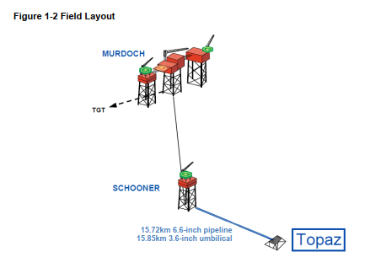

1.3 Project Delivery against the Approved Schedule (from the approved DP or from a revision to the DP)
Below is the revised schedule, as formally amended in January 2024.

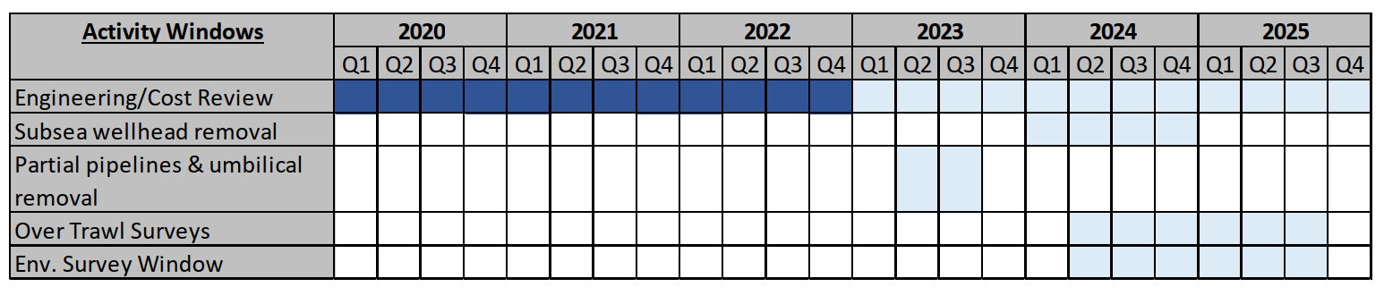

As described in the following sections, all activities are now complete.

Accordingly, the Operator has prepared this report as requested, within 1 year of completion of offshore work, to satisfy OPRED that the approved programme has been fully implemented.

1.4 Associated Decommissioning Approvals

Table 1.7: Associated Decommissioning Approvals
Pipeline Preparatory works | Flush and disconnect pipeline and umbilical, completed in Ocotber 2019. Approval obtained from NSTA via the PWA process and OPRED via the OPPC/environmental permitting process.
Pipeline Decommissioning | For removal works in Q3 2023, approval from NSTA via the PWA process and OPRED via the environmental permitting process.
Amendment of the approved DPs | The Schedule of the DPs was formally revised in January 2024 by letter agreement with OPRED, which extended the removal and survey schedule by 1 year, and confirmed a change to the ‘Selected Option’ for Decommissioning at the Pipeline ends
Subsea Well P&A | Approved via NSTA’s WONS portal July 2024. Extension of the suspension Consent to 15 December 2024 had previously been agreed by letter from NSTA on 31 October 2023.
Removal of WHPS | Compliant with revised DP schedule as per the above

DECOMMISSIONING ACTIVITIES

2.1 Contracts Awarded

Table 2.1: Contracts Awarded
Pipeline FCD: For the pipeline flushing that took place in March 2019, the Topaz owners were able to benefit from the programme of works having been contracted by third party infrastructure owners. In this case, the CMS operator had contracted Halliburton to carry out pipeline flushing in the CMS Area and at Schooner. The provision of these services for the Topaz flowlines was governed by a ‘Schooner-Topaz Flush, Clean and Disconnection Agreement’.

When the flowlines were disconnected from the Topaz wellhead structure later in 2019, this too was contracted by the CMS owners, who had contracted Rever Offshore to execute various DSV work scopes in the area.

Well P&A: After INEOS selected a rigless approach to well abandonment, the contract for the Light Well Intervention Vessel (LWIV) and associated services for subsea well P&A was awarded to Helix in 2022. This was awarded on the basis of its technical advantages of Through-Tubing Abandonment, as well as the commercial impact for the field owners. Although the well P&A had been planned to take place in 2023, the subsea tooling manufacture was affected by delays, and the contract was later varied to enable P&A works to take place in 2024.

Subsea Remediation: The works that were necessary for the disconnection of the Topaz flowlines from the host infrastructure at Schooner were planned by the Schooner operator, who had contracted Utility ROV Services Ltd. (“URS”) to execute this and similar work on other late-life DNO-operated SNS assets.

In May 2023, INEOS awarded its own contract for Subsea Remediation work to URS, on the basis of its market-leading position and that a campaign of work involving 2 other INEOS-operated SNS assets could be undertaken in summer 2023, in direct continuation from DNO’s programme of works referred to above. It was under this contract that the subsea remediation works at the Topaz end of the pipeline took place.

Seabed clearance verification survey: The contract for the post-decommissioning surveys was awarded to XOCEAN in July 2024. A tender was carried out and XOCEAN was deemed to have the required technical capability, whilst the unique solution of uncrewed vessels stood out amongst the tenderers for its SHE risk being as low as reasonably practicable, with lowest possible emissions.

WHPS recovery: Despite being within the scope of the Well P&A contract mentioned above, it became apparent shortly before the work began that the Helix Seawell LWIV was not capable of WHPS recovery, without significant additional cost and risk due to its geometry. It was therefore decided that a separate vessel would be contracted for this scope only, and in September 2024 the Maersk Involver was selected from an assessment of the market was made via INEOS’ vessel brokers, based on technical capability and commercial value. To improve value for the field owners, INEOS developed a vessel sharing agreement whereby costs were shared with Operator of the Minke field ENI, who also had subsea recovery operations to complete following its subsea well P&A.

2.2 Platform Operations

Table 2.2: Platform Decommissioning
N/A – Subsea installation only

2.3 Well P&A

Table 2.3: Well Decommissioning
Well | Designation | Status and Date of Abandonment | Category of Well
49/02a-6z | Gas Production | Fully Abandoned to AB3 3rd August 2024 | SS 3.1.3

2.4 Subsea Installations

Table 2.4: Subsea Installations Decommissioning
Description | Agreed Decom Solution | Total Removed (Actual)  and Date of Removal | Status
Tree | Complete removal | 1; removed on 2nd August 2024 via the Helix Seawell LWIV | Removed
Wellhead Protection Structure | Complete removal | 1; removed on 4th October 2024 via the Maersk Involver CSV | Removed

2.5 Subsea Installations Stabilisation Features

Table 2.5: Subsea Installations Decommissioning
Description | Agreed Decom Solution | Total Removed (Actual)  and Date of Removal | Status
N/A | N/A | N/A | N/A

2.6 Pipelines/Umbilicals & Jumpers

Table 2.6: Pipelines/Umbilicals & Jumpers Decommissioning
PL Number | Description | Agreed Decom Solution  and Date of Removal | Current Status  (Please state the length in kms, left in situ/removed)
PL2631 | 6.6” Steel gas export pipeline | Partial removal: Left in-situ except for exposed ends.  0.4km in aggregate was recovered via URS operations at the Topaz wellhead and at the Schooner platform in 2023. | 0.4km removed, 15.4km remaining in situ
PLU2632 | 3.6” Umbilical | Partial removal: Left in-situ except for exposed ends. 0.4km in aggregate was recovered via URS operations at the Topaz wellhead and at the Schooner platform in 2023. | 0.4km removed, 15.4km remaining in situ
There are no pipeline crossings as part of this scope.

2.7 Pipeline Stabilisation Features

Table 2.7: Pipeline Stabilisation Features Decommissioning
Description | Agreed Decom Solution and Date of Removal | Status
Concrete Mattresses | Agreed solution = Remove to shore. A total of 107* were removed via URS’ campaigns in 2023; 43 at the Schooner end in July and a further 64 in the Topaz 500m zone in August. | Removed to shore
Grout bags | Agreed solution = Remove to shore. A total of 9 were removed to shore via URS’ campaigns in 2023. | Removed to shore
Rock Dump | Agreed solution = Leave in-situ. Total 1,757 Te. | Existing rock dump left in-situ, plus a further ~124 tons deployed via URS campaigns as remediation of cut pipeline and umbilical ends (~62m² seabed coverage)
*The number of Concrete Mattresses in the approved DP was estimated to be 109, whereas just 107 were recovered. The seabed clearance verification surveys did not indicate that any mattresses were left behind on the sea bed.

2.8 Drill Cuttings

Table 2.8: Drill Cuttings Decommissioning
Description & Volume (m3) | Agreed Decom Solution and Date of Removal | Status
2 mounds of approx. 0.5m – 0.8m height, one on either side of the wellhead. Est. total volume is 250m³ | Left in place to degrade naturally | Remain in-situ. The mounds do not represent a snag hazard and are non-toxic.

2.9 Results of Post Decommissioning & Environmental Surveys & Debris Clearance
– Also include evidence of clear seabed

Table 2.9: Environmental Surveys & Debris Clearance
The post-decommissioning seabed clearance survey conducted by XOCEAN in July 2024 is provided alongside this report as evidence of clear seabed. See reference 9.1 in the Appendices.
This survey covered the 100m corridor of PL2631, PLU2632 and the previous location of the Topaz 500m zone. The survey showed there was no change in burial status of the Topaz Pipelines. There were no freespans or exposures found. There was no significant debris found which would be considered a hazard to the integrity of the Pipeline and Umbilical.
In 2025, a further post-decommissioning survey was carried out by BSL, specifically an “Environmental Baseline & Habitat Assessment Report” or simply hereafter, an “Environmental Survey”. See reference 9.2 in the Appendices.
In this survey, an agreed set of locations (or ‘stations’) were visited to take ‘grab samples’ of seabed sediment for laboratory analysis. This Environmental Survey concluded that the available data do not indicate any discernible environmental impact associated with either the former presence of the Topaz subsea well or the decommissioning activities, and that that there is no clear indication of a need for additional environmental investigations in the area.

2.10 Detail All Variance from the Approved Decommissioning Programme

Table 2.10: Variance
The Schedule of the DPs was formally revised in January 2024 by letter agreement with OPRED, to extend by one year the timeline to complete subsea wellhead removal works (by 31 December 2024) and associated surveys (by 30 September 2025).
The same letter also approved a proposed change to the ‘Selected Option’ for Decommissioning at the Pipeline ends. The original version of the DPs specified that backfilling with seabed sediment would be deployed to remediate the cut ends of the pipelines, however the DP was amended to enable INEOS’ Contractors URS to deploy rock placement instead, due to its much higher effectiveness.

The estimated number of mattresses in the DPs was 109, whereas in practice, 107 were located and removed. This figure is an aggregate total of the mattresses recovered from Schooner platform approach, and the Topaz subsea well 500m zone. The aggregate reported disposal weight of these mats is noted to be significantly under the estimated weight in the DP. This is based on measured values from Waste Transfer Notes when the mats were recovered to shore.

The measured tonnage figures for the Tree and WHPS disposal as waste were higher than those estimated in the DPs, at a combined 60 Te instead of 49 Te as stated in the DPs.

2.11 Stakeholder Engagement

Table 2.11: Stakeholder Engagement
A close working relationship was maintained with the Schooner operator DNO, to ensure there was no clash in scheduling disconnection and removal works. Close alignment was particularly evident in respect of the subsea remediation scopes, where INEOS were able to arrange the start of the URS campaign in direct continuation from DNO’s campaign, so that a well-informed and practiced crew could be deployed, and that cost savings could be realised by both field owner groups.

One of the challenges of well P&A was that bespoke tooling was required to gain access to the subsea well to perform abandonment operations. Design and manufacture of this tooling required not only the close attention of INEOS as well operator but also regular interface with Helix as vessel owner for the work scope. Maintaining this working relationship meant that, although the tooling failed its inspection test in 2023, the impact on the programme was mitigated, with Helix quick to agree a contract extension into 2024.

Rather than dispose of the subsea Xmas Tree, INEOS donated it to Score Group Ltd, who were happy to receive it and repurpose it as a training aid. This was deemed to be a ‘win-win’ as it avoided scrapping charges and could not have been re-used as a functioning Tree without full refurbishment at significantly higher cost.

INEOS’ change of plan for WHPS recovery was another example of stakeholder management, using positive working relationships with other offshore users and the supply chain to engineer a new solution. Once it was clear that the WHPS could not be recovered through the moonpool of the Helix Seawell in one piece, the decision was taken not to put divers at risk but instead charter a larger and more capable vessel to conduct removal in a separate campaign. INEOS worked with ENI, as the operator of nearby UK North Sea field Minke, to develop a combined scope of work and a vessel sharing agreement, resulting in a CSV being chartered from Maersk and the costs split between the fields.

Post removal surveys were planned and conducted in accordance with all relevant guidelines and in consultation with regulatory bodies.

3 IMPACT ON ENVIRONMENT
3.1 Activities
There have been no releases/discharges during the reporting period.

After major offshore works are concluded, ‘As-left’ surveys were conducted to confirm no adverse impact or physical disturbance of seabed.

Table 3.1: ‘As-left’ Surveys
Description | Date | Performed by | Comments
Post-Pipeline disconnection ROV survey at Topaz WHPS | October 2019 | Rever Offshore, on behalf of ConocoPhillips | All project equipment removed from worksite. Mattress protection reinstated over cut ends
Post-Subsea Remediation ROV Surveys | August 2023 | OceanInfinity for URS | All grout bags, mattresses and debris recovered
Post-P&A ROV survey | August 2024 | Helix | No debris located from P&A and tree recovery operation
Post-decommissioning seabed clearance verification survey | July 2024 | XOCEAN | No change in burial status of Topaz Pipelines, no significant debris found

3.2 Future Monitoring

Table 3.2: Future Surveys and Monitoring Proposals
1. Substructures
N/A
2. Pipelines, Flowlines & Umbilicals
The XOCEAN survey referred to in 2.9 confirmed that “there was no change in burial status of PL2631 and PLU2632” and “There was no significant debris found which would be considered a hazard to the integrity of the Pipeline and Umbilical.”
The next physical inspection is proposed in 2034. This follows the recommendation of Jee Ltd. in its ‘Risk Based Inspection’ report “JEE-INE40-TN-001 Rev B01”, which was commissioned to verify the post-decommissioning seabed clearance.
The report states: “Inspection data from 2015, 2019, and 2024 was reviewed to analyse the trends in exposures and spans... Only one exposure and span were identified in 2015 and were not observed in any subsequent inspections since 2015. Additionally, these anomalies reported in 2015 were located within a section of the pipeline system that was removed during the decommissioning operation... As such, they are no longer a concern for the pipeline system that remains in-situ. No anomalies have been reported within the remaining in-situ pipeline over the trending period, indicating that the seabed is stable”
3. Pipeline Stabilisation Features
N/A – these have been removed. Confirmed by seabed clearance verification survey.
4. Drill Cuttings
As agreed in the DPs, these are to be left degrade naturally in years to come, and are not expected to pose any risk to sea users whilst in-situ.
5. Environmental Surveys
Following the conclusions and recommendation of the BSL Environmental Survey carried out in 2025, it is not proposed to carry out any further post-decommissioning Environmental Surveys. The BSL Survey confirmed that the sampled stations did not show evidence of significant contamination or notable changes in macrofaunal communities between the pre- and post-decommissioning surveys. The available data do not indicate any discernible environmental impact associated with either the former presence of the Topaz subsea well or the decommissioning activities, and therefore the risk is not considered sufficiently high to warrant the further cost and emissions incurred by additional survey work.

Management Planning
N/A: Topaz is not an "Approved Derogation DP".

4 IMPACT ON HSE
4.1 Details of any Incidents / Accidents during Project Execution

No reportable incidents or accidents have occurred during the decommissioning of Topaz.

5 WASTE

Table 5.1: Materials/Waste Returned to Shore
Material/Waste | Total Weight (t) – as per the approved DP | Tonnage In situ | Tonnage to shore (including date) | Disposal Method
Steel: Xmas Tree and WHPS | 49 | 0 | 24 Te for Tree August 2024, + 36Te in October 2024 for WHPS* | Recycle
Steel Pipeline | 854 | 815 | 39 Te (returned to shore Jun-Aug 2023 following URS campaigns) | Recycle
Umbilical (Armoured hoses and wire) | 206 | 131 | 75 Te (returned to shore Jun-Aug 2023 following URS campaigns) | Repurposed or recycled
Concrete mattresses | 654 | 0 | 572 Te (returned to shore Jun-Aug 2023 following URS campaigns)* | Recycled
Grout bags | 0.2 | 0 | 0.2 Te (returned to shore Jun-Aug 2023 following URS campaigns) | Landfill
TOTAL | 1,681 | 946 | 746

*See Section 2.10 for explanation.

Note that the ‘Tonnage to shore’ figures come from actual measured weight by the responsible contractors for each work scope and differs from the estimated figure in the original DPs.

6 LESSONS LEARNED

For the pipeline flushing that took place in 2019, INEOS was led by the work taking place in the wider CMS area, which streamlined the process for Topaz as the owners were able to take advantage of the services already contracted by the CMS operator rather than separately negotiating such agreements. The administrative and contractual burden was reduced by ‘piggybacking’ these arrangements.

For subsea remediation and disconnection at the Schooner end, INEOS maintained close coordination with the Schooner operator, so that the workscope within Schooner’s 500m exclusion zone could proceed unimpeded by additional interfaces between field owners. To provide ‘peace of mind’ for Topaz owners regarding cost escalation, a fixed cost arrangement was reached, based on transparent sharing of figures from Schooner operator DNO. This process was simplified by DNO’s role as a JV Partner in Topaz.

The subsea remediation work at the Topaz end, again via URS, also benefitted greatly from a ‘back to back’ mobilisation, with INEOS’ ‘campaign’ following immediately after DNO’s contracted scope completed, allowing efficient planning of tools and resources. The campaign approach that was adopted further enabled URS to optimise their schedule across 6 worksites at 3 different INEOS-operated SNS assets. Through daily planning meetings and sharing ‘lookahead’ data with each other, INEOS and URS were able to minimise efficiency losses by adapting plans according to weather or port call restrictions.

Using the uncrewed vessel solution provided by XOCEAN resulted in extremely favourable outcomes for the project, and INEOS would encourage the use of similar technology to other operators. As well as the significant cost savings vs. larger, crewed vessels, INEOS and its JV Partners were able to minimise risk to personnel by removing the need to have an offshore crew, and vastly reduced CO₂ emissions.

7 COST SUMMARY

Decommissioning costs have been provided to OPRED out with this report.

8 PHOTOGRAPHS

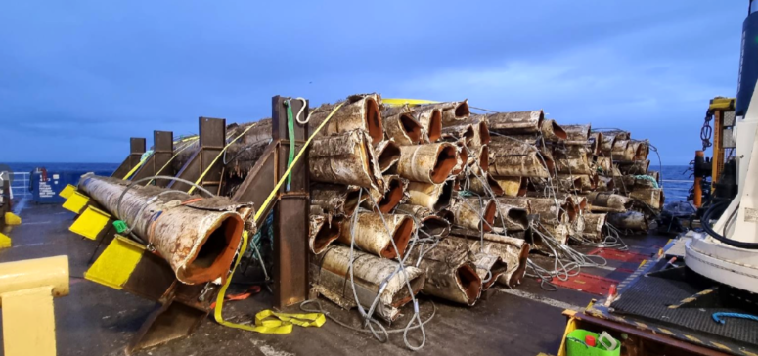
Fig. 8.1: cut lengths of pipe on board the Normand Superior
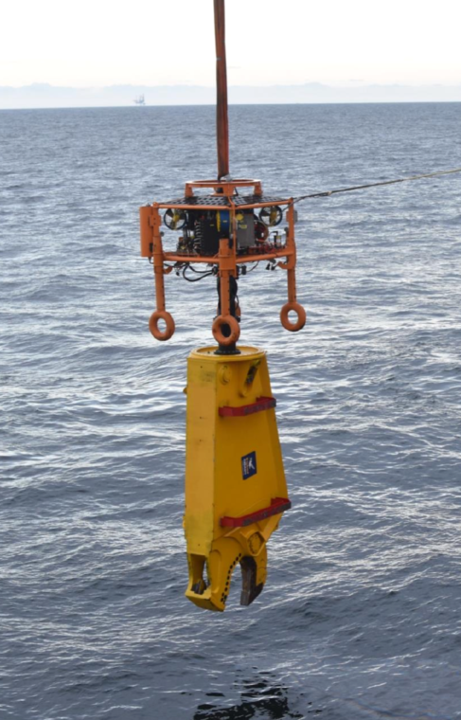
Fig. 8.2: pipe cutting tool mounted on the UTROV system
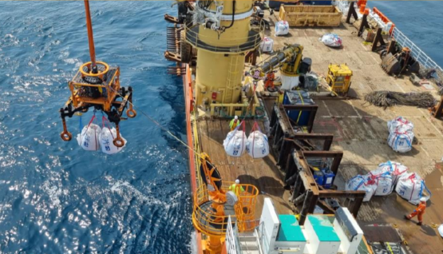
Fig. 8.3: rock bag deployment from the deck of the Normand Superior

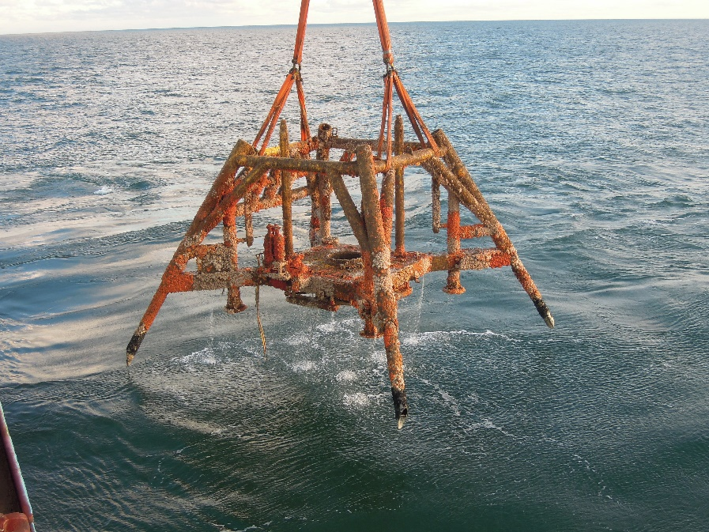
Fig. 8.4: Topaz WHPS being recovered to the deck of the Maersk Involver

9 APPENDICES
9.1 01193-INE-UKX-DECM – 2024 Post Decommissioning Topaz PL2631 and PLU2632 Survey Results Report, XOCEAN for INEOS, issued 21/10/24
9.2 Topaz Post-decommissioning Survey; Environmental Baseline & Habitat Assessment Report – Benthic Solutions Ltd. for INEOS, issued 26/01/26

