OFFICIAL: SENSITIVE-COMMERCIAL

Handling instructions: The information and attachments within this e-mail contain information which is commercially sensitive and is currently not within the public domain. Please treat this accordingly and do not distribute any further.



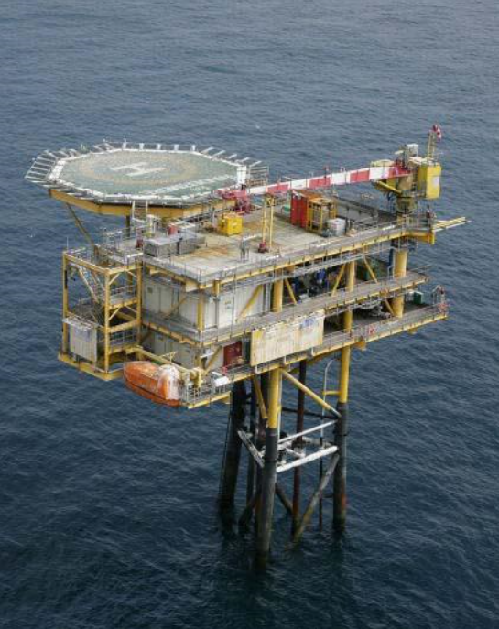



Decommissioning Close Out Report
Windermere Field

UNCOSTED VERSION
Rev B03 Final

DOCUMENT CONTROL TABLE:

Revision | Date | Description | By
A01 | 02/04/2025 | For JV Partner Review | NH
A02 | 21/08/2025 | To reflect JV Comments and OPRED feedback on another Close Out Report | NH
B01 | 15/10/2025 | To incorporate OPRED comments shared on 10/09/25 | NH
B02 | 20/03/2026 | To incorporate Env Survey results and remaining OPRED comments | NH
B03 | 24/07/2026 | To address further OPRED comments shared on 24/06/26 | NH

Contents

 |  | Page
1.1  1.2  1.3  1.4  2  2.1  2.2  2.3  2.4  2.5  2.6  2.7  2.8  2.9  2.10  2.11  3  3.1  3.2  4  4.1  5  6  7  8  9 | Summary  Summary of Decommissioning Programme  Schematic of Installation(s)/Pipeline(s) Being Decommissioned  Gantt Chart  Associated Decommissioning Approvals  Decommissioning Activities  Contracts Awarded  Platform Operations  Well P&A  Subsea Installations  Subsea Stabilisation features  Pipelines/Umbilicals & Jumpers  Pipeline Stabilisation features  Drill Cuttings  Results of Post Decommissioning & Environmental Surveys & Debris Clearance  Detail All Variance from the Approved Decommissioning Programmes  Stakeholder Engagement  Impact On Environment  Activities  Future Monitoring & Management Planning  Impact on HSE  Details of any Incidents/Accidents During Project Execution  Waste/Waste Inventory  Lessons learned  Cost Summary  Photographs  Appendices | 4  8  12  13  14  15  15  16  16

Terms and Abbreviations

Abbreviation | Explanation
BSL | Benthic Solutions Ltd.
BSO | Bluestream Offshore
DPs | Decommissioning Programmes
DSV | Diving Support Vessel
EPRD | Engineering, Procurement, Removal & Disposal
HLV | Heavy Lift Vessel
HSE | Health & Safety Executive
km | kilometres
KP | Kilometre Point
m | metres
NFFO | National Federation of Fishermen’s Organisations
NORM | Naturally Occurring Radioactive Material
NSTA | North Sea Transition Authority
OPPC | Oil Pollution Prevention and Control
OPRED | Offshore Petroleum Regulator for Environment and Decommissioning
P&A | Plug and Abandon (wells)
PL | Pipeline
PWA | Pipeline Works Authorisation
ROV | Remotely Operated Vehicle
SHE | Safety, Health & Environmental
SNS | Southern North Sea
Te | Metric ton
UKCS | United Kingdom Continental Shelf
URS | Utility ROV Services Ltd.

summary

1.1 Summary of Decommissioning Programme

The Windermere Field, located in the Southern Basin of the UKCS (see Figure 1-1) in license block 49/9b, was discovered in 1989 and is located in 35m water depth. The operator of the Windermere field is INEOS UK SNS Limited.

The Windermere facilities comprised the platform, export pipeline PL1273 (6.8km long) and umbilical PL1273.1-3 (7.0km long) between Windermere and the ST-1 platform. Original field layout of the Windermere facilities (to ST-1) prior to decommissioning is shown in Section 1.2.

The Windermere platform was a Normally Unattended Installation (NUI). It was installed in November 1996 and is a small topside minimum facilities structure, fixed on a three-legged tripod jacket. Production commenced in April 1997.

Production ceased from Windermere in April 2016. In 2017, the pipeline and umbilical between Windermere and ST-1 were cleaned and flushed and left in a flooded condition. The helideck, crane and lifeboat on Windermere were taken out of service and walk-to-work docking stations installed. Due to power supply from ST-1 no longer being available, solar powered NAVAIDS were installed on the platform whilst it remained in ‘hydrocarbon safe mode’ prior to decommissioning. The two wells on Windermere were plugged and abandoned in 2019.

- Production formally ceased in April 2016
- The Decommissioning programme was formally approved by OPRED on 31st March 2021; being Rev 11, doc. no RD-WIN-ZPL001.
- In January 2024, a revision to the Decommissioning Programmes was formally accepted by OPRED, which extended the Platform & Topsides removal schedule to end Q2 2024, the survey schedule to 31st December 2025, and confirmed a change to the ‘Selected Option’ for Decommissioning at the Pipeline ends, to allow rock placement instead of sediment backfilling.

A summary of the infrastructure that was to be decommissioned and the approved decommissioning options is outlined in the tables below.

Table 1.1: Overview of the Decommissioned Installation(s) In The Approved DP
Installation Type | Number | Weight
Small Tripod Fixed Steel Jacket/NUI | 1 | 452 Te topsides, 382 Te jacket
Subsea Installation Type
N/A | None | N/A

Table 1.2: Overview of the Decommissioned Pipelines & Umbilicals in The Approved DP
Number of Pipeline(s) to be decommissioned | 1 (cleaned/flushed and water filled)
Number of Umbilical(s) to be decommissioned | 1 (cleaned/flushed and water filled)
Total KM of Pipeline(s) & Umbilcal(s) to be decommissioned | 13.8
Total KM of Pipeline(s) & Umbilcal(s) left in situ | 13.4

Table 1.3: Overview of the Stabilisation Features In The Approved DP
Type | Number
Concrete Mattresses | 48
Grout Bags | 300
Rockdump | 78.5 Te

Table 1.4: Overview of the Wells in The Approved DP
Type | Number
Wells (Platform) | 2 (plugged and Abandoned)
Wells (Subsea) | N/A
Appraisal Wells | N/A

Table 1.5: Overview of the Drill Cuttings in The Approved DP
Number of Piles & Volume (m³) | N/A

Table 1.6: Summary of the Approved Decommissioning Option(s) In the Approved DP
Type | Selected Option
1. Topsides | Complete removal for re-use and recycling
2. Substructures (Jacket) | Complete removal for re-use and recycling
3. Subsea Installation(s) | N/A
4. Subsea Installation(s) stabilisation features | N/A
5. Pipelines, Flowlines & Umbilicals & Riser Sections | The pipeline and umbilical have been flushed and cleaned and will be partially removed. Buried sections of pipeline and umbilical will be left buried in-situ.
6. Pipeline and related infrastructure stabilisation Features | Mattresses & Grout bags will be removed
7. Pipeline Crossings | N/A
8. Wells | Abandoned in accordance with Oil and Gas UK Guidelines for Decommissioning of Wells
9. Drill Cuttings | N/A

1.2 Schematic of Installation(s)/Pipeline(s) Being Decommissioned

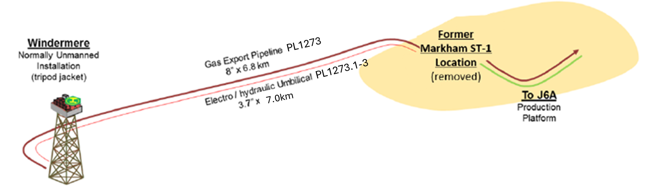
Fig. 1.2: schematic of Windermere Field Facilities and Pipeline

1.3 Project Delivery against the Approved Schedule (from the approved DP or from a revision to the DP)
Below is the revised schedule, as formally amended in January 2024.

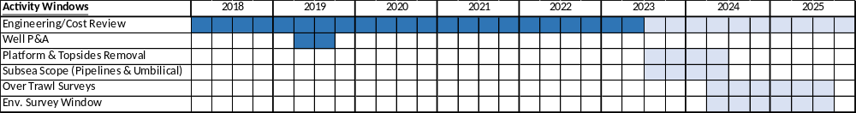

As described in the following sections, all activities are now complete.

Accordingly, the Operator has prepared this report as requested, within 1 year of completion of offshore work, to satisfy OPRED that the approved programme has been fully implemented.

1.4 Associated Decommissioning Approvals

Table 1.7: Associated Decommissioning Approvals
Platform well P&A | Completed November 2019
Topside removal | Approved by OPRED March 2021
Pipeline Preparatory works | Flush and disconnect pipeline and umbilicals, completed in June 2017. Approval from NSTA via the PWA process and OPRED via the OPPC/environmental permitting process. Windermere Pipeline placed in Interim Pipelines Regime by OPRED.
PWA | Up to date for works on Windermere and for removal of ST-1
Amendment of the approved DPs | In January 2024, a revision to the Decommissioning Programmes was formally accepted by OPRED, which extended the schedule and confirmed a change to the ‘Selected Option’ for Decommissioning at the Pipeline ends
Decommissioning Consent for removal of the Platform | DCA/194 was approved by OPRED in October 2023 to provide consent for the removal of the platform including: Consent to locate for the heavy lift vessel; Marine licence for seabed disturbance and deposits; Survey notification for the use of the ROV; and Disturbance licence for removal with nesting birds present

DECOMMISSIONING ACTIVITIES
2.1 Contracts Awarded

Table 2.1: Contracts Awarded
Seajacks were awarded the contract for the supply of a jack up barge to undertake the 2019 P&A work in May 2019. For the majority of associated services (e.g. cementing etc.), INEOS was able to utilise existing contracts.

In April 2023, INEOS awarded the contract for the next phase of activity, i.e. the ‘EPRD’ for the removal of the facilities at Windermere and another INEOS-operated SNS platform, to Scaldis Salvage & Marine Conractors (“Scaldis”). This was done following a tender process and detailed negotiation, with support from JV Partners. This contract also governs the subsea disconnection of the pipelines from the jacket, via Scaldis’ subcontractors, Bluestream Offshore (BSO). This work scope, taking place within 20m of the platform, was referred to as the ‘close proximity work.’

In May 2023, INEOS awarded a contract for Subsea Remediation work to Utility ROV Services Ltd. (“URS”), on the basis of its market-leading position and that a campaign of work involving 2 other INEOS-operated SNS assets could be undertaken in summer 2023.

The contract for the post-decommissioning surveys was awarded to XOCEAN in July 2024. A tender was carried out and XOCEAN was deemed to have the required technical capability, whilst the unique solution of uncrewed vessels stood out amongst the tenderers for its SHE risk being as low as reasonably practicable, with lowest possible emissions.

2.2 Platform Operations

Table 2.2: Platform Decommissioning
To avoid committing any offence relating to protected species, it was agreed with Scaldis not to attempt platform removal prior to 1st October 2023, deemed to be comfortably beyond the end of the kittiwake nesting season.
The offshore campaign for the Windermere platform decommissioning was carried out between 9th October 2023 and 19th March 2024. Between 5th December 2023 and 2nd March 2024 operations were paused due to expected adverse weather conditions, severely restricting the capability of the Gulliver Heavy Lift Vessel (HLV).
Working days for the Windermere platform were discontinuously spread across October and November 2023. A small crew boarded the platform from the Gulliver HLV when conditions were suitable to do so, to carry out preparation work scopes such as non-destructive testing of padeyes, welding lifting support beams, and installing access scaffolding on the jacket. Each time the platform was de-manned due to bad weather, a make safe campaign was performed upon return. The Windermere topside was eventually lifted and brought to shore at Sagro’s Decommissioning facilities in Vlissingen, Netherlands, on 1st December 2023, where dismantlement was completed in March 2024.
The jacket was lifted and brought to shore on 19th March 2024 following completion of dredging and cutting activities. This included the removal of the conductors, which were left in-situ at the time of the well P&A in 2019.

2.3 Well P&A

Table 2.3: Well Decommissioning
Well | Designation | Status and Date of Abandonment | Category of Well
49/9b-4z (W1) | Gas Production | Plugged in Q4 2019 and abandoned to AB3 status with jacket removal in March 2024 | PL 2-1-1
49/9b-W2z | Gas Production | Plugged in Q4 2019 and abandoned to AB3 status with jacket removal in March 2024 | PL 2-1-1

2.4 Subsea Installations

Table 2.4: Subsea Installations Decommissioning
Description | Agreed Decom Solution | Total Removed (Actual)  and Date of Removal | Status
N/A | N/A | N/A | N/A

2.5 Subsea Installations Stabilisation Features

Table 2.5: Subsea Installations Decommissioning
Description | Agreed Decom Solution | Total Removed (Actual)  and Date of Removal | Status
N/A | N/A | N/A | N/A

2.6 Pipelines/Umbilicals & Jumpers

Table 2.6: Pipelines/Umbilicals & Jumpers Decommissioning
PL Number | Description | Agreed Decom Solution  and Date of Removal | Current Status  (Please state the length in kms, left in situ/removed)
PL1273 | Gas Export Line (to ST-1) | Partial Removal via BSO and URS works in Aug-Sep 2023 | 0.2km removed; 6.6km remaining in situ
PL1273.1 to PL1273.3 | Umbilical (Methanol and Corrosion Inhibitor line) | Partial Removal via BSO and URS works in Aug-Sep 2023 | 0.2km removed; 6.8km remaining in situ

2.7 Pipeline Stabilisation Features

Table 2.7: Pipeline Stabilisation Features Decommissioning
Description | Agreed Decom Solution and Date of Removal | Status
Concrete Mattresses | 46* removed between 27/07/23 – 17/08/23 | Removed
Grout bags (300) | 300 removed between 27/07/23 – 17/08/23 | Removed
Rock Dump (42m) | Planned to leave in-situ | In-situ
*48 mattresses were identified in the original DPs

2.8 Drill Cuttings

Table 2.8: Drill Cuttings Decommissioning
Description & Volume (m3) | Agreed Decom Solution and Date of Removal | Status
N/A | N/A | N/A

2.9 Results of Post Decommissioning & Environmental Surveys & Debris Clearance
– Also include evidence of clear seabed

Table 2.9: Environmental Surveys & Debris Clearance
A post-decommissioning survey conducted by XOCEAN in July 2024 is provided alongside this report as evidence of clear seabed. See reference 9.1 in the Appendices.
This survey covered the 100m corridor of PL1273, PL1273.1-3 and the previous location of the Windermere Platform 500m Zone. The survey showed there was no change in burial status of PL1273 and PL1273.1-3. There were no freespans or exposure found. There was no significant debris found which would be considered a hazard to the integrity of the Pipeline or Umbilical. A possible Mattress was found near PL1273 at Markham ST-1, although no additional recovery operations took place as part of this survey, as the survey vessel was not equipped to do so. Sighting of this mattress had not been reported in the 2023 remediation work carried out by URS. There was no significant debris found in the Windermere 500m Zone.
In 2025, a further post-decommissioning survey was carried out by BSL, specifically an “Environmental Baseline & Habitat Assessment Report” or simply hereafter, an “Environmental Survey”. See reference 9.2 in the Appendices.
In this survey, an agreed set of locations (or ‘stations’) were visited to take ‘grab samples’ of seabed sediment for laboratory analysis. This Environmental Survey concluded that the available data do not indicate any discernible environmental impact associated with either the former presence of the Windermere platform or the decommissioning activities, and that that there is no clear indication of a need for additional environmental investigations in the area.

2.10 Detail All Variance from the Approved Decommissioning Programmes

Table 2.10: Detail All Variance from the Approved Decommissioning Programmes
In January 2024, a revision to the Decommissioning Programmes was formally accepted by OPRED, which extended the decommissioning schedule to 31 December 2025, and confirmed a change to the ‘Selected Option’ for Decommissioning at the Pipeline ends. The original version of the DPs specified that backfilling with seabed sediment would be deployed to remediate the cut ends of the pipeline, however the DP was amended to enable INEOS’ Contractors URS to deploy rock placement instead, due to its much higher effectiveness.

The estimated amount of concrete mattresses in the DPs was 48, whereas in practice, only 46 were located and removed. This figure is an aggregate total of the mattresses recovered from the Windermere platform approach and the former location of the ST-1 platform.

The measured tonnage figures for platform disposal as waste were higher than those estimated in the DPs.

2.11 Stakeholder Engagement

Table 2.11: Stakeholder Engagement
Prior to signing the contract for the EPRD scope, INEOS undertook nesting bird surveys to establish the likelihood that colonies of the protected black-legged kittiwake would nest on the installation. Specialist ornithologists were consulted and their input and advice was key to the engagement with OPRED and JNCC, influencing the timing of the removal programme. In March 2023, when it became clear that the agreed deterrent measures could not be implemented, the removal works were scheduled outside of the expected nesting season, to avoid disturbance to nesting kittiwakes.

When the Markham ST-1 platform was removed, INEOS engaged with Spirit Energy to determine the condition of the seabed and whether the remaining infrastructure (mattresses, exposed pipeline) presented a potential hazard to fishing activities. In consultation with OPRED, NFFO and UK Hydrographic Office, appropriate notifications were issued to inform sea users of the hazard, and a ‘Special Mark Buoy’ was procured and deployed in January 2020 to mark the hazard. All these entities have now been advised of its removal in August 2023.

Post removal surveys were planned and conducted in accordance with all relevant guidelines and in consultation with regulatory bodies.

3 IMPACT ON ENVIRONMENT
3.1 Activities

There have been no releases/discharges during the decommissioning works.

After major offshore works are concluded, ‘As-left’ surveys were conducted to confirm no adverse impact or physical disturbance of seabed.

Table 3.1: ‘As-left’ Surveys
Description | Date | Performed by | Comments
Post-Subsea Remediation ROV Survey | August 2023 | OceanInfinity for URS | GVI confirmed that all mattresses, and all pipeline and umbilical have been removed from the Ex-platform location to the  final cut location and debris clearance has been completed on the pipeline and umbilical routes
Post-Jacket Removal Seabed Clearance Report | March 2024 | BSO for Scaldis | Only 1 debris target was located; a 2m length of scaffold pipe next to the footprint of jacket leg B3. It was recovered.
Post-decommissioning seabed clearance verification survey | July 2024 | XOCEAN | No change in burial status of Windermere Pipelines, no significant debris found which would be considered a hazard to the integrity of the Pipeline or Umbilical.

3.2 Future Monitoring

Table 3.2: Future Surveys and Monitoring Proposals
1. Substructures
N/A – the substructure has been removed, as evidenced by Scaldis’ “As-removed – Decommissioning Windermere” report RD – XDRY – SCA – CH – PR - 00501
2. Pipelines, Flowlines & Umbilicals
The XOCEAN survey referred to in 2.9 confirmed that “there was no change in burial status of PL1273 and PL1273.1-3. There were no freespans or exposure found. There was no significant
debris found which would be considered a hazard to the integrity of the Pipeline or Umbilical”
The next physical inspection is proposed in 2034. This follows the recommendation of Jee Ltd. in its ‘Risk Based Inspection’ report “JEE-INE40-TN-001 Rev B01”, which was commissioned to verify the post-decommissioning seabed clearance. The report states that “Inspection data from 2014, 2019, and 2024 was reviewed to analyse the trends in exposures and spans... All of the observed exposures and spans identified in the historical survey data were no longer observed during the 2024 survey.
Additionally, these anomalies reported in historical inspections were located within a section of the pipeline system that was removed during the decommissioning operation... As such, they are no longer a concern for the pipeline system that remains in-situ. No anomalies have been reported within the pipeline section remaining in-situ over the trending period, indicating that the seabed is stable.”
3. Pipeline Stabilisation Features
N/A – these have been removed. Confirmed by seabed clearance verification survey.
4. Drill Cuttings
N/A
5. Environmental Surveys
Following the conclusions and recommendation of the BSL Environmental Survey carried out in 2025, it is not proposed to carry out any further post-decommissioning Environmental Surveys. The BSL Survey confirmed that the sampled stations did not show evidence of significant contamination or notable changes in macrofaunal communities between the pre- and post-decommissioning surveys. The available data do not indicate any discernible environmental impact associated with either the former presence of the Windermere platform or the decommissioning activities, and therefore the risk is not considered sufficiently high to warrant the further cost and emissions incurred by additional survey work.

Management Planning

N/A: Windermere is not an "Approved Derogation DP".

4 IMPACT ON HSE
4.1 Details of any Incidents / Accidents during Project Execution

No reportable incidents or accidents have occurred during the Decommissioning Programme.

5 WASTE

Table 5.1: Materials/Waste Returned to Shore
Material/Waste |  | Total Weight (t) – as per the approved DP | Tonnage In situ | Tonnage to shore (including date) | Disposal Method
 | Steel – platform topsides | 462.0 | 0 | 462 (December 2023) | Recycled
 | Steel – platform jacket and well conductors | 556.2 | 0 | 556.2 (March 2024) | Recycled
 | Steel – Production Trees and Completion Tubing | 20.5 | 0 | 20.5 (returned to shore Nov 2019 following P&A ops) | Recycled
 | Steel (API 5L X65) – from removed sections of Pipeline | 818 | 780 | 38 (Aug 2023 following URS campaign) | Recycled
 | Fibre optic cable and polyurethane sheath –Umbilical | 105 | 98 | 7 (Aug 2023 following URS campaign) | Recycled
 | Concrete mattresses | 250 | 0 | 250 (Aug 2023 following URS campaign) | Recycled
 | Grout bags | 9.6 | 0 | 9.6(Aug 2023 following URS campaign) | Landfill
 | TOTAL | 2,221 | 878 | 1,343

Because the waste was taken from UK waters and brought ashore to a disposal yard in Netherlands, a Transfrontier Shipment of Waste Process was followed. This involved liaisons with the Environment Agency on the UK side to prepare the necessary application paperwork, and put in place a Financial Guarantee. This paperwork was then required to be reviewed and accepted by the equivalent in Netherlands, the ‘Inspectie Leefomgeving en Transport’ (Human Environment and Transport Inspectorate).

6 LESSONS LEARNED

The well P&A was conducted using a jack-up barge rather than a rig, which although could offer greater operational capabilities, was not considered to be worth the incremental cost. INEOS was able to secure a highly competitive rate spread rate for the vessel and services via a ‘campaign’ approach, i.e. scheduling operations in sequence with the P&A and pipeline flushing of another operated SNS asset. The through-tubing methodology was also employed, which allowed time and therefore cost to be saved on the P&A operation.

BSO’s ‘close proximity’ operations were diver-based, and therefore had significant limitations on working time due to weather and tidal conditions. It would be difficult to avoid this in future, however, due to those unique conditions and the positioning of the infrastructure proving unworkable for larger craft to execute the workscope. Collaboration between the two subsea contractors (contracted independently) was demonstrated by the URS crew completing removals related to the close proximity work, with these deviations executed according to MOC processes.

Having subcontractors (BSO were working as part of the Scaldis agreement) execute this scope also made it more challenging for INEOS to optimise the work scope, particularly in relation to cutting methodology, as the shear cutters were unable to meet performance standards, leading to the adoption of saw cutting. Greater emphasis should therefore be placed on onshore testing of shear cutters on equivalent pipeline material and wall thickness.

The subsea remediation campaign via URS benefitted greatly from the ‘campaign’ approach adopted, with URS able to optimise the schedule of work across 6 worksites at 3 different INEOS-operated SNS assets. Through daily planning meetings and sharing ‘lookahead’ data with each other, INEOS and URS were able to minimise efficiency losses, despite access restrictions being imposed by the BSO work programme taking place in parallel.

Similarly, there were significant financial and practical benefits to the ‘campaign’ approach adopted for the EPRD scope, which was almost identical for 2 INEOS-operated assets. The contractual price was significantly reduced vs. a ‘standalone’ campaign, and the overheads incurred during preparation, execution and close-out phases are shared between the assets.

The timing of the lifting operations was dictated by avoiding disturbance to nesting birds, which increased the operational weather risk considerably. Although this increased risk was reflected in a higher price paid to the contractor, the ‘lump-sum’ arrangement benefitted the asset owners as limited the cost exposure due to weather delays.

The Transfrontier Shipment of Waste Process referred to in Section 5 proved to be somewhat longer than expected to obtain approval from all regulatory bodies. INEOS would recommend to other Operators that where this process cannot be avoided, it be taken off the ‘critical path’ where possible by an earliest possible commencement.

Using the uncrewed vessel solution provided by XOCEAN resulted in extremely favourable outcomes for the project, and INEOS would encourage the use of similar technology to other operators. As well as the significant cost savings vs. larger, crewed vessels, INEOS and its JV Partners were able to minimise risk to personnel by removing the need to have an offshore crew, and vastly reduced CO₂ emissions.

7 COST SUMMARY

Decommissioning costs WILL BE provided to OPRED out with this report.

8 PHOTOGRAPHS
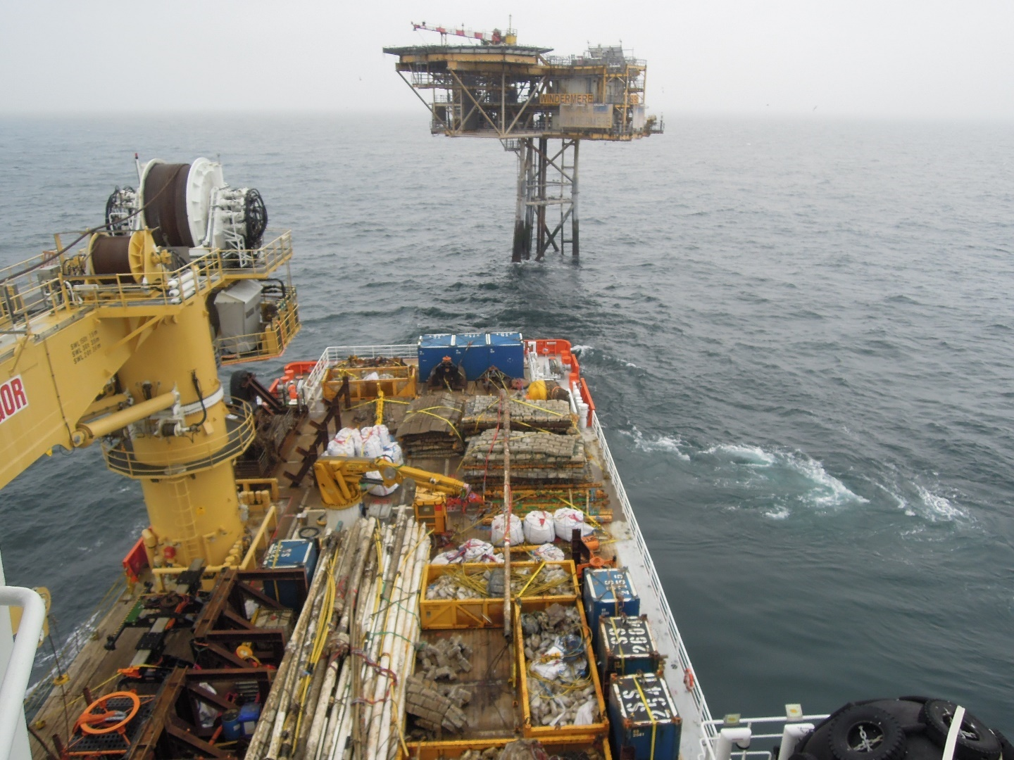
Fig. 8.1: Normand Superior sailing from Windermere on conclusion of remediation campaign

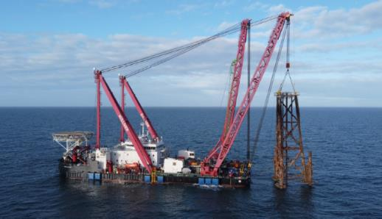
Fig. 8.2: The Gulliver HLV carrying the Windermere jacket structure back to shore

9 APPENDICES
9.1 01193-INE-UKX-DECM – 2024 Post Decommissioning Windermere, PL1273 and PL1273.1-3 Survey Results Report, XOCEAN, issued 21/10/24
9.2 Windermere Post-decommissioning Survey; Environmental Baseline & Habitat Assessment Report – Benthic Solutions Ltd. for INEOS, issued 05/02/26

