
Area name here

Merseyside MAPPA Annual Report 2025 to 26


Introduction

MAPPA SMB Chair – Matt Ashworth, Head of Probation Delivery Unit

On behalf of the Merseyside Strategic Management Board (SMB), I am pleased to present the 2025 to 26 MAPPA Annual Report, providing an overview of the Multi-Agency Public Protection Arrangements (MAPPA) across Merseyside.
MAPPA is the framework through which the Probation Service, Police and Prison Service, collectively known as the Responsible Authorities, work together to manage the risks posed by violent and sexual offenders. It ensures that agencies discharge their statutory responsibilities in a coordinated and effective manner, taking all reasonable steps to protect victims and safeguard the public from harm.
The data and updates contained within this report demonstrate the professionalism, dedication and collaborative commitment of our partner agencies in delivering robust and responsive risk management across Merseyside. We remain committed to reviewing our performance, identifying opportunities for continuous improvement, and ensuring that the membership and work of the SMB reflect the risks and needs presented by the MAPPA cohort.
During 2025 to 2026, Merseyside Police implemented a force-wide restructure and introduced a new operating model for MAPPA within its Public Protection function. Throughout this period of change, multi-agency partnership working has continued to strengthen, not only within MAPPA but also through Integrated Offender Management (IOM) and the development of Multi-Agency Tasking and Coordination (MATAC) meetings. These arrangements support a coordinated response to the risks posed by serial domestic abuse perpetrators and enhance the effectiveness of multi-agency safeguarding activity.
Merseyside MAPPA is governed by the Strategic Management Board, which meets quarterly to review performance, provide strategic oversight and drive continuous improvement in practice. I would like to express my sincere thanks to all those involved in both the SMB and the operational delivery of MAPPA for their ongoing commitment to managing some of the most complex and challenging individuals in our communities. Their dedication ensures that the protection of victims and the wider public remains our highest priority.
This year has also seen significant developments within the criminal justice system, including the implementation of the Independent Sentencing Review and other legislative and policy changes. These developments have contributed to an evolving landscape for offender management, requiring agencies to adapt and respond effectively while maintaining high standards of public protection.
I am confident that the strong partnerships and commitment demonstrated across Merseyside will continue to support the effective management of risk and the ongoing development of exceptional MAPPA practice.

MAPPA Statistics

MAPPA-eligible individuals on 31 March 2026
 | Category 1:  Subject to sex offender notification requirements | Category 2:  Violent  offenders | Category 3:  Other dangerous  offenders | Total
Level 1 | 2,178 | 975 | - | 3,153
Level 2 | 8 | 9 | 25 | 42
Level 3 | 0 | 2 | 4 | 6
Total | 2,186 | 986 | 29 | 3,201

MAPPA-eligible offenders in Levels 2 and 3 by category (yearly total)
 | Category 1:  Subject to sex offender notification requirements | Category 2:  Violent  offenders | Category 3:  Other dangerous  offenders | Total
Level 2 | 18 | 28 | 87 | 133
Level 3 | 7 | 10 | 14 | 31
Total | 25 | 38 | 101 | 31

Category 1 cautioned for breach of notification requirements | 0
Category 1 convicted for breach of notification requirements | 73

Category 1 who have had their life time notification revoked on application | 5

Restrictive orders for Category 1 offenders
Sexual Harm Prevention Order (SHPO) | 279
SHPO with foreign travel restriction | 5
Notification Order | 3

Number of individuals who became subject to sex offender notification requirements following a breach(es) of a Sexual Risk Order (SRO) | 3

Level 2 and 3 individuals returned to custody
Returned to custody for breach of licence | Category 1:  Subject to notification requirements | Category 2:  Violent  offenders | Category 3:  Other dangerous  offenders | Total
Level 2 | 16 | 18 | 21 | 55
Level 3 | 3 | 3 | 4 | 10
Total | 19 | 21 | 25 | 65

Breach of SHPO
Level 2 | 3
Level 3 | 0
Total | 3

Total number of individuals subject to sex offender notification requirements per 100,000 population | 165

This figure has been calculated using the mid-2025 estimated resident population, published by the Office for National Statistics (ONS) on 30 July 2026, excluding those aged less than ten years of age.

What are MAPPA?

MAPPA background
MAPPA (Multi-Agency Public Protection Arrangements) are a set of arrangements to manage the risk posed by individuals who have committed the most serious sexual, violent and terrorist offences (MAPPA-eligible individuals) under the provisions of sections 325 to 327B of the Criminal Justice Act 2003.
They bring together the Police, Probation and Prison Services in each of the 42 Areas in England and Wales into what is known as the MAPPA Responsible Authority.
A number of other agencies are under a Duty to Co-operate (DTC) with the Responsible Authority. These include Social Services, Health Services, local Youth Justice Services, Department for Work and Pensions, the Home Office and Local Housing and Education Authorities.
Local Strategic Management Boards (SMBs) comprising senior representatives from each of the Responsible Authority and DTC agencies are responsible for delivering MAPPA within their respective areas. The Responsible Authority is also required to appoint two Lay Advisers to sit on each MAPPA SMB.
Lay Advisers are members of the public appointed by the Minister with no links to the business of managing MAPPA-eligible individuals who act as independent, yet informed, observers; able to pose questions which the professionals closely involved in the work might not think of asking. They also bring to the SMB their understanding and perspective of the local community (where they must reside and have strong links).

How MAPPA work
MAPPA-eligible individuals are identified and information about them is shared between agencies to inform the risk assessments and risk management plans of those managing or supervising them.
That is as far as MAPPA extend in the majority of cases, but some cases require more senior oversight and structured multi-agency management. In such cases there will be regular MAPPA meetings attended by relevant agency practitioners.
There are 4 categories of MAPPA-eligible individual:
- Category 1 –subject to sex offender notification requirements;
- Category 2 – mainly those convicted of violent offences and sentenced to 12 months or more imprisonment or a hospital order;
- Category 3 – individuals who do not qualify under Categories 1, 2 or 4 but whose offences pose a risk of serious harm.
- Category 4 – terrorism convicted and terrorism risk individuals
Data on Category 4 individuals is not included in this report due to data protection issues related to low numbers. This data will be aggregated and published nationally.
There are three levels of management to ensure that resources are focused where they are most needed; generally those presenting the higher risks of serious harm.
- Level 1 is where the individual is managed by the lead agency with information exchange and multi-agency support as required but without formal MAPPA meetings;
- Level 2 is where formal MAPPA meetings are required to manage the individual.
- Level 3 is where risk management plans require the attendance and commitment of resources at a senior level at MAPPA meetings.
MAPPA are supported by ViSOR. This is a national IT system to assist in the management of individuals who pose a serious risk of harm to the public. The use of ViSOR increases the ability to share intelligence across organisations and enables the safe transfer of key information when high risk individuals move between areas, enhancing public protection measures. ViSOR allows staff from the Police, Probation and Prison Services to work on the same IT system, improving the quality and timeliness of risk assessments and interventions to prevent offending.

MAPPA ‘25
2025 marked the 25th anniversary of the legislation that first introduced mandatory multi-agency co-operation in the management of those convicted of violent and sexual offences.
Throughout the year, the National MAPPA Team held online engagement events to increase awareness of and confidence in MAPPA and improve MAPPA practice across a wide range of agencies. Events covered topics including the management of children and young adults, managing terrorist risks, humanising MAPPA and the value of prison partnerships. The online events proved hugely successful with more than 5,000 professionals attending the live events. Local MAPPA Strategic Management Boards also held events to mark the anniversary, bringing partners together to strengthen partnership arrangements
All MAPPA reports from England and Wales are published online on GOV.UK

Explanation commentary on statistical tables

MAPPA background
The totals of MAPPA-eligible individuals, broken down by category, reflect the picture on 31 March 2026 (i.e. they are a snapshot). The rest of the data covers the period 1 April 2025 to 31 March 2026.
(a) MAPPA-eligible individuals – there are individuals defined in law as eligible for MAPPA management because they have committed specified sexual, violent or terrorist offences or they currently pose a risk of serious harm. The majority are managed at Level 1 without formal MAPPA meetings. These figures only include those MAPPA eligible individuals living in the community. They do not include those in prison or detained under the Mental Health Act.
(b) Subject to Sex Offender Notification Requirements – those who are required to notify the police of their name, address and other personal details and to notify of any subsequent changes (this is known as the “notification requirement.”) These individuals are assessed and managed by the police. They may also be managed by probation, youth justice or health services if they are subject to licence or a hospital order. Failure to comply with the notification requirement is a criminal offence that carries a maximum penalty of 5 years’ imprisonment.
(c) Violent Offenders – individuals convicted of violent offences who were sentenced to imprisonment or detention for 12 months or more, or detained under a hospital order and a small number of individuals convicted of sexual offences who are not subject to notification requirements. These individuals are assessed and managed by the Probation Service, Youth Justice Service or Mental Health Services.
(d) Other Dangerous Offenders – individuals who do not qualify under the other MAPPA-eligible categories, but have committed an offence that indicates that they pose a risk of serious harm which requires management via MAPPA meetings. These individuals are assessed and managed by whichever agency has the primary responsibility for them.
(e) Terrorism and Terrorism Risk Offenders – individuals subject to terrorism offender notification requirements; individuals convicted of terrorism or terrorism related offences who were sentenced to imprisonment or detention for 12 months or more, or detained under a hospital order; and those who have committed an offence and may be at risk of involvement in terrorism-related activity. These individuals are assessed and managed by Counter-Terrorism Police and the National Security Division of the Probation Service.
(f) Breach of Licence – individuals released into the community following a period of imprisonment will be subject to a licence with conditions (under probation supervision). If the individual does not comply with these conditions, the Probation Service will take breach action and the individual may be recalled to prison.
(g) Sexual Harm Prevention Order (SHPO) (including any additional foreign travel restriction). Sexual Harm Prevention Orders (SHPOs) and interim SHPOs are intended to protect the public from individuals convicted of a sexual or violent offence who pose a risk of sexual harm to the public by placing restrictions and/or positive obligations on their behaviour. They require the individual to notify their details to the police (as set out in Part 2 of the 2003 Act) for the duration of the order.
The court must be satisfied on the balance of probability that an order is necessary to protect the public (or any particular members of the public) in the UK, or children or vulnerable adults (or any particular children or vulnerable adults) abroad, from sexual harm from the individual. In the case of an order made on a free standing application by a Chief Police Officer, the National Crime Agency (NCA), British Transport Police (BTP) or the Ministry of Defence Police (MODP), the chief officer/NCA/BTP/MODP must be able to show that the individual has acted in a way since their conviction that makes the order necessary.
The minimum duration for a full order is five years. The lower age limit is 10, which is the age of criminal responsibility, but where the defendant is under the age of 18 an application for an order should only be considered exceptionally.
(h) Notification Order – this requires individuals convicted of qualifying sexual offences overseas to register with the police, in order to protect the public in the UK from the risks that they pose. The police in England and Wales may issue a notification order directly to an offender who is already in the UK or who is intending to come to the UK who has to notify within three days of receipt. Individuals have a right of appeal against notification.

(i) Sexual Risk Order (including any additional foreign travel restriction) –The Sexual Risk Order (SRO may be made in relation to a person without a conviction for a sexual or violent offence (or any other offence), but who poses a risk of sexual harm.
The SRO may be made at the magistrates’ court on application by the police, NCA, BTP or MODP where an individual has committed an act of a sexual nature and the court is satisfied that the person poses a risk of harm to the public in the UK or children or vulnerable adults overseas.
An SRO may prohibit the person from doing anything described in it, including travel overseas, or place positive obligations upon them. Any prohibition and/or obligation must be necessary to protect the public in the UK from sexual harm or, in relation to foreign travel, protecting children or vulnerable adults from sexual harm.
An individual subject to an SRO is required to notify the police of their name and home address within three days of the order being made and also to notify any changes to this information within three days.
An SRO can last for a minimum of two years and has no maximum duration, with the exception of any foreign travel restrictions which, if applicable, last for a maximum of five years (but may be renewed).
The criminal standard of proof continues to apply. The person concerned is able to appeal against the making of the order and the police or the person concerned are able to apply for the order to be varied, renewed or discharged.
A breach of an SRO is a criminal offence punishable by a maximum of five years’ imprisonment. Where an individual breaches their SRO, they will become subject to full notification requirements.
Individuals made subject of an SRO are recorded on VISOR as a Potentially Dangerous Person (PDP) but are not MAPPA eligible.

(j) Lifetime notification requirements revoked on application – Qualifying individuals may submit an application to the police to review their indefinite notification requirements. The police review the application and decide whether to revoke the notification requirements. This decision is made at the rank of Superintendent. Those who continue to pose a significant risk will remain subject to notification requirements for life, if necessary.
Individuals will only become eligible to seek a review once they have been subject to indefinite notification requirements for a period of at least 15 years for adults and 8 years for children.

Local page

The Responsible Authorities for MAPPA in Merseyside are His Majesty's Prison and Probation Service (North West) and Merseyside Police. Working in partnership with a wide range of Duty to Co-operate (DTC) agencies, they remain committed to protecting the public, reducing reoffending and safeguarding victims. These arrangements continue to operate in accordance with national MAPPA guidance, ensuring a coordinated and effective multi-agency approach to the management of individuals who present the highest risk of serious harm.
Effective public protection is dependent upon strong partnership working. DTC agencies continue to play a vital role in supporting rehabilitation, reducing reoffending and contributing specialist knowledge in areas including housing, mental health, safeguarding, children's services, adult social care and employment support. Their involvement helps to ensure that risk assessments and risk management plans are comprehensive, informed and responsive to the changing circumstances, needs and risks presented by individuals managed under MAPPA.
Merseyside has experienced a continued increase in demand across the Level 2 and Level 3 MAPPA caseload, placing additional pressures upon Responsible Authorities and partner agencies. Despite this, attendance and engagement at MAPPA meetings remains consistently strong, demonstrating the commitment of partners to effective information sharing and collaborative risk management.
To support consistent and proportionate decision-making, Merseyside continues to operate weekly multi-agency threshold meetings to consider referrals for Level 2 and Level 3 MAPPA management. Representatives include Police Inspectors, Senior Probation Officers, the MAPPA Co-ordinator, Deputy MAPPA Co-ordinator and clinical and operational leads from Mersey Care NHS Foundation Trust. This multi-agency forum provides oversight from the earliest stage of the process, ensuring that decisions are informed by a broad range of professional expertise and perspectives.
During the reporting year, Merseyside introduced a programme of multi-agency audits to strengthen quality assurance activity across the MAPPA framework. These audits bring together representatives from a range of partner agencies to share expertise, identify opportunities for practice improvement and monitor compliance with national MAPPA guidance. The introduction of this approach has enhanced organisational learning and reinforced Merseyside's commitment to continuous improvement.
Domestic abuse continues to be a significant factor within Merseyside's MAPPA cohort, particularly within Categories 2 and 3. Agencies increasingly recognise the benefits of multi-agency oversight in managing complex and escalating risks associated with domestic abuse perpetrators. The development of Multi-Agency Tasking and Coordination (MATAC) arrangements across Merseyside has further strengthened partnership working in this area, with clear links to MAPPA processes and effective pathways between the two frameworks to ensure that individuals are managed within the most appropriate risk management arrangements.

Looking ahead, Merseyside MAPPA remains focused on delivering effective public protection through strong partnership working, continuous improvement and innovation. The Strategic Management Board has agreed a Business Plan for 2026-2028 which centres upon five key strategic priorities:
- Legislation and Policy
- Partnerships and Engagement
- Practice Development
- Technology and Innovation
- ViSOR/MAPPS Transformation
These priorities will support the continued development of high-quality MAPPA arrangements across Merseyside, ensuring a collaborative and responsive approach to managing risk, protecting victims and safeguarding communities.
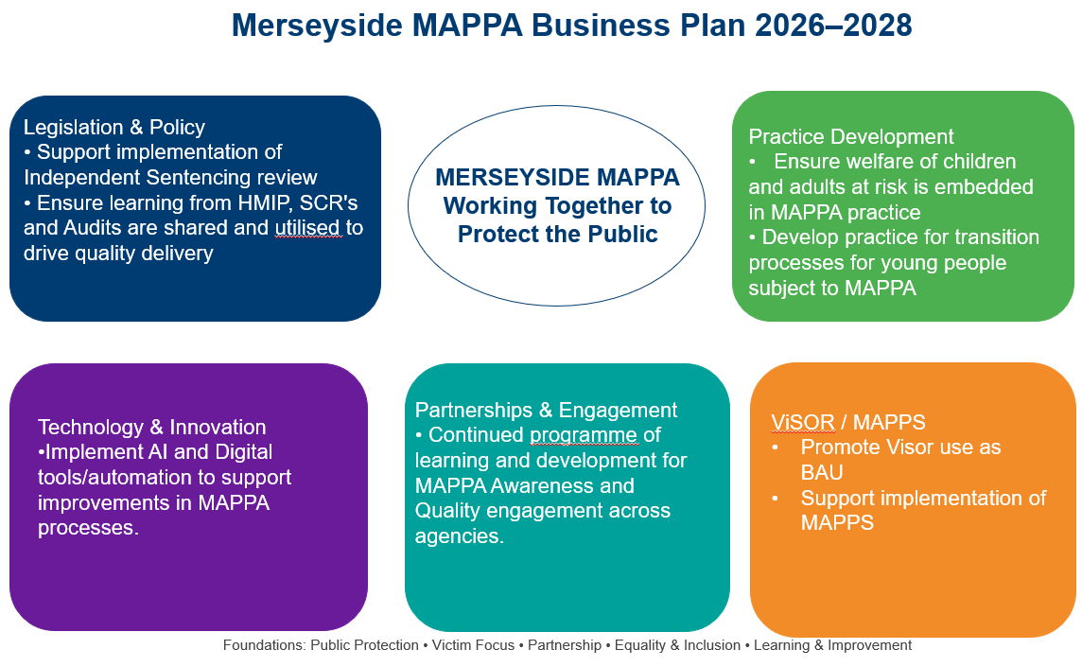

Merseyside Police:
Over the last year, Merseyside Police has continued to strengthen its approach to offender management and public protection, responding to increasing demand within MAPPA whilst adapting to wider changes across the criminal justice system. Demand within MAPPA has continued to rise, driven in part by changes to sentencing and prison release arrangements, requiring increased multi-agency activity, more frequent reviews and greater flexibility from all partner agencies involved in the management of high-risk offenders. Throughout this period, public protection has remained a key priority, supported by strong and established partnership arrangements across Merseyside.
A significant development during 2025 was the implementation of Merseyside Police's wider force restructure, moving from a strand-based operating model to a Basic Command Unit (BCU) model. This change has increased local accountability for crime, safeguarding and offender management within each borough, placing greater ownership with local commanders whilst retaining specialist centralised functions where a consistent and expert approach is required. The model has strengthened local decision-making and partnership engagement, ensuring that public protection activity remains closely aligned to local communities and risk profiles.
As part of these changes, MOSOVO, including the MAPPA Team, transferred into the newly established Centralised Public Protection function. This has brought offender management, sexual offender management, MAPPA, vulnerability and wider safeguarding functions into much closer alignment, creating improved opportunities for coordination, joint problem solving and risk management across areas of overlapping demand. The benefits of this approach are already being seen through enhanced governance, stronger partnership working and greater visibility of risk across public protection services.
The force has also continued to embed the recommendations arising from the internal Nominal Management Review implemented during 2024. This resulted in the creation of dedicated offender management functions responsible for the management of Category 2 and Category 3 MAPPA nominals, alongside the establishment of a proactive Domestic Abuse Offender Management Team (DAOMT). These arrangements have strengthened oversight of offenders who present the greatest risk of harm, improved consistency in risk management planning and enhanced engagement with partner agencies across Merseyside. Feedback from MAPPA Chairs, practitioners and partner organisations has been overwhelmingly positive, particularly in relation to improved ownership, accountability and information sharing.
Alongside traditional MAPPA arrangements, Merseyside Police has continued to develop its wider perpetrator management capability through multi-agency forums such as MATAC and MARAC. These arrangements complement MAPPA by identifying, assessing and managing high-harm perpetrators through coordinated safeguarding, disruption, enforcement and behavioural change activity. This ensures that risk is managed at the earliest opportunity and that agencies work collectively to protect victims and communities.
The combination of strengthened local accountability through the BCU model, enhanced specialist capability through Centralised Public Protection and dedicated offender management resources places Merseyside Police in a strong position to meet the increasing demands of offender management and public protection. We remain committed to working alongside responsible authority and duty-to-cooperate agencies to ensure the effective management of those presenting the highest risk of serious harm and to continually improve outcomes for victims and communities across Merseyside.

Update from Katy Orme, MAPPA Co-ordinator for National Security Division (NSD):
The National Security Division (NSD) is a specialist division within the Probation Service, operating across England and Wales to assess and manage the risks posed by three cohorts: individuals convicted of Terrorism Act offences, or otherwise assessed as presenting a terrorist risk; Critical Public Protection Cases; and those convicted of offences linked to Serious Organised Crime. The majority of cases are managed through Multi-Agency Public Protection Arrangements (MAPPA).

The NSD adopts an enhanced multi-disciplinary and multi-agency approach, ensuring resources are focused on the cases that require them most. This is supported by strong and well-established partnerships, particularly with Counter Terrorism Policing (CTP) and the Joint Extremism Unit (JEXU).

The UK Terrorism Threat Level was raised to Severe in May 2026, and we continue to operate in a challenging environment. The Category Four MAPPA landscape is shaped by both established extremist groups and individuals motivated by new and emerging ideologies. The growing availability of artificial intelligence and other advanced technologies presents additional risks, including enhanced propaganda, online radicalisation and sophisticated disinformation.

2025-2026 has been a productive year for the NSD, with further bespoke Chairs Training delivered to colleagues responsible for chairing Category Four MAPPA meetings, alongside a range of wider training and development events. The NSD remains proud of the work it undertakes and its continued contribution to public protection; delivering high-quality services that support the safety of the communities we serve.

Information from Kath Woods, Head of Programmes North-West
Data below summarises the intervention work completed in Merseyside by The Probation Service in working with Category 1 MAPPA nominals.
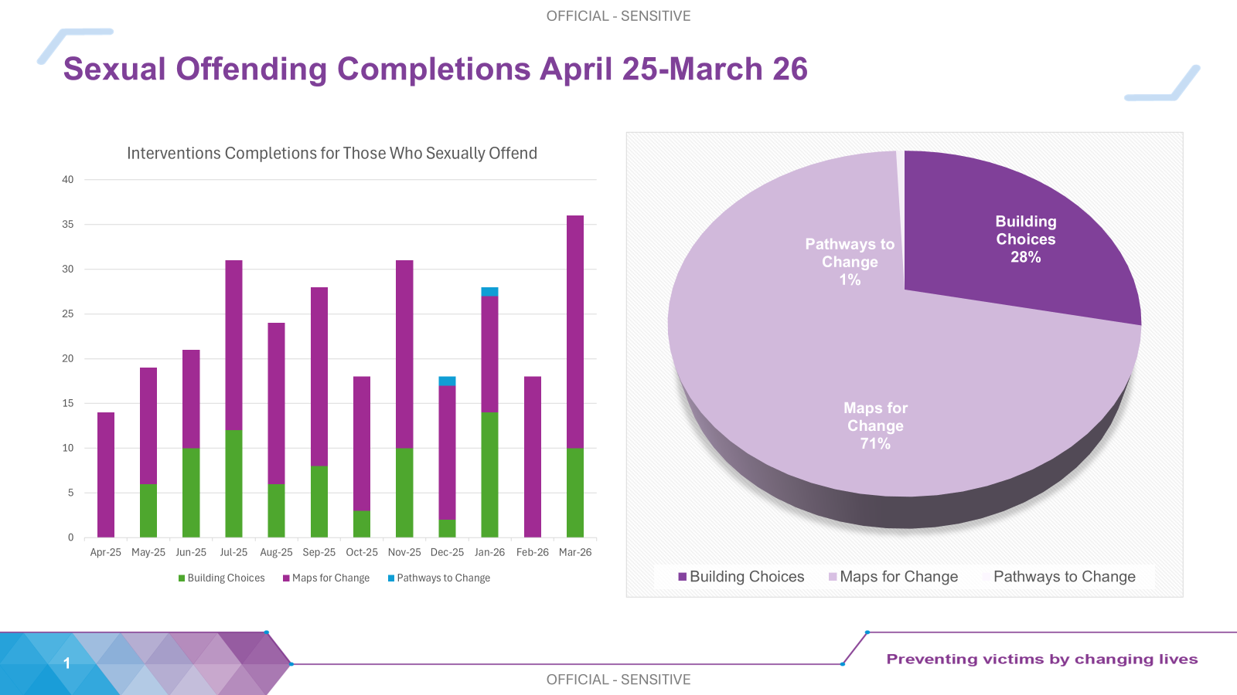

All MAPPA reports from England and Wales are published online at:
www.gov.uk

