
Area name here

London MAPPA Annual Report 2025 to 2026
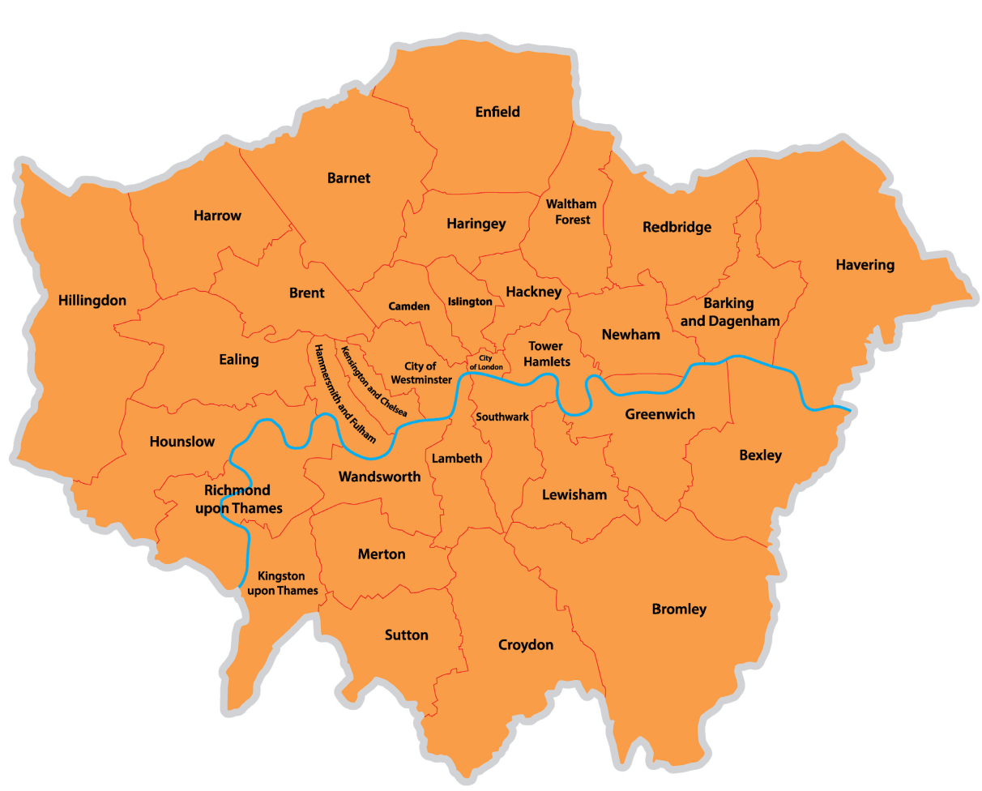

Introduction

This Annual Report, presented on behalf of the London Strategic Management Board (SMB), sets out how partner agencies have fulfilled their statutory responsibilities under the Multi-Agency Public Protection Arrangements (MAPPA) to minimise the risk of serious harm and protect the public.
The SMB provides strategic oversight and assurance of the effectiveness of public protection arrangements across London. This report outlines the number of individuals managed under MAPPA and evidences how the Responsible Authorities - Probation, Police and Prison Services - alongside Duty to Co-operate agencies, have worked collaboratively to ensure that those presenting the highest risk are subject to robust multi-agency management.
We recognise the significant and enduring impact that serious violent and sexual offending has on victims, their families, and our communities. During 2025/26, partners across London have continued to manage increasingly complex cases within a context of sustained demand and wider pressures across the criminal justice system.
This period has also been characterised by significant change in policy and operational delivery, including measures to address prison capacity pressures, requiring MAPPA to respond with pace and flexibility. Looking ahead, MAPPA in London will continue to operate within a complex and evolving landscape. However, through strong partnership working and a clear focus on London’s public protection priorities, we remain confident in our ability to meet these challenges effectively.
The SMB has maintained a strong focus on oversight, assurance, and continuous improvement. Through regular performance monitoring, audit activity, and scrutiny of MAPPA practice, the Board has sought to identify and address variation, strengthen the quality of risk management, and ensure agencies are effectively discharging their responsibilities. Learning arising from MAPPA Serious Case Reviews continues to be embedded, supported by clear expectations for translating recommendations into practice.
Over the past year, we have prioritised the development of professional capability across MAPPA, including joint multi-agency training, support for MAPPA Chairs, and opportunities to share learning and good practice. This reflects our commitment to ensuring that MAPPA arrangements remain effective, consistent, and responsive to emerging risks and challenges.
On behalf of the SMB, I would like to extend my sincere thanks to all colleagues across London who contribute to the delivery of MAPPA and the protection of our communities. This includes staff within the Responsible Authorities and Duty to Co-operate agencies, whose professionalism and commitment underpin effective public protection.
I am also pleased to acknowledge the recent appointment of two additional Lay Advisers, who bring valuable independent and community-focused perspectives to the work of the Board. I further extend my thanks to all three Lay Advisers, as well as the MAPPA Co-ordinator and Deputy MAPPA Co-ordinator, whose contributions strengthens governance and the continued effectiveness of MAPPA arrangements across London.
Pamela Spring
Chair of London MAPPA SMB and Head of Public Protection
The Probation Service – London Region

What are MAPPA?

MAPPA background
MAPPA (Multi-Agency Public Protection Arrangements) are a set of arrangements to manage the risk posed by individuals who have committed the most serious sexual, violent and terrorist offences (MAPPA-eligible individuals) under the provisions of sections 325 to 327B of the Criminal Justice Act 2003.
They bring together the Police, Probation and Prison Services in each of the 42 Areas in England and Wales into what is known as the MAPPA Responsible Authority.
A number of other agencies are under a Duty to Co-operate (DTC) with the Responsible Authority. These include Social Services, Health Services, local Youth Justice Services, Department for Work and Pensions, the Home Office and Local Housing and Education Authorities.
Local Strategic Management Boards (SMBs) comprising senior representatives from each of the Responsible Authority and DTC agencies are responsible for delivering MAPPA within their respective areas. The Responsible Authority is also required to appoint two Lay Advisers to sit on each MAPPA SMB.
Lay Advisers are members of the public appointed by the Minister with no links to the business of managing MAPPA-eligible individuals who act as independent, yet informed, observers; able to pose questions which the professionals closely involved in the work might not think of asking. They also bring to the SMB their understanding and perspective of the local community (where they must reside and have strong links).

How MAPPA work
MAPPA-eligible individuals are identified and information about them is shared between agencies to inform the risk assessments and risk management plans of those managing or supervising them.
That is as far as MAPPA extend in the majority of cases, but some cases require more senior oversight and structured multi-agency management. In such cases there will be regular MAPPA meetings attended by relevant agency practitioners.
There are 4 categories of MAPPA-eligible individual:
- Category 1 –subject to sex offender notification requirements;
- Category 2 – mainly those convicted of violent offences and sentenced to 12 months or more imprisonment or a hospital order;
- Category 3 – individuals who do not qualify under Categories 1, 2 or 4 but whose offences pose a risk of serious harm.
- Category 4 – terrorism convicted and terrorism risk individuals
Data on Category 4 individuals is not included in this report due to data protection issues related to low numbers. This data will be aggregated and published nationally.
There are three levels of management to ensure that resources are focused where they are most needed; generally those presenting the higher risks of serious harm.
- Level 1 is where the individual is managed by the lead agency with information exchange and multi-agency support as required but without formal MAPPA meetings;
- Level 2 is where formal MAPPA meetings are required to manage the individual.
- Level 3 is where risk management plans require the attendance and commitment of resources at a senior level at MAPPA meetings.
MAPPA are supported by ViSOR. This is a national IT system to assist in the management of individuals who pose a serious risk of harm to the public. The use of ViSOR increases the ability to share intelligence across organisations and enables the safe transfer of key information when high risk individuals move between areas, enhancing public protection measures. ViSOR allows staff from the Police, Probation and Prison Services to work on the same IT system, improving the quality and timeliness of risk assessments and interventions to prevent offending.

MAPPA ‘25
2025 marked the 25th anniversary of the legislation that first introduced mandatory multi-agency co-operation in the management of those convicted of violent and sexual offences.
Throughout the year, the National MAPPA Team held online engagement events to increase awareness of and confidence in MAPPA and improve MAPPA practice across a wide range of agencies. Events covered topics including the management of children and young adults, managing terrorist risks, humanising MAPPA and the value of prison partnerships. The online events proved hugely successful with more than 5,000 professionals attending the live events. Local MAPPA Strategic Management Boards also held events to mark the anniversary, bringing partners together to strengthen partnership arrangements
Local MAPPA ‘25 Activity
All MAPPA reports from England and Wales are published online on GOV.UK

MAPPA Statistics

MAPPA-eligible individuals on 31 March 2026
 | Category 1:  Subject to sex offender notification requirements | Category 2:  Violent  offenders | Category 3:  Other dangerous  offenders | Total
Level 1 | 7,540 | 3,709 | - | 11,249
Level 2 | 39 | 61 | 54 | 154
Level 3 | 7 | 5 | 13 | 25
Total | 7,586 | 3,775 | 67 | 11,428

MAPPA-eligible offenders in Levels 2 and 3 by category (yearly total)
 | Category 1:  Subject to sex offender notification requirements | Category 2:  Violent  offenders | Category 3:  Other dangerous  offenders | Total
Level 2 | 177 | 293 | 352 | 822
Level 3 | 23 | 25 | 38 | 86
Total | 200 | 318 | 390 | 908

Category 1 cautioned for breach of notification requirements | 23
Category 1 convicted for breach of notification requirements | 178

Category 1 who have had their life time notification revoked on application | 47

Restrictive orders for Category 1 offenders
Sexual Harm Prevention Order (SHPO) | 613
SHPO with foreign travel restriction | 0
Notification Notices | 60

Number of individuals who became subject to sex offender notification requirements following a breach(es) of a Sexual Risk Order (SRO) | 8

Level 2 and 3 individuals returned to custody
Returned to custody for breach of licence | Category 1:  Subject to notification requirements | Category 2:  Violent  offenders | Category 3:  Other dangerous  offenders | Total
Level 2 | 30 | 52 | 45 | 127
Level 3 | 6 | 4 | 7 | 17
Total | 36 | 56 | 52 | 144

Breach of SHPO
Level 2 | 1
Level 3 | 1
Total | 2

Total number of individuals subject to sex offender notification requirements per 100,000 population | 94

This figure has been calculated using the mid-2025 estimated resident population, published by the Office for National Statistics (ONS) on 30 July 2026, excluding those aged less than ten years of age.

Explanation commentary on statistical tables

MAPPA background
The totals of MAPPA-eligible individuals, broken down by category, reflect the picture on 31 March 2026 (i.e. they are a snapshot). The rest of the data covers the period 1 April 2025 to 31 March 2026.
(a) MAPPA-eligible individuals – there are individuals defined in law as eligible for MAPPA management because they have committed specified sexual, violent or terrorist offences or they currently pose a risk of serious harm. The majority are managed at Level 1 without formal MAPPA meetings. These figures only include those MAPPA eligible individuals living in the community. They do not include those in prison or detained under the Mental Health Act.
(b) Subject to Sex Offender Notification Requirements – those who are required to notify the police of their name, address and other personal details and to notify of any subsequent changes (this is known as the “notification requirement.”) These individuals are assessed and managed by the police. They may also be managed by probation, youth justice or health services if they are subject to licence or a hospital order. Failure to comply with the notification requirement is a criminal offence that carries a maximum penalty of 5 years’ imprisonment.
(c) Violent Offenders – individuals convicted of violent offences who were sentenced to imprisonment or detention for 12 months or more, or detained under a hospital order and a small number of individuals convicted of sexual offences who are not subject to notification requirements. These individuals are assessed and managed by the Probation Service, Youth Justice Service or Mental Health Services.
(d) Other Dangerous Offenders – individuals who do not qualify under the other MAPPA-eligible categories, but have committed an offence that indicates that they pose a risk of serious harm which requires management via MAPPA meetings. These individuals are assessed and managed by whichever agency has the primary responsibility for them.
(e) Terrorism and Terrorism Risk Offenders – individuals subject to terrorism offender notification requirements; individuals convicted of terrorism or terrorism related offences who were sentenced to imprisonment or detention for 12 months or more, or detained under a hospital order; and those who have committed an offence and may be at risk of involvement in terrorism-related activity. These individuals are assessed and managed by Counter-Terrorism Police and the National Security Division of the Probation Service.
(f) Breach of Licence – individuals released into the community following a period of imprisonment will be subject to a licence with conditions (under probation supervision). If the individual does not comply with these conditions, the Probation Service will take breach action and the individual may be recalled to prison.
(g) Sexual Harm Prevention Order (SHPO) (including any additional foreign travel restriction). Sexual Harm Prevention Orders (SHPOs) and interim SHPOs are intended to protect the public from individuals convicted of a sexual or violent offence who pose a risk of sexual harm to the public by placing restrictions and/or positive obligations on their behaviour. They require the individual to notify their details to the police (as set out in Part 2 of the 2003 Act) for the duration of the order.
The court must be satisfied on the balance of probability that an order is necessary to protect the public (or any particular members of the public) in the UK, or children or vulnerable adults (or any particular children or vulnerable adults) abroad, from sexual harm from the individual. In the case of an order made on a free standing application by a Chief Police Officer, the National Crime Agency (NCA), British Transport Police (BTP) or the Ministry of Defence Police (MODP), the chief officer/NCA/BTP/MODP must be able to show that the individual has acted in a way since their conviction that makes the order necessary.
The minimum duration for a full order is five years. The lower age limit is 10, which is the age of criminal responsibility, but where the defendant is under the age of 18 an application for an order should only be considered exceptionally.
(h) Notification Order – this requires individuals convicted of qualifying sexual offences overseas to register with the police, in order to protect the public in the UK from the risks that they pose. The police in England and Wales may issue a notification order directly to an offender who is already in the UK or who is intending to come to the UK who has to notify within three days of receipt. Individuals have a right of appeal against notification.

(i) Sexual Risk Order (including any additional foreign travel restriction) –The Sexual Risk Order (SRO may be made in relation to a person without a conviction for a sexual or violent offence (or any other offence), but who poses a risk of sexual harm.
The SRO may be made at the magistrates’ court on application by the police, NCA, BTP or MODP where an individual has committed an act of a sexual nature and the court is satisfied that the person poses a risk of harm to the public in the UK or children or vulnerable adults overseas.
An SRO may prohibit the person from doing anything described in it, including travel overseas, or place positive obligations upon them. Any prohibition and/or obligation must be necessary to protect the public in the UK from sexual harm or, in relation to foreign travel, protecting children or vulnerable adults from sexual harm.
An individual subject to an SRO is required to notify the police of their name and home address within three days of the order being made and also to notify any changes to this information within three days.
An SRO can last for a minimum of two years and has no maximum duration, with the exception of any foreign travel restrictions which, if applicable, last for a maximum of five years (but may be renewed).
The criminal standard of proof continues to apply. The person concerned is able to appeal against the making of the order and the police or the person concerned are able to apply for the order to be varied, renewed or discharged.
A breach of an SRO is a criminal offence punishable by a maximum of five years’ imprisonment. Where an individual breaches their SRO, they will become subject to full notification requirements.
Individuals made subject of an SRO are recorded on VISOR as a Potentially Dangerous Person (PDP) but are not MAPPA eligible.

(j) Lifetime notification requirements revoked on application – Qualifying individuals may submit an application to the police to review their indefinite notification requirements. The police review the application and decide whether to revoke the notification requirements. This decision is made at the rank of Superintendent. Those who continue to pose a significant risk will remain subject to notification requirements for life, if necessary.
Individuals will only become eligible to seek a review once they have been subject to indefinite notification requirements for a period of at least 15 years for adults and 8 years for children.

Local page

London MAPPA SMB Training Sub-Group (TSG)
Role of the Training Sub-Group (TSG)
The multi-agency London MAPPA SMB Training Sub-Group (TSG) oversees and implements the London MAPPA Training Plan on behalf of the London MAPPA Strategic Management Board (SMB).
A key objective of this plan is to ensure the delivery of regular, coordinated MAPPA training activities across London. These activities are aimed at enhancing the quality, consistency and effectiveness of MAPPA practice, with a particular focus on supporting the development of London MAPPA Chairs.
All MAPPA TSG training activities delivered in London are evaluated to assess their effectiveness. Feedback has consistently demonstrated that the training contributes positively to the knowledge, skills and confidence of London MAPPA Chairs.

MAPPA Chair Training Delivery
The training of London MAPPA Chairs is structured around an initial two-day MAPPA Chair Training course, followed by a programme of continuing professional development (CPD) events. These CPD sessions are designed to reinforce and build upon the foundational training, ensuring Chairs remain informed of emerging best practice and developments within MAPPA. Where possible, CPD events include contributions from individuals with lived experience of the criminal justice system, enhancing the learning and professional development of MAPPA Chairs.
During this MAPPA year, three two-day MAPPA Chair Training events were successfully delivered, providing training to 58 newly appointed MAPPA Chairs. While the training is primarily designed for MAPPA Chairs, all sessions were also made available to new London MAPPA Administrators. This inclusive approach aims to enhance their understanding of MAPPA processes and promote stronger collaborative working relationships across roles.
The TSG continues to review and refine the Chair Training materials. This includes working with presenters to revise and update content in response to participant feedback. We would like to thank all presenters from the Responsible Authorities and Duty to Co-operate Agencies for their invaluable contributions to MAPPA Chair Training.
This year's MAPPA Chairs' Surgery focused on the learning identified from recent MAPPA Serious Case Reviews. This included guest speakers presenting on the Human Factors approach as a means of promoting professional curiosity and constructive challenge.
To mark the 25 years since the establishment of MAPPA, the SMB Mental Health Advisory Group (MHAG) hosted a London MAPPA Mental Health Virtual Conference, attended by 170 participants. We would like to acknowledge and thank David Cochrane MBE (Forensic Social Work Consultant), who was the driving force behind this successful event, as well as the other MHAG members for their contributions and presentations.
Further training and briefing sessions were delivered to staff across the Probation Service London Region, the Metropolitan Police Service, London Mental Health Trusts and Youth Justice Teams. These sessions supported the continued development of MAPPA practice across agencies, contributing to the ongoing commitment to public protection.
London SMB Training Sub-Group

National Security Division (NSD)

The National Security Division (NSD) is a specialist division within the Probation Service, operating across England and Wales to assess and manage the risks posed by three cohorts: individuals convicted of Terrorism Act offences, or otherwise assessed as presenting a terrorist risk; Critical Public Protection Cases; and those convicted of offences linked to Serious Organised Crime. The majority of cases are managed through Multi-Agency Public Protection Arrangements (MAPPA).
The NSD adopts an enhanced multi-disciplinary and multi-agency approach, ensuring resources are focused on the cases that require them most. This is supported by strong and well-established partnerships, particularly with Counter Terrorism Policing (CTP) and the Joint Extremism Unit (JEXU).
The UK Terrorism Threat Level was raised to Severe in May 2026, and we continue to operate in a challenging environment. The Category Four MAPPA landscape is shaped by both established extremist groups and individuals motivated by new and emerging ideologies. The growing availability of artificial intelligence and other advanced technologies presents additional risks, including enhanced propaganda, online radicalisation and sophisticated disinformation.
2025 to 2026 has been a productive year for the NSD, with further bespoke Chairs Training delivered to colleagues responsible for chairing Category Four MAPPA meetings, alongside a range of wider training and development events. The NSD remains proud of the work it undertakes and its continued contribution to public protection; delivering high quality services that support the safety of the communities we serve.


All MAPPA reports from England and Wales are published online on GOV.UK

