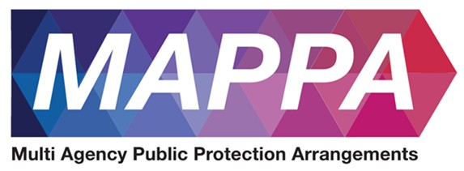
Area name here

Area name here

Lancashire MAPPA Annual Report 2025 to 2026


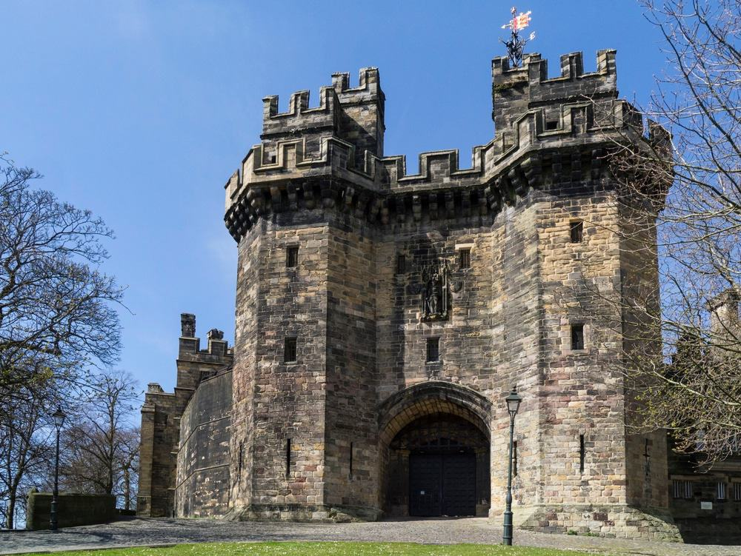


Introduction

Mahala McGuffie, Governor of HMP Wymott and Chair of Lancashire MAPPA Strategic Management Board.
As Chair of the Lancashire MAPPA Strategic Management Board, I am pleased to introduce the 2025 to 2026 Annual Report.
Protecting the public from serious harm is one of the most important responsibilities we hold across the criminal justice system, but it is not a responsibility that any single organisation can discharge alone. Effective Multi-Agency Public Protection Arrangements rely upon strong professional relationships, timely information sharing, constructive challenge and, above all, a shared commitment to managing risk and preventing further victims.
This year has also marked 25 years since the introduction of the arrangements that established mandatory multi-agency co-operation in the management of people convicted of serious violent and sexual offences. That anniversary provides an opportunity not simply to reflect on how MAPPA has developed, but to look ahead and ensure that our arrangements continue to respond effectively to changing and increasingly complex risks.
Across Lancashire, colleagues from Police, Probation and the Prison Service work alongside our Duty to Co-operate agencies and wider partners to bring together their knowledge, expertise and professional judgement. The statistics within this report describe the scale of that work, but behind every case is the careful assessment and management of risk, with decisions that can have a profound impact on victims, families and communities.
As Strategic Management Board Chair, my priority is that our partnership remains focused not only on robust processes, but on the quality and effectiveness of our collective practice. We must continue to learn, challenge ourselves and each other, share information confidently, strengthen the transition between custody and the community, and ensure our plans translate into meaningful action that protects the public.
I would like to thank everyone across Lancashire who contributes to MAPPA, from frontline practitioners to senior leaders, our partner agencies and Lay Advisers. Their professionalism and commitment underpin these arrangements. During the year ahead, the Strategic Management Board will continue to build on that commitment, strengthen our partnership and maintain a clear and unwavering focus on preventing serious harm and protecting the communities we serve.
Mahala McGuffie
Governor, HMP Wymott
Chair, Lancashire MAPPA Strategic Management Board

What are MAPPA?

MAPPA background
MAPPA (Multi-Agency Public Protection Arrangements) are a set of arrangements to manage the risk posed by individuals who have committed the most serious sexual, violent and terrorist offences (MAPPA-eligible individuals) under the provisions of sections 325 to 327B of the Criminal Justice Act 2003.
They bring together the Police, Probation and Prison Services in each of the 42 Areas in England and Wales into what is known as the MAPPA Responsible Authority.
A number of other agencies are under a Duty to Co-operate (DTC) with the Responsible Authority. These include Social Services, Health Services, local Youth Justice Services, Department for Work and Pensions, the Home Office and Local Housing and Education Authorities.
Local Strategic Management Boards (SMBs) comprising senior representatives from each of the Responsible Authority and DTC agencies are responsible for delivering MAPPA within their respective areas. The Responsible Authority is also required to appoint two Lay Advisers to sit on each MAPPA SMB.
Lay Advisers are members of the public appointed by the Minister with no links to the business of managing MAPPA-eligible individuals who act as independent, yet informed, observers; able to pose questions which the professionals closely involved in the work might not think of asking. They also bring to the SMB their understanding and perspective of the local community (where they must reside and have strong links).

How MAPPA work
MAPPA-eligible individuals are identified and information about them is shared between agencies to inform the risk assessments and risk management plans of those managing or supervising them.
That is as far as MAPPA extend in the majority of cases, but some cases require more senior oversight and structured multi-agency management. In such cases there will be regular MAPPA meetings attended by relevant agency practitioners.
There are 4 categories of MAPPA-eligible individual:
- Category 1 –subject to sex offender notification requirements;
- Category 2 – mainly those convicted of violent offences and sentenced to 12 months or more imprisonment or a hospital order;
- Category 3 – individuals who do not qualify under Categories 1, 2 or 4 but whose offences pose a risk of serious harm.
- Category 4 – terrorism convicted and terrorism risk individuals
Data on Category 4 individuals is not included in this report due to data protection issues related to low numbers. This data will be aggregated and published nationally.
There are three levels of management to ensure that resources are focused where they are most needed; generally those presenting the higher risks of serious harm.
- Level 1 is where the individual is managed by the lead agency with information exchange and multi-agency support as required but without formal MAPPA meetings;
- Level 2 is where formal MAPPA meetings are required to manage the individual.
- Level 3 is where risk management plans require the attendance and commitment of resources at a senior level at MAPPA meetings.
MAPPA are supported by ViSOR. This is a national IT system to assist in the management of individuals who pose a serious risk of harm to the public. The use of ViSOR increases the ability to share intelligence across organisations and enables the safe transfer of key information when high risk individuals move between areas, enhancing public protection measures. ViSOR allows staff from the Police, Probation and Prison Services to work on the same IT system, improving the quality and timeliness of risk assessments and interventions to prevent offending.

MAPPA ‘25
2025 marked the 25th anniversary of the legislation that first introduced mandatory multi-agency co-operation in the management of those convicted of violent and sexual offences.
Throughout the year, the National MAPPA Team held online engagement events to increase awareness of and confidence in MAPPA and improve MAPPA practice across a wide range of agencies. Events covered topics including the management of children and young adults, managing terrorist risks, humanising MAPPA and the value of prison partnerships. The online events proved hugely successful with more than 5,000 professionals attending the live events. Local MAPPA Strategic Management Boards also held events to mark the anniversary, bringing partners together to strengthen partnership arrangements
All MAPPA reports from England and Wales are published online on GOV.UK

MAPPA Statistics

MAPPA-eligible individuals on 31 March 2026
 | Category 1:  Subject to sex offender notification requirements | Category 2:  Violent  offenders | Category 3:  Other dangerous  offenders | Total
Level 1 | 2,667 | 828 | - | 3,495
Level 2 | 16 | 7 | 19 | 42
Level 3 | 1 | 2 | 6 | 9
Total | 2,684 | 837 | 25 | 3,546

MAPPA-eligible offenders in Levels 2 and 3 by category (yearly total)
 | Category 1:  Subject to sex offender notification requirements | Category 2:  Violent  offenders | Category 3:  Other dangerous  offenders | Total
Level 2 | 24 | 28 | 41 | 93
Level 3 | 7 | 9 | 21 | 37
Total | 31 | 37 | 62 | 130

Category 1 cautioned for breach of notification requirements | 3
Category 1 convicted for breach of notification requirements | 71

Category 1 who have had their life time notification revoked on application | 4

Restrictive orders for Category 1 offenders
Sexual Harm Prevention Order (SHPO) | 271
SHPO with foreign travel restriction | 1
Notification Order | 1

Number of individuals who became subject to sex offender notification requirements following a breach(es) of a Sexual Risk Order (SRO) | 5

Level 2 and 3 individuals returned to custody
Returned to custody for breach of licence | Category 1:  Subject to notification requirements | Category 2:  Violent  offenders | Category 3:  Other dangerous  offenders | Total
Level 2 | 12 | 9 | 23 | 44
Level 3 | 3 | 2 | 7 | 12
Total | 15 | 11 | 30 | 56

Breach of SHPO
Level 2 | 0
Level 3 | 0
Total | 0

Total number of individuals subject to sex offender notification requirements per 100,000 population | 186

This figure has been calculated using the mid-2025 estimated resident population, published by the Office for National Statistics (ONS) on 30 July 2026, excluding those aged less than ten years of age.

Explanation commentary on statistical tables

MAPPA background
The totals of MAPPA-eligible individuals, broken down by category, reflect the picture on 31 March 2026 (i.e. they are a snapshot). The rest of the data covers the period 1 April 2025 to 31 March 2026.
(a) MAPPA-eligible individuals – there are individuals defined in law as eligible for MAPPA management because they have committed specified sexual, violent or terrorist offences or they currently pose a risk of serious harm. The majority are managed at Level 1 without formal MAPPA meetings. These figures only include those MAPPA eligible individuals living in the community. They do not include those in prison or detained under the Mental Health Act.
(b) Subject to Sex Offender Notification Requirements – those who are required to notify the police of their name, address and other personal details and to notify of any subsequent changes (this is known as the “notification requirement.”) These individuals are assessed and managed by the police. They may also be managed by probation, youth justice or health services if they are subject to licence or a hospital order. Failure to comply with the notification requirement is a criminal offence that carries a maximum penalty of 5 years’ imprisonment.
(c) Violent Offenders – individuals convicted of violent offences who were sentenced to imprisonment or detention for 12 months or more, or detained under a hospital order and a small number of individuals convicted of sexual offences who are not subject to notification requirements. These individuals are assessed and managed by the Probation Service, Youth Justice Service or Mental Health Services.
(d) Other Dangerous Offenders – individuals who do not qualify under the other MAPPA-eligible categories, but have committed an offence that indicates that they pose a risk of serious harm which requires management via MAPPA meetings. These individuals are assessed and managed by whichever agency has the primary responsibility for them.
(e) Terrorism and Terrorism Risk Offenders – individuals subject to terrorism offender notification requirements; individuals convicted of terrorism or terrorism related offences who were sentenced to imprisonment or detention for 12 months or more, or detained under a hospital order; and those who have committed an offence and may be at risk of involvement in terrorism-related activity. These individuals are assessed and managed by Counter-Terrorism Police and the National Security Division of the Probation Service.
(f) Breach of Licence – individuals released into the community following a period of imprisonment will be subject to a licence with conditions (under probation supervision). If the individual does not comply with these conditions, the Probation Service will take breach action and the individual may be recalled to prison.
(g) Sexual Harm Prevention Order (SHPO) (including any additional foreign travel restriction). Sexual Harm Prevention Orders (SHPOs) and interim SHPOs are intended to protect the public from individuals convicted of a sexual or violent offence who pose a risk of sexual harm to the public by placing restrictions and/or positive obligations on their behaviour. They require the individual to notify their details to the police (as set out in Part 2 of the 2003 Act) for the duration of the order.
The court must be satisfied on the balance of probability that an order is necessary to protect the public (or any particular members of the public) in the UK, or children or vulnerable adults (or any particular children or vulnerable adults) abroad, from sexual harm from the individual. In the case of an order made on a free standing application by a Chief Police Officer, the National Crime Agency (NCA), British Transport Police (BTP) or the Ministry of Defence Police (MODP), the chief officer/NCA/BTP/MODP must be able to show that the individual has acted in a way since their conviction that makes the order necessary.
The minimum duration for a full order is five years. The lower age limit is 10, which is the age of criminal responsibility, but where the defendant is under the age of 18 an application for an order should only be considered exceptionally.
(h) Notification Order – this requires individuals convicted of qualifying sexual offences overseas to register with the police, in order to protect the public in the UK from the risks that they pose. The police in England and Wales may issue a notification order directly to an offender who is already in the UK or who is intending to come to the UK who has to notify within three days of receipt. Individuals have a right of appeal against notification.

(i) Sexual Risk Order (including any additional foreign travel restriction) –The Sexual Risk Order (SRO may be made in relation to a person without a conviction for a sexual or violent offence (or any other offence), but who poses a risk of sexual harm.
The SRO may be made at the magistrates’ court on application by the police, NCA, BTP or MODP where an individual has committed an act of a sexual nature and the court is satisfied that the person poses a risk of harm to the public in the UK or children or vulnerable adults overseas.
An SRO may prohibit the person from doing anything described in it, including travel overseas, or place positive obligations upon them. Any prohibition and/or obligation must be necessary to protect the public in the UK from sexual harm or, in relation to foreign travel, protecting children or vulnerable adults from sexual harm.
An individual subject to an SRO is required to notify the police of their name and home address within three days of the order being made and also to notify any changes to this information within three days.
An SRO can last for a minimum of two years and has no maximum duration, with the exception of any foreign travel restrictions which, if applicable, last for a maximum of five years (but may be renewed).
The criminal standard of proof continues to apply. The person concerned is able to appeal against the making of the order and the police or the person concerned are able to apply for the order to be varied, renewed or discharged.
A breach of an SRO is a criminal offence punishable by a maximum of five years’ imprisonment. Where an individual breaches their SRO, they will become subject to full notification requirements.
Individuals made subject of an SRO are recorded on VISOR as a Potentially Dangerous Person (PDP) but are not MAPPA eligible.

(j) Lifetime notification requirements revoked on application – Qualifying individuals may submit an application to the police to review their indefinite notification requirements. The police review the application and decide whether to revoke the notification requirements. This decision is made at the rank of Superintendent. Those who continue to pose a significant risk will remain subject to notification requirements for life, if necessary.
Individuals will only become eligible to seek a review once they have been subject to indefinite notification requirements for a period of at least 15 years for adults and 8 years for children.

Lancashire

MAPPA Coordinator, The National Security Division
The National Security Division (NSD) is a specialist division within the Probation Service, operating across England and Wales to assess and manage the risks posed by three cohorts: individuals convicted of Terrorism Act offences, or otherwise assessed as presenting a terrorist risk; Critical Public Protection Cases; and those convicted of offences linked to Serious Organised Crime. The majority of cases are managed through Multi-Agency Public Protection Arrangements (MAPPA).
The NSD adopts an enhanced multi-disciplinary and multi-agency approach, ensuring resources are focused on the cases that require them most. This is supported by strong and well-established partnerships, particularly with Counter Terrorism Policing (CTP) and the Joint Extremism Unit (JEXU).
The UK Terrorism Threat Level was raised to Severe in May 2026, and we continue to operate in a challenging environment. The Category Four MAPPA landscape is shaped by both established extremist groups and individuals motivated by new and emerging ideologies. The growing availability of artificial intelligence and other advanced technologies presents additional risks, including enhanced propaganda, online radicalisation and sophisticated disinformation.
2025 to 2026 has been a productive year for the NSD, with further bespoke Chairs Training delivered to colleagues responsible for chairing Category Four MAPPA meetings, alongside a range of wider training and development events. The NSD remains proud of the work it undertakes and its continued contribution to public protection; delivering high-quality services that support the safety of the communities we serve.

Detective Chief Inspector of Lancashire Constabulary, Vulnerabilities Governance Unit.

2025 to 26 has been a challenging year for the MOSOVO (Management of Sexual Offenders and Violent Offenders) unit, driven by increased demand resulting from legislative changes, improved investigative practices and the use of enhanced technology, leading to more offenders being identified, prosecuted, and convicted. In response, the department has continued to review staffing levels and resource requirements to ensure it remains capable of managing current and future demand effectively.
To improve resilience and provide operational contingency, MAPPA Chair training has been delivered to Detective Inspectors, increasing the pool of suitably trained officers available to support meetings and provide cover during periods of sickness, annual leave or increased demand.
All MOSOVO officers receive Lancashire Constabulary's bespoke annual refresher training programme, ensuring staff remain up to date with legislation, national guidance, emerging risks, and local best practice. A particular focus during the year has been enhancing officers' professional curiosity, ensuring that staff continue to challenge assumptions, identify risk indicators and take a proactive approach to safeguarding and offender management.
Quarterly meetings with the Crown Prosecution Service (CPS) have also been established to identify evidential and court-related issues at the earliest opportunity, supporting more effective investigation and prosecution outcomes.
Governance arrangements have continued to strengthen through improved performance management processes, accurate data tracking and enhanced quality assurance of offender management activity, including visits and risk management interventions.
Regular performance meetings are held to review activity, monitor compliance and identify opportunities for improvement. National and local learning is considered through the Performance and Improvement Board, ensuring that lessons identified from inspections, reviews and operational activity are translated into practice improvements across the department.
Work is also underway to develop a management information tool that will provide a live operational dashboard, enabling supervisors to monitor visits, workloads and key performance indicators in real time, supporting more effective daily management and oversight.
The Constabulary has strengthened partnership working with Children's Social Care to improve the identification and safeguarding of children who may be linked to addresses visited by Sexual Offender Managers. This collaborative approach enhances information sharing and supports earlier identification of vulnerability and risk.
During the year, the process for applying for Sexual Harm Prevention Orders (SHPOs) has been reviewed and enhanced. A new SHPO template has been introduced to improve the quality and consistency of applications submitted to the courts. This has resulted in stronger and more robust orders being granted, with clearer restrictions tailored to offender risk. The improvements have been particularly beneficial within Internet Child Exploitation (ICE) investigations, where effective restrictions are essential in managing online offending behaviours and protecting children.
MOSOVO continues to explore innovative technologies to enhance offender risk management and safeguarding activity. ClearSpeed, a Voice Risk Analysis solution, has the potential to provide a more flexible and scalable approach to offender risk assessment, complimenting existing polygraph testing arrangements and supporting risk management decision-making. AirFlagger technology has also been introduced. This portable device requires minimal training and can detect Bluetooth signals, enabling officers to locate concealed smartphones, tablets, smartwatches, AirTags and other electronic devices. This provides an additional capability for identifying hidden devices and supporting investigations. The department is also developing SmartARM, an artificial intelligence-enabled solution designed to assist officers in producing ARMS assessments. The system aims to improve consistency, reduce administrative burden and allow officers to spend more time focused on offender management and safeguarding activity.
Despite significant increases in demand, Lancashire's MOSOVO teams have continued to strengthen governance, invest in staff development, improve partnership working and embrace technological innovation. These developments have enhanced the effectiveness of offender management arrangements, improved safeguarding opportunities and supported the continued delivery of robust public protection across Lancashire.

Lancashire Female Justice Partnership Board, Partnership Manager, Probation Service.
Over the past 12 months the Female Justice Partnership has been chaired by HMPPS and Lancashire Women and has focussed on the needs of women in the Criminal Justice System across the areas of out of court disposals, sentencing, pre and post release work and accommodation.
The Board has taken a Trauma Informed approach with a focus on ensuring neurodiverse needs relating to women are understood and pathways identified. The work has been undertaken using a co- production model with women serving sentences in HMP Styal along with other women who have been released into the community.
We identified that a number of women are managed through MAPPA largely due to the complexity of their needs and challenges in securing the right levels of support relating to mental health and social care. Work has been undertaken with the support of the University of Lancashire to explore this, with four workshops held and partner agencies attending. We were able to scope out the issues relating to accommodation and support with an emphasis on problem solving and on building relationships with partners from statutory, voluntary and third sector organisations towards improving outcomes.
The work has been evaluated by the University of Lancashire and will provide a strong base for further work to be undertaken into 2027.

All MAPPA reports from England and Wales are published online on GOV.UK


