Procurement Compliance and Oversight
Progress Report 2025/26

Trends from 6 April 2025 to 5 April 2026

Foreword by Andrew Forzani
Welcome to the Public Procurement and Oversight Progress Report for 2025/26. This reporting period marks a significant milestone in our journey following the introduction of the Procurement Act 2023 (PA23), which brought in new procurement oversight powers. This publication represents the 15th progress report on public procurement compliance, marking a key transition from a single service to a dual service model.
The transition to this new legislative landscape has led to an increase in cases with the Public Procurement Review Service (PPRS) handling 136 new cases this year, a 52.8% increase largely driven by public sector buyers adjusting to the new regulations. Despite the increase, the PPRS has continued to deliver unblocking £380,970.82 in late payments and maintaining a 100% success rate in releasing valid, overdue, and undisputed invoices. Furthermore, the launch of the Procurement Compliance Service (PCS) in February 2026 introduces a vital mechanism to address institutional and systemic compliance concerns.
These developments align directly with the core pillars of the GCF Strategy 2026–2029, particularly our strategic focus on People and expanding commercial capability across the Function.
Andrew Forzani
Government Chief Commercial Officer
Head of Function and Chair,
Government Commercial Agency.
Introduction by Prof. Barry Hooper
Managed by Procurement Compliance and Oversight (PCO) within the Standards, Assurance and Strategy team, this report provides insight of how public sector authorities are complying with the Procurement Act 2023 (PA23) and where relevant the Public Contracts Regulations 2015 (PPRS only), setting out the main trends observed by both the PPRS and the PCS across different sectors.
The data from the past year highlights clear operational realities, with top reported issues such as Payment, G-Cloud, Transparency, and Evaluation indicating exactly where issues persist. In alignment with the Commercial Functional Strategy's focus on elevating our people by expanding their capabilities and skills, we must interrogate this data to uncover systemic friction points and address them directly.
The true value of this oversight lies in how we apply its findings to drive continuous improvement across the commercial function. Our priorities for 2026/27 are centred on establishing an active feedback loop with contracting authorities. We will deliver a series of targeted insights and masterclass sessions for the public sector buying community designed to explicitly feedback the issues that are raised to the PPRS. By translating these case findings into practical learning, we will improve long-term procurement quality and ensure the landscape possesses the required skills to execute compliant, high-impact commercial outcomes.
Prof. Barry Hooper MCIM, FWCC, FCIPS
Director of Strategy, Assurance & Standards
Contents:
1. Background
2. Executive Summary
3. Public Procurement Review Service Highlights
3.1 Cases Received and Sectors Involved
3.2. Non-case Enquiries
3.3. Main Issues Raised
3.4. Sub Level Classification
3.5. Top Issues and Action
3.6. Case Received and Sectors Involved
3.6.1 Collapsed and Rejected Cases
3.7. Service Satisfaction Surveys
3.8. Actions in response to Feedback
4. The Procurement Compliance Service
4.1. Promoting Procurement Compliance and Oversight
5. Forward Look for 2026/27
6. Contact Us
Annex A - Main Trends for Central Government
Annex B - Main Trends for Wider Public Sector

Background
Procurement Compliance and Oversight (PCO), aims to improve the capability and practices of contracting authorities for the benefit of everyone involved in public procurement by ensuring their compliance with the Procurement Act 2023 (PA23). PA23 introduced new procurement oversight powers and with it, the establishment of the Procurement Review Unit when it came into force in February 2025.
Alongside the existing Public Procurement Review Service (PPRS) which continues its focus on individual procurement concerns from suppliers and late payments, the Procurement Compliance Service (PCS) was created to consider the most severe compliance breaches at the institutional or systemic level. The PCS began accepting referrals in February 2026, to allow for procurements to begin to take place under the new legislation.
In April 2026, the PRU was disbanded, with the Debarment Review Service moving to the newly created Government Commercial Agency (GCA). The PPRS and PCS were renamed the PCO and retained in the Commercial Function as part of Standards, Assurance and Strategy, based within the Cabinet Office.

Executive Summary
This Progress Report for Procurement Compliance and Oversight (PCO) sets out the main trends observed by the Public Procurement Review Service (PPRS) from 6 April 2025 to 5 April 2026 and initial insights from the Procurement Compliance Service (PCS) since it began receiving referrals in February 2026. The report includes a comparison of procurement issues across sectors, details user survey feedback, and provides a forward look for the 2026/27 financial year.

The Public Procurement Review Service (PPRS) allows public sector suppliers and potential government suppliers to raise concerns, with the option to remain anonymous, where they believe that there has been poor public sector procurement practice. PPRS also accepts cases raised by suppliers concerning the late payment (i.e. not paid within 30 calendar days or as stated in the contract terms) of valid and undisputed invoices on a public sector contract. PPRS received 136 cases in 2025/26 (plus 18 cases carried forward, making a 52.8% increase from 89 cases in 2024/25. This rise was primarily driven by public sector buyers adjusting to the legislative transition under the Procurement Act 2023 (PA23). This year 61.0% (83 cases) came from first-time service users.

During the same period, there were 2,446 contract opportunities posted on Contracts Finder, while 17,077 opportunities. And 59,731 award notices were published on Find a Tender Service. PPRS also handled 150 general enquiries, up from 90 the previous year, signposting non-complaint matters and referring complex cases to the PCS and Debarment Review Service

The top 4 reported issues to PPRS this year were:
- Payment.
- G-Cloud Use (Direct Award).
- Transparency (including Feedback and Communication).
- Evaluation.

Additional trending concerns included:
- Contract Management.
- SME Exclusion.
- Pricing.

Payment remained the primary issue, though cases fell by 12.5%. PPRS unblocked £380,970.82 in late payments, a 15.9% increase in value over 2024/25, and maintained a 100% success rate in releasing valid, undisputed invoices. Total unblocked funds since PPRS inception now stand at £13.8 million. In terms of speed, 86.6% of cases met SLAs, resolving within two months for the central government and three months for wider public sector bodies. Prompt intervention directly enabled adjustments to live procurements in two instances.

The newly established PCS received 10 referrals during its initial launch window through 31 March 2026, focusing on systemic and institutional compliance breaches. Early PCS referral trends centred on Transparency (30%), Direct Awards (20%), and Contract Modifications (20%). User satisfaction remains strong with 92.6% of surveyed suppliers would use PPRS again, while 90.5% of contracting authorities found PPRS advice and recommendations useful.

Looking ahead to 2026/27, PCO will undertake a review of the PPRS Protocol, embed PCS investigations, leverage AI tools for case analysis, and deliver targeted master class sessions, based on case insights, across the public sector buying community to build commercial capability.

Public Procurement Review Service Highlights

3.1 Cases Received and Sectors Involved
In the reporting year ended 5 April 2026, 136 new cases were received along with a further 18 cases which were carried forward from the previous year. This report focuses on the trends for the 105 cases handled through to closure; the remaining cases were either collapsed or rejected once further information was received.

Cases are rejected if new evidence arises indicating that the complaint raised falls outside our scope and remit. We collapse cases if we lose contact with a supplier, if they request to withdraw from the service, or if they request to work directly with the contracting authority. 29 cases were carried forward to 2026/27.

Chart 1: Sectors we have received concerns about since the service started (closed only):
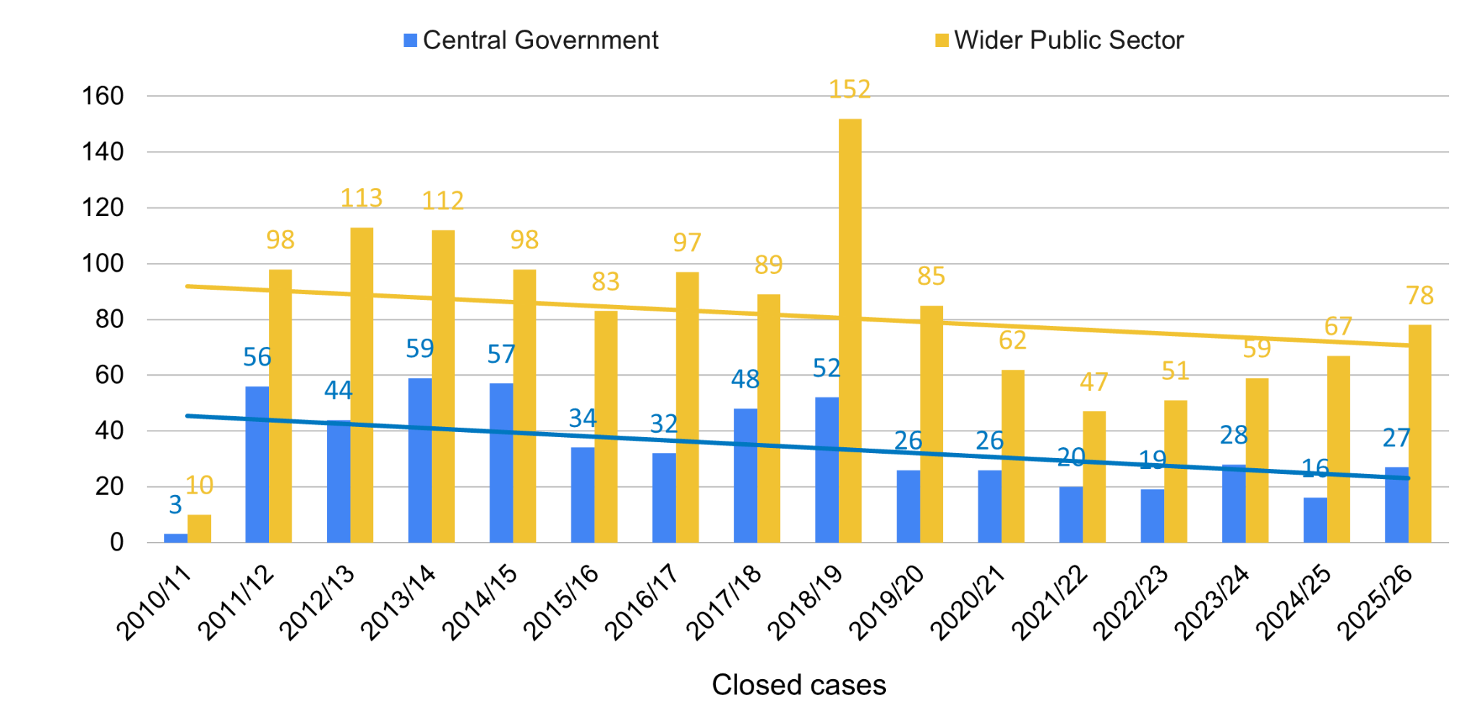
The number of complaints received for CG has increased from 16 cases in 2024/25 to 27 cases in 2025/26. There has also been an increase in the number of cases received for WPS, from 67 cases in 2024/25 to 78 in 2025/26.

Case numbers have increased since the introduction of the new Procurement Act 2023. This is most likely due to public sector buyers’ lower familiarity with the new regulations.

3.2. Non-case Enquiries
PPRS continually reviews its processes and identifies areas for improvement. We track enquiries received to understand the volume that does not progress to a full case. Often, these are of a general nature seeking further information, or enquiries that could be handled directly by contracting authorities without the need to establish a case.

We handled 150 enquiries by 5 April 2026, compared to 90 enquiries handled by the same point the previous year. Additionally, we have also classified the nature of the enquiry to identify any further trends that could support our ongoing spot check programme. Of the enquiries received, 62 were not related to complaints about procurement processes and were signposted appropriately, while 35 were outside our scope and remit. Furthermore, 11 did not respond to our requests for further information needed to establish a case and 4 were referred to the Devolved Administrations. Seven enquiries were referred to Debarment Review Service, and two were referred to Procurement Compliance Service. The remainder were answered by PPRS.

3.3. Main Issues Raised
High Level Classification
We classify enquiries by the overarching nature of the issue. The types of concerns we investigate are categorised at the closure stage of the investigation. These fall under 7 categories:

- Procurement Strategy (the approach to achieving what the contracting authority requires from the procurement)
- Procurement Process (issues relating to the submission or evaluation of tenders)
- Late Payment
- Transparency (where the process was not clear)
- Technology/Systems (e.g. broken links or issues with eTendering Portals)
- Contract Management (problems at any stage of the contract management process)
- Bureaucracy of the Process (procurement red tape)

This high level classification enables us to produce and analyse trends around the main issues received.

Chart 2: Types of Issues raised - High Level - 2025/26 comparison against previous year:

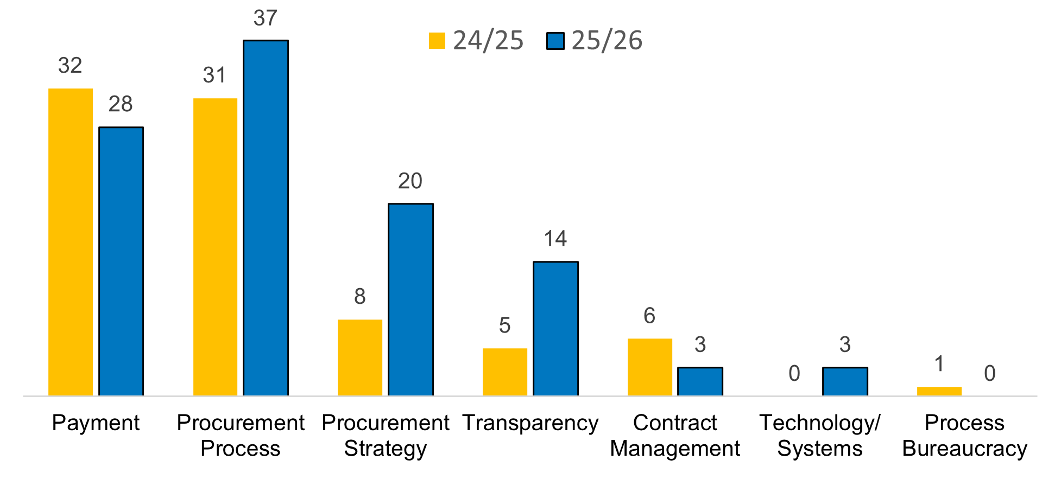

- In 2025/26 there was a decrease in ‘Payment’ cases to 28 cases (30.5% of all cases) compared to 2024/25 where ‘Payment’ cases accounted for 32 cases (38.6% of all cases).
- PPRS routinely reminds contracting authorities of their obligations under the Prompt Payment Policy and the PCR 2015 regulation 113.
- ‘Procurement Process’- has remained similar with 31 in 2024/25 (37.3%) and 37 in 2025/26 (35.2%).
- ‘Procurement Strategy’ - has increased in cases from 8 cases in 2024/25 (9.6%) to 20 cases in 2025/26 (19.0%).
- ‘Transparency’ - has increased in cases from 5 in 2024/25 (6.0%) to 14 in 2025/26 (13.3%).
- ‘Contract Management’ - there was a decrease in cases from 6 cases (7.2%) in 2024/25 to 3 cases (2.9%) in 2025/26.
- ‘Technology/Systems’ - there were zero cases in 2024/25 and there were three (2.9%) in 2025/26.
- ‘Bureaucracy of the whole process’ - there was one case (1.2%) in 2024/25 where there were zero in 2025/26.

3.4. Sub Level Classification

Closed cases are further classified to provide a more granular level of detail to enable us to identify and analyse trends. Late payment accounted for more than a quarter (26.7%) of all issues reported to PPRS this year with 28 cases, compared to just over a third, 32 cases (38.6%), of all cases the previous year. Within this report we have grouped issues where two cases or a single case has been received as ‘Other’.

‘Upheld’ represents cases where we have made recommendations for change in the contracting authority’s processes and provided signposting to published guidance. ‘Not upheld’ refers to cases where the contracting authority has followed the correct procedures and we were able to educate suppliers.

Chart 3: Types of Issues raised - Sub Level 2025/26

Type of Issue Raised | No .of Cases | % of Total | Upheld | Not Upheld
Late Payments | 28 | 26.7% | 25 | 3
Other | 23 | 21.9% | 10 | 13
G-Cloud | 9 | 8.6% | 4 | 5
Evaluation | 7 | 6.7% | 3 | 4
SME Exclusion | 4 | 3.8% | 2 | 2
Prices | 4 | 3.8% | 1 | 3
Feedback | 4 | 3.8% | 3 | 1
Contract Management | 4 | 3.8% | 4 | 0
Communication | 4 | 3.8% | 2 | 2
Transparency | 3 | 2.9% | 0 | 3
Timescales | 3 | 2.9% | 2 | 1
Technical Issues with E-Portal | 3 | 2.9% | 1 | 2
Changing Approach | 3 | 2.9% | 0 | 3
Award | 3 | 2.9% | 1 | 2
Assessment & Scoring | 3 | 2.9% | 2 | 1
 | 105 | 100% | 60 | 45

3.5. Top Issues and Action
The main areas of complaints received against contracting authorities are outlined in the table below. There was an increase in the number of complaints acknowledged by contracting authorities, indicating recognition that improvements could be made in the future.

MAIN TRENDS
Issue | Context | Action
‘Payment’  25 cases raised  CG five cases (four upheld);  WPS - 23 cases (21 upheld)  (payment complaints are closed at the point where the supplier receives payment) | The cases concerned either the non-payment of valid and undisputed invoices or disputes regarding invoices.  Where public sector invoices are not paid within 30 days and are not disputed, interest becomes liable as set out in the Late Payment of Commercial Debts (Interest) Act 1998. In addition, under the PCR 2015, public sector buyers must publish the amount of interest paid to suppliers due to late payment. As specified in regulation 113 of the PCR 2015  https://www.gov.uk/guidance/prompt-payment-policy | We unblocked £380,970.82 in late payments on behalf of suppliers.  We remind contracting authorities of their obligations under the PCR 2015, including PPN 02/20 and PPN 04/20 that set out information and guidance for public bodies on payment of their suppliers to ensure service continuity during the coronavirus outbreak.
‘G-Cloud’  Nine cases:  CG - four cases (three upheld)  WPS - five cases (one upheld) | Suppliers were concerned about a lack of transparency in G-Cloud procurements, and were concerned that customers were able to misuse the direct award process under G-Cloud. | PPRS upheld around half the cases it received. There is some evidence that G-Cloud is being used to avoid the rigorous requirements for direct award under the new act, and PPRS intends to monitor trends once the new iteration of G-Cloud goes live later in 2026.
Transparency  Eleven cases raised  CG - two cases (one upheld)  WPS - nine cases (four upheld) | The complaints related to feedback and communication. Suppliers were concerned about the lack of clarity in these areas, which lowered confidence in the procurement process overall. | Around a third of these cases were upheld. Transparency is a key part of democratic accountability, and is crucial in the execution of public duties.  Where cases were upheld, customers were encouraged to communicate with greater clarity and to give more detail.
‘Evaluation’  Seven cases raised  CG - one case (not upheld)  WPS - six cases (two upheld) | Concerns were raised on how the evaluation process was run, including the evaluation criteria and potential conflicts of interest within the evaluation panel. There were also concerns about the due diligence being undertaken prior to award | For the majority of cases, where complaints were not upheld, PPRS was able to confirm a fair and transparent process had been followed that aligned with the advertised opportunity.  Where complaints were upheld, PPRS recommended that contracting authorities provide clear guidance on the way in which answers will be evaluated, to ensure all opportunities meet the relevant sections of the Public Contract Regulations 2015 or the Procurement Act 2023.  Where improvements could be made in the future PPRS recommended that the Authority should consider referring to the Sourcing Playbook when planning future evaluations.  PPRS also followed-up with the authorities, as appropriate, to review the implementation of this recommendation.

3.6. Case Received and Sectors Involved
Where PPRS upholds a case, the main output is a report including best practice guidance. Under the new Procurement Act 2023, if we consider that the issues raised might have wider applicability to general public procurement practice, we work with the PCS and the commercial policy team to determine how to promote best practice. As this year marked the first year of the Procurement Act 2023, the cases were a mixture of issues raised under the new act, and issues related to legacy contracts and frameworks.

Serious or persistent issues are escalated within contracting authorities and can be raised with the SME Crown Representative in addition to our investigations.

Prompt review resulted in changes being made to two live procurements. We handled 43 cases where the contracting authority had followed the correct procedure and we were able to advise the supplier to help them understand what had occurred and why. This represented a decrease from 35 cases the previous year.

3.6.1 Collapsed and Rejected Cases

Chart 4: Outcome of closed cases - 2025/26 compared against 2024/25
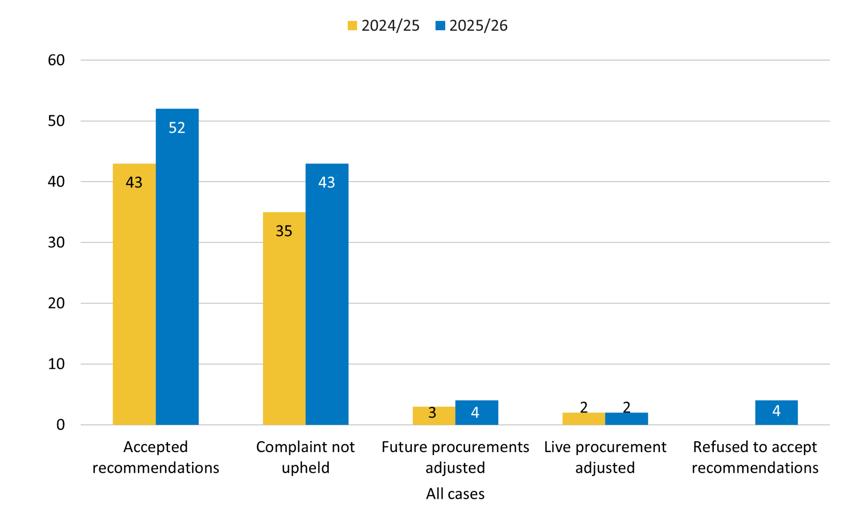
Out of 125 cases managed, two cases were rejected and 18 cases were collapsed. This compared to nine cases (two rejected, seven collapsed) in the previous year. Cases are rejected if new evidence indicates that the complaint falls outside our scope and remit. We collapse cases if we lose contact with a supplier, they request to withdraw from the service, or they request to work directly with the contracting authority.

3.7. Service Satisfaction Surveys
We aim to handle CG cases within 60 days and WPS cases within 90 days. In 2025/26 86.6% of cases were managed through to conclusion within this service level agreement (SLA).

Feedback surveys are sent directly to suppliers and contracting authorities following case closure. Feedback from suppliers has shown that we have a positive impact on public sector procurement by recommending changes in contracting authorities’ procurement activities.

Supplier Feedback
A total of 101 surveys have been sent to suppliers. We had 27 responses, giving a 26.7% response rate, down from 52.4% the previous year.

- 81.5% agreed it was easy to find information on PPRS, down from 87.5% the previous year
- 92.6% agreed the process and outcome was explained, down from 93.8% the previous year
- 92.6% were satisfied with the service provided, up from 81.8% the previous year
- 92.6% were happy that the caseworker understood the issues involved and was professional throughout, up from 83.3% the previous year
- 92.6% would use the service again, down from 96.9% the previous year
- 92.6% would recommend the PPRS to others, up from 90.6% the previous year

Contracting Authority Feedback
A total of 99 surveys have been sent to contracting authorities that have been contacted by PPRS and we have received 21 responses giving a response rate of 21.2%, which has decreased from 33.3% the previous year.

- 95.2% agreed the process and case outcome was explained, down from 95.5% the previous year
- 85.7% were happy that the caseworker understood the issues involved and was professional throughout, down from 100% the previous year
- 90.5% agreed that the advice received and recommendations were useful, down from 100% the previous year
- 85.7% agreed that PPRS is a helpful route to question procurement practice, down from 100% the previous year

3.8. Actions in response to Feedback
We rely on the surveys to give us information to help improve the service we provide going forward. We received a lot of positive feedback from both suppliers and contracting authorities, some of the comments this year have include:

Supplier comments
- Excellent communication. Excellent information sharing e.g. applicable legislation relevant to this issue.
- Overall, I was really impressed with the service and ease of it. [The caseworker] was very informative throughout, keeping me up to date with the procedure and explaining how it worked. Thank you
- It felt like the caseworker took the time and effort to thoroughly read and understand our response/position. Was impressed by [their] professionalism and as a result had more trust in service/decisions made.
- I am very grateful for your service. After being ignored by [the] council for over a month, as soon as the PPRS got involved, they contacted me and the situation got resolved quickly after that. I suspect I'd still be being ignored if it wasn’t for the PPRS. Thank you for what you do!!
- PPRS were very reactive and genuinely interested in our case. They were easy to deal with and made every effort to familiarise themselves with a very technical case very quickly.
- I found the service professional and very supportive, with good communication and responses to email or calls. The case workers fully understood the issues I had and were very responsive
- The matter that we raised was dealt with promptly with frequent updates throughout. The conclusion of the investigation was shared with us with clear, logical outcomes and next steps.

Customer comments
- We agreed with the PPRS view
- The recommendations made by the caseworker were very easy to understand and follow, without confusion or delay on getting the case resolved.
- The advice was clear and we will be able to use the recommendation to support future procurement planning
- Recommendations were clearly set out and were appropriate to the issue
- The email communication was clear and friendly. When asking for some clarifications, the responses again were clear and friendly.
- clear and concise

In terms of making improvements to the service we have taken on the constructive feedback received below:

You Said | Our response
“However the question looms at the moment as to what the purpose of the process was if purchasing authorities suffer no consequences for their non compliant practice”  “They know what they've done, but they clearly don't care...and so far there are no consequences for them”  “However, there doesn't seem to be a huge amount of consequences to come out of the procedure, or accountability on the department.” | The Procurement Compliance Service (PCS) sits alongside the Public Procurement Review Service (PPRS). In cases where PPRS believes that a customer authority will repeat the non-compliant behaviour, there is now the option to refer the issue over to the PCS.  PCS is able to conduct a more thorough review of any institutional failings and put an improvement plan in place.
“We think it would be useful to address all issues raised by the complainant and to make findings of fact on them as part of the investigation process. In this way, it will be possible for complainants to see that all aspects of the complaint has been dealt with.”  “One of the aspects where your service could have perhaps been better was in agreeing the extent and terms of reference of the matters to be investigated” | PPRS will strengthen the sections of the PPRS Protocol that outlines how we deal with initial supplier engagement. We will ensure all cases start with an agreed scope for the investigation to ensure that all aspects of the complaint are dealt with.

4. The Procurement Compliance Service

The Procurement Compliance Service (PCS) started accepting referrals in February 2026 and focuses on investigating in-scope contracting authorities’ compliance with the requirements of the PA23 to improve the capability and practices of contracting authorities. Referrals can be made by anyone and PCS focuses on systemic (actual or potential breaches common across multiple contracting authorities) and institutional (breaches that are regularly being made, or are anticipated to be made, by one particular contracting authority). Following an investigation, findings and recommendations will be captured in a report which may be published on GOV.UK. A contracting authority may also be requested to provide progress reports (which could include an action plan), to demonstrate what actions (if any) the contracting authority has taken as a result of a recommendation. These may also be published. The PCS may issue guidance that applies to contracting authorities more generally relating to the lessons learnt from an investigation.

Since PCS’s launch, in February 2026 to March 31st 2026, the service received 10 referrals. Of these, 8 have been outside the scope and remit of the service. These have included referrals for procurements undertaken under other legislation (such as PCR2015 and the NHS Provider Selection Regime) and 2 have been referred onto the PPRS. The remaining two progressed to triage.

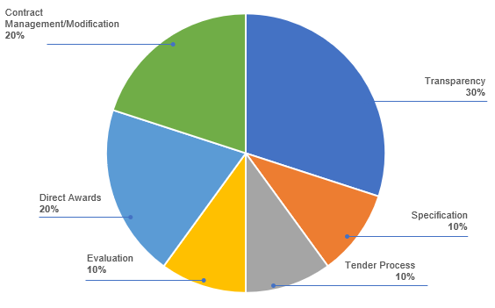
Chart 5: PCS Referral Themes for 2025/26

4.1. Promoting Procurement Compliance and Oversight
The PPRS and PCS have a presence on GOV.UK as part of Procurement Compliance & Oversight, where the services’ scope and remits, referral forms and further information can be found.

The services are promoted on UK government Find a Tender homepage and Contracts Finder, where notices for public sector procurements are published. The Find a Tender service allows organisations to search and apply for high value contracts (usually above £135,000) and awards for all public procurements over £30,000. The Find a Tender service published 14,817 tender notices and 59,731 award and contract notices in 2025/26. Contracts Finder, which publishes notices for procurements completed under the previous legislation such as framework call offs, published 39,088 award notices in 2025/26. PPRS is also promoted on the SME Hub on GOV.UK and is referenced within the commercial playbooks. As these are updated, they will include all PCO services.
We continue to promote PCO services through the Cabinet Office’s SME Panel and the Government Commercial Agency (GCA) SME Crown Representatives. Additionally, we work with the Small Business Commissioner, the SME Crown Representative, similar services in the Devolved Administrations and the VCSE Crown Representative to identify trends and share experience of best practices. We also strengthen procurement practitioner understanding of the services by presenting at commercial meetings across the public sector and presenting Transforming Public Procurement, now Public Procurement Community, webinars for the entire public sector.

5. Forward Look for 2026/27
The PCO is committed to continuous improvement. We will adapt the service outputs in line with policy, feedback, trends and issues.

With one year since the new Procurement Act 2023 went live and the launch of Procurement Compliance and Oversight it is a good opportunity to reflect on historic trends and ensure that the service is fit for purpose.

The top reported issues have shifted over time and the current complexity of the procurement landscape - with procurements under legacy frameworks that are still governed by the Public Contracts Regulations 2015 sitting alongside procurements under the Procurement Act 2023 - presents a challenge for suppliers. It is crucial that suppliers can continue to engage with public sector procurement with confidence.

Our priorities for 2026/27 include:

- Refreshing the PPRS Protocol to reflect feedback from stakeholders and to ensure alignment with emerging issues under the new Procurement Act
- PCS will embed the service, responding to issues identified in referrals, investigations and monitoring to improve commercial capability across the sector
- Using AI to improve team efficiencies and to improve the quality of our research and recommendations
- Providing quarterly trend analysis to ensure Procurement Compliance & Oversight can respond quickly to new developments
- Providing an active feedback loop to suppliers and contracting authorities:
  - Continue to work with suppliers and public sector procurement practitioners to ensure that the service offer is clear and understood.
  - Continue to work with suppliers to ensure that their concerns are heard and responded to.
  - Continue to work with contracting authorities to ensure that recommendations are taken forward in future procurements
  - Continue to work with teams across the Government Commercial Function and the GCA to feedback on the issues that are raised to improve commercial capability
  - Share the lessons learned from our reviews more widely in order to increase the quality of public sector procurements, through a series of insights sessions for the public sector buying community

6. Contact Us

The PCO is a small team, made up of case workers. All initial external communication with the team(s) must be conducted via the referral form for the service(s).

Both teams are notified of each new referral form via their respective shared inbox. Once a case has commenced, the same case worker will liaise with the referrer and/or the contracting authority, where appropriate.

A service description can be found on the PCO GOV.UK page. For more information on the PCO and to make a referral to either PPRS or PCS, please visit https://www.gov.uk/guidance/procurementcompliance-oversight

The PCO operates Monday to Friday during normal business hours.
- procurementcompliance@cabinetoffice.gov.uk
- publicprocurementreview@cabinetoffice.gov.uk

Annex A - Main Trends for Central Government
Chart 6: Issues investigated with CG - High Level - 2025/26 comparison against previous year
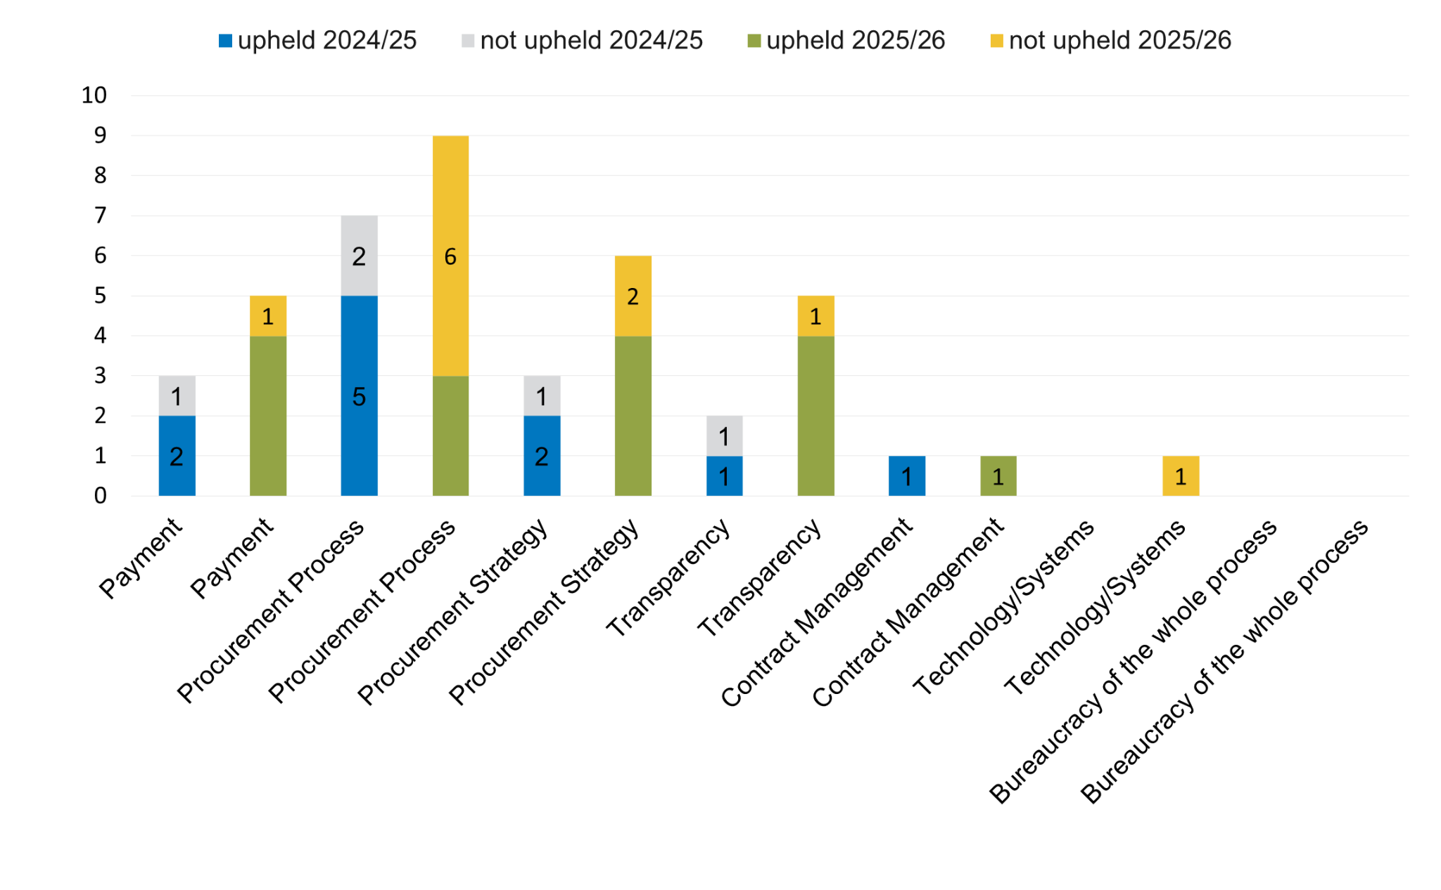
We investigated 27 cases classified as CG in 2025/26, an increase from 16 the previous year. Cases classified as ‘Procurement Process’ had the highest number of complaints with nine cases, an increase from seven the previous year; three complaints were upheld, which is a decrease from five cases upheld in 2024/25. Cases categorised under ‘Procurement Strategy’ increased in this sector this year, accounting for six cases, where four were upheld, compared to three cases, where two were upheld in the previous year.

Chart 7: Issues investigated with CG - Sub Level - 2025/26
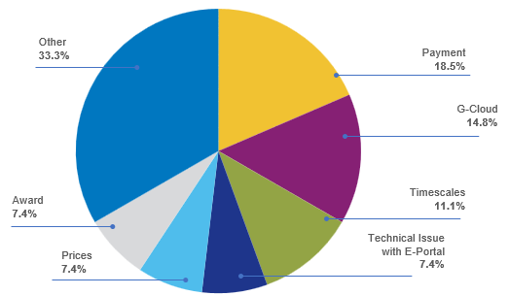

‘Payment’ was the highest reported issue with five complaints. ‘G-Cloud’ was the second highest reported issue for CG with four cases. Four ‘Payment’ complaints were upheld, where the Contracting Authority accepted our recommendations. Three ‘G-Cloud’ cases were upheld, where the Contracting Authority accepted our recommendations. ‘Timescales’ received three complaints and ‘Technical issue with e-portal’, ‘Prices’, and ‘Award’ all received two complaints.

In the previous year the highest reported issues were regarding ‘Payment’ and ‘Evaluation’ both with three cases and ‘Communication’ and ‘Transparency’ with two cases.

Individual complaints were received regarding ‘SME exclusion’, ‘Feedback’, ‘Favours incumbent’, ‘Evaluation’, ‘contract management’, ‘Conflict of interest’, ‘Communication’, ‘Assessment and scoring’, and ‘Advertisement’.

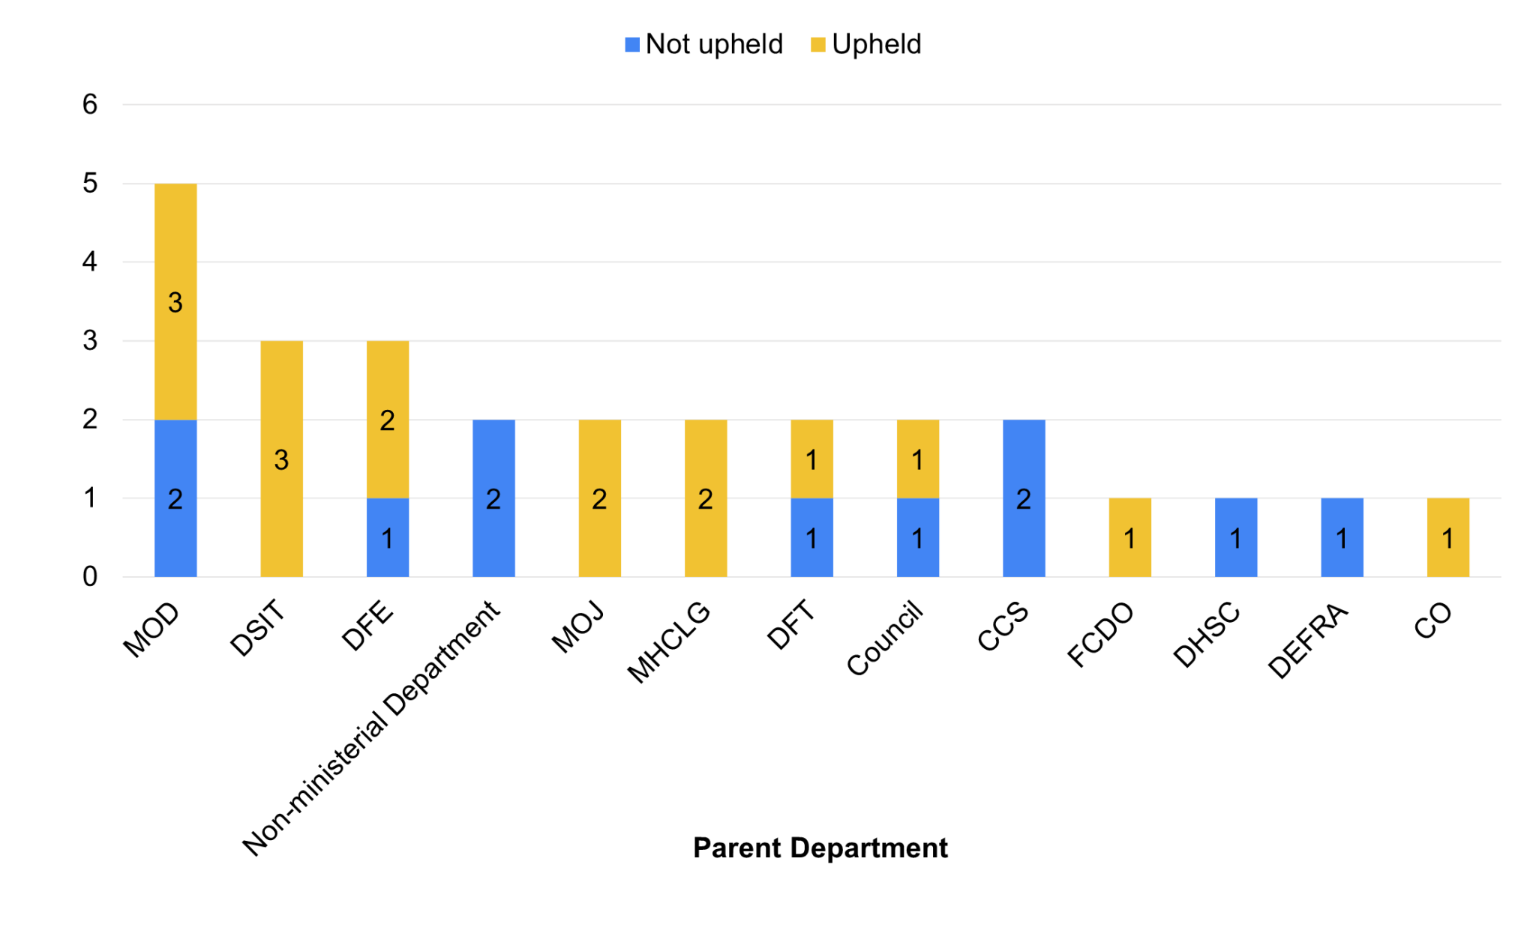
Chart 8: CG department split of cases not upheld and upheld 2025/26

59.3% (16 cases) of the complaints made on CG cases were upheld in 2025/26, down from 68.8% (11 cases) of complaints that were upheld in 2024/25. A detailed breakdown of complaints upheld can be seen in Section 6: Top Issues and Action above (page 10).

Annex B - Main Trends for Wider Public Sector
Chart 9: Issues investigated with the WPS - High Level - 2025/26 comparison against previous year
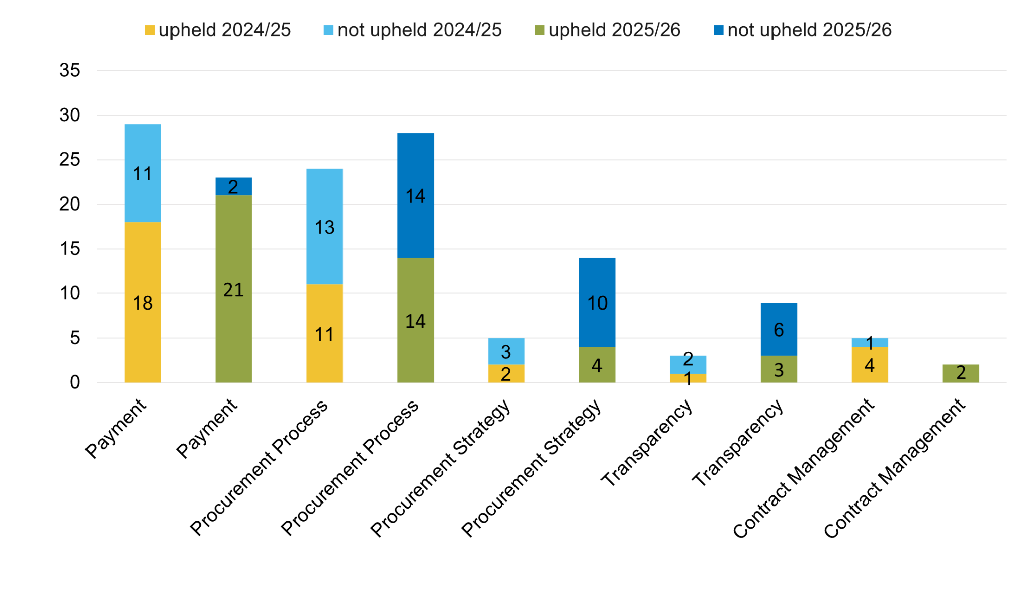
The WPS accounted for 74.3% of cases, the number of complaints closed increased from 67 (80.7%) in 2024/25 to 78 this year. In 2025/26 ‘Payment’ received the highest number of complaints, 23 cases, down from the 29 cases closed the previous year. ‘Procurement Process' cases continued to be prevalent with 28 cases, up from 24 cases the previous year.

Chart 10: Issues investigated with the WPS - Sub Level 2025/26

Type of Issue Raised | No .of Cases | % of Total | Upheld | Not Upheld
Payments | 21 | 29.11% | 21 | 2
Evaluation | 6 | 7.58% | 4 | 2
G-Cloud | 5 | 6.33% | 1 | 4
Evaluation | 3 | 3.80% | 0 | 3
SME Exclusion | 3 | 3.80% | 1 | 2
Feedback | 3 | 3.80% | 3 | 0
Contract Management | 3 | 3.80% | 3 | 0
Communication | 3 | 3.80% | 1 | 2
Changing Approach | 3 | 3.80% | 3 | 0
TUPE | 2 | 2.53% | 2 | 0
Tender Withdrawn | 2 | 2.53% | 0 | 2
Tender Process | 2 | 2.53% | 1 | 1
Prices | 2 | 2.53% | 0 | 2
Experience | 2 | 2.53% | 0 | 2
Clarification | 2 | 2.53% | 1 | 1
Award | 2 | 2.53% | 0 | 2
Assessment & Scoring | 2 | 2.53% | 2 | 0
Tender Requirement | 1 | 1.27% | 0 | 1
Technical Issue with E-Portal | 1 | 1.27% | 1 | 0
Scoring | 1 | 1.27% | 0 | 1
Release of Commercial in Confidence Information | 1 | 1.27% | 1 | 0
References | 1 | 1.27% | 0 | 1
Previous Experience | 1 | 1.27% | 1 | 0
Favours Incumbent | 1 | 1.27% | 0 | 1
Costing in Bids | 1 | 1.27% | 1 | 0
Competition | 1 | 1.27% | 0 | 1
Advertisement | 1 | 1.27% | 0 | 1
Administration | 1 | 1.27% | 1 | 0
 | 105 | 100% | 50 | 32

Payment accounted for 29.5% (23 cases) of all WPS issues reported to PPRS in 2025/26. This is a decrease from the previous year where ‘Payment’ represented 43.3% (29 cases) of WPS complaints. ‘Evaluation’ at 7.7% is an increase to the previous year where only 3 complaints were received. ‘G-Cloud’ received 5 complaints, where in the previous year there were none.

‘SME exclusion’, ‘Feedback’, ‘Contract management’, ‘Communication’, and ‘Changing approach’ received 3 cases. ‘TUPE’, ‘Tender withdrawn’, ‘Tender process’, ‘Prices’, ‘Experience’, ‘Clarification’, and ‘Assessment & scoring’ received 2 complaints. In the previous year the highest reported issues were regarding ‘Payment’ with 29 cases, ‘Communication’ with 5 cases, ‘Transparency’, ‘Evaluation’, and ‘Award’, with 3 cases.

Chart 11: WPS - sector split of cases not upheld and upheld 2025/26
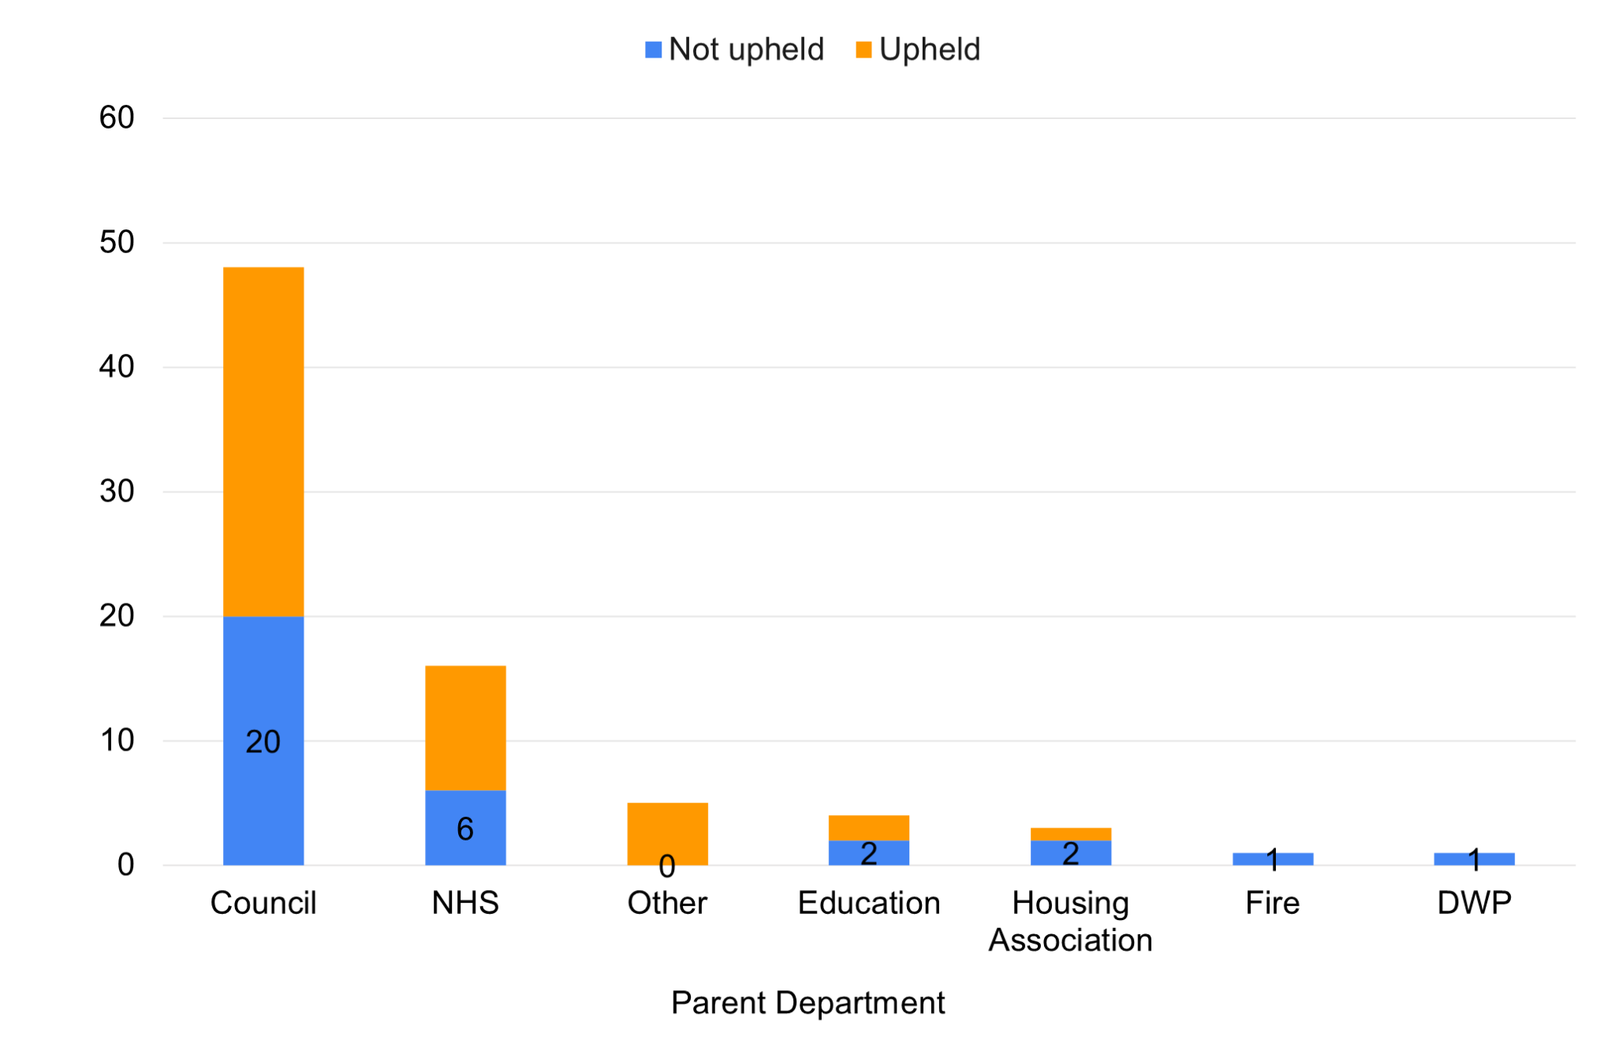

The majority of WPS complaints were upheld. Overall, 46 out of 78 WPS cases (58.9%) were upheld in 2025/26 similar to 2024/25 where 37 out of 67 WPS cases (55.3%) were upheld.

In the previous year the NHS was the subject of 15 cases, where 11 were upheld. Councils were the subject of 48 cases where 25 were upheld.

http://www.legislation.gov.uk/uksi/2015/102/regulation/113/made
The concerns recorded under ‘Other’ include: 'TUPE’, ‘Tender withdrawn’, ‘Tender process’, ‘Favours incumbent’, ‘Experience’, ‘Clarification’, ‘Advertisement‘, ‘Tender requirement’, ‘Scoring’, ‘Release of commercial in confidence information’, ‘References’, ‘Previous experience’, ’Costing in bids,’ ‘Conflict of Interest’, ‘Competition’ and ‘Administration’.
http://www.legislation.gov.uk/uksi/2015/102/regulation/113/made
https://www.gov.uk/government/publications/procurement-policy-note-0220-supplier-relief-due-to-covid-19
https://www.gov.uk/government/publications/procurement-policy-note-0420-recovery-and-transition-from-covid-19
https://www.gov.uk/find-tender
https://www.gov.uk/contracts-finder
https://www.gov.uk/guidance/small-and-medium-business-hub
Other services exist in: Northern Ireland - CPD Charter: https://www.finance-ni.gov.uk/publications/cpd-supplier-charter / Scotland - Single Point of Enquiry: http://www.gov.scot/Topics/Government/Procurement/Selling/supplier-enquiries / Wales - Supplier Feedback Service:https://gov.wales/topics/improvingservices/bettervfm/supplier-feedback-service/?lang=en

