
Predevelopment costs research
HM Revenue and Customs (HMRC)

September 2026
Oliver Fenton, Sophia Hasapopoulos, Tash Angus, Polly Hollings, Shahil Parmar, Rebecca Klahr
Disclaimer

The views in this report are the author’s own and do not necessarily reflect those of HM Revenue and Customs.

© King’s Printer and Controller of HMSO 2026
This publication is licensed under the terms of the Open Government Licence v3.0 except where otherwise stated. To view this licence, visit nationalarchives.gov.uk/doc/open-government-licence/version/3.
Where we have identified any third party copyright information you will need to obtain permission from the copyright holders concerned.
Published by HM Revenue and Customs, October 2026
[25-045206-01] | Version 1 | Internal Client Use | This work was carried out in accordance with the requirements of the international quality standard for Market Research, ISO 20252, and with the Ipsos Terms and Conditions which can be found at https://www.ipsos.com/en-uk/legal. © Ipsos 2026

Contents
Glossary 1
Executive summary 2
1. Introduction 5
2. Prevalence of predevelopment costs 8
3. Overall picture and tax treatment of predevelopment costs 12
4. Broader consideration of predevelopment costs 20
5. Tax treatment of predevelopment costs 28
7. Annex 1 – Additional methodological details 39

Glossary
Term | Definition
Corporation Tax | A tax paid by UK limited companies and other organisations on their taxable profits, with rates varying depending on profit levels.
Investment projects | Projects with significant spending by a business aimed at improving, expanding, or transforming how it operates. These are typically planned activities that involve allocating resources such as money, time, or staff to achieve longer-term benefits.
Micro business | A micro business refers to a business with 1 to 9 employees.
Small business | A small business refers to a business with 10 to 49 employees.
Medium business | A medium business refers to a business with 50 to 249 employees.
Large business | A large business refers to a business with 250 or more employees.
Predevelopment costs | Predevelopment costs are the expenses incurred in the early stages of an investment project before work begins, such as costs including project feasibility, or to obtain regulatory approvals such as planning consent, an environmental impact assessment, or project management costs (if they are incurred at that stage).
Research and Development tax relief | Research and Development (R&D) tax reliefs support UK companies working on innovative projects in science and technology.

Executive summary

Background to the research
Capital allowances offer tax relief aiding business growth by allowing deductions on expenses like machinery and property investments. However, some predevelopment costs such as the cost of environmental impact assessments are generally not eligible for tax relief and some businesses have expressed uncertainty on the correct tax treatment despite it sometimes being a significant share of total investment expenditure.
Prior to this study, HM Revenue and Customs (HMRC) had limited data on the prevalence and scale of predevelopment costs and their potential effects on investment and infrastructure development. HMRC commissioned Ipsos to conduct a mixed-methods study comprising 4,972 surveys with corporation tax-paying businesses and 20 follow-up depth interviews to assess the prevalence, types and amounts of predevelopment costs, as well as investment impact and tax treatment.
The Supreme Court issued its judgment in Orsted West of Duddon Sands (UK) Ltd and others v HMRC on 15 April 2026. The case considered the tax treatment of certain predevelopment costs, specifically whether the costs in dispute qualified for capital allowances. The Supreme Court concluded that the expenditure did not qualify for capital allowances. This research was conducted between August 2025 and March 2026, before the judgment was issued. Respondents’ views on the tax treatment of predevelopment costs therefore reflect the position at the time the research was undertaken.

Prevalence of predevelopment costs
The survey estimates that 16% of UK businesses paying corporation tax had incurred predevelopment costs since 2020, with 9% reporting that they had incurred these costs during the 2023 to 2024 financial year. The prevalence of predevelopment costs varied by business size. Small businesses (27%), medium-sized businesses (28%) and large businesses (45%) were more likely than average to report incurring predevelopment costs since 2020 (16% across all businesses).
There were also notable differences by sector. Businesses operating in the pharmaceutical (42%), electricity and gas (29%), accommodation and food (26%), education (26%), automotive (25%) and manufacturing (22%) sectors were more likely than businesses overall (16%) to report having incurred predevelopment costs since 2020.
Of the total predevelopment costs incurred since 2020, one-third (33%) was incurred in 2023 to 2024. Spending was broadly even across the preceding financial years, accounting for 24% in 2020 to 2021, 18% in 2021 to 2022, and 24% in 2022 to 2023. The mean total amount spent on predevelopment costs since 2020 was £357,000, compared with a mean spend of £139,000 in the 2023 to 2024 financial year.

Overall picture and tax treatment of predevelopment costs
Businesses participating in the qualitative research described costs incurred at the predevelopment phase as playing an essential strategic role. They reported that this expenditure enabled them to build business cases, assess opportunities for expansion, and conduct required legal and regulatory work needed to determine project feasibility. On average, businesses incurred four different types of predevelopment costs during the 2023 to 2024 financial year. The most common type of predevelopment costs incurred in 2023 to 2024 were project management costs (63%), followed by financial feasibility (45%), engineering or architectural services costs (43%) and market analysis costs (42%). Geographically, the most common region for businesses’ main expenditure of predevelopment costs were in physical sites in London (26%) and the Southeast of England (24%). Main expenditure refers to the location where a business incurred the greatest share of its predevelopment costs, noting that expenditure for some businesses may have been spread across multiple regions.
The qualitative research highlighted a clear difference in approach to incurring predevelopment costs: while some businesses undertook predevelopment for infrequent, one-off projects, for others, particularly in product development or construction, it formed an important and continuous part of their business model. Qualitative participants described incurring both internal and external costs. Where internal costs primarily related to staff time, businesses, especially smaller ones, found them challenging to quantify in financial terms. In contrast, external costs were often financially significant and included consultancy fees for regulatory or financial advice, legal fees for contractual matters, and design fees that could increase if redesigns became necessary.
Overall, 42% of businesses had deducted some amount of their predevelopment costs incurred in 2023 to 2024, and the size of predevelopment costs in relation to total investment project expenditure varied. Two-fifths of businesses (39%) indicating that predevelopment costs accounted for between 0 and 19% of the total cost of investment project expenditure. Just over 1 in 10 businesses said predevelopment costs accounted for 80 to 99% of total investment expenditure. 6% of businesses said that the predevelopment costs they incurred in 2023 to 2024 were in relation to a project that did not go ahead. The type of investment project influenced the proportion of the total budget spent during the predevelopment phase: businesses described spending a lower proportion on projects that focused on feasibility and preparatory work, but a higher proportion of spend for projects that involved building and construction or creating a product.

Broader consideration of predevelopment costs
The average timeframe from incurring predevelopment costs to the start of investment project delivery was 2 years. Qualitative interviews revealed that predevelopment timeframes varied considerably, with the duration of the predevelopment stage being influenced by factors such as a business’s experience, the time taken for regulatory approvals, the business's financial health, market pressures, and the involvement of specialist partners. Half (53%) of businesses with predevelopment costs in 2023 to 2024 said that predevelopment costs were spread evenly across the investment planning period.
However, the qualitative research found that costs were concentrated at specific points rather than being incurred evenly. For some businesses, expenditure peaked during the middle of the phase, driven by internal staff time, but for businesses involved in construction or infrastructure, costs were concentrated at the beginning, associated with groundwork and securing upfront architectural and regulatory services.
A quarter of businesses with predevelopment costs in the 2023 to 2024 financial year (28%) reported that their most recent occurrence of predevelopment costs for a project that did not go ahead was within the last year. The decision to proceed with a project beyond the predevelopment stage depended on several factors, including confidence in customer demand, the project's overall financial viability, and the ability to secure external funding or partnerships. On average, businesses deducted 57% of predevelopment costs for investment projects that did not proceed when calculating taxable profits.

Tax treatment of predevelopment costs
Overall, 36% of businesses agreed and 31% disagreed that they understood the tax treatment of predevelopment costs. The qualitative interviews found that understanding of the tax treatment of predevelopment costs was influenced by previous experience, professional involvement and perceived tax complexity. Businesses with limited knowledge on tax affairs sometimes reported low engagement with the tax treatment of predevelopment costs. This was particularly the case where accountants managed these costs as part of the business’s wider accountancy arrangements. Perceived complexity, uncertainty about changing rules and uncertainty about eligibility also contributed to low engagement.
Among businesses with predevelopment costs in the 2023 to 2024 financial year that were uncertain about the tax treatment of predevelopment costs, 38% agreed that this uncertainty affected their investment decisions, although 58% said it did not. The qualitative research found that uncertainty, including limited awareness of the available tax treatments, affected how some participants handled predevelopment costs. For example, some treated these costs as standard business expenses or used Research and Development (R&D) tax credits where possible.
The topic of predevelopment costs was often not a business priority, as it was delegated to accountants or overshadowed by more immediate concerns. Consequently, it typically had no impact on investment decisions, although some businesses noted a negative effect where lack of tax relief increased a project’s financial risk.
Where businesses reported that the tax treatment of predevelopment costs had a positive impact on their business this focused on reliefs and incentives that encouraged or enabled further investment or business activities. For example, a business noted that being able to claim R&D credits in turn incentivised them to make more investments.

1. Introduction

1.1 Research context
Capital allowances are a type of tax relief that allow businesses to deduct certain capital expenditure incurred such as on plant and machinery, from their taxable profits. In contrast, some predevelopment costs, such as the costs of environmental impact assessments are not generally eligible for tax relief. Some businesses have expressed uncertainty on the correct tax treatment, even though they often represent a significant share of total investment expenditure.
Prior to this study, HMRC had limited data on the prevalence and scale of predevelopment costs and their potential effects on investment and infrastructure development. HMRC therefore commissioned Ipsos to conduct a mixed-methods study comprising 4,972 surveys and 20 depth interviews among corporation tax paying businesses. The survey measured the prevalence, types and amount of predevelopment costs, examined their tax treatment and assessed self-reported impacts on investment decisions.
The Supreme Court issued its judgment in Orsted West of Duddon Sands (UK) Ltd and others v HMRC on 15 April 2026. The case considered the tax treatment of certain predevelopment costs, specifically whether the costs in dispute qualified for capital allowances. The Supreme Court concluded that the expenditure did not qualify for capital allowances. This research was conducted between August 2025 and March 2026, before the judgment was issued. Respondents’ views on the tax treatment of predevelopment costs therefore reflect the position at the time the research was undertaken.

1.2 Research aims
The research aimed to understand:
- the proportion of corporation tax paying businesses that incurred predevelopment costs in the financial year ending 2023 to 2024
- what the key types of predevelopment costs were and the associated costs for each
- whether any costs were deductible or not and by how much
- whether there was uncertainty in the tax treatment of any predevelopment costs
- the self-reported impact of the tax treatment of predevelopment costs in decisions to invest

1.3 Methodology

Quantitative fieldwork
The sample of UK businesses for this study was drawn from HMRC’s internal database of current corporation tax paying businesses. The sample frame consisted of 105,844 businesses across all sizes, business sectors and UK regions, regardless of whether they had predevelopment costs or not. As the prevalence rate of predevelopment costs was unknown, a stratified sample was used boosting sector and size bands expected to have higher incidence of costs. Full sampling assumptions and sector definitions are provided in Annex 1. A random probability approach was used for survey fieldwork, allowing findings to be generalised to the population of corporation tax paying businesses. Screening questions asked at the start of the survey ensured that all participants held senior roles and had dealt with both investment projects and tax affairs for their organisation.
All businesses first completed a short (c. 5 minutes) screener questionnaire on predevelopment costs since 2020. Those reporting predevelopment costs in the 2023 to 2024 financial year qualified for the full survey (c. 18 minutes) on the nature of those costs and the impact of their tax treatment on investment decisions.
The survey was conducted via a mixed-mode approach (telephone and online). A pilot survey was conducted between 28 August and 18 September 2025, to gauge early indications of prevalence rates for predevelopment costs. In total, 899 screener interviews were completed in the pilot, including 74 businesses with predevelopment costs in the 2023 to 2024 financial year.
Following the pilot, the survey design was finalised and the sector boost retained. The mainstage fieldwork was conducted between 6 January and 20 February 2026. Across the pilot and mainstage, 4,972 surveys were completed in total, including 543 businesses with predevelopment costs in the financial year 2023 to 2024. Final survey data was weighted to be representative of the population of corporation tax paying businesses in the UK. More details on the sample design can be found in Annex 1.

Qualitative fieldwork
Following the quantitative survey, Ipsos carried out qualitative research with a small sample of businesses that had taken part in the survey. The aim of this research was to further explore themes that emerged in the survey and cover areas that were more difficult to cover in detail quantitatively. For example, exploring what shaped understanding of the tax treatment of predevelopment costs. A qualitative approach allowed for open discussion on these topics, with participants sharing their thoughts in their own words.
Ipsos conducted 20 in-depth qualitative interviews between the 9 February and 9 March 2026. A discussion guide detailing key areas of exploration for interviews was developed by Ipsos and HMRC. Interviews lasted between 45 to 60 minutes and were conducted via Microsoft Teams or telephone depending on participant preference.
Ipsos and HMRC agreed a sample structure for the interviews. This was based on a purposive sampling approach to ensure the research generated detailed insights into key areas of interest, while also including a diverse range of businesses. The sample frame included those who had agreed to be recontacted to participate in future research, at the end of the survey.
A recruitment screener was used alongside the quantitative survey data to ensure eligibility for the qualitative research. Recruitment quotas were set for firmographics to include a diverse range of businesses including quotas for business size, sector, location and turnover. Quotas were also set to include businesses that gave a range of responses to questions in the survey relating to predevelopment cost experiences. For example, including both those who reported that they did and did not understand the tax treatment of predevelopment costs.
Annex 1 provides further detail on the sample characteristics and a summary of the interviews achieved.

How to read this report
The survey data referred to in section 2 of the report (prevalence of predevelopment costs) are based on all businesses responding to the screener survey (comprising 4,972 completed interviews).
The rest of the report (sections 3 to 5) refers to the responses from the subset of businesses surveyed who had predevelopment costs in the financial year 2023 to 2024 (i.e. 543 interviews). The qualitative data are based on depth interviews with 20 businesses with predevelopment costs in the financial year 2023 to 2024.
Survey results are subject to margins of error (see Annex 1) and can vary depending on the actual sample size and specific percentage figures. The following should be considered when interpreting the data:
- for questions on predevelopment expenditure, the mean is reported
- expenditure figures are rounded to the nearest thousand
- where sub-group differences are reported, these were found to be statistically significant at the 95% confidence level and are referring to a statistically significant difference to the total result, unless otherwise stated
- not all questions or charts in the report will sum to 100%, due to rounding of percentages, multiple answers being allowed, or do not know or prefer not to say responses being excluded from the chart
- where base sizes were below 50 respondents, the data has not been included in this report
When considering the qualitative findings throughout this report it is important to bear in mind that qualitative research is illustrative and exploratory. The findings in this report are intended to provide insight into the experiences of a selection of businesses that took part in the quantitative research. Participants were identified for inclusion in this qualitative report based on the types of responses given to survey questions (to enable further exploration of key emerging topics) and did not set out to be representative of the wider business population. Qualitative research cannot be presented as quantifiable. It provides descriptive insights into the complex factors influencing business views, providing nuance and detail that is not easily captured through quantitative methods.

2. Prevalence of predevelopment costs
This section summarises the prevalence of predevelopment costs among businesses that pay corporation tax in the UK. The survey examined 2 core timeframes: whether the business incurred any predevelopment costs at any point since 2020 and whether it incurred predevelopment costs specifically in the 2023 to 2024 financial year. Follow up questions captured total expenditure on predevelopment costs and the proportion allocated to each year.

2.1 Prevalence of predevelopment costs
This survey estimates that 16% of corporation tax paying businesses have incurred predevelopment costs since 2020, and 9% did so in the 2023 to 2024 financial year.
Large businesses were more likely than average to report incurring predevelopment costs since 2020 (45% compared with 16% across all businesses). Small (27%) and medium (28%) businesses were also more likely to report such costs. Although all three groups reported rates above the overall average, the average was lower because micro businesses, which made up 70% of Corporation Tax paying businesses, reported predevelopment costs less frequently. See Figure 2.1 for a breakdown of the prevalence of predevelopment costs since 2020 by business size. Annex A provides a breakdown of the proportion of Corporation Tax paying businesses by business size.
Business sectors more likely than average to have incurred predevelopment costs since 2020, included pharmaceuticals (42% of businesses in that sector have incurred predevelopment costs since 2020), electricity and gas (29%), accommodation and food (26%), education (26%), automotive (25%) and manufacturing (22%).

Figure 2.1 Prevalence of predevelopment costs since 2020, overall and by business size
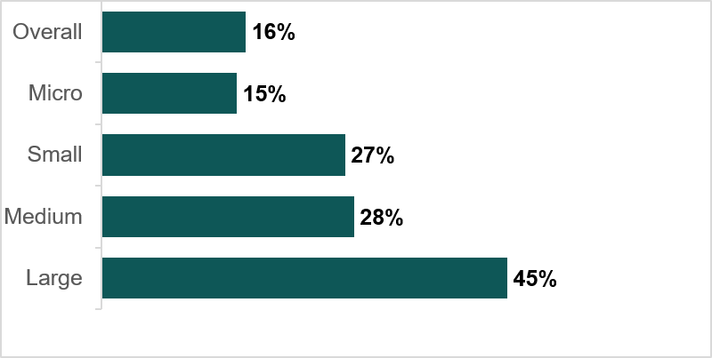
Q_PREDEV_2020. Has your business incurred predevelopment costs for any of the investment projects you have conducted since April 2020?
Unweighted base: All Corporation Tax paying businesses (4,972). Micro (1-9 employees): 3,400, Small (10-49 employees): 841, Medium (50-249 employees), 212 Large (with 250 + employees): 104 with predevelopment costs since 2020 who could specify when the costs were incurred (632).
Businesses in wholesale, retail trade and repairs (12%) and those based in the East Midlands (9%) were less likely than average (16%) to have incurred predevelopment costs since 2020. No sector had fewer than 10% of businesses reporting predevelopment costs since 2020, indicating that these costs occur across a broad range of businesses.

2.2 Predevelopment costs expenditure since 2020
Among businesses that incurred predevelopment costs since April 2020, the mean total spend was £357,000. Over half (53%) of businesses with predevelopment costs since 2020 spent less than £50,000 on them (see Figure 2.2 for a breakdown of predevelopment expenditure incurred since 2020). Expenditure varied by business size with large businesses having a mean spend of £2.1 million since 2020, medium businesses £1 million, small businesses £443,000 and micro businesses £170,000. In terms of sector, expenditure in the pharmaceutical sector was significantly higher than average (mean of £2.2 million).

Figure 2.2 Predevelopment expenditure incurred since 2020
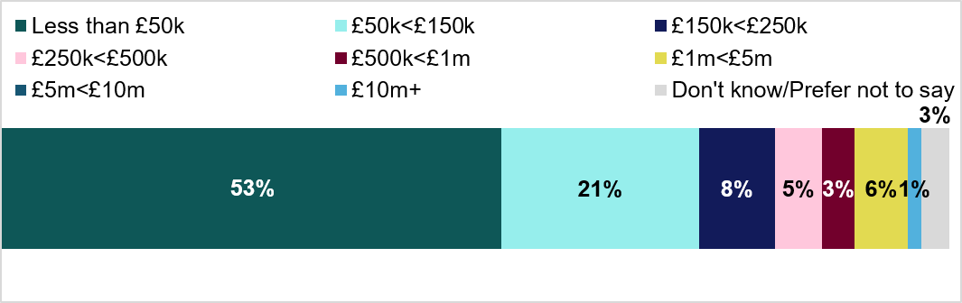
Q_PREDEV_2020EXPENDITURE_BAND. Approximately how much has your business spent on predevelopment costs for the investment projects you have conducted since April 2020?
Unweighted base: All businesses with predevelopment costs since 2020 (922).
Businesses that had incurred predevelopment costs since 2020 were asked to indicate the financial years in which these costs were incurred. They allocated percentages across four financial years (2020 to 2021 to 2023 to 2024) representing the share of total spend in each year. Figure 2.3 shows the average percentage across businesses that reported predevelopment costs and could specify timing.

Figure 2.3 Share of predevelopment spend by year since 2020
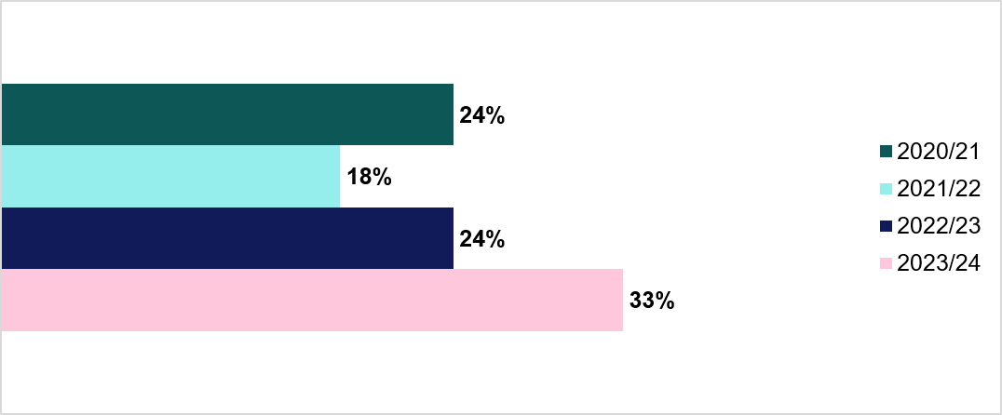
Q_PREDEV_DISTRIBUTION_BLOCK. From the amount your business spent on predevelopment costs since 2020, approximately what percentage of this was incurred in the following years?
Unweighted base: All businesses with predevelopment costs since 2020 who could specify when the costs were incurred (632).
A third (33%) of total predevelopment cost expenditure since 2020 occurred in 2023 to 2024, while spending was broadly even across the other financial years (2020 to 2021 to 2022 to 2023). However, 20% of businesses either did not know their total predevelopment spend since 2020 or could not allocate it by year. This suggested that a significant minority of businesses relied on external support to keep track of predevelopment costs, and qualitative interviews confirmed this by highlighting that external agents were frequently used to manage predevelopment costs. This included instances where, for example, an accountant dealt with predevelopment costs as part of the general accountancy for the business.

2.3 Predevelopment costs expenditure and total market value in 2023 to 2024
Businesses that incurred predevelopment costs in 2023 to 2024 reported a mean spend of £139,084. Two-thirds of businesses (66%) spent less than £50,000, indicating that most businesses incurred relatively small amounts in that year. Micro businesses were significantly more likely than average to spend under £50,000 on predevelopment costs during this period (76% compared to 66% overall). See Figure 2.4 for a breakdown of predevelopment expenditure incurred in the financial year 2023 to 2024.

Figure 2.4 Predevelopment expenditure incurred in 2023 to 2024
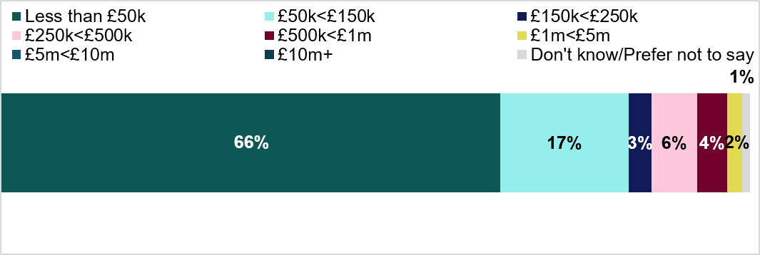
_PREDEV_EXPENDITURE_BAND. Approximately how much has your business spent on predevelopment costs for your accounting period ending in 2023 to 2024?
Unweighted base: All businesses with predevelopment costs in 23 to 24 (543).
As noted above, an estimated 289,000 businesses incurred predevelopment costs in the 2023 to 2024 financial year. Applying the mean per business spend implies a total market spend of approximately £40.1 billion in that year. Breaking this down by business size (see Figure 2.5) shows the role of large businesses: although they only make up 4% of businesses with predevelopment costs in 2023 to 2024, their spending is estimated to represent 19% of total predevelopment expenditure.

Figure 2.5 Businesses incurring predevelopment costs in 2023 to 2024 and share of total spend

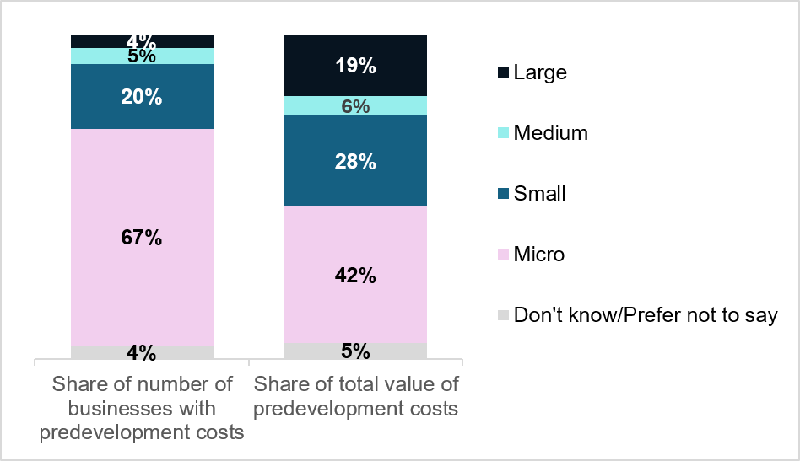

Q_PREDEV_2023_24: Has your business incurred predevelopment costs in the accounting period ending in 2023 to 2024? Q_PREDEV_EXPENDITURE_BAND. Approximately how much has your business spent on predevelopment costs for your accounting period ending in 2023 to 2024?
Unweighted base size: All businesses with predevelopment costs in 23 to 24 (543). Mean averages used to create value estimates by business size groupings and estimate the percentage share of total value by business size.

3. Overall picture and tax treatment of predevelopment costs
The following section focuses on businesses that incurred predevelopment costs in the 2023 to 2024 financial year. Specifically, this section covers the types of predevelopment costs incurred, the location these costs were typically incurred, and the share of predevelopment costs that were deducted from taxable profits. Qualitative insights are integrated throughout this section to expand on the role and type of predevelopment costs for businesses and the different phases of activity during the predevelopment stage.

3.1 The role of predevelopment costs
Qualitative interviews highlighted the role that the predevelopment stage of projects played for businesses. Predevelopment costs were widely seen as essential to growth and resilience and were built into standard planning processes. They allowed businesses to generate business cases to secure external funding, assess the value of expanding into new areas and to capitalise on new opportunities and technologies. For example, one participant described how development of an in-house AI model allowed them to increase efficiencies across the business, enabling them to take on more work as a result.
"[Predevelopment costs are for] internal business planning, and to support the bids for money we were going to get. To try and make a business case and make sure there is a commercial case. “
Medium size business, Manufacturing sector
Predevelopment costs were also associated with legal and regulatory activities required to determine feasibility of a new project and ensure compliance. This could include requirements to carry out activities such as planning consent and environmental impact assessments and were typically noted in relation to building and construction works.
"Costs were for the regulatory approvals from the different countries, and the cost of planning […] Before I could take on the project, I had to go into the regulatory side of it to see if the project was actually feasible, and I did run up against quite a few barriers."
Micro size business, Education sector
In the qualitative research there was variation in how frequently businesses carried out projects that involved predevelopment phases. Businesses described ‘one-off’ or infrequent projects such as those to make changes to internal processes (for example IT systems or processes), customer products or physical infrastructure.
Where carried out frequently, businesses described these projects and the predevelopment phase as integral to companies’ business model. For example, where the business’s core activity was related to product development or building or infrastructure. For these businesses, predevelopment was a standard part of business operations, and without it, they would not be commercially viable.
“We would go bankrupt if we didn’t do [the investment project] […] If we didn’t do this, we wouldn’t exist now. “
Micro size business, Professional, Scientific and Technical sector

3.2 Types of predevelopment costs incurred
On average, businesses tended to have incurred four different types of predevelopment costs during the 2023 to 2024 financial year. The most common type of predevelopment cost was for project management, which were incurred by almost two-thirds of businesses (63%). The second most common type of predevelopment cost was financial feasibility (45%), followed by engineering or architectural services costs (43%) and market analysis (42%). Figure 3.1 provides a full breakdown of the types of predevelopment costs businesses reported in the survey.

Figure 3.1 Types of predevelopment costs in the 2023 to 2024 financial year
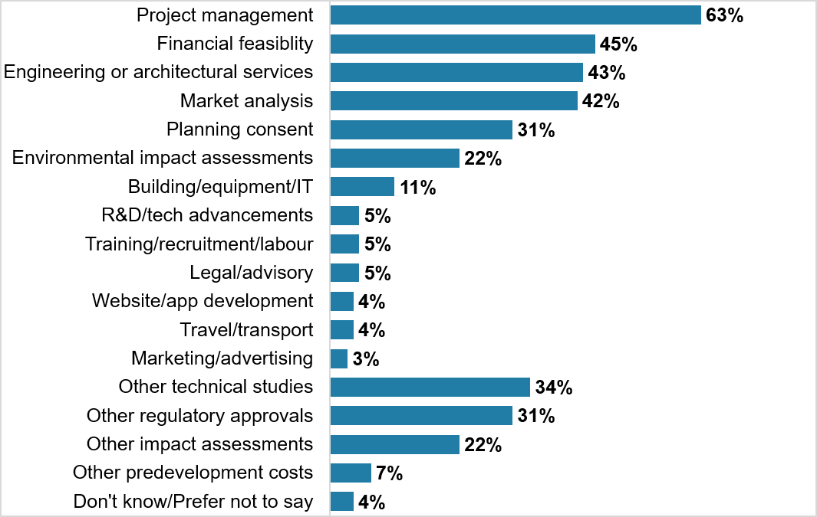
Q_LAST_PREDEV_WHAT: Thinking about the accounting period ending in 2023 to 2024, what types of predevelopment costs did your business incur?
Unweighted base: All businesses with predevelopment costs in the 2023 to 2024 financial year (n = 543). Multiple responses were allowed.
Businesses in the construction sector were more likely than businesses overall to have incurred costs related to engineering or architectural services costs (71% compared to 43%), planning consent (58% compared to 31%) and environmental impact assessment costs (45% compared to 22%).
Businesses with a higher total predevelopment cost expenditure in the financial year 2023 to 2024 (more than £150,000) were more likely to have incurred engineering or architectural services costs (70%), planning consent (51%) and environmental impact assessment costs (39%) compared to businesses overall (43%, 31%, and 22% respectively).
As shown in Figure 3.2, project management costs accounted for the largest share of spend, with an average of 18% of all predevelopment costs attributable to that type of cost. On average, 14% of a business’s predevelopment costs related to engineering or architectural services.

Figure 3.2 Average (mean) share of total predevelopment spend by cost type in 2023 to 2024
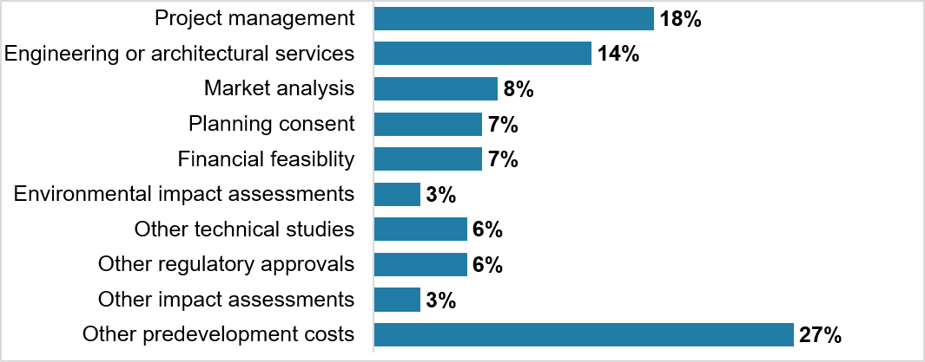
Q_LAST_PREDEV_EXPENDITURE_BLOCK: Approximately what amount of your total predevelopment costs were each of the following costs in the accounting period 2023 to 2024? - Summary table of mean % scores. Unweighted base: All businesses (answering) with predevelopment costs in 23 to 24 who selected multiple predevelopment cost types at Q_LAST_PREDEV_WHAT and answered Q_LAST_PREDEV_EXPENDITURE BLOCK, and those who selected only one type at Q_LAST_PREDEV_WHAT (n = 463).
Further analysis examined expenditure levels across the different types of predevelopment costs business incurred, by multiplying the proportion of expenditure for 2023 to 2024 for each type of expenditure against the total value of predevelopment cost expenditure that business had in 2023 to 2024. This enabled the proportion shares to be turned into actual expenditure results for each business and predevelopment cost type.
Figure 3.3 shows the location of the physical site where the main expenditure of predevelopment costs occurred for businesses in 2023 to 2024. The pattern broadly reflects the regional spread of corporation tax paying businesses across the UK. Geographically, the most common region for businesses’ main expenditure of predevelopment costs were in physical sites in London (26%) and the South East of England (24%). Just under one in ten businesses reported their main expenditure occurred outside the UK (9%). Main expenditure refers to the location where a business incurred the greatest share of its predevelopment costs, noting that expenditure for some businesses may have been spread across multiple regions.

Figure 3.3 Location of main predevelopment spend in 2023 to 2024
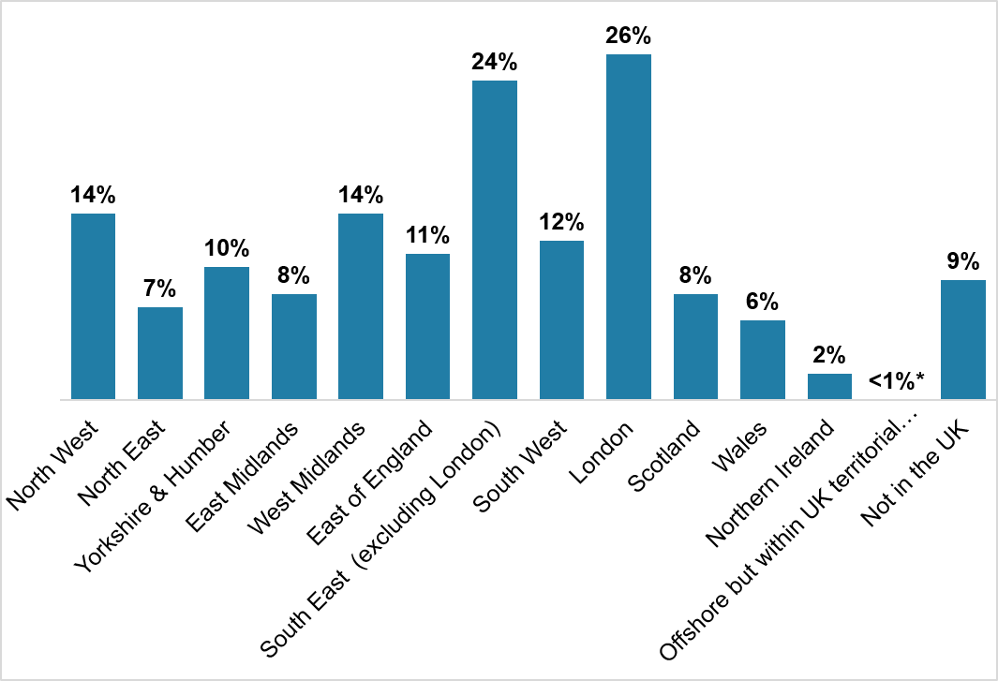
Q_LAST_PREDEV_WHERE. Can you tell us where the main expenditure of your predevelopment costs has been delivered?
Base: All businesses with predevelopment costs in 23 to 24 (n = 543). Do not know or Prefer not to say not charted (n = 7). Please note that businesses could select more than one location in response to this question, therefore percentages will not add to 100%.
Qualitative participants were asked to describe the types of predevelopment costs that their business had incurred. A range of costs were identified which can be categorised as internal and external costs.
Internal costs incurred during predevelopment were usually related to staff time. Businesses noted that these types of costs could be challenging for them to quantify, particularly when attempting to translate time invested in a project into financial terms.
This perspective was more common in smaller businesses, where staff often held multi-faceted roles that included carrying out project management and scoping activities. Additionally, these businesses conceptualised internal work primarily as a time related cost rather than a direct financial expense. For example, a micro-sized business described carrying out scoping activities internally, using staff time.
"With four of us, market analysis and project management is just time rather than cost. We can go out and buy the odd report from third parties, but in the main it is a lot of our work to prove things ourselves."
Micro size business, Information and Communication sector

Staffing resource was associated with different types of predevelopment activities
Financial feasibility, scoping, and market research were predevelopment activities that required staffing resources. Scoping activities required internal staff time and in-house expertise. Smaller businesses mentioned using existing staff resource to conduct market research, rather than outsourcing it. For example, a medium-sized business in the education sector described internal staff time related to looking into expanding their business through acquiring further property. Activities included assessing the benefits of the purchase, consulting with the local Council and gathering costs.
Another small-sized business in the construction sector described internal time to look into the feasibility of acquiring a competitor whilst a further medium-sized business in the manufacturing sector noted that predevelopment costs focused on market analysis activities to build a business case for their project.
"Internal business planning, and to support the bids for money we were going to get. To try and make a business case and make sure there is a commercial case."
Medium-sized business, Manufacturing Sector
If seeking to work in other countries, costs could also include travel for staff to visit these other countries as part of scoping activities.
Other businesses described this initial scoping phase as involving staff time to develop products, prototypes or a proof of concept. For example, a medium-sized business in the Arts, Entertainment and Recreation sector described staff time being spent on generating creative assets during the predevelopment phase.
Project management costs were often present and consistent throughout the phases of predevelopment.
Where mentioned, hiring and training new and existing staff prior to an investment project commencing was a large internal cost for businesses. For example, one business in the health and social work sector described needing to hire and train staff during the predevelopment phase to ensure staff would comply with regulatory standards and protocols prior to the opening of a care facility. Activities during this time also included putting software systems and security systems in place. They explained that any delays in the project resulted in increased staffing costs, as they needed to pay staff even though they were unable to start working. Another large business described needing to train staff to use a new system in a short time frame during the predevelopment stage.
“We had to find a warehouse, get planning consent, develop staff to make sure we could create a bespoke system […] all in 8 weeks.”
Large size business, Professional, Scientific and Technical Sector
The types of external costs incurred during predevelopment are described below, providing further detail on some of the common types of predevelopment costs cited in the survey.

Consultancy costs
Where a business incurred consultancy costs, these were identified as a financially significant external cost. Businesses worked with consultants for a range of activities. For example, one business indicated that their primary expenditure was on consultancy services from their accounting firm, who provided compliance and regulatory advice, financial consulting, as well as assistance with tax issues. Another business mentioned employing consultants to conduct feasibility studies and environmental impact assessments prior to seeking planning permission. A further business described bringing in external consultants to advise on demolition work before construction began.
A medium sized business described their main external costs as consultancy with accountancy providers as part of work to look at software development for internal processes.

“I'd say the main costs were consultancy costs with our accountancy providers […] We had our own internal cost, with our software developer guy, but a lot of them were external consultancy costs that we incurred.”
Medium size business, Transport sector

Legal costs
Legal fees typically focused on contractual matters. For example, one business noted that legal consultants helped to advise them on intellectual property rights. Another large-sized business in the professional, scientific and technical sector mentioned the cost of solicitor fees whilst a further business in the construction sector described legal fees related to land or property purchases.
“Roughly the legal is anything between £50,000 and £120,000, and accounting is generally between £5,000 and £25,000 depending on the size, and obviously, they have minimum fees. So, you're straight into those costs from an acquisition perspective.”
Large size business, Construction sector
Design and architectural fees
Design and architectural fees included those in relation to building and properties. Examples mentioned included building design and input from people working architectural heritage, and surveys. For example, a business in the construction sector described needing a building survey to access finance packages from banks.
Businesses noted that design and architectural fees could evolve as a project progressed. These fees were inherently flexible due to potential adjustments necessitated by new regulatory requirements or insights gained during activities such as environmental impact assessments. Redesign activities resulted in increased costs and timescales.
“So, we have conceptual designers who will develop and design things to a much higher level than a square block of buildings […] So it’s a lot of design fees and re-design fees”
Large size business, Accommodation and Food sector
Where design is focused on a product, associated costs could include purchasing design software or paying specialists to take on specific tasks such as software development. For example, a micro size business in the professional, scientific and technical sector noted sourcing expert product designers and needing to purchase design software they had not previously owned.

Planning and regulatory requirements
Where relevant, determining necessary regulatory and planning requirements and obtaining these was identified as an important phase of predevelopment and often happened early during the process. For example, a construction company noted that environmental surveys were important but time-consuming with some surveys restricted to being carried out at certain times of the year due to environmental conditions. Another micro-sized business in the education sector described needing to obtain regulatory approvals from different countries for their product or service.
The process of obtaining planning permissions, building control fees, permits and necessary regulatory requirements was also a large external cost. For example, one business described how the anticipated cost of acquiring information about necessary planning permissions and then obtaining these had stopped them going ahead with an investment project.
“Planning permission is extremely time consuming and difficult and even if you get planning permission it's not always implementable.”
Medium-sized business, Education sector

3.3 Deduction of predevelopment costs
Overall, 42% of businesses indicated that they had deducted some amount of their predevelopment costs that they incurred in 2023 to 2024 from taxable profit. On average (mean), businesses deducted 61% of their predevelopment costs when calculating taxable profits. Just under one-fifth (17%) of businesses reported that they did not deduct their predevelopment costs. It is important to note that around 2 in 5 businesses responded ‘Do not know’ to this question (41%). Figure 3.4 shows the breakdown of the percentage deducted for the 2023 to 2024 accounting period.

Figure 3.4 Share of predevelopment costs deducted from taxable profits in 2023 to 2024 (mainstage only)
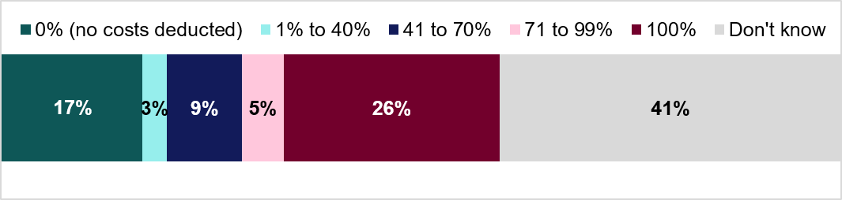
Q_LAST_PREDEV_TAX_NEW. For your total predevelopment costs in 2023 to 2024, approximately what percentage of these costs will not be deducted when calculating taxable profits? Chart reversed to calculate % deducted. *Note this is a new question post-pilot. Mean scores include 0%
Base: Post-pilot businesses that have incurred predevelopment costs in 2023 to 2024 (n = 469).
Figure 3.5 shows a breakdown of the proportion of total investment project expenditure accounted for by predevelopment costs. Two-fifths of businesses (39%) indicated that predevelopment costs accounted for between 0 and 19% of the total cost of investment project expenditure. Just over 1 in 10 businesses said predevelopment costs accounted for 80 to 99% of total investment expenditure. 6% of businesses said that the predevelopment costs they incurred in 2023 to 2024 were in relation to a project that did not go ahead. Section 4.3 examines such cases in more detail, including predevelopment costs beyond the 2023 to 2024 period.

Figure 3.5 Share of investment project cost that were predevelopment costs in 2023 to 2024
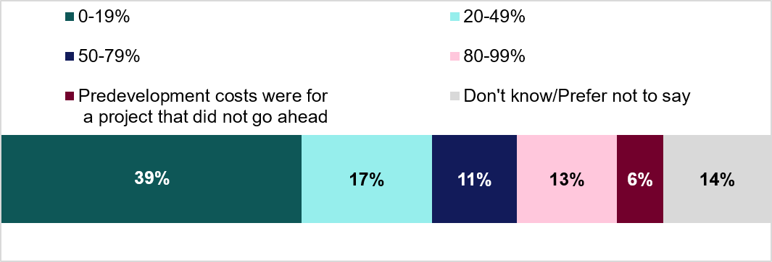
Q_LAST_PREDEV_TOTAL: Approximately what percentage of the total cost of the investment projects was predevelopment costs?
Base: Businesses that incurred predevelopment costs in 2023 to 2024 (n = 543).
The qualitative interviews found that the type of investment project undertaken influenced the proportion of the overall project budget spent during the predevelopment phase. Where businesses described spending a lower proportion of the entire project budget during the predevelopment phase, projects often focused on conducting feasibility work and preparatory work before the project delivery phase.
For these cases, the main project activities such as production and work began after predevelopment. Where businesses noted a higher proportion of spend during predevelopment, they were more likely to describe projects that involved building and construction work, or projects that focused on creating a product during the predevelopment phase.
“Majority of it is from the beginning… 80% towards the beginning. Costs for materials which is the drones, costs for the licences of the operators, costs of the regulatory approvals from the different countries, the cost of planning. This is all before any work could be undertaken. There is a lot of planning and regulatory paperwork needed, especially in the UK, and licensing as well.” Micro size business, Education sector
For example, a medium size business in the health and social work sector described an investment project where around 50% of the project budget fell in the predevelopment phase as they were building a new care facility and needed to recruit and train staff in advance.

4. Broader consideration of predevelopment costs

The next section also focuses on businesses that incurred predevelopment costs in the 2023 to 2024 financial year. This section outlines the timeframes between businesses incurring predevelopment costs to the start of investment project delivery and factors that may influence timings, the stage within predevelopment where most costs were incurred, and experiences of predevelopment costs for investment projects that did not ultimately go ahead. 4.1 Timeframes of predevelopment costs
The average timeframe from incurring predevelopment costs to the start of investment project delivery was 2 years. As shown in Figure 4.1, around a quarter of businesses began delivering the investment project within a year of incurring these costs, while 11% reported five years or more. Businesses with higher spend on predevelopment costs in 2023 to 2024 (more than £150,000) were less likely to say the timeframe between incurring predevelopment costs and investment projects beginning was less than a year (18% compared to 27% overall).

Figure 4.1 Timeframe between predevelopment costs being incurred and start of investment project
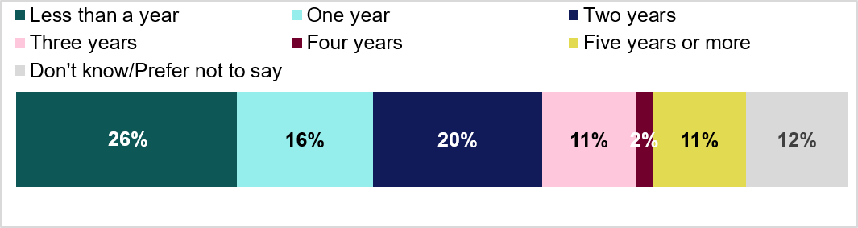
Q_PREDEV_TIMEFRAME. What is the average timeframe between beginning to incur predevelopment costs and starting to deliver an investment project? Base: All businesses (answering) with predevelopment costs in 23 to 24 (n = 527).
In the qualitative interviews, businesses described a variety of timescales for the predevelopment phase of investment projects. For example, one business described logistical, labour intensive activities as part of the predevelopment phase lasting around 6 weeks whilst another described the predevelopment phase for construction and development of a hotel lasting around 5 years.
Amongst businesses involved in product development, there was acknowledgment that they would spend more time in the predevelopment phase compared to the project delivery phase.
“[The predevelopment phase] takes probably as long as the actual work, a year to 18 months on predevelopment, and the actual delivery takes the same amount of time.”
Medium size business, Manufacturing sector
Although this made predevelopment timeframes longer, these businesses considered this an important part of their business model. For example, one business noted that spending enough time during predevelopment was essential to ensuring the product they were delivering was good enough quality and fit for their customers.
“If we were in the business of spending more time delivering than we were developing, we’d be delivering rubbish product and not having any economies of scale in terms of delivering it so we wouldn’t make a profit. It has to be the other way round.”
Micro size business, Information and Communication sector
More broadly, across the qualitative interviews, a range of factors emerged as important in influencing the timeframe for the predevelopment phase including:

Familiarity with the process and business experience
Businesses that frequently carried out investment projects had structured processes and milestones in place to ensure projects kept to tight timelines. For example, a business in the manufacturing sector described having project milestones that were clearly defined in the company's quality management system.
“[Milestones] are very defined in our quality management system. So, we'd have input requirement to a new project form. The predevelopment will define all the inputs that we stick into the project when it starts.”
Small size business, Manufacturing sector

Time required for obtaining planning and regulatory approvals
Regulatory approvals were considered time consuming and involved convoluted processes. Businesses noted that they could lead to delays beyond their control which contributed to extended predevelopment phases.
For example, a business described postponing construction to conduct an ecological survey to monitor the number of bats living in the specified construction zone. This survey could only be conducted during the summer months, which caused delays and increased costs. Another business in the health and social Work sector mentioned that getting planning permissions and inspections from councils often took time due to the scheduling of site visits and interviews. This had held the project up with the business noting that they were still paying rent for the project location during this delay.
“I guess just getting the regulatory approval and going through all the hoops just takes time.”
Small size business, Education sector

Financial health of the business
Where businesses were reliant on cash flow, they experienced delays and extended predevelopment periods during times when they were unable to prioritise and direct resource to new investment projects. For example, a micro-sized business in the oil and gas sector business described having to spread the predevelopment costs out over the planning period and evaluating whether they had the cash available at that time. The business noted that a key element of the predevelopment phase was sending a staff member to the country where the project would take place. This cost needed to be paid upfront, and this was not always affordable, changing year on year depending on the companies’ finances.
"It’s all driven by managing cash flow. It’s about what needs doing, but more so, have we got the cash to do it?"
Micro size business, Oil and Gas sector

Market pressures
Timeframes could be expedited when businesses were reacting to market pressures. For example, to capitalise on new technologies, businesses had to shorten timescales to remain innovative and competitive.
This was the case for a small business in the information and communication sector, who sought to quickly create and implement AI systems to compete with others in their industry and retain customers.

Role of partners
Where partners could assist in product development with specialised knowledge and materials, timeframes were reduced. For example, one large business in the professional, scientific and technical sector was able to partner with a university for the development of an in-house product, which allowed them to deliver the project in a timeframe that was suited to their client’s needs.
"We spent a good year or so researching AI and what was out there, what could be used and how we could apply it for our clients. Once we'd refined down what the options were, that’s when we started having conversations with clients on whether they would want to do this… feasibility, I guess. We partnered with a university to do this.”
Large size business, Professional, Scientific and Technical sector

4.2 When during the predevelopment phase costs were incurred
Just over half (53%) of businesses reported that predevelopment costs were spread evenly across the investment planning period. A further 27% said costs were concentrated at the beginning of the investment planning period, while 16% said they tended to fall towards the end (see Figure 4.2).

Figure 4.2 How predevelopment costs were incurred throughout the investment planning period
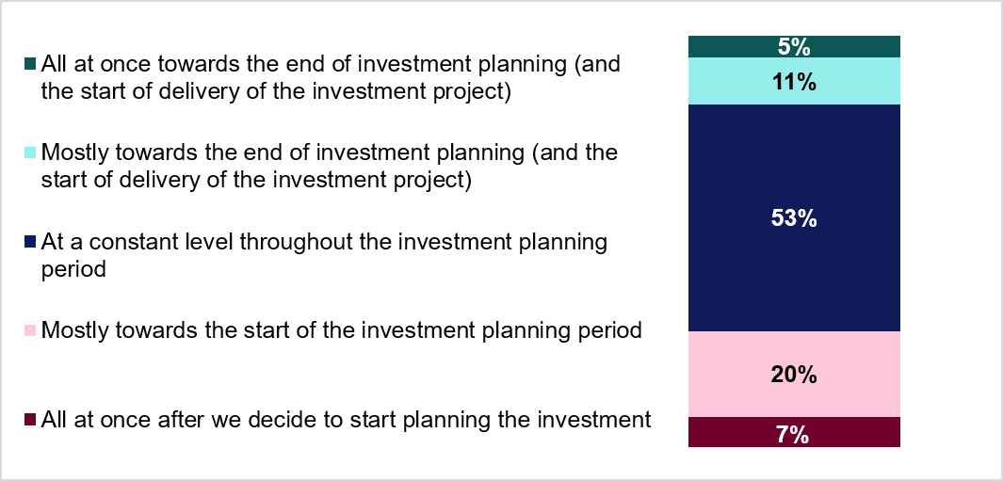
Q_PREDEV_DISTRIBUTION. How do the predevelopment costs tend to be incurred?
Base: All businesses with predevelopment costs in 23 to 24 (n = 543). Do not know or Prefer not to say not charted (n = 10).
The qualitative research further explored when costs were incurred. There was no consistent pattern across the businesses interviewed. Instead, the point at which each business incurred costs varied depending on the project's nature and the business's specific circumstances.
For example, a business explained that it concentrated costs most heavily in the middle of its predevelopment phase. This stage demanded the most resources, primarily staff time, as the project required the business to bring in and coordinate with various internal teams. In this specific case, the immediate team managed the earlier stages with existing resources, which kept costs lower. The business dedicated the final stages to product testing, which also incurred fewer costs. The business explained this was because it used its existing technology for testing, which in turn reduced its need for additional staff resources.
"The initial costs are smaller. There are usually one or two people working on [investment project]. It gets a lot more when you get to design and [generating creative content], then it would drop off again as there are less people working on [the next part].”
Medium size business, Arts, Entertainment and Recreation sector
The survey found that construction businesses were more likely to report incurring predevelopment costs all at once or mostly at the start of the investment planning period (44% compared to 27% overall).
The qualitative research included businesses in the construction sector and those whose investment project involved infrastructure (e.g. building works). For example, one business described the flow of the expenditure being more concentrated at the beginning of the predevelopment phase associated with initial groundwork for clearing a site prior to construction work commencing.
Other businesses described more concentrated expenditure at times aligned with external activities such as contractual processes, seeking regulatory approvals or engaging architect and design services. This meant that the majority of their costs were incurred towards the beginning, as without obtaining these approvals, they were unable to continue with the project.
"Mostly towards the beginning, by the time it is going ahead we wouldn’t really be spending that much money at that point in time. It is more getting groundwork and clearing the site, so early part of the project."
Medium size business, Manufacturing sector
“A lot of it is early and upfront. It depends on who you're dealing with, but a lot of the big costs are architectural designs […] a lot of those costs have been done upfront in terms of having to buy secure properties to make sure that we're well-prepared to be able to move forward when we need to.”
Large size business, Accommodation and Food sector

4.3 Predevelopment costs for investment projects that did not go ahead
Half of businesses reported that their most recent investment project that they proceeded with was in the last year (50%). A further 16% said that it was 1 to 2 years ago. Eight percent of businesses stated that they had not yet proceeded with any investment projects that had incurred predevelopment costs at the time of the survey.
As noted previously, 6% of businesses reported incurring predevelopment costs for an investment project that did not go ahead in the 2023 to 2024 financial year. More broadly, when asked about the most recent occurrence of predevelopment costs for an investment project that did not go ahead, just over a quarter (28%) said this happened in the last year.
The proportion of businesses incurring predevelopment costs for an investment project that did not go ahead in the last year was higher among construction businesses (43% compared to 28% of businesses overall) and businesses whose main predevelopment spend was in the Southwest (48% compared to 28% of businesses overall). It was also higher for businesses that reported the tax treatment of predevelopment costs had a negative impact on investment decisions (46% compared to 28% of businesses overall).
As shown in Figure 4.3, 13% of businesses incurred predevelopment costs for investment projects that did not go ahead in the last 1 to 2 years. By contrast, 34% of businesses said they have never incurred predevelopment costs for a project that did not proceed (i.e. all such projects went ahead).

Figure 4.3 Last time predevelopment costs incurred for an investment project that did not go ahead
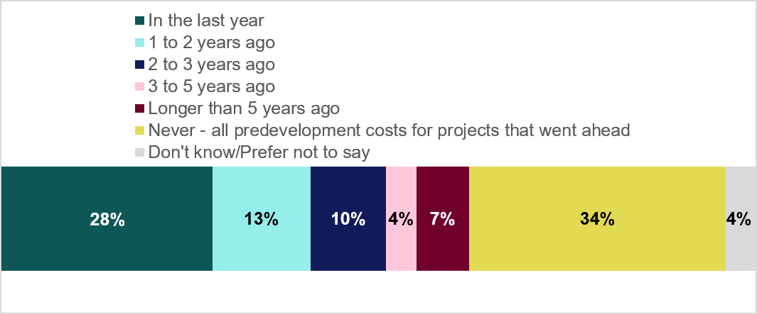
Q_PREDEV_NOINVEST. When, if at all, was the last time your business incurred predevelopment costs for an investment project that did not then go ahead?
Base: All businesses with predevelopment costs in 23 to 24 (n = 543).
On average, businesses deducted 57% (mean) of predevelopment costs for investment projects that did not proceed when calculating taxable profits. This average excludes businesses that answered do not know or preferred not to say. Figure 4.4 shows the distribution of the share which were deducted.

Figure 4.4 Share of predevelopment costs for investment projects that did not go ahead deducted from taxable profits
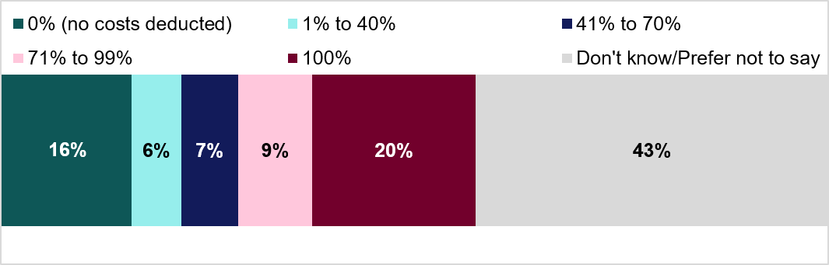
Q_PREDEV_NOINVEST_TAX_NEW. For your total predevelopment costs for investment projects that did not go ahead, approximately what percentage of these costs will not be deducted when calculating taxable profits? Chart reversed to calculate % deducted. *Note this is a new question post-pilot. Mean scores include 0%
Base: Post-pilot businesses that had incurred predevelopment costs for an investment project that did not go ahead (n = 309).
In the qualitative research, businesses were asked how decisions were made regarding whether to go ahead with a project following the predevelopment phase. A range of factors emerged as influencing this decision.

Customer demand
This could be identified either through pre-existing business knowledge or specific market analysis carried out during the predevelopment phase. Confidence in customer demand supported the decision to proceed with further steps in the predevelopment phase and the subsequent delivery phase and reduced the likelihood of investing in a project that would not be commercially viable.
For example, a business in the education sector was looking to build a new residential building to reflect increased student numbers and to meet changing student demographics. The participant noted that being confident in this student demand was the critical factor that justified progressing with the project, as it was the sole consideration in their decision–making.
"It’s not like we’re expending loads on design projects that might not go ahead, that sort of stuff would be limited. We wouldn’t really invest in something that wouldn’t go ahead. We’re not writing off loads of costs."
Medium size business, Manufacturing sector

Securing access to funding and partnerships
Access to investment and funding also played an important role. In order to progress with a project, funding could be essential, particularly for those working in research and development (R&D).
A business in the professional, technical and scientific sector explained that funding and a university partnership were essential to developing an in-house AI model. Without the expertise and financing, they would have struggled to build a model that kept up with market demand.
"Definitely customer demand, and funding, [influence whether we go ahead with the project] because we managed to secure funding from Innovate UK which helped fund costs."
Large size business, Professional, Scientific and Technical sector

Financial health of the business
The financial position of the business such as cashflow availability could influence the decision on whether to go ahead with a project. For example, a business in the transport sector noted how the upfront expenditure of costs could impact cash flow and act as a deterrent.
“I think, like with this current system that we're looking to go on to, we've been more hesitant towards it because of the cash flow effects it has on the business. Because we're having to pay more upfront to even have a development phase. It's definitely put us off looking forwards. Luckily, the CEO and the Managing Director, they are very, sort of, they want the business to grow and that sort of stuff. So, they're quite willing to go ahead with these upfront costs.”
Medium-sized business, Transport

Overall feasibility and viability of the project
This included consideration of how profitable and beneficial the project would be to the business taking into account both cost and timing considerations. For example, for one business, the cost of obtaining the necessary regulatory approvals became too high and time consuming for them to proceed with a planned project.
“The project I just cancelled, what that revolved around was costs for materials, costs for licences of the operator and costs for regulatory approvals from different countries. This was all before any work could be undertaken.”
Micro size business, Education sector
"Belief that we could deliver it in a sensible timeline based on the effort we'd put in to understand what we needed to do. It was the research we'd done about the market and the pricing for it. And then the overall financial viability of it."
Large size business, Professional, Scientific and Technical sector

Outcomes from regulatory requirements
Problems identified during environmental impact assessments or other surveys could prevent projects from going ahead. For example, one business identified structural issues with a building and had to stop the project. Another business described a convoluted process and cost involved in obtaining regulatory approvals for businesses to operate within the EU as an issue.
“We didn't proceed because there was a material issue with the building that came out on the survey.”
Large size business, Construction sector
Across the qualitative interviews, tax treatment of costs did not emerge as a key factor influencing decision making. Businesses’ views on the tax treatment of the predevelopment phase are explored in the next section.

5. Tax treatment of predevelopment costs
This final section of the report covers businesses with predevelopment costs in 2023 to 2024 and their understanding of the tax treatment of those costs. It also explores the types of costs where businesses were more uncertain about tax treatment and the impact uncertainty had on investment decisions. The qualitative analysis examines what influences how businesses understand the tax treatment for predevelopment costs. It looks at when businesses consider the tax treatment and how they engage with professional advice to support them. This section also explores ways to help businesses better understand and manage the tax treatment of predevelopment costs.

5.1 Understanding of the tax treatment of predevelopment costs
In the survey, businesses’ understanding of the tax treatment of predevelopment costs was mixed. As shown in Figure 5.1, 36% agreed and 31% disagreed that they understood the tax treatment of predevelopment costs.

Figure 5.1 Extent to which businesses understood the tax treatment of predevelopment costs
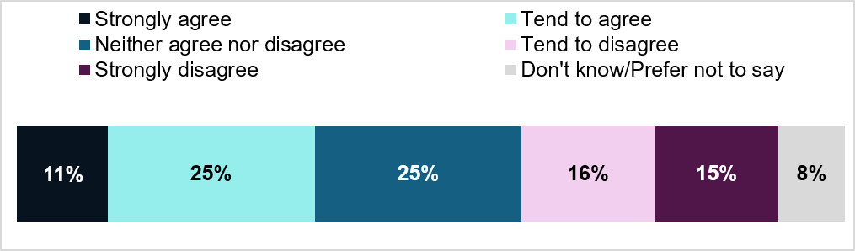
Q_TAX_UNDERSTAND: To what extent do you agree or disagree with the following statement? I understand the tax treatment of predevelopment costs
Base: All businesses with predevelopment costs in 23 to 24 (n = 543).
Half of businesses (50%) reported obtaining professional advice about the tax treatment of predevelopment costs since 2020 to 2021. Those businesses that obtained advice were more likely to agree that they understood the tax treatment of predevelopment costs (43%) than those that did not obtain advice (29%).
Figure 5.2 shows the types of predevelopment costs for which businesses were uncertain about the tax treatment. Uncertainty was highest for project management costs (46%), followed by financial feasibility costs (45%), and environmental impact assessment costs (43%). By contrast, 18% of businesses reported being certain about the tax treatment of all types of cost types.

Figure 5.2 Types of predevelopment costs for which businesses were uncertain about the tax treatment
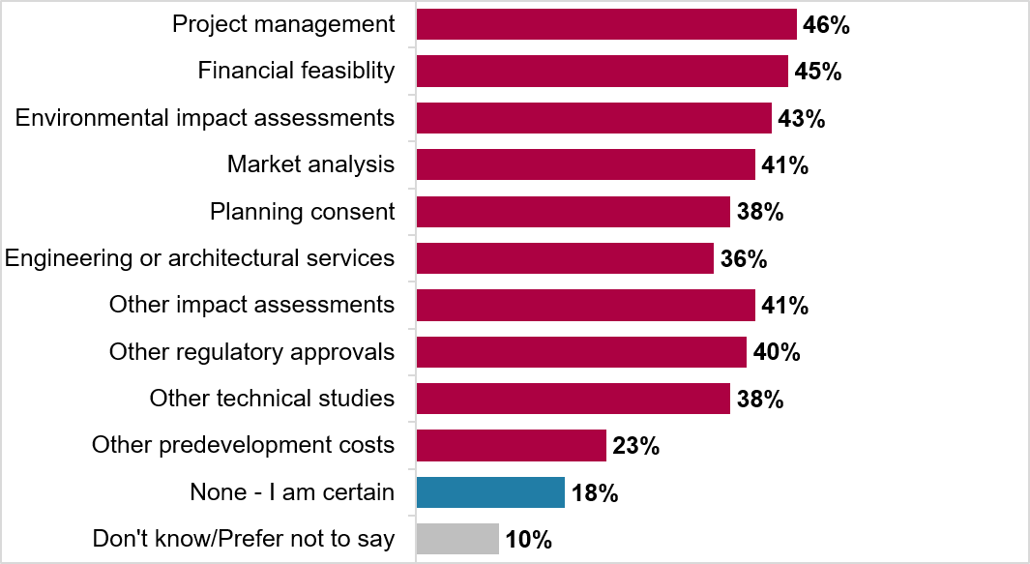
Q_TAX_UNCERTAINTY. Which, if any, types of predevelopment costs are you uncertain about the tax treatment?
Please note that the option to select ‘Other predevelopment costs’ at this question was not available in the pilot, so responses for this code are only represented by mainstage data.
Base: All businesses with predevelopment costs in 23 to 24 (n = 543).
To understand levels of certainty and confidence in tax treatment of predevelopment costs further, participants in the qualitative research were asked to describe their views on this in more detail. Across the qualitative interviews, previous experience, professional involvement, and tax complexity shaped understanding of tax treatments for predevelopment costs. These factors were not discrete, and businesses often described a combination of these factors.
Previous experience played a significant role in building understanding. For example, one participant felt confident in their understanding because they had been in business for around 50 years, had dealt with most aspects of tax treatment and had built experience through running a group of small businesses.
Familiarity with conducting predevelopment phases could also play a role. Businesses in qualitative interviews indicated that regularly dealing with predevelopment costs could lead to greater confidence and clearer processes. For example, a research and development firm described predevelopment work as a core part of their day-to-day business, and they followed a standard process for managing their predevelopment costs.
The level of familiarity with the predevelopment process did not always lead to greater or lesser understanding of tax treatment. Businesses in qualitative interviews indicated that this could be further shaped by engagement with professionals. For example, a business might frequently carry out predevelopment phases of projects, but tax treatment of these costs was managed by an accountant meaning that the participant had limited understanding of how this was handled. Similarly, a business carrying out a one-off investment project might seek predevelopment cost tax advice, increasing their level of understanding.
More broadly, participants reported that seeking professional input from tax agents, accountants and auditors could enable their understanding. This was particularly in relation to directly approaching a professional for advice on how to manage tax treatment and building experience through individual professional development.
For example, a participant described how they built their understanding from a variety of sources including professional development materials, discussions with auditors and professional input from tax agents and accountants.
“There are all sorts of different sources. There's a lot of material that you get because of professional development that you have to keep up to date with... Discussions with auditors and other information that comes through at different times… When we have big projects, we will tend to get our tax advisors to review the connotations [i.e. implications] and to ensure that we can optimise our tax position and our capital allowances.”
Large size business, Accommodation and Food sector
Multiple factors emerged as barriers to understanding the tax treatment of predevelopment costs. A key barrier was the complex nature of the tax treatment of predevelopment costs which could deter businesses from engaging with it. It could also lead to decisions to avoid looking into the tax treatment in more detail with an assumption that the time and cost taken was unlikely to be outweighed by the financial benefit gained.
“I don’t get it [tax treatment of predevelopment costs], I don’t understand it fully and therefore don’t spend time worrying about it.”
Small size business, Construction sector
Keeping up to date with changes to tax rules in general was considered challenging. Businesses described uncertainty around the types of tax treatments that could be applied to predevelopment costs, or how these might differ to other tax treatments.
For example, one business noted that they were unsure how the tax treatment of predevelopment costs applied to the creative industry but felt more confident around creative industry tax credits. Another participant described lack of certainty regarding the difference between predevelopment costs and research and development tax reliefs querying whether there were any specific tax relief options available for predevelopment costs.
Small and micro businesses were particularly likely to mention feeling a lack of support aimed specifically at smaller businesses. For example, a participant raised concerns about the cost of getting advice, and there were also comments about being unsure where to get advice from.
“I think it's hard to find the right advice, because there does seem to be quite a few grey areas… I may have potentially found it quite hard to get the correct advice, because it's not massively advertised out there in the market.”
Medium size business, Construction sector

5.2 Tax treatment applied to predevelopment costs
Across the qualitative interviews, businesses were asked about the tax treatment applied to their predevelopment costs. The tax treatment of predevelopment costs or how they differed from other costs was not always clear. Those who reported not using a specific tax treatment for predevelopment costs typically described a lack of certainty or awareness regarding tax treatments that could be used or what they could claim for. Other reasons given by businesses for not applying a particular tax treatment to predevelopment costs included:
- lack of eligibility including uncertainty around what tax treatment might be available or whether a business might be eligible
- concerns about compliance were also cited as a barrier
For example, one business stated that their accountant had not provided any specific details about the tax treatment of predevelopment costs, so they considered it was not relevant for their industry (the creative sector).
" They [accountant] didn’t provide any further detail about tax treatment of predevelopment costs, in terms of what to do to make it eligible – it just doesn’t fit our business."
Medium-size business, Arts, Entertainment, and Recreation sector
Overall, participants were less clear regarding the tax treatment for predevelopment costs where management of this was delegated to accountants as part of their overall accountancy work for the business.
“I don’t involve myself in any of that [tax treatment of predevelopment costs] so I just hand it over [to the accountant].”
Small size business, Education sector
Where participants did apply a particular tax treatment to predevelopment costs, they described treating these like any other type of investment cost. For example, a business explained that because full-time employees constantly worked on predevelopment activities, the businesses categorised their payroll as standard business costs rather than separating them for specific tax purposes.
Another business explained that their business model revolved entirely around R&D with employees on the payroll for this specific purpose, continually working on the predevelopment of potential investment projects. This meant that there was a department of the business focused solely on predevelopment activities and they claimed R&D tax credits for this business department.

5.3 When the tax treatment of predevelopment costs was considered
During the qualitative interviews participants were asked at what stage during the investment project they considered the tax treatment of predevelopment costs. Responses revealed this was not always considered, with participants reflecting that they did not feel it was a key priority for the business.
Where businesses described other priorities, they centred on those considered to be a current focus and beneficial to the company. Priorities mentioned varied by business and included planning permissions, tourism tax, access to cash and funding, new business generation and maximising intellectual property.
We also heard from businesses that reflected that they simply did not consider the tax treatment of predevelopment costs. These businesses noted that it was not a top-of-mind concern, was delegated to accountants (as part of broader accountancy for the business), or was something not looked into due to concerns regarding compliance. This latter point was noted by a business concerned that because they worked from home, there would be confusion regarding items claimed for business purposes with items for personal use. This was specifically related to the need to purchase residential items, like doors, for prototyping, which made it confusing to know what they could claim for without looking non-compliant.
“We didn’t consider it [predevelopment costs] in the slightest. We genuinely didn’t think about tax in any way, shape or form… We thought vaguely about whether there were any grants available which we then gave up on anyway.”
Micro size business, Professional, Scientific and Technical sector
Where businesses did consider the tax treatment of predevelopment costs, we heard from those who considered it early on during the predevelopment phase as well as those who considered it later.
Businesses that considered tax treatment of predevelopment costs at an early stage described considering tax relief options that might be available. Examples included a business seeking to understand how treatment would work for cross-border work in the EU, a business looking to understand whether they or a company they had commissioned to build an IT product for the company could apply for R&D tax credits, and a business keen to understand what type of tax treatment would be available if a project did not go ahead (noting that costs would need to be absorbed by the company).
The point when businesses considered predevelopment costs varied due to their unique financial and operational situations. In the construction sector, for instance, one business absorbed these costs into their daily operations as a trading overhead. They kept the costs on their books as 'work in progress' right up until the project was developed and sold.
“The predevelopment costs, although they've hit our cash hard, they wouldn't come into any tax consideration until plot sale stage.”
Medium size business, Construction sector
Others took a different approach and waited to deal with predevelopment costs until they prepared their annual tax return, only asking for tax advice when a need for clarification arose. The financial scale of the project played a part as well with a business noting that a much larger investment (they suggested a figure of around £750,000) would have required them to consider the tax treatment of costs far earlier in the process than they normally would.

5.4 Engagement with professionals
As mentioned in section 5.1, 50% of businesses in the survey reported obtaining professional advice about the tax treatment of predevelopment costs since 2020 to 2021. Across the qualitative interviews, three types of engagement with professionals regarding the tax treatment of predevelopment costs emerged:
- No advice sought
- Dealt with by an accountant
- Approached a professional with a specific query
No advice sought
A key reason for not accessing advice regarding the tax treatment of predevelopment costs was that this was not considered or that businesses were not aware of specific tax treatments that were potentially available.
Another reason for not accessing advice was having accessed advice in the past which had informed an approach to tax which had been applied to future similar projects.

Dealt with by an accountant
Where this approach was described by businesses, they reflected that an accountant was responsible for the tax treatment of costs incurred by the business in general which would include costs incurred at the predevelopment stage.
This could include the accountant managing annual tax returns and coverage of tax reliefs and incentives in general as part of business discussions with accountants. These businesses relied on their accountants to optimise their tax position.
“We've got a tax accountant…and when I started the project, I immediately went to them to say, what's the tax implications of this project?”
Micro-sized business, Education sector
Approached a professional with a specific query
Businesses approached professionals when they had a specific query that needed an answer. These queries often focused on the investment project as whole, for example, seeking clarity on tax credits or to ask an expert to sense-check their approach to VAT or corporation tax.
The question of grant eligibility was another reason cited by a business for seeking advice, and there was also mention of seeking advice to help understand whether a business or the company they had commissioned to develop a new IT system were eligible to claim R&D tax credits.
There were instances where businesses found limitations in the professional guidance they sought. For example, a business described that the advice they received had lacked information on relevant tax treatments they might be able to look at or eligibility criteria for these.
Even after seeking help, businesses reflected that advice from accountants and tax advisors was not always perfectly clear. For example, a participant noted that the professional they had contacted for advice had themselves commented that the tax treatment of predevelopment costs was complex. Where participants felt the information was not clear enough, they were left with a sense of uncertainty.
“[The accountant] didn’t provide any further detail about tax treatment of predevelopment costs, in terms of what to do to make it eligible [for tax treatments available for predevelopment costs] it just doesn’t fit our business [as a part of the creative sector]. “
Medium size business, Arts, Entertainment and Recreation sector

5.5 The impact of uncertainty regarding the tax treatment of predevelopment costs on investment decisions
Among businesses with predevelopment costs in the 2023 to 2024 financial year that were uncertain about the tax treatment of predevelopment costs, 38% agreed that this uncertainty affected their investment decisions, whereas the majority (58%) said it did not.
Half of businesses with predevelopment costs in 2023 to 2024 reported that the tax treatment of predevelopment costs had no impact on their investment decisions (51%), while around a quarter stated a negative impact (24%) (see Figure 5.3).

Figure 5.3 Reported impact of predevelopment tax treatment on investment decisions
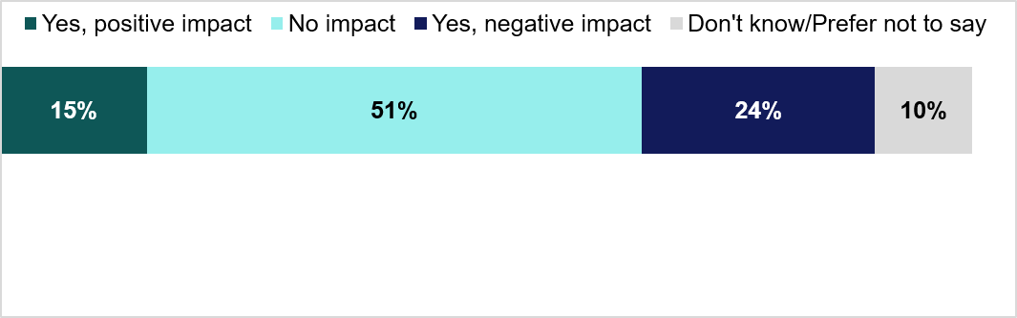
Q_TAX_IMPACT: Has the tax treatment of predevelopment costs had an impact on your businesses' decisions to invest?
Base: All businesses with predevelopment costs in 23 to 24 (n = 543).
Among businesses that agreed that they understood the tax treatment of predevelopment costs, 27% reported a positive impact of that tax treatment on investment decisions, compared with 15% overall.
In the qualitative research businesses were asked for their views on the impact that the tax treatment of predevelopment costs had played in investment decisions. Views focused on the extent to which businesses currently considered it and clarity regarding treatment options.
Where businesses reported that the tax treatment of predevelopment costs had a positive impact on their business this focused on reliefs or incentives that encouraged or enabled further investment or business activities. For example, a business noted that being able to claim R&D credits in turn incentivised them to make more investments.
Where participants reported that the tax treatment of predevelopment costs had no impact on their business, a range of circumstances and priorities were described. For example, one business explained that predevelopment activities were an integral part of its operations, not a separate financial consideration.
Other businesses noted that other factors played a bigger role for their business such as the need to obtain planning permission, the effect of a tourism tax, or the challenge of accessing funding.
“Ultimately, what's going to have perhaps bigger concerns are things like the tourist tax which are coming in.”
Large size business, Accommodation and Food sector
In other instances, a lack of engagement with the tax treatment for predevelopment costs was the reason why the tax treatment did not play a role in their business decisions to invest. For example, one business had not considered the tax treatment because it was not on its radar. Another did not consider it because they did not claim any tax relief. Further factors that could deter consideration of the tax treatment of predevelopment costs were cited by participants and included the complexity of the rules and a fear of non-compliance.
Overall, this lack of understanding and engagement ultimately meant the tax treatment did not play a role in their business decisions.
Businesses that reported the tax treatment of predevelopment costs as having a negative impact on investment decisions cited several reasons. This included a lack of confidence and certainty regarding tax implications and whether they were able to claim relief for these expenditures.
For example, a business noted that when they had to spend money upfront to cover predevelopment costs, it diverted their cash flow reducing their capacity to pursue other business activities during that time. Another business noted that lack of tax relief posed a risk if the investment project did not go ahead, as the business would need to absorb those costs.

5.6 Suggestions for ways to support business understanding and management of predevelopment costs
In the qualitative research participants spontaneously raised and were asked for their views on what could support increased understanding of the tax treatment of predevelopment costs. To address the challenges they faced, participants suggested a range of specific changes. These included the creation of simpler and more consolidated guidance, the introduction of new tax reliefs to reduce financial risk, and a review of existing legislation to better incentivise investment.
The call for clearer guidance came from a need to understand exactly what they could and could not claim, particularly at an early project stage e.g., during predevelopment. They also suggested support for businesses to help them keep up to date with rule changes.
There were also suggestions for measures designed to encourage investment and reduce financial risks associated with taking on an investment project. For example, participants explained that guarantees on tax deductions would make a business feel more comfortable about working on a project that might not ultimately go ahead.
“It would be useful to be able to claim tax credits similar for animation credits for development work when it wasn’t successful – we spend a lot of money on development every year, you’re taking a chance on that. Because of the timeline of when that development happens so then we might not be eligible for the tax credit – good to have something for nondevelopment work that didn’t go ahead. “
Medium size business, Arts, Entertainment and Recreation sector
Participants also identified a need for support targeted at smaller businesses, which they believed might be less likely to invest. To support them, they recommended a review of corporation tax thresholds to incentivise investment and expansion.
There were concerns related to longer-term investments raised including concern that tax treatments might shift over time, and suggestions for simplifying the tax treatment for any costs that spanned multiple tax years.
Focusing on information provision, participants explained that simple and user-friendly information would be key to helping them understand the tax treatment of predevelopment costs. With regards to content, they suggested information tailored to sector, basic and top-level information that was easy to engage with in the first instance, and content written in simple terms that avoided technical jargon. It was also noted that streamlined content that consolidated existing documentation and guidance would be helpful.
“A simple explanation, a simple understanding about it [tax treatment of predevelopment costs] would make me feel a lot more confident rather than having an idea or concept of it.
Small size business, Construction sector
To deliver this information, participants sought practical formats. Suggestions included quick guides and a helpline staffed by accountants rather than chatbots, with minimal waiting times. They also proposed a PowerPoint presentation with human commentary, using illustrations and example scenarios to clarify key concepts. A participant recalled previous face-to-face sessions from several years ago and suggested that this format, tailored to business sector, would be their preferred learning method.
Participants felt that this type of information should be provided by HMRC and considered it important that it be made available free of charge. There was also suggestion for HMRC to provide the information directly to accountants, who could then filter this down to business clients as an additional way to share information.
“Actually, having something in place where small businesses could get proper advice which no one seems willing to do […] The only way you can get it at the moment is by paying very expensive tax advisors.”
Micro size business, Professional, Scientific and Technical sector

6. Annex A – Additional methodological details

Sampling
The sample of businesses was drawn from HMRC’s database of UK corporation tax paying businesses. As the prevalence rate of predevelopment costs among UK corporation tax paying businesses was unknown, the sample design assumed the overall prevalence of businesses with predevelopment costs was 6.5%. Within this, it was assumed that some business sectors were more likely to have predevelopment costs than others, with business sectors that were seen as more likely to have predevelopment costs consequently boosted in the sample design. Large businesses were expected to be more likely to incur predevelopment costs, so all available large businesses were included. This helped to increase the likelihood of achieving a robust base size of ‘businesses with predevelopment costs’, while also ensuring that the prevalence results found in this research could be mapped back to a total sample that was representative of all Corporation Tax paying businesses (regardless of whether they had predevelopment costs or not).. Table A.1 shows the number of records drawn for this research, including both those with business sector details available and the additional set large business records.
Table A.1 Profile of HMRC database of Corporation Tax paying businesses compared to interviews achieved
Organisation type | Number of sample records drawn by HMRC | Number of valid* sample records for fieldwork | % of usable records
Businesses with business sector details available | 168,750 | 99,538 | 59%
Additional set of large businesses | 2,002 | 1,727 | 86%
Total | 170,752 | 101,265 | 59%
* Valid sample means records that had a telephone number and or email address attached to them following contact information matching.
HMRC’s sample included more businesses from certain sectors and more large businesses than their share of the overall population (i.e., it oversampled them). HMRC did this because it expected predevelopment costs to be more common in these groups. However, these groups made up only a relatively small share of all corporation tax-paying businesses. Tables A.2 to A.4 compare the full corporation tax population (by organisation type) with the businesses we interviewed.

Table A.2 Profile of HMRC database by business sector compared to interviews achieved
Sector | All corporation tax paying businesses | Unweighted interview profile
Automotive | 0.1% | 2%
Construction | 12% | 24%
Oil and Gas | 0.1% | 1%
Pharmaceuticals | 0.1% | 3%
Professional, Scientific and Technical | 14% | 14%
Telecommunications | 0.5% | 3%
Transport and Storage | 3% | 5%
Utilities or Renewables | 0.6% | 4%
Agriculture, Forestry, Fishing, Mining and Quarrying | 1% | 1%
Manufacturing | 5% | 8%
Electricity, Gas, Steam Air Conditioning, Water, Sewerage and Waste | 0.1% | 1%
Wholesale and Retail Trade, Repairs | 12% | 8%
Accommodation and Food | 5% | 2%
Information and Communication | 9% | 4%
Financial and Insurance | 4% | 2%
Real Estate Activities | 11% | 5%
Admin and Support Services | 9% | 3%
Education | 2% | 2%
Health and Social Work | 5% | 3%
Arts, Entertainment and Recreation | 3% | 2%
Other Service Activities | 5% | 3%
Total | 100.00% | 100.00%

Table A.3 Profile of HMRC database by business size compared to interviews achieved
Size | All corporation tax paying businesses | Unweighted interview profile
Micro | 70% | 64%
Small | 7% | 15%
Medium | 2% | 3%
Large | 0.4% | 2%
Unknown | 22% | 15%
Total | 100.00% | 100.00%

Table A.4 Profile of HMRC database by English regions and devolved nations compared to interviews achieved
English regions and devolved nations | All corporation tax paying businesses | Unweighted interview profile
East of England | 10% | 11%
East Midlands | 6% | 6%
London | 26% | 22%
Northeast | 2% | 3%
Northwest | 10% | 8%
Northern Ireland | 2% | 2%
Scotland | 5% | 7%
Southeast | 15% | 16%
Southwest | 7% | 8%
Wales | 3% | 3%
West Midlands | 8% | 8%
Yorkshire and The Humber | 6% | 7%
Total | 100.00% | 100.00%

Once the total sample was drawn, it was randomly allocated into three batches: 26,600 records for the pilot stage (which took place from August to September 2025), 100,000 records for the mainstage fieldwork (from January to February 2026) with the remaining 44,152 records kept in reserve. After this random allocation process was completed, valid sample records were drawn specifically to ensure that the fieldwork team only processed records that had either a phone number or an email address and so could be contacted for the survey. This allocated 74,262 valid records altogether to pilot and mainstage fieldwork, with 27,003 valid records left in reserve.

Advance opt-out communication
Before the pilot and the main survey, a letter was sent to every business. The letter explained the research and how to opt out if they did not want Ipsos to contact them. Companies in Wales received this communication in both Welsh and English. A total of 74,262 letters were sent. The opt out period between sending out the advance communication and the start each of the fieldwork stages was 2 weeks and 1,277 businesses opted out altogether, an opt out rate of 2%.

Response rate
Of the 74,262 records that were sent an opt out letter, 25,054 were email-only records as they did not have a telephone number, which left 49,208 to be attempted to be contacted by telephone. Table A.5 outlines the sample outcomes and the adjusted response rate.

Table A.5 Sample outcomes
Outcome | Total
Completed interviews | 4,972
Refusals | 6,006
Wrong number or company out of business | 21,739
Unobtainable or failed to make contact | 3,684
Unknown outcome within fieldwork period | 12,807
Total | 49,208
Adjusted response rate* | 14%
*The adjusted response rate has been calculated as completed interviews or (completed interviews + incomplete interviews + (refusals x eligibility) + (working numbers with unknown eligibility x eligibility))

Data processing, editing, and cleaning
Following fieldwork, data editing and cleaning was undertaken to review any potential data errors or outliers. The top 5% and bottom 5% of responses to numeric questions were examined to review potential errors in the data. Each potential error was then reviewed within the context of the respondent’s other answers and their business data to ensure logical consistency. In instances of telephone interviews, recordings were listened back to, to ensure accurate numeric data input. All data was felt to be consistent or explainable as a result of these checks.
Cases which were greater than four standard deviations away from the mean were flagged to review as outliers. All outliers were kept in the dataset as their responses were determined as logical in relation to other answers and in agreement with HMRC.
Ipsos’ coding team manually coded all “other-specify” responses and where possible, assigned them to the existing code frame. Where at least 5 respondents provided a similar answer outside the coding frame, it was possible for new codes to be added. The accuracy of the coding was verified by the Ipsos research team, who checked and approved each new code proposed. The final code frame was shared with HMRC for final approval.

Weighting
The weighting approach, agreed with HMRC, aimed to ensure the total sample was representative of all corporation tax paying businesses in the UK. The weights were produced using sector, size and region count from HMRC’s database of corporation tax paying businesses. Individual weights were trimmed at the 5th and 95th percentiles across all subgroups to avoid very small or very large weights. Weight trimming caps extreme survey weights to reduce the influence of a few cases on the estimates.

Statistical testing
T tests analysis was applied for statistical analysis across the data at the 95% level of confidence. This test looks at each row of the data table independently and compares pairs of columns to test whether the proportion of respondents in one column is significantly different from the proportion in the other.

Margins of error
The participants in this survey were a sample of the total population of corporation tax paying businesses, so we cannot be certain that the figures obtained are exactly those we would have if all the population had been interviewed (the ‘true’ values).
However, the variation between the sample results and the ‘true’ values can be estimated from the size of the samples on which the results were based on and the number of times that a particular answer has been given. The confidence with which these estimates can be made is typically chosen to be at 95% thus the chances are 95 in 100 that the ‘true’ value will fall within a specified range.
For example, based on a sample of 4,972 businesses, where 50% gave a particular answer, the chances that the ‘true’ value (which would have been obtained if the whole population had been interviewed) will fall within the range of ± 1.9 percentage points from the sample result (i.e., between 48.1% and 51.9%). Table A.8 below outlines business sample sizes and 95% intervals for survey estimates.

Table A.6 Sample sizes and 95% confidence intervals
 | Unweighted base (N) | Weighted base (N) | Effective base (N) | 95% confidence interval for a survey estimate
 |  |  |  | 10% | 30% | 50%
Total businesses | 4,972 | 4,972 | 2,780 | 1.1 | 1.7 | 1.9
Size |  |  |  | + / - | + / - | + / -
Micro (1 to 9 employees) | 3,400 | 3,752 | 2,045 | 1.3 | 2.0 | 2,2
Small (10 to 49 employees) | 841 | 563 | 392 | 3.0 | 4.5 | 4.9
Medium (50 to 249 employees) | 212 | 138 | 87 | 6.3 | 9.6 | 10.5
Large (250+ employees) | 104 | 49 | 38 | 9.5 | 14.5 | 15.9
Sector |  |  |  | + / - | + / - | + / -
Automotive | 98 | 5 | 95 | 5.9 | 9.1 | 9.9
Construction | 1195 | 596 | 985 | 1.9 | 2.9 | 3.1
Pharmaceuticals | 110 | 5 | 106 | 5.6 | 8.6 | 9.4
Professional, Scientific, and Technical Activities | 694 | 692 | 457 | 2.7 | 4.2 | 4.6
Telecoms | 143 | 24 | 131 | 5.1 | 7.8 | 8.5
Transport and Storage | 252 | 152 | 65 | 7.3 | 11,1 | 12.2
Electricity, Gas, Steam Air Conditioning, Water, Sewerage and Waste, Utilities or Renewables | 231 | 35 | 184 | 4.3 | 6.6 | 7.2
Agriculture, Forestry, Fishing, Mining and Quarrying, Oil and Gas | 138 | 66 | 50 | 8.3 | 12.7 | 13.9
Manufacturing | 399 | 238 | 340 | 3.2 | 4.9 | 5.3
Wholesale and Retail Trade, Repairs | 381 | 594 | 343 | 3.2 | 4.8 | 5.3
Information and Communication | 192 | 415 | 178 | 4.4 | 6.7 | 7.3
Real Estate Activities | 229 | 551 | 220 | 4.0 | 6.1 | 6.6
Admin and Support Services, Financial and Insurance Activities | 258 | 589 | 228 | 3.9 | 5.9 | 6.5
Education | 85 | 98 | 70 | 7.0 | 10.7 | 11.7
Health and Social Work | 158 | 248 | 133 | 5.1 | 7.8 | 8.5
Arts, Entertainment and Recreation, Accommodation and Food | 198 | 353 | 165 | 4.6 | 7.0 | 7.6
Other Service Activities | 211 | 309 | 158 | 4.7 | 7.1 | 7.8

Table A.7 Sample sizes and 95% confidence intervals for businesses who incurred predevelopment costs in 2023 to 2024
 | Unweighted base (N) | Weighted base (N) | Effective base (N) | 95% confidence interval for a survey estimate
 |  |  |  | 10% | 30% | 50%
Total businesses with predevelopment costs in 2023 to 2024 | 543 | 459 | 258 | 2.5 | 3.9 | 4.2

Qualitative interviews
Areas for qualitative exploration and related sampling were identified based on findings from the pilot stage of the quantitative survey and a workshop with HMRC.
Primary quotas for the qualitative interviews were set to ensure the interviews included a range of predevelopment cost experiences including:
- a spread of business spends on predevelopment costs for the accounting period ending in 2023 to 2024
- those who had and had not sought professional advice about the tax treatment of predevelopment costs
- those who reported that they did and did not understanding the tax treatment of predevelopment costs
- those who said that the tax treatment of predevelopment costs either had or had not impacted business decisions
Secondary quotas were set based on business characteristics to ensure a mix of business type, location, turnover and size.
Table A.10 sets out the sample achieved against recruitment criteria.

Table A.10 Sample achieved for qualitative fieldwork
Recruitment criteria | Feature | Achieved
Predevelopment costs | Accounting period after 2023 to 2024 | 7
Predevelopment costs | Accounting period 2023 to 2024 | 19
Predevelopment costs | Accounting period from before 2023 to 2024, after 2020 to 2021 | 8
Business size | Micro business (1 – 9 employees) | 4
Business size | Small business (10 – 49 employees) | 4
Business size | Medium business (50 – 249 employees) | 7
Business size | Large business (more than 250 employees) | 5
Business turnover | Less than £90,000 | 1
Business turnover | £90,000 to less than £250,000 | 1
Business turnover | £250,000 to less than £1 million | 4
Business turnover | £1 million to less than £10 million | 7
Business turnover | £10 million or more | 7
Approximate business spends on predevelopment costs for their accounting period ending in 2023 to 2024 | Less than £50,000 | 9
 | £50,000 to less than £150,000 | 5
 | £150,000 to less than £250,000 | 2
 | £250,000 to less than £500,000 | 2
 | £500,000 to less than £1 million | 1
Obtained professional advice specifically about the tax treatment of predevelopment costs since the accounting period ending 2020 to 2021 | Yes | 13
 | No | 7
Understanding of tax treatment of predevelopment costs | Strongly agree | 3
Understanding of tax treatment of predevelopment costs | Tend to agree | 7
Understanding of tax treatment of predevelopment costs | Neither agree nor disagree | 2
Understanding of tax treatment of predevelopment costs | Tend to disagree | 3
Understanding of tax treatment of predevelopment costs | Strongly disagree | 4
Whether the tax treatment of predevelopment costs had an impact on decisions to invest | Yes, a positive impact | 3
 | Yes, a negative impact | 5
 | No impact | 11
Business location | Northwest England | 1
Business location | Yorkshire & Humber | 1
Business location | East Midlands | 1
Business location | West Midlands | 1
Business location | East of England | 1
Business location | Southeast England (excluding London) | 4
Business location | Southwest England | 3
Business location | London | 5
Business location | Scotland | 2
Business location | Wales | 1
Business sector | Accommodation and Food | 1
Business sector | Arts, Entertainment and Recreation | 1
Business sector | Construction | 3
Business sector | Education | 3
Business sector | Health and Social Work | 1
Business sector | Information and Communication | 2
Business sector | Manufacturing | 2
Business sector | Oil and Gas | 1
Business sector | Professional, Scientific and Technical | 3
Business sector | Real Estate | 1
Business sector | Transport and Storage | 2

Please note that pilot participants were asked this question generally, and not since the accounting period 2020 to 2021, so it is possible that respondents from the pilot may be considering professional advance obtained prior to 2020 to 2021, or only for the accounting period 2023 to 2024.

