
Final Order Decision
Papers on file
By Harry Wood BA (Hons) MA PhD MIPROW
an Inspector appointed by the Secretary of State for Environment, Food and Rural Affairs
Decision date: 19 October 2026

Order Reference: ROW/3370318M

- This Order is made under Section 53(2)(b) of the Wildlife and Countryside Act 1981 and is known as The Northumberland County Council Definitive Map Modification Order (No 24) 2016 Byway Open to All Traffic No 155 and Restricted Byway No 160 (Parish of Allendale).
- Northumberland County Council submitted the Order for determination to the Secretary of State for Environment, Food and Rural Affairs.
- The Order is dated 28 November 2016 and proposes to modify the Definitive Map and Statement for the area by adding a byway open to all traffic and upgrading a public footpath to a restricted byway, as shown on the Order Plan and described in the Order Schedule.
- In accordance with paragraph 8(2) of Schedule 15 to the Wildlife and Countryside Act 1981, notice has been given of my proposal to confirm the Order with modifications.

Summary of Decision: The Order is confirmed subject to the modifications set out in the Formal Decision.

Procedural Matters
- The effect of the Order, if confirmed with the modifications I previously proposed, would be to record the full length of the Order Route (between points A and D on the Order Plan) as a byway open to all traffic.
- In my interim decision dated 29 June 2026, I proposed to confirm the Order subject to the modifications described in paragraph 1 above. As the modifications proposed in my interim decision would show as a highway of one description a way which is shown as a highway of another description in the Order as submitted, I was required by virtue of paragraph 8(2) of Schedule 15 to the Wildlife and Countryside Act 1981 to give notice of my proposal to modify the Order and to give an opportunity for objections and representations to be made to the proposed modifications.
- No objections were received following advertisement of the notice and deposit of the associated documents relating to the proposed modifications.

Conclusion
- Bearing in mind the above, I conclude that the Order should be confirmed subject to the modifications set out in paragraph 39 of my interim decision dated 29 June 2026.

Formal Decision
- I confirm the Order subject to the following modifications:

In the Order Schedule

● Delete Part I under ‘Footpath No 26’ and ‘Footpath No 30’;

● Change all references to ‘restricted byway’ to ‘byway open to all traffic’;

On the Order Plan

● Amend the map as shown in red.

Harry Wood

INSPECTOR

Order Plan (not to scale)

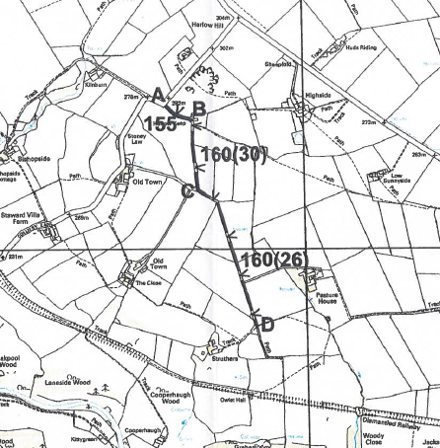
V
V
V
V
V
V

