

Order Decision
Inquiry opened on 8 September 2026
by K Taylor BSc (Hons) PGDip MRTPI
An Inspector appointed by the Secretary of State for Environment, Food and Rural Affairs
Decision date: 28 September 2026

Order Ref: ROW/3366900
- This Order is made under Section 53(2)(b) of the Wildlife and Countryside Act 1981 and is known as the Worcestershire County Council Addition of Footpath NC-574, North Claines, Modification Order 2024.
- The Order is dated 13 June 2024 and proposes to modify the Definitive Map and Statement for the area by adding a footpath as shown in the Order plan and described in the Order Schedule.
- There was 1 objection outstanding when Worcestershire County Council submitted the Order to the Secretary of State for Environment, Food and Rural Affairs for confirmation.
Summary of Decision: The Order is confirmed subject to modifications set out in the Formal Decision.

Preliminary Matters
- I have found it convenient to refer to the points marked on the Order Plan and therefore I have attached a copy of it to this decision. I conducted an unaccompanied site visit on Tuesday 25 August 2026, during which I walked the Order route and connecting roads. I carried out an accompanied site visit with the objector and a representative from the Council. The primary purpose of the accompanied site visit was to measure the narrowest sections of the Order route.

The Main Issues
- The Order has been made having regard to section 53(3)(b) of the Wildlife and Countryside Act 1981 (the 1981 Act). This requires me to consider if the enjoyment by the public of the Order route during a period of time raises a presumption that it has been dedicated as a public path.
- User evidence was submitted in support of the Order which relies on the presumption of dedication arising from tests laid out in section 31 of the Highways Act 1980 (the 1980 Act). This requires me to consider if the public have used the route as of right and without interruption, for a period of twenty years immediately prior to its status being brought into question.
- I must establish the date when the public’s right to use the Order route was brought into question and then I must determine if use by the public occurred for a 20-year period prior to this that is sufficient to raise a presumption of dedication. If this is the case, I must then consider if there is sufficient evidence that there was no intention on the part of the landowner to dedicate a public footpath during this period.

Reasons

Bringing into Question
- In 2017, the Officers and Committee of the Fernhill Heath and District Memorial Club (the Memorial Club) agreed to relinquish their rights to what they refer to as a ‘private right of way’ linking the hall’s car park and Sling Lane. The written evidence indicates that access between the hall car park and Sling Lane was denied to members of the public in about April/May 2017. The precise date on which access was denied was not known, and the Council took this to be 1 May 2017. This was not challenged by the objector prior to the opening of the Inquiry. Accordingly, the relevant 20-year period would be 1 May 1997 to 1 May 2017.
- At the Inquiry the objector raised 2 other issues which could mean that the use of the Order route was brought into question at earlier dates, albeit it was framed as potential interruptions to use. The objector stated that the fence, which blocked the Order route, was erected in late March 2017 and that various signs, asserting that the path was not a public footpath were erected, the first being in January 2017. No corroborating evidence of these matters was provided, such as dated photographs or receipts or invoices related to the purchase of fencing materials or signage. However, if the objector is correct on these matters the date of bringing into question would be a little earlier, making the earliest January 2017 and so the relevant 20-year period would be January 1997 to January 2017.

Analysis of Use
- Two separate applications were made to seek a modification to the Definitive Map and Statement (DMS). One application included only a portion of the route, between Sling Lane and the car park, with the other including the whole length of the route. In total 35 user evidence forms were provided.
- Given that the section of the Order route between Ciguena and Lyndale can only be accessed through the car park and access drive for the Memorial Club, it is reasonable to assume that the forms relating to the shorter route included a journey along the whole of the Order route. Some individuals submitted forms for both applications, with the forms representing 33 unique users. Of these, 5 users described their use as being private and, as such, it would have been with permission rather than ‘as of right’; therefore, these users should be discounted.
- There is a record of an interview with a local resident and user. This user considered that the route was private and he only used it with permission. As such, his use should be discounted. However, this did not appear to be a widely held view, given the weight of evidence from other users who considered that the Order route was a public right of way.
- Some users report use of the Order route (or part of it) to visit the Memorial Club and also for journeys unrelated to a visit to this building. Where their use included a visit to the building, this would be for private purposes with permission and so not as of right. Even for those who were members of the Club, there is no evidence to indicate that they had permission to use the route through the car park as a shortcut for other purposes. As such I do not consider it appropriate to discount all use of the Order route by club members. There are other users who report using the route only for other purposes with no indication that they ever used the route to visit the club, which indicates that their use was always as of right.
- There are only a small number of properties in Sling Lane, and so journeys by residents using the Order route to visit shops and other facilities in the village would likely be relatively limited. There is a public footpath which continues south from the end of Sling Lane and the Order route would cut a corner and allow a user to avoid walking along a section of a main road (Droitwich Road). It is therefore very plausible that the Order route was also used as part of recreational journeys, such as for dog walking, by those who were not residents of Sling Lane.
- The user evidence forms indicate that there was regular use of the route over the entire relevant period, with many reporting daily, weekly, or monthly use. At the Inquiry 3 local residents gave evidence of their use of the route, including the occupier of Ciguena to the immediate northwest of the Order route. Regardless of whether the date for the start of the relevant period was May, March or January 1997, this would have no substantive effect on the numbers of users as several report using the route from considerably prior to 1997.
- The objector’s property has a living room with large windows to the front and side which are close to the Order route and part of the garden is immediately adjacent to it. His evidence was that he did not see or hear people regularly use the Order route.
- Taking the evidence in the round, it does indicate that the Order route has been used as of right, for the full length of the relevant period and before it. While the degree of use may not have been very high, the numbers of individuals and the level of use would be sufficient to bring home to a non-absentee landowner that the public were asserting their right to use the route as a footpath.
- There are reports of people using the Order route to demonstrate against its closure. As these events would have occurred after the relevant period, they are not relevant to considering the level and nature of use of the path during it.

Interruptions to Use
- The erection of signage in January 2017, or the construction of fencing blocking the Order route in March 2017, would not constitute an interruption to the use of the Order route, but rather it would bring its use into question at a slightly earlier date.
- There is annual growth of vegetation along the boundary which, according to the objector, renders the path impassable each year, thus resulting in an interruption to its use. Vegetation growth may have made the path less easy to use at certain times of the year, but there is no evidence that it was so dense that it was impassable. The evidence from the user evidence forms and that heard at the Inquiry did not suggest that the use of the Order route was only seasonal. The growth of boundary vegetation did not result in an interruption to the use of the Order route.

Lack of Intention to Dedicate
- On the User evidence forms, there are several reports of a sign appearing in 2017 stating that the route was not a footpath. This is when the route was brought into question, and it does not suggest a lack of intention to dedicate the path at an earlier time.
- One user evidence form suggests there were signs between 2002 and 2017 stating ‘no public right of way’. This user noted that they were regularly removed by vandals. This is the only report of signage at this early date, and the objector and landowner of part of the Order route does not claim that such signs were in place. The weight of the available evidence indicates that signage, prior to early 2017, was not in place to indicate a lack of an intention to dedicate.
- In the past a barrier was erected within the grounds of the Memorial Club close to Droitwich Road. However, none of the user evidence forms indicate that it was a barrier to pedestrian use, with the suggestion being that there was sufficient room for a pedestrian to pass the barrier. The barrier is no longer in place. At the Inquiry the evidence given was that, when it was present, it was almost always kept in the open position. This barrier did not indicate a lack of an intention to dedicate the path.
- There is evidence that in the early 1970s a previous owner of Lyndale had a dispute with the Trustees of the Memorial Club and was alleged to have blocked the accessway from Sling Lane to Yew Tree Cottage. Ultimately there was an injunction issued by the County Court to prohibit the blocking of the access. This dispute relates to private rights only and it falls well outside the relevant 20-year period and so it is not relevant.

Documentary Evidence
- The Ordnance Survey (OS) map from 1885 shows a route from what is now Sling Lane which appears to be in the location of section A-C of the Order route. The 1927 OS map includes the Memorial Hall building. Section A-C of the Order route is shown but there does not appear to be a link through to the land at the side of the hall and onto Droitwich Road. On the OS map from 1971 Woodside and Ciguena are present, but not Lyndale. Section A-C is shown and then a dashed line, approximately section C-D heading towards the southern wall of the hall. The 1991 OS map shows Lyndale. The route (approximately section A-B) is not clearly shown. A parcel of land, approximately section B-C is visible with a dashed line roughly representing section C-D.
- A sale notice and plan for Yew Tree Cottage from 1971 notes that ‘The Cottage is situated south of the Memorial Hall and is approached by a right of way coloured yellow on the Plan which is included in this lot’. The Plan appears to be based on the 1927 OS map with the route, approximately section A-C, coloured yellow.
- Most of the OS maps indicate that a route approximately aligning with sections A-C of the Order route has physically existed since at least 1885. It appears to have provided access to Yew Tree Cottage, the curtilage and an orchard surrounding it, as well as a parcel of land which is now incorporated into the Memorial Hall car park. Since 1971 there is an indication of a link between this access track and the curtilage of the hall.
- Since the late 19th century, OS maps have carried a disclaimer stating that tracks and paths shown provide no evidence of public rights. Nevertheless, these maps indicate the physical existence of the parts of the claimed route which were shown on these maps at the time the relevant survey was undertaken. The documentary evidence indicates that a link from Sling Lane to the curtilage of the hall has existed, however, there is not sufficient documentary evidence to indicate that, on this evidence alone, the route had become dedicated as a public highway.
- The case for the making of the Order is not based on documentary evidence. However, as the documentary evidence indicates the longstanding existence of a route, predating the relevant period, it indicates that use of the route over many decades is plausible, and this corroborates the user evidence.

Conclusions on Section 31
- Taken as a whole, I conclude that there is sufficient evidence of 20 years use as of right, without permission, force, secrecy or challenge to demonstrate, on the balance of probabilities, presumed dedication. This is the case whether the relevant period starts in January, March or May 1997. There is insufficient evidence to show a lack of intention to dedicate. The evidence is sufficient to raise a presumption of dedication of public footpath rights over the Order route.

Width of the Order Route and Modifications to the Order
- The Order refers to the section of the route between point A and B as having a minimum width of 0.9m. This was measured with the parties at the site visit and the minimum gap between the boundary wall and a concrete fence post was 0.72 metres. To ensure accuracy, the Order should therefore be modified accordingly. As this would not result in any additional land being affected, there would be no prejudice as a result of this amendment, and further notification is not required.
- The Order refers to both sections 53(3)(b) and 53(3)(c)(i) of the 1981 Act and directly quotes only the legislative provisions for section 53(3)(c)(i). Although there is overlap between these provisions, the Council confirmed that the Order was primarily made with regard to section 53(3)(b). As such, it is prudent to modify the Order to only refer to section 53(3)(b) and quote the relevant legislative provision. As both sections were quoted in the Order as made, there would be no prejudice in amending the Order in this manner, and further notification is not required.

Other Matters
- The objector has referred to 2007 guidance from the Department for Environment Food and Rural Affairs (DEFRA). This advises on dealing with cases where there is little, if any, documentary or user evidence as to the width of the route. It suggests that Councils should take account of physical features and that they should bear in mind that such a width should be the minimum necessary for the reasonable exercise of public rights in these circumstances, enough for 2 users to pass in comfort, occasional pinch points excepted.
- As set out within this guidance letter, Definitive Map Modification Orders do not create rights, but merely record them. In this case, where the Order route passes between Lyndale and Ciguena, there are clear physical features, the boundary wall and fencing, which aid with identifying the width of the path. There was some evidence given at the Inquiry that this section of the route was wider in the past, before the existing fencing at the side of Lyndale was installed in around 2000. The current boundaries therefore indicate the available and used width of the Order route over the majority of the relevant period.
- The width of this section of the Order route may be narrower than is ideal, but it is not so narrow that its use over the relevant period was implausible. Given that this section of the Order route is straight, it is likely that, if 2 users wished to use the route, heading in opposite directions, one user would wait at one end, allowing the other to pass first. The 2007 DEFRA guidance does not, and cannot, indicate that Definitive Map Modification Orders can never be made for routes with sections where 2 users could not comfortably pass. Such Orders need to record the width that has been used throughout the relevant period.
- Reference has also been made to minimum widths referred to in Schedule 12A of the Highways Act 1980. This relates to the powers a Highway Authority has in relation to interference with highways; it is not relevant to how a width should be recorded as part of Definitive Map Modification Orders.
- Part I of the Order Schedule refers to the right of way being the ‘full width’ between the boundaries. Concerns were raised regarding the meaning of this, for example could it be interpreted to mean a width given in a guidance document. The plain reading of the Order is that it is the width between the existing boundary treatments for Ciguena and Lyndale and with the Order corrected to give the appropriate minimum distance, it will provide clarity as to the extent of the width of the path.
- Two separate applications were made for the addition of the Order route to the DMS, one of which was made by the Parish Council. There was an earlier application made by the Parish Council which was found to be invalid. A revised application was subsequently submitted and accepted as valid by the Council. It appears that the user evidence forms which formed part of the invalid application were then submitted as part of the revised application, and the objector considers that these should be discounted.
- Section 53 of the 1981 Act requires the Council to make an Order modifying the DMS where public enjoyment of a path raises a presumption that the way has become dedicated as a public path. Whether user evidence forms were gathered as part of an earlier, rejected, application is not relevant and all evidence of public enjoyment of the route should be considered. In this case, all the forms relate to the Order route, or part of it, and so they must be taken into account.
- The Order route includes a section of unregistered land. This has now been confirmed to be within the ownership of the Memorial Club who were notified about the Order.

Conclusion
- Having regard to these matters, and all other matters raised at the Inquiry and in the written representations, I conclude that the Order should be confirmed, subject to modifications.

Formal Decision
- I confirm the Order subject to the following modifications:
- Within the opening paragraph of the Order:
  - Delete the “s” at the end of the word “Sections”
  - Delete “and 53(3)(c)(i)”
  - Delete “the discovery by the authority of evidence which (when considered with all other relevant evidence available to them) shows that a right of way which is not shown in the map and statement subsists or is reasonably alleged to subsist over land in the area to which the map relates, being a right of way such that the land over which the right subsists is a public path.”
  - After “namely, ” insert: “the expiration, in relation to any way in the area to which the map relates, of any period such that the enjoyment by the public of the way during that period raises a presumption that the way has been dedicated as a public path.”
- Within Schedule Part I
  - Delete “0.9” and replace with “0.72”.

K Taylor

INSPECTOR

Modifications made to the Order
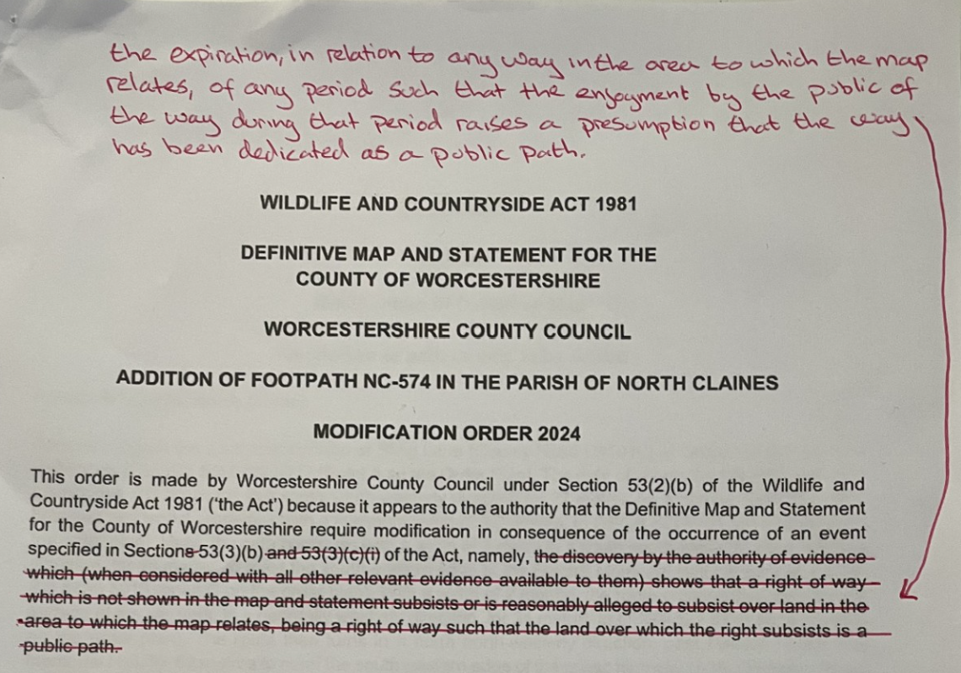

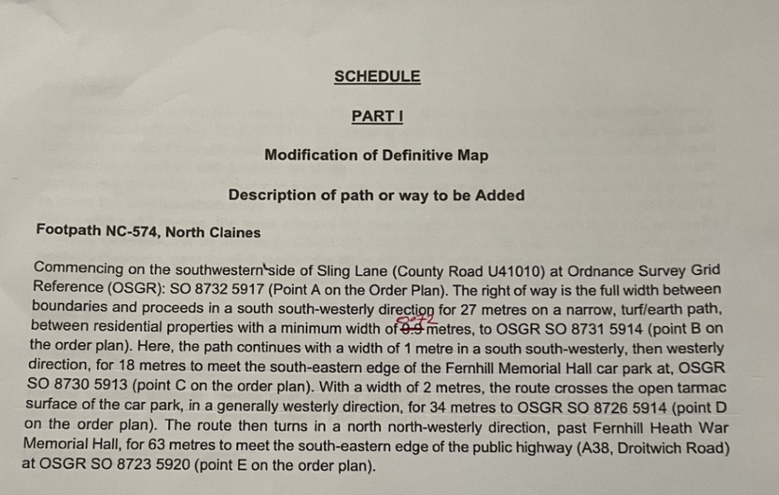

APPEARANCES

In Support of the Order

Ms Saravanan Counsel for Worcestershire County Council

Who called:

Mr Kerby Public Rights of Way Mapping Officer, Worcestershire County Council
Mrs Harris Local Resident

Others in Support of the Order

Mr Wood Local Resident
Mr Harris Local Resident
Mr Challoner North Claines Parish Council

Objecting to the Order

Mr Foster Landowner and Objector

DOCUMENTS PRODUCED AT THE INQUIRY

- Measurements of the width of parts of the Order route

Copy of Order Plan (not to scale)

