

Order Decision
Site visit made on 7 October 2026
by Harry Wood BA (Hons) MA PhD MIPROW
appointed by the Secretary of State for Environment, Food and Rural Affairs
Decision date: 19 October 2026
Order reference: ROW/3347437
- The Order is made under section 118 of the Highways Act 1980 and is known as the Public Bridleway U16 (Part) and Public Footpath U17 (Part) Huit Farm, Earl Shilton Borough of Hinckley and Bosworth Public Path Extinguishment Order 2021.
- The Order is dated 28 January 2021 and proposes to extinguish the public rights of way shown on the Order Plan and described in the Order Schedule, and to amend the definitive map and statement accordingly.
- There were two objections outstanding when Leicestershire County Council submitted the Order to the Secretary of State for Environment, Food and Rural Affairs for confirmation.
Summary of Decision: The Order is confirmed.

Preliminary Matters
- I have found it convenient to refer to points marked on Plan 2545P and have attached a copy of it to this decision. I have also added to the existing annotations (in red), to which I will refer throughout the decision. This plan was produced by the order making authority (Leicestershire County Council, hereafter the OMA) at my request. It is not a legal document and has been included here solely for the purpose of reference. I have also attached a copy of the Order Plan.
- In reaching a decision on the Order, regard must be had to any material provision contained in a rights of way improvement plan (ROWIP) for the area under section 119(6A) of the Highways Act 1980 (the 1980 Act). Other relevant factors are not excluded from consideration and could, for instance, include those pointing in favour of confirmation.
- The Government guidance on diversion or extinguishment of public rights of way that pass through private dwellings, their curtilages and gardens, farmyards and industrial or commercial premises (also known as the Presumptions Guidance) was issued by Defra in August 2023. It states that I should weigh the interests of the owner against the overall impact of the proposals on the public as a whole. Reducing or eliminating the impact of the existing rights of way on the owner, in terms of privacy, security and safety are important considerations to which due weight should be given.
- In considering the current alignment of Bridleway U16 and Footpath U17, I will disregard any artificial or temporary circumstances preventing or diminishing use of the existing rights of way and apply the above tests as if the legally recorded lines were open and available for use.

Main Issues
- Section 118(2) of the 1980 Act sets out what must be taken into account when considering a public path extinguishment order. If I am to confirm the Order, I must be satisfied that it is expedient to extinguish the route, having regard to:
- the extent to which it appears that the path or way would, apart from the Order, be likely to be used by the public; and
- the effect that the extinguishment of the path or way would have as respects land served by the path or way, account being taken of the provisions as to compensation.
- I have had regard to the judgments of R v SSE ex parte Stewart [1980] KPL 537 and R v SSE ex parte Cheshire County Council [1991] JPL 537 which clarified the relevant tests to be applied. Whilst the OMA must consider the need for the route when making an Order, I must consider its likely future use.
- The Order relates to proposals concerning several public rights of way in the vicinity of Huit Farm, to the south of Earl Shilton. These proposals aim to divert Footpath U17 and Bridleway U16, which both currently run between points A and C. The diversion would see Bridleway U16 rerouted to the west (between points A and F) linking up with the public carriageway Breach Lane, with Footpath U17 also being diverted westwards (between points D and E).
- The Order was submitted to the Inspectorate alongside a linked Creation Order (known as the Public Bridleway U16 (Part) and Public Footpath U17 (Part) Huit Farm, Earl Shilton Borough of Hinckley and Bosworth Public Path Creation Order 2021). This Order was rejected by the Inspectorate due to a fundamental error in its drafting. Rather than remaking the flawed Creation Order, the OMA proposed that a deed of dedication, “where the intended new public rights are created by express dedication under common law”, would serve the same purpose. This document is entitled “Deed of Dedication of Public Bridleway U16 (part) Public Footpath U17 (part) on land at Earl Shilton in the Borough of Hinckley and Bosworth and in the County of Leicestershire”. It is dated 15 October 2026 and has been formally sealed by the OMA. The Deed includes a clause (paragraph D) that states it only takes effect at the point the relevant Extinguishment Order is confirmed. The OMA compare the Deed of Dedication directly to the Creation Order, describing it as “simply a different way of giving effect to those intentions”.
- Section 118(5) of the 1980 Act states that where “proceedings preliminary to the confirmation of the public path extinguishment order are taken concurrently with proceedings preliminary to the confirmation of a public path creation order”, the Secretary of State “may have regard to the extent to which the public path creation order […] would provide an alternative path or way.” This provision makes no reference to using deeds of dedication in an equivalent manner, and I am not satisfied that the legislation allows for what are distinct legal documents to be approached as interchangeable. However, the existence of the Deed of Dedication is clearly of direct relevance to the matter in hand, and I am satisfied that I can take it into account while reaching my decision.

Reasons

The extent to which it appears that the footpath and bridleway would, apart from the Order, be likely to be used by the public
- When I visited the site in October 2026 I walked the full length of the existing bridleway (between points C-B1-B-A). While there was a faintly trodden route on the ground, there was minimal evidence of public use, perhaps in part because of the lack of signage and waymarkers. I also walked between points D to E and A-G-E, so as to trace the routes referred to in the Deed of Dedication. There is currently no way of accessing Breach Lane at point E, meaning that I had to follow the field boundary to a field gate near point F. I did not walk the existing footpath between points C and B, as it crossed a ploughed field with no obvious presence on the ground, but I was able to view it from various vantage points.
- The OMA highlight that there is no public right of way recorded between points C and D. This appears to be a longstanding anomaly in the local public rights of way network that the Extinguishment Order and Deed of Dedication would resolve. While a degree of use seems to have been tolerated by the landowner between points C and D, I have no evidence before me concerning the extent of this use and nothing suggesting that it was as of right in nature. As it stands, Bridleway 16 and Footpath 17 effectively reach a cul-de-sac at point C.
- The OMA contend that the Deed of Dedication creates suitable alternatives to the existing footpath and bridleway. They note the support of Leicestershire & Rutland Bridleways Association, who suggest the Order and Deed “resolves a complicated situation relating to the ‘critical gap’ [between points C and D]”. I am satisfied that the Deed of Dedication will secure appropriate alternative public access in the vicinity of Huit Farm, as illustrated by Plan 2545P.

The effect that extinguishment of the footpath and bridleway would have as respects land served by the footpath and bridleway, account being taken to the provisions as to compensation
- The existing footpath and bridleway cross land entirely in the ownership of the Applicant. The Applicant has sought an extinguishment primarily for reasons of farm security, raising concerns about irresponsible dog walkers and highlighting an incident where a farm cat was killed.
- One of the objectors emphasises that neither Footpath U17 nor Bridleway U16 pass directly through the farmyard of Huit Farm. Although this is accurate, both routes terminate at a location immediately adjacent to the farmyard (point C).

Rights of Way Improvement Plan (ROWIP)
- The OMA have provided extracts from the relevant ROWIP, highlighting several paragraphs including one relating to “missing links” and “anomalies”. Anomalies are defined in the attached glossary as “inconsistencies on the Definitive Map, such as legal gaps where rights of way meet public roads”. I am satisfied that the gap between points C and D appears to represent the sort of anomaly the ROWIP aims to rectify, and that the proposed Extinguishment Order and Deed of Dedication are consistent with the aims of this theme.

Conclusions
- If the Order is not confirmed, public use of the relevant sections of Footpath U17 and Bridleway U16 is likely to remain low. The extinguishment would benefit the Applicant and their land, reducing interaction between users and farm animals. The Order would also be consistent with the shared extracts of the OMA’s ROHIP insofar as it seeks, in conjunction with the Deed of Dedication, to address and rectify anomalies across the public rights of way network. I am therefore satisfied that it is expedient to confirm the Order.

Other matters
- The objectors raise various concerns about the A-G-E route, including its drainage in comparison to the existing routes and the proximity of the A47 between points A and G.
- Both the existing bridleway (between points A-B-B1-C) and the proposed bridleway (between points A-G-E) are field edge routes, running along grass strips adjacent to agricultural fields. When I visited the site the routes had similar gradients and comparable conditions underfoot. While the condition of both routes may suffer during prolonged periods of heavy rain, there is no evidence before me to suggest that the drainage along the existing bridleway is markedly superior to that along the proposed route.
- The section of the proposed bridleway between points A and G is close to the A47 and the traffic noise is not insignificant. One objector suggests that the volume of noise may make the proposed route dangerous for horse riders. Though I accept that some horses may find the proposed route unnerving, I note that the northern continuation of Bridleway U16 continues to run adjacent to the A47 for some distance, before turning west under the road towards the sewage works. It seems likely that prospective riders will be aware that this network of bridleways runs parallel to a major trunk route and will plan accordingly.

Formal Decision
- I confirm the Order.

Harry Wood

INSPECTOR

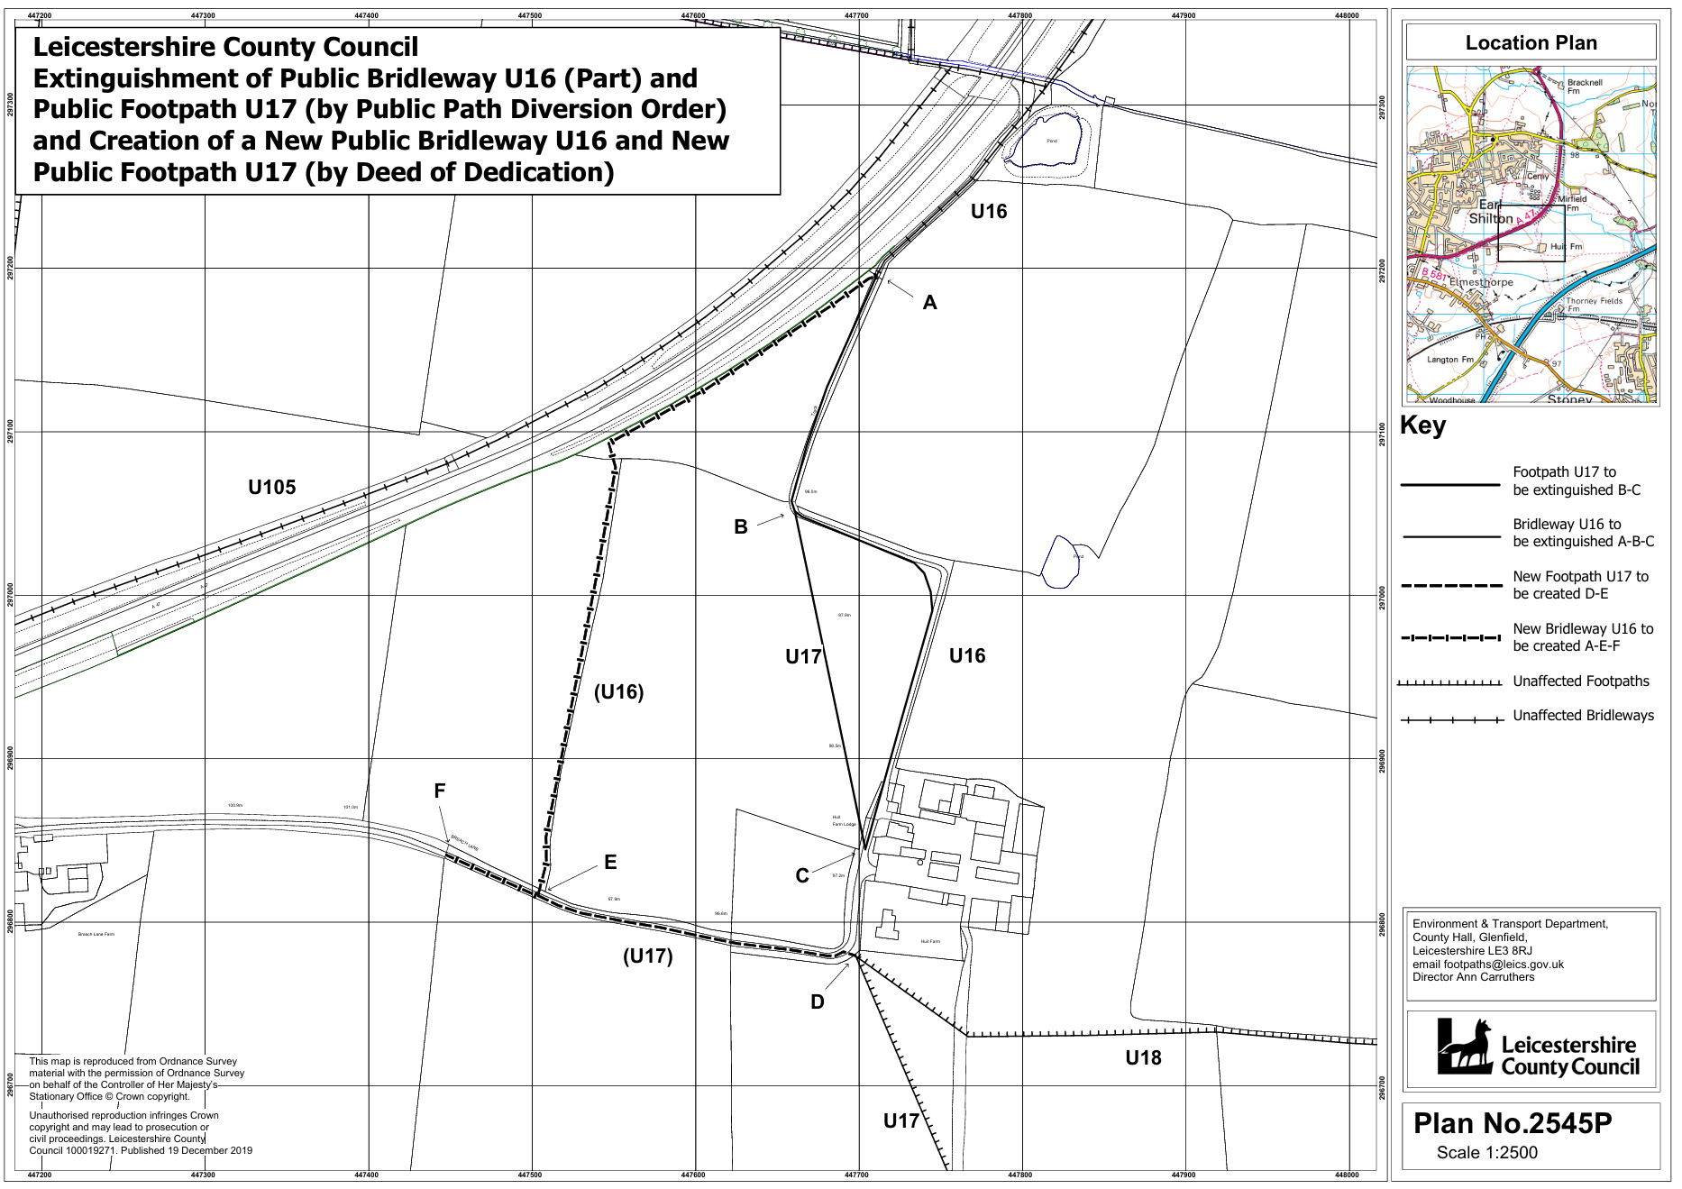
B1
G
