

Application Decision
by Dominic Dobbs
Appointed by the Secretary of State for Environment, Food and Rural Affairs
Decision date: 9 October 2026

Application Ref: COM 3378085
Broad Street Common, Wood Street, Guildford
Register Unit Number: CL 46
Commons Registration Authority: Surrey County Council

- The application, dated 23 February 2026, is made under Section 38 of the Commons Act 2006 (the 2006 Act) for consent to carry out restricted works on common land.
- The application is made by Bewley Homes Plc.
- The works comprise:
- The improvement of the existing access ways to the Common including returning areas of the Common to green space and the addition of a new footway. The total area of the combined works is approximately 318.58m²
- Works on existing utilities and the instillation of new utilities and the digging of trenches to felicitate these works.

Decision
- Consent is granted for the works in accordance with the application dated 23 February 2026 and the plans submitted with it subject to the following conditions set out below:
- the works shall begin no later than three years from the date of this decision;
REASON: To provide certainty to users of Broad Street Common.
- the land shall be fully reinstated within one month from the completion of the works with the addition of the regreening of areas of the Common effected by the works (note that this does not apply to any physical changes or permanent features introduced as part of the works for which consent is granted);
REASON: To retain access and condition of the Common for commoners, public and livestock across Congdon's Shop Green.
- For the purposes of identification only the location of the works is shown on Figure 1 attached to this decision.
Preliminary Matters
- I have had regard to Defra’s Common Land Consents Policy Guidance (November 2015) in determining this application under section 38, which has been published for the guidance of both the Planning Inspectorate and applicants. However, every application will be considered on its merits and a determination will depart from the guidance if it appears appropriate to do so. In such cases, the decision will explain why it has departed from the guidance.

- This application has been determined solely on the basis of written evidence. I have taken into account the representations received from The Open Spaces Society (OSS) and Natural England (NE).

- I am required by section 39 of the 2006 Act to have regard to the following in determining this application:
- the interests of persons having rights in relation to, or occupying, the land (and in particular persons exercising rights of common over it);
- the interests of the neighbourhood;
- the public interest; Section 39(2) of the 2006 Act provides that the public interest includes the public interest in; nature conservation; the conservation of the landscape; the protection of public rights of access to any area of land; and the protection of archaeological remains and features of historic interest;
- any other matter considered to be relevant.

Reasons
- The applicant explains that these works are required in order to provide an adequate access to the residential development which is proposed to be constructed within the adjoining development site and to ensure that the current utilities are in sufficient condition for the new development.

- There are no viable alternatives to these works as they are alternations to existing works on the Common.
The interests of those occupying or having rights over the land
- Surrey County Council are the freeholders of the Common land and the applicant has acquired planning permission from Guildford Borough Council reference 25/P/00903 for the residential development. It follows that the applicant will acquire any additional permissions required to lawfully carry out the works from the appropriate authorities.

- The Common Land Register records rights of pannage for swine and other cattle over the whole of the land known as Broad Street Common.

- The applicant has outlined that they have not observed these rights being carried out on the land in question and I have not received any comments from rights holders on the Common.

- I am satisfied that the applicant has carried out the required consultation and no further comments were received, and the planned works would not interfere with the interest of those occupying or having rights over the land.
The interests of the neighbourhood and public access
- The interests of the neighbourhood relate to whether the works will unacceptably interfere with the way the common land is used by local people and is closely linked with interests of public access.

- The common land subject to this application is already part of an existing accessway to a residential area with the works being improvements and an addition to this. It follows that this area of the Common is primarily used to access the residential area or other areas of the Common. I view that the area has some nature value due to the surrounding green space but is unlikely to be used as a recreational space due to its location next to the highway and accessway.

- The primary reason for the current application is for the maintenance and improvement of the existing accessway with the addition of the new adjoining footway and for the improvement of utilities crossing the site for a new planned development.

- The improvement to the utilities would introduce an impediment to access to and across the Common where they are located for the duration of the works. This is as trenches will need to be dug to access those located under the surface of the Common. However, any trenches will be temporary in nature and therefore will not have a lasting impact on the Common and the wider Common will still be accessible for members of the public via alternate routes. The utilities themselves will be located underground and therefore will not have a lasting impact on the Common in terms of public access.

- The alterations to the existing accessway would not introduce any new impediments to access on the Common and in the case that the condition of the existing accessway is improved access could also be improved. The addition of a new footway as part of the accessway improvements will also not impact on people’s ability to access the Common and would likely improve accessibility.

- Overall, I do not believe the works as planned would create any unacceptable impediment to people’s access to and across the Common and I do not believe the implementation of these works would interfere with the way the Common is currently used.
The public interest
- As well as having regard to the public interest in the protection of public rights of access, I must also have regard to the public interest in nature conservation, the conservation of the landscape and the protection of archaeological remains and features of historic interest.

- These works are for the improvement of an existing accessway, the addition of a new footway and existing utilities on the Common. Although the primary reason for the works is for private development of the Common, it is noted that the improvement of an existing accessway to the Common and to existing utilities does provide some benefit to the wider public and residents local to the area.
Nature conservation and conservation of the landscape
- In this case the works that are taking place on the existing hardstanding surface on the Common will not have any further impact on the Common. The addition of a new footpath along the accessway will detract from the Commons green spaces, however the applicant also plans to return a large area of the Common to verge which will off set this and would be an overall net positive for the natural value of the Common

- The applicant has outlined that some removal of vegetation would be required for the excavation of the trenches for the related utilities works on the site. It is expected that where possible the trenches will be refilled with the material extracted at the site and that the applicant will carry out regreening as part of the maintenance and restoration of the Common after the works are complete. In this case the restoration of the Common can be assured by attaching the appropriate condition to this decision.

- NE has been consulted on the application and outline that they have no concerns regarding any adverse impacts on the landscape or the commons overall level of accessibility for the public.

- Overall, I am content that the works as planned will not have an unacceptable impact on the Natural conservation interests or the conservation of the landscape and once areas of the Common have been returned to green space this would improve the natural condition of the Common.
Protection of archaeological remains and features of historic interest
- We have not received any comments on the impact that these works could have on archaeological remains or historic interests. It is assumed that as there are existing underground utilities that these works would not impact these interests and that the applicant will also carry out any required surveys.

- There is no evidence before me to suggest that these interests will be harmed by the proposed works.
Other matters
- It is noted that on the application form that consent has been requested for the ‘laying of matting with holes over the grass area for vehicle parking’ to provide access to a sales office located off the Common for the new planned development.

- As the matting is neither permanent nor a hardstanding surface and would not impede on people’s access to the Common, I do not view that it constitutes restricted works and therefore it has not been included in this decision.

Conclusion
- In this case I conclude that the works will not introduce an unacceptable barrier to public access to the Common and the works will not seriously harm the other interests set out in paragraph 5 above. Consent for the works is therefore granted subject to the conditions set out at paragraph 1 above.

Dominic Dobbs
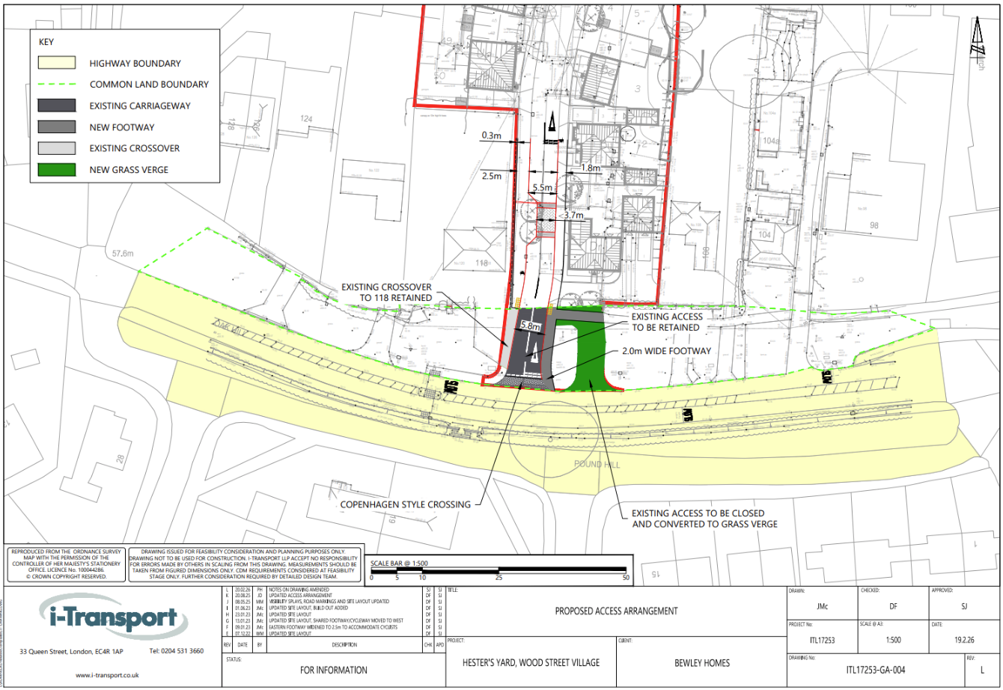
Figure 1 – Location of works on the common

