

Inclusive teaching and areas of development

Facilitator guidance

Post-16 settings

Purpose: This guidance supports facilitators to understand the structure and content coverage of the session prior to delivery.
Audience: Facilitators in post-16 settings.
How to use this document:
- This guidance relates to the third of three introduction sessions focusing on SEND reforms, inclusive teaching and areas of development.
- The slide deck for this session is available separately. We recommend you download the slide deck and view it alongside this guidance as you prepare.
- The session can be delivered in full or in parts. Use this document to help you plan. This will depend on the context of your setting and the structure of your planned professional development time.
- Further guidance on planning and delivering these professional development materials can be found in the Guide to Materials.
Preparation:
If you have limited time or feel comfortable with the content covered in this session, it is recommended that you focus on pages 4-8 of this document. These pages cover the aims and instructions on how to deliver the session.
If you have more time to prepare, it is recommended that you read the document in full. This covers the aims and instructions for delivery of the session as well as the content knowledge covered by the session.

Document explainer

Table of contents
Aims 4
Facilitator instructions 5
Potential adaptations 6
Facilitator checklist 8
Content knowledge 9
Inclusive teaching and the areas of development 9
Glossary 18
References 20
Appendix: development journeys in the areas of development 21

Aims
- To introduce the areas of development and explain why these are useful in understanding the developmental journeys of all children and young people.
- To explain how greater awareness of the areas of development can inform our teaching practice.
- To understand that all learners have learning needs and these are dynamic.
- To explain how inclusive teaching practices relate to high-quality teaching and the universal offer.
- To support staff to see strengths and challenges in learners through the lens of the areas of development.
- To begin to consider how support for learners’ needs can be made both effective and ineffective.

Feel free to add into the box below any additional aims that you would like to achieve from this session:

Facilitator instructions
Timings​ | Section​ | Overview​
15 mins | What do we mean by areas of development? | Aims of the session, followed by an introduction to the different areas of development and how these impact everyday life.  These are exemplified in terms of developmental journeys so that staff can understand that all learners will develop in these areas, not just learners with additional needs.
15 mins | What do we need to know about learning needs? | Introduces what we mean by learning needs and how these can change over time.  Choice of two discussion tasks to give staff an opportunity to think about the link between learning needs and the areas of development.  The first task asks staff to think about a specific learner or group, the second is scenario-based.
25 mins | How can the areas of development help us approach inclusive teaching? | Looks at defining inclusive teaching and the two-part model of support for learning needs.  Two discussion tasks:  - To think about curriculum challenges in relation to the areas of development.  - To apply universal approaches and specific adaptations to help overcome challenges, evaluating what can make support effective or ineffective.
5 mins | Reflection | Choice of two different reflection tasks.

Potential adaptations
Potential adaptations | Suggestions
General | You may wish to add your name or the name of your setting to the bottom of the first slide.  NOTE ON LANGUAGE: Throughout this, and other resources, we have made choices about the names we use to refer to people, places and ideas (such as ‘teachers’ and ‘learners’). You may be accustomed to using different terms within your own setting. Please feel free to change any of these terms where you feel that doing so would be appropriate and helpful. (A quick way to do so is to use CTRL+F, ‘Replace All’.)
Session timings | Timings of individual slides (e.g., 2 minutes) and a running timing in minutes (e.g., [4]) are provided based on a 60-minute session.  However, the session is intended to be flexible enough to adapt this to slightly longer or shorter times as required (e.g., 75 mins or 50 mins).  For shorter sessions, you may need to limit optional slides and consider the use of time provided for reflection activities – for example, considering the length of discussion time and how many responses you elicit.  For longer sessions, you might offer more of the optional slides and extend the time available for reflection and discussion – for example, taking more contributions from FE teachers and explicitly drawing out the suggested key points as they are raised by the FE teachers themselves.  It might be that you would prefer to deliver this content over several, shorter sessions in which case you can adapt the deck accordingly. For example, you might cover a session via three 20-minute slots, rather than in a single one-hour slot.
Learning journeys in ‘What do we mean by areas of development?’ | In the section ‘What do we mean by areas of development?’ there are optional slides showing examples of developmental journeys for the different areas of development.  It is suggested that you select one or two of these journeys, picking the ones you think will be most relevant to your setting’s priorities or your audience’s phase/context.
Discussion task choice in ‘What do we need to know about learning needs?’ | The choice of discussion tasks gives staff an opportunity to think about the link between learning needs and the areas of development.  The first task asks staff to think about a specific learner or group, the second is scenario-based.  You may wish to make the scenario-based task relevant for your context and setting.
Discussion and examples in ‘How can the areas of development help us approach inclusive teaching?’ | The discussion task is broken down into two sections. The first asks staff to discuss an area of curriculum content that learners find challenging and see this through the lens of the areas of development.  The second then asks them to think about learner support, starting with universal approaches and then specific adaptations. Staff are also asked to consider what can make support effective or ineffective.  Two hidden examples are provided for both these tasks, and you will need to decide whether to share these before staff start their discussions as a model. There is an example for primary and secondary.
Reflection question options | At the end of the session, there are options for different reflection activities – you could use one of these or edit/ replace the questions to reflect the priorities, strengths and challenges in your own context.  The options suggested are:  A final consolidation of how the universal approach might be used to support a group where there is a variety of needs  A broader reflection of how this session might influence staff practice.

Facilitator checklist
This checklist catalogues steps that you may wish to work through in order to prepare for the delivery of this session, and future sessions.
Task | Status (Tick for complete)
Prior to delivery…
I have read the aims of this session
I have read the instructions on how to deliver the session
I have read the section of the guidance on the content knowledge of the session and completed the reflection questions
I have established the context within which I will be delivering this session (such as the allotted time, and how this session will relate to other PD)
I have considered the prior knowledge and range of experiences of those I will be delivering to
I have considered the range of roles of those I will be delivering to, and how I can ensure that all staff feel motivated and able to contribute
I have considered the best route to take through the session
I have adapted resources, such as using different examples of practice or learner voice, where appropriate
I have considered how to group or pair-up staff where they will be discussing and reflecting with one another
I have identified what I think will be the trickiest parts of the session to deliver, and I have either scripted these or practised delivering the existing scripts
I have planned how I might get feedback on the session once it has been delivered
Where staff are required to have read a pre-read or attended another session prior to this one, I have ensured that the pre-read has been shared and/or the session has been delivered
Having delivered the session…
I have reflected on what went well
I have reflected on what I might do differently for future sessions
I have recorded these insights so that I can use them to support my planning of future sessions

Content knowledge
Some of the content in this section is drawn from primary research conducted in schools, but is included here where there is good confidence it also applies to post-16 settings.

Inclusive teaching and the areas of development

What do we mean by areas of development?
The SEND reforms propose new ‘Areas of Development’ to replace the current ‘Areas of Need’. These areas are designed to focus on how children and young people develop and function, considering their areas of strength, rather than just their difficulties. This new framework aims to help staff identify and support needs more holistically and consistently.
The areas of development help educators to understand the different skills that all learners will develop over their time in education (and beyond). The areas of development support early and dynamic needs-led provision, enabling educators to recognise and respond to the educational needs that are likely to present in a learning environment. They should provide an organising framework around which educators can structure and build their knowledge of actions that they can take in the classroom or setting to support a young person to progress.
The Department for Education evidence review highlights that identifying need should focus on understanding this interaction between the learner and their environment through holistic, context-sensitive assessment, rather than relying solely on diagnostic labels or explanations that sit within the individual (Antalek et al., 2025).

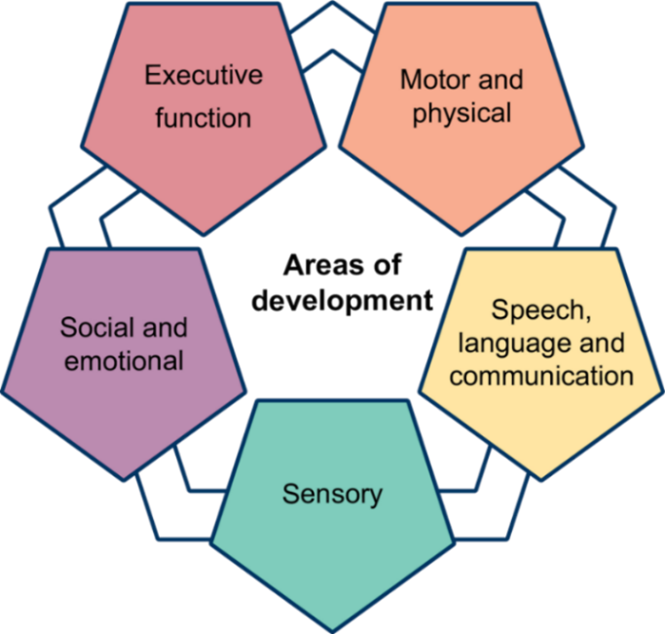
Note: The final Areas of Development are subject to change - DfE is considering feedback from SEND reform consultation and recommendations from the Expert Panel.

 Reflection:
- How do these areas of development present in learning environments in your setting?
- What are the strengths and challenges in relation to the areas of development in your setting and how do you know this?
- What setting-wide approaches or strategies are already in use to support with the areas of development and where are the gaps or priorities?

Area of development | Description
Speech, language and communication (SLC) | Understanding and using language to interact and learn.
Sensory | Processing and responding to sensory information (such as sight, sound, touch).
Motor and physical | Movement, coordination and physical health needs.
Executive function | Skills for organising, planning, remembering and managing tasks.
Social and emotional development | Building relationships, managing feelings and social interaction.
Department for Education (2026). SEND Reform: putting children and young people first.

Development in each of these areas is lifelong and looks different for different individuals at various points in their life. Learners’ development across the five areas of development continues into adolescence and adulthood and is consequently highly relevant to learners in FE settings. These differences often reflect varied environments and the interplay of external factors such as family, culture, FE environment or peer influence. For example, learners who attend settings with access to a wider range of extracurricular activities may develop different interests and skills compared to those in settings with fewer opportunities.
Development can be seen as:
- Dynamic, meaning it changes over time.
- Transactional, meaning individuals and their environment influence each other.
- Shaped by the interaction between the individual and the contexts in which they live and learn.
(Antalek et al., 2025).

Development and environmental demands
There is an intersection between individual development and environmental demands, such as social expectations, transitions between phases, peer influence or academic challenge. This means that at different points, learners might respond with varying degrees of competence depending on the complexity of what they are faced with.
Where the gap between demands and individual development is small, the learner is likely to be responding well because their skills are well matched to the demands they face. Where the gap becomes larger, the learner may need additional support or teaching adjustments because the demands of the environment are exceeding their current skills in a particular area of development.
The size of this gap can change over time. A learner who responds well at a certain age or in one setting may need support later if expectations increase more quickly than their development. Equally, with effective support, teaching and experience, the gap may reduce again. This reinforces the importance of ongoing review and evaluation, recognising that needs are not static and that the level and nature of support should change in response to changing developmental and environmental demands (Antalek et al., 2025).
Conceptualising development in this way reflects the person–environment fit perspective, which suggests that a learner’s satisfaction and success depend on how well their skills, interests and personality match the demands and characteristics of their learning or work environment (Bronfenbrenner & Morris, 2006; Antalek et al., 2025). For example, a learner may thrive in a hands-on apprenticeship setting but need extra support with academic study, or vice versa. This therefore requires FE teachers to recognise that outcomes are shaped by both the individual and their environment, and to adapt support and expectations accordingly.
Support should be based on the match between a learner's skills and the demands of their current environment, not simply on their age or stage of education (Antalek et al., 2025). This is consistent with recommendations from evidence (Antalek et al., 2025) that support should be responsive, graduated and evidence-informed, adapting to the learner's changing profile of strengths, needs and participation across contexts rather than being determined by age, diagnosis or educational phase alone.
A developmental journey will look different for every individual. Although there are indicative milestones that we may use to determine whether learners need help to make expected progress, there will always be areas where some learners accelerate, and others take longer to reach their goals. This will usually vary across the different areas of development for each person. Children and young people frequently present with uneven developmental profiles and co-occurring strengths and needs across multiple domains, supporting the importance of considering the whole learner rather than isolated areas of difficulty (Antalek et al., 2025).
As we move through education, employment and daily life, we inevitably use and develop our skills in the different areas of development. These areas of development represent skills that every child and young person will need to develop, not just those who might have additional needs in these areas.
The development of all learners is shaped by the support and guidance they receive from educators. FE teachers play a crucial role in creating environments that are responsive to learners’ needs, using evidence-informed approaches that promote participation and learning for everyone. Research highlights the importance of universal approaches and inclusive teaching strategies, while recognising that some learners will need more targeted support at different times (Antalek et al., 2025).
As children and young people grow, the demands they face socially, emotionally and academically often increase. Their skills develop too, but not always at the same pace. This means that the support learners need will change over time. Effective FE teachers notice these shifts and adapt their practice, working collaboratively and responsively to provide the right support at the right moment. By doing so, they help learners to thrive, whatever their starting point or background (Antalek et al., 2025).
Example – a developmental journey in speech, language and communication (Department for Education, 2025; The Communication Trust, 2015)
Early Years
Using gestures and words to express wants and needs, understanding simple instructions, taking turns in conversation.
Primary
Language underpins emerging literacy. Understanding more complex vocabulary, giving reasons for opinions, working collaboratively with peers.
Secondary
Using subject-specific language, debating ideas, understanding inference, interpreting multiple meanings, planning extended spoken and written responses.
Further Education
Participating in sessions, using vocationally-specific vocabulary, negotiating group work, communicating professionally with tutors and employers.
Early adulthood
Performing in interviews, communicating in the workplace, resolving conflict, adapting communication for different audiences.
There are examples for the other four areas of development in the appendix of this document (and the slide deck).
It is important to note that these developmental journeys are examples. For learners facing specific barriers to learning in different areas of development or learning needs, these developmental journeys and the approaches and strategies that support them can and do look different.

What do we need to know about learning needs?
Learning needs can be thought of in three ways:
- All young people have common needs. For example, the need to receive effective teaching.
- Some young people have specific needs that are shared with a similar group. For example, learners with a hearing impairment need access to audiological support.
- All young people have individual needs. For example, learners with a Speech and Language Disorder may benefit from pre-teaching of vocabulary and scaffolded talk opportunities.
(EEF, 2025, p.14.)

For example, one learner with a Speech and Language difficulty may need pre-teaching of vocabulary, while another may benefit more from visual supports and additional processing time. These strategies may also support other learners who experience communication or language needs, whether or not they have an identified diagnosis.
Special educational needs relate to the additional support a learner needs to learn and participate in education settings. A diagnosis is given by health professionals to identify a specific physical, developmental or mental health condition. Diagnosis can provide helpful information about a learner's likely strengths and needs and may help the learner to better understand their own experiences. However, learners with the same diagnosis can have very different strengths, needs and experiences, and these may change over time. For this reason, understanding a learner's individual experience of FE is essential for identifying their specific needs and planning effective teaching and support.
Looking beyond diagnostic labels to understand how a learner learns, communicates, interacts and participates in education helps ensure that support is effective. In FE settings, where learners can have greater autonomy over disclosure and support decisions, a focus on educational needs rather than diagnostic labels can help avoid stigma, self-limiting beliefs, and reduced expectations.
Learning needs are often dynamic and they can interact with each other. Support should be based on the match between a learner's skills and the demands of their current environment, not simply on their age or stage of education. At times, many learners will require tailored or additional support to fully participate in everything the education setting has to offer. Learners’ development is not linear. As learners age, the complexity of their needs will change. Some learners might not have SEND to begin with but will develop SEND as they mature. Others who are considered to have SEND at the beginning of their lives may no longer have these needs later in life. Recent research has indicated that this change happens for significant proportions of learners with SEND (EEF, 2025).

Reflection:
- To what extent does the definition of need in your setting align with this?
- Can you think of an example of a learner or group of learners where needs may change as the learner(s) transition into and out of your setting? What change to support was required as a result of this?
- As the facilitator, what parts of this content might be the most challenging to deliver, and how will you approach this?

How can the areas of development help us approach inclusive teaching?
The Education Endowment Foundation guidance (EEF, 2026) suggests:
- Inclusive teaching is about supporting every learner to achieve and thrive;
- It involves collaboration to support learners who find learning hardest;
- Evidence-informed approaches to teaching act as the foundations of inclusion.

Inclusive teaching is what great teachers do every day. It means anticipating that learners will have different strengths, needs and ways of learning, and adapting teaching so that as many learners as possible can access, participate in and succeed. This is skilled, responsive practice, and it isn't easy. FE teachers are constantly making decisions about how best to assess and respond to needs to ensure they support everyone to learn. Quality professional development around a small set of priorities and the time to reflect on and implement changes can help support FE teachers to develop confidence in this area. A collaborative process with other staff, parents, carers, specialist input and, most importantly, learners themselves, is fundamental to the best inclusive teaching.
High-quality teaching practices that make the biggest difference to all learners are equally important when we think about supporting learners to make progress in the different areas of development. Using evidence-informed practices such as scaffolding, explicit literacy instruction and well-planned, thoughtfully sequenced explanations can all make a tangible difference to how learners encounter new information, and the likelihood that new learning will stick.
The EEF (2026) guide on inclusive teaching suggests we should adopt a two-part model when we’re thinking hard about how to support learners.
- Universal approaches: What we do every day: Approaches that benefit everyone but are likely to be especially important for learners who face additional challenges.
- Adaptations and additional support:
- Adaptations and additional support that might only be needed for a short time, or on an ongoing basis, for some learners.

The universal approaches recommended are:
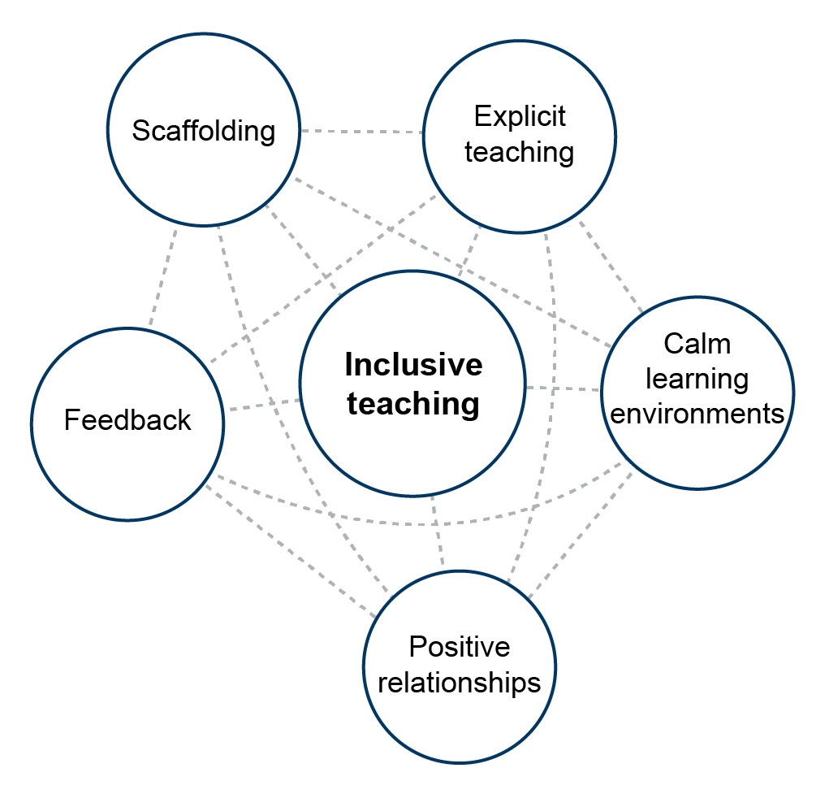
1 Adapted from EEF, 2026

Great, inclusive teaching helps to support everyone, but it is especially important for learners who have additional needs or face disadvantages. For some of our learners, adaptations and additional support may be needed – perhaps for a short time or on a more ongoing basis. However, it is important to recognise that adaptations and additional support can be effective or ineffective, and that ineffective support or adaptation can hinder learning.
For example, the provision of structured scaffolds, to help a learner with SLC needs contribute in situations where professional talk is required, can become an ineffective support if the learner is not supported to manage the withdrawal of the scaffold. Scaffolds should always be used with the intention of gradual removal, building learner independence over time.
Inclusive teaching practices benefit all learners and are especially important for those with additional needs. These should be used ‘universally’ as part of everyday teaching practice. By embedding these approaches consistently, FE teachers and support staff can create a supportive environment for everyone, reducing the need for further adaptations while still allowing flexibility to respond to individual learners. While individual inclusive teaching practices, such as positive relationships, are valuable, their impact on learning is limited if they are used in isolation or without careful attention to how they complement other universal approaches to high-quality teaching. For example, providing scaffolding during a practical workshop will be most effective when combined with clear explanations, regular feedback and opportunities for learners to practise independently. It is the thoughtful integration of these approaches that supports all learners to make progress.

Reflection:

- What demands within the curriculum, vocational or technical learning, practical activities, or workplace settings are most challenging for learners in your context? On which area of development do they place the highest demand?
- How can all learners be supported with this through universal approaches?
- How might some learners be supported through adaptation?
- How might these supports be made effective or ineffective?
- As the facilitator, what parts of this content might be the most challenging to deliver, and how will you approach this?

Glossary
Some selected terms used within the slide deck and within the government’s reforms are included here for reference. Some staff will be familiar with these terms, but others may not. In the latter case, you might consider explicitly providing some of these definitions alongside the slide presentation.
Additional Needs: A general term used to describe where additional support, adjustments or provision is needed by children and young people to access education and training on an equal basis with others. This includes Special Educational Needs and Disabilities but can also refer to economic disadvantage, looked-after-children or children and young people who have low prior attainment and need extra support to succeed in education.
Areas of Development: Replacing the ‘Areas of Need’, these are focused on promoting the development of children and young people and consider their strengths as well as things they find difficult. The five proposed ‘Areas of Development’ were (Department for Education (2026b), Fig. 5):
- executive function – Skills for organising, planning, remembering and managing tasks
- speech, language and communication – Understanding and using language to interact and learn
- social and emotional – Building relationships, managing feelings and social interaction
- sensory – Processing and responding to sensory information (such as sight, sound, touch)
- motor and physical – Movement, coordination and physical health needs
Developmental journey: The way an individual's skills and abilities develop over time, which may vary across different areas of development.

Diagnosis: A formal identification of a physical, developmental or mental health condition by a qualified health professional.

Environmental demands: The social, emotional, physical or academic expectations placed on a learner by their environment.

Inclusion: The government’s approach to inclusion is guided by the definition set by the UN Convention on the Rights of Persons with Disabilities, which focusses on breaking down barriers. Children’s and young people’s needs are not fixed. They may change over time, and many will face barriers to learning at different stages of their lives – whether due to poverty, bereavement, caring responsibilities or other life circumstances. All staff in truly inclusive settings are able to recognise and respond to a wide range of additional needs, not as a response to specific diagnoses, but as a proactive approach towards creating environments where all children and young people can access learning, feel valued and safe, and succeed.

Inclusive teaching: Teaching that anticipates learner differences and adapts practice so that as many learners as possible can access, participate in and succeed in learning.
Layers of support: three layers of support, above the Universal offer. These are called:
- Targeted: Additional support for learners who need more help, but not specialist provision.
- Targeted Plus: More intensive support, possibly involving external specialists.
- Specialist: Specialist settings or provision for learners with the most complex needs.

SEN: special educational needs.
SENCO: special educational needs co-ordinator – a professional responsible for overseeing SEND provision within a school or setting. In an FE setting, functions similar to those of a school SENCO are typically distributed across one or more teams including SEND managers, EHCP administrators, learning support coordinators, and other roles
SEND: special educational needs and disabilities – a broader term than SEN.
Settings: the different types of educational environments where children and young people receive learning and support. This includes early years provision (including childminders, maintained nursery schools, school-based nurseries, and private, voluntary and independent (PVI) nurseries), schools (mainstream and special), and colleges or other post-16 education providers.
Universal offer: is the everyday support and inclusive teaching that all mainstream settings provide for all children and young people.

References
Antalek, C., Castro-Kemp, S., Dixon, F., Esposito, R., Hayton, J., Herbert, E., Kamenopoulou, L., Kolak, J., Loyd, D., Roberts, A., Romualdez, A. M., Somerville, M. P., Taha, J., & Tunks, F. (2025). Cross-cutting themes in identifying, supporting and collaborating for children and young people with SEND: A rapid evidence review. Department for Education.
Bronfenbrenner, U., & Morris, P. A. (2006). The bioecological model of human development. In W. Damon & R. M. Lerner (Eds.), Handbook of child psychology: Vol. 1. Theoretical models of human development (6th ed., pp. 793–828). John Wiley & Sons.
Collaborative for Academic, Social, and Emotional Learning (CASEL). (2020). CASEL’s SEL Framework.
The Communication Trust. (2015). Universally Speaking: The ages and stages of children’s communication development from 11 to 18 years. Accessed online at: https://drive.google.com/file/d/1dAkFpc43x3CE56apJfINx2O1uaRJVvqf/view?pli=1
Department for Education. (2025). Early years foundation stage statutory framework: Setting the standards for learning, development and care for children from birth to five. Accessed online at: EYFS statutory framework for group and school-based providers.
Department for Education (2026). SEND Reform: putting children and young people first.
Denham, S. (2018). Keeping SEL Developmental: The Importance of a Developmental Lens for Fostering and Assessing SEL Competencies.
Education Endowment Foundation. (2025). Special Educational Needs in Mainstream Schools: Guidance Report.
Education Endowment Foundation. (2026). The EEF guide to inclusive teaching. - note a version of this inclusive teaching guidance for 16-19 is forthcoming
World Health Organisation. (2001). International Classification of Functioning, Disability and Health (ICF).

Appendix: development journeys in the areas of development

Sensory development
Early Years
Experiencing different textures, responding to sounds and visual cues, beginning to regulate reactions to everyday sensory experiences, exploring the environment through touch and movement.
Secondary
Managing multiple sensory inputs across different classrooms, busy corridors, practical subjects, changing routines and increasing independence while maintaining attention and emotional regulation.
Early adulthood
Coping with less structured environments, balancing sensory needs with job expectations, recognising and communicating when sensory input becomes overwhelming.
Further Education
Developing practical vocational skills in new settings and managing sensory input in workplaces or classrooms. Some learners use assistive technology or strategies to access learning.

Department for Education. (2025). Early years foundation stage statutory framework: Setting the standards for learning, development and care for children from birth to five.

Executive function development
Early Years
Waiting for short periods, following simple routines, starting to control impulses with adult support.
Primary
Following classroom routines, completing simple multi-step tasks, planning simple projects, organising and remembering homework and equipment, managing increasing independence.
Secondary
Organising work across multiple subjects, planning revision and homework, prioritising deadlines and tasks, solving problems independently and adapting to change.
Further Education
Managing a timetable with greater independence, balancing coursework and placements, planning longer-term assignments, recognising when support is required and seeking this out.
Early adulthood
Performing in interviews, communicating in the workplace, resolving conflict, adapting communication for different audiences.
Department for Education. (2025). Early years foundation stage statutory framework: Setting the standards for learning, development and care for children from birth to five.
World Health Organisation. (2001). International Classification of Functioning, Disability and Health (ICF).

Social and emotional development
Early Years
Sharing and taking turns, forming secure relationships, recognising simple emotions in self and others, seeking comfort from trusted adults.
Primary
Making friendships, beginning to resolve simple disagreements and developing more nuanced social understanding (taking other people’s perspectives).
Secondary
Navigating increasingly complex friendships, managing emotions more independently, responding to peer influence, developing identity and self-awareness.
Further Education
Building new relationships, working effectively with unfamiliar people, resolving conflict appropriately, advocating for personal needs and maintaining wellbeing.
Early adulthood
Developing healthy relationships, managing workplace interactions, coping with life transitions, balancing independence with seeking support when needed.

Collaborative for Academic, Social, and Emotional Learning (CASEL). (2020). CASEL’s SEL Framework.
Department for Education. (2025). Early years foundation stage statutory framework: Setting the standards for learning, development and care for children from birth to five.
Denham, S. (2018). Keeping SEL Developmental: The Importance of a Developmental Lens for Fostering and Assessing SEL Competencies.

Motor and physical development
Early Years
Running, climbing, using cutlery and crayons, developing balance and coordination to move safely.
Primary
Managing movement across a larger school site, participating safely in practical subjects (e.g. PE and science), coordinating complex tasks.
Further education
Equipment use, occupationally specifical physical demands.
Early adulthood
Meeting the physical demands of independent living and employment, maintaining physical health, adapting movement for different environments and situations.

Department for Education. (2025). Early years foundation stage statutory framework: Setting the standards for learning, development and care for children from birth to five.
World Health Organisation. (2001). International Classification of Functioning, Disability and Health (ICF).

Developed in partnership with
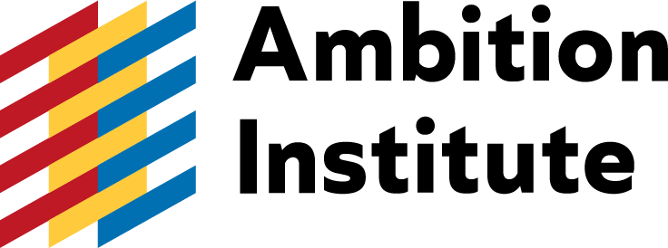

© Crown copyright 2026
This publication is licensed under the terms of the Open Government Licence v3.0, except where otherwise stated. To view this licence, visit nationalarchives.gov.uk/doc/open-government-licence/version/3.
Where we have identified any third-party copyright information, you will need to obtain permission from the copyright holders concerned.

