
Inclusive teaching and areas of development
Facilitator guidance

Primary and Secondary schools

Purpose: This guidance supports facilitators to understand the structure and content coverage of the session prior to delivery.
Audience: Facilitators in primary and secondary schools.
How to use this document:
- This guidance relates to the third of three introduction sessions focusing on SEND reforms, inclusive teaching and areas of development.
- The slide deck for this session is available separately. We recommend you download the slide deck and view it alongside this guidance as you prepare.
- The session can be delivered in full or in parts. Use this document to help you plan. This will depend on the context of your setting and the structure of your planned professional development time.
- Further guidance on planning and delivering these professional development materials can be found in the Guide to Materials.
Preparation:
If you have limited time or feel comfortable with the content covered in this session, it is recommended that you focus on pages 4-8 of this document. These pages cover the aims and instructions on how to deliver the session.
If you have more time to prepare, it is recommended that you read the document in full. This covers the aims and instructions for delivery of the session as well as the content knowledge covered by the session.

Document explainer
Table of contents
Aims 4
Facilitator instructions 5
Potential adaptations 6
Facilitator checklist 8
Content knowledge 9
Glossary 19
References 21
Appendix: development journeys in the areas of development 22

Aims
- to introduce the areas of development and explain why these are useful in understanding the developmental journeys of all children and young people
- to explain how greater awareness of the areas of development can inform our teaching practice
- to understand that all pupils have learning needs and these are dynamic
- to explain how inclusive teaching practices relate to high-quality teaching and the universal offer
- to support staff to see strengths and challenges in their pupils through the lens of the areas of development
- to begin to consider how support for pupils’ learning needs can be made both effective and ineffective

Feel free to add into the box below any additional aims that you would like to achieve from this session:

Facilitator instructions
Timings​ | Section​ | Overview​
15 mins | What do we mean by areas of development? | Aims of the session, followed by an introduction to the different areas of development and how these impact everyday life.  These are exemplified in terms of developmental journeys so that staff can understand that all pupils will develop in these areas, not just pupils with additional needs.
15 mins | What do we need to know about learning needs? | Introduces what we mean by learning needs and how these can change over time.  Choice of two discussion tasks to give staff an opportunity to think about the link between learning needs and the areas of development.  The first task asks staff to think about a specific pupil or group, the second is scenario-based.
25 mins | How can the areas of development help us approach inclusive teaching? | Looks at defining inclusive teaching and the two-part model of support for learning needs.  Two discussion tasks:  - to think about curriculum challenges in relation to the areas of development  - to apply universal approaches and specific adaptations to help overcome challenges, evaluating what can make support effective or ineffective
5 mins | Reflection | Choice of two different reflection tasks

Potential adaptations
Potential adaptations | Suggestions
General | You may wish to add your name or the name of your school or college to the bottom of the first slide.  NOTE ON LANGUAGE: Throughout this and other resources, we have made choices about the names we use to refer to people, places and ideas (such as ‘teachers’ and ‘pupils’). You may be accustomed to using different terms within your own setting. Please feel free to change any of these terms where you feel that doing so would be appropriate and helpful. (A quick way to do so is to use CTRL+F, ‘Replace All’.)
Session timings | Timings of individual slides (e.g., 2 minutes) and a running timing in minutes (e.g., [4]) are provided based on a 60-minute session.  However, the session is intended to be flexible enough to adapt this to slightly longer or shorter times as required (e.g., 75 mins or 50 mins).  For shorter sessions, you may need to limit optional slides and consider the use of time provided for reflection activities – for example, considering the length of discussion time and how many responses you elicit.  For longer sessions, you might offer more of the optional slides and extend the time available for reflection and discussion – for example, taking more contributions from teachers and explicitly drawing out the suggested key points as they are raised by the teachers themselves.  It might be that you would prefer to deliver this content over several, shorter sessions in which case you can adapt the deck accordingly. For example, you might cover a session via three 20-minute slots, rather than in a single one-hour slot.
Learning journeys in ‘What do we mean by areas of development?’ | In the section ‘What do we mean by areas of development?’ there are optional slides showing examples of developmental journeys for the different areas of development.  It is suggested that you select one or two of these journeys, picking the ones you think will be most relevant to your setting’s priorities or your audience’s phase/context.
Discussion task choice in ‘What do we need to know about learning needs?’ | The choice of discussion tasks gives staff an opportunity to think about the link between learning needs and the areas of development.  The first task asks staff to think about a specific pupil or group, the second is scenario-based.  You may wish to make the scenario-based task relevant for your context and setting.
Discussion and examples in ‘How can the areas of development help us approach inclusive teaching?’ | The discussion task is broken down into two sections. The first asks staff to discuss an area of curriculum content that pupils find challenging and see this through the lens of the areas of development.  The second then asks them to think about pupil support, starting with universal approaches and then specific adaptations. Staff are also asked to consider what can make support effective or ineffective.  Two hidden examples are provided for both these tasks, and you will need to decide whether to share these before staff start their discussions as a model. There is an example for primary and secondary.
Reflection question options | At the end of the session, there are options for different reflection activities – you could use one of these or edit/ replace the questions to reflect the priorities, strengths and challenges in your own context.  The options suggested are:  A final consolidation of how the universal approach might be used to support a class where there is a variety of needs  A broader reflection of how this session might influence staff practice.

Facilitator checklist
This checklist catalogues steps that you may wish to work through in order to prepare for the delivery of this session, and future sessions.
Task | Status (Tick for complete)
Prior to delivery…
I have read the aims of this session
I have read the instructions on how to deliver the session
I have read the section of the guidance on the content knowledge of the session and completed the reflection questions
I have established the context within which I will be delivering this session (such as the allotted time, and how this session will relate to other PD)
I have considered the prior knowledge and range of experiences of those I will be delivering to
I have considered the range of roles of those I will be delivering to, and how I can ensure that all staff feel motivated and able to contribute
I have considered the best route to take through the session
I have adapted resources, such as using different examples of practice or pupil voice, where appropriate
I have considered how to group or pair-up staff where they will be discussing and reflecting with one another
I have identified what I think will be the trickiest parts of the session to deliver, and I have either scripted these or practised delivering the existing scripts
I have planned how I might get feedback on the session once it has been delivered
Where staff are required to have read a pre-read or attended another session prior to this one, I have ensured that the pre-read has been shared and/or the session has been delivered
Having delivered the session…
I have reflected on what went well
I have reflected on what I might do differently for future sessions
I have recorded these insights so that I can use them to support my planning of future sessions

Content knowledge
Inclusive teaching and the areas of development

What do we mean by areas of development?
The SEND reforms propose new ‘Areas of Development’ to replace the current ‘Areas of Need’. These areas are designed to focus on how children and young people develop and function, considering their areas of strengths, rather than just their difficulties. This new framework aims to help staff identify and support needs more holistically and consistently.
The areas of development help educators to understand the different skills that all pupils will develop over their time in education (and beyond). The areas of development support early and dynamic needs-led provision, enabling educators to recognise and respond to the educational needs that are likely to present in a classroom or setting. They should provide an organising framework around which educators can structure and build their knowledge of actions that they can take in the classroom or setting to support a child to progress.
The Department for Education evidence review highlights that identifying need should focus on understanding this interaction between the pupil and their environment through holistic, context-sensitive assessment, rather than relying solely on diagnostic labels or within-child explanations (Antalek et al., 2025).

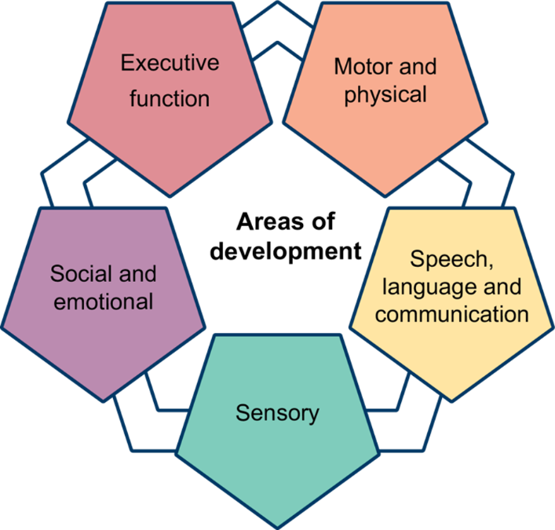
Note: The final Areas of Development are subject to change - DfE is considering feedback from SEND reform consultation and recommendations from the Expert Panel.

 Reflection:
- How do these areas of development present in classrooms in your setting?
- What are the strengths and challenges in relation to the areas of development in your setting and how do you know this?
- What school-wide approaches or strategies are already in use to support with the areas of development and where are the gaps or priorities?

Area of development | Description
Speech, language and communication (SLC) | Understanding and using language to interact and learn
Sensory | Processing and responding to sensory information (such as sight, sound, touch)
Motor and physical | Movement, coordination and physical health needs
Executive function | Skills for organising, planning, remembering and managing tasks
Social and emotional development | Building relationships, managing feelings and social interaction
Department for Education (2026). SEND Reform: putting children and young people first.

Development in each of these areas is lifelong and looks different for different individuals at various points in their life. These differences often reflect varied environments and the interplay of external factors such as family, culture, school environment or peer influence. For example, pupils who attend schools with access to a wider range of extracurricular activities may develop different interests and skills compared to those in schools with fewer opportunities.
Development can be seen as:
- dynamic, meaning it changes over time
- transactional, meaning individuals and their environment influence each other
- shaped by the interaction between the individual and the contexts in which they live and learn
(Antalek et al., 2025).

Development and environmental demands
There is an intersection between individual development and environmental demands, such as social expectations, transitions between school stages, peer influence or academic challenge. This means that at different points, pupils might respond with varying degrees of competence depending on the complexity of what they are faced with.
Where the gap between demands and individual development is small, the pupil is likely to be responding well because their skills are well matched to the demands they face. Where the gap becomes larger, the pupil may need additional support or teaching adjustments because the demands of the environment are exceeding their current skills in a particular area of development.
The size of this gap can change over time. A pupil who responds well at a certain age or in a particular setting may need support later if expectations increase more quickly than their development. Equally, with effective support, teaching and experience, the gap may reduce again. This reinforces the importance of ongoing review and evaluation, recognising that needs are not static and that the level and nature of support should change in response to changing developmental and environmental demands (Antalek et al., 2025).
Support should be based on the match between a pupil's skills and the demands of their current environment, not simply on their age or stage of education (Antalek et al., 2025). This is consistent with recommendations from evidence (Antalek et al., 2025) that support should be responsive, graduated and evidence-informed, adapting to the pupil's changing profile of strengths, needs and participation across contexts rather than being determined by age, diagnosis or educational phase alone.
A developmental journey will look different for every individual. Although there are indicative milestones that we may use to determine whether children need help to make expected progress, there will always be areas where some pupils accelerate, and others take longer to reach their goals. This will usually vary across the different areas of development for each person.
Children and young people frequently present with uneven developmental profiles and co-occurring strengths and needs across multiple domains, supporting the importance of considering the whole pupil rather than isolated areas of difficulty (Antalek et al., 2025).
As we move through education, employment and daily life, we use, learn and develop our skills in the different areas of development. These areas of development represent skills that every child and young person will need to develop, not just those who might have additional needs in these areas.
The development of all children is shaped by the support and guidance they receive. Teachers and teaching assistants play a crucial role in creating environments that are responsive to pupils’ needs, using evidence-informed approaches that promote participation and learning for everyone. Research highlights the importance of universal approaches and inclusive teaching strategies, while recognising that some pupils will need more targeted support at different times (Antalek et al., 2025).
As children and young people grow, the demands they face socially, emotionally and academically often increase. Their skills develop too, but not always at the same pace. This means that the support pupils need will change over time. Effective teachers and teaching assistants notice these shifts and adapt their practice, working collaboratively and responsively to provide the right support at the right moment. By doing so, they help pupils to thrive, whatever their starting point or background (Antalek et al., 2025).

Example: a developmental journey in speech, language and communication (Department for Education, 2025; The Communication Trust, 2015)
Early Years
Using gestures and words to express wants and needs, understanding simple instructions, taking turns in conversation
Primary
Language underpins emerging literacy. Understanding more complex vocabulary, giving reasons for opinions, working collaboratively with peers
Secondary
Using subject-specific language, debating ideas, understanding inference, interpreting multiple meanings, planning extended spoken and written responses
Further Education
Participating in sessions, using vocationally-specific vocabulary, negotiating group work, communicating professionally with tutors and employers
Early adulthood
Performing in interviews, communicating in the workplace, resolving conflict, adapting communication for different audiences
There are examples for the other four areas of development in the appendix of this document (and the slide deck).
It is important to note that these developmental journeys are examples. For pupils facing specific barriers to learning in different areas of development or learning needs, these developmental journeys and the approaches and strategies that support them can and do look different.

What do we need to know about learning needs?
Learning needs can be thought of in three ways:
- All children have common needs. For example, the need to receive effective teaching.
- Some children have specific needs that are shared with a similar group. For example, pupils with a hearing impairment need access to audiological support.
- All children have individual needs.

(EEF, 2025, p.14.)
For example, one pupil with a Speech and Language difficulty may need pre-teaching of vocabulary, while another may benefit more from visual supports and additional processing time. These strategies may also support other pupils who experience communication or language needs, whether or not they have an identified diagnosis.
Special educational needs relate to the additional support a pupil needs to learn and participate in school. A diagnosis is given by health professionals to identify a specific physical, developmental or mental health condition. Diagnosis can provide helpful information about a pupil's likely strengths and needs and may help the pupil to better understand their own experiences. However, pupils with the same diagnosis can have very different strengths, needs and experiences, and these may change over time. For this reason, understanding a pupil's individual experience of school is essential for identifying their specific needs and planning effective teaching and support. Looking beyond diagnostic labels to understand how a pupil learns, communicates, interacts and participates in school helps ensure that support is effective.
Learning needs are often dynamic, and they can interact with each other. Support should be based on the match between a pupil's skills and the demands of their current environment, not simply on their age or stage of education. At times, many pupils will require tailored or additional support to fully participate in everything the school has to offer. Pupils’ development is not linear. As pupils age, the complexity of their needs will change. Some pupils might not have SEND to begin with but will develop SEND as they mature. Others who are considered to have SEND in early childhood may no longer have these needs later in life. Recent research has indicated that this change happens for significant proportions of pupils with SEND (EEF, 2025).

Reflection:
- To what extent does the definition of need in your setting align with this?
- Can you think of an example of a pupil or group of pupils where needs have changed over time? What change to support was required as a result of it?
- As the facilitator, what parts of this content might be the most challenging to deliver, and how will you approach this?

How can the areas of development help us approach inclusive teaching?
The Education Endowment Foundation guidance (EEF, 2026) suggests:
- inclusive teaching is about supporting every pupil to achieve and thrive
- it involves collaboration to support pupils who find learning hardest
- evidence-informed approaches to teaching act as the foundations of inclusion
Inclusive teaching is what great teachers do every day. It means anticipating that pupils will have different strengths, needs and ways of learning, and adapting teaching so that as many pupils as possible can access, participate in and succeed. This is skilled, responsive practice, and it isn't easy. Teachers are constantly making decisions about how best to assess and respond to needs to ensure they support everyone to learn. Quality professional development around a small set of priorities and the time to reflect on and implement changes can help support teachers to develop confidence in this area. A collaborative process with other staff, parents, carers, specialist input and, most importantly, pupils themselves, is fundamental to the best inclusive teaching.
High-quality teaching practices that make the biggest difference to all pupils are equally important when we think about supporting pupils to make progress in the different areas of development. Using evidence-informed practices such as scaffolding, explicit literacy instruction and well-planned, thoughtfully sequenced explanations can all make a tangible difference to how pupils encounter new information, and the likelihood that new learning will stick.
The EEF (2026) guide on inclusive teaching suggests we should adopt a two-part model when we’re thinking hard about how to support pupils.
- universal approaches: what we do every day
approaches that benefit everyone but are likely to be especially important for pupils who face additional challenges
- adaptations and additional support
adaptations and additional support that might only be needed for a short time, or on an ongoing basis, for some pupils

The universal approaches recommended:
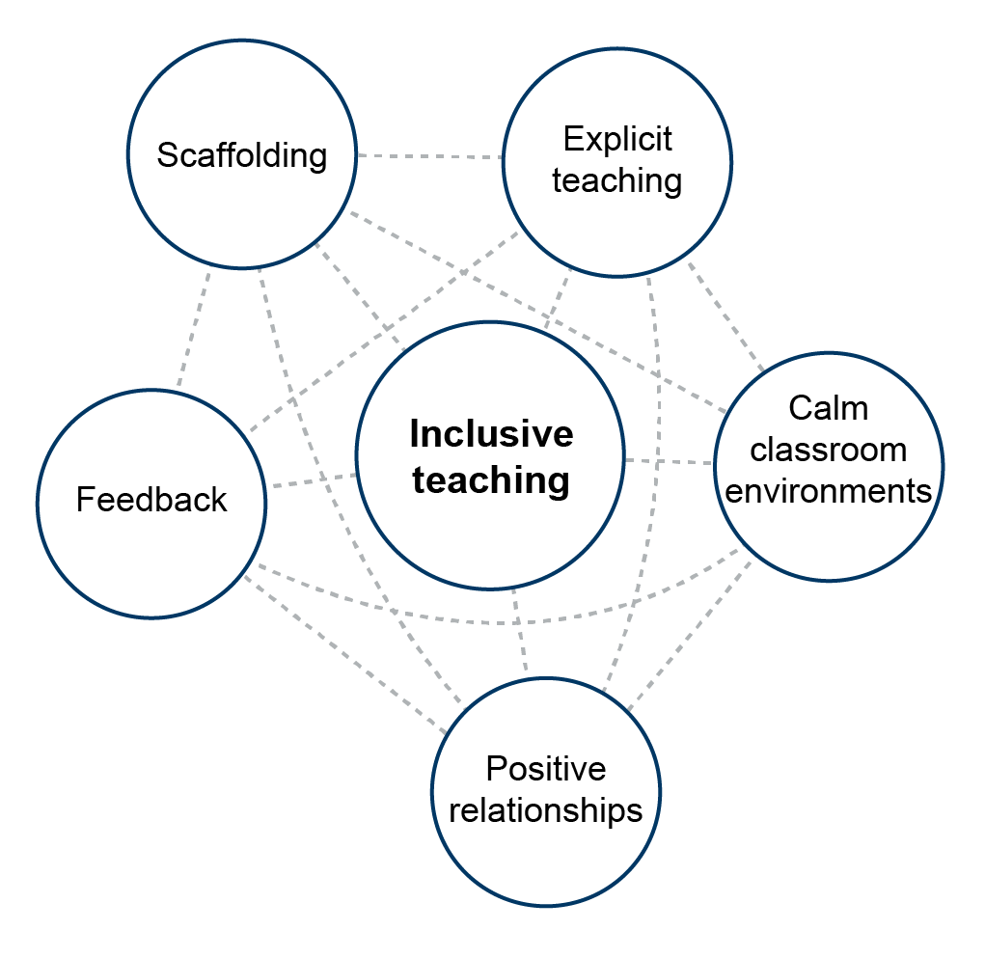
1 Adapted from EEF, 2026

Great, inclusive teaching helps to support everyone but is especially important for pupils who have additional needs or face disadvantages. For some of our pupils, adaptations and additional support may be needed, perhaps for a short time or on an ongoing basis. However, it is important to recognise that adaptations and additional support can be effective or ineffective, and that ineffective support or adaptation can hinder learning. For example, the provision of structured scaffolds to help a pupil with SLC needs contribute to talk activities can become an ineffective support if the pupil is not supported to manage the withdrawal of the scaffold. Scaffolds should always be used with the intention of gradual removal, building pupil independence over time.
Inclusive teaching practices benefit all pupils and are especially important for those with additional needs. These should be used ‘universally’ as part of everyday teaching practice. By embedding these approaches consistently, teachers create a supportive environment for everyone, reducing the need for further adaptations while still allowing flexibility to respond to individual pupils. While individual inclusive teaching practices, such as positive relationships, are valuable, their impact on learning is limited if they are used in isolation or without careful attention to how they complement other universal approaches to high-quality teaching. For example, providing scaffolding during a lesson will be most effective when combined with clear explanations, regular feedback and opportunities for pupils to practise independently. It is the thoughtful integration of these approaches that supports all pupils to make progress.

Reflection:
- What demands of the curriculum can prove challenging in your setting? On which area of development do they place the highest demand?
- How can all pupils be supported with this through universal approaches?
- How might some pupils be supported through adaptation?
- How might these supports be made effective or ineffective?
- As the facilitator, what parts of this content might be the most challenging to deliver, and how will you approach this?

Glossary
Some selected terms used within the slide deck and within the government’s reforms are included here for reference. Some staff will be familiar with these terms, but others may not. In the latter case, you might consider explicitly providing some of these definitions alongside the slide presentation.
Additional Needs: a general term used to describe where additional support, adjustments or provision is needed by children and young people to access education and training on an equal basis with others. This includes Special Educational Needs and Disabilities but can also refer to economic disadvantage, looked-after-children or children and young people who have low prior attainment and need extra support to succeed in education.
Areas of Development: replacing the ‘Areas of Need’, these are focused on promoting the development of children and young people and consider their strengths as well as things they find difficult. The five proposed ‘Areas of Development’ were (Department for Education (2026b), Fig. 5):
- Executive function: skills for organising, planning, remembering and managing tasks
- Speech, language and communication: understanding and using language to interact and learn
- Social and emotional: building relationships, managing feelings and social interaction
- Sensory: processing and responding to sensory information (such as sight, sound, touch)
- Motor and physical: movement, coordination and physical health needs
Developmental journey: the way an individual's skills and abilities develop over time, which may vary across different areas of development.

Diagnosis: a formal identification of a physical, developmental or mental health condition by a qualified health professional.

Environmental demands: the social, emotional, physical or academic expectations placed on a pupil by their environment.

Inclusion: the government’s approach to inclusion is guided by the definition set by the UN Convention on the Rights of Persons with Disabilities, which focusses on breaking down barriers. Children’s needs are not fixed. They may change over time, and many will face barriers to learning at different stages of their lives – whether due to poverty, bereavement, caring responsibilities or other life circumstances. All staff in truly inclusive settings are able to recognise and respond to a wide range of additional needs, not as a response to specific diagnoses, but as a proactive approach towards creating environments where all children can access learning, feel valued and safe, and succeed.
Inclusive teaching: Teaching that anticipates pupil differences and adapts practice so that as many pupils as possible can access, participate in and succeed in learning.
Layers of support: three layers of support, above the Universal offer. These are called:
- Targeted: additional support for pupils who need more help, but not specialist provision.
- Targeted Plus: more intensive support, possibly involving external specialists.
- Specialist: specialist settings or provision for pupils with the most complex needs.
SEN: special educational needs.
SENCO: special educational needs co-ordinator – a professional responsible for overseeing SEND provision within a school or setting.
SEND: special educational needs and disabilities – a broader term than SEN.
Settings: the different types of educational environments where children and young people receive learning and support. This includes early years provision (including childminders, maintained nursery schools, school-based nurseries, and private, voluntary and independent (PVI) nurseries), schools (mainstream and special), and colleges or other post-16 education providers.
Universal offer: is the everyday support and inclusive teaching that all mainstream settings provide for all children and young people.
Within-child explanation: An explanation that focuses only on characteristics of the child as the cause of difficulties, rather than considering the interaction between the child and their environment.

References
Antalek, C., Castro-Kemp, S., Dixon, F., Esposito, R., Hayton, J., Herbert, E., Kamenopoulou, L., Kolak, J., Loyd, D., Roberts, A., Romualdez, A. M., Somerville, M. P., Taha, J., & Tunks, F. (2025). Cross-cutting themes in identifying, supporting and collaborating for children and young people with SEND: A rapid evidence review. Department for Education
Bronfenbrenner, U., & Morris, P. A. (2006). The bioecological model of human development. In W. Damon & R. M. Lerner (Eds.), Handbook of child psychology: Vol. 1. Theoretical models of human development (6th ed., pp. 793–828). John Wiley & Sons.
Collaborative for Academic, Social, and Emotional Learning (CASEL). (2020). CASEL’s SEL Framework.
The Communication Trust. (2015). Universally Speaking: The ages and stages of children’s communication development from 11 to 18 years.
Department for Education. (2025). Early years foundation stage statutory framework: Setting the standards for learning, development and care for children from birth to five.
Department for Education (2026). SEND Reform: putting children and young people first.
Denham, S. (2018). Keeping SEL Developmental: The Importance of a Developmental Lens for Fostering and Assessing SEL Competencies.
Education Endowment Foundation. (2025). Special Educational Needs in Mainstream Schools: Guidance Report.
Education Endowment Foundation. (2026). The EEF guide to inclusive teaching.
World Health Organisation. (2001). International Classification of Functioning, Disability and Health (ICF).

Appendix: development journeys in the areas of development

Sensory development
Early Years
Experiencing different textures, responding to sounds and visual cues, beginning to regulate reactions to everyday sensory experiences, exploring the environment through touch and movement
Secondary
Managing multiple sensory inputs across different classrooms, busy corridors, practical subjects, changing routines and increasing independence while maintaining attention and emotional regulation
Early adulthood
Coping with less structured environments, balancing sensory needs with job expectations, recognising and communicating when sensory input becomes overwhelming
Further Education
Developing practical vocational skills in new settings and managing sensory input in workplaces or classrooms. Some learners use assistive technology or strategies to access learning

Department for Education. (2025). Early years foundation stage statutory framework: Setting the standards for learning, development and care for children from birth to five.

Executive function development
Early Years
Waiting for short periods, following simple routines, starting to control impulses with adult support
Primary
Following classroom routines, completing simple multi-step tasks, planning simple projects, organising and remembering homework and equipment, managing increasing independence
Secondary
Organising work across multiple subjects, planning revision and homework, prioritising deadlines and tasks, solving problems independently and adapting to change
Further Education
Managing a timetable with greater independence, balancing coursework and placements, planning longer-term assignments, recognising when support is required and seeking this out
Early adulthood
Managing work or work application deadlines, organisation and planning for independent living
Department for Education. (2025). Early years foundation stage statutory framework: Setting the standards for learning, development and care for children from birth to five.
World Health Organisation. (2001). International Classification of Functioning, Disability and Health (ICF).

Social and emotional development
Early Years
Sharing and taking turns, forming secure relationships, recognising simple emotions in self and others, seeking comfort from trusted adults
Primary
Making friendships, beginning to resolve simple disagreements and developing more nuanced social understanding (taking other people’s perspectives)
Secondary
Navigating increasingly complex friendships, managing emotions more independently, responding to peer influence, developing identity and self-awareness
Further Education
Building new relationships, working effectively with unfamiliar people, resolving conflict appropriately, advocating for personal needs and maintaining wellbeing
Early adulthood
Developing healthy relationships, managing workplace interactions, coping with life transitions, balancing independence with seeking support when needed

Collaborative for Academic, Social, and Emotional Learning (CASEL). (2020). CASEL’s SEL Framework.
Department for Education. (2025). Early years foundation stage statutory framework: Setting the standards for learning, development and care for children from birth to five.
Denham, S. (2018). Keeping SEL Developmental: The Importance of a Developmental Lens for Fostering and Assessing SEL Competencies.

Motor and physical development
Early Years
Running, climbing, using cutlery and crayons, developing balance and coordination to move safely.
Primary
Managing movement across a larger school site, participating safely in practical subjects (e.g. PE and science), coordinating complex tasks.
Further Education
Equipment use, occupationally-specific physical demands.
Early adulthood
Meeting the physical demands of independent living and employment, maintaining physical health, adapting movement for different environments and situations.

Department for Education. (2025). Early years foundation stage statutory framework: Setting the standards for learning, development and care for children from birth to five.
World Health Organisation. (2001). International Classification of Functioning, Disability and Health (ICF).

Developed in partnership with


© Crown copyright 2026
This publication is licensed under the terms of the Open Government Licence v3.0, except where otherwise stated. To view this licence, visit nationalarchives.gov.uk/doc/open-government-licence/version/3.
Where we have identified any third-party copyright information, you will need to obtain permission from the copyright holders concerned.

