

Order Decision
Site visit made on 25 August 2026
by K Taylor BSc (Hons) PGDip MRTPI
appointed by the Secretary of State for Environment, Food and Rural Affairs
Decision date: 26 August 2026

Order Ref: ROW/3362354
- This Order is made under Section 119 of the Highways Act 1980 and is known as the Wiltshire Council Parish of Brixton Deverill Path Nos. 1, 2 and 16 Diversion and Definitive Map and Statement Modification Order 2024.
- The Order is dated 18 November 2024 and proposes to divert the public rights of way shown on the Order plan and described in the Order Schedule.
- There was 1 objection outstanding when Wiltshire Council submitted the Order to the Secretary of State for Environment, Food and Rural Affairs for confirmation.
Summary of Decision: The Order is confirmed.

Preliminary Matters
- I have referred to the points of the route given in the Order plans and a copy of these are attached for ease of reference. This Order relates to 3 separate bridleways, BDEV1, BDEV2, and BDEV16. In the remainder of this decision, I will refer to these as Bridleways 1, 2 and 16. The objection related only to Bridleway 2; as such, I will deal with this first. However, as the Order relates to all 3 diversions, this decision also addresses Bridleways 1 and 16.
- I conducted an accompanied site inspection on 25 August 2026, in respect of Bridleway 2 in the company of representatives from the Council, the Parish Council, and the Open Spaces Society, as well as the landowner and a local resident. Site visits for Bridleways 1 and 16 were carried out unaccompanied.

Main Issues
- Section 119(6) of the Highways Act 1980 sets out three separate tests for an Order to be confirmed. These are:
TEST 1: whether it is expedient in the interests of the landowner, occupier or the public for the path to be diverted. This is subject to any altered point of termination of the path being substantially as convenient to the public.
TEST 2: whether the proposed diversion is substantially less convenient to the public.
TEST 3: whether it is expedient to confirm the Order having regard to the effect which— (a) the diversion would have on public enjoyment of the path as a whole, (b) the coming into operation of the Order would have as respects other land served by the existing public right of way, and (c) any new public right of way created by the Order would have as respects the land over which the right is so created and any land held with it.
- In determining whether to confirm the Order at Test 3 stage, (a)-(c) are mandatory factors. On (b) and (c) of Test 3, the statutory provisions for compensation for diminution in value or disturbance to enjoyment of the land affected by the new paths must be taken into account, where applicable. Regard must also be had to any material provision contained in a rights of way improvement plan (ROWIP) for the area under section 119(6A). Other relevant factors are not excluded from consideration and could, for instance, include those pointing in favour of confirmation.

Reasons

Bridleway 2

Whether it is expedient in the interests of the owner that the path should be diverted
- The southern end of the definitive route of Bridleway 2 is accessed from an unclassified road with a 30mph speed limit which itself is accessed from the B3095. The definitive route of Bridleway 2 passes the front of Cliff House by 2 ground floor windows and the front door. The alignment of the path runs very close to the northeast corner of the building. The route then continues through approximately the centre of the rear garden and then joins a track with the appearance of a lane. The diverted route would also start from the unclassified road, but a little to the west, joining the track which makes up the majority of Bridleway 2 sooner at a point of access to a farmyard.
- The diverted route would remove bridleway users from the landowner’s residential property. It would allow for increased privacy and security for the residential occupiers of the dwelling. The diversion is clearly expedient in the interests of the owner.

Whether any new termination point is substantially as convenient to the public
- The northern termination point of the diversion meets the existing route of Bridleway 2 on the definitive alignment and so there would be no effect at the northern terminus. At the southern end of the path, both the existing and the diverted route are accessed from the same unclassified road. Most longer journeys utilising Bridleway 2 along with other public rights of way would require travelling along a section of the unclassified road. This would not be any more or less convenient to the public in any material way.
- Previously, the northern terminus of Footpath 3 was located immediately opposite the southern terminus of Bridleway 2. Footpath 3 has been diverted and so the northern terminus is now almost directly opposite the proposed diverted route of Bridleway 2. Visibility looking east along the unclassified road is a little better from the proposed southern terminus of Bridleway 2 than from the definitive alignment. The new termination point would be a little more convenient for users on a longer journey which includes Footpath 3.

Whether the new path will not be substantially less convenient to the public
- The definitive route, from the unclassified road to the continuation point on Bridleway 2 is reported as being approximately 70m compared with around 65m on the diverted route. This 5m difference is unlikely to be noticeable for users of the route.
- The Department for Environment, Food and Rural Affairs (DEFRA) has published guiding principles where a public right of way passes through a garden of a residential premises and working farmyards. Reducing or eliminating the effects of the route of a right of way on the owner/occupier in terms of privacy, security and safety are important considerations that should be given due weight and there should be a predisposition to confirm an Order if it satisfies the relevant legislative tests.
- In this case, the proposal would divert the route away from a residential curtilage with the associated benefits in terms of privacy and security. The guidance acknowledges that users can feel uncomfortable using routes through private gardens which may discourage use. The representations made in this case indicate that this applies to some existing users. The diversion would eliminate this issue which would add to the convenience of users.
- The diversion would, however, result in the route passing along an access way to a farmyard and immediately adjacent to working farm buildings with large access doors close to the proposed diverted route. The guidance notes that users may not feel comfortable following a path, if doing so means they would feel they were being endangered by activities within a farmyard.
- This cluster of buildings, to the north of the unclassified road, has a second and more central access to these buildings which provides an alternative access to the land and buildings used as part of a game bird rearing enterprise. Agricultural access to these buildings and land uses would likely be split between the two, with the other access (rather than the route proposed for the diversion) appearing more convenient for many of the activities. The existence of the second access is likely to mean that vehicles using the diverted route would be relatively limited.
- The larger portion of Bridleway 2, to the north of the proposed diversion, is located on the same track which provides access to agricultural land and uses, including a storage area to the east of the track and immediately north of the residential garden. As such Bridleway 2 is not currently free from conflicts with agricultural vehicles.
- The diverted route would have a width of 5m, which is wider than the definitive route. This would be wide enough to accommodate a bridleway user, including on horseback or leading a horse, while an agricultural vehicle was passing, or while loading, unloading or manoeuvring activities were taking place near the large doors. Users on the diverted route would likely have to pass agricultural vehicles more frequently than on the definitive alignment. However, the diverted route would be straight, allowing for good visibility between users. With the width proposed, bridleway users could be accommodated safely and the effect on their convenience would be minimal.
- While the DEFRA guidance encourages allowing diversions which would eliminate or reduce routes through working farmyards, the guidance does not suggest that all routes through or close to working farmyards should be avoided. When the circumstances of this diversion are considered, the route would still allow for a safe and convenient route. Overall, the diverted route would not be substantially less convenient to the public.

The effect of the diversion on public enjoyment of the path as a whole
- The diversion would pass an access to buildings and land used for various agricultural purposes including the game bird rearing enterprise, all of which have a utilitarian appearance. The vegetation along the boundary of the garden is such that when walking along the definitive alignment, views of these agricultural uses are screened to a large extent. However, these uses are visible when travelling along Bridleway 2 to the north of the diversion including where there is a secondary access to this land which provides open views of these agricultural uses. While the enjoyment of the diverted route would be affected a little more by views of the yard and game rearing enterprise, as both routes are affected by this land use, any reduction in enjoyment of the route would be minimal for most users.
- There is evidence from a number of users which indicates that passing close to a residential dwelling and through a garden area feels uncomfortable as, for some users, it feels like an invasion of privacy. The diverted route would be outside of any residential curtilage and as such this issue would be avoided.
- While some users may find the diverted route less enjoyable, there is evidence from users that indicates that the diverted route would be equally as enjoyable or preferable to other users. When considered in the round, removing the route from a residential garden, which some users would likely find uncomfortable, will likely result in a route which is more enjoyable for most users of the path as a whole.

The effect of the diversion on other land served by the existing path and the land over which the new path would be created
- The diverted route will remain in the same ownership, and the landowner has proposed the diverted route. As such, there are no matters of concern in this respect.

Duty to consider the needs of agriculture, forestry, and conservation
- Under section 29 of the 1980 Act, there is a duty to have due regard to the needs of agriculture and forestry and the desirability of conserving flora, fauna and geological and physiographical features.
- The diverted route would use a greater extent of a track which provides access to various agricultural buildings, storage and land. There would be some potential for increased conflict between agricultural vehicles and bridleway users, but this already exists, albeit to a lesser extent as agricultural land, buildings, and storage areas are also accessed from the existing bridleway route to the north of the diversion. Any increased conflicts would likely be minimal, and no productive agricultural land would be lost as a result of the diversion. As such, the effect on the needs of agriculture as a result of the diversion would be very minor. The diversion would utilise an existing track laid with a hardcore surface and so there would be no impact on forestry or conservation.

Rights of Way Improvement Plan
- The Wiltshire Countryside Access Improvement Plan is the ROWIP for this area. It recognises the need to consider the needs of and improve accessibility for those with mobility impairments when maintaining the network and authorising structures. The diverted track would be over a lane with a hard surface which is generally level. No structures such as stiles or gates are proposed on the diversion. There would be some potential for increased conflicts with agricultural vehicles and operations on the diverted route. However, given the width of the route, Bridleway 2 would remain accessible for users with impaired mobility.

Other Matters
- Near the southern end of the definitive route (point E) at the end of the domestic driveway, there is a garden wall with a pedestrian gate allowing access to the garden. The width of the gate is such that it would likely prohibit access for users with a horse. At the northern end (point D) access to the track, and the continuation of Bridleway 2, is blocked by fencing and hedging. In considering the merits of the diversion I have done so as if the blockages and limitations were not present.
- The objector considers there is a reasonable alternative to the proposed diverted route, located to the east of the garden area and still within the same land ownership. That alternative is not before me, and I have considered the proposed diversion on its merits having regard to the relevant tests, guidance and other relevant matters.

Conclusions on whether it is expedient to confirm the Order for Bridleway 2
- I consider that the diversion would be in the interests of the landowner and it would not be substantially less convenient to the public. The enjoyment of the path as a whole would not be negatively affected for most users. Having regard to all matters raised in the written representations, I consider it is expedient to confirm the Order in respect of this bridleway.

Bridleway 1

Whether it is expedient in the interests of the owner that the path should be diverted
- The diversion would avoid the need for the bridleway to pass through an area of agricultural field which is regularly planted with crops, using a nearby track instead. The diversion would clearly be expedient in the interests of the landowner as it would avoid the loss of crops.

Whether any new termination point is substantially as convenient to the public
- Both termination points are on the existing route of Bridleway 1. As such there would be no effect for public convenience in this regard.

Whether the new path will not be substantially less convenient to the public
- The current length of the relevant section of Bridleway 1 is approximately 520m, with the diverted route being 545m. Over a route of this length, which would only be experienced as part of a longer journey, this would be a modest increase and would not cause any inconvenience of substance. The diverted route would be over a track rather than a ploughed field making it easier to use for most users. Overall, there would be no significant negative effect in terms of the convenience to the public.

The effect of the diversion on public enjoyment of the path as a whole
- Both routes have a similar outlook, with the diverted route benefiting from an improved surface which would make it a little more accessible and help users avoid travelling through excessive mud. Overall, the diversion is likely to result in the path as a whole being moderately more enjoyable to most members of the public.

The effect of the diversion on other land served by the existing path and the land over which the new path would be created
- The diverted route will remain in the same ownership, and the landowner has proposed the diverted route. As such, there are no matters of concern in this respect.

Duty to consider the needs of agriculture, forestry, and conservation
- The diversion would alter the alignment of the path away from a cropped area to an existing track thus minimising the effect on productive agricultural land. The diversion would utilise an existing track and so there would be no impact on forestry or conservation.

Rights of Way Improvement Plan
- The use of a track would minimise the length of the route which is soft underfoot. This would be a benefit for users with limited mobility and so the diversion would align with aims within the Council’s ROWIP.

Conclusions on whether it is expedient to confirm the Order for Bridleway 1
- I consider that the diversion would be in the interests of the landowner and it would not be substantially less convenient to the public. The enjoyment of the path as a whole would not be negatively affected. Having regard to all matters raised in the written representations, I consider it is expedient to confirm the Order in respect of this bridleway.

Bridleway 16

Whether it is expedient in the interests of the owner that the path should be diverted
- The diverted route would avoid a copse and be routed around an area of field which is regularly planted with crops. This will assist with the landowner’s management of the land and avoid the effect on crops. The diversion would clearly be expedient in the interests of the landowner.

Whether any new termination point is substantially as convenient to the public
- The western end of the diversion would meet the existing definitive alignment of Bridleway 16, thereby having no impact on convenience. At the eastern end of the route, the diversion would meet Bridleway 2 (point H and J), in a very slightly altered location. The alteration is so minor there would not be any substantive effect on the convenience of the public.

Whether the new path will not be substantially less convenient to the public
- The current length of the relevant section of Bridleway 16 is approximately 590m, with the diverted route being 685m. Over a route of this length, which would only be experienced as part of a longer journey, this would be a modest increase and would not cause any inconvenience of substance. The definitive route includes an area of steep bank which would be avoided by the diversion which would be more convenient for users of the path. Suitable gates to allow for access and stock management can be provided on the diverted route. Overall, there would be no significant negative effects in terms of the convenience to the public.

The effect of the diversion on public enjoyment of the path as a whole
- Both routes have a similar outlook and a similar surface, but the diversion would avoid a steep section. Overall, the diversion is likely to result in the path as a whole being moderately more enjoyable to most members of the public.

The effect of the diversion on other land served by the existing path and the land over which the new path would be created
- The diverted route will remain in the same ownership, and the landowner has proposed the diverted route. As such, there are no matters of concern in this respect.

Duty to consider the needs of agriculture, forestry, and conservation
- The diversion would alter the alignment of the path away from a cropped area thus minimising the effect on productive agricultural land. The diversion would not require any tree removal, and it would be on land with a similar surface. As such, there would be no impact on forestry or conservation.

Rights of Way Improvement Plan
- The diversion would remove the use of an area of steep ground which would be a benefit for users with limited mobility. Thus, the diversion would align with aims within the Council’s ROWIP.

Conclusions on whether it is expedient to confirm the Order for Bridleway 16
- I consider that the diversion would be in the interests of the landowner and it would not be substantially less convenient to the public. The enjoyment of the path as a whole would not be negatively affected. Having regard to all matters raised in the written representations, I consider it is expedient to confirm the Order in respect of this bridleway.

Conclusion
- Having regard to the above, and all other matters raised in the written representations, I conclude that the Order should be confirmed.

Formal Decision
- I confirm the Order.

K Taylor

INSPECTOR

Order Plans (not to scale)
Bridleway 2

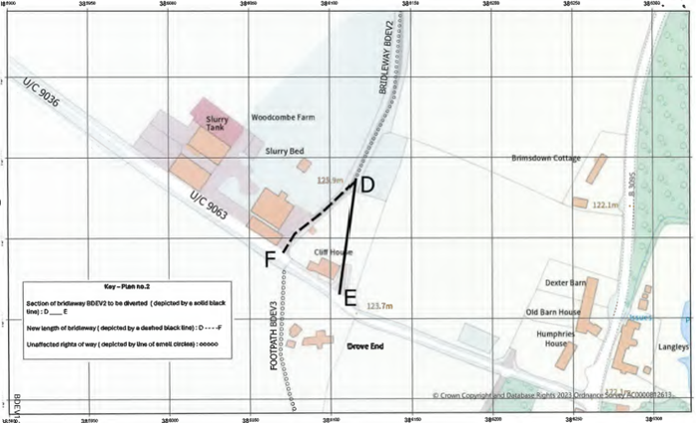

Bridleway 1

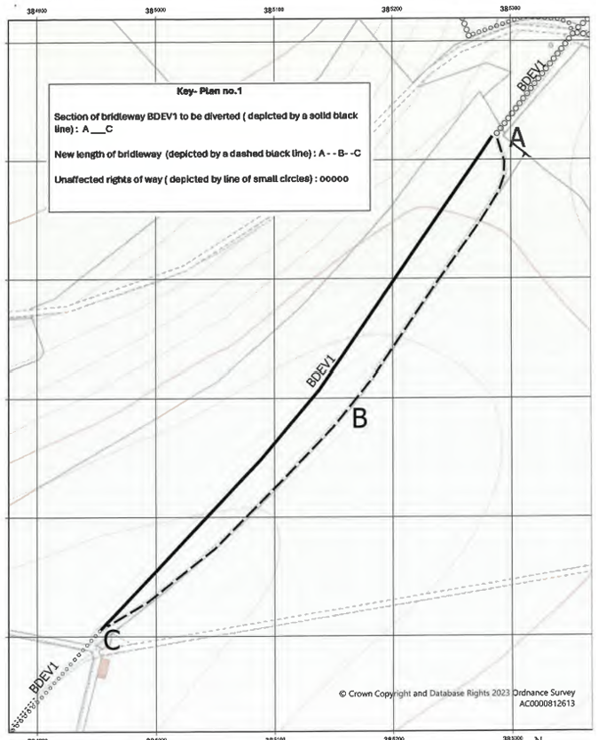
Bridleway 16

