

Order Decision
Site visit on 1 September 2026
by Harry Wood BA (Hons) MA PhD MIPROW
an Inspector appointed by the Secretary of State for Environment, Food and Rural Affairs
Decision date: 8 September 2026

Order reference: ROW/3369910
- This Order is made under section 119 of the Highways Act 1980 and section 53A(2) of the Wildlife and Countryside Act 1981 and is known as the Gloucestershire County Council Public Footpaths GDY 57 (Part) (Parish of Dymock) and GKE 38 (Parish of Kempley) Diversion Order 2023.
- The Order is dated 19 December 2023 and proposes to divert the public right of way shown on the Order Plan and described in the Order Schedule, and to amend the definitive map and statement accordingly.
- There was one objection outstanding when Gloucestershire County Council submitted the Order to the Secretary of State for Environment, Food and Rural Affairs for confirmation.
Summary of Decision: The Order is confirmed.

Preliminary Matters
- I have found it convenient to refer to points marked on the Order Plan and have attached a copy of it to this decision, for reference. I have also added to the existing annotations, to which I will refer throughout the decision.
- The Government guidance on diversion or extinguishment of public rights of way that pass through private dwellings, their curtilages and gardens, farmyards and industrial or commercial premises (also known as the Presumptions Guidance) was issued by Defra in August 2023. It states that I should weigh the interests of the owner against the overall impact of the proposals on the public as a whole. Reducing or eliminating the impact of the existing rights of way on the owner, in terms of privacy, security and safety are important considerations to which due weight should be given.

Main Issues
- Section 119(6) of the Highways Act 1980 (the 1980 Act) involves three separate tests for an Order to be confirmed. These are:
Test 1: whether it is expedient in the interests of the landowner, occupier or the public for the path to be diverted. This is subject to any altered point of termination of the path being substantially as convenient to the public.
Test 2: whether the proposed diversion is substantially less convenient to the public.
Test 3: whether it is expedient to confirm the Order having regard to the effect which (a) the diversion would have on public enjoyment of the path as a whole, (b) the coming into operation of the Order would have as respects other land served by the existing public right of way, and (c) any new public right of way created by the Order would have as respects the land over which the right is so created and any land held with it.
- In determining whether to confirm the Order at Test 3 stage, (a)-(c) are mandatory factors. On (b) and (c) of Test 3, the statutory provisions for compensation for diminution in value or disturbance to enjoyment of the land affected by the new paths must be taken into account, where applicable.
- Regard must also be had to any material provision contained in a rights of way improvement plan (ROWIP) for the area under section 119(6A). Other relevant factors are not excluded from consideration and could, for instance, include those pointing in favour of confirmation.
- Representations have been made concerning the availability of the existing public footpath, including the presence of a hedgerow that is blocking the route at point B1. In comparing the definitive alignment of the footpath in question (hereafter Footpath 160) to the proposed diversion route, I will disregard any artificial or temporary circumstances preventing or diminishing use of the existing footpath and apply the above tests as if the legally recorded line were open and available for use.

Reasons

Whether it is expedient in the interests of the landowner that the path in question should be diverted
- The application has been made jointly by the owners of two properties, The Redlands and Felania. Footpath GKE38 runs immediately to the south of The Redlands between points C and B1, then through a grassy area belonging to Felania between points B1 and B. Becoming Footpath GDY57 at the Parish boundary (point B), the route crosses an agricultural field (between points B and A) belonging to New Grange Farm.
- Gloucestershire County Council (the order making authority, hereafter the OMA) assert that the proposed diversion “would increase privacy and security for the owners of Felania and The Redlands”, and that the new field edge route (between points A and D) “will enable the owner of the field to make better use of the land for grazing cattle or cultivating arable crops.”
- Reducing or eliminating the impact of rights of way in terms of the effect on privacy and security are important considerations which should be given due weight when considering orders. I also note the practical benefits that replacing a cross-field path with a field edge path would bring for New Grange Farm. I am therefore satisfied that it is expedient to divert the footpath in the interests of the landowners.

Whether any new termination point is substantially as convenient to the public
- The definitive line of the existing footpath runs from the main road (C55) through the village (point C) in a north-easterly direction, crossing the parish boundary at point B before terminating at point A. The proposed diversion route begins at point A, running in a generally southerly direction along a field boundary before terminating at the junction with footpath GDY55 (point D). GDY55 continues in a south-westerly direction, becoming GKE39 when it crosses the Parish boundary, before terminating on the main road to the south of the property Felania (approximately 271 metres south of point C). As both the existing footpath and the proposed diversion route ultimately provide access to the same public carriageway, I am satisfied that the new termination point is substantially as convenient to the public.

Whether the new path will not be substantially less convenient to the public
- The OMA advise that the “total distance from point A, the start point of the diverted route, to point C, the termination point of the definitive path would be 657 metres”. This is 354 metres longer than the length of the existing footpath. While this increase will impact public use, it is not considered a substantial increase given the rural location and the context of the local public rights of way network. By way of example, the long-distance Three Choirs Way runs along the main road in Kempley Green.
- The Forest of Dean Ramblers Group and Gloucestershire Ramblers Area, who jointly have made the sole objection, state that the objection was lodged “so that the route to/from the centre of the Village can be retained”. They argue that the existing footpath provides convenient access to the centre of Kempley Green and other paths including the Three Choirs Way” and that the loss of this path “would result in a circuitous and less convenient route to the centre via the outskirts of the village.”
- The OMA point out that there “are no shops, pubs, public attractions or buildings of particular interest in the centre of Kempley Green village to attract walkers from outside the village, and local car parks for visitors are located on the edges of the village.” This is echoed by Kempley Parish Council, who assert that the existing route “neither leads to the centre of the village or to any existing services within the community”. They add that the proposed diversion “would remove a public right of way from two private gardens and open up a new circular route from Kempley Green to the benefit of local walkers”.
- If the Order were confirmed it would leave three public rights of way entering the village from the east: Restricted Byways GKE31 and GKE32 to the north and Restricted Byway GKE39 to the south (from which Footpath GKE40 branches off to the south-east). These routes are approximately 500 metres apart. While the loss of the existing footpath will inevitably have an effect on public convenience, the existence of these alternatives suggests that any impacts are unlikely to be substantial. I note that there are two bus stops marked on Google Maps close to point C (although there is no obvious trace of them on the ground). However, I would suggest that bus passengers are more likely to live in the village itself rather than accessing the service from the east. Taking all this into account, I am satisfied that the proposed diversion will not be substantially less convenient to the public than the existing footpath.

The effect of the diversion on public enjoyment of the path as a whole
- The Objector argues that the existing route “gives enjoyable views over the village and to the hills beyond”. The OMA describes the proposed diversion in a similar manner, describing it as “a pleasant walk along the edge of a grassy field with enjoyable views of the surrounding countryside.” Having visited the site in September 2026, my view is that the existing footpath and the proposed diversion route enjoy broadly comparable views of the village and surrounding countryside.
- The OMA points to the relevance of the Presumptions Guidance as regards public enjoyment, arguing that “it is generally accepted that walkers would prefer not to walk through what appears to be a private driveway and garden.” They also highlight that their pre-order consultation process elicited numerous responses from supporters of the diversion proposals. This includes the Windcross Paths Group, who express the view that the proposed diversion route would “provide a most useful link in the network of paths around Kempley and Kempley Green, allowing for good circular walks.” The OMA suggest that the proposed diversion route may compliment various mid-distance routes in the vicinity of Kempley Green, such as the Daffodil Way. I am satisfied that the proposed diversion will not have a negative impact on the public enjoyment of the path as a whole.

The effect of the diversion on other land served by the existing paths and the land over which the new paths would be created
- The existing footpath and proposed diversion route cross land owned by three different landowners, as discussed above. I have not seen any evidence that the proposed diversion will have a negative impact on the land served by the existing footpath or the proposed diversion route.

Rights of Way Improvement Plan (ROWIP)
- The OMA highlight several aspects of their ROWIP that they consider relevant to the proposed diversion, including ‘Annex D – Priority guidelines for public path orders’. This outlines factors that should be taken into consideration prior to making a public path order, including situations where “the definitive route is affected by long-term obstructions or where considerable works/expenditure would be required from the applicant to open up the definitive route”. While no estimates have been offered as to how much it might cost to carry out the necessary maintenance works on the existing footpath, I accept that such costs are likely to be significant.

Conclusions on whether it is expedient to confirm the Order
- I consider that the proposed diversion is in the interests of the relevant landowners. It will not be substantially less convenient to the public. While there will be a minor negative impact from an access point of view, I am satisfied that the diversion will not negatively impact the public enjoyment of the path as a whole. The information before me indicates that the proposed diversion provides a useful link within the local rights of way network, and that it appears to have considerable public support. I conclude that it is expedient to confirm the Order.

Other matters
- The Objector refers to the Order in two parts, stating that they support the “Creation Order” but oppose the “Extinguishment”. For clarity, the Order under consideration is a diversion order in which the stopping up and creation aspects are part of a single legal document.
- The Objector refers to the proposed diversion route (between points A and D) as a “lost way” and have submitted various historical documents alongside their representations. My task in this matter solely concerns the tests set out in section 119(6) of the 1980 Act. The proposed diversion route is not currently recorded as a public right of way, but I note that the Objector has the right to submit a definitive map modification order application.

Overall Conclusion
- Having regard to the above, and all other matters raised in the written representations, I conclude that the Order should be confirmed.

Formal Decision
- I confirm the Order.

Harry Wood

INSPECTOR

Order Plan (not to scale)
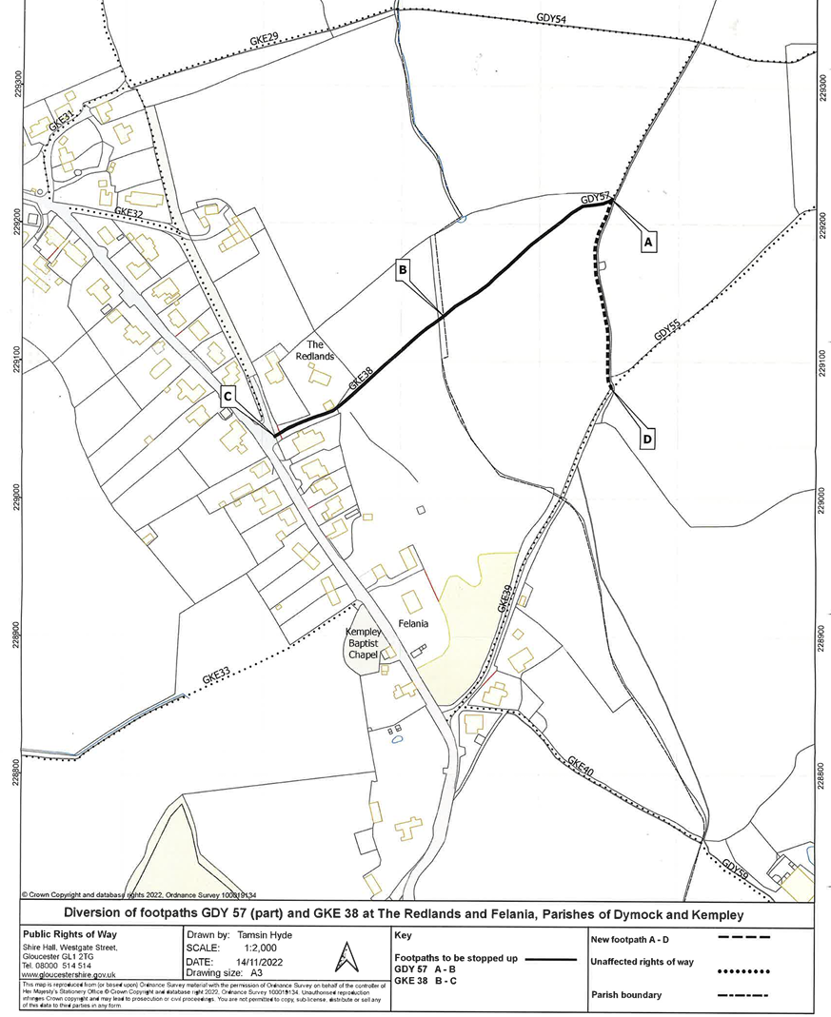
B1

