

Order Decision
Site visit on 9 June 2026
by Nigel Farthing LLB
an Inspector appointed by the Secretary of State for Environment, Food and Rural Affairs
Decision date: 26 August 2026

Order Ref: ROW/3355474
- This Order is made under Section 53(2)(b) of the Wildlife and Countryside Act 1981 (the 1981 Act) and is known as the Kent County Council (Bridleway HE374 at Stelling Minnis) Modification Order 2024.
- The Order is dated 9 August 2024 and proposes to modify the Definitive Map and Statement (‘DMS’) for the area by adding a bridleway between Eastleigh Court Road and High Minnis, via Sandy Lane in the parish of Stelling Minnis, as shown on the Order Map and described in the Order Schedule.
- There were three objections outstanding and one representation in support of the Order at the date the Order was submitted for confirmation.
Summary of Decision: The Order is not confirmed.

Procedural Matters
- I have considered the objections and the representation in reaching this decision.
- I made an unaccompanied site inspection on Tuesday 9 June 2026.
- In this decision I have found it convenient to refer to the annotation of the Order route A – D on the Order map and for ease of reference a copy is attached.
- The Order seeks to add to the DMS a bridleway in two sections with a total length of approximately 467 metres, as shown on the Order Map between the points marked A to B and C to D.

The Main Issues
- The Order has been made under section 53(3)(c)(i) of the 1981 Act which requires the discovery of evidence which (when considered with all other relevant evidence available) shows that a right of way which is not recorded on the DMS subsists or is reasonably alleged to subsist.
- At this confirmation stage of the process, it is necessary for the evidence to show that the right of way subsists, a reasonable allegation is not sufficient.
- The standard of proof to be applied is the balance of probabilities.
- Section 32 of the Highways Act 1980 (the 1980 Act) requires me to take into consideration any map, plan or history of the locality or other relevant document provided, giving it such weight as is appropriate, before determining whether or not a way has been dedicated as a highway.
- The Order has been made on a consideration of historic documentary evidence, principally the Lyminge High and Rhodes Minnis Inclosure Award 1855. There is no user evidence before me. For the Order to be confirmed it will be necessary for me to be satisfied that the documentary evidence demonstrates, on a balance of probability, that the Order route has the historic status of a public bridleway.

Reasons

Site visit
- I made an unaccompanied site visit on 9 June 2026 when I viewed the length of the Order route (approximately 470 metres) and familiarised myself with the area. The Order route is effectively in two parts; the first section commences at point A on the Order map which is at a bend in Eastleigh Court Road. There is a field gate into a field of rough grass which slopes uphill. There is no evidence of any route on the ground. Assessing the route by eye it would seem to skirt a spinney and proceed across the field to Sandy Lane at point B.
- The west side of Sandy Lane has a substantial hedge. There is no opening in the hedge in the vicinity of point B, although there is a section which appears lower than the remainder of the hedge and could be where it growing to fill a gap. I could not identify whether this correlates to point B.
- The second section commences at point C on the east side of Sandy Lane and proceeds in a straight line to point D on High Minnis. There is a field boundary coincident with the Order route, and it is not apparent which side of the boundary the Order route runs. There is no defined route on the ground between points C and D on either side of the boundary.
- The Order route C to D crosses two separate fields. To the north of the boundary the first field is grass which had been cut shortly before my visit. This section of the route is level. The Order route intersects with a field boundary approximately halfway between C and D. This boundary was very overgrown such that I could not traverse it. Beyond this boundary the Order route continues (if it is on this side of the boundary) along the margin of a field of rough grass which slopes downhill to High Minnis at point D. The boundary between this field and the compartment to the south is marked by a post and wire fence.
- To the south of the boundary there is only a single field between Sandy Lane and High Minnis which, at the time of my visit, was in arable cultivation. The Order route, if it were on the south side of the boundary, would run along the field margin but there is no evidence of a defined route or use of any nature.

Consideration of the evidence
- There is no evidence to suggest that the Order route has previously been considered for inclusion on the DMS and I am therefore satisfied that there has been a sufficient discovery of evidence to satisfy the requirements of section 53(3)(c) of the 1981 Act in that respect.
- The principal evidence relied upon to support the Order is the setting out of the route in the Lyminge, High and Rhodes Inclosure Award (1855) (‘the Award’). Ordnance Survey (‘OS’) mapping is produced by the Applicant which it is said demonstrates that the route was in fact laid out in accordance with the Award and came into use.
- The Tithe Map for Lyminge (1840) demonstrates that prior to the Award the land in the vicinity of the Order route was part of a large parcel of unenclosed common land.

The Award
- The Award was made under the Inclosure Act 1845 (‘the 1845 Act’) the purpose of which was stated to be to facilitate the inclosure of Commons and lands held in common. The scheme of the 1845 Act required various stages to be undertaken.
- First, under section 62, a valuer was to be appointed to carry out a survey and valuation of the land to be inclosed. It was the responsibility of the valuer to divide and award the land to individuals. The valuer also had power to set out “Roads and Ways”.
- The second stage, detailed in section 65, required the valuer to ‘form and complete’ newly made roads and ways in accordance with the requirements as to width contained in the Highways Act 1835. This provided for “every public Horseway” to have a minimum width of eight feet.
- The final stage of the process is set out in section 67 of the 1845 Act which required ‘public roads and ways’ to be certified by two Justices of the Peace once they had been physically laid out and completed. This section also provided that after certification, public roads would become publicly maintainable. This provision does not refer to ‘ways’.
- The Award included the award of: -

“One public Bridle Way of width of twelve feet and numbered 4 on the Map commencing at East Leigh Lane at a point marked G and extending thence in an easterly direction across the Sand Gate Road to and terminating at the Wheelbarrow Town Road at a point marked H on the said Map”.

Although the names of the roads have changed, it is common ground that the route so set out is the Order route.
- The Award was confirmed by the Inclosure Commissioners on 21st June 1855. The effect was to confirm that the proper procedures had been followed in the making of the Award and that it is legally binding.
- There is no evidence of the route so set out having been certified by two Justices of the Peace as required by section 67. Indeed, no evidence has been found of the certification of any of the ‘Roads or Ways’ set out by the Award within High Minnis, although certification exists for some roads within Rhodes Minnis.

OS Mapping
- The First Edition OS (1872) depicts with double-pecked lines a route broadly consistent with the Order route. The section A to B is shown with a clear kink in contrast to the Award map which shows this section to be a straight line. The section C to D is shown as a straight line, in accordance with the Award map and is shown to the north of the field boundary. The route is not annotated.
- The OS Second (1896-98) and Third (1906-07) editions depict the route in identical manner to the First edition save that both sections of the route are annotated “FP”. The Fourth edition (1939-45) differs from the previous editions in showing the section A to B as a straight line, and the section C to D to the south of the field boundary.

Bartholomew Maps (1904, 1922 and 1941)
- The Order route is not shown on any of these editions of Batholomew’s Maps.

Finance Act 1910
- The Order route is shown on the Finance Act Map within coloured and numbered hereditaments. The section A to B is within hereditament 211 which is a large parcel of land against which a deduction of £25 is made for public rights of way. This parcel contains a different public footpath which is currently recorded on the DMS and could account for the deduction. No deduction is made against the parcels through which the section C to D passes.

Parish Map and the DMS
- The Order route was not identified on the Parish Map as a public right of way of any description and did not appear on the draft, provisional or final versions of the DMS and has not been claimed at any subsequent review.
- Other documentary evidence has been investigated but nothing further has been found supportive of or relevant to public status of the Order route.

Assessment of the evidence
- The evidence in this case is simple; the Applicant relies upon the Award as evidence that a public bridleway was awarded on the alignment of the Order route and relies upon OS mapping to prove that the way was “sufficiently formed and completed” as required by section 67 of the 1845 Act.
- An Inclosure Award can be conclusive evidence of the creation of public rights of way. In this case there is no credible argument against the intention of the Award being to create a public bridleway with a width of 12 feet on the alignment of the Order route. Had such a route been created and come into effect then, in the absence of evidence of some subsequent formal process to divert or stop it up, the status would subsist no matter that the route had fallen into disuse.
- The single issue for me to decide is whether, in the absence of evidence of certification by two Justices of the Peace, the route set out by the Award did in fact come into effect. The Applicant argues that there are five options to consider; -
- That the 1845 Act does not require this bridleway to be certified;
- That the 1845 Act does not require a bridleway to be certified;
- That certification may be presumed;
- That if certification is required and cannot be evidenced or presumed the only consequence is that the way does not become publicly maintainable; or
- That public interest dictates that the bridleway came into existence.
- The first contention is that the requirement for certification did not apply to a route which existed prior to inclosure. I do not need to spend any time on this line of argument because, as the Applicant appears to acknowledge, there is no evidence that the Order route existed prior to inclosure when the land in question was open common. The Applicant suggests it is ‘highly likely that such a track did exist’. There is no basis in the evidence for such an assertion.
- The second contention, that the 1845 Act does not require a bridleway to be certified, is predicated upon an argument that the term ‘Roads and Ways’ in section 62 of the 1845 Act should not, for certain purposes, include bridleways or footpaths. The Applicant notes that the section does not specifically refer to bridleways and footpaths but recognises the section does give specific power to set out new bridleways and footpaths over inclosed land and therefore the term ‘Ways’ must include them.
- The Applicant acknowledges that the requirement for certification under section 67 applies to ‘public Roads and Ways’ but argues that bridleways and footpaths were not to be publicly maintainable and therefore the requirement for certification had no purpose and thus, for this purpose the reference to ‘Ways’ should not include bridleways.
- At best the Applicant’s submission would seem to be that the certification procedure was intended mainly to apply to roads. I do not consider that it is credible to adopt an interpretation of the Act which relies upon the same word (Ways) being given a different meaning according to its purpose (that it should include bridleways when dealing with setting out but not for the purposes of certification). Accordingly, I reject the argument that there was no requirement for certification of a bridleway.
- The third contention is that certification can be presumed. The Applicant relies upon the authority of R v Inhabitants of Enford (Wiltshire Easter County Quarter Sessions, Salisbury 28 March 1956) to support an argument that in the absence of any evidence to the contrary, certification should be presumed. In that case the issue before the court was whether the road in question was publicly maintainable. The road had been set out under an inclosure award under the 1801 Act which contained a certification provision equivalent to section 67 of the 1845 Act. Under that provision failure by the surveyor to complete the relevant duties under the Act could result in a fine of £20. In those particular circumstances the court concluded it could be presumed that the duty to obtain certification had been complied with unless there was evidence to the contrary which would rebut the presumption.
- I accept that in principle certification can be presumed unless there is sufficient contrary evidence. The issue I have to consider is whether in this case there is contrary evidence, and if so, whether it is sufficient to rebut any presumption.
- The evidence relied upon by the Applicant to demonstrate that the route was set out in accordance with the Award is the depiction of the route on OS mapping. I accept the OS mapping indicates that from at least 1872 a route of some description existed broadly on the alignment for Bridle Way No.4 as depicted on the Award Map. However, there are a number of discrepancies between the Award and the OS mapping.
- First, the alignment of the Order route section A – B shown on the OS First to Third editions departs from the Award Map alignment. Instead of a straight line between these points, the OS route has a clear deviation, which is repeated in each of the first three editions. Although the alignment is shown to be straight, and therefore consistent with the Award map, on the OS Fourth edition, that has no relevance to what was set out on the ground in consequence of the Award.
- Second, the feature shown on the OS mapping appears somewhat narrower than 12 feet which is the width prescribed by the Award. Kent County Council (the Council) state that the width shown on the OS, scaled from the map, is no more than 2 metres for the majority of its length. The Council describe this as “considerably less than the ‘twelve feet’ (of 3.6 metres) set out in the Award”.
- Although the route shown on the OS First edition is not annotated, the subsequent editions each annotate the route as a footpath, which is perhaps more consistent with the width of route shown.
- The Award Map and the 1st, 2nd and 3rd editions of the OS show the Order route C – D to the north of the field boundary but the 4th edition shows the path to the south of the boundary. Whilst this is another inconsistency, I do not consider it to be material as the early editions of the OS are consistent with the Award and demonstrate that whatever existed between C and D was on the specified alignment.
- There is no evidence of use of the Order route as a bridleway. The depiction of the route on OS mapping gives rise to an inference that the route was used on foot, but nothing more, and representation of a route on an OS map is not evidence of public status.
- The treatment of the Order route on the map prepared for the Finance Act 1910 valuation process (no deduction for C – D and a deduction for the parcel containing A – B which is explicable by the presence of an established footpath) is consistent with it not having the reputation of being a public right of way in the early 20th century and this is maintained by the fact that the route was ignored at the time of the First DMS and subsequently.
- These various inconsistencies inevitably give rise to some doubt as to whether the route was set out strictly in accordance with the Award. At the order making stage the Council recognised these issues but to make the Order was required only to be satisfied that the route was reasonably alleged to subsist, and it was on this basis that the Order was made. At this confirmation stage I have to be satisfied that the Order route subsists; this is a more demanding test requiring me to make a finding on a balance of probabilities.
- Each of the factors I have identified would, on their own, probably be insufficient to rebut a presumption that the route was set out in accordance with the Award. The combined effect of the various factors however creates a more finely balanced position. I am struck by the lack of any evidence which might readily corroborate the existence of a 12’ bridleway at any point in time after 1855. The OS First edition is only 17 years after the Award and yet it does not appear to show a route consistent with a 12’ width and after a further 14 years the route is shown as a footpath and a further 12 years later no deduction is made under the Finance Act procedures for a public right of way of any description. Since that time there is no evidence of any public use or reputation of any public status.
- The Council note that some of the footpaths set out in the Award were not brought into use. Of six footpaths set out, two are recorded on the DMS and are in use by the public. One appeared on the OS County Series First and Second editions suggesting a path was evident to the OS surveyor after the Award. The other three paths have not appeared on any of the OS County Series maps suggesting that despite being awarded they were not made and put into effect. This is some evidence that not every awarded way came into being, but the Applicant understandably points out that in the case of the Order route the OS does evidence the existence of a route consistent with the alignment of the awarded bridleway.
- Against these factors must be set the weight that attaches to the Award and the fact that a route, broadly consistent with the Award, came into existence no later than 1872, being the date of the 1st edition OS. In my judgement the evidence is finely balanced. In such circumstances it is necessary to have regard to where the burden of proof lies. In this case the burden lies with the Applicant to prove the case on a balance of probabilities. As I find the arguments are balanced, I must fall back on the burden of proof which accordingly is not discharged. For this reason, my conclusion is that I am satisfied that the Awarded route cannot be presumed to have been certified to have been set out strictly in accordance with the Award.
- The Applicant’s fourth contention is that certification was not required and that the Order way came into existence even if there is no evidence of certification and no presumption of certification arises. The Applicant argues that certification was not relevant to the public right to use the route as a bridleway and that the only consequence of non-certification was that the way would not be publicly maintainable.
- In Cubitt v Maxse [1873] LR 8 CP 704 the court found that the award of a road in an Inclosure Award was ineffective because there was no evidence of certification and no evidence that the public at large had used the route. The court in Cubitt dismissed an argument that certification was relevant only to liability for public maintenance (and thus not to status) where Keating J said: -

“I take the intention of the legislature to have been that the moment a way was ascertained to be a highway, it became repairable by the parish as at common law: and, when the Act of Parliament says that the road shall not be repairable by the parish until certain preliminaries are gone trough [sic], it appears to me that it was not intended that it should be a highway until all these were done.”

Put simply, Keating J was saying that both public status and public maintenance liability were dependent on certification where certification was required.
- The decision in Cubitt concerned an Award made under the 1801 Act rather than the 1845 Act but the principles are the same and there is no obvious reason why they would not apply in this case.
- The Applicant’s fifth contention is supported by a detailed submission that the public interest requires that the bridleway was created effectively. At the heart of the submission is an argument that the awarding of public rights was part of the ‘give and take’ of the inclosure process and that it would be inequitable for a landowner to enjoy the benefit of an allotment of land without accepting the burden of an awarded public right of way. Whilst recognising some moral value in this argument, I am required to make a decision on the evidence; I do not have the benefit of any jurisdiction in equity and have not been provided with any legal basis for me to adopt it in this case.

Conclusions
- Having regard to the foregoing and for the reasons given, I conclude that the Order should not be confirmed.

Formal Decision
- I do not confirm the Order.

Nigel Farthing
Inspector

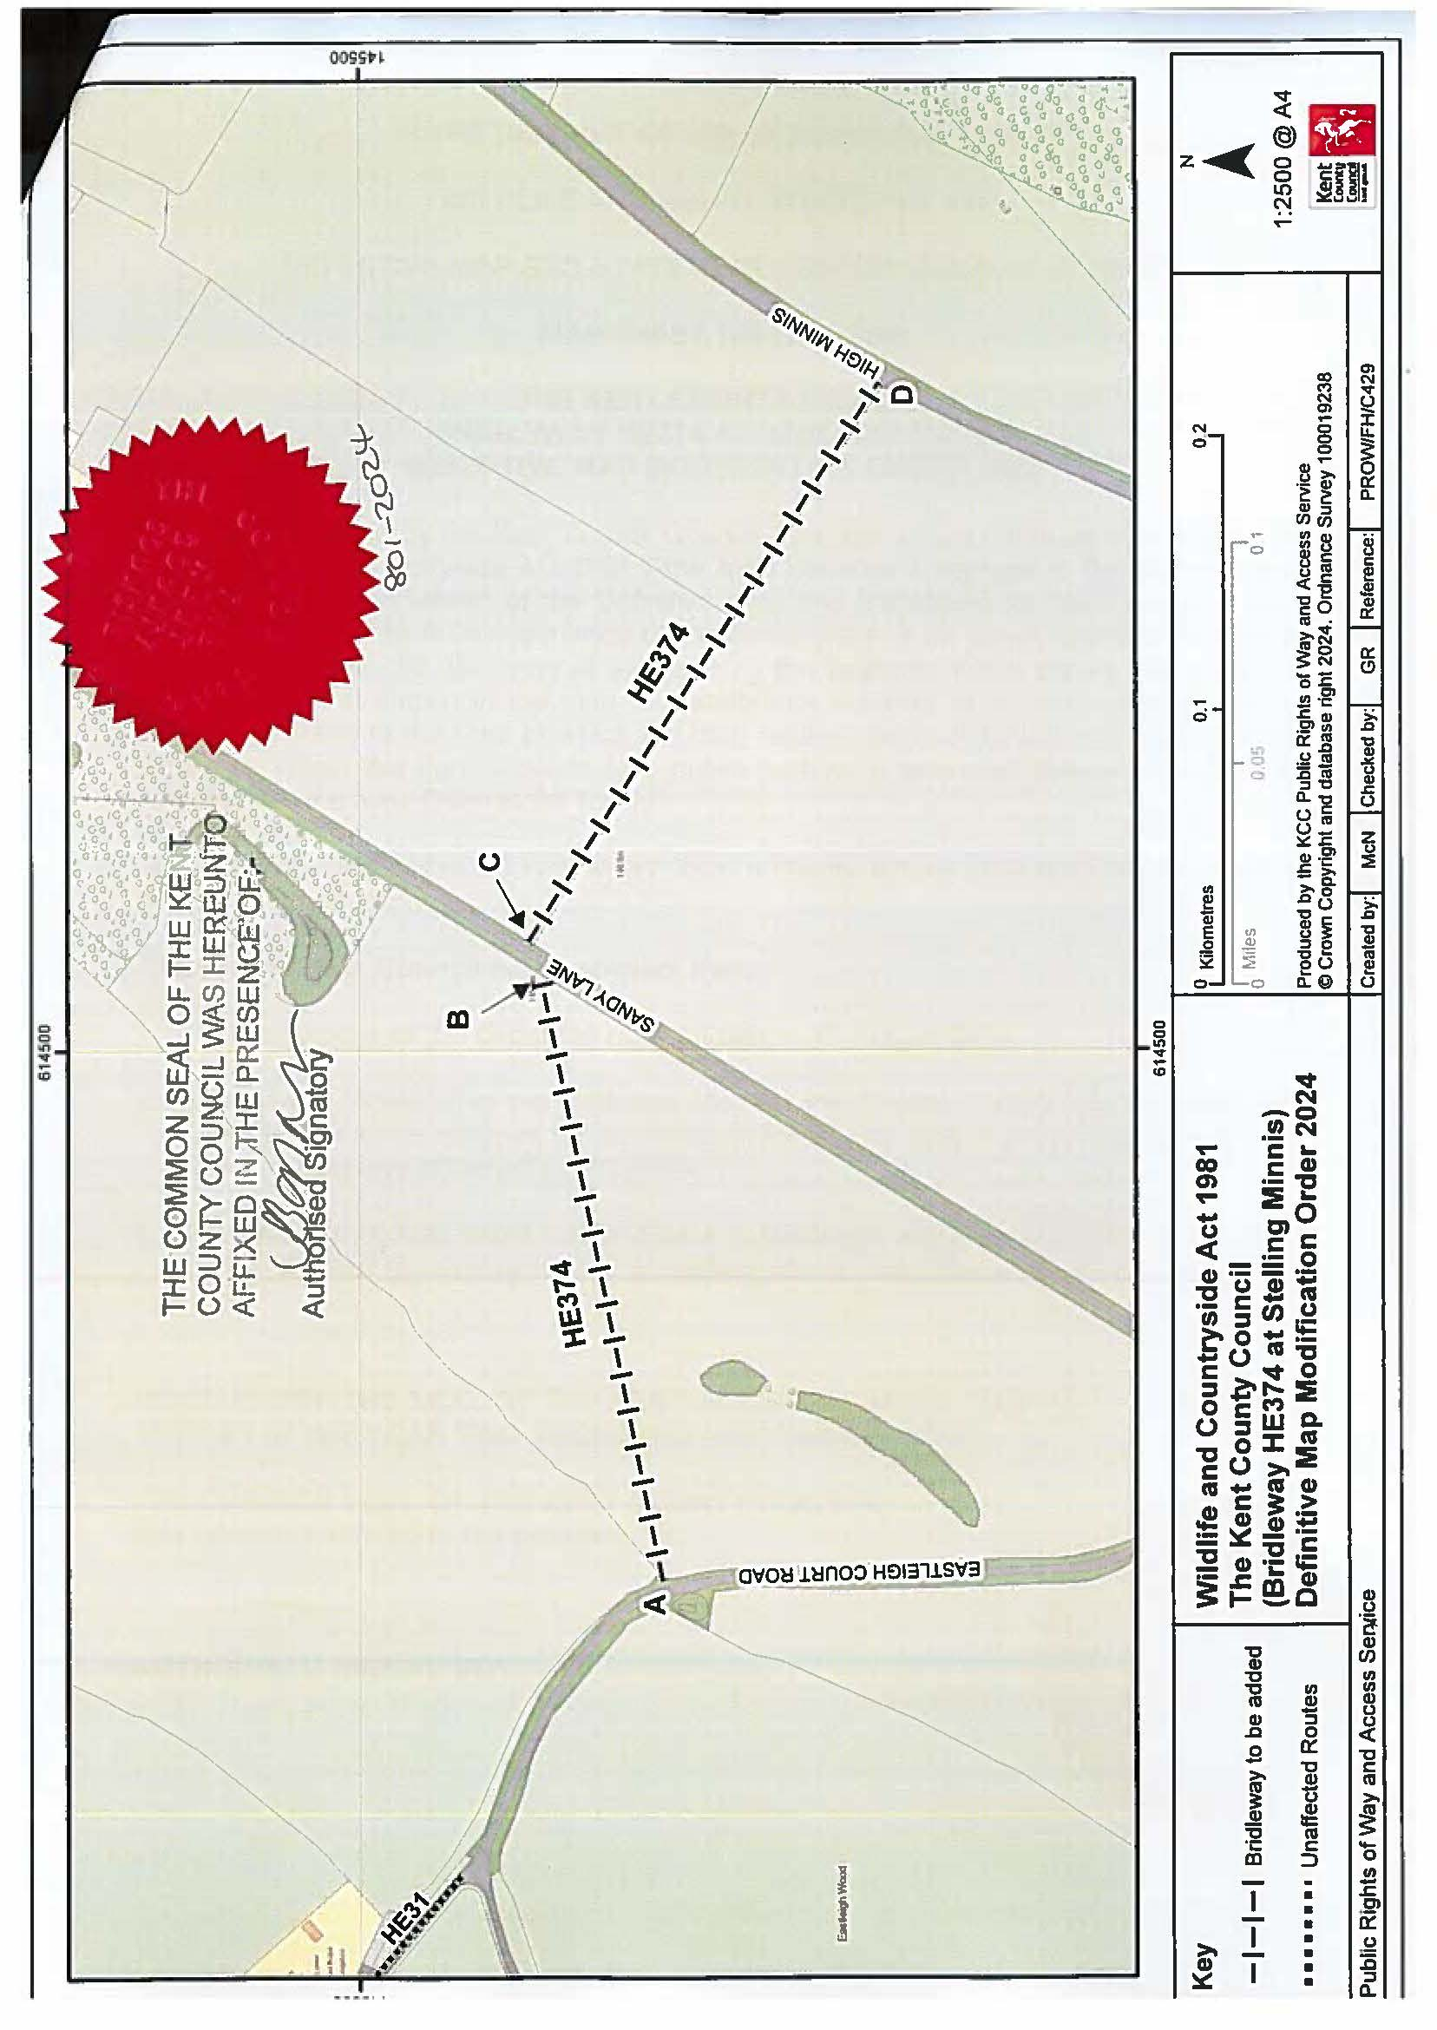
Order Plan

