

Order Decisions
Inquiry held on 25 August 2026
Site visits made on 24 and 25 August 2026
by James Blackwell LLB (Hons) PGDip, Solicitor
An Inspector appointed by the Secretary of State for Environment, Food and Rural Affairs
Decision date: 7 September 2026

Order Refs: ROW/3345849, ROW/DMM/00256 (Order A)
- This Order is made under Section 53(2)(b) of the Wildlife and Countryside Act 1981 (1981 Act) and is known as the Suffolk County Council (Parish of Kedington FP32) Modification Order 2024.
- The Order is dated 8 January 2024 and proposes to modify the Definitive Map and Statement for the area by adding a public footpath as shown in the Order plan and described in the Order Schedule.
- There were objections outstanding when Suffolk County Council (‘the Council’) submitted the Order to the Secretary of State for Environment, Food and Rural Affairs for confirmation.
Summary of Decision: The Order is confirmed.
Order Refs: ROW/3345850, ROW/DMM/00255 (Order B)
- This Order is made under Section 53(2)(b) of the Wildlife and Countryside Act 1981 (1981 Act) and is known as the Suffolk County Council (Parish of Kedington FP33) Modification Order 2024.
- The Order is dated 8 January 2024 and proposes to modify the Definitive Map and Statement for the area by adding a public footpath as shown in the Order plan and described in the Order Schedule.
- There were outstanding objections when Suffolk County Council (‘the Council’) submitted the Order to the Secretary of State for Environment, Food and Rural Affairs for confirmation.
Summary of Decision: The Order is confirmed.

Preliminary Matters
- The Orders concern the proposed addition of two footpaths to the Council’s Definitive Map and Statement (DMS), which run along either side of the watercourse known as The Cut, in the parish of Kedington. Order A concerns the route along the western side, and is shown between points E and F on the plan attached to the Order. Order B concerns the route along the eastern side, and is shown between points A, B, C and D on the plan attached to the Order.
- The route between points A and B runs through private residential property, which is known as The Watermill. Whilst the owner objects to the Order, this objection is limited to the route between points A and B, which falls within her property.
- The majority of affected land outside of points A and B is owned by The Thurlow Estate, and is occupied by the Parish Council pursuant to a licence dated 13 April 2011. The Environment Agency (EA) also owns a small section of land affected by Order A at the very northern end of the route, and Suffolk County Council owns a small section of the land affected by Order B, between points C and D.
- In terms of A – B, the Objector says use of the route has compromised her home, privacy, safety and wellbeing. Whilst I fully sympathise with these concerns, the Wildlife and Countryside Act 1981 is limited to ascertaining the existence of public rights of way, but not the respective merits of those rights. Indeed, confirmation of the Orders would not create new footpaths, but instead would formally record footpaths found to subsist. This means the respective merits of the footpaths are not relevant to confirmation of the Orders, and I cannot consider such factors when reaching my decisions.

Main Issues
- Both Orders have been made under Section 53(2)(b) of the 1981 Act on the basis of an event specified in Section 53(3)(b), namely the expiration, in relation to any way in the area to which the map relates, of any period such that the enjoyment by the public of the way during that period raises a presumption that the way has been dedicated as a public path.
- In turn, the provisions of s31 of the Highways Act 1980 (HA 1980) are also relevant. These say that where a way has been enjoyed by the public as of right and without interruption for a period of 20 years, the way is deemed to have been dedicated as a highway, unless there is sufficient evidence to show there was no intention during that period to dedicate it. The relevant 20-year period is calculated retrospectively from the date the right of the public to use the way was brought into question. ‘As of right’ means use must have been open, without force and without permission.
- Whilst a definitive map modification order can be made on the basis of a public right of way being reasonably alleged to subsist, the standard of proof is higher for an Order to be confirmed. At this stage, evidence must show, on the balance of probability, that a right of way subsists over the claimed routes.
- Whilst the two Orders are closely related, the issues and evidence are slightly different between the two. I have therefore addressed each Order in turn.

ORDER A (FP32 – Western side of The Cut)

Reasons

When was use by the public brought into question?
- As mentioned, the majority of this route runs through land owned by The Thurlow Estate, with the exception of a small parcel at the very northern end, which is owned by the EA.
- In 2009, The Thurlow Estate deposited a map and statement under Section 31(6) of the HA 1980 in respect of their land. This formally recorded the public rights of way which they accepted on their land, and indicated their intention not to dedicate any further routes over the same. A further deposit was subsequently lodged in 2015. Neither acknowledged the Order route as a public footpath.
- These deposits and statements evidence a clear lack of intention to dedicate the Order route as a public footpath. In terms of The Thurlow Estate-owned land, the relevant 20-year period should therefore be calculated retrospectively from the date of the first deposit, as this would have brought into question the public’s right to use the route.
- As for the EA land, there is no known challenge to use, and the relevant 20-year period should be calculated by reference to the date of application, which was made in 2021.
- Accordingly, I have assessed the user evidence by reference to the following periods:
- The Thurlow Estate owned land: 1989 – 2009
- The EA owned land: 2001 – 2021

User Evidence
- The applications for the Orders were supported by more than 60 user evidence forms (UEFs). The Council conducted telephone interviews with a sample of 12 of these users, and 17 users also gave evidence during the Inquiry.
- In terms of Order A, claimed use of the path covers a period in excess of 50 years, with several users detailing their use as far back as the early-mid 1960s. More than 30 users say they used the route throughout the relevant 20-year period, with more than 20 others saying they used the route during at least part of the period. Whilst frequency of use does vary, users generally point to regular and routine use of the path, with many saying they used it daily or weekly. Whilst a multitude of reasons for use are cited by users, it is most commonly said to be used for recreation and dog-walking. Many say they used the route as part of a circular walk, together with the route alongside the eastern side of The Cut.
- Whilst the relevant period in respect of the EA-owned land is 2001 – 2021, most UEFs were completed in 2020, and only detail use up until this point. Nonetheless, those who were interviewed by the Council confirmed their use had continued beyond this time, as did witnesses who appeared at Inquiry. In turn, I am satisfied that use of the Order route continued up until 2021.
- Whilst not disputed, the user evidence is credible and consistent, and is indicative of the route having been used by the public on foot throughout the relevant period.

As of Right
- The user evidence suggests the path was used openly and without force during the relevant period.
- In terms of permission, in a letter dated 15th November 1972, The Thurlow Estate granted use of an area of its land to Kedington Parish Council, for a peppercorn rent of £1 per annum. With the exception of the small section of EA land, this grant included all land encompassed in the Order route.
- It certainly seems plausible that the grant was given to the Parish Council for the purpose of public recreation, noting that the public has used the land since the early 1960s (if not before). However, the letter is limited in detail, and does not specify what the land is to be used for, nor does it say that public access is permitted. Therefore, whilst arguably, the letter suggests use of the land by the Parish Council was permissive, it does not necessarily follow that use by the public was permissive.
- In the case of R v Oxfordshire County Council ex parte Sunningwell Parish Council [2000] 1 AC 335 (Sunningwell), the House of Lords emphasised the objective nature of the inquiry into whether use is "as of right". The fact that a landowner may privately have regarded use as permitted is not sufficient to render that use permissive. Instead, there must be some outward manifestation of permission, so that users understand their continued use is dependent upon the landowner’s consent.
- In this instance, there is little to suggest that the general public were aware of the 1972 letter between The Thurlow Estate and the Parish Council. Moreover, there is no evidence of any signs, notices or other communication within the land itself, that would have made the public aware that their use was permissive. Therefore, most users likely thought they were using a public footpath, rather than thinking their use was dependent on landowner permission. In turn, the letter is not sufficient to establish that use of the Order route was permissive during the relevant period.
- Whilst a formal licence was entered into between The Thurlow Estate and the Parish Council in 2011, this post-dates the relevant period and therefore has little bearing on the character of use during the critical timeframe.
- Overall, I consider the evidence is indicative of use having been open, without force and without permission during the relevant period, and was therefore as of right.

Intention of Landowner
- As mentioned, there is no suggestion that any users were challenged when using the Order route. There is also no evidence of any signs, notices or other obstacles which may have suggested to users that the landowner did not intend to dedicate the Order route as a public footpath.
- In the context of R (on the application of Godmanchester Town Council) v Secretary of State for the Environment, Food and Rural Affairs [2007] UKHL 28 (Godmanchester), this is again important. In this case, it was held that a landowner’s lack of intent must be overtly communicated to the public in order to prevent dedication of a public right of way. This test is objective, and is based on what a reasonable person would understand, and not a landowner’s private intention.
- Therefore, notwithstanding the 1972 letter from The Thurlow Estate to the Parish Council, even if the landowner did not intend to dedicate the Order route as a public right of way, this would not defeat the claim of presumed dedication, as this was not made sufficiently clear to the general public.

Conclusion – Statutory Dedication
- Overall, the evidence is demonstrative of the claimed route having been enjoyed by the public as of right and without interruption throughout the relevant 20-year period. There is also little to suggest any lack of intention to dedicate the claimed route as a public right of way was ever made clear to the public. The evidence therefore shows, on the balance of probability, that the claimed route is deemed to have been dedicated as a public footpath under s31 HA 1980.

ORDER B (FP33 – Eastern Side of The Cut)

Reasons

When was use by the public brought into question?
- In September 2020, temporary fencing was erected across points A and B of the Order route. In October of the same year, this fencing was replaced with locked five-bar gates (albeit access could still be requested from the Owner on a permissive basis). For most users, it was the erection of these barriers that brought into question their right to use the route. Accordingly, I have assessed the user evidence by reference to the period between 2000 – 2020.
- Nonetheless, it is worth noting that the Objector mentions verbally challenging a number of users following her purchase of the property in 2017 (and prior to the erection of fencing in 2020). Whilst no users who gave evidence recall being challenged in this way, arguably such action could have brought the public’s right to use the way into question. However, even if the user evidence was considered by reference to an earlier 20-year period (e.g. 20 years prior to 2017), it would not have changed the outcome of my decision, as evidence of use dates back long before 1997.

User Evidence
- Once again, claimed use of the path covers a period in excess of 50 years. This time, more than 40 users say they used the route throughout the relevant 20-year period, with more than 15 others saying they used the route during part of it. Again, frequency of use varies, but most point to regular and routine use of the path, with many citing daily or weekly use.
- As with Order A, the path is said to have been most commonly used for recreation and dog-walking. Users also mention using the path to access Silver Street Park at its southern end, as well as a memorial situated along the route. Several witnesses say they prefer this route to the path along the western side of The Cut, due to it being sunnier, less shaded, drier and more accessible.
- Whilst the extent of use is not readily disputed by the Objector, the user evidence is again credible and consistent, and indicative of the route having been used by the public on foot throughout the relevant period.

As of Right
- The user evidence again suggests the path was used openly and without force during the relevant period. Indeed, whilst some historic photos appear to show fencing near to point A, they do not appear to show access being blocked – and none of the users recall any physical barrier to access prior to 2020. However, the Objector contends that use of the route has always been permitted or tolerated by successive owners of the Watermill.
- Whilst the 1972 letter from The Thurlow Estate to the Parish Council does not grant specific rights over the land encompassed in A - B, the letter does say that access is to be obtained over the land adjoining the mill (which presumably relates to the section of route between A - B). The letter refers to The Thurlow Estate having “spoken to Mr. Wildman, the owner of the mill and he is aware of the position”, and goes on to say that “If, in the future, he wishes to stop this access he is obliged to build a bridge over the stream at point A on the map”.
- Based on this letter, it seems a conversation (at least) must have taken place between The Thurlow Estate and the owner of the Watermill, to discuss and agree access arrangements to the land granted to the Parish Council. Given the user evidence confirms regular use of the route long before this time, it can also be deduced that the Watermill owner agreed to such access.
- However, as with Order A, this does not equate to use of the route being permissive. As per Sunningwell, tolerance or acquiescence of public use is not the same as permission, which demands some kind of overt act to make it clear to the public that their use is permissive.
- A number of the Objector’s witnesses say they had always understood use of the route between A - B to be permissive. One of these witnesses is a close neighbour to the Watermill, two had worked there, one had attended an open garden, and another had house-sat at the property. These witnesses therefore have, or had, some kind of direct association with the property or its owners. In terms of permissive use, this may have meant they had more knowledge of the owner’s intentions, than the public more generally.
- Indeed, the vast majority of users say they were never given permission to walk the path by the owners of The Watermill, nor did they think such permission was needed. There is again little evidence of any signs, notices or other wider communications during the relevant period that would have made it clear to the public that their use was permissive. These factors suggest that the general public, who did not have a direct association with the property or its owners, thought they were using a public path, rather than thinking their use was dependent on the landowner’s permission.
- The Objector suggests users should have been aware of the private nature of the section of route between A - B, as its character and maintenance can be distinguished from the remainder of the Order route. Notwithstanding such differences, the path between A - B is bounded on its eastern side by a tall hedgerow and fencing, which separates it from the main garden to the Watermill. In turn, it may not have been clear that the route formed part of this property.
- Even if users did think the land was private, it does not follow that they would assume permission was needed. Indeed, public and private rights commonly coexist over land, and many public rights of way run across private land. As highlighted by most users who gave evidence, they simply assumed the route was a public footpath – and the character of the path did not readily impact on their understanding in this regard.
- The Parish Council letter in November 2020 refers to the public being “afforded access” by owners of the Watermill. Whilst this could suggest that the Parish Council understood access to be permitted, given this letter post-dates the relevant 20-year period, it would not have altered how the general public perceived their use during the relevant period. It therefore has little bearing on whether use was permissive or not.
- Overall, whilst there is some limited evidence of users understanding their use of A - B to be permissive, for most users who gave evidence, this was not the case. The evidence therefore points to use being open, without force and mostly without permission during the relevant period, and therefore as of right.

Intention of Landowner
- The Objector says she has, on occasion, challenged footway users to highlight that her land is private. However, she acknowledges such challenges were not made routinely, and the vast majority of users say they weren’t ever challenged when using the claimed route. Even if the owner of the property (past or present) did not intend to dedicate the route as a public footpath, the evidence suggests most users were not aware of this. In the context of Godmanchester, this means insufficient action was taken by the landowners to communicate any lack of intention to dedicate to the public.

Conclusion – Statutory Dedication
- Overall, the evidence is indicative of the claimed route having been enjoyed by the public as of right and without interruption throughout the relevant 20-year period. There is also little to suggest any lack of intention to dedicate the claimed route as a public right of way was ever made clear to the public. The evidence therefore shows, on the balance of probability, that the claimed route is deemed to have been dedicated as a public footpath under s31 HA 1980.

Other Matters
- Whilst the 2020 Parish Council letter says the routes are not designated public rights of way, this is because they were not recorded on the Council’s DMS. Nonetheless, the letter acknowledges that an application for a Definitive Map Modification Order could be made, as has now been done.
- Whilst there are no way markers along the Order routes, this is to be expected, as the routes are not currently recorded as footpaths. However, the lack of signage does not affect the application of presumed dedication under s31 HA 1980, which is based on use.
- In user evidence cases, it is common for someone to take responsibility for gathering user evidence, and to invite local users to complete evidence forms. This is a normal part of the process and does not undermine the credibility of the evidence contained therein. The forms appear to have been completed independently by each witness, with many providing further oral evidence at Inquiry. As highlighted, I am satisfied this evidence is robust and credible.
- The land encompassed in A - B is privately owned land, as confirmed by the title documents provided. However, this factor does not affect the application of presumed dedication under s31 HA 1980, which applies irrespective of the ownership status of land. As noted, many public rights of way cross private land, including residential properties.

Conclusion
- Based on the evidence before me, I am satisfied, on the balance of probability, that footpaths subsist over the claimed routes. Having regard to these and all other matters raised in the written representations and during Inquiry, I conclude that the Orders should be confirmed.

Formal Decisions

Order A
- I confirm the Order.

Order B
- I confirm the Order.

James Blackwell

Inspector

APPEARANCES

FOR THE ORDER MAKING AUTHORITY

Jonathan Lockington
David Last
Kevin Betts
Ian Davison
Sue Davison

FOR THE APPLICANT

James Stringer

FOR THE OBJECTOR

Tracey Cole
Simon Gent
Sharon Eames
Robert Randall

INTERESTED PARTIES

Colin Bailey
George Bellamy
William Betts
Laurence Freel
Linda Freel
James Halpin
Rebecca Irvine
Stuart Issacs
Shaun Jarvis
Mike Jesky
Alan Kent
Mike Shearer
Jean Twitchett
Jill Waite

PLAN – ORDER A

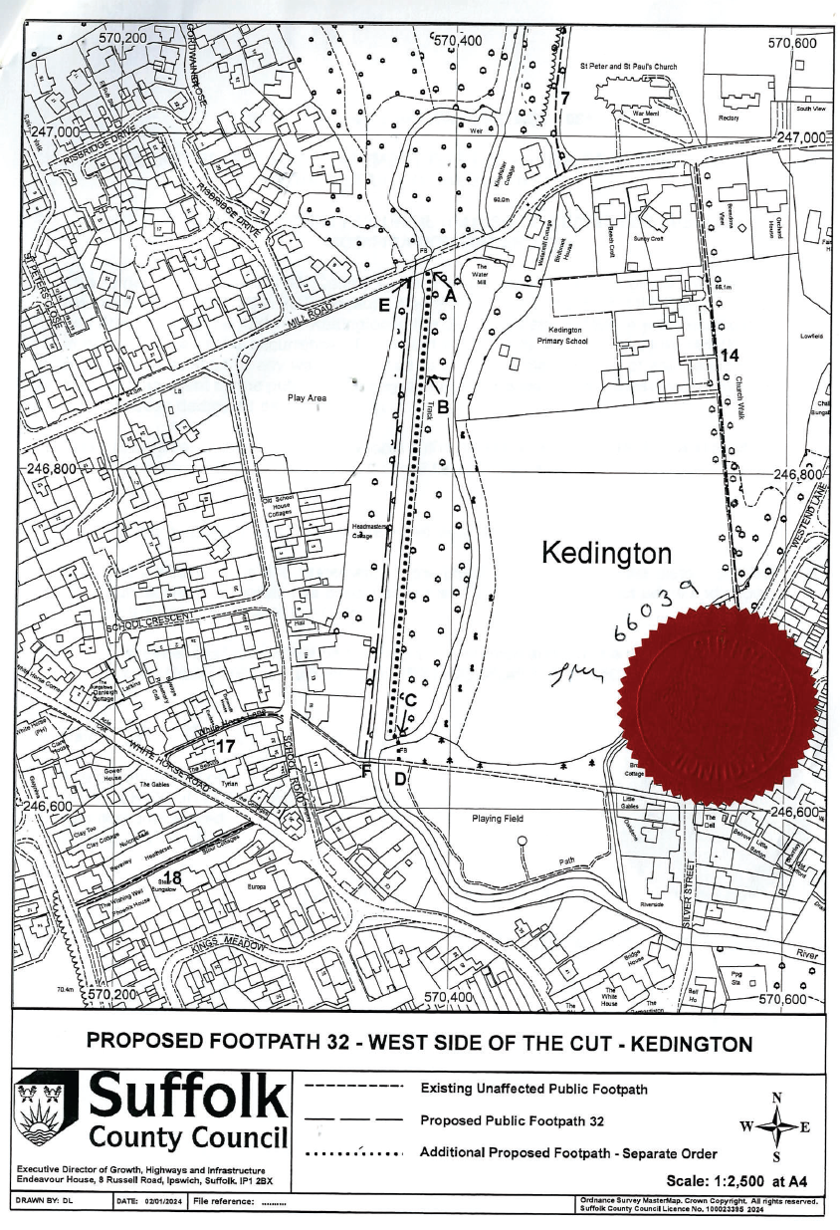
PLAN – ORDER B

