National Minimum Wage Naming Scheme
Round 24, 3 September 2026: Educational bulletin

Introduction
The National Minimum Wage Naming Scheme exists to increase awareness of National Minimum Wage Legislation and to act as a deterrent to the minority of employers who may be tempted to underpay their workers.
This educational bulletin focuses on correctly applying the uprated National Minimum Wage.
It also includes some general statistics regarding breaches of National Minimum Wage legislation in this naming round.
Information on how to make sure you are paying your workers the minimum wage can be found in Calculating the Minimum Wage guidance .

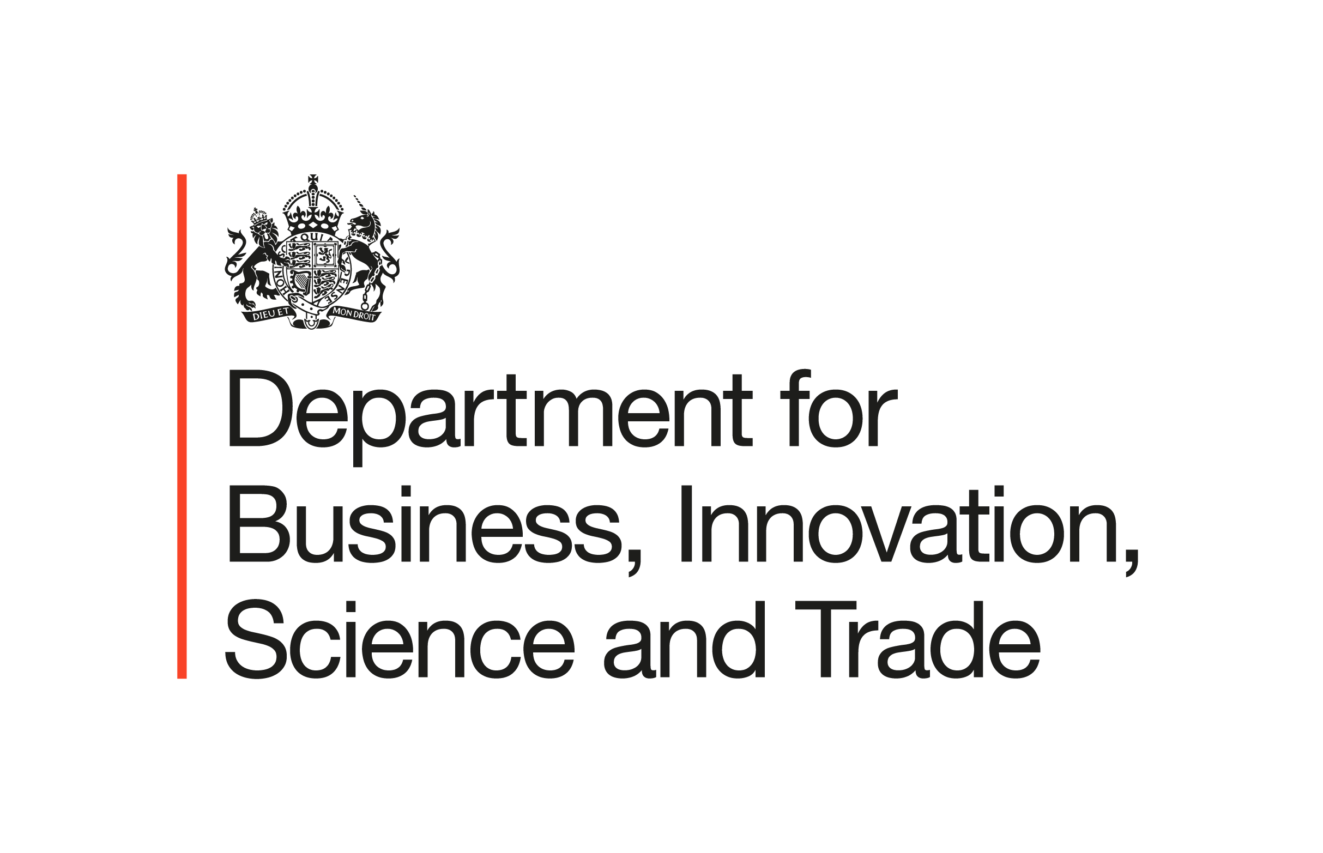
Figure 1. Number of employers named in Round 24 by region / country
658 employers from across the UK were named as part of Round 24 of the Government’s National Minimum Wage Naming Scheme
employers from across the UK were named as part of Round 22 of the Government’s National Minimum Wage Naming Scheme
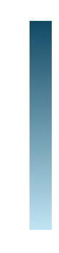
34
50
86
Number of employers names in Round 24 by region / country
Lowest
Highest
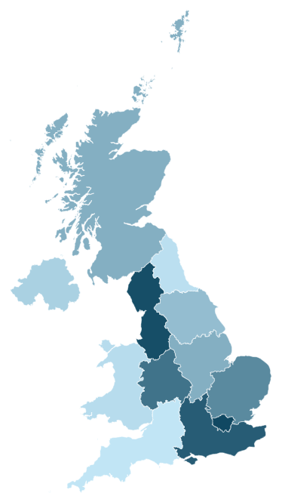
31
36
Contains National Statistics Data @ Crown copyright and Database Right 2026
Note: Geography information is based on the postcode from the employer’s trading address. In some cases, this may not be where the minimum wage underpayment occurred.
63
78
70
49
45
33
83
Reasons for minimum wage underpayment in Round 24
Table 1 shows the reasons for underpayment identified for employers named in Round 24. Some employers had underpayments for more than one reason.
- 39% of employers made deductions or reductions that reduced pay (257 / number of cases)
- 34% of employers failed to pay workers correctly for their working time (221)
- 16% of employers failed to pay the uprated minimum wage (104).

Table 1. Reasons for minimum wage underpayment in Round 24
Type of underpayment | Further information | Number of employers named
Reductions/ deductions or payments that take pay below the minimum wage | Deductions, including reductions in salary, may include:  - Food / meals  - Parking permits and/or travel costs  - Cost of, or lost, work equipment and/ or personal protective equipment  - Stock or till shortage  - Training costs  - Savings schemes  - Uniform  - Childcare costs  - Salary sacrifice schemes e.g. cycle to work, pension and employer benefit schemes  - Worker purchase of clothes to meet dress code | 257
Unpaid working time takes pay below the minimum wage | Unpaid working time includes:  - Additional work before and after a worker’s shift  - Rounding clock-in time  - Unpaid travel time  - Issues with final pay where employment has come to an end  - Pay is delayed / underpaid due to cashflow / cessation in trading / or ad hoc payments  - Paid for ‘regular’ hours or day rate, but a worker has worked for more time than this  - A salaried hours worker has worked in excess of basic hours  - Time for undertaking mandatory training  - Time worked during a sleep-in shift  - Trial shifts  - Overtime | 221
Failure to pay the uprated minimum wage | This includes:  - Failure to increase a worker’s pay when they become eligible for a new, higher minimum wage rate following a birthday  - Failure to uplift after the increase to the minimum wage rates on 1 April | 104
Failure to apply the correct rate to apprentices | This includes instances where a worker:  - Is an apprentice aged over 19, has completed the first year of their apprenticeship and is still paid the apprentice rate  - Is incorrectly classified as an apprentice and paid the apprentice rate  - Has finished their apprenticeship but has not had their pay increased to reflect the age-appropriate higher minimum wage rate to which they are entitled | 103
Failure to correctly apply the accommodation offset | This includes:  - Accommodation charged above the accommodation offset rate therefore reducing pay below the minimum wage | 71
Worker status error | This includes instances where the worker is incorrectly treated as self-employed, or an unpaid intern who should be classified as a worker | 7
Incorrect work type | Incorrect work type has impacted the calculation of National Minimum Wage pay for example, incorrectly treating a worker as performing:  - Time work (broadly, paid according to the number of hours they work)  - Output work (broadly, paid by the piece - the number of things they make or the tasks they complete)  - Unmeasured work (paid in any other way) | 4
Other | Any other reason for arrears which does not fit another category, such as:  - Pay not covering workers’ basic hours (e.g., flat‑rate pay leading to a sub‑NMW hourly rate, or salaries set too low for annual hours)  - Late payments made outside the pay reference period  - Base rates relying on commission top‑ups that are not earned or paid  - Non‑cash benefits (e.g., food or housing) provided instead of pay  - Missed payroll due to cash‑flow issues  - Workers incorrectly treated as family members or volunteers instead of NMW‑entitled workers | 108
Notes:
Some employers had underpayments for more than one reason. The total number of employers is therefore more than the 658 employers named in Round 24.

Further details and guidance on the type of underpayment is available as follows:
- Reductions/ deductions or payments that take pay below the minimum wage was covered in the Educational Bulletin accompanying Round 16; it was published on 13 December 2020, available here.
- Failure to pay the correct rate to apprentices was covered in the Educational Bulletin accompanying Round 17; it was published on 5 August 2021, available here.
- Types of work and salaried hours work was covered in the Educational Bulletin covering Round 18, it was published on 9 December 2021, available here.
- Unpaid working time was covered in the Educational Bulletin covering Round 19, it was published on 21 June 2023, available here.
- Salary sacrifice was covered in the Educational Bulletin covering Round 20, it was published on 20 February 2024, available here.
- Apprentices and dress codes was covered in the Educational Bulletin covering Round 21, it was published on 29 May 2025, available here.
- Paying the correct rate of National Minimum Wage was covered in the Education Bulletin covering Round 22, it was published on 17 October 2025. Available here.
- Uprated National Minimum Wage was covered in the Education Bulletin covering Round 23, it was published on 19 March 2026. Available here.

National Minimum Wage Age Rates and Apprenticeship Rate
The rate you must pay your worker generally depends on how old they are. Those aged over 21 are generally entitled to the National Living Wage.
There are currently 4 rates of minimum wage:
- £12.71 (aged 21 and over)
- £10.85 (aged 18 to 20)
- £8.00 (aged under 18)
- £8.00 (apprentice rate)

As a worker gets older, or progresses through their apprenticeship, they will become entitled to a higher minimum wage rate. Employers are responsible for holding accurate information about their workers and acting in a timely fashion to ensure that the appropriate rate is paid from the correct pay reference period.
Failure to sufficiently increase a worker’s pay at the right time when a new minimum wage rate applies is a common cause of underpayment.

Record Keeping
Employers’ records must be sufficient to show that they are paying each worker at least the minimum wage for every pay reference period worked.
The records kept by the employers could include records of payments to workers, deductions and payments from workers, actual hours worked and proof of payment of wages (please note this list is not exhaustive).
From 1 April 2021, the minimum period for retaining National Minimum Wage records increased from three years to six years (after the end of the pay reference period which follows the pay reference period the records cover). As a result, employers must retain records created from 1st April 2021 onwards for six years. Any records which an employer was required to keep on 1st April 2021 under the three year requirement must now be retained for 6 years.
For example, an employer in March 2026 would be required to keep records dating back to February 2020 if they run a monthly pay reference period.

For more information on record keeping, please visit https://www.gov.uk/guidance/calculating-the-minimum-wage/enforcing-the-minimum-wage#minimum-wage-record-keeping

What to do if an underpayment has been identified
For workers: If you believe you have been underpaid, you can report this to HMRC using their online complaints form. HMRC enforces the National Minimum Wage on behalf of the Fair Work Agency: https://www.gov.uk/government/publications/pay-and-work-rights-complaints. Reports can be made anonymously, and workers can ask for their personal details to be kept confidential. Every complaint is considered by HMRC. HMRC can enforce arrears for up to six years.
Alternatively, you can contact the Acas helpline on 0300 123 1100 for free, impartial and confidential advice about your rights and entitlements. Acas can pass on cases to HMRC for further consideration where appropriate. Acas also offers a translation service.
For employers: If this bulletin has highlighted some issues that you need to rectify, you must do this now and repay your workers. Then tell HMRC by submitting a voluntary declaration. Please email: voluntarydeclaration.nmw@hmrc.gov.uk to request the relevant form.

Further information
Calculating the minimum wage - Guidance - GOV.UK
Check Your Pay - Check Your Pay
Complain about pay and work rights - GOV.UK
Acas | Making working life better for everyone in Britain
Calculating the minimum wage - A checklist for employers - Guidance - GOV.UK
If employers have any concerns about whether they are paying the correct minimum wage or need guidance on the appropriate records to keep, to help meet their national minimum wage obligations, they can contact the Acas Helpline on 0300 123 1100 or visit their website for free, confidential and impartial advice.
For more information on National Minimum Enforcement see the Fair Work Agency’s Enforcement Policy Statement, available at: www.gov.uk/government/publications/fair-work-agency-enforcement-policy-statement
HMRC also provide webinars to employers and workers on various topics regarding the National Minimum Wage - HMRC email updates, videos and webinars for employing people - GOV.UK
National Minimum Wage channel: National Minimum Wage | GoToStage.com
Annex A

Table 2. Number of employers named in Round 24 by region / country
Region | Number of Employers
London | 86
North West | 83
South East | 78
West Midlands | 70
East of England | 63
Scotland | 50
East Midlands | 49
Yorkshire and the Humber | 45
Northern Ireland | 36
Wales | 34
North East | 33
South West | 31
Total | 658
Notes: Geography information is based on the postcode from the employer’s trading address. In some cases, this may not be where minimum wage underpayment occurred.

