Whole of Government Accounts
Annex- Examples Resolving validation error 2025-26

Contents
a. How to use this guide 4
b. What is a Validation report 5
c. Counter Party Identified (CPID) Validation errors 7
d. How to resolve validation errors 12
e. DCT Mapping tool 13
f. Hard validations 15
g. Soft validations 16
h. Examples of Validation Errors and Guidance on How to Resolve Them 17
How to resolve Validation 899I0003 17
How to resolve Validation 899I0011 19
How to resolve Validation 899I0012 20
How to resolve Validation 899N0033 23
How to resolve Validation 899N0034 24
How to resolve Validation 899N0035 24
How to resolve Validation 899N0038 25
How to resolve Validation 899N0039 26
How to resolve Validation 899N0055 26
How to resolve Validation 899N0066 27
How to resolve Validation 899N0111 28
How to resolve Validation 899N0104 29
How to resolve Validation 899L0117 30
How to resolve Validation 899L0121 31
How to resolve Validation 899N0030 32
How to resolve Validation 899N0122 33
How to resolve Validation 899N0125 35
How to resolve Validation 899N0127 36
How to resolve Validation 899N0128 37
How to resolve Validation 899N0130 38
How to resolve Validation 900V0024 39
How to resolve Validation 900V0026 40
How to resolve Validation 900V0031, 900V0032 41
How to resolve Validation 900V0033 43
How to resolve Validation 900V0034 44
How to resolve Validation 900V0042 45
How to resolve Validation 900V0051 45
How to resolve Validation 900V0052 46
How to resolve Validation 900V0057, 900V0058, 47
How to resolve Validation 900V0061 48
How to resolve Validation 900V0082 51
How to resolve Validation 900V0083 51
How to resolve Validation 900V0094 53
How to resolve Validation 900V0131 54
How to resolve Validation 900V0148, 900V0151 54
How to resolve Validation 900V0149, 900V0150 55
How to resolve Validation 900V0152 57
How to resolve Validation 900V0153 57
How to resolve Validation 900V0154 57
How to resolve Validation 900V0155 57
How to resolve Validation 900V0156 57
How to resolve Validation 900V0157 57
How to resolve Validation 900V0158 58
How to resolve Validation 900V0159 58
How to resolve Validation 900V0160 58
How to resolve Validation 900V0161 58
How to resolve Validation 900V0167 58
How to resolve Validation 900V0171 59
How to resolve Validation 900V0193 61
How to resolve Validation 900V0194 62
How to resolve Validation 900V0195, 900V0196, 900V0197, 900V0198, 900V0199, 900V0200, 900V0201, 900V0202, 900V0203, 900V0204, 900V0205, 900V0206, 900V0207, 900V0208, 900V0209. 63
How to resolve Validation 900V0226 64
How I resolve validation error with our CPID entry for ‘44112200 INC-CURRENT GRANTS FROM CG – PUBLIC HEALTH GRANT’ 66
i. Trial Balance Input Method 67
j. Restatement CI&E - Prior Year Comprehensive Income and Expenditure Statement - Restated 72
k. Restatement Analysis 73

How to use this guide

This document is intended as a guide to outline the principles for investigating and resolving validation errors. It does not cover all possible DCT validations. Please follow the steps in the document, along with the guidance provided on the relevant tab, to investigate validation errors.

Entities are expected to use this guide in conjunction with the written guidance provided elsewhere. The guide should be used as a practical reference to support the instructions and requirements set out in the formal documentation. Where specific validation errors arise, refer both to this guide and to the written guidance to ensure a consistent and thorough approach.

If your entity submitted a DCT in Prior year, please use this guide as a reference.

We kindly ask that you take your time when reviewing the written guidance and this document — a careful read-through will really help with identifying and resolving any errors.

Steps to follow:
- Understand your figures.
- Familiarise yourself with how the DCT works using the DCT mapping tool.
- Read the validation message to understand what the error message is saying.
- Go to the relevant tab and review it to ensure it appears fully completed.
- If anything looks incorrect or unusual, it is probably the error.
- Review the value returned in the ‘Value Return’ column on the validation report; this can also act as a clue to guide you to what the issue might be.
- Follow the guidance provided on the tab.
- Read the instructions provided in the tables within the tab.
- Read the instructions provided for each cell. Where a cell asks for further analysis below, please provide this in the relevant section on the tab.
- Consult the written guidance for additional context and clarification, especially for complex or unusual validation errors.
- Use both resources together to help ensure all validation issues are properly investigated and resolved.

What is a Validation report

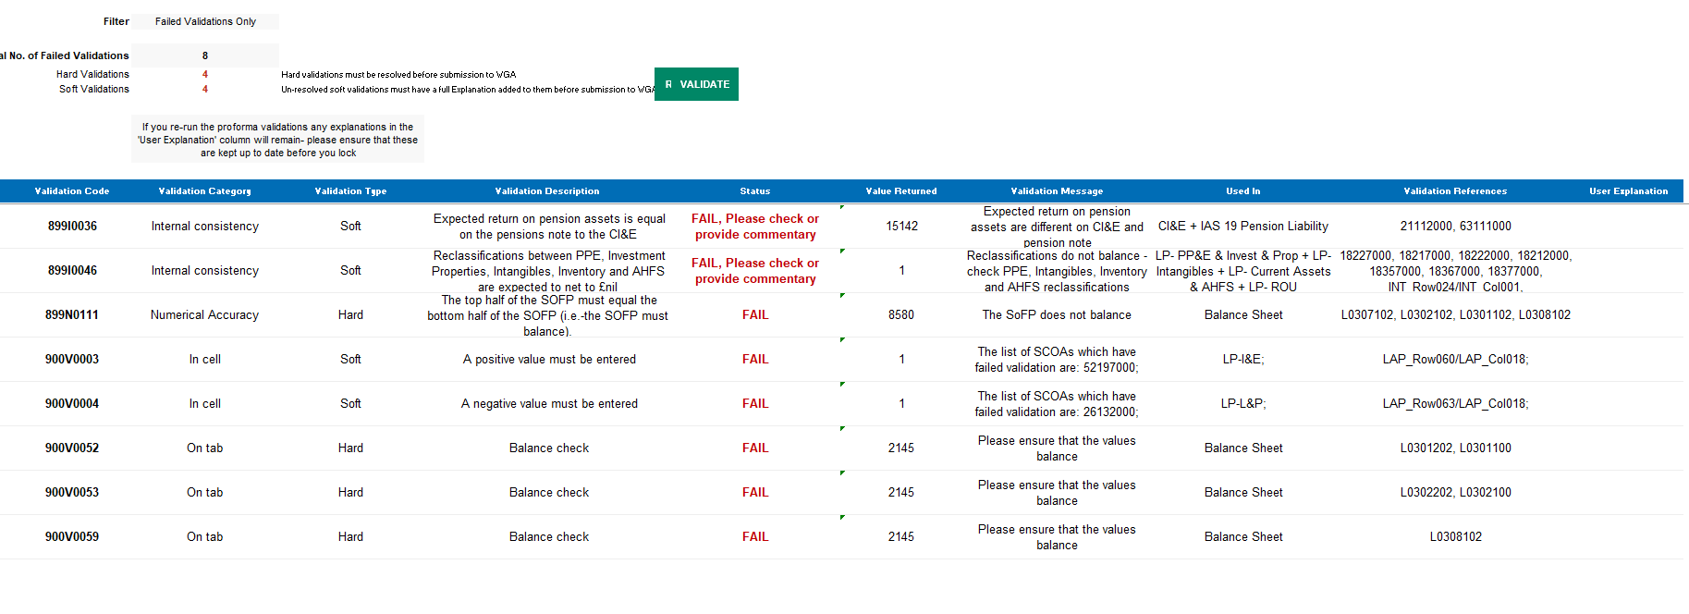
Entities should start by using the DCT mapping tool on the website to identify the specific cells affected by these errors.
For comprehensive instructions on navigating and completing the DCT, including the investigation and resolution of validations, the written guidance contains all the relevant information. Additionally, there are screenshots provided to assist you in navigating through the process. You can access the written guidance on our website.

Validations exist on all tabs and there are specific areas you can investigate to get greater detail on the validation errors.

Validations can be viewed on the ‘Validations Report’ worksheet on OSCAR.

- Select if you would like to view all validations – ‘Select All’ or ‘Failed Validations Only’.
- Select ‘Refresh’ to adjust your worksheet view according to the applied filter in Step 1
- Total number of Validations will appear.
- Select ‘Validate’ to reflect on recent changes made. It is recommended you refresh the Validation report as often as possible.
- On the Validation Report, you will find the following details:
  - Validation Code – automated code allocated to each validation error, for internal purposes.
  - Validation Category – internal consistency, materiality, numerical accuracy
  - Validation Type – Soft/Hard. Hard validation failures will need to be resolved before submission and on all soft validations, comments must be provided. DCT can still be validated with soft validation failures if you provide comments. Soft validations are warnings only and you can still proceed.
  - Validation Description - details and guidance on each validation error for example: NIC contributions should be between 6% and 12% of gross wages. If they are not, could you please provide an explanation.
  - Status – used to describe the status for example FAIL, please provide cometary/PASS.
  - Value Returned – the value of the validation error.
  - Validation Message – details on why validation has failed for example ‘values do not balance’.
  - Used In – location of the validation error for example ‘Financial Instruments ‘worksheet.
  - Validation References – account codes and other internal reference codes concerned with specific validation error
  - User Explanations – any comments entered on the validation errors.

You must clear all hard validation errors on the validation report and provide explanations for soft validations before you can submit the DCT Return. The same also applies to CPID validations.

Counter Party Identified (CPID) Validation errors

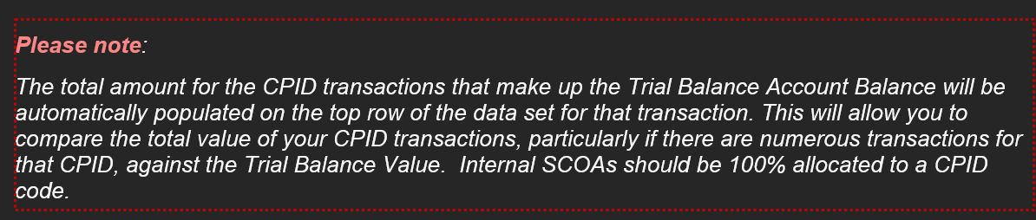

If there are errors on the CPID transaction tab, it will block the submission of your DCT.

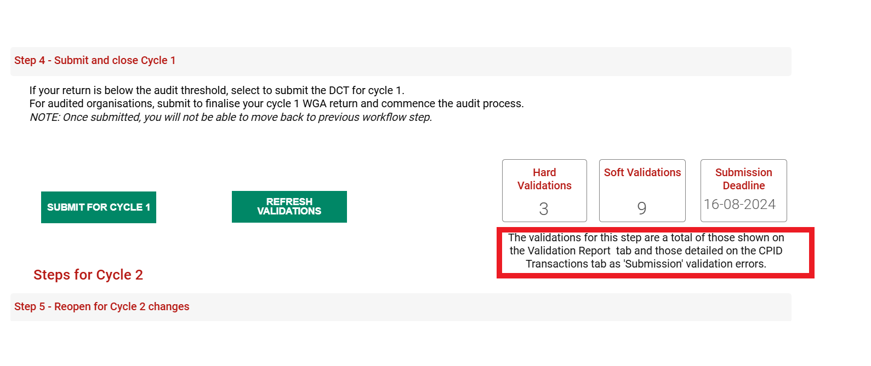

Go to the CPID transaction tab and investigate those errors and resolve them based on the status message.
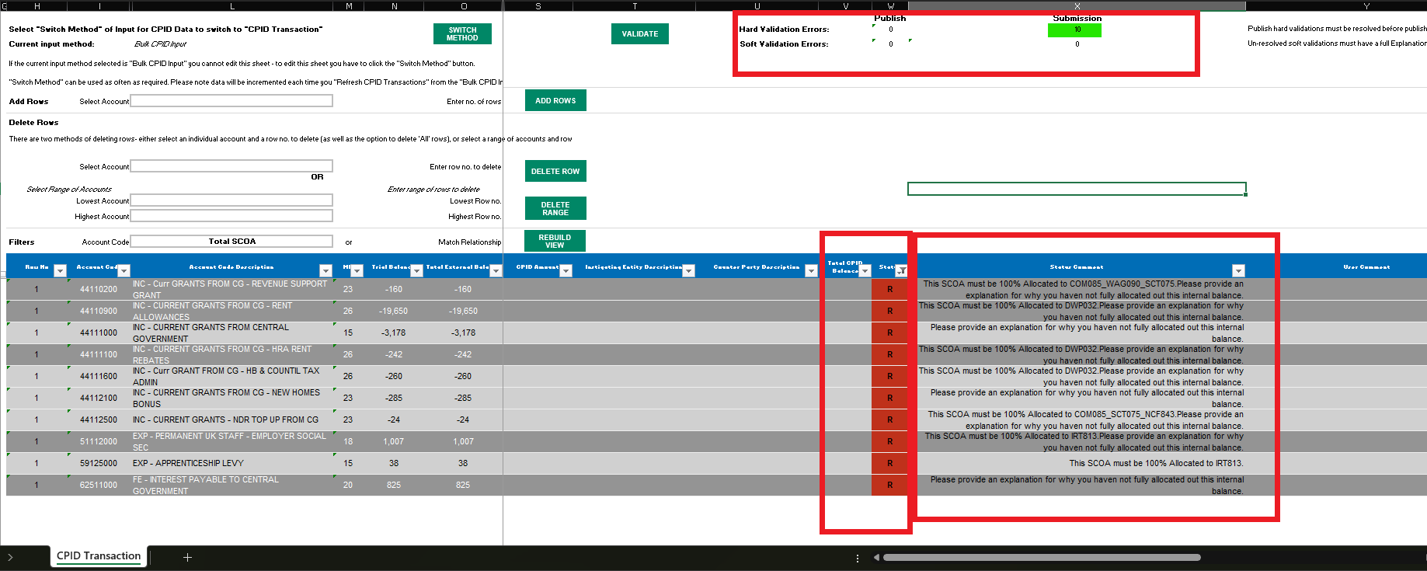

Please be aware of counterparty validation errors listed below which will prevent your ability to ‘Publish’ counterparty transaction:
- Incomplete data fields
- Account code does not exist.
- Account code cannot be used.
- Instigating Entity does not exist.
- Counter Party does not exist.
- Entity CPID was entered in lowercase (e.g., "afs902") instead of uppercase ("AFS902").
- The column CPID Amount £000 contains a decimal place. Please remove the decimal place
- This SCOA must be 100% Allocated.
- The amount allocated to counterparties must not exceed the amount on the Trial balance (TB).
- The CPID amount must have the same signage as the TB.
- If the TB amount is zero, there should be no CPID amount.
- Please delete the Instigator or CPID from the row
- Please delete the Instigator/CPID as there is no CPID value.
- Invalid CPID Entity in column Counter Party Code
- Invalid Instigator Entity. The counter party is in your group.
- Your chosen CPID is within your Instigator group.
- Incomplete CPID entities provided.
- The Counterparty code has been entered more than once for the same SCOA. Please aggregate the amounts and report as one line entry.
- The Counterparty Code is not valid for this SCOA. Please change SCOA or use a valid Central Gov Counterparty Code.
- The Counterparty Code is not valid for this SCOA. Please change SCOA or use a valid Local Gov Counterparty Code.
- The Counterparty given is not required to submit a Return and therefore cannot be a valid Counterparty.

Please ensure these issues are resolved to allow you to ‘Publish’ your counterparty transactions.
In the context of the Whole of Government Accounts the terms "instigator" and "counterparty" are used to describe the parties involved in transactions between different government entities.

- Instigator: This is the entity that initiates a transaction. In the WGA, this would typically be the government department or public sector body that is responsible for starting a financial transaction or event, such as making a payment or transferring an asset.

- Counterparty: This is the entity on the other side of the transaction. In the WGA, the counterparty is the government department or public sector body that is involved in the transaction initiated by the instigator, such as receiving a payment or asset.

How to resolve Counterparty Validation Errors
Counterparty validation errors on the CPID Transactions tab will prevent you from publishing your counterparty data and may also prevent submission of the DCT. All hard validation errors must be resolved before you can proceed.

To assist entities, we have provided a list of common counterparty validation errors together with suggested actions to help resolve them. These suggestions are based on the WGA guidance covering CPID entry, CPID lists, SCOA lists, validation reports and counterparty transactions.
Before contacting the WGA team, please ensure that you have:
- Reviewed the relevant guidance and status comment.
- Checked the CPID List and SCOA List for valid codes.
- Revalidated your CPID transactions after making corrections.
- Confirmed that all mandatory fields have been completed and that balances have been allocated correctly.
The table below provides guidance on how to resolve the most common counterparty validation errors.

Validation Error | How to Resolve
Incomplete data fields | Check that all mandatory fields have been completed, including Account Code, Instigating Entity, Counter Party Code and CPID Amount.
Account code does not exist | Verify that the SCOA/account code is valid. Refer to the SCOA List or WGA Mapping Tool and correct the account code.
Instigating Entity does not exist | Check the Instigating Entity Code and ensure a valid entity code has been selected from the available list.
Counter Party does not exist | Check the Counter Party Code against the published CPID list and select a valid counterparty entity.
The amount allocated to counterparties must not exceed the amount on the Trial Balance (TB) | Ensure the total CPID allocations do not exceed the TB balance for the SCOA. Compare the CPID total to the TB value and reduce allocations where necessary.
The CPID amount must have the same signage as the TB. | Check whether the TB balance is positive or negative and ensure all CPID allocations use the same sign.
The column CPID Amount £000 contains a decimal place. Please remove the decimal place | Round the amount and enter whole numbers only. OSCAR does not accept decimal values in CPID entries.
This SCOA must be 100% Allocated | Allocate the entire TB balance to counterparties so that the total CPID amount equals the SCOA/TB balance.
If the TB amount is zero, there should be no CPID amount | Remove any CPID allocations where the corresponding TB balance is zero
Please delete the Instigator or CPID from the row | Remove any unnecessary Instigating Entity or Counter Party information from the row where no valid CPID transaction exists.
Please delete the Instigator/CPID as there is no CPID value | Enter a CPID amount or remove the Instigating Entity and Counter Party information from the row.
Invalid CPID Entity in column Counter Party Code | Verify the Counter Party Code against the CPID List available in OSCAR or on the WGA website and replace it with a valid code.
Invalid Instigator Entity. The counter party is in your group | Review the organisational relationship. Transactions should not generally be allocated to entities within the same instigator group. Select the correct counterparty or remove the allocation if inappropriate
Your chosen CPID is within your Instigator group | Select the correct external WGA counterparty. CPIDs within the same group should not be used for these allocations
Incomplete CPID entities provided | Ensure both the Instigating Entity Code and Counter Party Code have been completed correctly.
The Counterparty code has been entered more than once for the same SCOA. Please aggregate the amounts and report as one line entry. | Aggregate the duplicate entries and report the total as a single line for that SCOA and counterparty combination.

- The Counterparty code has been entered more than once for the same SCOA. Please aggregate the amounts and report as one line entry. - Please aggregate the amounts and report as one line entry
- The Counterparty Code is not valid for this SCOA. Please change SCOA or use a valid Central Gov Counterparty Code.- Please change SCOA or use a valid Central Gov Counterparty Code.
- The Counterparty Code is not valid for this SCOA. Please change SCOA or use a valid Local Gov Counterparty Code.- Please change SCOA or use a valid Local Gov Counterparty Code.
- The Counterparty given is not required to submit a Return and therefore cannot be a valid Counterparty.- Please allocate to the Parent entity. If one does not exist, please do not allocate

Tip: If you are unsure whether a CPID or SCOA code is valid, refer to the CPID List, SCOA List, Match Relationships guidance, or the Matches Analysis Tool available within OSCAR and on the WGA website.

How to resolve validation errors

To address the entity's validation issues, it is necessary to investigate the reasons for the errors and rectify any inaccuracies on the DCT. The errors stem from inaccuracies in the entity's DCT entries. To resolve the validation errors, the entity must understand the root causes of the errors.
The first step is to generate a validation report. This report will provide the validation codes that are triggering the errors, show the affected tabs, and explain the reasons for the errors. On the right side of the report, you'll find descriptions guiding you on how to address each validation issue. It is crucial to carefully review and act upon the comments in the status column corresponding to each validation code.

DCT Mapping tool

Consulting the DCT Mapping Tool
The DCT Mapping Tool will provide guidance on how to navigate the DCT. Additionally, the validation report on the validation page explains each validation error, what tab the error is on and indicates which tab it refers to.
How to Use the DCT Mapping Tool:
- Search for the Validation Error Number: a. Locate the validation error number on the DCT Mapping tool.
- Consult the DCT Mapping tool Screenshot: The screenshot from the DCT Mapping tool provides the following key information:
  - The validation error number
  - The SCOA (Standard Chart of Accounts)
  - The expected value
  - The validation description
  - The affected tab

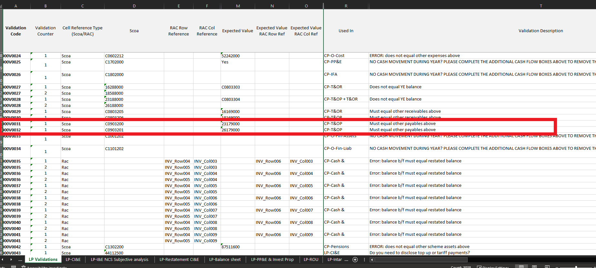

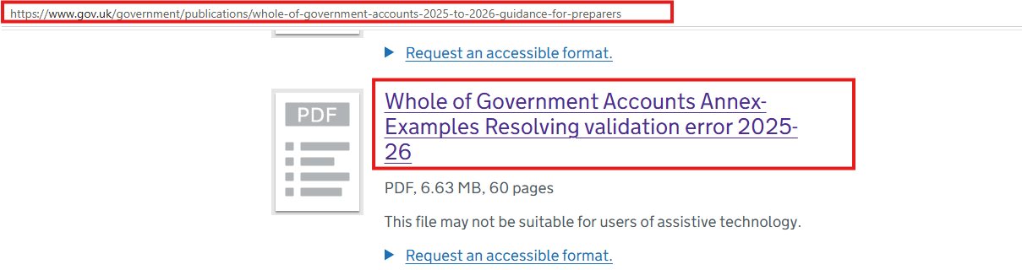

Whole of Government Accounts - GOV.UK alongside videos, webinars, and other materials to help with this.

Hard validations

For hard validations, start by investigating the cause of the error. Use the find command to search for the validation error codes on the DCT Mapping Tool. This will take you to the relevant cells for that code and provide you with the necessary information on what to do next.

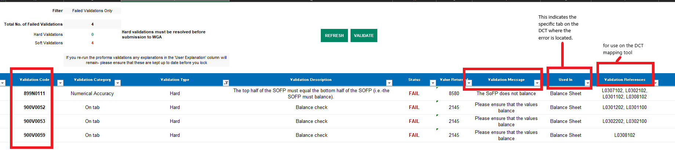

Soft validations

For soft validations, you’ll need to provide an explanation in the relevant cells.
You need to provide an explanation in the User explanation column.

The validations do not disappear once you have commented. Once you validate the comments, the system will allow the DCT to progress.
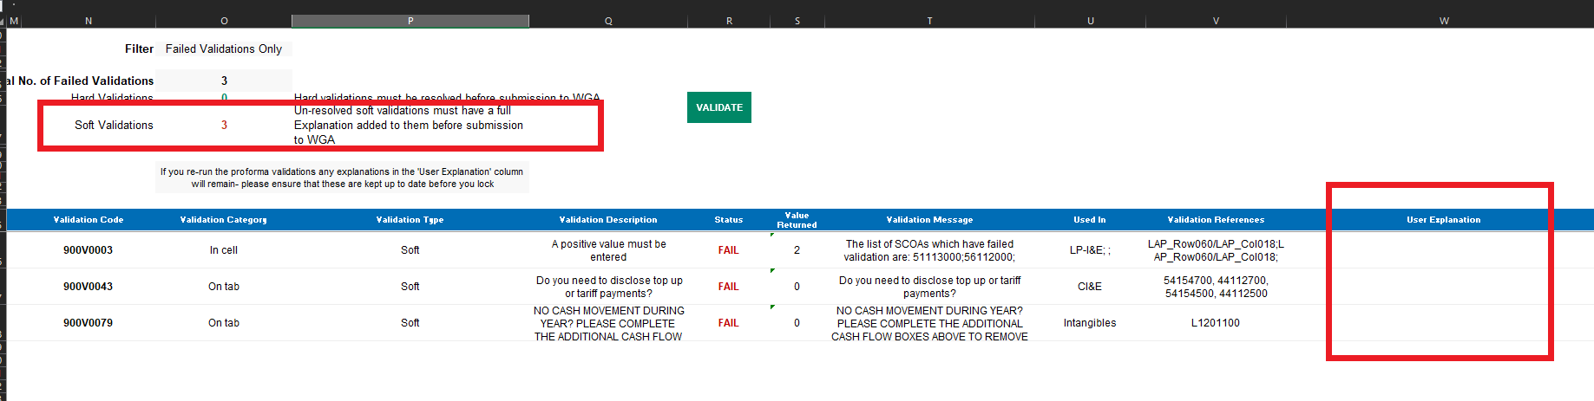

Examples of Validation Errors and Guidance on How to Resolve Them

How to resolve Validation 899I0003
Please follow the instructions on the validation report to resolve the issue.
The following is an illustrative example and does not represent actual data from your entity.

The validation message is as follows;

You need to investigate and resolve the validation message. The DCT operates on a double-entry, or T-account, basis, meaning that every debit must have a corresponding credit.
The message indicates that the depreciation expense does not agree with the depreciation charged in the PP&E and ROU notes. In other words, the depreciation recorded in the PP&E and ROU tabs does not equal the depreciation expense entered in the Operating Costs tab. These amounts should reconcile.

Please review the PP&E, ROU and Operating Costs tabs to identify and resolve the discrepancy.

Your DCT currently shows the following:

PPE

Depreciation for PPE is shown here as 454.
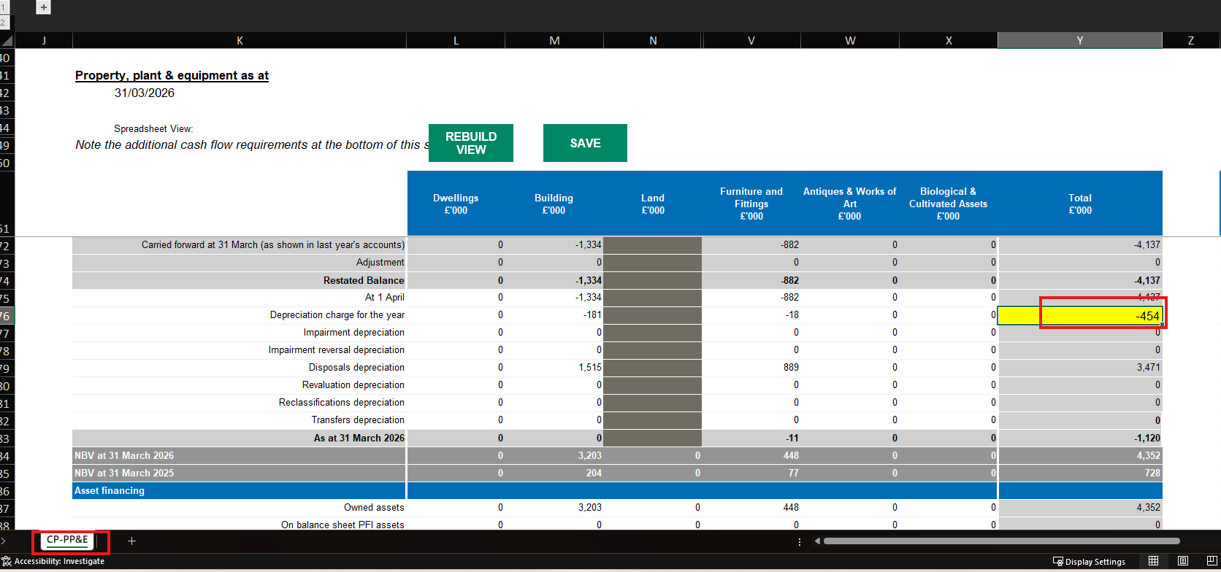

ROU tab

Depreciation is shown for ROU as 649
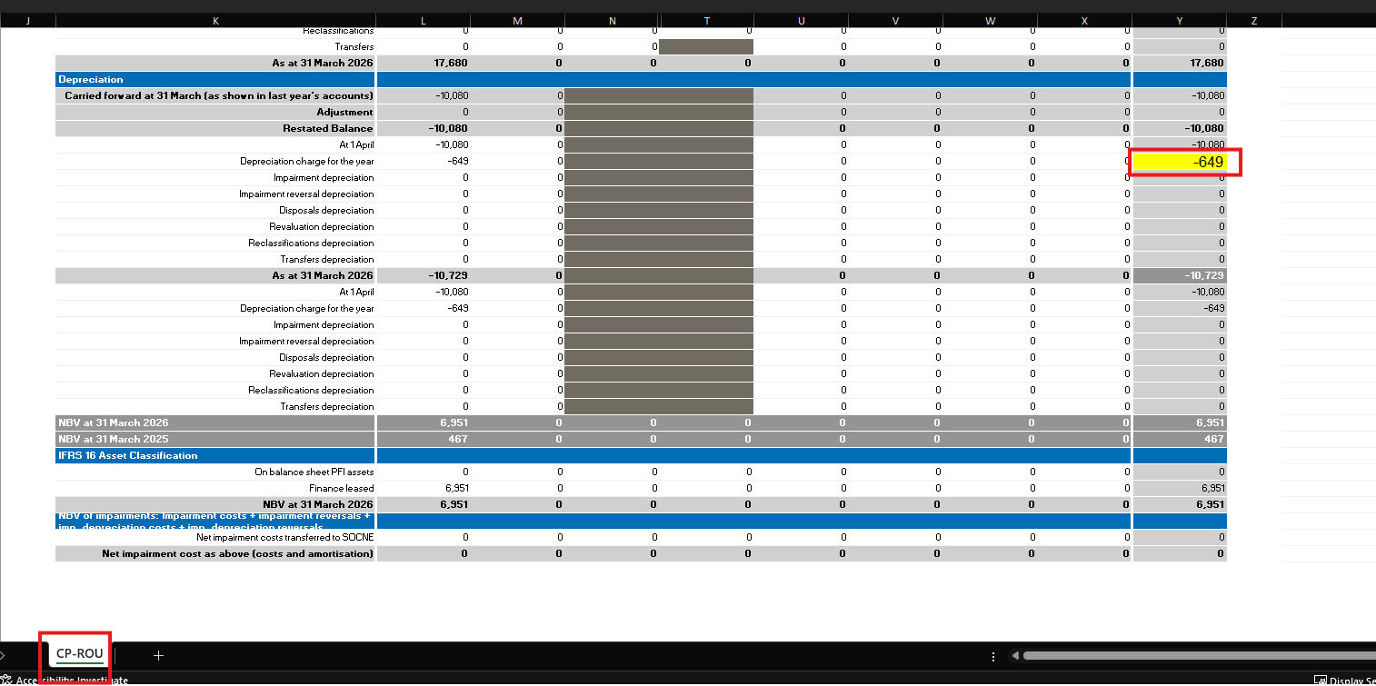

Operating costs tab

Deprecation for the entity is shown here as 387.

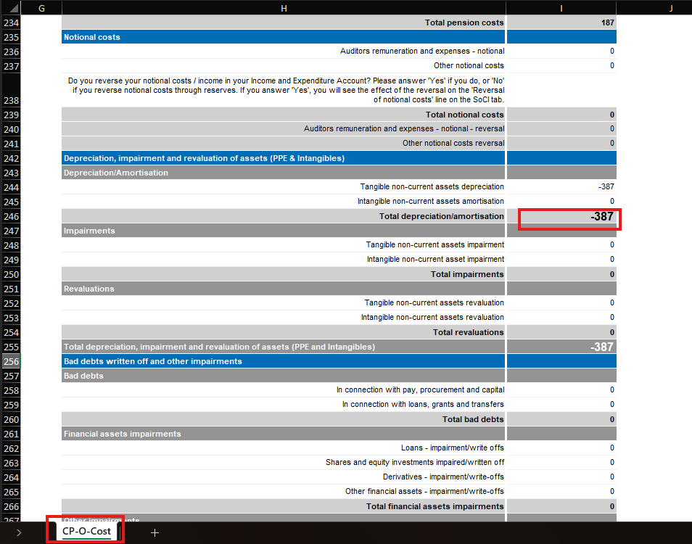

The total of 454 +387+649 is 1490 . This is what is shown on the Validation report below in the value returned column.

Please investigate the discrepancies and correct.

How to resolve Validation 899I0011
Please follow the instructions on the validation report to resolve the issue.
The following is an illustrative example and does not represent actual data from your entity.

To fix the errors, the entity must make sure the values in the two specified cells below are identical.

Please go to the row labelled ‘(Surplus) or Deficit on Provision of Services’ within the ‘Reserves’ tab.
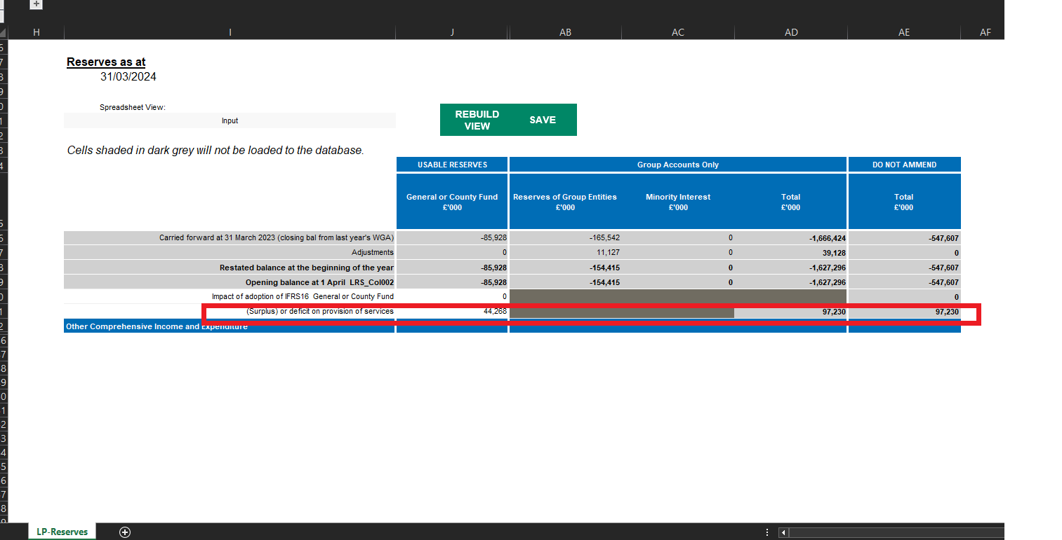

Then go to the ‘CI&E’ tab:
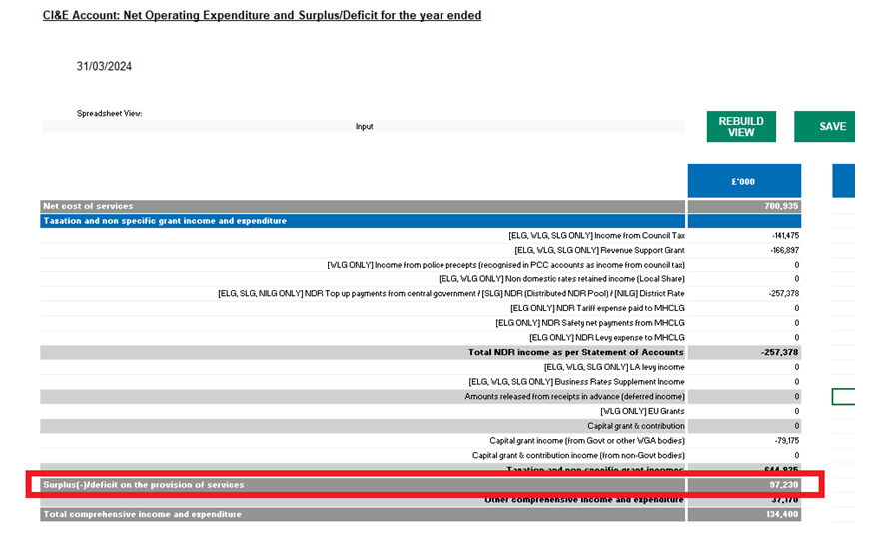

The two cells needs to agree. Please investigate and resolve.

How to resolve Validation 899I0012
Please follow the instructions on the validation report to resolve the issue.
The following is an illustrative example and does not represent actual data from your entity.

Validation report

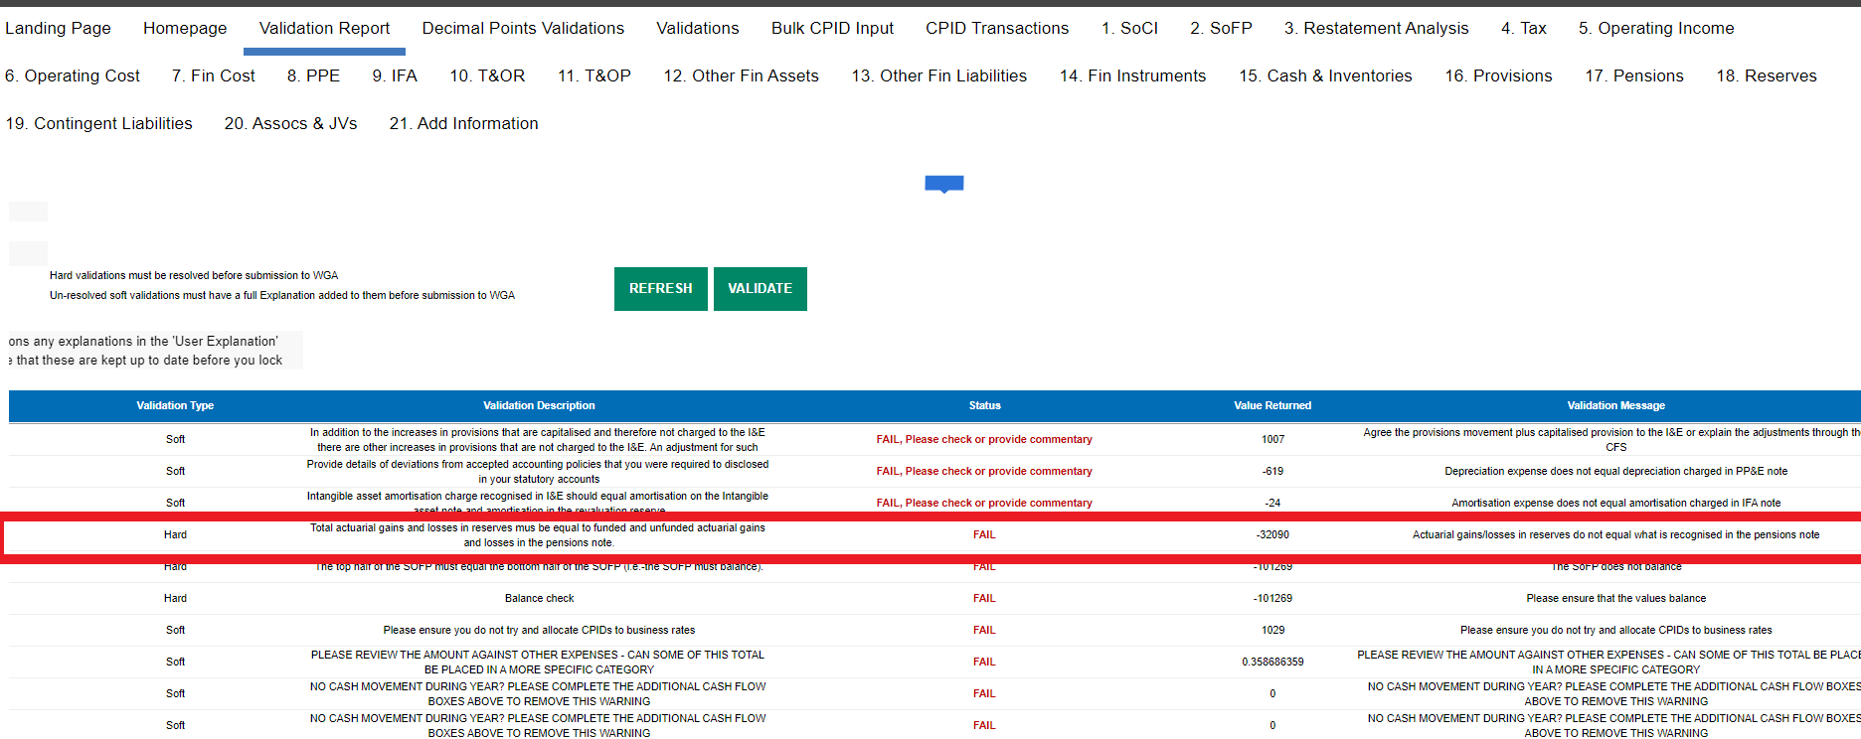

The difference of -32,090 shown on the validation report (screenshot 1) is made up of the difference between the Reserves and Pensions tab as highlighted below.

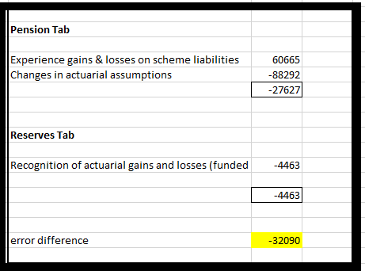

The yellow cells on the Reserves (screenshot 2) tab must equal the yellow cells on the Pensions tab (Screenshot 3).

Reserves tab
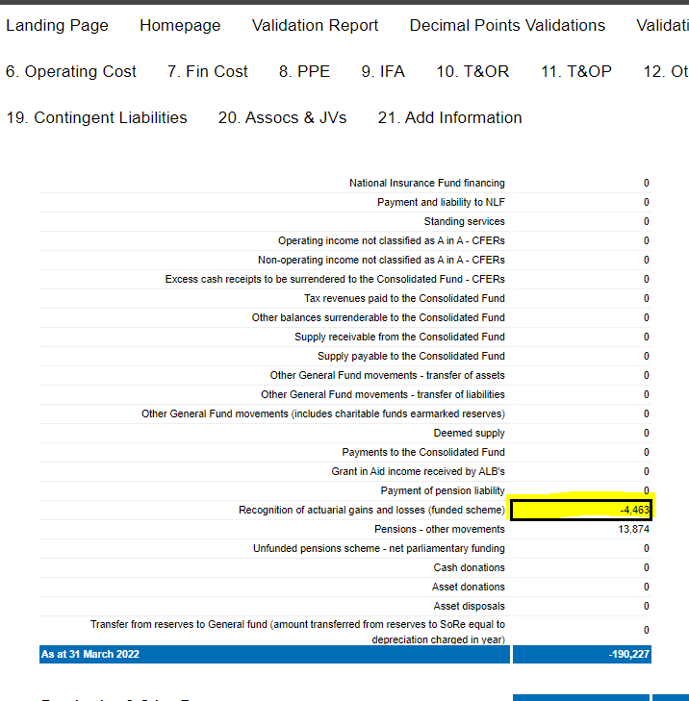

Pensions tab

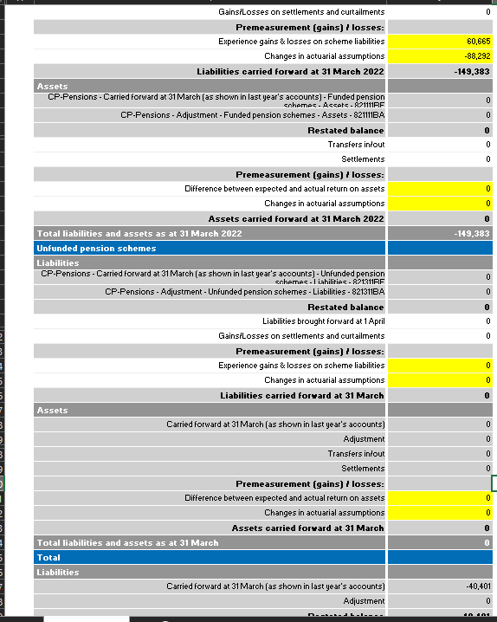

Please investigate and resolve.

How to resolve Validation 899N0033
Please follow the instructions on the validation report to resolve the issue.
The following is an illustrative example and does not represent actual data from your entity.

Below is a sample of the PPE tab. Ensure that all closing balances align with the opening balance. The cells in the green boxes need to agree. Use this principle to examine and rectify red box on all affected individual tabs.
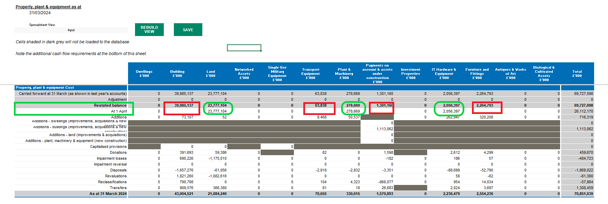

Please investigate and resolve.

How to resolve Validation 899N0034
Please follow the instructions on the validation report to resolve the issue.
The following is an illustrative example and does not represent actual data from your entity.

Below is a sample of the PPE tab. Ensure that all closing balances align with the opening balance.

The cells in the green boxes need to agree. Use this principle to examine and rectify red box on all affected individual tabs.

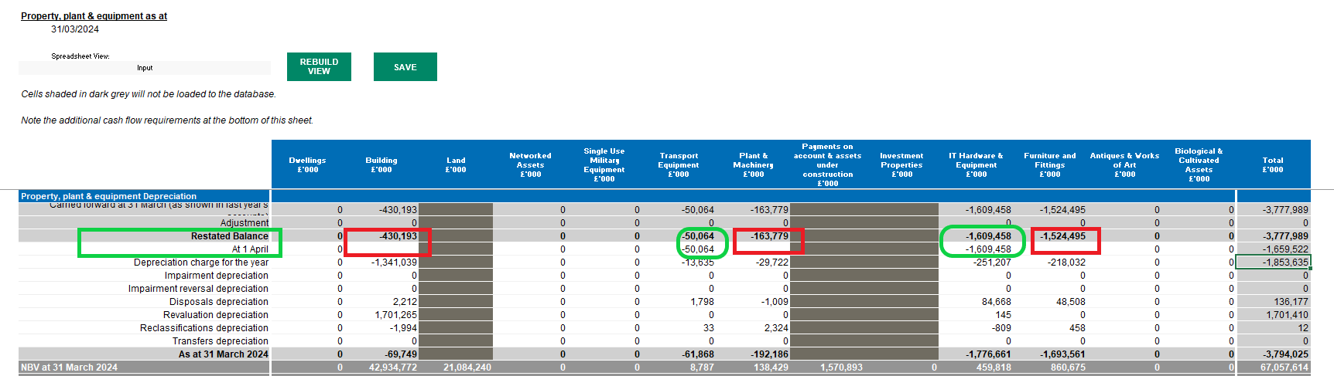

Please investigate and resolve.

How to resolve Validation 899N0035
Please follow the instructions on the validation report to resolve the issue.
The following is an illustrative example and does not represent actual data from your entity.

Below is a sample of the PPE Depreciation table. Total of the breakdown by the asset type must equal the NBV of each asset type. Asset financing breakdown must equal NBV of asset.

The cells in the green boxes need to agree. Use this principle to examine and rectify red box on all affected individual tabs.

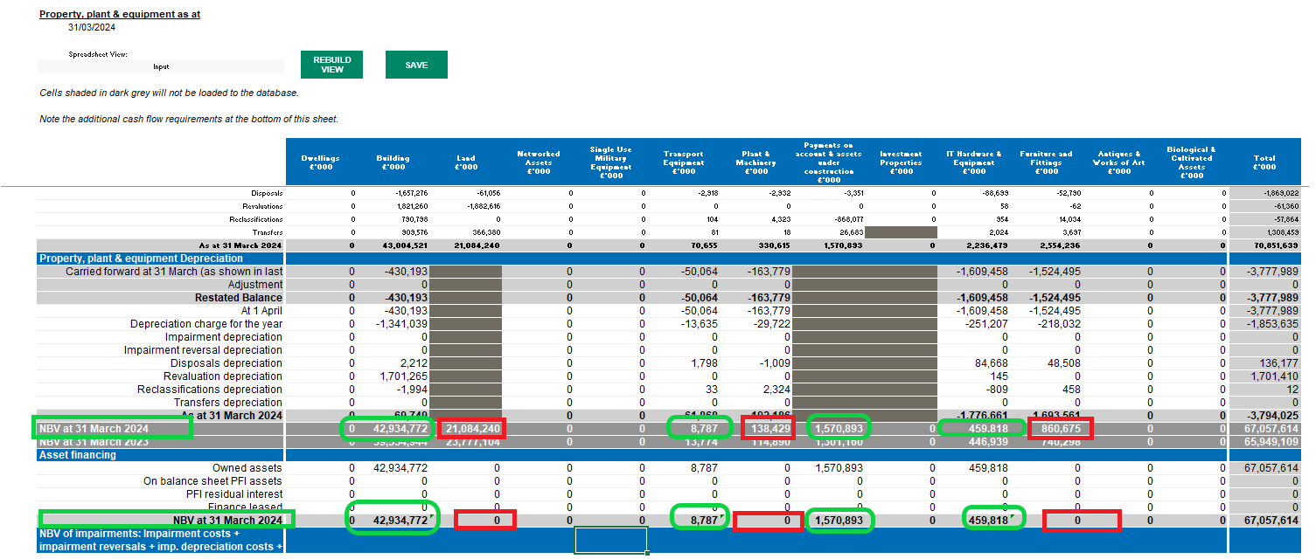

Please investigate and resolve.

How to resolve Validation 899N0038
Please follow the instructions on the validation report to resolve the issue.
The following is an illustrative example and does not represent actual data from your entity.

Below is a sample of the IFA tab. Ensure that all closing balances align with the opening balance.

The cells in the green boxes need to agree. Use this principle to examine and rectify red box on all affected individual tabs.

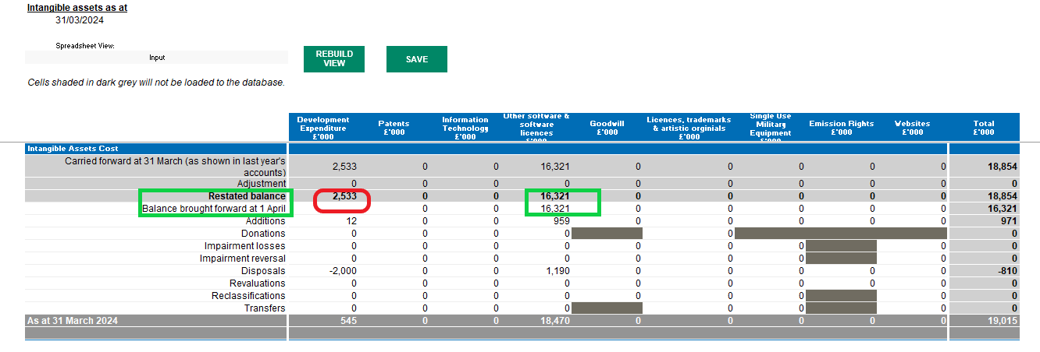

Please investigate and resolve.

How to resolve Validation 899N0039
Please follow the instructions on the validation report to resolve the issue.
The following is an illustrative example and does not represent actual data from your entity.

Below is a sample of the IFA Amortisation table. Ensure that all closing balances align with the opening balance.

The cells in the green boxes need to agree. Use this principle to examine and rectify red box on all affected individual tabs.

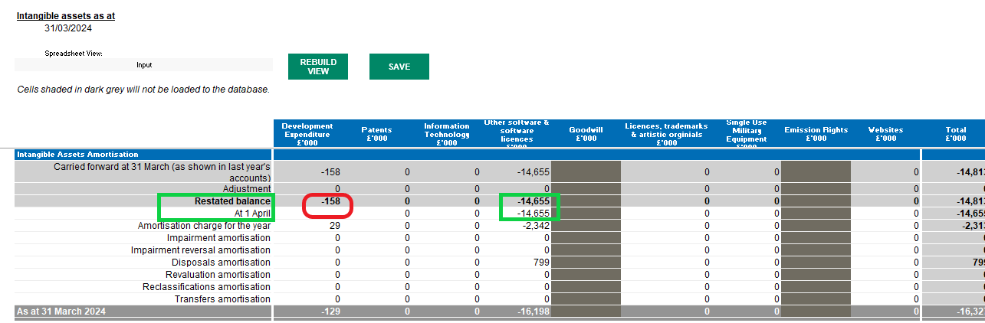

Please investigate and resolve.

How to resolve Validation 899N0055
Please follow the instructions on the validation report to resolve the issue.
The following is an illustrative example and does not represent actual data from your entity.

General fund restated opening balance must equal the balance at the 1st of April. Restated balances must equal the balance as at 1 April.

The cells in the green boxes need to agree.

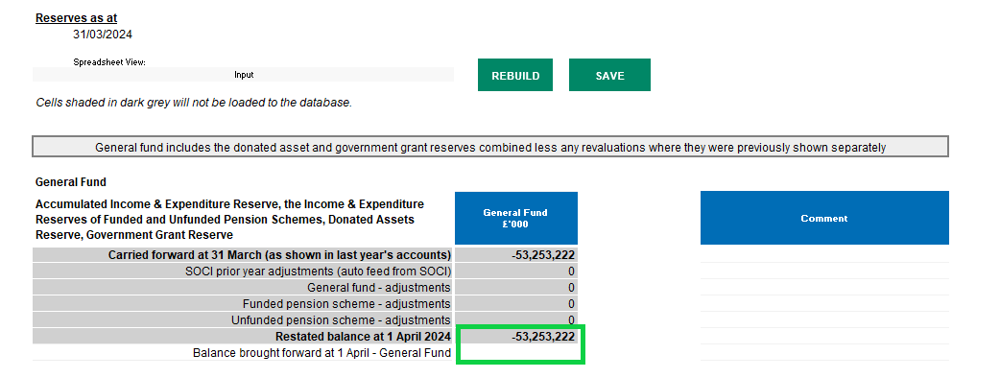

Please investigate and resolve.

How to resolve Validation 899N0066
Please follow the instructions on the validation report to resolve the issue.
The following is an illustrative example and does not represent actual data from your entity.

The impairment split between recognised in I&E and reval reserve must equal the sum of the net impairments recognised in the PP&E movement table. This validation is made up of the following numbers in your DCT:

- NCS II&E-Impairment: 866

Equals

- PPE tab: Net Impairments to the I&E: -852
- Intangibles-Net impairments top the I&E: 0
- Current Assets and AHFS: Impairments of assets Held for Sale: 3

The amounts entered for the I&E don’t agree to what’s in PPE, Intangibles or Current assets and AHFS.

I&E NCS subjective analysis:

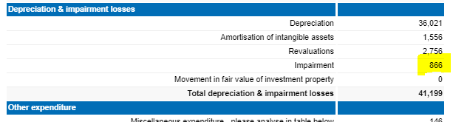

PPE tab:

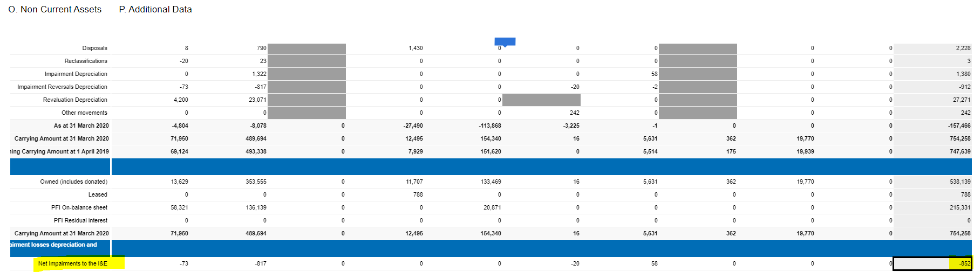

Intangibles:

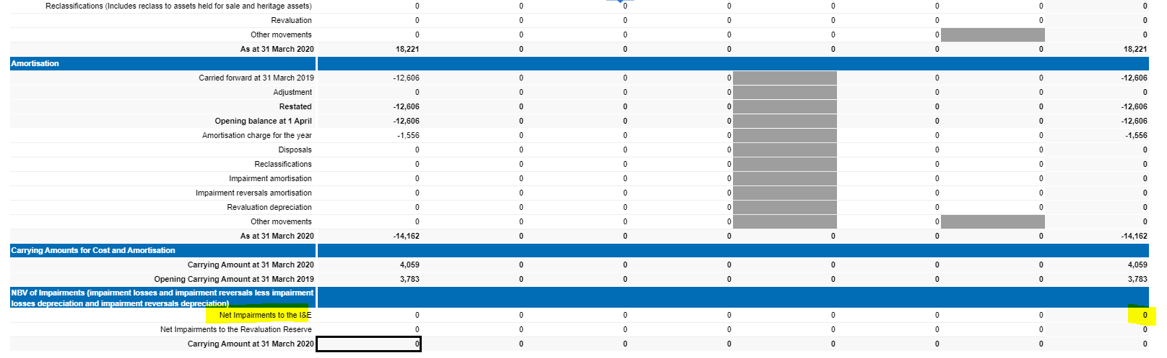

AHFS

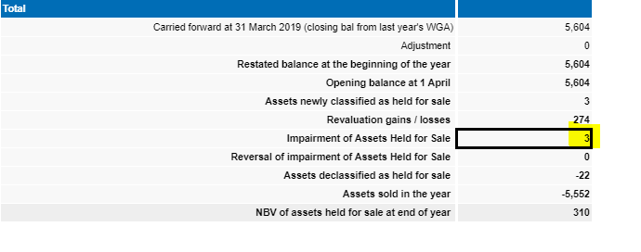

Please investigate and resolve.

How to resolve Validation 899N0111
Please follow the instructions on the validation report to resolve the issue.
The following is an illustrative example and does not represent actual data from your entity.
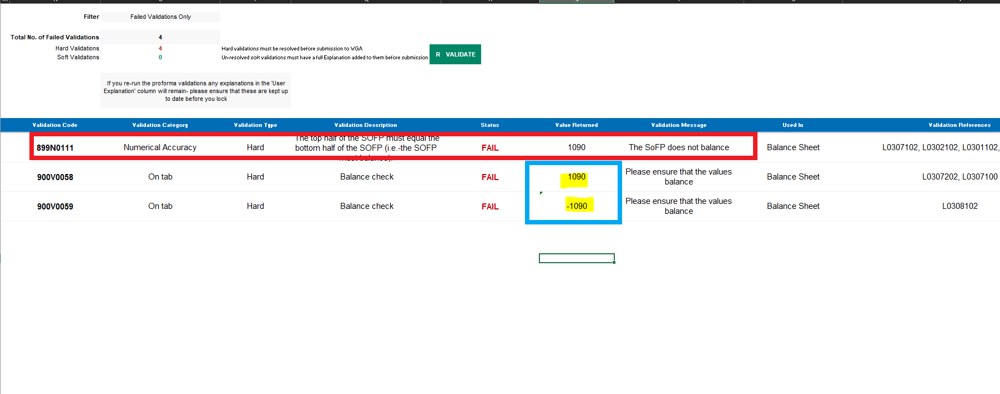

Please investigate and resolve any hard validations on the Validation report. Once all hard validations are cleared, the validation 899N0111 should also clear.
An alternative method to investigate this validation error is to run an Audit report as described in ‘How to Resolve Validation 900V0052’ and address the unbalanced items in your Trial balance.
If the error is connected to the prior year figure, you’ll need to navigate to the Restatement Analysis tab and update your prior year balance to address the issue.

How to resolve Validation 899N0104
Please follow the instructions on the validation report to resolve the issue.

The following is an illustrative example and does not represent actual data from your entity.
Total on 'Expected timing of discounted cash flows' table must equal the total provision balance in the movement table. Please go to the “Liab & Provs” tab and correct so that the breakdown of provisions by expected timing equal the total provisions on the movement table. All the three red boxes below need to agree.

If you complete the green box, they will.

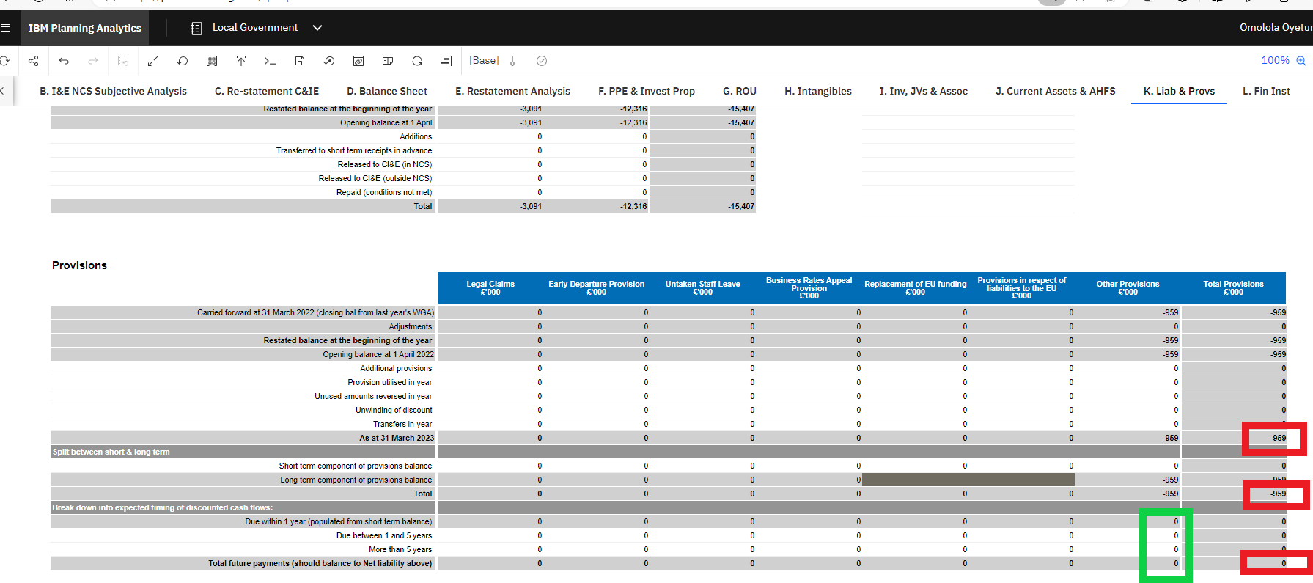

Please investigate and resolve.

How to resolve Validation 899L0117
Please follow the instructions on the validation report to resolve the issue.
The following is an illustrative example and does not represent actual data from your entity.
In the step 2 table, make sure for each line that the total classed as internal, matches back to the total you have allocated on the CPID transactions sheet for the SCOA shown.
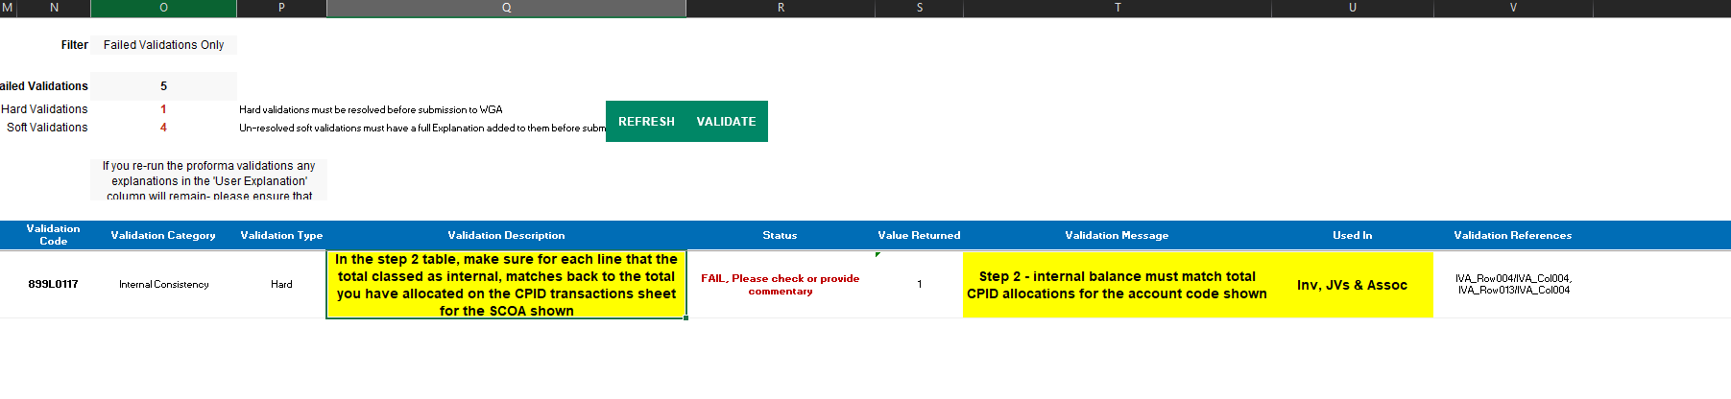
Step 2 does not match the CPID transaction tab.
The figures do not match; one figure is 20,307, and the other is 25,307.
Inv, JVs& Association tab
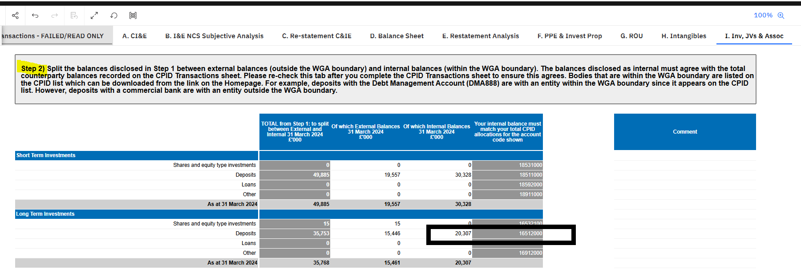
CPID transaction tab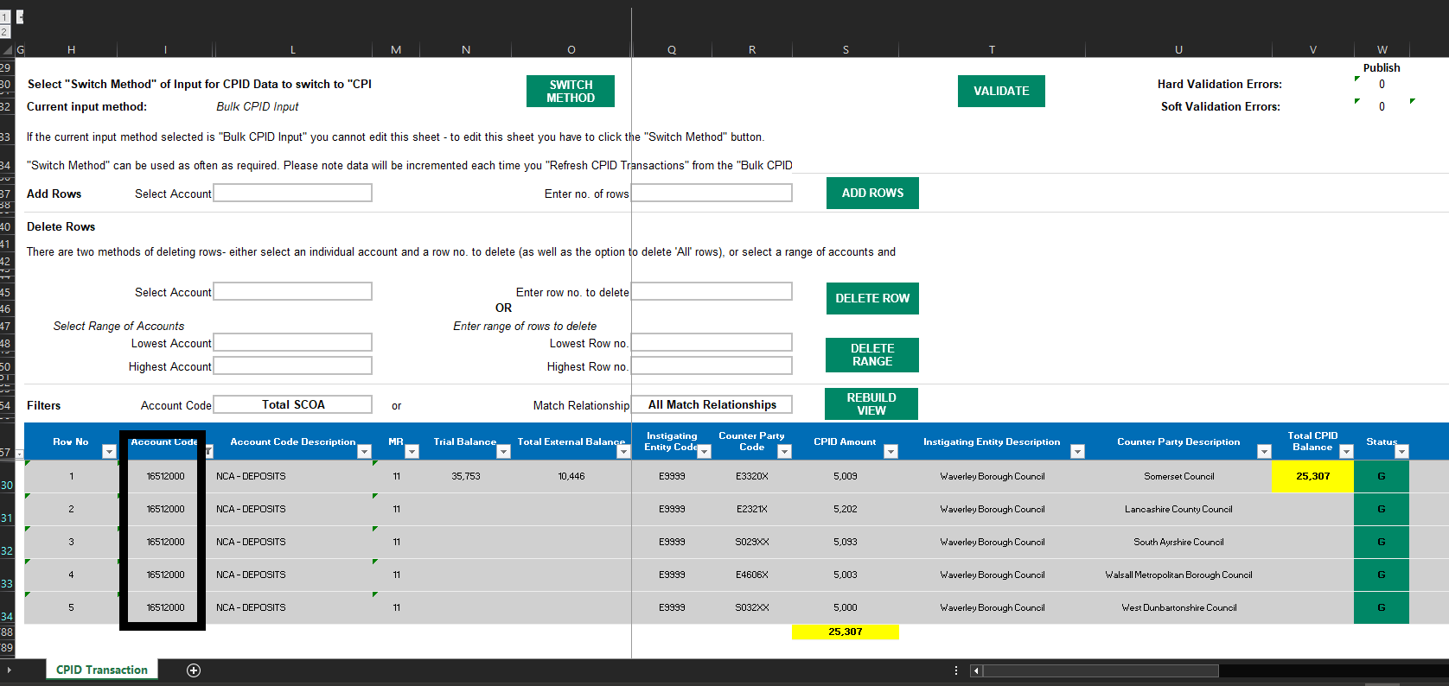
Please investigate and resolve.

How to resolve Validation 899L0121
Please follow the instructions on the validation report to resolve the issue.
The following is an illustrative example and does not represent actual data from your entity.
There are unanswered questions in sheet ‘Additional Data' tab. Go to the “Additional data” tab and complete the mandatory questions. All mandatory questions must be answered.
This is for the first three questions of the 'Contingent Assets/Liabilities' section, and all rows of the 'Post balance Sheet events' section. Please complete the red boxes below to resolve.

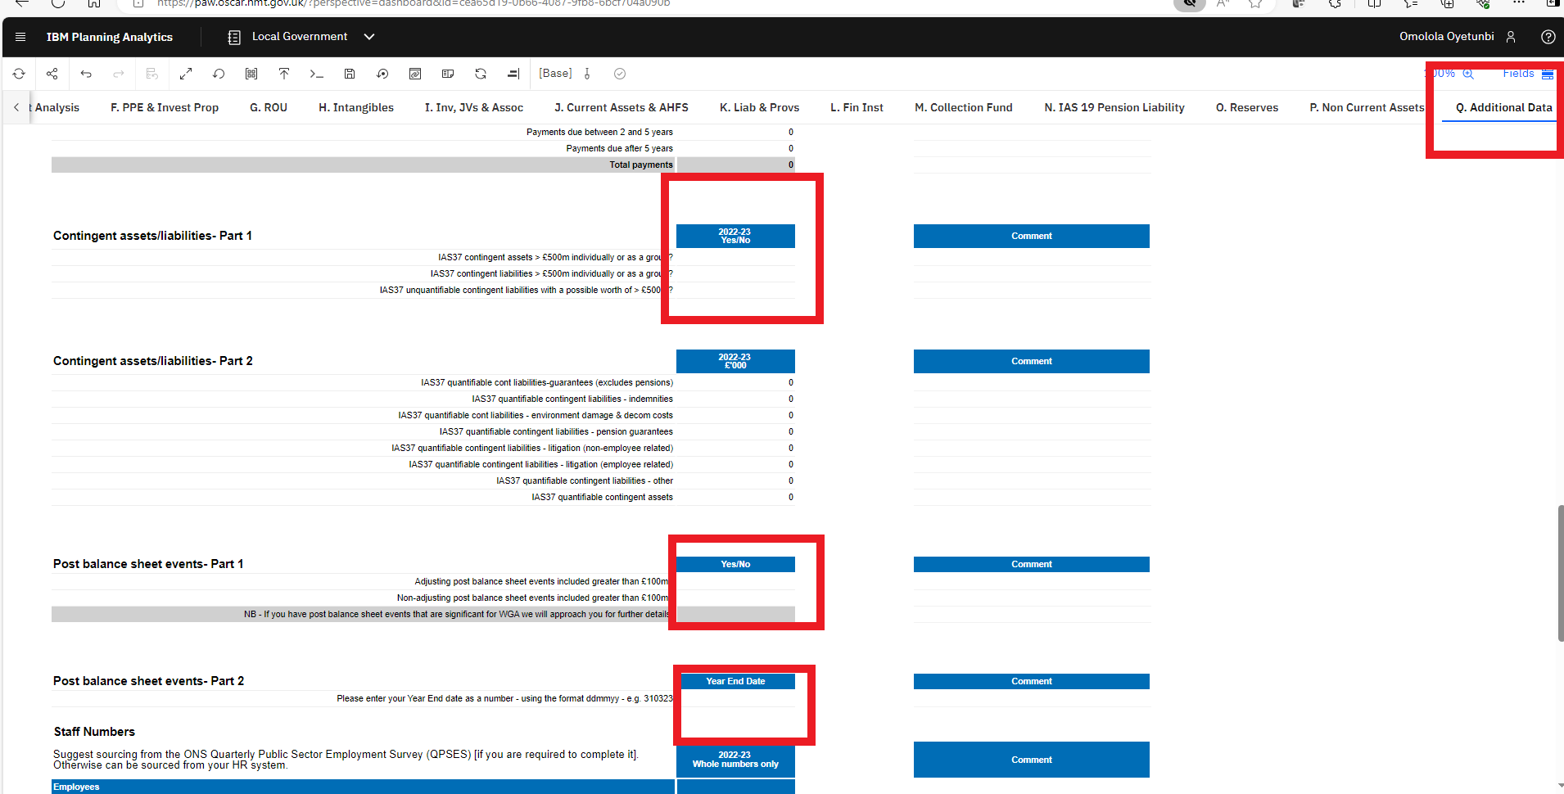
Please investigate and resolve.

How to resolve Validation 899N0030
Please follow the instructions on the validation report to resolve the issue.
The following is an illustrative example and does not represent actual data from your entity.

The external liability type breakdown total must equal the current external OFL balance disclosed on the movement table
The total of the external balances (current and non-current) in Step 2 should agree to the total of External balance (Amortised Cost and "Of Which Fair Value Through Profit or Loss (FVPL) in Step 3.
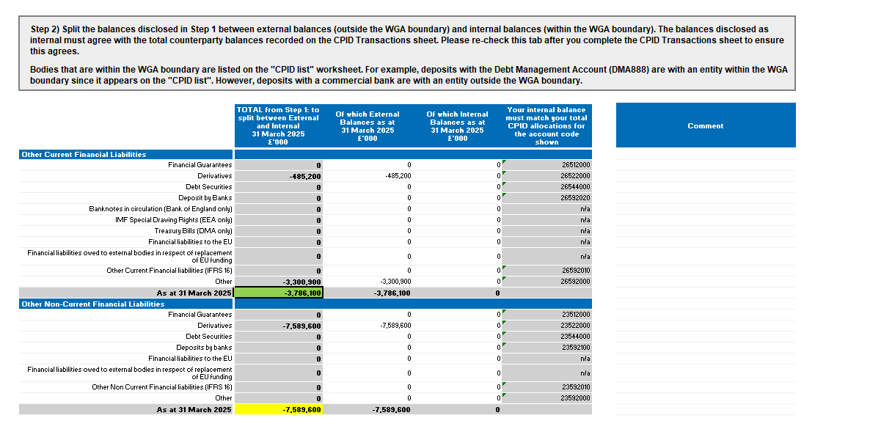
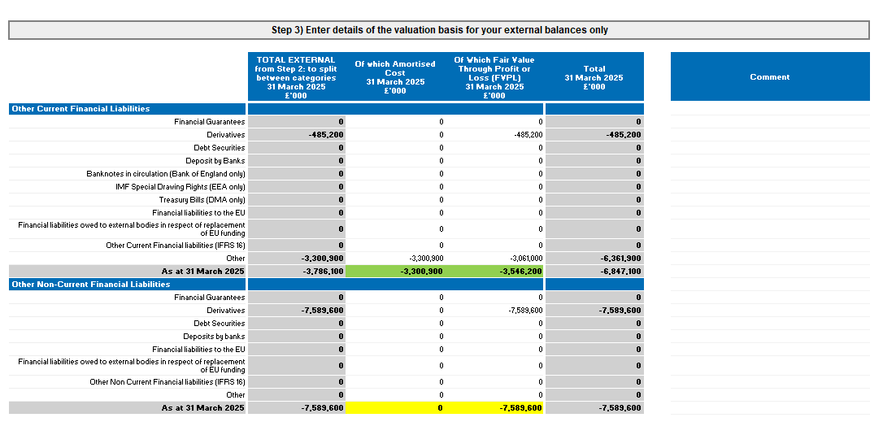
Please investigate and resolve.

How to resolve Validation 899N0122
Please follow the instructions on the validation report to resolve the issue.
The following is an illustrative example and does not represent actual data from your entity.

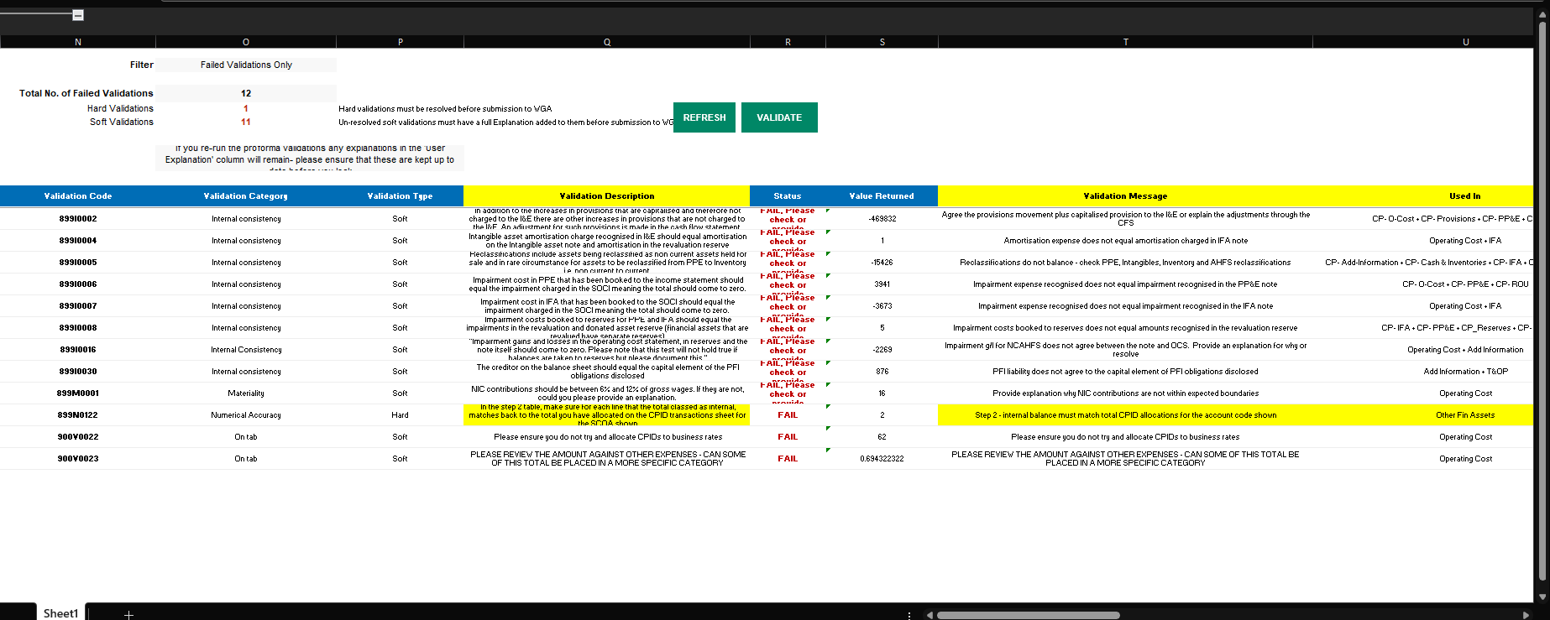

Go to the Other Financial Asset tab as shown on the validation report.

Got to Step 2 as shown on the narrative report “validation description”

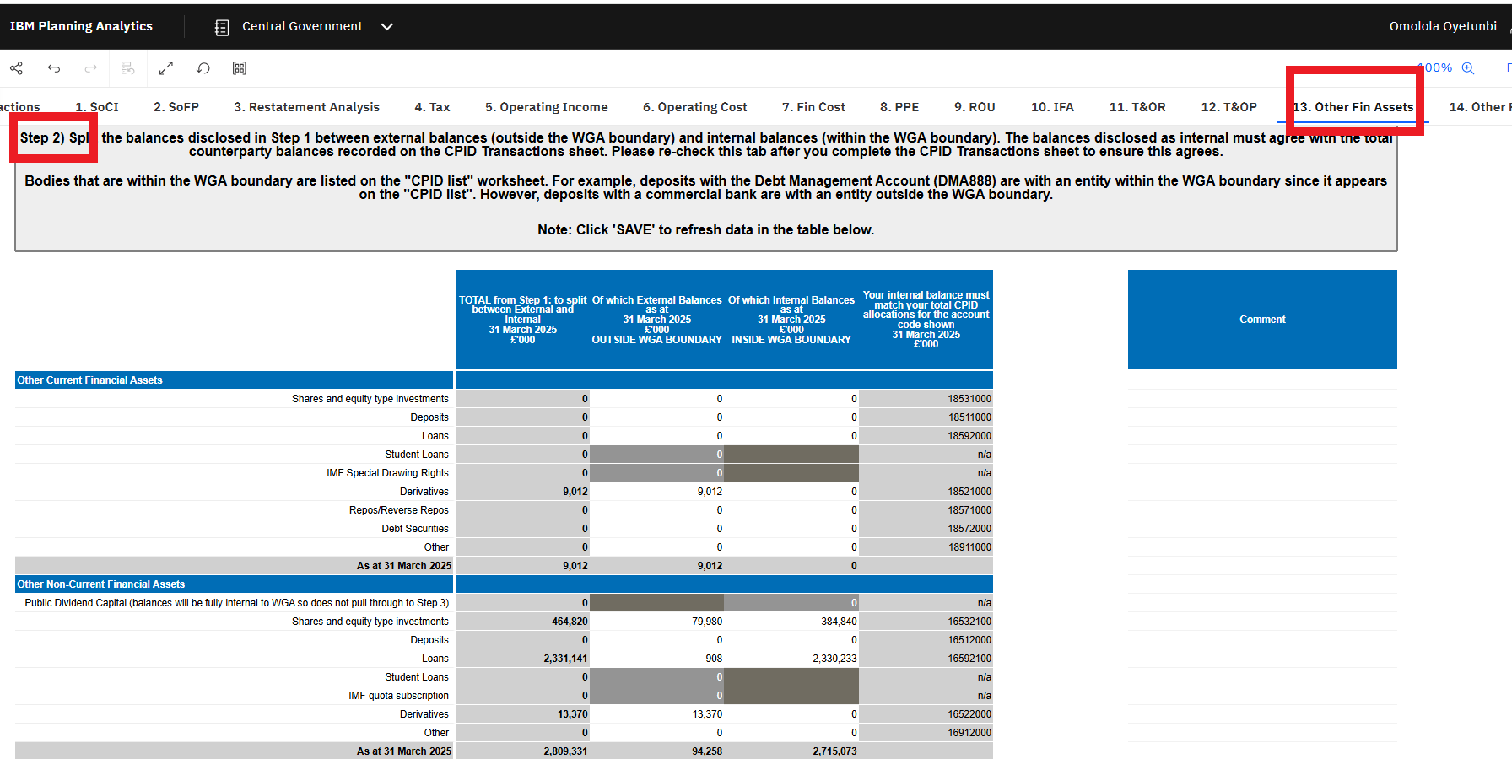

Check that the balance for each SCOA code (green box) in Step 2 agrees to the CPID transaction tab

In the step 2 table, make sure for each line that the total classed as internal, matches back to the total you have allocated on the CPID transactions sheet for the SCOA shown

It needs to agree 100%

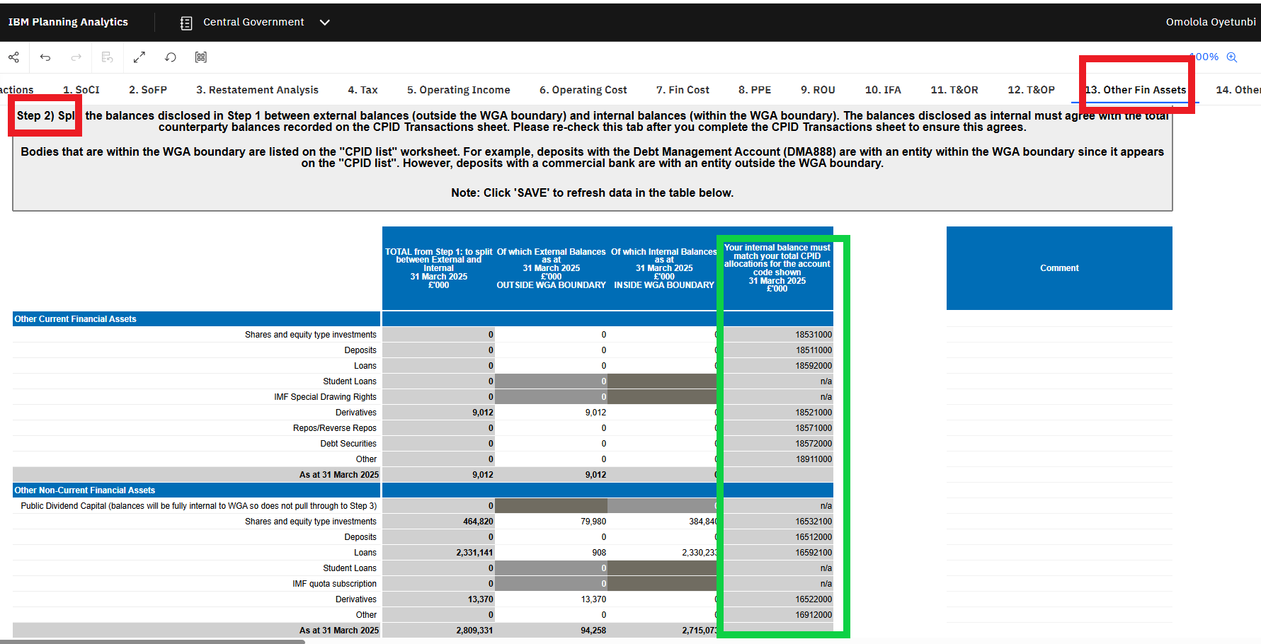

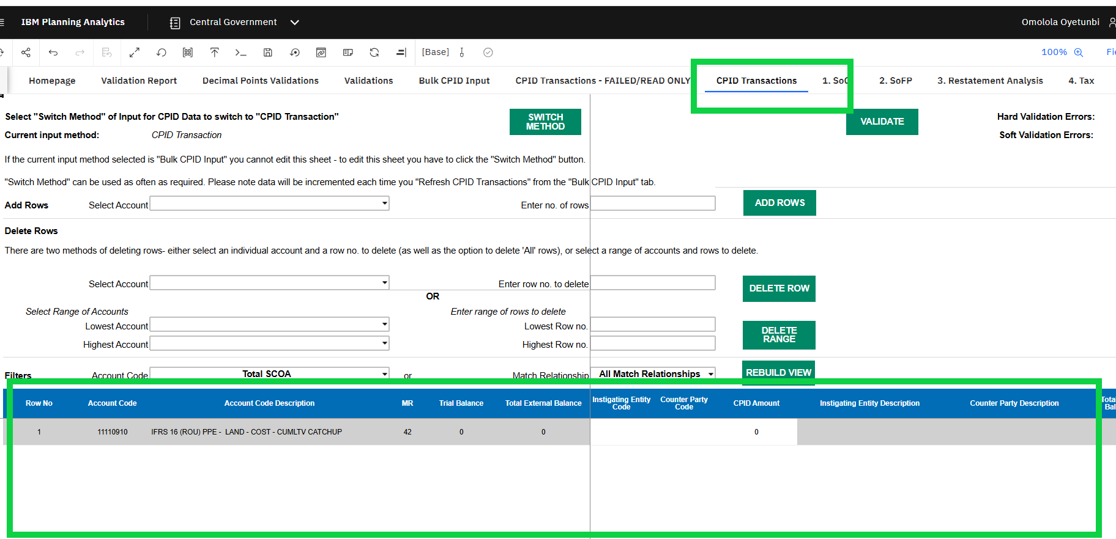

Please investigate and resolve.

How to resolve Validation 899N0125
Please follow the instructions on the validation report to resolve the issue.
The following is an illustrative example and does not represent actual data from your entity.

In the step 2 table, make sure for each line that the total classed as internal, matches back to the total you have allocated on the CPID transactions sheet for the SCOA shown.
Other Financial Liabilities tab
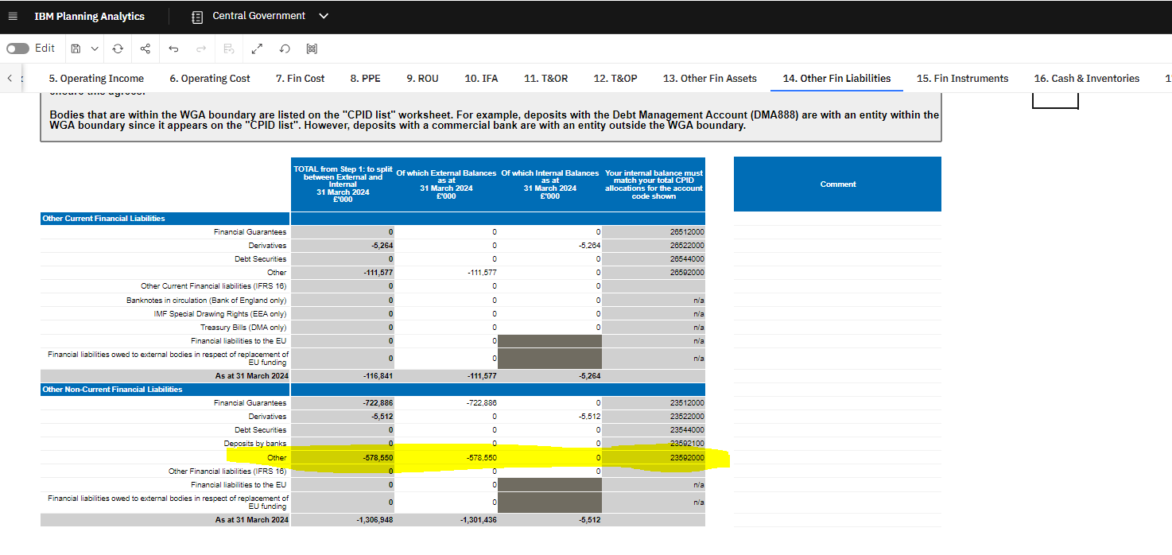

CPID transaction tab

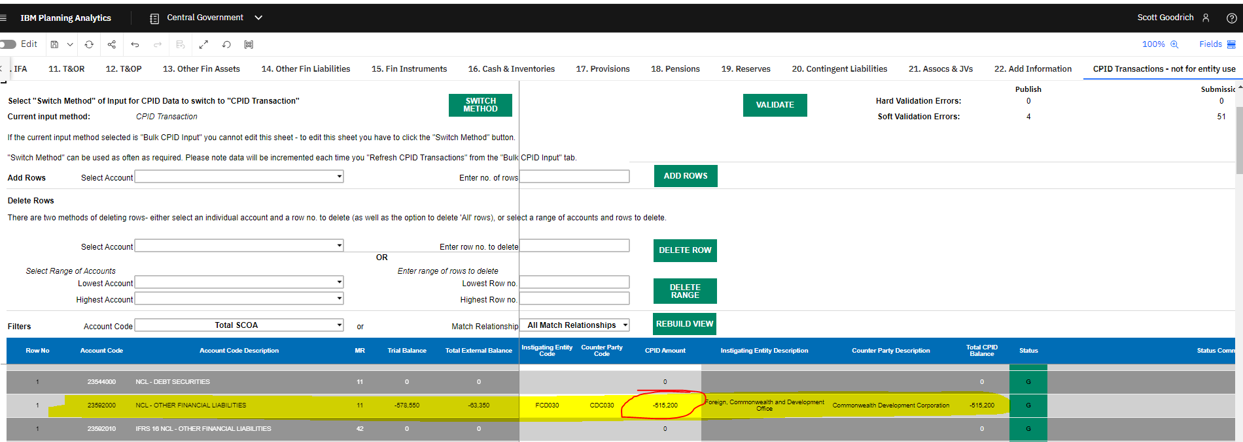
The entity has not listed an internal balance against 23592000 on the Other Fin Liab tab but have assigned a CPID amount against this. The two values need to match, otherwise the validation will fail.
Please investigate and resolve.

How to resolve Validation 899N0127
Please follow the instructions on the validation report to resolve the issue.
The following is an illustrative example and does not represent actual data from your entity.

In the step 3 table, make sure that your amortised cost + FVPL amount for each line, tallies to the total external balance as shown in the left hand column.
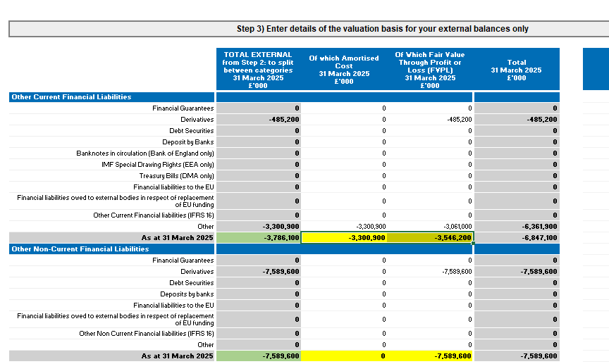

The two yellow cells under Other Current Financial Liabilities (Amortised Cost and FVPL) must sum to the total shown in the green cell. Similarly, the two yellow cells under Other Non-Current Financial Liabilities (Amortised Cost and FVPL) must also sum to the total in the corresponding green cell.
Please investigate and resolve.

How to resolve Validation 899N0128
Please follow the instructions provided in the validation report to resolve the issue.

The example below is for illustrative purposes only and does not reflect actual data from your entity.

Fair Value Through Profit or Loss (FVPL) table
The individual transaction categories reported under the “Fair Value Through Profit or Loss (FVPL) £’000” column must reconcile with the corresponding category splits in the “TOTAL External Assets at FVPL & FVOCI £’000” table below.
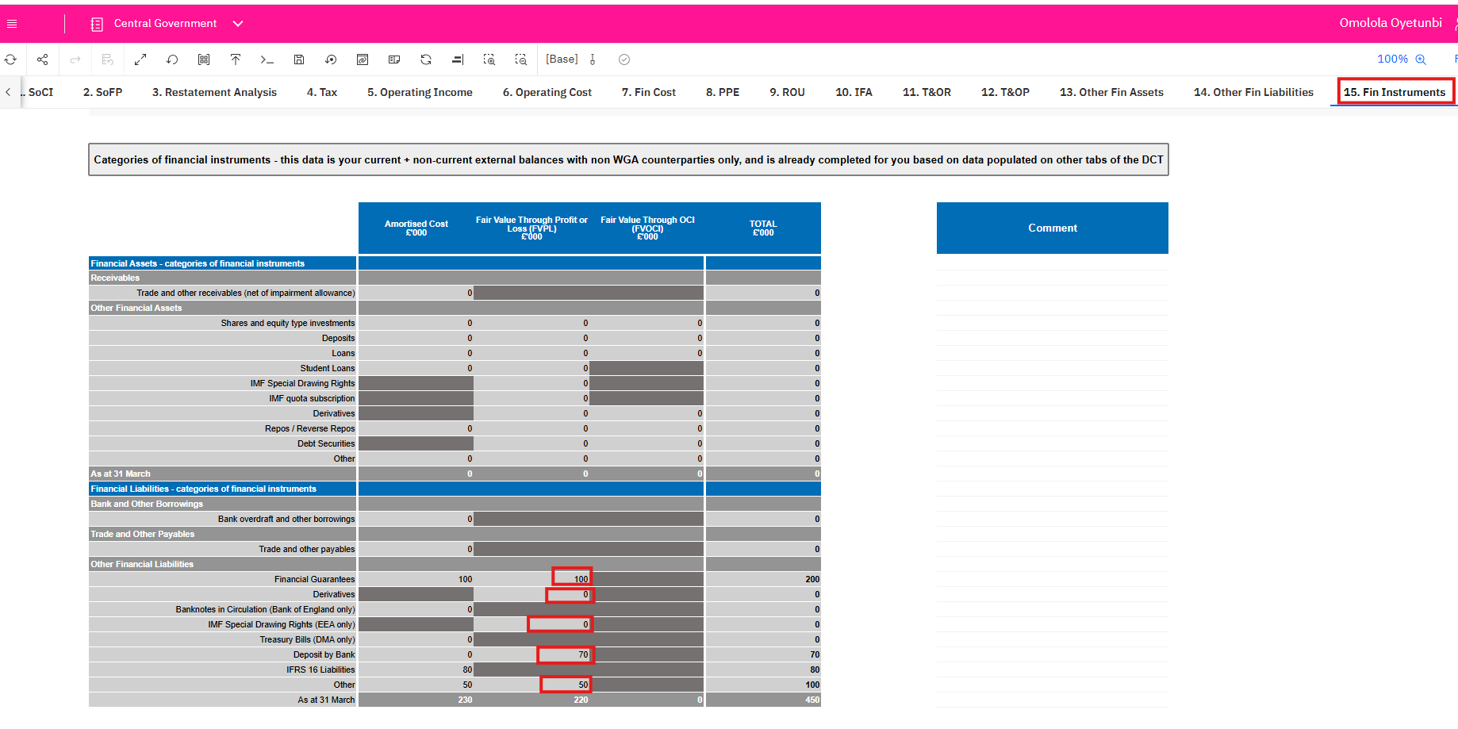

Valuation hierarchy table
Please split your current and non-current external balances held at FVPL and FVOCI (as shown in column C) between Levels 1, 2, and 3. The split must agree to the total of the breakdown provided in the table above for individual categories.

For financial assets, please enter positive values. For financial liabilities, please enter negative values.

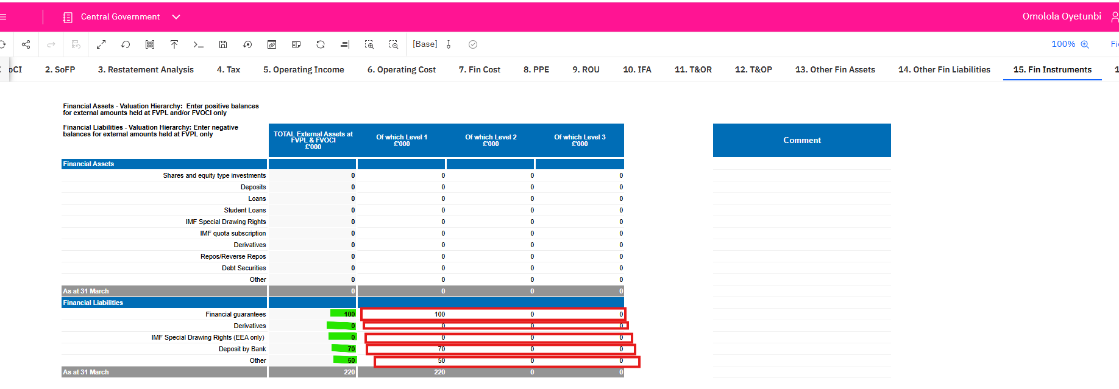

Please investigate and resolve.

How to resolve Validation 899N0130
Please follow the instructions on the validation report to resolve the issue.
The following is an illustrative example and does not represent actual data from your entity.

All mandatory questions must be answered.

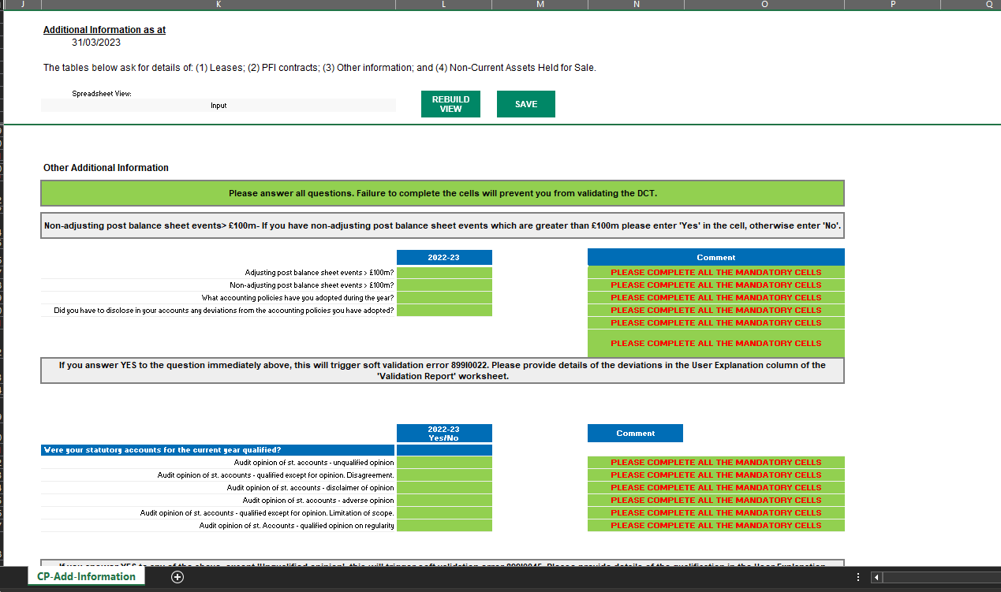
Please investigate and resolve.

How to resolve Validation 900V0024
Please follow the instructions on the validation report to resolve the issue.
The following is an illustrative example and does not represent actual data from your entity.

ERROR: does not equal other expenses above

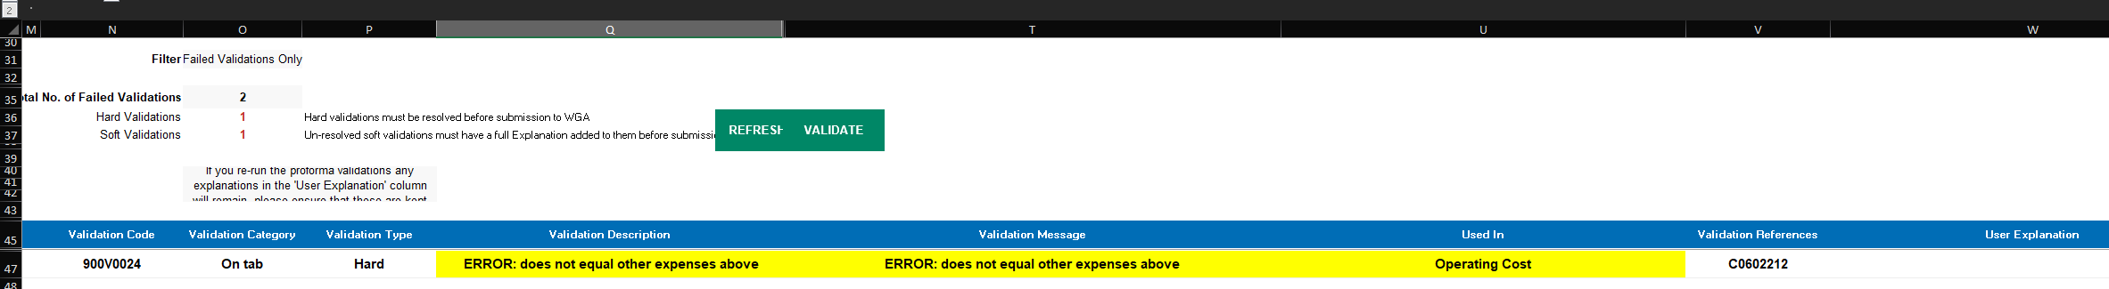
Please analyse the ‘Other Expenses’ in the table below and complete any missing information to resolve the error.
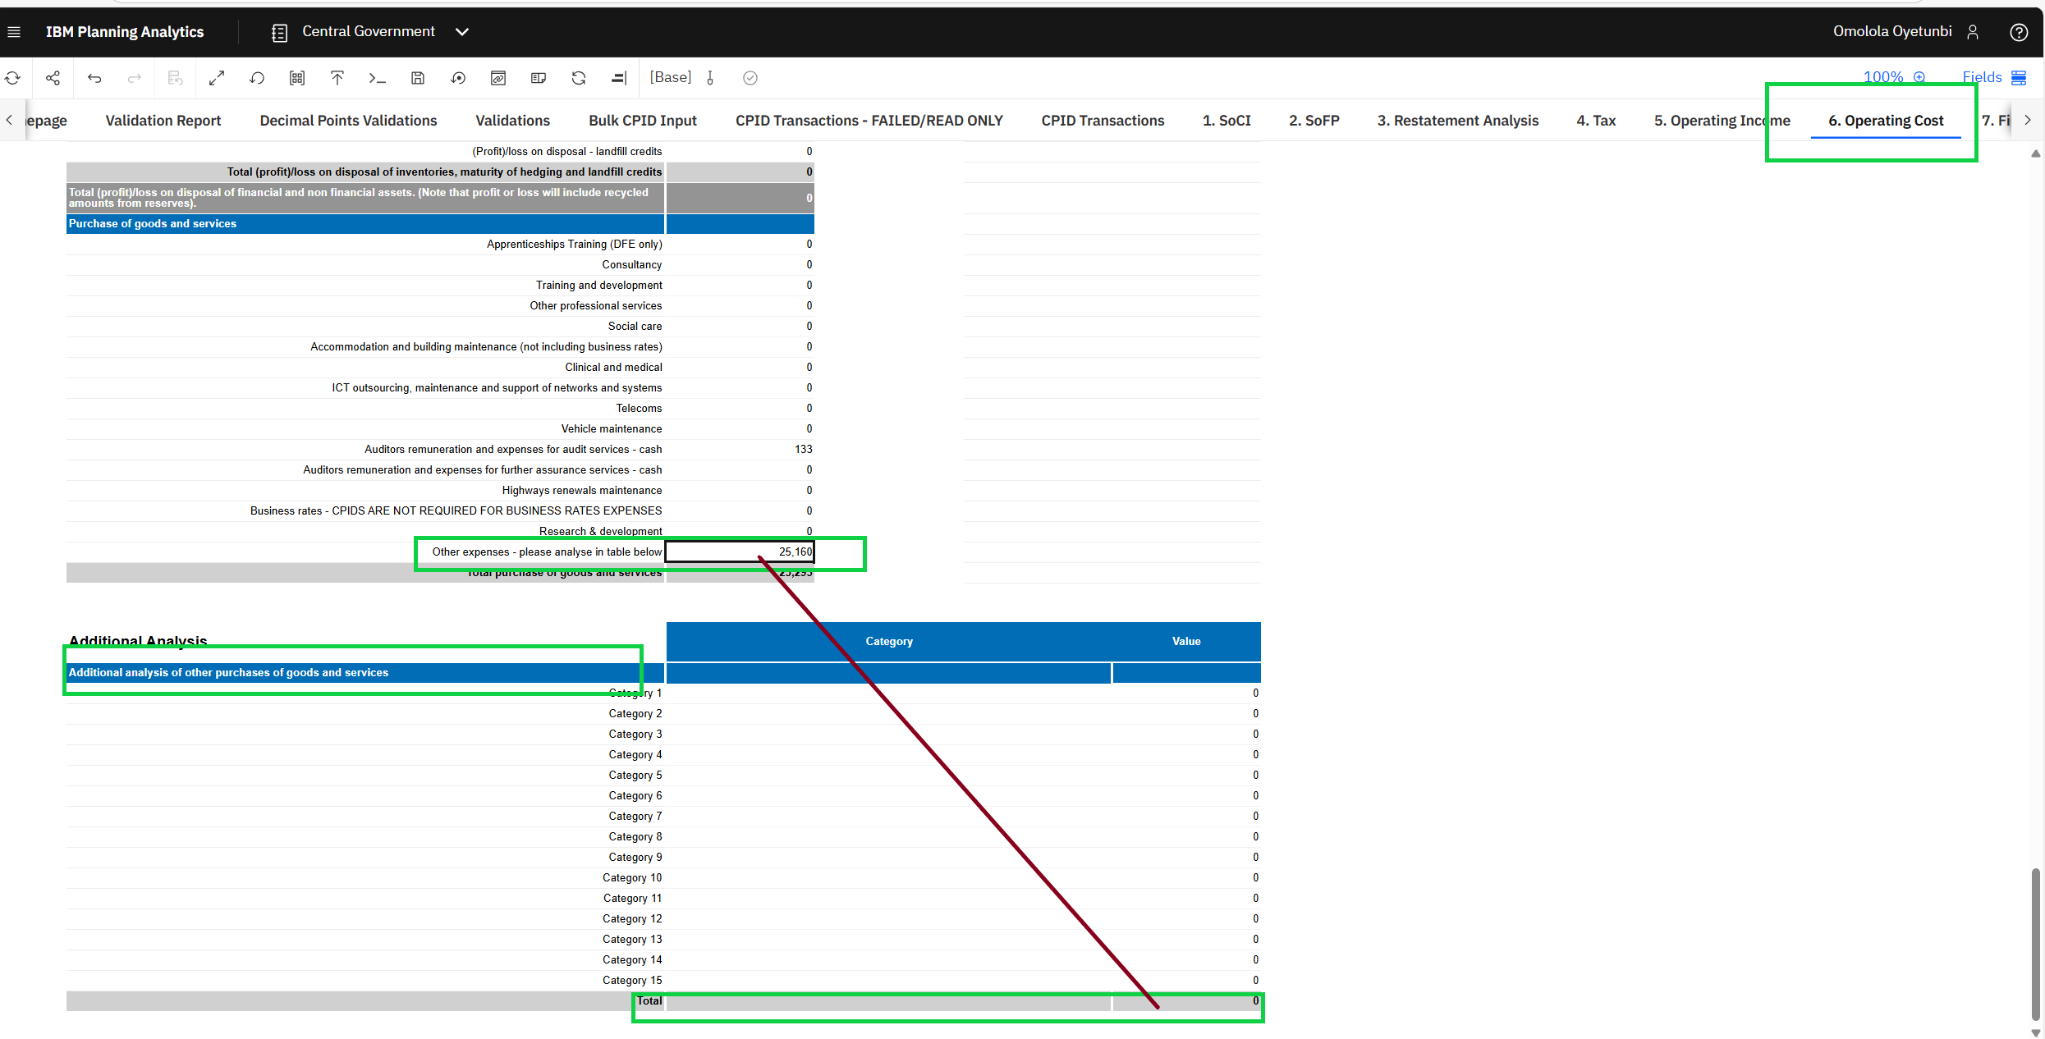

How to resolve Validation 900V0026
Please follow the instructions on the validation report to resolve the issue.
The following is an illustrative example and does not represent actual data from your entity.
No cash movement during year. Please complete the additional cashflow boxes above to remove the error.
On the IFA (Intangible Fixed Assets) tab, the entity has not completed the additional section.
Please complete to resolve the error.
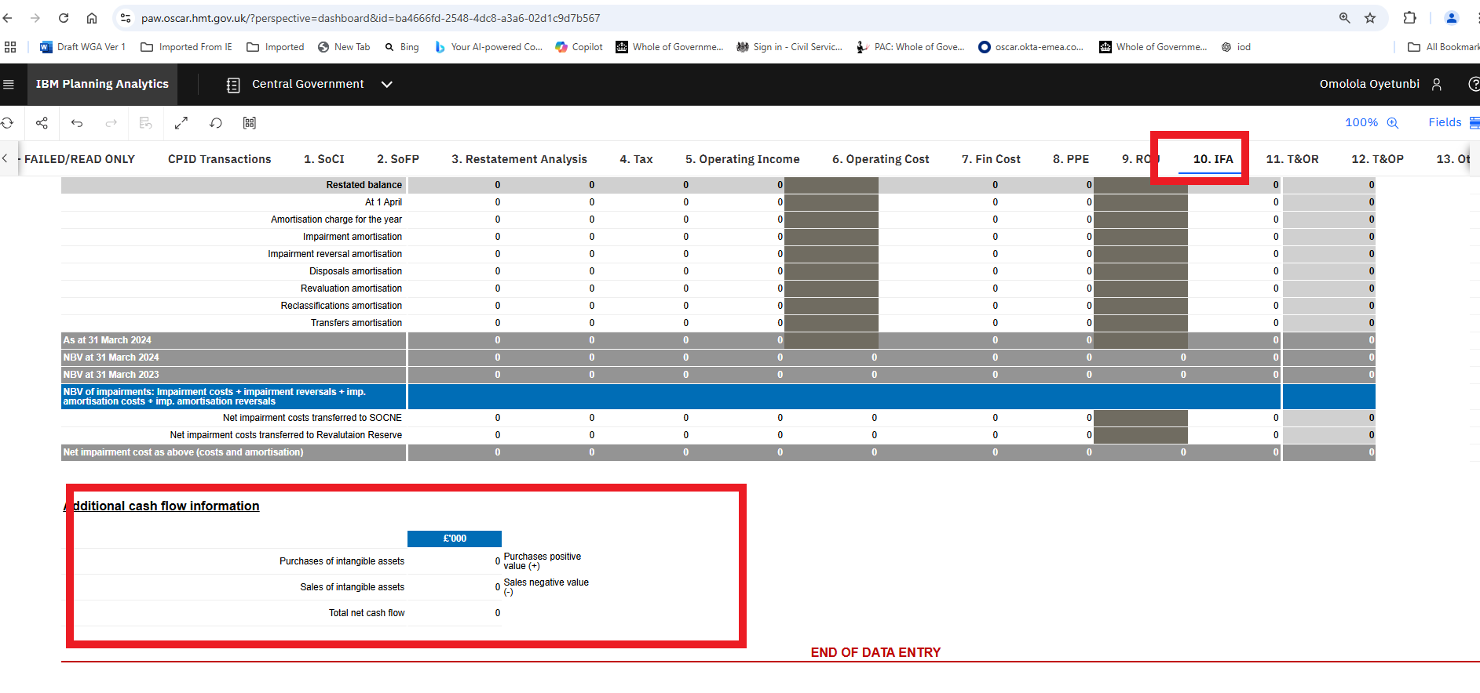

How to resolve Validation 900V0031, 900V0032
Please follow the instructions on the validation report to resolve the issue.
The following is an illustrative example and does not represent actual data from your entity.

Must equal other payables above. There is a table at the bottom of the ‘payables’ that breaks out the ‘other payables’ number in the main payables table. The entity will need to provide a breakdown in the table at the bottom of the payables tab to get this validation to clear.

Go to the CP-T&OP affected by the error and look at where the SCOA codes should be going

You need to investigate why your total payable at the top of the page does not match the analysis below. Screen shots of Current Trade and other payables and the breakdown is below for your DCT is below.

Current Trade and other payables

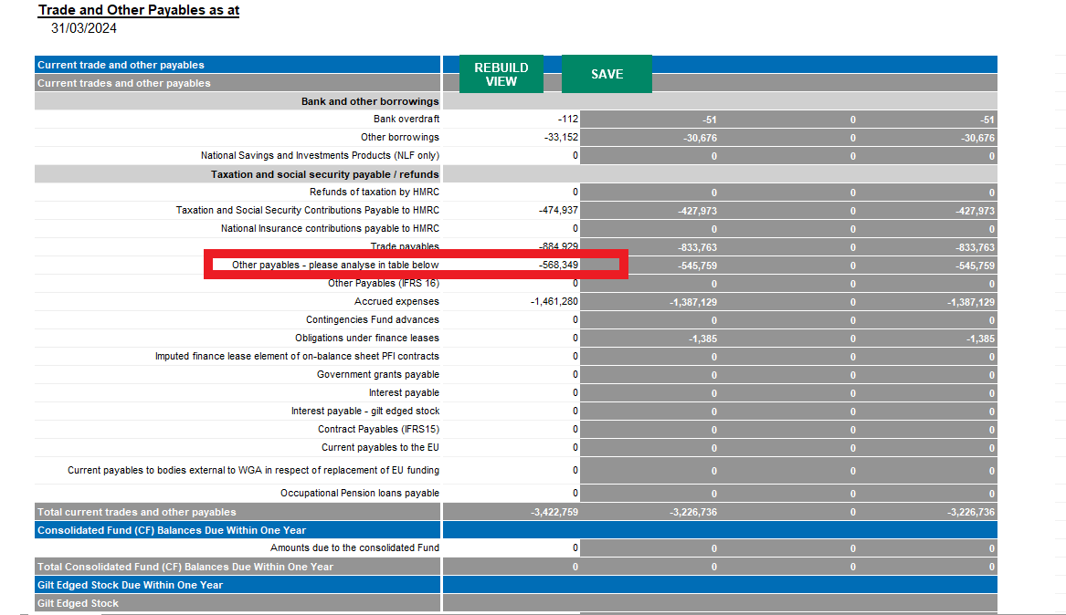

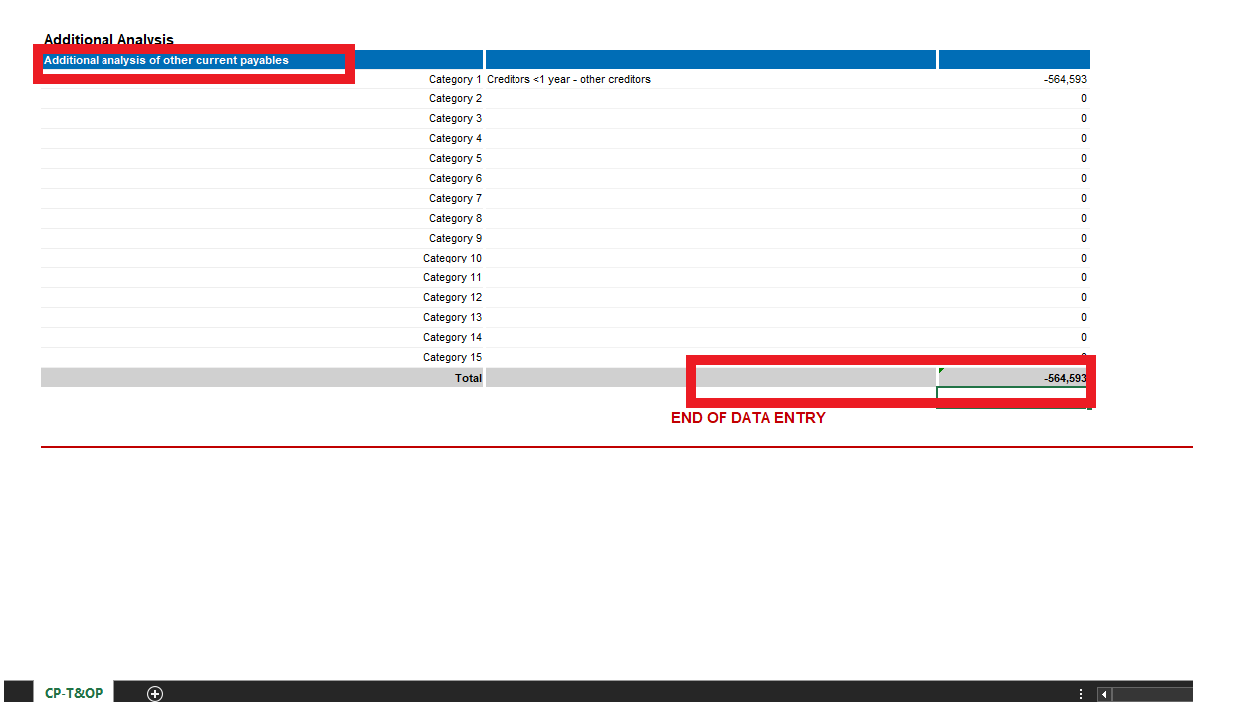

You can see from above the total and the breakdown does not match. Please correct to resolve.

Non - Current Trade and other payables

In this case the entities total does not match the breakdown for Non - Current Trade and other payables

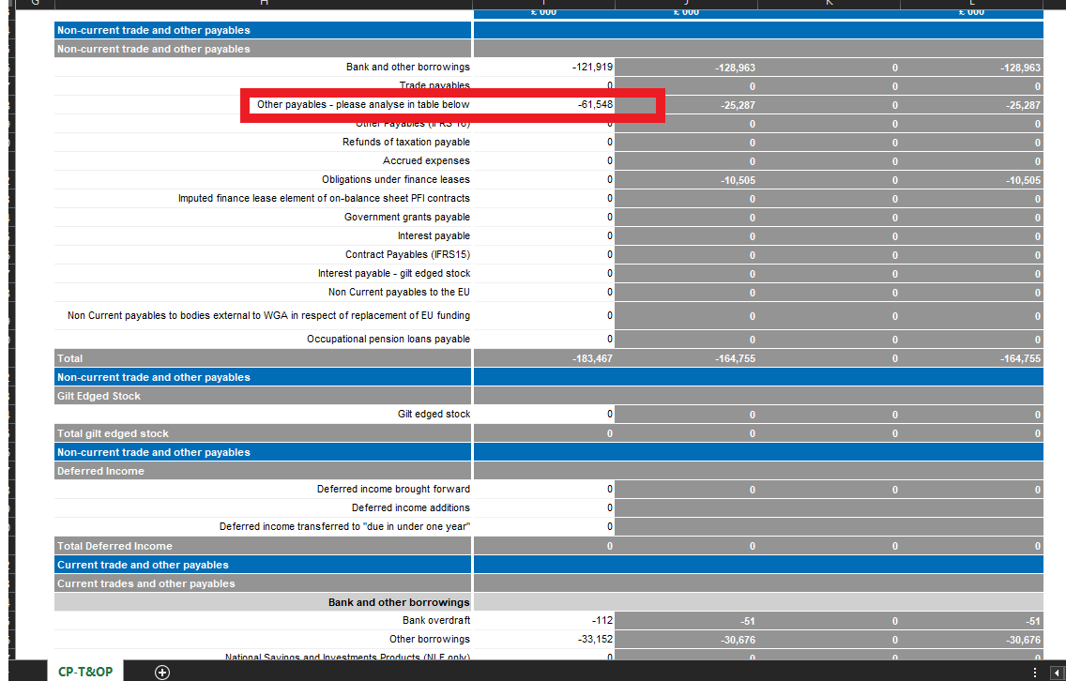

The breakdown for the non-Current other payables figures is showing £-25,178

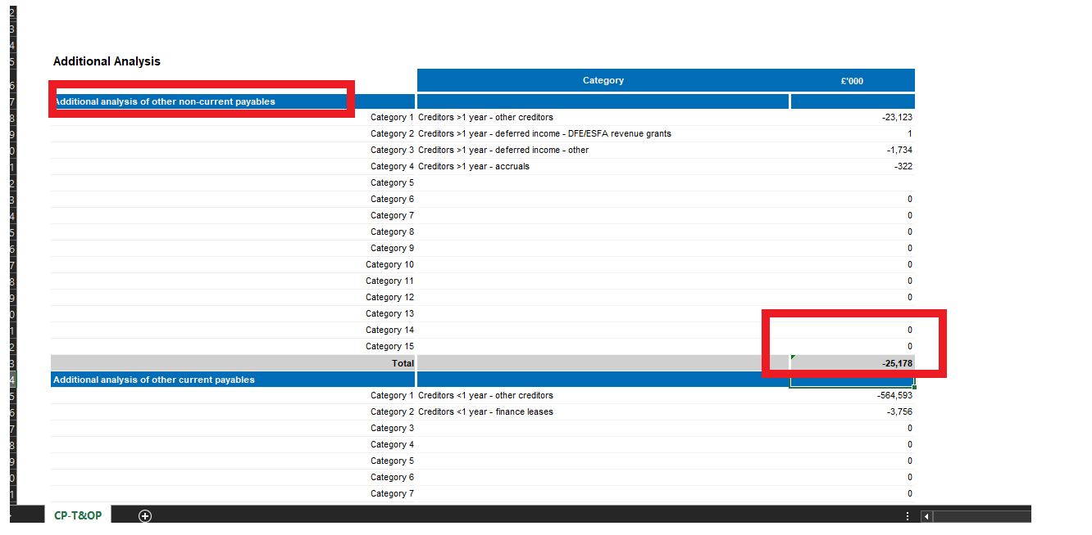

You can see from above the total and the breakdown does not match. Please correct to resolve.

How to resolve Validation 900V0033
Please follow the instructions on the validation report to resolve the issue.
The following is an illustrative example and does not represent actual data from your entity.
No cash movement during year. Please complete the additional cashflow boxes above to remover the error.
On the Other Financial Assets tab, the entity has not completed the additional section.
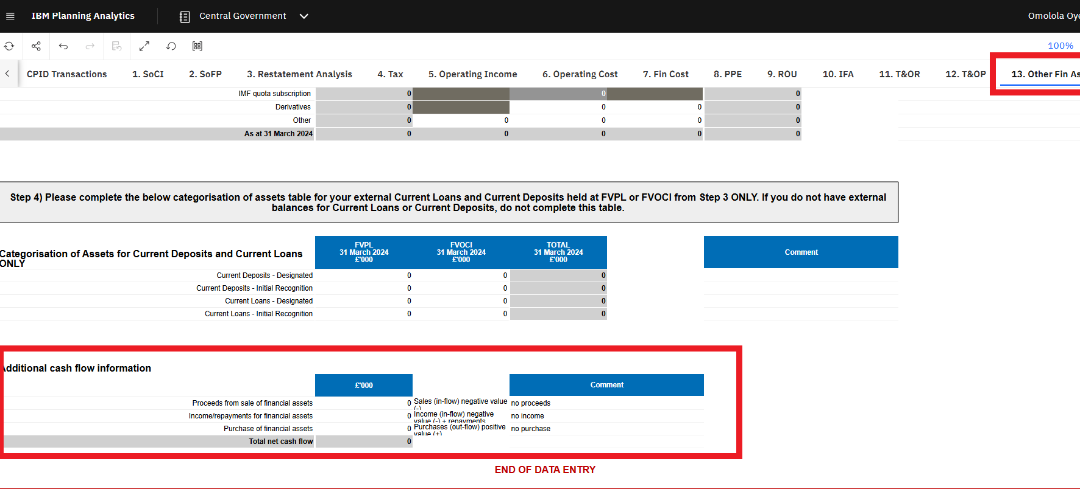
Please complete to resolve the error.

How to resolve Validation 900V0034
Please follow the instructions on the validation report to resolve the issue.
The following is an illustrative example and does not represent actual data from your entity.
No cash movement during year. Please complete the additional cashflow boxes above to remove this warning
On the Other Financial Liabilities tab, the entity has not completed the additional section. See the screenshot below.
Please complete to resolve the error.
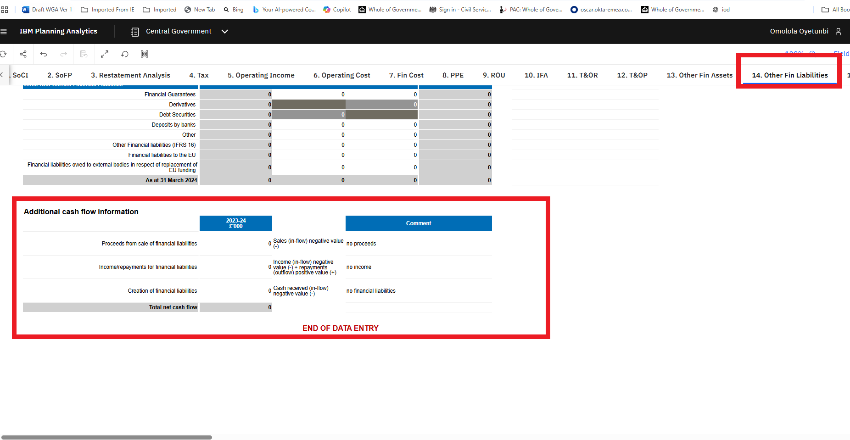

How to resolve Validation 900V0042
Please follow the instructions on the validation report to resolve the issue.
The following is an illustrative example and does not represent actual data from your entity.

Below is a sample of the Provision tab. Ensure that all closing balances align with the opening balance.

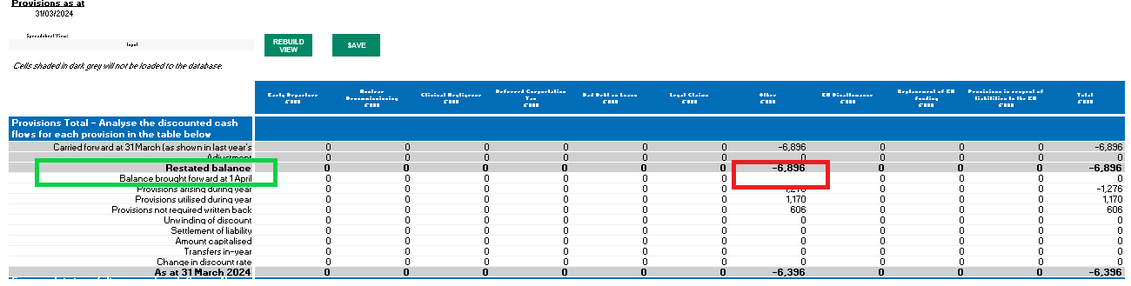

The cells in the green boxes need to agree. Use this method to examine and rectify red box on all affected individual tabs.

Please investigate and resolve.

How to resolve Validation 900V0051
Please follow the instructions on the validation report to resolve the issue.
The following is an illustrative example and does not represent actual data from your entity.

ERROR: does not equal other operating income above. Please ensure that the value balance.

Please analyse the Other Operating Income - in table below. The two yellow cells should agree.

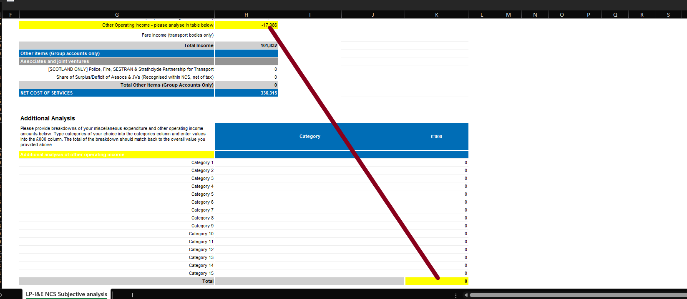

Please investigate and resolve.

How to resolve Validation 900V0052
Please follow the instructions on the validation report to resolve the issue.
The following is an illustrative example and does not represent actual data from your entity.

Balance check. Please ensure that the value balance.

Please run an audit report on your current DCT. Details can be found in the written guidance on our website.

On the ‘Variance Analysis_4’ tab, total your 1-6 series SCOA codes and ensure they amount to zero, as shown in the example below. If they do not, it indicates that your trial balance is out; please investigate and resolve this issue accordingly. The entity is responsible for investigating and resolving its own errors.

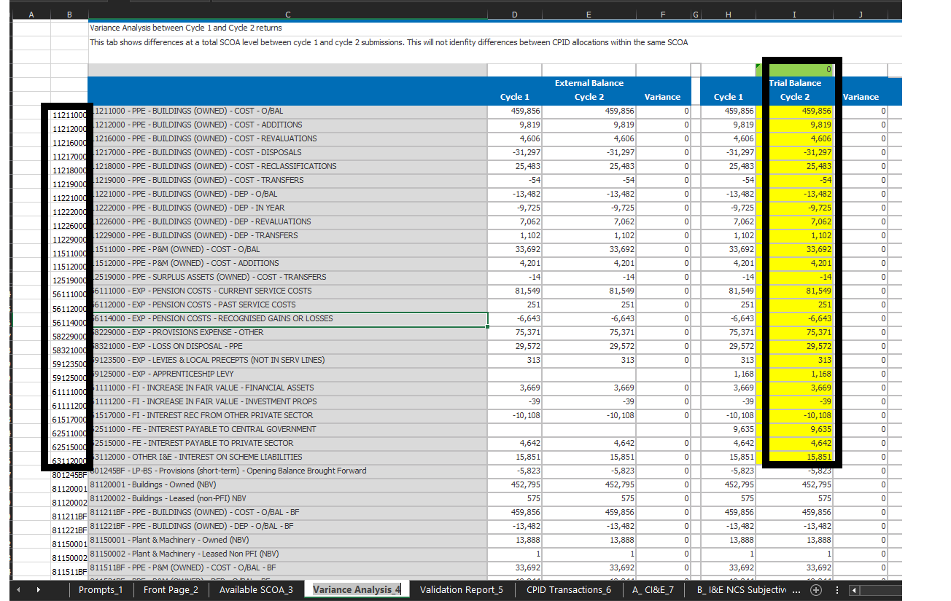

Please investigate and resolve.

How to resolve Validation 900V0057, 900V0058,
Please follow the instructions on the validation report to resolve the issue.
The following is an illustrative example and does not represent actual data from your entity.

The Fin Instruments sheet gets data for the first table from Other Fin Assets and Other Fin Liabs from the Step 3 Split of External into Amortised FVPL and FVOCI. The third table where they enter the split into Level 1-3 should not have anything enterable in the first column for the TOTAL. Instead, this gets its figure by summing the FVPL and Amortised columns of the first table.
899N0057 – Financial Assets: Fair Value missing where Carrying Value exists
899N0058 – Financial Liabilities: Fair Value missing where Carrying Value exists
What the Errors Mean
Both validations are triggered when a carrying value has been entered for a financial asset or liability type, but the corresponding fair value cell has been left blank. Where a carrying value exists, a fair value must also be provided.
How to Resolve
Step 1 – Navigate to the Financial Instruments tab in the DCT.
Step 2 – Locate the rows where you have entered a carrying value for a financial asset (899N0057) or financial liability (899N0058).
Step 3 – Check the corresponding Fair Value cells for those rows — these will be blank where the validation has been triggered.
Step 4 – Enter the relevant fair value figures in those cells.
Step 5 – Once all Fair Value cells have been completed, the validation errors should clear.
Extract of Validation report
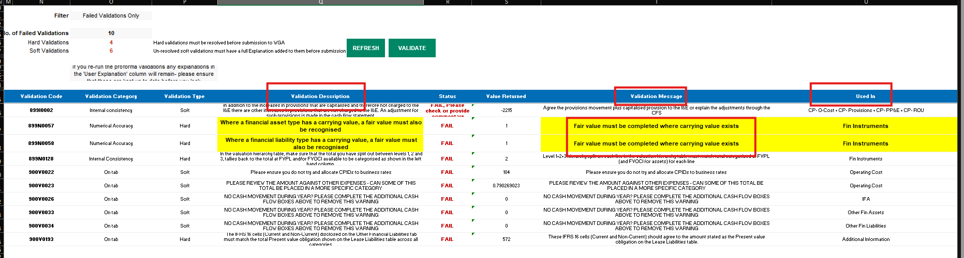
Financial Instrument tab
The Financial Instruments tab indicates that the Fair Value cells have not been completed for one or more rows where a carrying value has been entered.
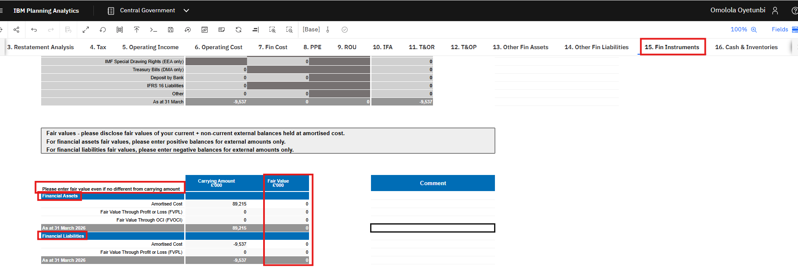

How to resolve Validation 900V0061
Please follow the instructions on the validation report to resolve the issue.
The following is an illustrative example and does not represent actual data from your entity.

So, the validation we’re looking at here is 900V0061

If you go on the LP validation tab, and filter for this validation you get the following:

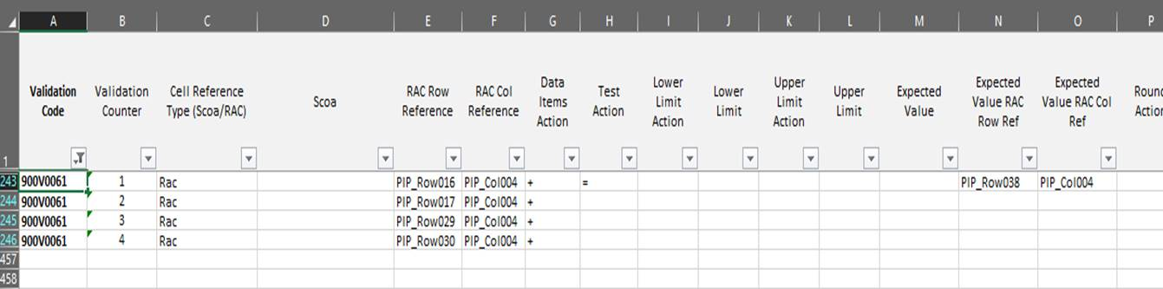

So instead of SCOA codes it shows Row and Column codes in columns E and F.

You can easily find these references by using the search function in Excel, or if you navigate to the PPE and E tab you can see these orange-y peach bits around the edge.

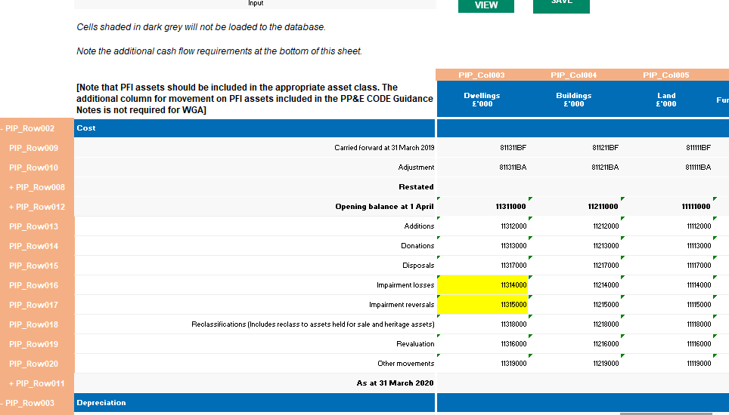

So, you can see here PIP_Row 16/PIP_Col004 is SCOA 11214000

The other bit worth remembering is how to read the validation list itself:

So, what is being compared is in column E&F, but what it is comparing it to is in columns N&O?

So, looking at our example:

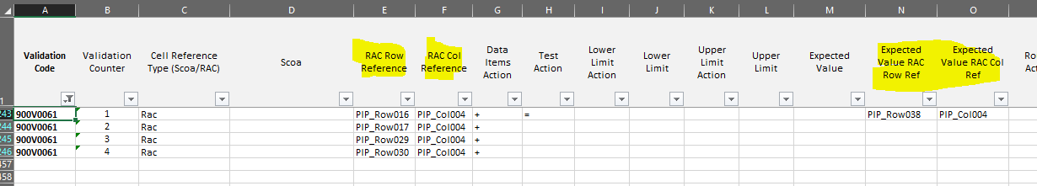

What the validation is asking you to do is compare rows 16+17+29+30 to Row 38
Please investigate and resolve.

How to resolve Validation 900V0082
Please follow the instructions on the validation report to resolve the issue.
The following is an illustrative example and does not represent actual data from your entity.

ERROR: does not equal other debtors above. The two yellow cells need to be the same.

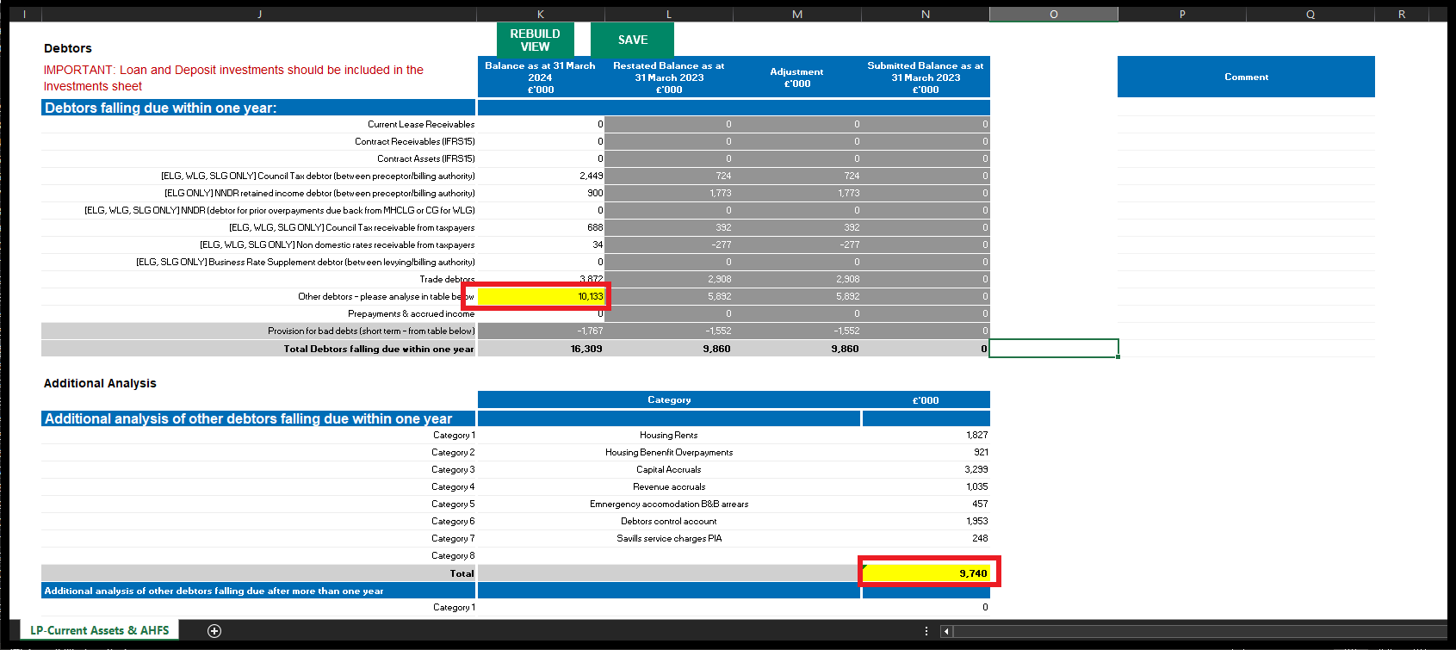

Please investigate and resolve.

How to resolve Validation 900V0083
Please follow the instructions on the validation report to resolve the issue.
The following is an illustrative example and does not represent actual data from your entity.

ERROR: does not equal other debtors above. The two yellow cells need to be the same.

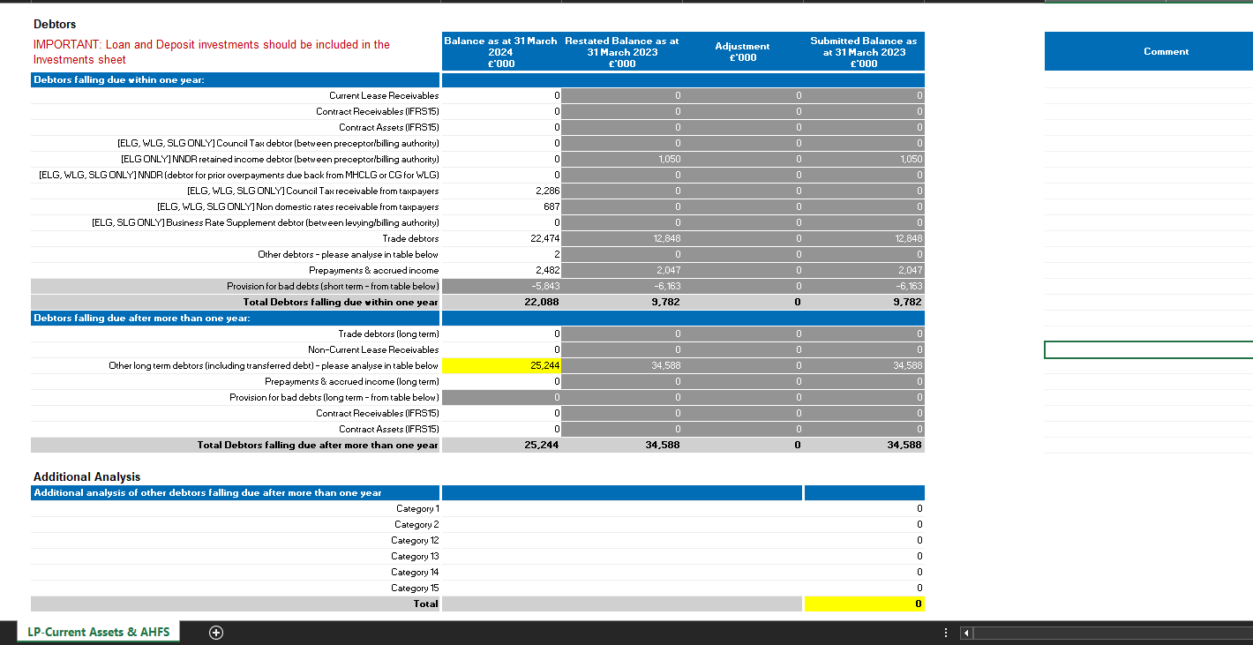
To resolve this error, please break down the “Other long-term debtors (including transferred debt) - please analyse in table below” entry as below.
Please correct to resolve.
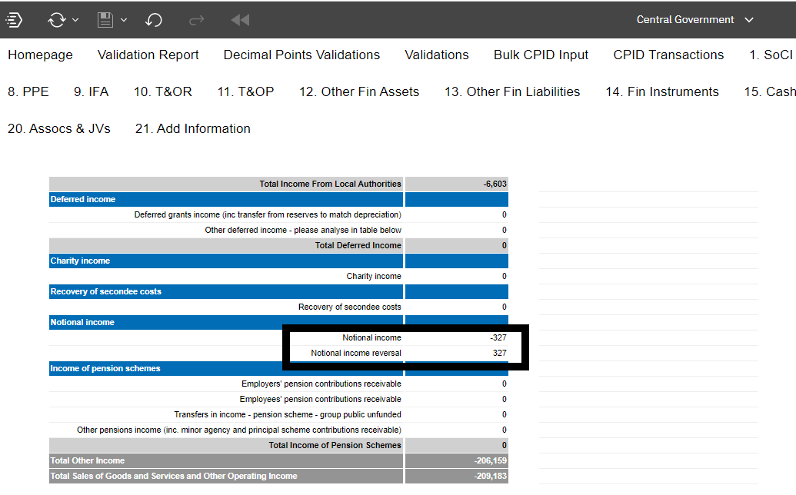

Please investigate and resolve.

How to resolve Validation 900V0094
Please follow the instructions on the validation report to resolve the issue.
The following is an illustrative example and does not represent actual data from your entity.

ERRORERROR: does not equal other scheme invested above.

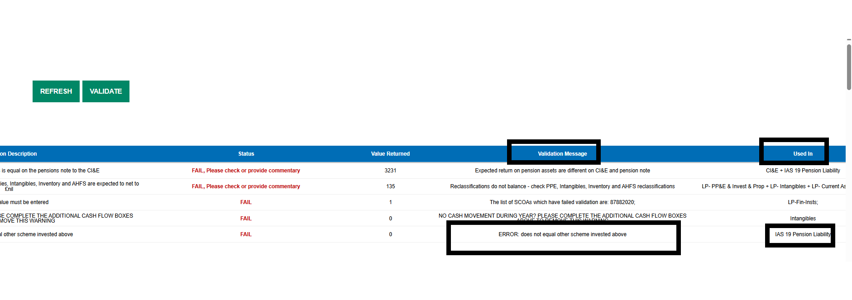

Go to the IAS 19 Pension Liability tab and correct. Please breakdown the Other scheme invested in the table below
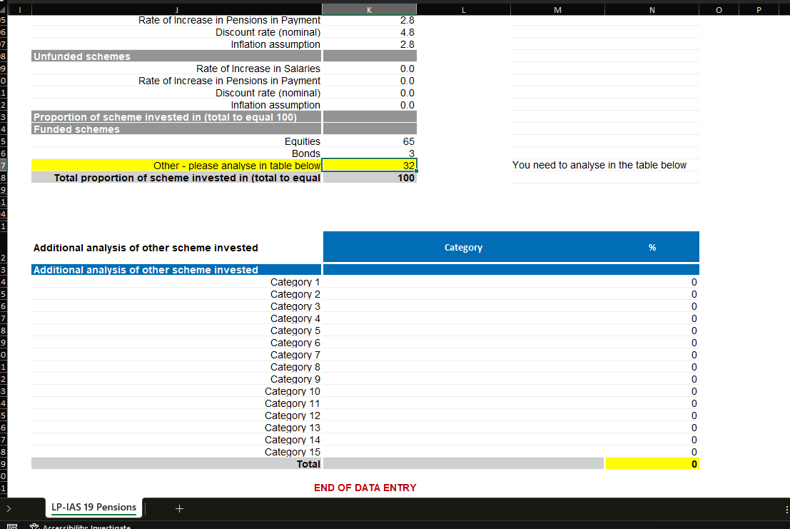

How to resolve Validation 900V0131

Please follow the instructions on the validation report to resolve the issue.
The following is an illustrative example and does not represent actual data from your entity.

Please run an audit report on your current DCT. Details can be found in the written guidance on our website.

On the ‘Variance Analysis_4’ tab, total your 1-6 series SCOA codes and ensure they amount to zero, as shown in the example below. If they do not, it indicates that your trial balance is out; please investigate and resolve this issue accordingly. The entity is responsible for investigating and resolving its own errors.

How to resolve Validation 900V0148, 900V0151
Capital commitment

The validation codes are:

LG: 900V0148
CG: 900V0151

Check your entries for Capital Commitment. Non-zero total should pass validation. A zero total with no "Y" will fail validation and show in the validation report.

By adding the "Y" in the extra line below "other financial commitments" and rerunning the validation report should now pass.

Please investigate and resolve.

How to resolve Validation 900V0149, 900V0150
This validation ensures that 16592100 Loans in Step 1 equals the total of loans entered in Step 2 (81651901 + 81651903).

If this equality is not met, the validation will fail.

If the equality holds, the validation will pass.

Please investigate and resolve.

Step 1
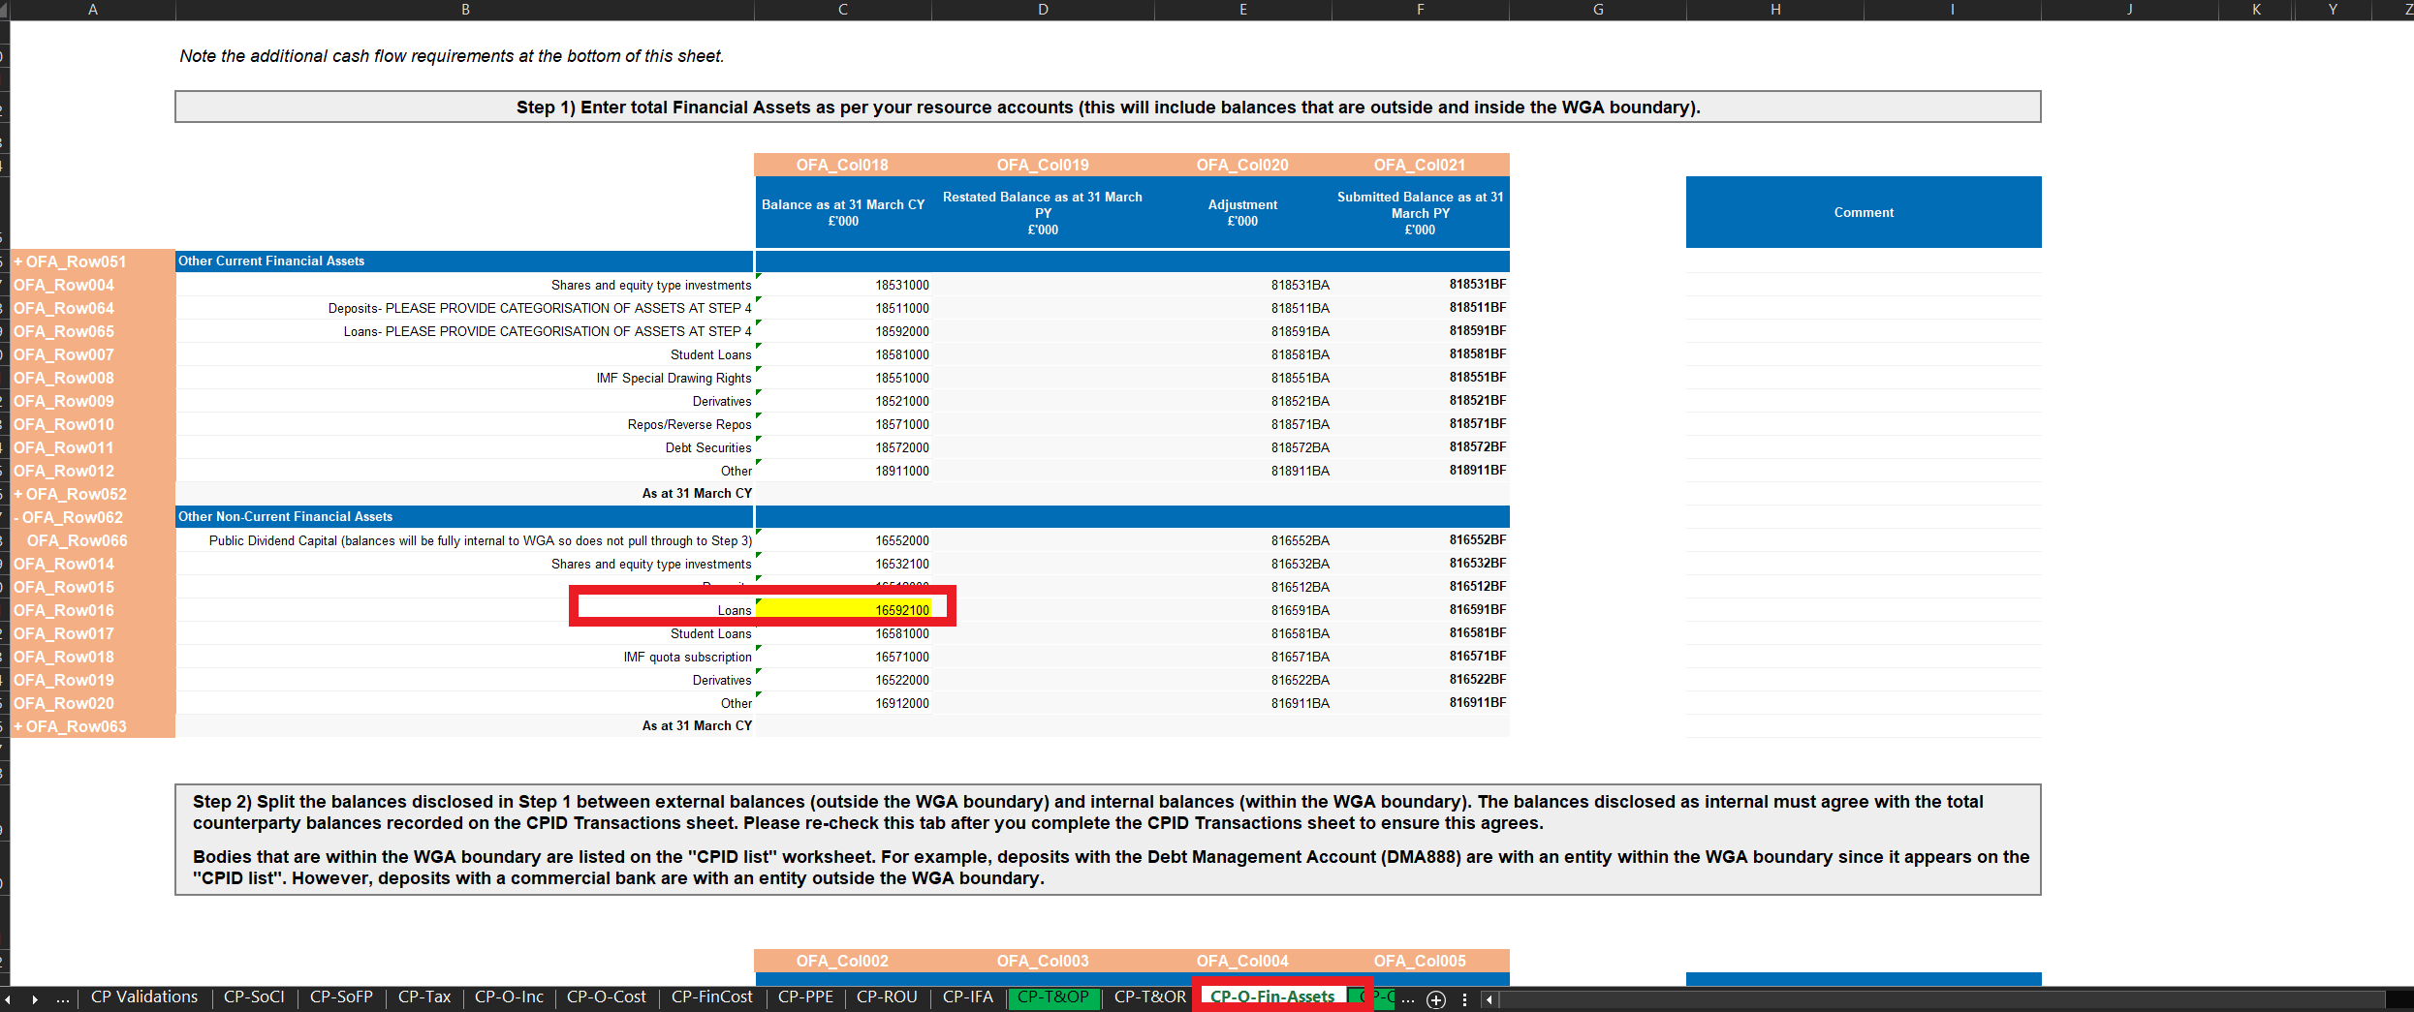

Step 2

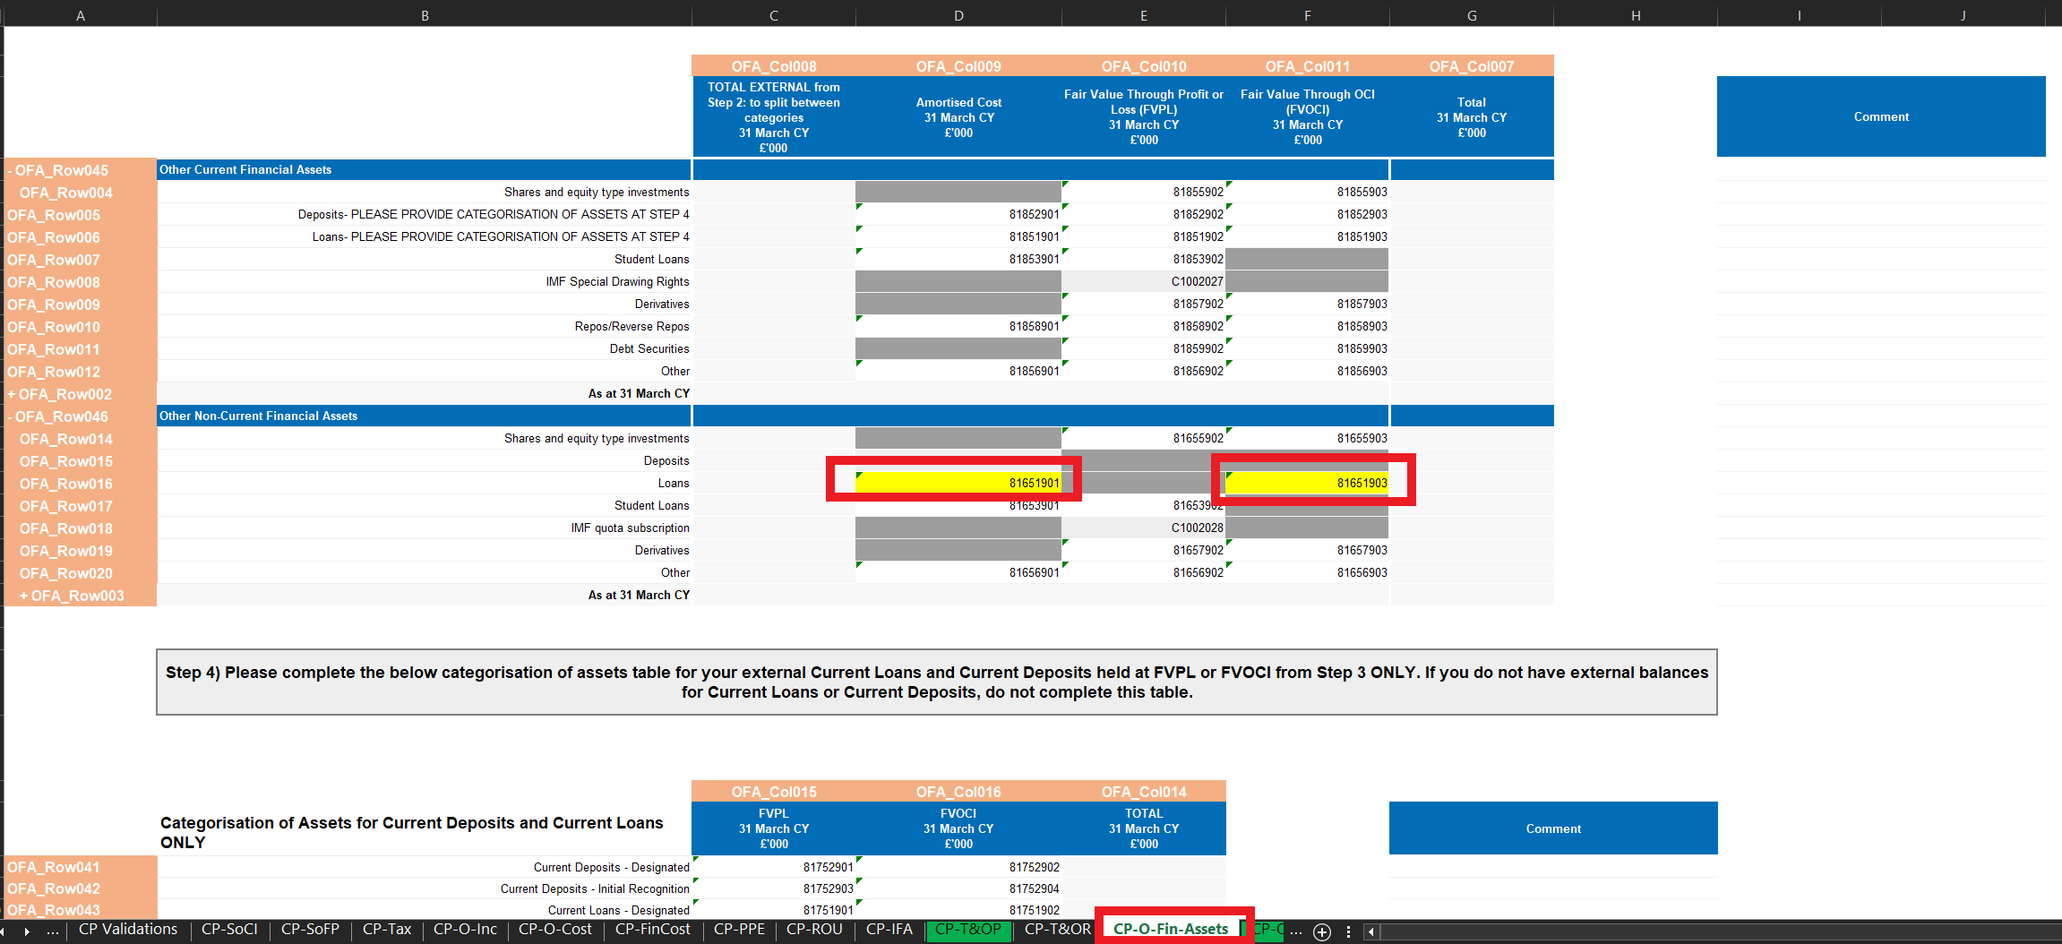

Please investigate and resolve.

How to resolve Validation 900V0152
Please follow the instructions on the validation report to resolve the issue.
ERROR Check exit costs are not too high for £100,000+ column (local government).

Please investigate and resolve.

How to resolve Validation 900V0153
Please follow the instructions on the validation report to resolve the issue.
ERROR Check exit costs are not too low for £40,000 - £60,000 column (local government)

Please investigate and resolve.

How to resolve Validation 900V0154
Please follow the instructions on the validation report to resolve the issue.
ERROR - Check exit costs are not too low for £60,000 - £100,000 column (local government)

Please investigate and resolve.

How to resolve Validation 900V0155
Please follow the instructions on the validation report to resolve the issue.
ERROR - Check exit costs are not too high for < £10,000 column (central government)

Please investigate and resolve.

How to resolve Validation 900V0156
Please follow the instructions on the validation report to resolve the issue.
ERROR - Check exit costs are not too high for £10,000 - £50,000 column (central government)

Please investigate and resolve.

How to resolve Validation 900V0157
Please follow the instructions on the validation report to resolve the issue.
ERROR - Check exit costs are not too high for £50,000 - £100,000 column (central government)
Please investigate and resolve.

How to resolve Validation 900V0158
Please follow the instructions on the validation report to resolve the issue.
ERROR - Check exit costs are not too high for > £100,000 column (central government)
Please investigate and resolve.

How to resolve Validation 900V0159
Please follow the instructions on the validation report to resolve the issue.
ERROR - Check exit costs are not too low for £10,000 - £50,000 column (central government)

Please investigate and resolve.

How to resolve Validation 900V0160
Please follow the instructions on the validation report to resolve the issue.
ERROR - Check exit costs are not too low for £50,000 - £100,000 column (central government)

Please investigate and resolve.

How to resolve Validation 900V0161
Please follow the instructions on the validation report to resolve the issue.
ERROR - Check exit costs are not too low for > £100,000 column (central government)

Please investigate and resolve.

How to resolve Validation 900V0167

Please follow the instructions on the validation report to resolve the issue.
The following is an illustrative example and does not represent actual data from your entity.

ERROR: Other Current Financial Liabilities in section 2 must equal Other Current Financial Liabilities in section 3 (sum of amortised and FVPL)

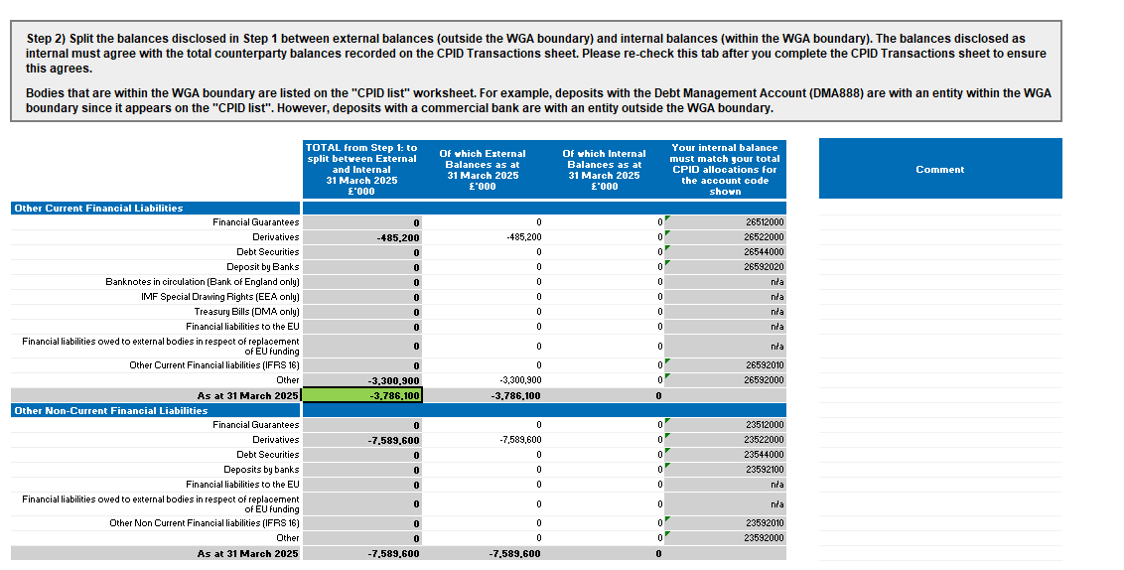

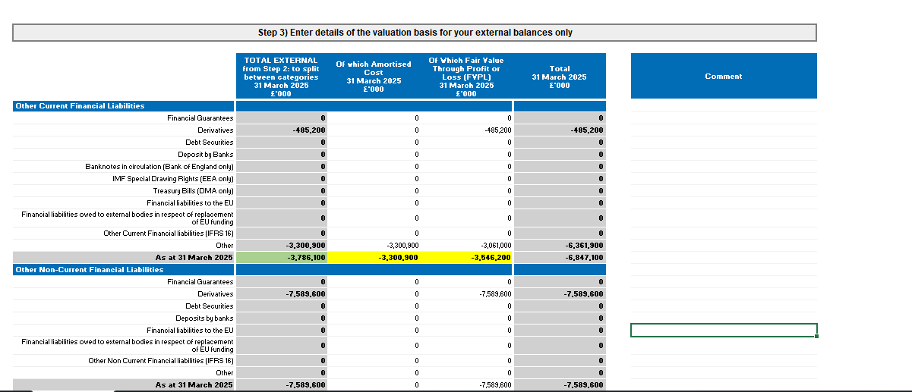
The total of the external balances (current and non-current) in Step 2 should agree to the total of External balance (Amortised Cost and "Of Which Fair Value Through Profit or Loss (FVPL) in Step 3.
Please investigate and resolve.

How to resolve Validation 900V0171

Please follow the instructions on the validation report to resolve the issue.
The following is an illustrative example and does not represent actual data from your entity.

Validation 900V0171 is triggered when data has been entered in one of the following areas but not the other:

- the Right of Use (ROU) Assets tab; or
- the Lease Liabilities table on the Additional Data tab.
The validation message states:
Error – If you have disclosed ROU assets on the ROU tab, you also need to complete the Lease Liabilities table on the Additional Data tab, and vice versa.
ROU assets and the related lease liabilities must be reported together. If you disclose ROU assets but do not complete the Lease Liabilities table, the validation will be triggered. The same applies if you complete the Lease Liabilities table but do not report the related ROU assets.

How to resolve the validation
- Review the ROU tab and check whether any ROU asset balances have been entered.
- Review the Additional Data tab and check whether the Lease Liabilities table has been completed.
- If ROU assets have been reported, enter the corresponding lease liability information in the Lease Liabilities table.
- If lease liabilities have been reported, enter the corresponding ROU asset information on the ROU tab.
- Check that the amounts entered are consistent and relate to the same leases.
- Revalidate the DCT.
The validation should clear once both the ROU asset information and the corresponding lease liability information have been completed.
Illustrative example

ROU tab

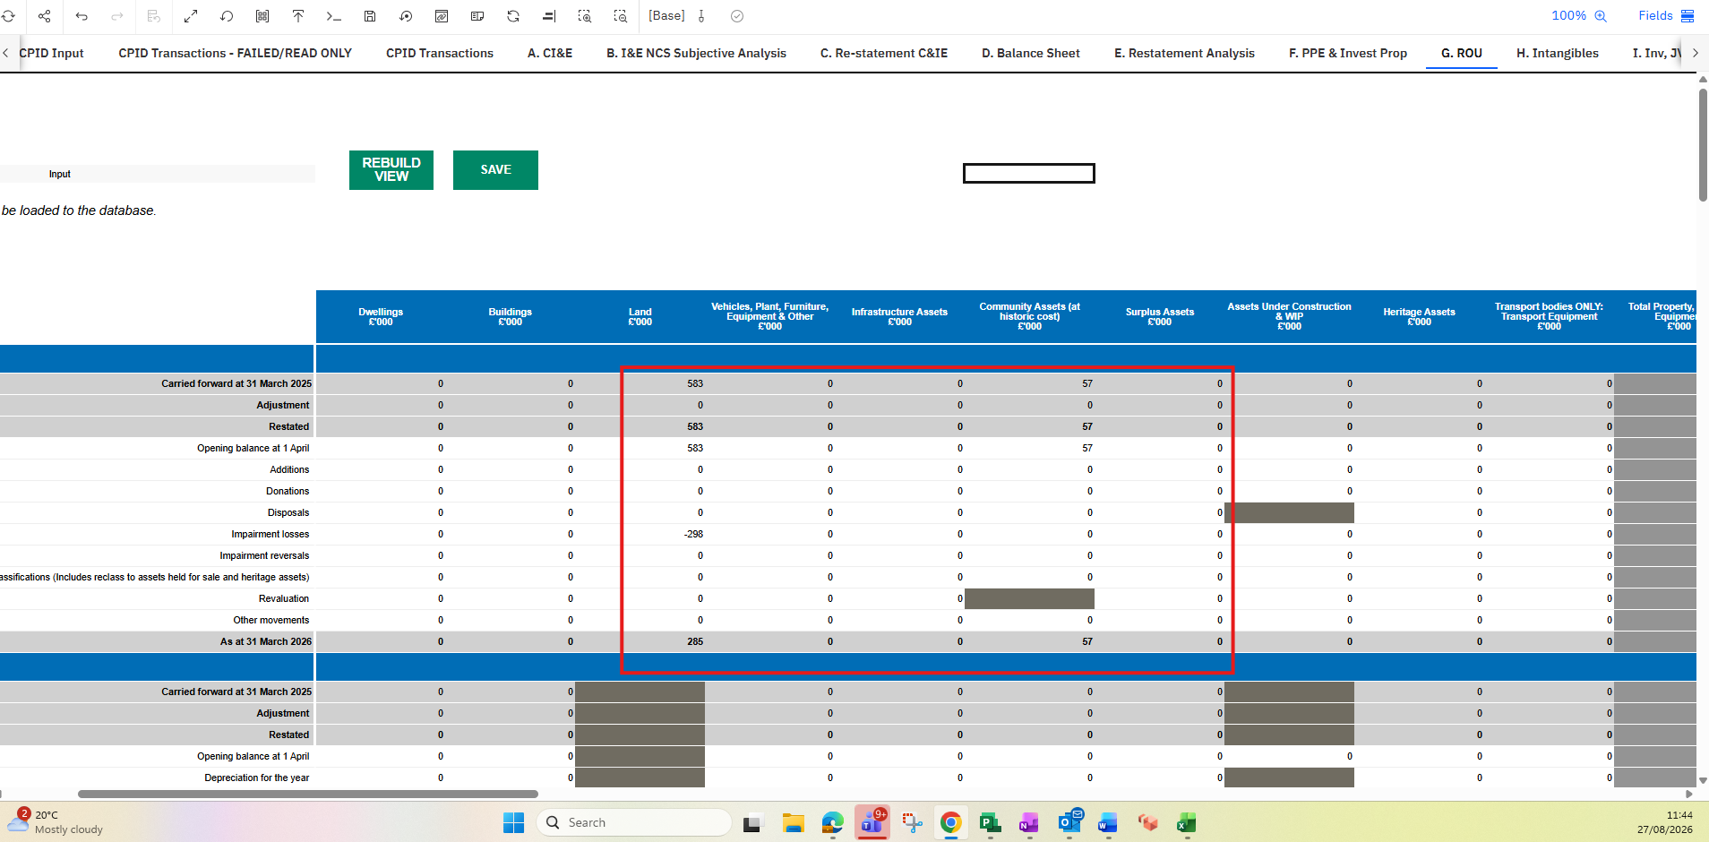

Lease Liabilities table
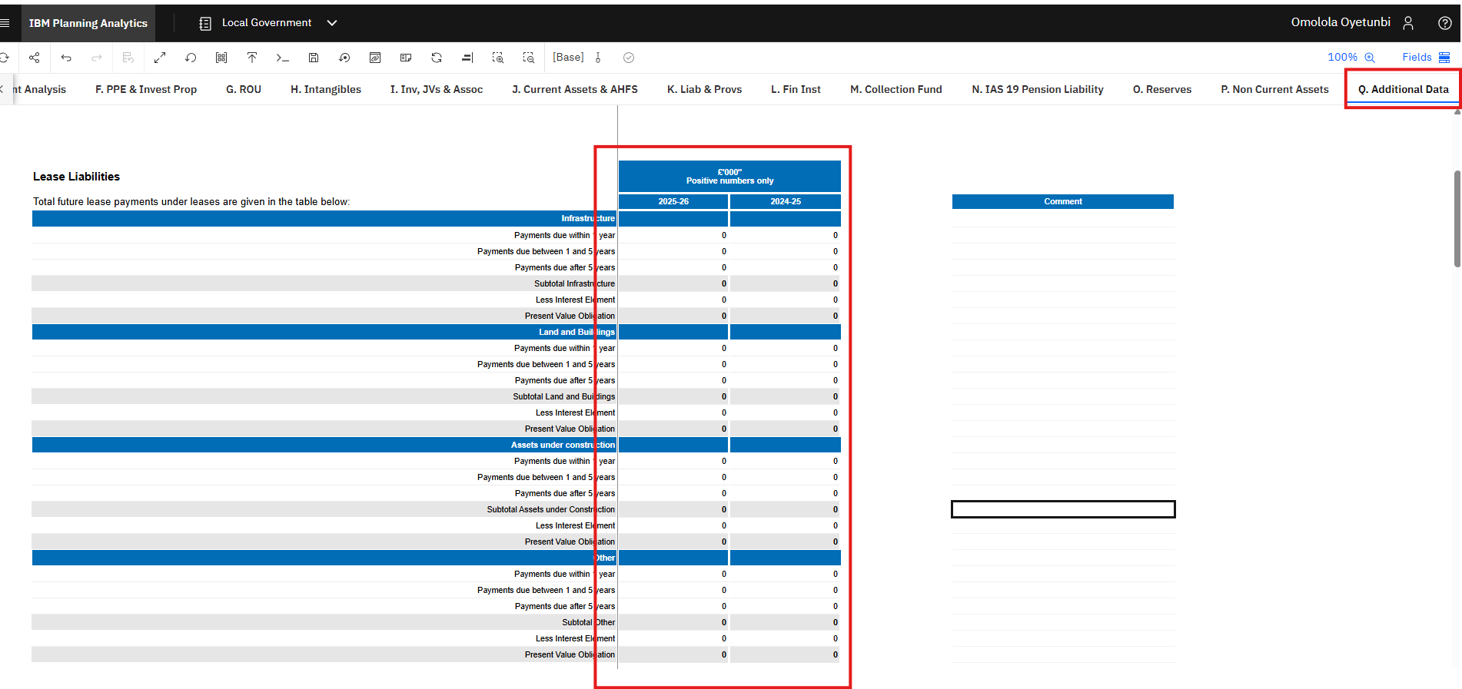

To resolve the error, please enter data in the Additional data.

How to resolve Validation 900V0193

You need to complete the Other Financial Liabilities tab so that it matches the details on your Lease Liabilities.

The Other Financial Liabilities tab must include the present value obligation of your lease liabilities across all categories.

The validation error is intended to prevent this issue from recurring. To resolve and pass validation 900V0193, please ensure that the amounts entered on the Other Financial Liabilities tab (both IFRS 16 Current and Non-Current) agree with the total present value of all lease liability categories, as shown below.

Please also remember to complete Step 1, Step 2, and Step 3 on the Other Financial Liabilities tab.

Other Financial Liabilities tab:

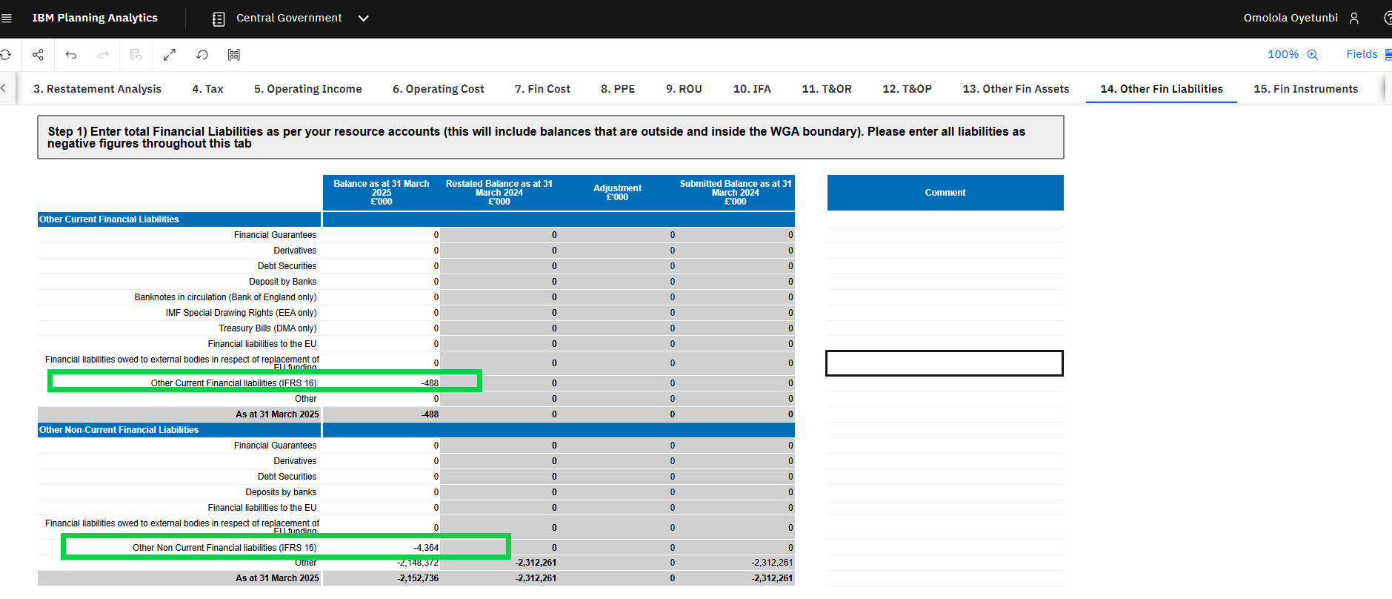

Other additional information tab

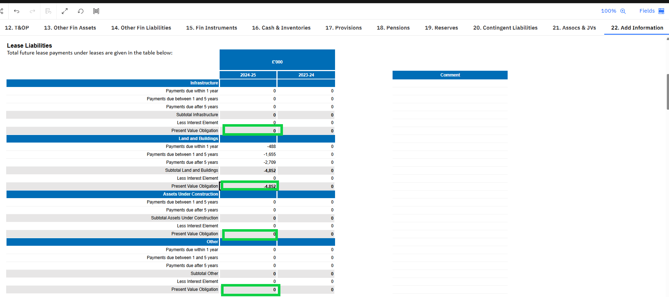

How to resolve Validation 900V0194

The Error message says:

The sum of Other amortised and Other FVPL should equal Other, Total external.
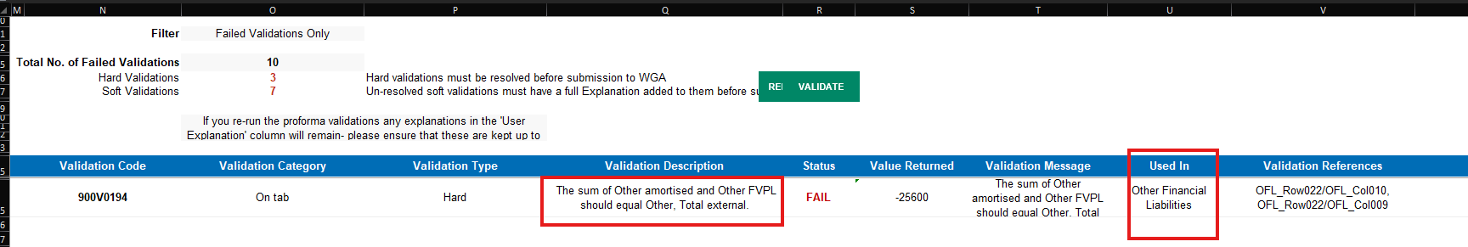

The is error is from the Other Financial Liabilities tab as shown on the validation tab.

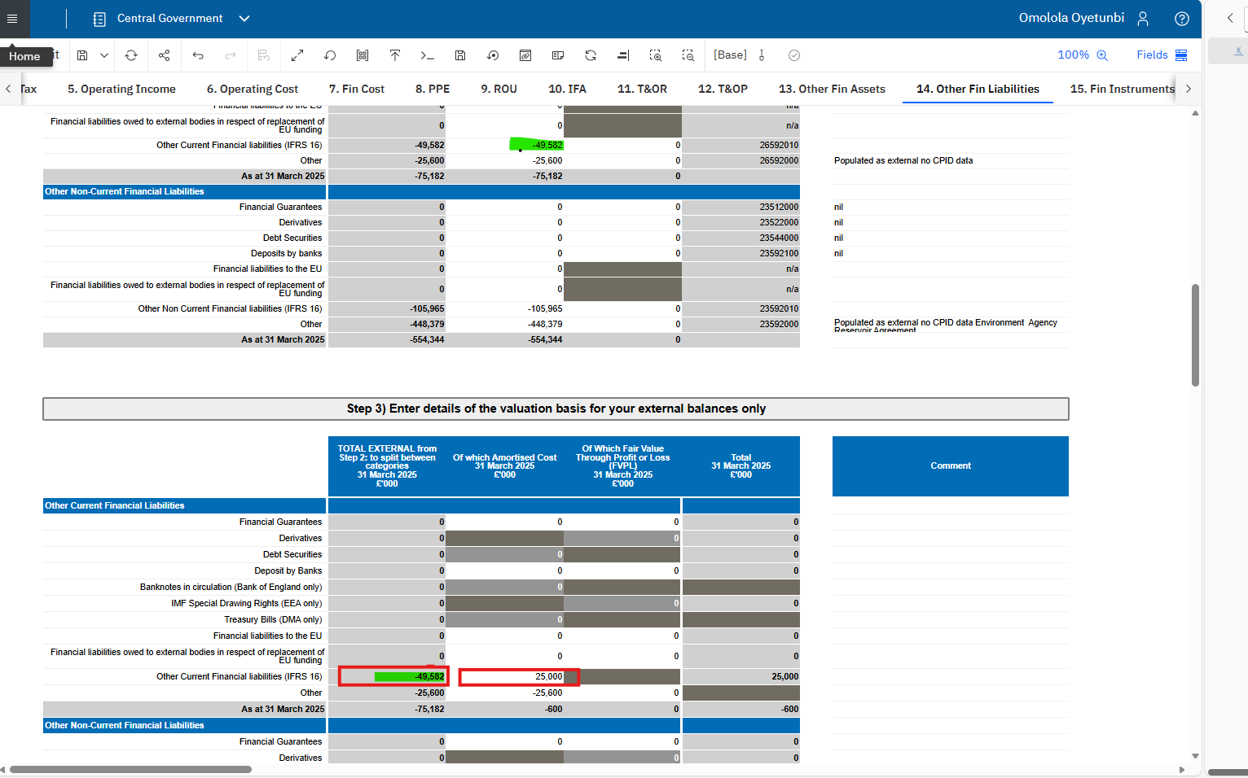

The two cells highlighted in the red boxes must match

How to resolve Validation 900V0195, 900V0196, 900V0197, 900V0198, 900V0199, 900V0200, 900V0201, 900V0202, 900V0203, 900V0204, 900V0205, 900V0206, 900V0207, 900V0208, 900V0209.

The Error message says:

A positive value must be entered in the Lease Liabilities table.

Please go to the “Additional Data” tab and verify that there are no negative values in any of the cells.

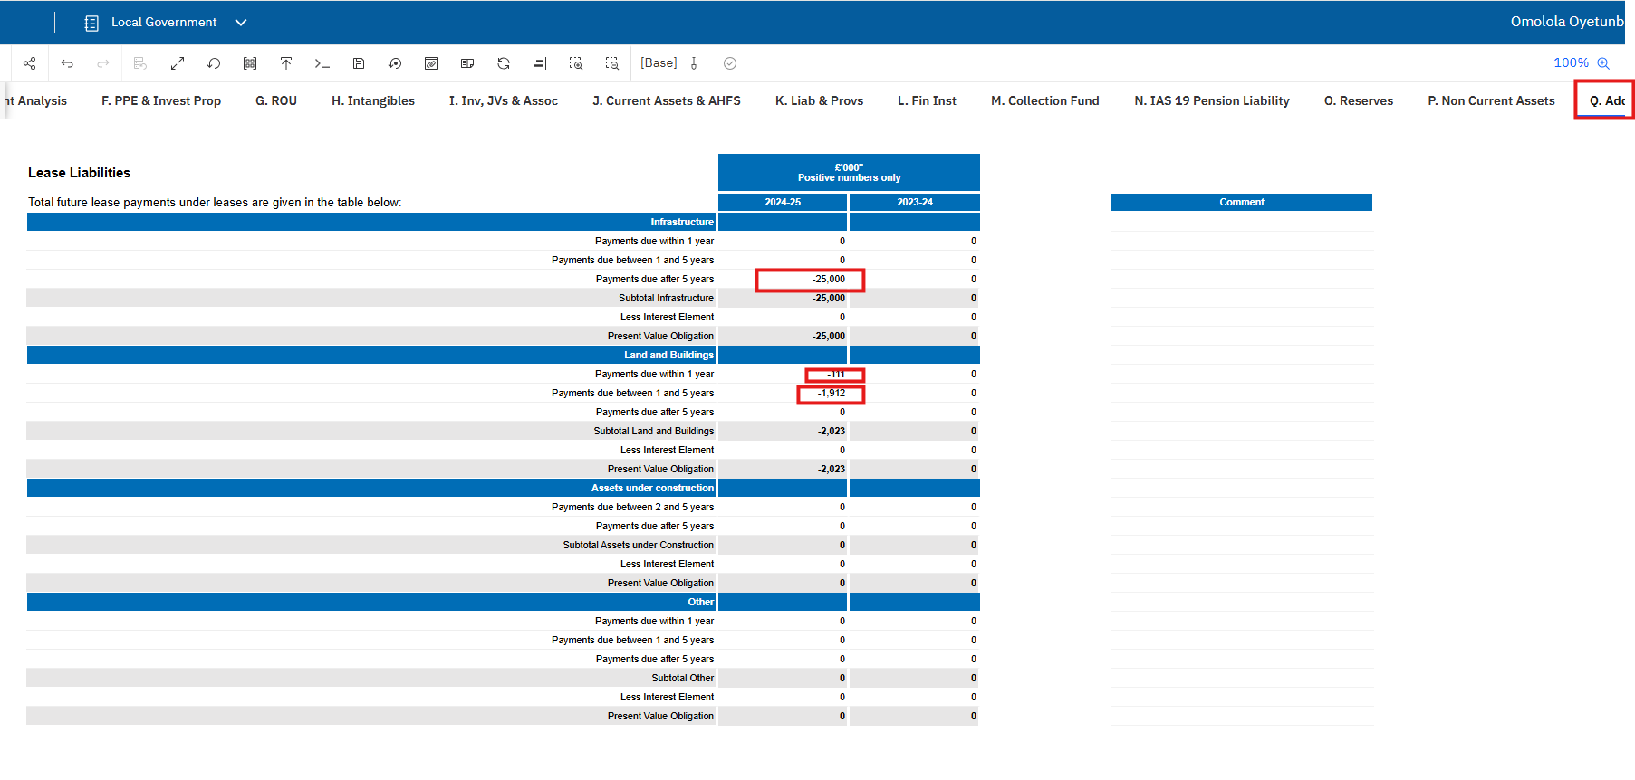

Please update all negative values to positive. This should resolve the validation issues.

How to resolve Validation 900V0226

The Error message says:

The Other Payables IFRS 16 cells (Current and Non-Current) disclosed on the Liabilities and Provisions tab must match the total Present value obligation shown on the Lease Liabilities table across all categories.

Go to the Liab and Provisions tab.

Check that the total of the Short term creditors -Other Payables (IFRS 16) and Long term Creditors - Other Payables (IFRS 16) agree

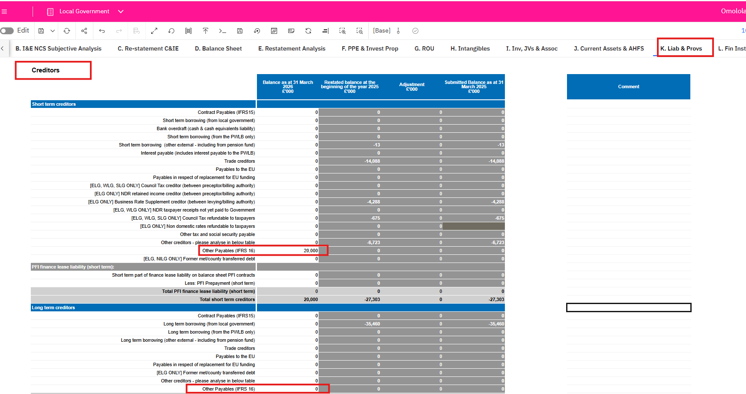

To

The total Present value obligation shown on the Lease Liabilities table across all categories

The Lease Liabilities figures must be positive numbers alone.

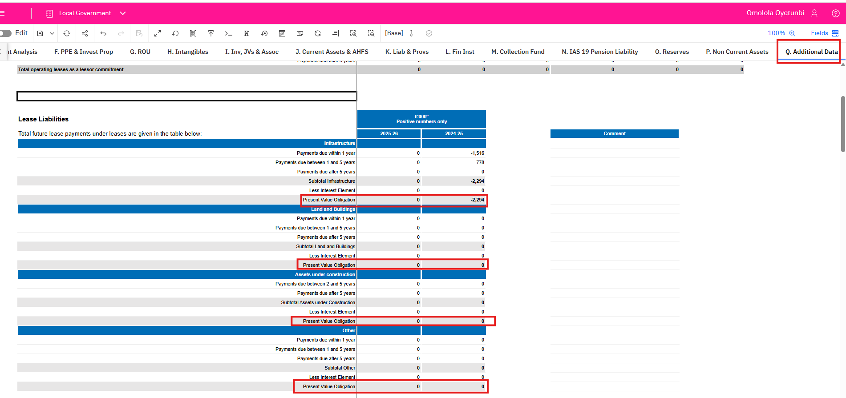

Please correct and ensure the two agrees. The “Other Payables – IFRS 16” amounts (both current and non-current) on the Liabilities and Provisions tab must equal the total present value of the lease obligation shown in the Lease Liabilities table (adding up all categories).This should resolve the validation issue.

How I resolve validation error with our CPID entry for ‘44112200 INC-CURRENT GRANTS FROM CG – PUBLIC HEALTH GRANT’

SCOA code 44112200 is specifically for Public Health Bodies. DOH (Department of Health) is not a Public Health Body. The system will block allocations to DOH if you use 44112200.

To resolve:
- Remove the amount from the cell currently using 44112200 on your DCT tab.
- Select a generic grant SCOA code that is valid for allocations to DOH.
- Move the amount to a cell with this generic code (often marked in green on the DCT template).
Typical Generic Grant SCOA Codes:
While your entity’s specific codes may vary, common generic grant codes used for DOH allocations include:
  - 44110000 (Grants to Central Government Departments)
  - 44110010 (Grants - General)
  - 44110020 (Grants - Other)
  - Or another generic grant code provided in your DCT template’s green cells.
Steps:
- Go to your DCT tab.
- Delete or cut the amount from the cell using 44112200.
- Paste or enter the amount into a cell with a generic grant SCOA code (one of the green cells).
- Ensure the code you select allows allocation to DOH (check the DCT template notes or legend if unsure).
- Save your changes.
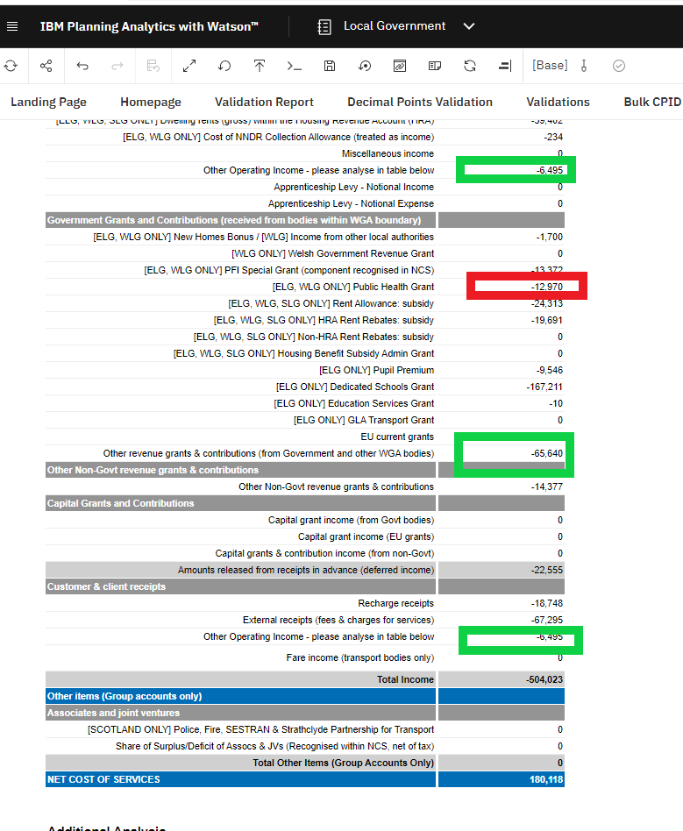

Trial Balance Input Method

Please follow steps below
  - How to select the Entity for DCT Input
  - How to map your codes against OSCAR codes
  - Steps to Input your Trial Balance
  - How to review Trial Balance Posted Amounts
  - List of Available SCOAs

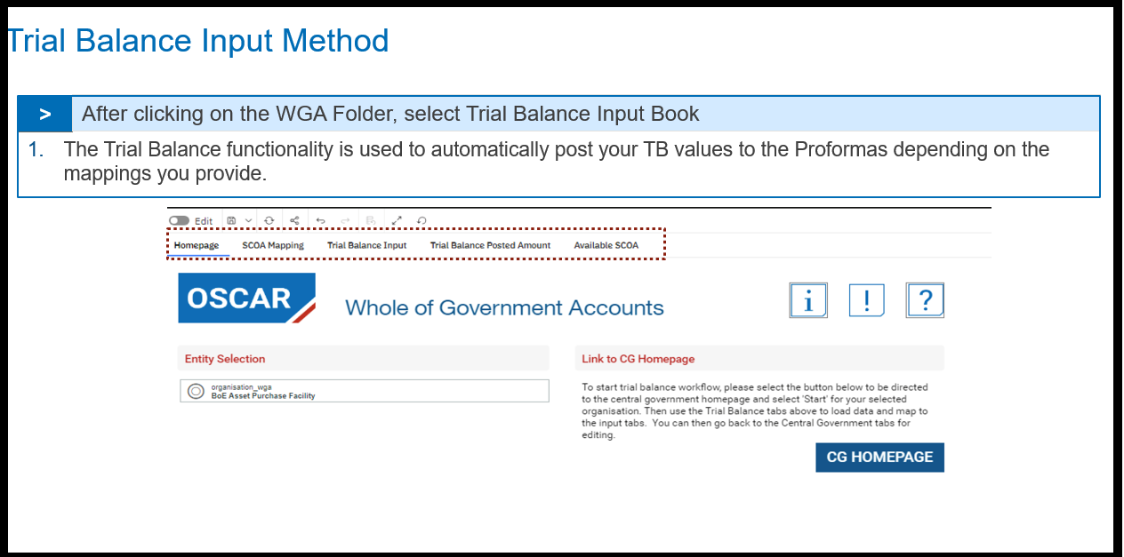

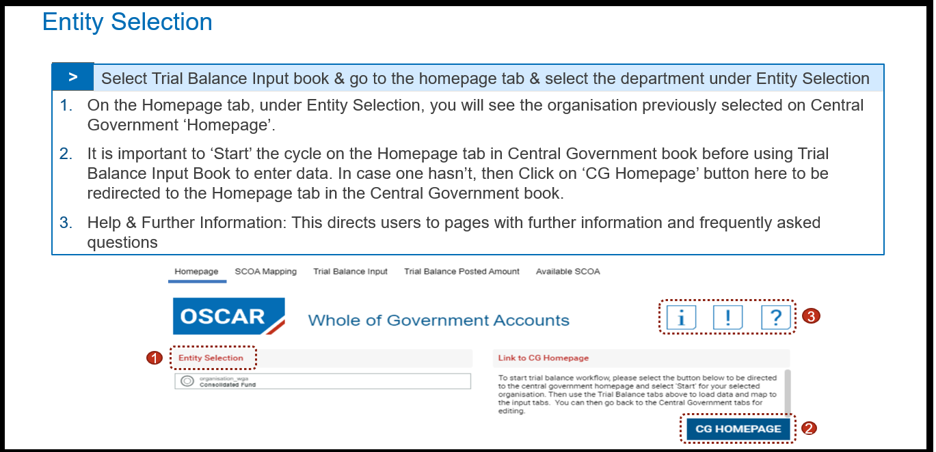
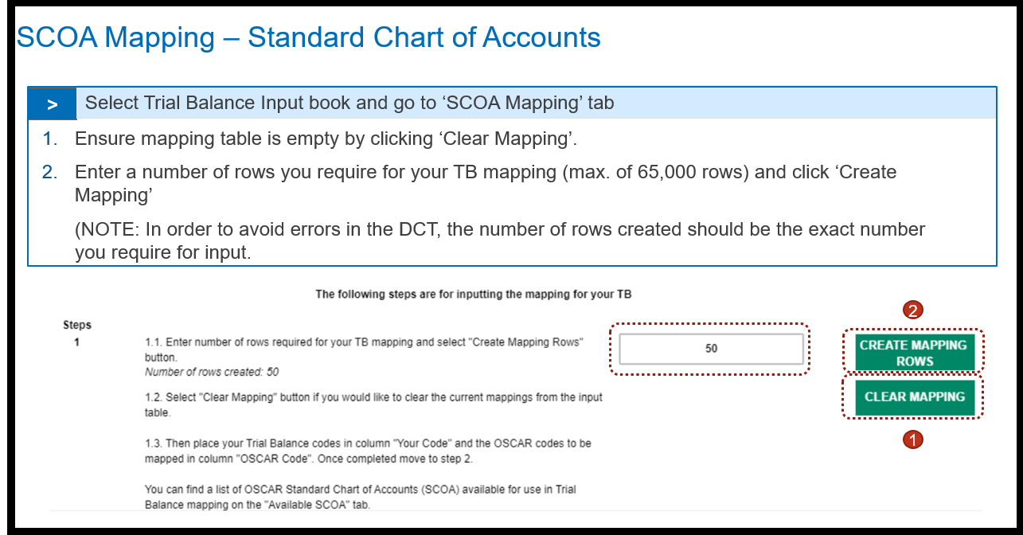
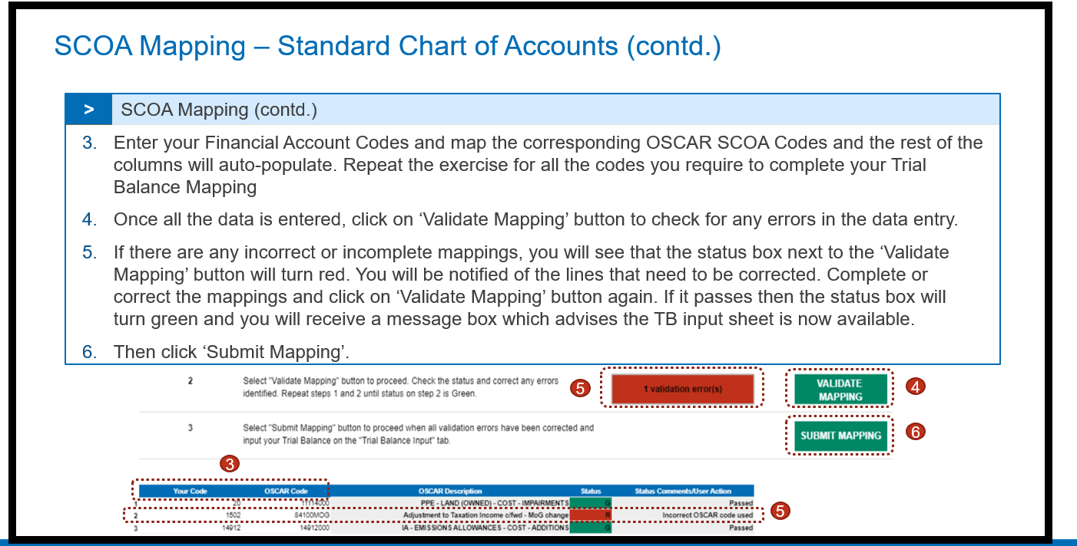

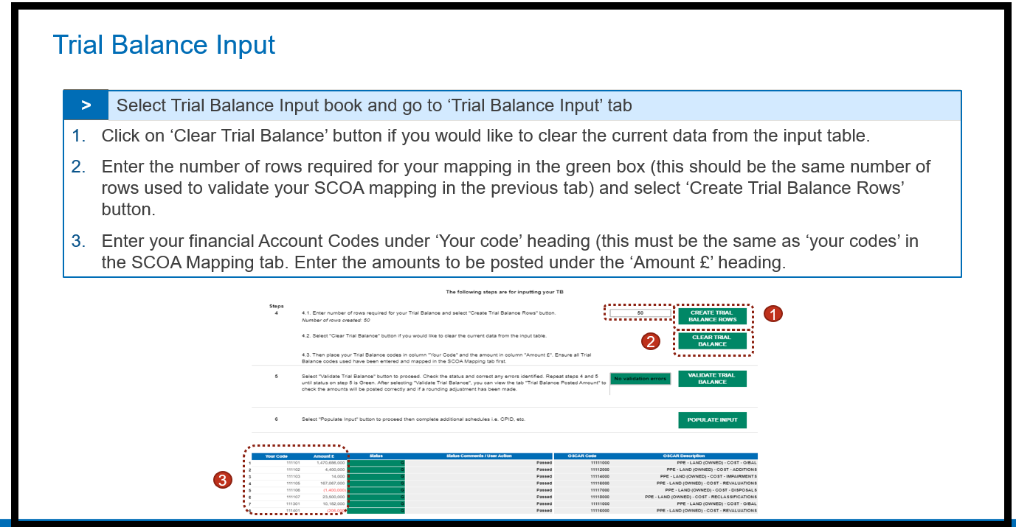
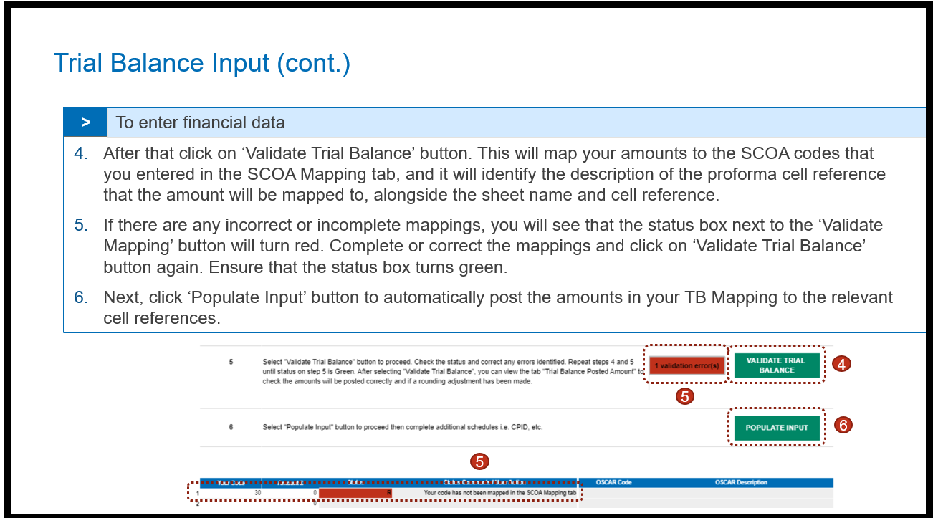
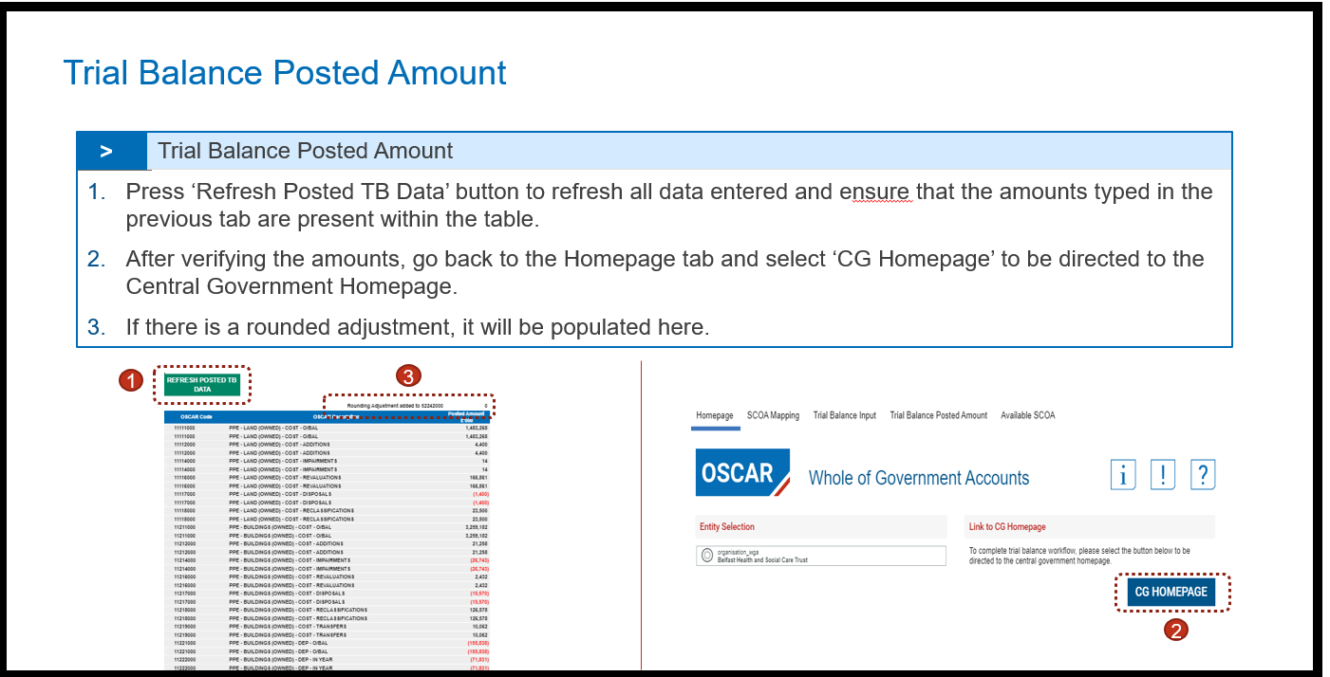
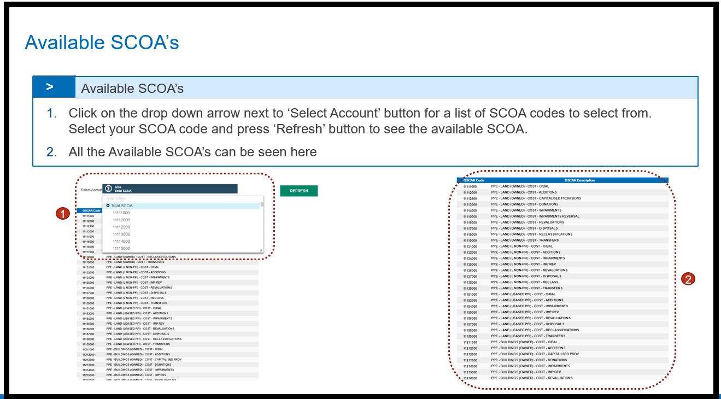

Q: Our account codes do not map easily to the SCOAs, so the TB method is not possible

A: You can map your entity’s codes to Oscar II via the audit report (TB tab). Entities only need to go through the mapping exercise once. You can reuse the mapping to Oscar II SCOAs for many years after, as WGA SCOA code are not changed annually.

Restatement CI&E - Prior Year Comprehensive Income and Expenditure Statement - Restated

- The restatements for prior year comprehensive income and expenditure that have been restated in the Restatement Analysis tab will be auto-populated in the Middle column on this tab, with the ability to enter adjustments in the first columns according to the income or expenditure type (such as staff costs, or grants and subsidies), and according to the reason for the adjustment (such as accounting policy changes, or changes to your authority’s structure).

- There is a spreadsheet view option on this tab to select from the two data input methods: Input and Copy/Paste.

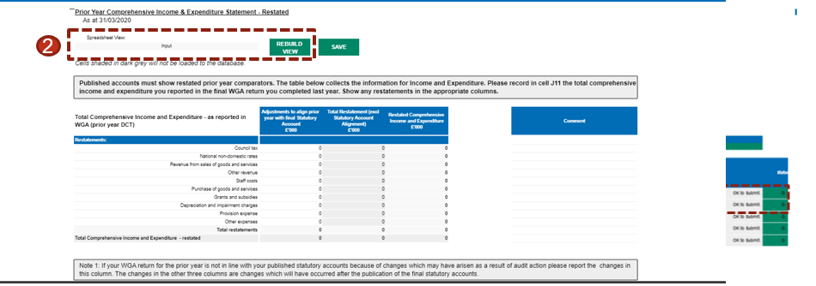

Restatement Analysis

The Restatement tab is a new method and a singular tab for restatements which auto-populates the relevant proforma tabs.

Any entity who has made a prior period adjustment must complete this tab, detailing transactions at SCOA level, which affect their statements.

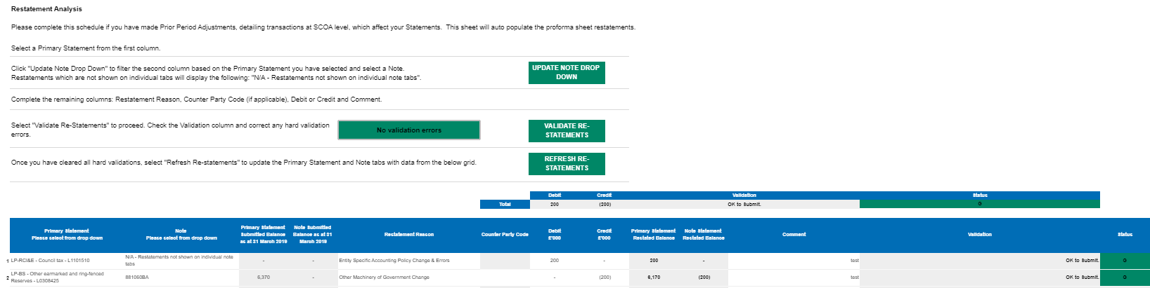

Please select the name of the affected tabs from the Primary Statement from the drop-down list. Click “Update Note Drop Down” to filter the Note column based on the primary statement you have selected and select a Note from the Note drop down list.

After that select the Restatement Reason from the drop down and leave a comment or description, without which the restatement won’t be validated. Enter Counter Party Code from the dropdown if required

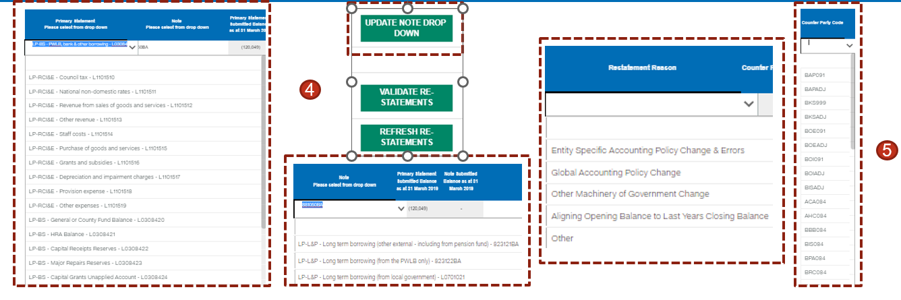

Then enter the debits and credits into the schedule.

Once the readjustments are entered, click on ‘Validate Restatement’ button, and correct primarily the hard validation errors which will be highlighted in red. Soft Validations highlighted in yellow can be commented. Restatements highlighted in Green needs no resolution. Once these validations are resolved, select ‘Refresh Re-statements’ to update inputs with restatement data.

Note - Positive numbers to be entered as is and negative numbers should be entered with a minus (-) sign before them and users should ensure that the Schedule balances, i.e., debits and credits should net to zero.

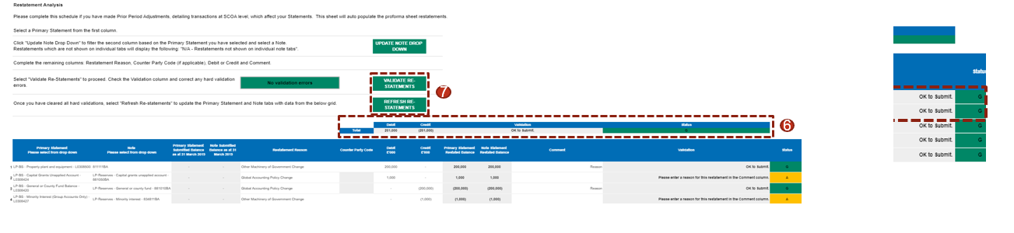

To change or delete a re-statement that has been validated, a reverse re-statement needs to be added. Note: Please do not amend or delete the re-statement, and instead add a reverse re-statement.

To add a reverse re-statement, select the Primary Statement and Note details like the re-statement that needs to be reversed and then reverse the debit or credit amounts. For e.g., in the below screenshot, Re-statement line 4 has been reversed in Restatement line 5 and the amount that was debited in Line 4 has been credited back in Line 5.

