

Order Decision
Site Visit on 12 June 2026
by Laura Renaudon LLM LARTPI Solicitor
an Inspector appointed by the Secretary of State for Environment, Food and Rural Affairs
Decision date: 28 July 2026

Order Ref: ROW/3361460
- This Order is made under section 119 of the Highways Act 1980 (‘the 1980 Act’) and is known as the Leeds City Council (Bramham Footpath No. 7 (Part)) Diversion Order 2022.
- The Order is dated 7 March 2022 and proposes to divert a section of existing footpath from diagonally across an agricultural field to the field edges.
- There were two objections outstanding when the Leeds City Council (‘the Council’) submitted the Order to the Secretary of State for Environment, Food and Rural Affairs for confirmation.
Summary of Decision: The Order is confirmed with minor modifications.

Preliminary Matters

- I have been appointed by the Secretary of State to determine whether to confirm the above Order. I inspected the existing and proposed routes on Friday 12 June 2026. A copy of the Order Plan is appended to this decision for ease of reference.
- The Council have asked me to modify the Order to reflect the fact that the references to Points A and B on the Order Plan are the wrong way round. They have suggested deleting those points and replacing them with ‘X’ and ‘Y’ so as to avoid confusion. However, I consider it more straightforward to leave the plan uncorrected but to modify the Order so that the text aligns with what is shown on the plan. Essentially this means reversing the references to points A and B in both parts of the Schedule. I am satisfied that this can be done without causing confusion, with both objectors to the Order evidently now clear about what it intends to do.

- Another issue with the Order and Plan however is that the ‘proposed path’ depicted on the Plan does not correspond to its description in the Order. The proposed diversion, as described, turns 90° at a point at approximate grid reference 444460 443580 (or, using the Council’s referencing, 4446 4358). I shall refer to this as point “C”, and have annotated the copy of the Order Plan appended to this decision to show its approximate location. However, I understand from the legend of the Order Plan that the ‘proposed path’ on the Plan includes the whole length running approximately north from point “B” beyond point “C” to the top edge of the page, as well as the east-west section from point “A” to point “C”.

- I have seen a plan of a proposed Creation Agreement whereby the landowner proposes to dedicate an additional length of footpath to run north from point “C” to meet the existing footpath network (variously referred to as Footpath no. 8 or no. 9). I am not informed whether this dedication has yet taken effect or whether any agreement (perhaps conditional on the confirmation of the present Order) has been executed. I therefore give it no weight in my considerations.

- In order that the Order Plan aligns with what is described in the Schedule, it is necessary to delete the part of the ‘proposed path’ north of point “C”. This is the part that I understand forms (part of) the creation agreement.

- Again, none of the parties appears under any illusion that the intended effects of the Order are any different from what is described in the Schedule. The modification would not affect land not already affected by the Order and I see no reason to give notice of the modification if the Order is to be confirmed.

- One of the objectors raises concerns that the Order had not been effectively advertised, because walkers may not have seen the notices or if they did then they were not easily understandable. I have no real reason to think that the Council have not carried out the necessary statutory procedures in relation to this aspect.

The Main Issues

- Section 119(6) of the Highways Act 1980 involves three separate tests for a diversion Order to be confirmed. These are:

TEST 1: whether it is expedient in the interests of the landowner, occupier or the public for the path to be diverted. This is subject to any altered point of termination of the path being substantially as convenient to the public;

TEST 2: whether the proposed diversion is substantially less convenient to the public; and

TEST 3: whether it is expedient to confirm the Order having regard to the effect which— (a) the diversion would have on public enjoyment of the path as a whole, (b) the coming into operation of the Order would have as respects other land served by the existing public right of way, and (c) any new public right of way created by the order would have as respects the land over which the right is so created and any land held with it.

- Tests 1 and 2 are ‘gateway’ tests, in that they must be satisfied in order to consider the wider question of expediency under Test 3. In determining whether to confirm the Diversion Order at Test 3 stage, (a)-(c) are mandatory factors. On (b) and (c) of Test 3, the statutory provisions for compensation for diminution in value or disturbance to enjoyment of the land affected by the new path must be taken into account, where applicable.

- Regard must also be had to any material provision contained in a rights of way improvement plan (“ROWIP”) for the area under section 119(6A). Other relevant factors are not excluded from consideration and could, for instance, include those pointing in favour of confirmation. Inherent to my considerations is the Public Sector Equality Duty conferred by the Equality Act 2010, although no particular issues of accessibility arise because there are no proposed gates, stiles or other limitations on the proposed diverted route.

Reasons

TEST 1

Expediency of diversion

- The Diversion Order was made in the interests of the landowner.

- The existing footpath takes the form, first, of a diagonal route through a field used to grow biofuel crops before, secondly, entering a copse of woodland to the north. The principal body of woodland is to the west (and north) of that section of the path. To the east, beyond the diagonal part, the path is fenced at close quarters from a field that I understand was until recently wooded, but the woodland has been cleared and it now has the appearance of scrubland. To the north, at point “A”, the existing path meets the proposed diversion where it then continues north through the woodland before emerging over a stile to a field. The Order map shows it to continue on a broadly northerly trajectory, but on the ground it then appears to head west to the next field boundary.

- The application to divert the path appears to have been made some decades ago, and I understand that in practice it may have been assumed that the path had already been diverted, with objectors saying that the existing path has been unused because it has been either unknown about or inaccessible. At the time of my site observation it was available, with a clear gap in vegetation allowing passage.

- I understand that the landowner seeks to pursue the cultivation of biofuel crops. A cross-field path is unsatisfactory because of the loss of land available for cultivation and the potential user conflicts between users of the path and the farming activities including ploughing, drilling and spraying. I am in no doubt that for these reasons a diversion of the path would be expedient in the interests of the landowner.

Convenience of any new termination point

- The termination points remain as existing so this question does not arise.

TEST 2

Whether the proposed diversion is substantially less convenient to the public

- The length of the relevant part of the footpath that is the subject of the Order increases by around 140 metres. From the Order description, the length increases from 419 metres to 556 metres. In the context of a recreational path, I do not consider this increase in length to result in any substantial loss of convenience. The diverted path would take the form of existing farm tracks, with a concomitant increase in width from 0.9 metres to 2.10 metres. Avoiding the adjoining crops and undergrowth (including nettles) of the existing path to instead walk more freely, and potentially two or more abreast, would be considerably more convenient than the existing. Additionally, the need to pass a field gate would be removed.

- I therefore conclude on this issue that the proposed route would not be substantially less convenient to the public.

TEST 3

- Effect of diversion on public enjoyment

- As well as being more convenient, the proposed path would be a slightly more enjoyable walk in some ways because walkers would not have to proceed in single file. The greater distance from the fence would be considerably less oppressive. I understand that the biocrops adjacent to the existing route could be expected to grow to a considerable height which would obscure views (and give rise to safety concerns). Whilst it can be pleasant to walk through a crop field, it really depends on the crop and at certain times of the year, depending on the crop height, the existing route could be somewhat unpleasant.

- At present, long range views out to the Cleveland Hills including what appeared to be of the Kilburn White Horse are obtained at the top of the hill round about point “B” of the Order map. On the diversion route, these views are maintained for some time although they fall away as the track descends. On the existing route, they are lost almost immediately as the path turns westwards and views are obscured by the remaining woodland to the north (as well as potentially by biofuel crops being cultivated, although the crops were not that high at the time of my visit). To this extent the diversion route appears more enjoyable than the existing one. By taking the existing farm tracks instead, longer views would be preserved to some degree until entering the woodland at the more easterly point.

- At the moment, the path passes the fenced field on only one side (the field’s western side), although at very close quarters. The proposed diversion would pass it on both its eastern and northern sides. This longer distance walked adjacent to the high fence would result in some loss of enjoyment, but the wider and more open aspects of the diversion route and greater distance of the route from the fence would counterbalance that. Objectors are concerned that there is a loss of a woodland path, but now that the woodland in that fenced field has been felled, I do not consider this to be the result of the proposed change. Either way, walkers would pass adjacent to, rather than within, woodland before reaching point “A” (when walking from the south).

- One objection was made on the grounds that the path would be very waterlogged. I did encounter some difficulty in passage, but that was in the woodland section north of point “A”; in other words, in a section of the path that is not the subject of the diversion Order. The part to be diverted appeared to be very secure underfoot, taking the form of existing wide vehicular farm tracks.

- Another objection suggests there will be some loss of amenity and potential safety risks arising from conflicts between users of the path and farm vehicles and machinery. I consider it likely that farm vehicles will be audible to users even if not visible when approaching, and the tracks are wide enough to avoid any safety concerns arising. On the day of my visit, I witnessed only a single tractor using the north-bound element of the path. There is a silage heap adjoining the path further south, and the nature of the farm means that tractors and other traffic will use the tracks, but I do not consider that this is likely to be of such a volume as to result in any serious loss of amenity to users. The diversion route would continue to take walkers along a relatively short section of a track they would already have been using from Toulston Lane.

- Both objectors have suggested alternatives. I must consider the effects of the Order as made in deciding whether or not to confirm it. It is not within the scope of my considerations to seek to redesign the diversion to result in a different scheme.

- Having regard to all these factors and other matters raised in correspondence I find that overall there would be a neutral, if not slightly beneficial, effect on the public’s enjoyment of the path as a result of the diversion.

(b) and (c): Effect of diversion on other land and the land over which the new paths would be created

- The Order is made upon the landowner’s application, and no other land is affected by it.

Rights of Way Improvement Plan (‘ROWIP’)

- The ROWIP has no specific objectives in respect of diversion orders. The proposed additional link, achieved through the creation agreement, would undoubtedly assist in improving the connectivity of the network, but for the reasons given above I am unable to attribute any weight to that aspect. The existing path can be expected to be open and available if the Order is not confirmed, and so similarly I give no weight to the removal of any obstructions (such as vegetation) hindering the use of the existing path.

- Where the Order would specifically support the ROWIP objectives is in the omission of a field gate that is recorded against the existing path, which would lead to a slight improvement in the accessibility of the route if the Order were confirmed. The Order therefore appears to me generally consistent with those objectives of the ROWIP for the area that have been drawn to my attention.

Conclusions on whether it is expedient to confirm the Order

- For all the above reasons I consider it expedient to confirm the Order, subject to the modifications affecting the grid identifiers and the omission from the Plan of the section north of point “C” that I have identified above.

Formal Decision

- I confirm the Order subject to the modifications set out in the Schedule below.

Laura Renaudon

INSPECTOR

SCHEDULE of Modifications to the Order

Amend the Schedule to the Order as follows:

Part 1

Delete from the description in the first line “point A” and replace it with “point B”

Delete from the description in the third line “point B” and replace it with “point A”

Part 2

Delete from the description in the first line “point A” and replace it with “point B”

Delete from the description in the second line “point B” and replace it with “point A”

Amend the Order Plan as follows:

Delete the section of path north of the point (referred to in this decision as “point C”) where the path changes from a northerly to a west south westerly direction from point B to point A.

APPENDIX

THE ORDER PLAN

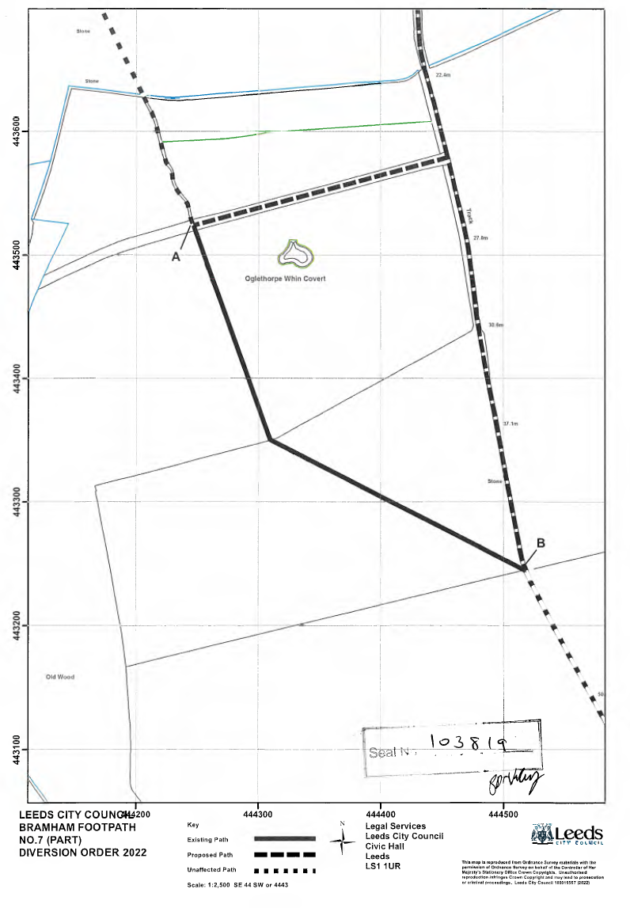
C

