

Order Decision
Site visit made on 22 July 2026
by Harry Wood BA (Hons) MA PhD MIPROW
appointed by the Secretary of State for Environment, Food and Rural Affairs
Decision date: 28 July 2026

Order reference: ROW/3358627
- This Order is made under section 119 of the Highways Act 1980 and is known as the Herefordshire Council Footpath HB1 (Part) Hampton Bishop Public Path Diversion Order 2024.
- The Order is dated 20 August 2024 and proposes to divert the public right of way shown on the Order Plan and described in the Order Schedule, and to amend the definitive map and statement accordingly.
- There was one objection outstanding when Herefordshire Council submitted the Order to the Secretary of State for Environment, Food and Rural Affairs for confirmation.
Summary of Decision: The Order is confirmed.

Preliminary Matters
- I have found it convenient to refer to points marked on the Order Plan and have attached a copy of it to this decision, for reference. I have also added to the existing annotations, which I have marked in red.

Main Issues
- Section 119(6) of the Highways Act 1980 (the 1980 Act) involves three separate tests for an Order to be confirmed. These are:
Test 1: whether it is expedient in the interests of the landowner, occupier or the public for the path to be diverted. This is subject to any altered point of termination of the path being substantially as convenient to the public.
Test 2: whether the proposed diversion is substantially less convenient to the public.
Test 3: whether it is expedient to confirm the Order having regard to the effect which (a) the diversion would have on public enjoyment of the path as a whole, (b) the coming into operation of the Order would have as respects other land served by the existing public right of way, and (c) any new public right of way created by the Order would have as respects the land over which the right is so created and any land held with it.
- In determining whether to confirm the Order at Test 3 stage, (a)-(c) are mandatory factors. On (b) and (c) of Test 3, the statutory provisions for compensation for diminution in value or disturbance to enjoyment of the land affected by the new paths must be taken into account, where applicable.
- Regard must also be had to any material provision contained in a rights of way improvement plan (ROWIP) for the area under section 119(6A). Other relevant factors are not excluded from consideration and could, for instance, include those pointing in favour of confirmation.
- Various representations have been made by the Objector concerning the historical availability (or lack thereof) of the recorded footpath and the growth of crops by the landowner impeding public use. In comparing the definitive alignment of the footpath in question (hereafter HB1) to the proposed diversion route, I will disregard any artificial or temporary circumstances preventing or diminishing use of the existing footpath and apply the above tests as if the legally recorded line were open and available for use.

Reasons

Whether it is expedient in the interests of the public that the path in question should be diverted
- HB1 is a cross-field path, running eastwards from point B over arable land until it meets the Stank embankment at point C1. The proposed diversion route runs south-eastwards from point B along the northern bank of the River Wye, before turning to the north-east at point D, crossing the drain at point C and meeting HB1 at point A.
- The order making authority (Herefordshire Council, hereafter the OMA) describe the proposed diversion route as “the currently walked route which the public have been using for many years”. They additionally emphasise that the bridge crossing the drain is at point C on the proposed diversion route. The OMA believe that HB1 crosses the drain at point C1 and that there is no crossing on the definitive alignment of the footpath. Asserting that “the cost of replacing the bridge in the existing location together with the cost of carrying out the diversion process would be less that putting a new bridge on the existing legal line”, the OMA argue that the money this approach would save means that the diversion is in the public interest.
- The Open Spaces Society (OSS), who are the sole objector in this matter, state that no documentary evidence has been provided to show that the bridge is in the wrong location. They further contend that resource implications should not take precedence over the OMA’s statutory duty to maintain highways maintainable at public expense, as set out by section 41 of the 1980 Act.
- When I visited the site in July 2026 I walked the full length of the proposed diversion route. The cross field section between points C and D was a rough way through crops, though there was a faint route on the ground. The riverside section between points D and B was much clearer and appears well used. I note that there are various waymarkers along this section despite it not currently being recorded in the DMS. I also walked a perimeter track to the east of the proposed diversion route connecting points D and C. There were clear footprints on this route, suggesting that it may be preferred to the cross field route between points C and D.
- I was not able to walk the full length of the existing route. While HB1 was available after a fashion (there is a clear gap in the hedgerow at point E1, for example), the mature crops in the field made traversing the route extremely difficult. I am nonetheless satisfied that I was able to see all of the existing route from various vantage points.
- The footbridge at point C was out of repair when I visited the site. A large concrete block has been laid immediately to its west by way of temporary replacement. I am satisfied that the bridge is on the alignment of the proposed diversion route rather than HB1. The latter appears to cross from the Stank further to the west at point C1, close to the overhead electricity transmission wires.
- While benefits to the public purse may be in the public interest, I am not satisfied that the potential for cost savings alone could be said to meet the above expediency text. However, it is clear from my site visit that the section of the proposed diversion route between points D and B is well used by the public, and that this reflects long term patterns of usage. Taking this into account, and given the practical challenges raised by the OMA of building a new bridge on the definitive line of HB1, I consider that it is expedient to divert the footpath in the interests of the public.

Whether any new termination point is substantially as convenient to the public
- As both routes begin and end at the same locations (points A and B), no new termination points would be introduced if this Order were confirmed without modifications.

Whether the new path will not be substantially less convenient to the public
- The length of HB1 between points A and B is approximately 669 metres. The proposed diversion route between points A, D, and B is approximately 841 metres, 172 metres longer than the current footpath.
- OSS consider the proposed diversion to be substantially less convenient to the public, arguing that it amounts to an “unnecessary South Easterly detour” and that it makes “no navigational sense”.
- Although the proposed diversion is longer, 172 metres is not considered a substantial increase given the semi-rural location and the context of the local public rights of way network. I note that HB1 forms part of both the Wye Valley Walk (136 miles) and the Three Choirs Way (100 miles) and consider that the proposed increase is unlikely to negatively impact users walking either of these long-distance routes. I do not accept that the proposed diversion is difficult to navigate, and consider the riverside route to represent a straightforward alternative to HB1. I am therefore satisfied that the proposed diversion will not be substantially less convenient to the public than the existing footpath.

The effect of the diversion on public enjoyment of the path as a whole
- OSS believe that the proposed diversion would have a negative impact on public enjoyment of the path as a whole, with a particular focus on its position as part of the Wye Valley Walk and Three Choirs Way. They highlight that both of these long-distance routes “enjoy a great mixture of open riverbank terrain, orchards, open fields, and woods”, and argue that the proposed diversion route “will diminish the public enjoyment and efficiency of these long distance walking routes”. OSS also point to the “founderous and narrow” nature of the riverside path, the fact that the proposed diversion route is liable to flooding, the threat of erosion, and the presence of the invasive plant Himalayan Balsam on the riverbank, concluding that the diversion “brings no public benefit”.
- The OMA suggest that the proposed diversion route “is a more scenic and enjoyable walk along the riverbank, rather than across an open field”. They state that improvements to the surface of the riverside route will be made if the Order is confirmed, and emphasise that both HB1 and the proposed diversion route lie in the flood plain of the River Wye. The OMA point to efforts by the landowner to minimise erosion and manage the Himalayan Balsam. They further highlight the lack of objections from members of the public, suggesting that this indicates the proposed diversion “has already been accepted by the public over many years”.
- Several members of the Hereford and District Angling Club made representations to the OMA expressing their support for the diversion. One member described suggested that the proposals “will bring in a longer route with extra frontage along the river wye making it a much more pleasurable route for everyone to enjoy”.
- The removal of rights over the existing alignment of HB1 will negatively affect the enjoyment of some users. However, the section of the proposed diversion route between points D and B appears to have been used by the public for many years. The riverside nature of this route is likely to be preferred to the cross field path by some users, such as the anglers who have expressed their support. Though finely balanced, I am satisfied that the proposed diversion will not have a negative impact on the public enjoyment of the path as a whole.

The effect of the diversion on other land served by the existing paths and the land over which the new paths would be created
- The existing footpath and the proposed diversion route cross land in the ownership of a single landowner. I have not seen any evidence that the proposed diversion route will have a negative impact on the land served by the existing footpath or the diversion route.

Rights of Way Improvement Plan (ROWIP)
- OSS point to provisions in the relevant ROWIP concerning ploughing and cropping offences, suggesting that the OMA’s failure to take enforcement measures against the landowner amounts to “non-compliance”. The OMA argue that these issues are not relevant to the matter at hand, and that concerns regarding the maintenance and availability of HB1 were acted on as soon as they were raised. While noting these contrasting positions, there is no evidence before me to suggest that the ROWIP contains provisions that directly relate to the proposed diversion.

Conclusions on whether it is expedient to confirm the Order
- I consider that the proposed diversion is in the interests of the public. It will not be substantially less convenient to the public. While there may be an impact on some users’ enjoyment, I am satisfied that the diversion will not negatively impact the public enjoyment of the path as a whole. My view is that the proposed diversion route is both more pleasant and easier to navigate than the existing cross field footpath. I therefore conclude that it is expedient to confirm the Order.

Other matters
- OSS have made representations covering a broad range of issues that I have not covered in my reasoning, including accusations regarding the OMA’s procurement process when replacing bridges. This is because they are not relevant to my decision. My task concerns the three tests set out by section 119(6) of the 1980 Act, and I have disregarded representations that concerns matters above and beyond this statutory process.
- OSS have raised concerns relating to the existing use of the proposed diversion route by members of the Hereford & District Angling Association, asserting that the OMA is seeking “to supply a commercial fishing, private limited company, with an access track maintainable at public expense”. While noting these representations, I do not share OSS’s view that this “could easily be interpreted as misfeasance”. The proposed diversion route will be maintainable at public expense as a public right of way, and as such will be available to all members of the public to use on foot.

Overall Conclusion
- Having regard to the above, and all other matters raised in the written representations, I conclude that the Order should be confirmed.

Formal Decision
- I confirm the Order.

Harry Wood

INSPECTOR

Order Plan (not to scale)
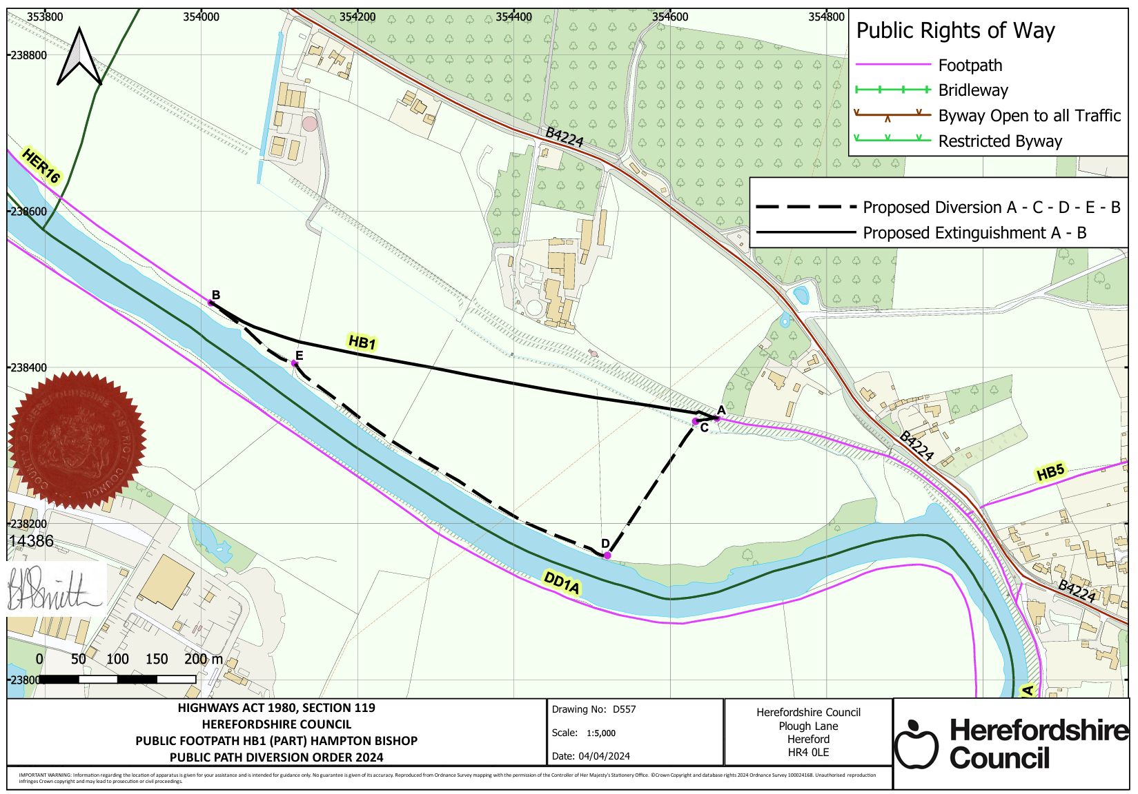
C1
E1

