
Interim Order Decision
Site visit made on 1 July 2026
By Harry Wood BA (Hons) MA PhD MIPROW
an Inspector appointed by the Secretary of State for Environment, Food and Rural Affairs
Decision date: 12 August 2026

Order Reference: ROW/3347304

- This Order is made under Section 53(2)(b) of the Wildlife and Countryside Act 1981 and is known as the St Helens Public Right of Way 201 Footpath to Bridleway Order 2024.
- The Order is dated 5 April 2024 and proposes to modify the Definitive Map and Statement for the area by upgrading a public footpath to a public bridleway, as shown on the Order Plan and described in the Order Schedule.
- There was one objection outstanding when St Helens Borough Council submitted the Order to the Secretary of State for Environment, Food and Rural Affairs for confirmation.

Summary of Decision: The Order is proposed for confirmation subject to the modifications set out in the Formal Decision.

Procedural Matters
- This matter was first considered by the Inspectorate in November 2021 as a Schedule 14 Appeal (appeal reference: FPS/H4315/14A/1). The relevant Inspector directed St Helens Borough Council (hereafter the OMA) to make an order under section 53(2) and schedule 15 of the Wildlife and Countryside Act 1981 (the 1981 Act) to modify the definitive map and statement (DMS) by upgrading Footpath 201 to bridleway status. That decision was made without prejudice to any subsequent decision issued by the Secretary of State in accordance with their powers under schedule 15 of the 1981 Act. I am therefore not bound by the 2021 decision and will reach an independent conclusion based on the evidence before me.
- The application to the OMA for a definitive map modification order (DMMO) was submitted in November 2020 by a British Horse Society (BHS) volunteer. The Applicant has subsequently asked the BHS to act for them in this matter. When referring to the BHS throughout this decision, this relates to submissions made by that organisation on behalf of the Applicant.
- An initial Order was made in 2023 which received multiple objections. This Order was rejected by the Inspectorate due to a fundamental error in its drafting. The 2024 Order only received one objection, but I have also considered the representations made in the objections to the 2023 Order.
- I have found it convenient to refer to points marked on the Order Plan and have attached a copy of it to this decision, for reference. I have also added to the existing annotations, to which I will refer throughout the decision.

Main Issues
- The Order has been made under section 53(2)(b) of the 1981 Act in consequence of the occurrence of an event specified in section 53(3)(c)(ii), namely that a highway shown in the map and statement as a highway of a particular description ought to be there shown as a highway of a different description. The legal test I am required to deploy is the balance of probability test.
- The user evidence submitted in support of the Order relies on the presumption of dedication as set out in section 31 of the Highways Act 1980. Assessing such evidence involves establishing the date when the public’s right to use the Order route was brought into question. The evidence can then be examined to determine whether use by the public has been as of right and without interruption for a period of not less than 20 years. It is also necessary to consider whether there is sufficient evidence that there was no intention on the part of the landowners to dedicate public footpath rights during the relevant 20-year period.
- Under common law, an inference that a way has been dedicated for public use may be drawn when the actions of the landowners (or lack of action) indicate that they intended a way to be dedicated as a highway and where the public have accepted that dedication. Use by the public can be evidence of the intention to dedicate; this use should be as of right without force, secrecy, or permission. There is no fixed period of use at common law and use may range from a few years to several decades, based on the facts of the case. The more intensive and open the use, the shorter the period required to raise the inference of dedication. The burden of proof lies with the claimant to demonstrate that the evidence is sufficient to indicate an intention of dedication.
- Section 32 of the Highways Act 1980 (the 1980 Act) requires that documentary evidence is taken into consideration “before determining whether a way has or has not been dedicated as a highway”, and that such weight is given to the evidence as “justified by the circumstances, including the antiquity of the tendered document, the status of the person by whom and the purpose for which it was made or compiled, and the custody in which it has been kept and from which it was produced.”

Reasons

Documentary Evidence
- A key feature of the documentary evidence is the contrast between the historical alignment of Cronton Lane (running between points A1 and D) and the modern route (running between points A and D), to the north of the M62. The circumstances that led to this change will be considered in detail below. For clarity, I will use Cronton Lane when referring to the historical alignment and the Order Route when referring to the modern alignment.

Commercial maps 1786-1828
- The 1786 Yates’s County Palatine of Lancashire Map records a route that closely resembles Cronton Lane, linking Rainhill Hall and Cronton. It is depicted between solid parallel lines of equal thickness. The Map’s legend explains that this depiction was used to indicate a cross road.
- The 1818 Greenwood’s Map records Cronton Lane in a similar manner to Yates’s Map, running to the west of Rainhill Hall and south towards Cronton. It is depicted between solid parallel lines of equal thickness. As with Yates’s Map, the Greenwood’s legend explains that this depiction was used to indicate a cross road.
- The 1828 Hennet’s Map records Cronton Lane in a manner largely consistent with both the Yates’s and Greenwood’s maps. As with the earlier maps, the use of solid parallel lines of equal thickness is used to depict Cronton Lane as a cross road.
- Case law has established that a cross road may mean a public road for which no toll is payable, though the weight of such evidence can vary depending on the totality of the evidence under consideration. It is significant that three independently-surveyed maps over a forty-year period all recorded Cronton Lane as a cross road. This strongly suggests that the route was capable of taking vehicular traffic during this period.

Tithe Map 1840
- Tithe maps officially recorded the boundaries of all tithe areas on which a tithe rent-charge was apportioned. Their purpose was not to identify highways.
- BHS submitted a copy of the Rainhill Tithe Map (1840). It records a route that corresponds with the alignment of Cronton Lane, depicted by solid parallel lines. The BHS highlight the inclusion of the directional annotation “From Cronton” on what they describe as the “southern continuation of the route at its junction with what is now Hall Lane” (point A1).
- BHS have engaged in a comparative exercise to highlight their view that the relevant Tithe Commissioners recorded private and public routes in a distinct manner, with reference to the judgment Maltbridge Island Management Company vs Secretary of State for the Environment [1998] EWHC Admin 820, [1998] EGCS 134. While I accept that several modern-day public roads are depicted in the same manner as Cronton Lane, it would be unsafe to draw significant conclusions from what appears to be a relatively small sample size. The Tithe Map offers evidence that Cronton Lane existed on the ground in 1840 and that the Commissioners may have considered it a public road, but this latter aspect is of limited evidential weight.

Ordnance Survey (OS) maps 1892-1896
- Several OS maps have been submitted covering the period 1892 to 1896. The First Edition 25 Inch County Series Map (1892) records the full length of Cronton Lane between solid parallel lines and shaded sienna. The dotted line that follows the route for much of its length represents a local authority boundary.
- Cronton Lane is depicted with a thickened casing line on its eastern and southern sides. This was a technique used by OS from 1884 to indicate metalled public roads for wheeled traffic. While public rights did not necessarily exist over all routes depicted in this manner, case law suggests that thickened casing may be indicative of public rights in certain circumstances. The Six Inch Map (1894) is broadly consistent with the 25 Inch Map, including the thickened casing line.
- The One Inch Map (1896) records the full length of Cronton Lane between solid parallel lines. The accompanying Key shows that such depiction indicates a “Metalled Road: Third Class”.
- While OS maps often provide useful evidence as to the physical characteristics of a route, they tend not to provide direct evidence of status. In this instance, the OS maps suggest that the full extent of Cronton Lane existed on the ground between 1892 and 1896, and that several surveyors over this period considered the route to have the physical characteristics of a vehicular carriageway.

Bartholomew’s maps 1904-1941
- Three Bartholomew’s maps have been submitted, published in 1904, 1920, and 1941. The 1904 Map includes three classes of roads: First, Secondary (Good), and Indifferent (Passable). It also recorded footpaths, bridleways, and uncoloured roads. The Map included the advisory statement “uncoloured roads are inferior and not to be recommended for cyclists.” The first three classes were distinguished by the use of red infill between either solid, pecked or dotted lines. The full length of Cronton Lane is depicted by solid parallel lines and is uncoloured, meaning that it was considered an inferior road.
- The 1920 and 1941 maps depict Cronton Lane in a manner consistent with the 1904 Map, as an uncoloured inferior road.
- BHS draw attention to the judgment in Commission for New Towns and Worcestershire County Council v J.J. Gallagher Limited [2002] EWHC 2668 (Ch), [2003] 2 P & CR 3. This considers the “somewhat paradoxical” implication of the advisory statement referred to above: “the indication in the description of the uncoloured road is that they can lawfully be used by cyclists, which […] would have meant that they were public carriageways”. However, Bartholomew’s maps also included the disclaimer “[the] representation of a road or footpath is no evidence of the existence of a right of way”. While noting that this disclaimer did not mean such maps should be cast aside, the Judge stated that “the disclaimer underlines the fact that one cannot place much weight on Bartholomew’s maps”.
- Accordingly, the Bartholomew’s maps offer evidence that the full length of Cronton Lane was a public road between 1904 and 1941. However, all three maps can be awarded limited evidential weight.

Property sales documents 1920
- The Rainhill Hall Farm estate sale advertisement (1920) describes a “High-class arable farm” with “long road frontages to Blundell’s Lane, Cronton Lane and Hall Lane”.
- BHS assert that the “clear inference is that at the time, Cronton Lane was considered to be a public road”. While it is similarly plausible that Cronton Lane was a private road serving adjoining properties, the fact that it is grouped with two other routes that are now recognised public carriageways suggests that the producer of the advertisement considered Cronton Lane to enjoy the same status.

Highway records 1970
- The M62 Lancashire-Yorkshire Motorway (Tarbock to Croft Section Side Roads) Order 1970 (hereafter the SRO) details numerous changes to the highway and public rights of way network in the vicinity of Cronton Lane.
- Schedule 2 concerns Cronton Lane. It describes stopping up three public footpaths, including a route marked on the accompanying Site Plan with crosses what is now the M62 (between points B and A2 on the Order Plan”). Schedule 2 also refers to the “diversions of the Public Footpaths listed above […] repositioned to accord with the alterations to the Motorway fence-lines”. This includes a route marked “C” on the Site Plan which runs along the northern boundary of the proposed motorway (points B to A of the Order Route).
- While recognising that this section of the Order Route was “purportedly constructed as a footpath”, BHS point to paragraph 3(a) of the Order, which states: “as respects each length of highway the stopping up of which is authorised by this Order, that another reasonably convenient route is available or will be provided before the highway is stopped up”. Starting from their position that the documentary evidence points to bridleway rights existing over Cronton Lane, BHS argue that the effect of the Order must have been to create the new route as a bridleway, as only a route of the same status as the stopped-up highway could be considered “reasonably convenient”.
- The SRO makes clear that in 1970 Cronton Lane was considered to be a public footpath by the relevant authority. What is less clear is the exact statutory provisions that were being used. Section 13(c) of the Highways Act 1959 contains two subsections. Subsection 13(c)(i) authorises the relevant authority “to stop up, divert, improve, raise, lower or otherwise alter a highway that crosses or enters the route of a special road”. Subsection 13(c)(ii) authorises the relevant authority “to construct a new highway for purposes connected with any such alteration”.
- The SRO does refer to diverting public footpaths. However, the overall effect of the Order was to establish parallel routes on either side of the proposed motorway: namely section B to A of the Order Route and section A2 to A1 of Cronton Lane. Given the majority of the historical route remained in situ, it seems more likely that section B to A of the Order Route was brought into being by subsection 13(c)(ii) as a newly created public footpath, rather than as part of a statutory diversion. The Order therefore offers strong evidence that this section of the Order Route was created as a public footpath.

List of Streets
- The OMA have not provided an official copy of their List of Streets, but BHS have provided the information via the website Find My Street. The full length of the Order Route is recorded as “Cronton Lane Track from Blundells Lane to Hall Lane” and is described as “not maintainable at public expense”.

Rainhill’s past in pictures (date unknown)
- Several extracts have been submitted from Rainhill’s Past in Pictures, a book published by the Rainhill Civic Society. These include a photograph of Dukes Clough “in the 1900s”. The subtitle describes it as “an ancient right of way”, adding that it is “shown on early maps as Cronton Lane”.
- Dukes Clough is marked on various maps including the OS First Edition 25 Inch County Series Map. It is depicted as a small copse of woodland roughly between points B and A2 on the Order Plan. Although this extract suggests that Dukes Clough may have been used interchangeably to refer to the whole of Cronton Lane, the copse itself seems to have been partially destroyed by the construction of the M62.

INSPIRE database
- The INSPIRE database, which is derived from Land Registry information, shows both the Order Route and Cronton Lane as excluded from any registered land parcels. Though this is typical of ancient highways, it is not in and of itself evidence of public rights.

Conclusions on documentary evidence
- From the evidence presented in this case it is clear that a route following the full line of Cronton Lane existed on the ground from at least 1786. The modern alignment of the Order Route was established by the 1970 SRO, which caused the section between points B and A to be added to the DMS.
- There are numerous pieces of evidence, including the three commercial maps (1786-1828), the 1840 Tithe Map, the OS maps (1892-1896), the Bartholomew’s maps (1904-1941), and the 1920 estate sale advertisement that suggest Cronton Lane was historically a public vehicular highway. While none of these individual sources are of significant evidential weight, taken together they offer consistent evidence (spanning a period of over 150 years) that Cronton Lane was thought to be a public road. I have also seen no evidence that indicates Cronton Lane was incapable of being a public vehicular highway. I am therefore of the view that, on the balance of probability, public vehicular rights once existed over the full length of Cronton Lane.
- My reading of the 1970 SRO is that it stopped up public footpath rights over Cronton Lane between points B and A2 and created new public footpath rights over the section of the Order Route between point B and A.
- The documentary evidence suggests that, on the balance of probability, public vehicular rights subsist between points D and B of the Order Route, while public footpath rights exist between points B and A.

Impact of the Natural Environment and Rural Communities Act 2006
- Section 67(1) of the above Act (hereafter the 2006 Act) had the effect of extinguishing all unrecorded public rights of way with mechanically propelled vehicles (MPVs). However, section 67(2) set out five exceptions, identifying circumstances in which public MPV rights were not extinguished by this statutory provision. Having established that public vehicular rights exist between points D and B of the Order Route, it is now necessary to consider the implications of the 2006 Act in this case.
- I am satisfied that the Order Route does not meet any of the relevant exceptions, and I have not been presented with any evidence arguing to the contrary. This means that only rights on foot, horseback, bicycle and non-mechanically propelled vehicles now exist between points D and A.

User Evidence
- In the Appeal decision referred to above (FPS/H4315/14A/1), the Inspector concluded that there was insufficient evidence to satisfy the tests concerning dedication of public rights through use set out by section 31 of the 1980 Act. Having considered the user evidence available to me, I have reached the same view. However, dedication can still be established under common law principles.

Nature of use
- 12 user evidence forms (UEFs) have been submitted, detailing use between 1955 and 2020. 11 of the respondents refer to using the Order Route on horseback, while five refer to walking or running, and two to cycling.
- The claimed use is largely made up of riding for leisure. One user explains that Cronton Lane formed part of a two hour circuit from Wellfield Riding School prior to its closure in 1970. The same user “rode the route most weeks on my own horse” between 1984 and 2004.
- The frequency of use varied and included weekly, monthly, and quarterly use. Of the 12 people who completed UEFs, eight referred to weekly use, one to monthly use, and three to a range of more specific usages. The timeframe of use also varied, with use gradually building from the 1950s onwards before tailing off from around 2004. The most intensive period of use was 1984 to 1994. During this period seven users claim weekly use, one user monthly use, and another six times per year.
- Numerous users refer to structures at either end of the route. One user describes “an ‘anti tank’ type block of concrete at the golf club end”. Another user states that “At the east end of Blundell Lane onto Hall Lane there was concrete blocks put in (1980s) to prevent vehicle access”, adding that the blocks “didn’t obstruct horse riding, cycling or walkers”.
- None of the users recall being challenged while using the Order Route by bicycle or on horseback. One user describes straying on to the golf course when riding during heavy snow and being directed back to the Order Route by a groundsman, but there is no suggestion that their use on horseback was called into question. I have also seen no evidence that indicates use of the Order Route by bicycle or on horseback was by force or by stealth, or that there was any period of interruption.

Intention to dedicate
- The ownership of the land over which the Order Route runs has not been established. The owners of Blundells Hill Golf Club have made submissions to the OMA in opposition to the Order, but they have not explicitly claimed ownership of any part of the Order Route.
- Writing in November 2020, the Golf Club owners refer to having been at the location for 28 years. This suggests that their association with the site began around 1992, towards the end of the 1984-1994 period of intensive use. Highlighting that “green keepers and members cross the path in four places”, they state that they have faced “a daily battle to keep the public to the path, in particular teenagers on bikes and dog walkers”. They go on to state that “the one thing that stops motor bikes and quad bikes is the fact that it is a Footpath and restrictions (concrete tubes) are at both ends”.
- It is unclear who constructed these barriers (which include large concrete cylinders to the south of point C and at point A, and a rusting metal stile at point A) or when they were first installed. Several users assume that the OMA were responsible for such measures, but no evidence has been provided to confirm this. Although the OMA have suggested these structures may have made equestrian use difficult, none of the users refer to these barriers having prevented use of the route on horseback.
- There is a range of signage along the Order Route, including “Public Footpath” waymarkers at either end, “Danger: No Public Right of Way” signs at numerous points through the Golf Course, and a sign at point C advising the public to “keep strictly to the defined footpath” and warning of “the danger of flying golf balls”. One user suggests that there “used to be [a] bridleway sign”, but I found no evidence of this on site.
- While I note the Golf Club’s concerns regarding trespass, I have seen no evidence to suggest that they discouraged use of the Order Route as a bridleway. Indeed, their comments regarding keeping the public to the path suggest that they were happy for people to cycle along the Order Route provided they did not stray onto the greens.

Conclusions on User Evidence
- I have seen no evidence of actions on or on behalf of landowners during the period of recorded use (1955 to 2020) that demonstrate a lack of intention to dedicate bridleway rights over the Order Route. This period of use peaked between 1984 and 1994.
- While there may not have been an overt acknowledgment of dedication, the evidence considered above suggests that the landowners acquiesced in public use of the Order Route on horseback and by bicycle. I consider the lack of action to challenge those using the path and the acquiescence of use demonstrated in the Golf Club’s representations is sufficient evidence of an inference of dedication of the Order Route as a public bridleway under common law. The evidence of use is also sufficient to show acceptance of the right of way by the public.
- The documentary evidence examined above indicates that public vehicular rights exist between points D and B. On the basis of the legal maxim once a highway, always a highway, public vehicular rights continue to exist regardless of recent patterns of use (this excludes MPV rights, which were extinguished by the 2006 Act). My conclusions regarding user evidence, therefore, are primarily of relevance to the eastern section of the Order Route (between points B and A).

Overall Conclusion
- Having regard to these and all other matters raised in the written representations I conclude that the Order should be modified to record part of the Order Route as a restricted byway (between points D and B), with the eastern section (between points B and A) to be recorded as a bridleway.

Other Matters
- The southern section of Cronton Lane (between points A2 and A1) is recorded as a public footpath in Knowsley Council’s DMS. The documentary evidence before me suggests that the full length of Cronton Lane (between points D and A1) was historically a public road. This raises the question as to whether I should modify the Order to reflect these unrecorded public rights.
- I am not aware of any previous DMMO decision issued by the Inspectorate that has modified an order so as to impact a distinct order making authority who have not taken a direct or indirect part in the relevant case (e.g. as an interested party, or having discharged their functions pursuant to section 101 of the Local Government Act 1972). While it may be possible to make such modifications, I am disinclined to follow such an untested course. I have therefore determined not to modify the Order in a manner that impacts the southern section of Cronton Lane.
- Defra’s Non Statutory Guidance on the recording of widths on public path, rail crossing and definitive map modification orders allows for the use of variable widths when making orders. However, these widths need to specify two measurements between which the width of a route varies, rather than recording the width of a route at various different points in the manner of this Order. I therefore propose to modify the Order so as to record the width of the Order Route in a manner that complies with the relevant guidance.
- The Applicant and the objectors have raised several arguments in their representations that I have not considered above, including safety concerns, the practical implications for Blundells Hill Golf Club should the Order Route be upgraded, and the fairness (or otherwise) of the statutory framework. While these concerns are entirely understandable, they cannot influence my decision. My task is to establish what public rights exist over the Order Route, and questions concerning the desirability or sustainability of such rights can have no bearing on this process.

Formal Decision
- I propose to confirm the Order subject to the following modifications:

In the Order Schedule

● Amend Part I of the Order as follows: “from a footpath to a restricted byway (between points D and B) and bridleway (between points B and A)”.

● Amend Part II of the Order as follows: “deleting ‘Footpath’ and inserting ‘Restricted Byway’ for the section between points D and B and inserting ‘Bridleway’ for the section between points B and A”.

● In Part I and Part II of the Order, update the width description as follows: “The width of the restricted byway between points D and B varies from 3.6 metres to 4.2 metres. The width of the bridleway between points B and A varies from 3.6 metres to 4.2 metres.

On the Order Map

● Amend the map as shown in red.
- Since the confirmed Order would show as a highway of one description a way which is shown in the Order as a highway of another description, paragraph 8(2) of schedule 15 to the 1981 Act requires that notice shall be given of the proposal to modify the Order and to give an opportunity for objections and representations to be made to the proposed modifications. A letter will be sent to interested persons about the advertisement procedure.

Harry Wood

INSPECTOR

Order Plan

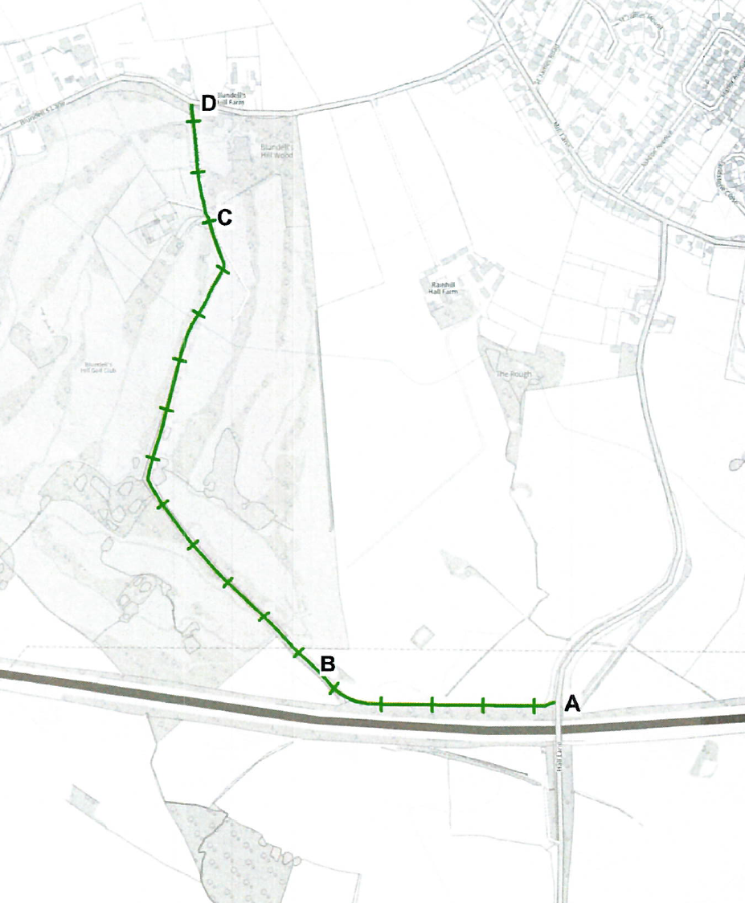
A2
A1
A1
A1
B1
B2
B1

