Receiver Name  Address Line 1  Address Line 2  Town/City  Post Code | Sender Name Address Line 1  Address Line 2 Town/City  Post Code

[Date-month-year]
Dear [first name] [last name]
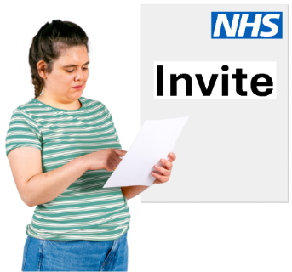

Why you are getting this letter

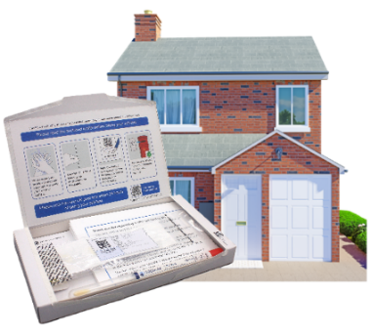

We recently asked you to do a self-test, to check if you have a virus called HPV.

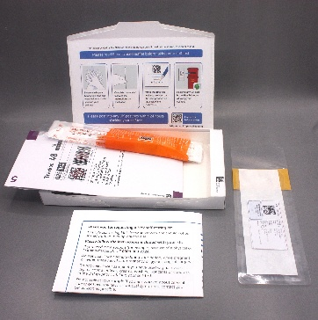
But we have noticed you haven't ordered your free test kit yet.

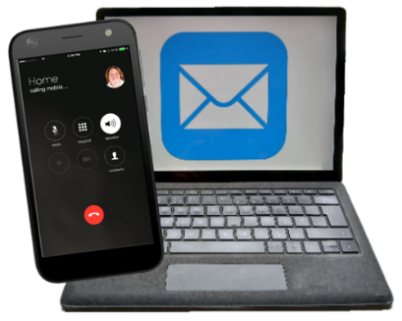
You can order the free test kit online at www.nhs.uk/order-hpv-test, or by phoning 0300 303 2724. Or you can ask someone to order it for you.


What is HPV?

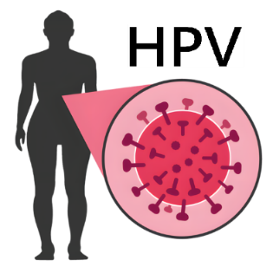
HPV is a type of virus. Viruses are very tiny germs that can get inside people and make them ill.

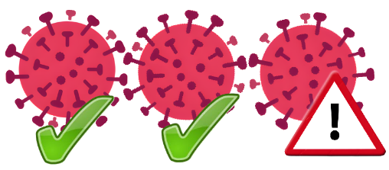
It does not usually cause problems.
But some types of HPV virus can cause cervical cancer.



Find out more about HPV at www.mencap.org.uk/easyread/information-about-hpv.


What is cervical cancer?

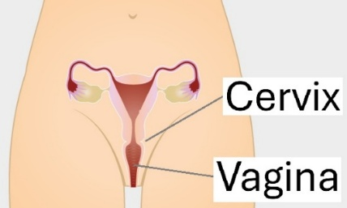
Cervical cancer is cancer of the cervix.
Your cervix is inside your body, at the top of your vagina.


What is cervical screening?

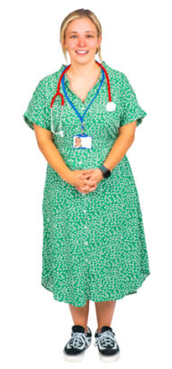


We check for HPV by doing cervical screening. It is usually done at a doctor’s
surgery.

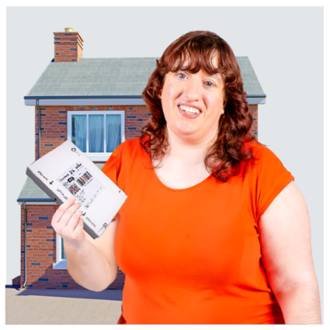

If you want to, you can now do this self-test instead.

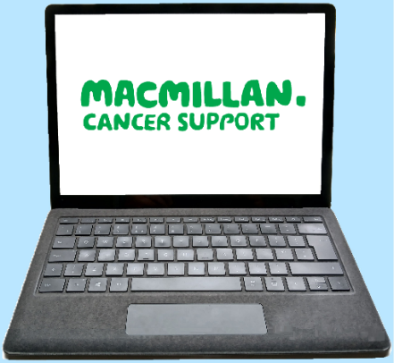
Find out more about cervical screening at www.macmillan.org.uk/cancer-information-and-support/stories-and-media/booklets/cervical-screening-easy-read

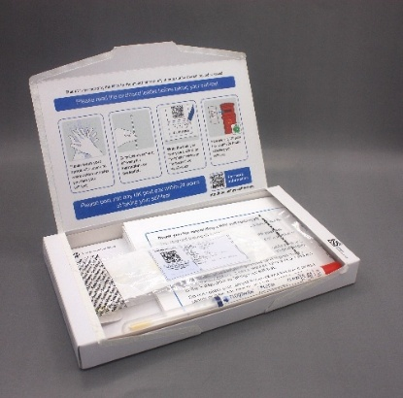

Why you might want to do the self-test



Our records show you have not had cervical screening lately.

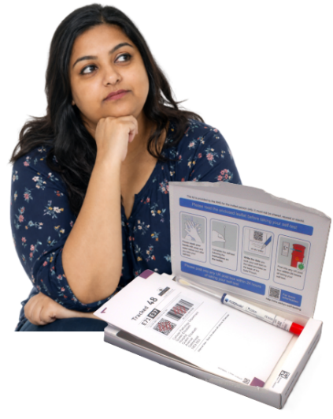

It is important to get tested, even if you feel well.

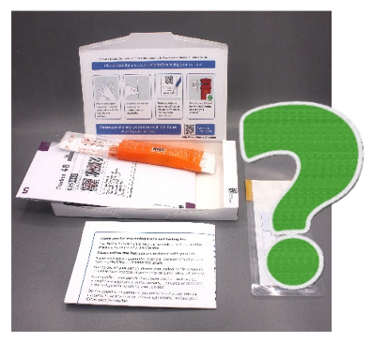

What to do with the self-test

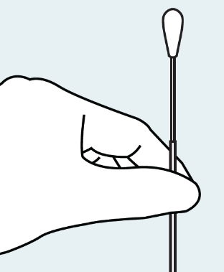

The test uses a swab, a bit like a cotton bud.

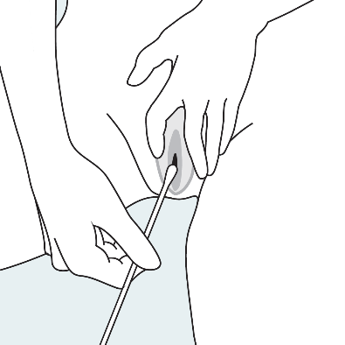

You put the swab into your vagina to do the test.

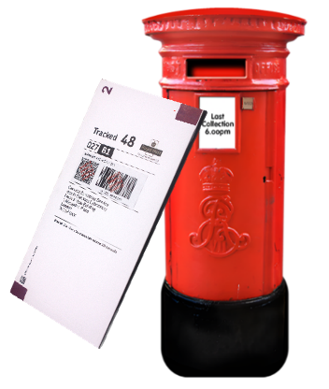
When you have done the test, send the kit back in the post. Or ask someone you trust to post it for you.

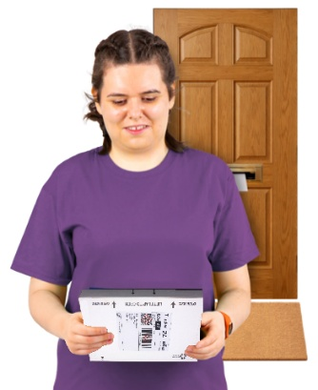
The test should be quick. It should not hurt.
You can do it on your own at home, at a time that suits you.

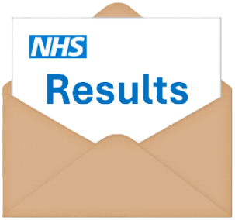

Your test results

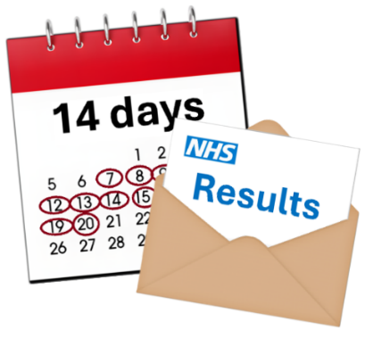

Your results will be sent to you within 14 days.


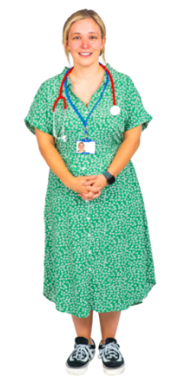


If the test shows that you have an HPV virus, we will ask you to see your doctor for another test.


Doing the cervical screening test with your doctor

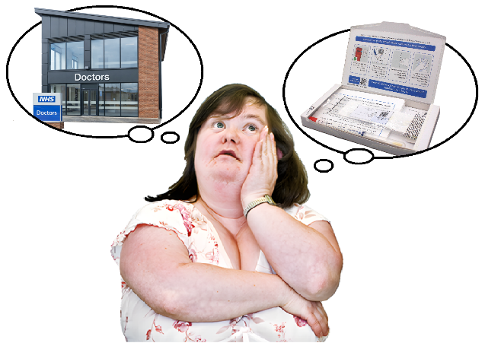

If you would rather have a cervical screening test at your doctor’s surgery instead of the self-test, you can.

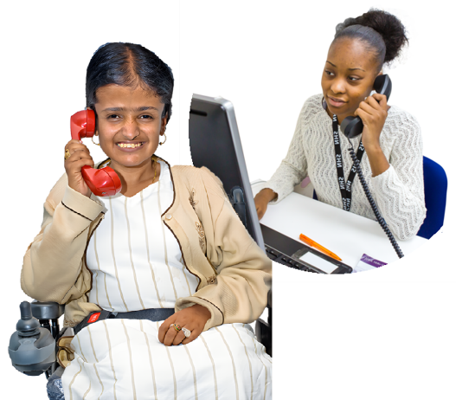

You can make an appointment or ask someone you trust to do it for you.

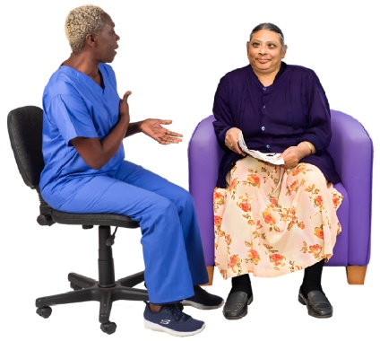

If you are worried about cervical screening, talk to your learning disability nurse or doctor’s surgery.

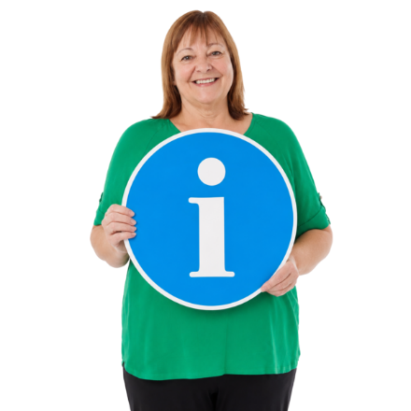

Find out more

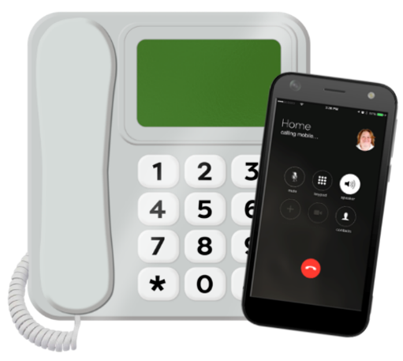

For more information about the self-test, call our helpline on 0300 303 2724.


Watch our film about people with a learning disability getting the right support for cervical screening. Go to www.youtube.com/watch?v=zOq_a2BYERc.

Yours sincerely,

NHS Cervical Screening Programme,
on behalf of your GP (doctor)

