

Appeal Decision
by Harry Wood BA (Hons) MA PhD MIPROW
an Inspector appointed by the Secretary of State for Environment, Food and Rural Affairs
Decision date: 03 August 2026

Appeal Reference: ROW/3375666
- This appeal is made under section 53(5) and paragraph 4(1) of schedule 14 of the Wildlife and Countryside Act 1981 against the decision of Staffordshire County Council not to make an order under section 53(2) of that Act.
- By application dated 5 May 2020, Julie Turner claimed that Public Footpath 10 (known as Wetley Lane) between Onecote and Ford should be upgraded so as to be recorded in the Definitive Map and Statement as a byway open to all traffic.
- The application was refused by the Council and the Applicant was formally notified on 10 October 2025.
Summary of Decision: The appeal is allowed.

Preliminary Matters
- I have been directed by the Secretary of State for Environment, Food and Rural Affairs to determine this appeal on the basis of the papers submitted. I have not visited the site, but I am satisfied that I can make my decision without the need to do so.
- I have found it convenient to refer to points on the plan produced by Staffordshire County Council (hereafter the Council) and have attached a copy of it to this decision, for reference. I have also added to the existing annotations (in red), to which I will refer throughout the decision.
- The application in question is for Public Footpath 10 (hereafter Wetley Lane) to be upgraded to a byway open to all traffic (BOAT). However, the Appellant refers in their representations to their understanding of the impact of the Natural Environment and Rural Communities Act 2006, asserting that “mechanically propelled vehicular rights are extinguished” and that “the status of a Restricted Byway should be recorded”. While noting the Applicant’s revised view on this matter, I will consider the merits of the application as originally made.
- While the application was made by an individual, the Appeal has been made by the same individual on behalf of the Staffordshire Moorlands Bridleways Group.

Main Issues
- The application was made under section 53(2) of the Wildlife and Countryside Act 1981 (the 1981 Act) which requires the surveying authority (in this case the Council) to keep their Definitive Map and Statement (DMS) under continuous review, and to modify them upon the occurrence of specific events cited in section 53(3).
- Section 53(3)(c)(ii) of the 1981 Act provides that a modification order should be made on the discovery of evidence which, when considered with all other relevant evidence available, shows that a highway shown in the DMS as a highway of a particular description ought to be shown as a highway of a different description. The evidential test to be applied is the balance of probability.
- Part III of Schedule 3 of the Countryside Act 1968 (the 1968 Act) required routes shown on the DMS as roads used as public paths (RUPPs) to be reclassified as BOATs, bridleways, or footpaths due to confusion as to the rights of the public over them.
- In R v Secretary of State for the Environment ex parte Hood [1975] QB 891 (CA) (Hood) the Court held that in the absence of new evidence, or evidence not previously considered by the surveying authority, a RUPP could not be reclassified at a special review as a footpath because of the conclusive presumption contained in section 32(4) of the National Parks and Access to the Countryside Act 1949 (the 1949 Act) that there are equestrian rights over a RUPP.
- R v Secretary of State for the Environment ex parte Riley [1989] JPEL 921 (Riley) and R (Kind) v Secretary of State for the Environment, Food, and Rural Affairs [2005] EWCH 1324 (Admin) (Kind) established that a reclassification under a special review did not extinguish any higher rights which may have existed over a route.
- Section 32 of the 1980 Act requires that documentary evidence is taken into consideration “before determining whether a way has or has not been dedicated as a highway”, and that such weight is given to the evidence as “justified by the circumstances, including the antiquity of the tendered document, the status of the person by whom and the purpose for which it was made or compiled, and the custody in which it has been kept and from which it was produced.”

Reasoning

Documentary Evidence

Inclosure records 1769
- The Bradnop Inclosure Map depicts a route between solid parallel lines and shaded sienna. It is broadly consistent with the modern-day alignment of Wetley Lane, linking Onecote in the west to Ford in the east. The route runs through numerous allotments and is annotated “42”. The entry in the accompanying Inclosure Award describes the route as “private horse carriage and drift road No 42 leading from Onecote to Ford”. Describing the ownership details of the various allotments, the Award then refers to the usage rights of the route:

the aforesaid road hereby for the use of the said Richard Sherwin, the said Thomas Coot and John Finney, the said William Radcliffe of Ford William Hall Thomas Ball William Plant and Robert Edge and for the inhabitants of Onecote and Ford.
- The Appellant emphasises the significance of the final section of the above passage, “for the inhabitants of Onecote and Ford”. They argue that as this allowed use “by many local persons”, it is evidence “that the public were allowed to use this route”. The Appellant interprets the phrase “private horse carriage and drift road” as referring to “use by horses and carts or carriages in addition to lesser rights”, and argues that the Award extended these rights to the public in full.
- The Council point to the way in which other routes were set out by the Award, highlighting that a clear distinction is drawn between “public horse carriage and drift roads” and “private horse carriage and drift roads”. They also highlight the fact that no width is set out for route 42, “which supports the contention that the route was a private route as public routes recorded a width for the passing of traffic”. I have been unable to locate any information regarding the width of public or private roads within the Award, though I note that the scanned version before me is of variable quality.
- The wording of the Award suggests that some form of public rights existed over routes set out as private roads. Given that the Award clearly distinguishes between public and private horse carriage and drift roads, it seems more likely than not that the former were intended as public carriageways and the latter private vehicular routes with lower public rights.
- The relevant Inclosure Act has not been submitted as evidence. This reduces the evidential weight that can be attributed to these records, as I have been unable to establish the extent of the powers available to the Inclosure Commissioners. These records offer strong evidence that the Inclosure process set out what is now Wetley Lane as some form of public right of way in 1769. It seems probable that these rights were lower than those of a public horse carriage and drift road, but without sight of the relevant Inclosure Act I can only attach limited weight to this speculation.

Yates’ Map 1775
- The Yates Map does not depict Wetley Lane. It does record Onecote, Ford, and the River Hamps, with which the Appeal Route runs roughly in parallel to the south.

Greenwood’s Map 1820
- The Greenwood’s Map depicts a route running eastwards from Onecote towards Ford. It is depicted between solid parallel lines of equal thickness. The Greenwood’s legend explains that this depiction was used to indicate a cross road.
- Case law has established that a cross road may mean a public road for which no toll is payable, though the weight of such evidence can vary depending on the totality of the evidence under consideration.
- The Council suggest that this route “does not represent with any certainty the line of the claimed route”, arguing that it enters Onecote village “to the north of the termination point of the claimed route”. While I accept that this route does not follow the exact alignment of modern mapping, I am satisfied that its location to the south of the River Hamps and to the north of Morridge Road (what is now Fairview Road) is broadly consistent with Wetley Lane.
- The Greenwood’s Map indicates that Wetley Lane existed on the ground in 1820 and that the surveyor considered it capable of taking vehicular traffic.

Ordnance Survey (OS) Maps 1856-1908
- Several OS maps have been submitted covering the period 1856 to 1908. The First Series 1:63660 Map (1856) records the full length of Wetley Lane. The majority of the route is shown by solid parallel lines, with a short section in the centre (roughly between points A1 and A2) shown by one solid line and one pecked line. Pecked lines were usually used by OS to represent features which were not obstructions to pedestrians.
- The Second Edition 25 Inch County Series Map (1899) depicts Wetley Lane through a combination of solid parallel lines (points A to A1 and A3 to B), one pecked line and one solid line (points A1 to A2) and parallel pecked lines (points A2 to A3). The Appellants highlight that several routes annotated “F.P.” branch off Wetley Lane, which they consider to be “suggestive of higher rights on this route”.
- The One Inch Map (1908) is broadly consistent with the County Series Map, showing Wetley Lane through a combination of parallel solid lines and parallel pecked lines. The accompanying legend indicates that both styles depict third class roads, fenced and unfenced respectively.
- While OS maps often provide useful evidence as to the physical characteristics of a route, they tend not to provide direct evidence of status. In this instance, the OS maps suggest that the full extent of Wetley Lane existed on the ground between 1856 and 1908, and that the central section (between points A1 and A3) was not an enclosed lane in the manner of the western and eastern sections.

Handover Maps 1929 & 1987
- Responsibility for maintaining many classifications of highway was transferred from rural district councils to county councils by the Local Government Act 1929. In order to assist in the transfer of responsibilities documents were prepared, listing all roads that were maintained at public expense at that time.
- Wetley Lane is not shaded or otherwise annotated on the 1929 Handover Map, suggesting it was not formally recognised as a publicly maintainable highway during this process.
- The Council have submitted a second document (dated 1987) they describe as a Handover Map, although it is not made clear the circumstances in which it was produced. The full extent of Wetley Lane is shaded sienna. An accompanying text box reads: “HC 1-9-87. Wetley Lane to be declared as above pursuant to section 47 procedure”. The Map does not make clear what status of highway the proposed declaration involved.

Local Authority Correspondence 1982-1991
- Various letters sent and received by the Council have been submitted as evidence, many of which concern the section 47 proposals referred to above.
- Section 47 of the 1980 Act allows for highway authorities to apply to a magistrates’ court for an order declaring that a highway shall no longer be maintainable at public expense. This concerns situations in which highway authorities consider a route to be “unnecessary for public use”. The proposals in question appear to relate to use of Wetley Lane by motorcycles and 4x4 vehicles, although the associated Report produced by the County Surveyor suggests there was some dispute as to the extent of such use.
- Although there is little clarity regarding the nature of the highway rights that the Council considered unnecessary, related correspondence suggests that this concerned vehicular rights. Writing to the representatives of Ford Little Farm in December 1982, the County Surveyor explains that the County Highways Committee was “recommended to acknowledge that this route was a publicly maintainable highway when the Highways Act 1835 came into force and therefore still publicly maintainable”. The letter then states that there are “no legal restrictions on the classes of traffic legally entitled to use a public highway as opposed to specific public rights of way established under […] [the] 1949 and 1968 Acts”. This statement appears to misuse the term highway, which simply means a way over which the public has the right to pass and repass. It seems likely that are using the term to refer to a BOAT, that is, a right of way over which the public have the right to drive a mechanically-propelled vehicle.
- There are several other letters that relate to the status of Wetley Lane. This includes a letter from Onecote Parish Council in December 1982, requesting information “as to precisely when the public right of way for vehicular use along Wetley Lane ceased to exist as Councillor[s] cannot recollect this happening and indeed are of the opinion that this right of way still exists”.
- While the correspondence indicates that an application under section 47 was considered, it also makes clear that the Council resolved not to follow through with these proposals. This means that Wetley Lane remains a highway maintainable at public expense. However, as the route was (and remains) recorded as a public footpath in the DMS, this correspondence points to significant confusion within the Council regarding the exact nature of public rights over Wetley Lane and the associated maintenance implications.

DMS Preparation Records 1951-1954
- The Survey Card for what is now recorded as Public Footpath 10 identifies the route as a “CRB”. Although this term has no legal significance, it is short for carriage road used mainly as a bridleway. The route is described as follows:

Path starts at Bank Top Farm. Path finishes at Cheadle Longnor Road opposite Onecote Vicarage. Field gate at Ford Wetley Farm. Field gate through field gate through field gate through field gate at Wetley Barn by Clough House Farm to Cheadle Longnor Road at Onecote Vicarage.

Under the heading “Grounds for believing path to be public”, the surveyors have stated “local knowledge & maps. Open for at least 20 years without dispute”.
- The 1954 Definitive Statement lists “Path No. 10” as “R.P.”, short for “Road used as a public path”. Under “other relevant information” the entry states “Known as Wetley Lane”.

Special Review Documents 1977-1978
- The Council have submitted two documents relating to the special review conducted over the course of 1977 and 1978. The first of these is an Inspector Report following an Inquiry held in September 1977. The Inspector explains that the inquiry was held under Schedule 3 of the 1968 Act “into objections and representations which have been made in respect of the Draft Revised Map and Statement prepared by Staffordshire County Council”, adding that “in addition to being an ordinary review of the previous Definitive Map”, the special review “also reclassified ‘roads used as public paths’ into byways open to all traffic or bridleways”.
- The Report details the Council’s case relating to “No. 10 Onecote”, which the review proposed to reclassify from RUPP to footpath. Explaining that the route was “impassable to all vehicles”, the Council state that they “have surfaced each end periodically sharing the expense with the owners of the two farms [Ford Wetley Farm and Clough Head Farm]”, adding that the track “would be better as a bridleway than as a footpath”. The Report then summarises the case made by the Objector, the British Motor Cycles Federation, who wished the route to be reclassified as a BOAT. They argued that documentary evidence pointed to the route being “an old public road” and that it was capable of being ridden “without too much difficulty”. The Objectors also provided a description of the route: “the track passes across fields, then becomes grass with a good surface, firm and no mud when inspected”. The Report additionally refers to evidence collected on a site visit from “a farmer’s wife”, who complained about “picknickers in cars, who parked in the lane causing obstruction, and horse riders who did not keep to the track and ramblers and horse riders who left open the gates”.
- Paragraph 10 of part III of schedule 3 to the 1968 Act set out considerations to be taken into account when deciding the status to which RUPPs should be reclassified:

(a) whether any vehicular right of way has been shown to exist,

(b) whether the way is suitable for vehicular traffic having regard to the position and width of the existing right of way, the condition and state of repair of the way, and the nature of the soil,

(c) where the way has been used by vehicular traffic, whether the extinguishment of vehicular rights of way would cause any undue hardship

Addressing these considerations, the Inspector asserted that it was “doubtful whether any vehicular right of way has been shown to exist”, adding that the route “is not suitable for vehicular traffic in its present state”. The Inspector was also of the view that extinguishment of vehicular rights “would not […] cause undue hardship”. Stating that there was “some evidence of horse riding”, the Inspector recommended dismissing the objection and, “if it be legally possible at this stage, that the Secretary of State should direct the Staffordshire County Council to modify the Draft Revised Map and Statement by re-classifying the right of way as a bridleway”.
- Responding to the Inspector’s recommendation, an official writing on behalf of the Secretary of State explained their understanding of the statutory position:

[…] in the absence of “new evidence” […] the Secretary of State has no power to direct any reclassification other than sought in the objection. Consequently no alternative reclassification is possible and the way must remain on the map reclassified as a footpath.
- The Special Review evidence raises two points of particular significance. Firstly, the Inspector reached the conclusion that there was no clear evidence of vehicular rights over Wetley Lane. Secondly, both the Inspector and the Secretary of State appear to have shared the view that Wetley Lane should have been recorded as a bridleway but for the limitations of statutory procedure. The fact that the route was believed to be of a higher status than public footpath carries significant evidential weight in the determination of its correct current status.

List of Streets
- The Council’s List of Streets includes two entries for Wetley Lane: D1102 and G1102. The Appellant points to the Council’s Rights of Way Improvement Plan (ROWIP), which states that G class routes are “roads open to all traffic”, and argue that this offers evidence that Wetley Lane “is still considered to be some type of vehicular highway”. The Council emphasise that the List of Streets solely concerns maintenance responsibility and does not confer legal status.
- The Appellant has also provided the information via the website Find My Street. The full length of the Appeal Route is recorded as “Wetley Lane, Onecote” and is described as “maintainable at public expense”.

Conclusions on documentary evidence
- From the evidence presented in this case it is clear that a route following the full extent of Wetley Lane has existed on the ground from at least 1769. While there are several pieces of evidence (including the Greenwood’s Map and the Local Authority correspondence) that suggest the route is a vehicular highway, these are all of relatively limited evidential weight. I also note the significance of the Inspector’s 1978 Special Review Report, which concluded that there was no clear evidence of vehicular rights over Wetley Lane.
- There are numerous documents (including the OS maps, the DMS preparation records, the Greenwood’s Map and the Local Authority correspondence) that are suggestive of higher rights than a public footpath existing over the Appeal Route. The Special Review documents clearly indicate a belief on the part of the Inspector that bridleway rights existed over Wetley Lane. Case Law has established, furthermore, both the conclusive presumption that equestrian rights existed over RUPPs and that the reclassification process did not extinguish any higher rights which may have existed over a route.
- I am therefore of the view that, on the balance of probability, public bridleway rights exist over the full length of Wetley Lane. The making of an Order will give the opportunity for public consultation and any further evidence in support of higher rights may be discovered. In addition, if objections are made there would be an opportunity for the conflicting evidence to be tested more thoroughly and the issues determined at an inquiry.

Other Matters
- The Council have shared various letters and emails they received concerning the application, raising issues such as the environmental impacts of a prospective upgrade in status, and the use of Wetley Lane and the field gates on it to move livestock. While these concerns are understandable, they cannot influence the issue of whether or not higher public rights exist over the Appeal Route.

Conclusion
- Having regard to these and all other matters raised in the written representations I conclude that the appeal should be allowed.

Formal Decision
- In accordance with paragraph 4(2) of Schedule 14 to the 1981 Act, Staffordshire County Council is directed to make an Order under section 53(2) and Schedule 15 of the 1981 Act within three months of the date of this decision, to upgrade Public Footpath 10 to a public bridleway.
- This decision is made without prejudice to any decisions that may be given by the Secretary of State in accordance with her powers under Schedule 15 of the 1981 Act.

Harry Wood

INSPECTOR

Appeal Plan (not to scale)

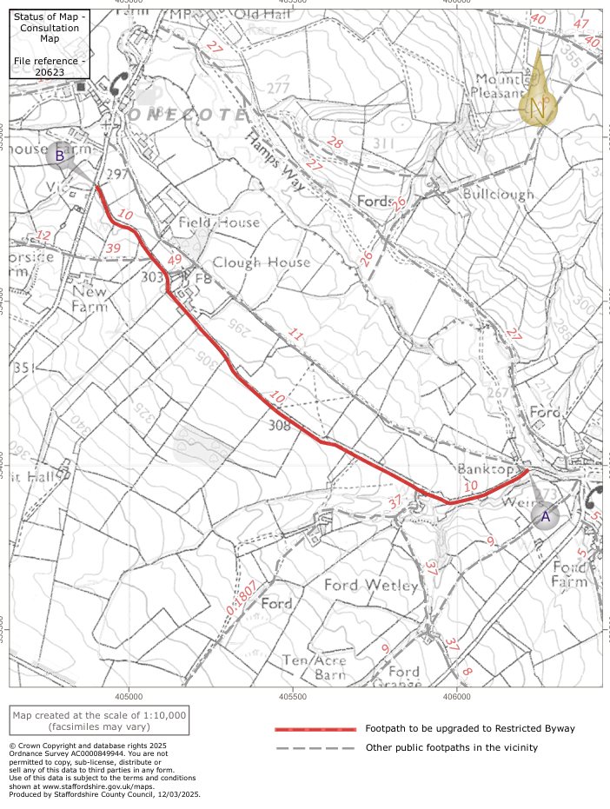
A2
A1
A3

