NOTICE OF ORDER

Wildlife and Countryside Act 1981 - Section 53
City of York Council
COUNCIL OF THE CITY OF YORK – OPPOSED PUBLIC FOOTPATH SKELTON 13 MODIFICATION ORDER 2021

Notice is hereby given that the above referenced Order(s) has/have been submitted to the Secretary of State for Environment, Food and Rural Affairs for determination. An Inspector will be appointed by the Secretary of State to determine the Order(s).

The start date for the above Order(s) is 15 July 2026.

Consideration of the Order(s) will take the form of a hearing.

The Hearing will be held at City of York Council, West Offices, Station Rise, York YO1 6GA on 18 November 2026 at 10.00am.

The effect of the Order, if confirmed without modifications, will be to modify the definitive map and statement for the area by adding a public footpath between The Village and Moor Lane across Skelton Moor (SE 5705 5651 to SE 5828 5771).

Any queries relating to this Order should be referred to Joanne Reid by email: rightsofway2@planninginspectorate.gov.uk quoting reference number ROW/3366284 on all correspondence. Alternatively, queries may be sent in writing to The Planning Inspectorate, Rights of Way Section, c/o QUADIENT, 69 Buckingham Avenue, Slough, SL1 4PN. Telephone: 0303 444 5136.

Any person wishing to view the statements of case and other documents relating to this Order may do so by appointment at City of York Council West Offices, Station Rise, York YO1 6GA, 8.30am to 5.00pm Monday-Friday. Please contact Russell Varley Tel: 01904 551500 rightsofway@york.gov.uk

Timetable for sending in statements of case

Within 8 weeks of the start date [by 9 September 2026]

The Order Making Authority, or where the Order Making Authority is taking a neutral stance and the applicant or other party are taking the case forward in support of the order, must ensure their statement of case is received by the Secretary of State. As soon as possible after the deadline, the Secretary of State will send a copy (excluding copies of any supporting documents, although these will be available to view at the Authority’s offices) to everyone who has made an objection or representation, the applicant and any other person who has written to us in respect of the Order.

Within 12 weeks of the start date [by 7 October 2026]

Everyone who has made an objection or representation and anyone who wishes to give evidence at the Hearing must ensure their statement of case is received by the Secretary of State. As soon as possible after the deadline, the Secretary of State will send full copies to the Authority. Copies will also be sent to the applicant, every person who has made an objection or representation and any other person who has written to us in respect of the Order (excluding copies of any supporting documents - these will be available to view at the Authority’s offices).

Within the same period the applicant (if applicable) must ensure their statement of case is received by the Secretary of State. As soon as possible after the deadline, the Secretary of State will send a full copy to the Authority. Copies will also be sent to everyone who has made an objection or representation and any other person who has written to us in respect of the Order (excluding copies of any supporting documents - these will be available to view at the Authority’s offices).

All parties must keep to the timetable set out above and ensure that statements of case are received by the Secretary of State on time. Late documents will be returned.

We cannot accept any inflammatory, discriminatory or abusive comments. Any documents containing such comments will be returned.

If you use Artificial Intelligence (AI) to create or alter any part of your documents, information or data, you should tell us that you have done this when you provide the material to us. See the detailed guidance for further information.

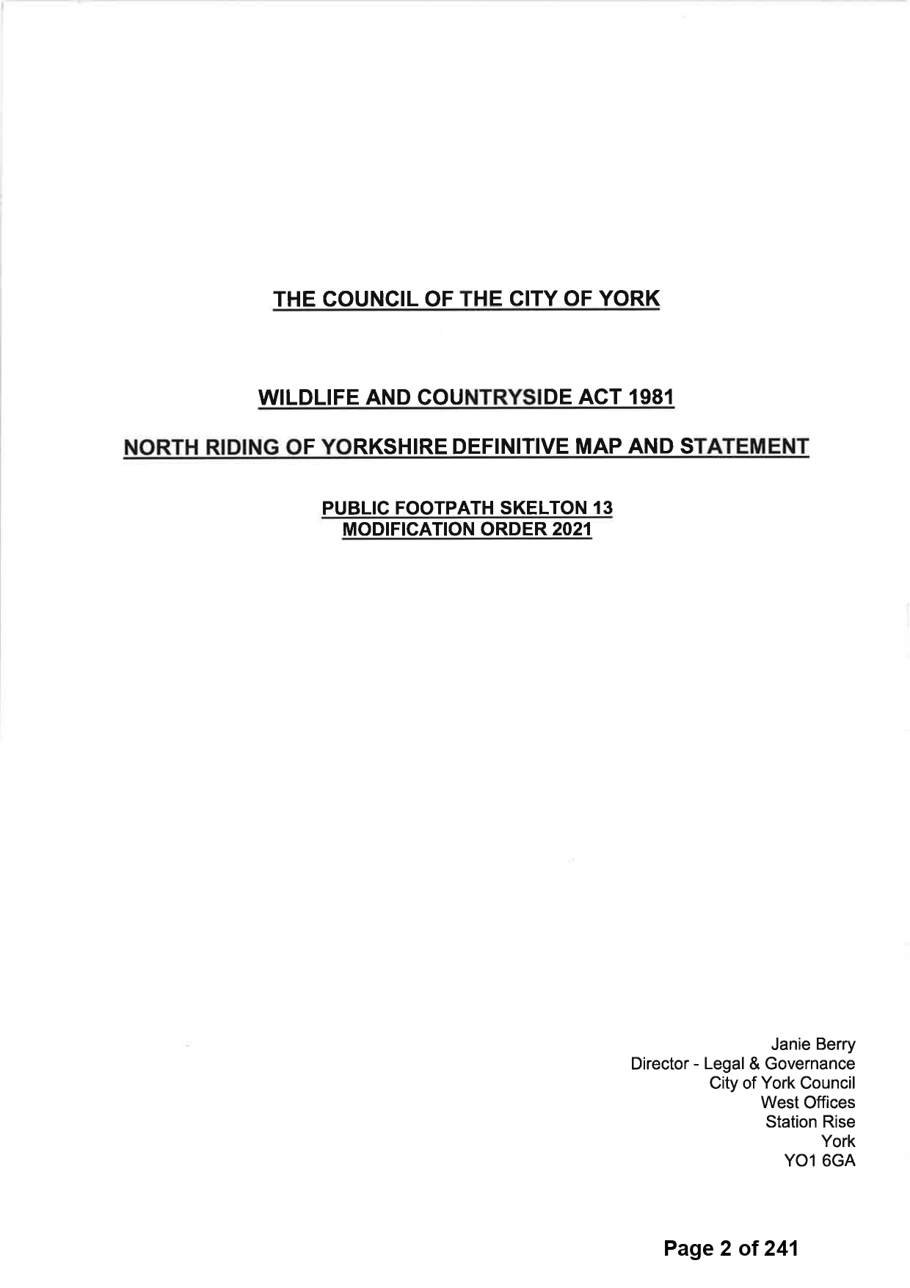

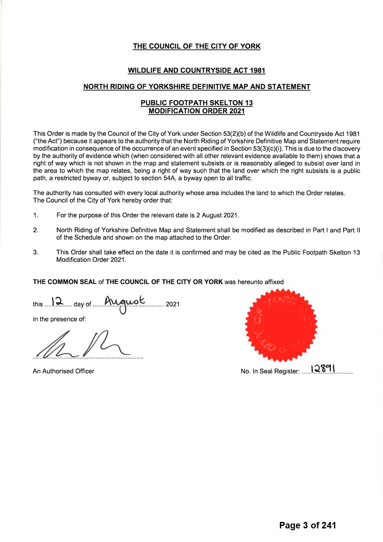

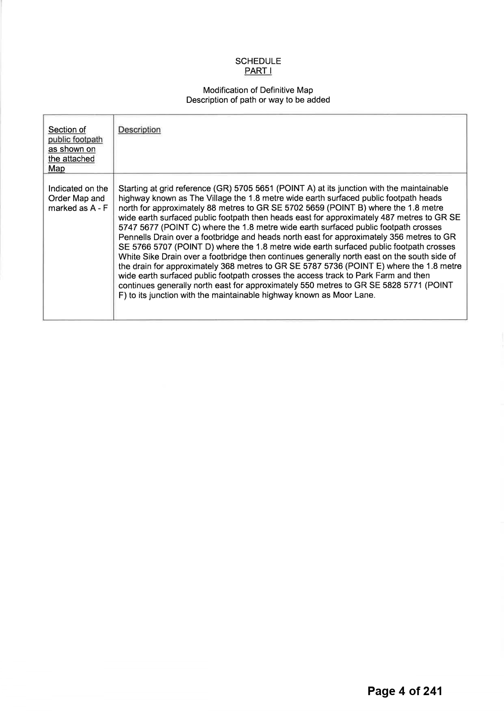

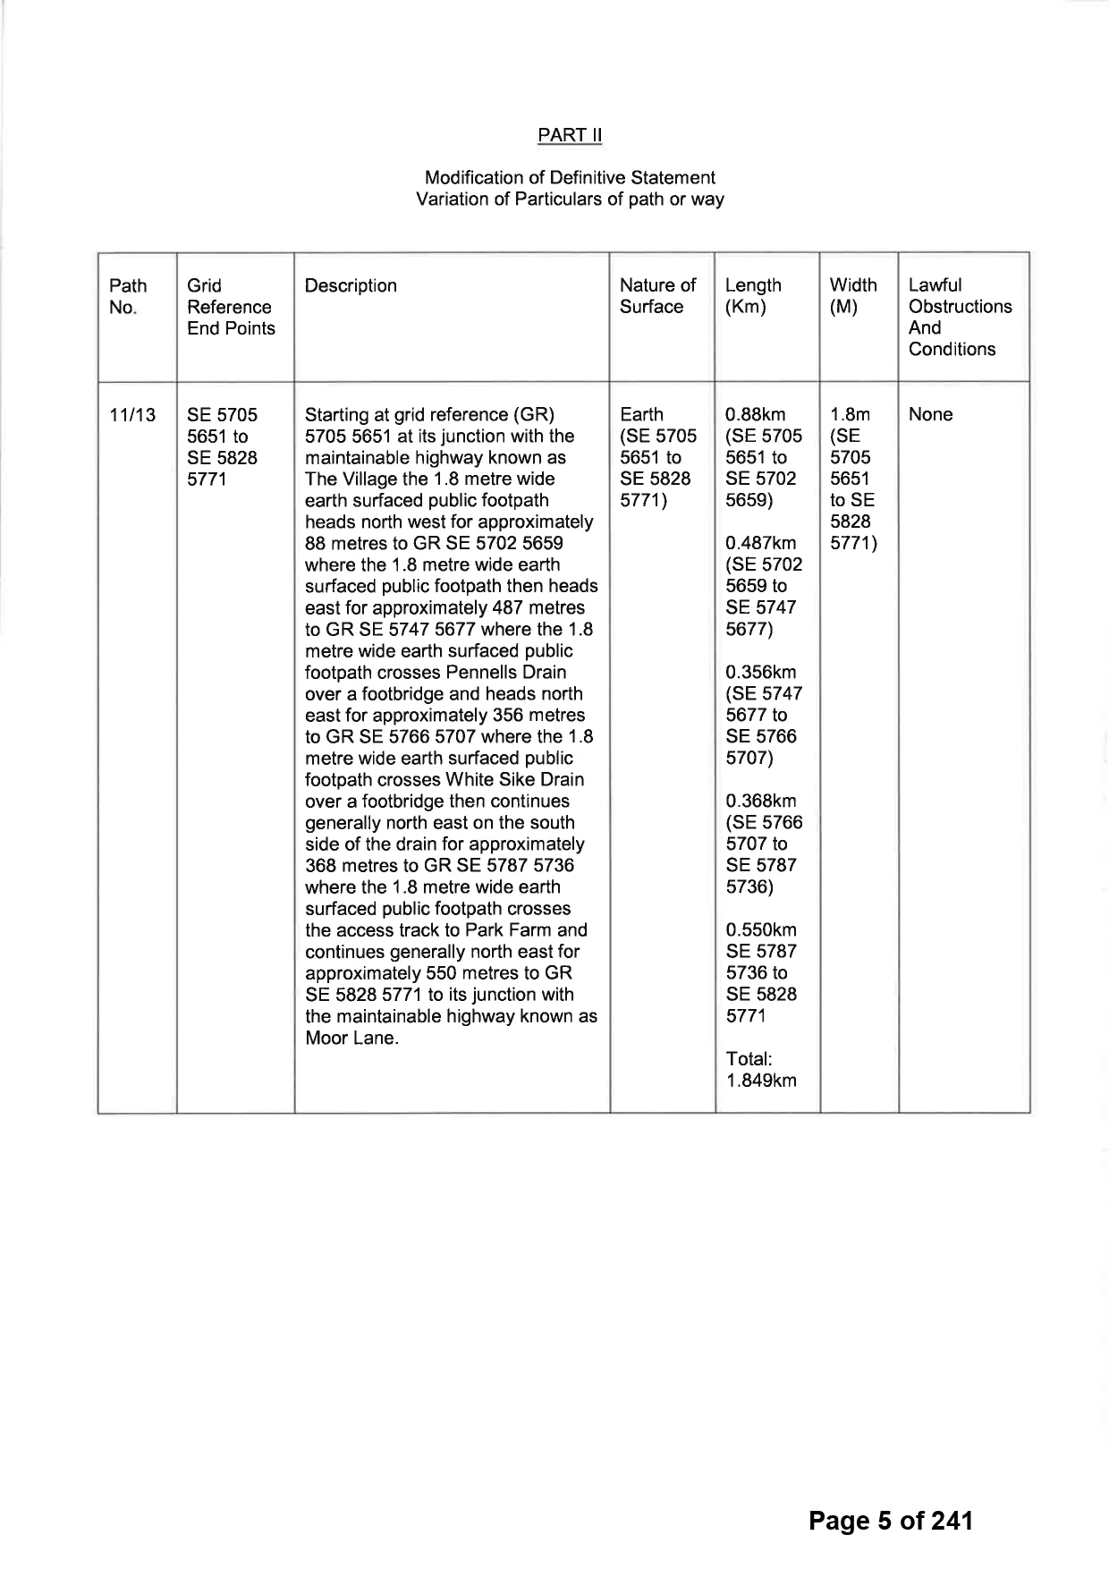

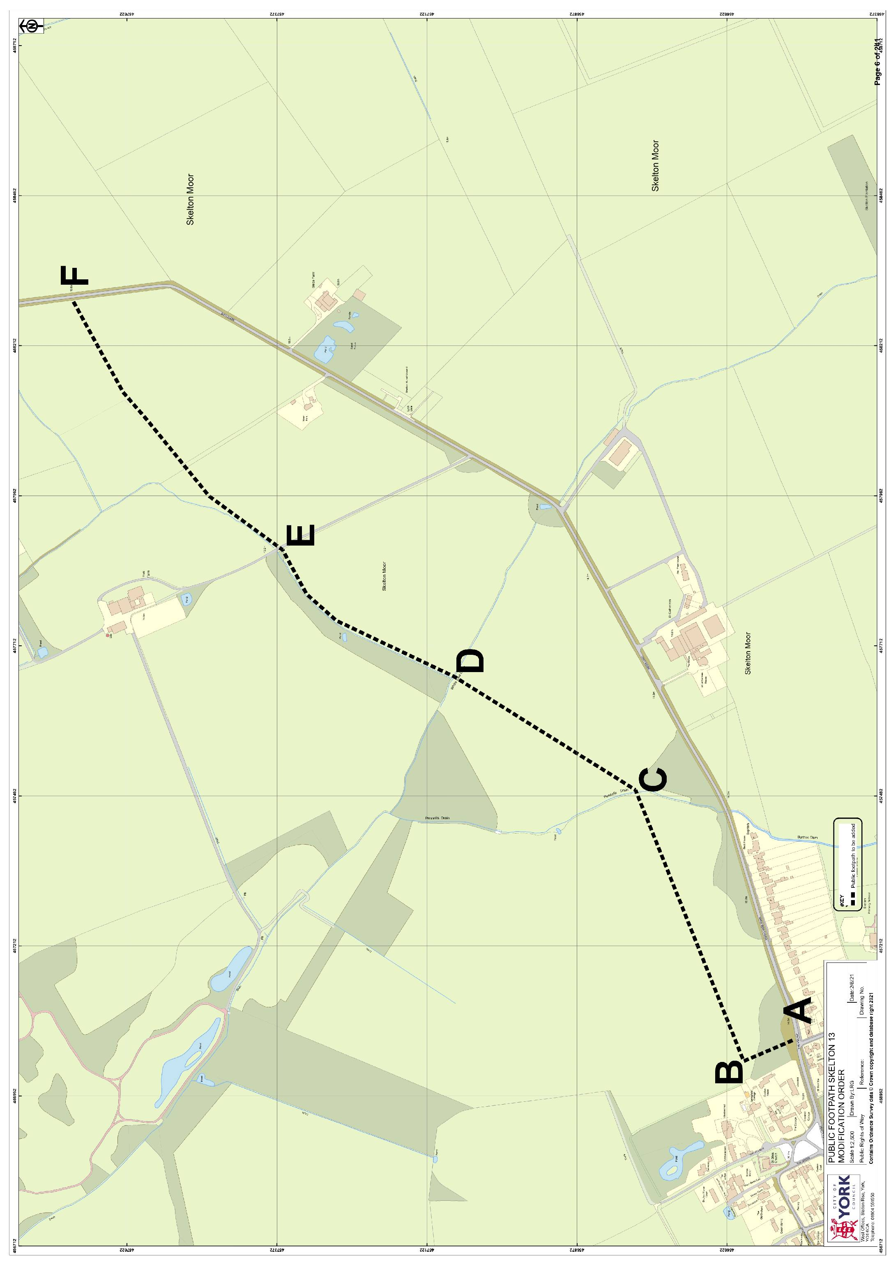

If you wish to make a legal submission, this should be submitted at the same time as your statement of case. Otherwise legal submissions will have to be submitted in writing on the day of the hearing.

