NOTICE OF ORDER

Highways Act 1980, 119

Pendle Borough Council

THE BOROUGH COUNCIL OF PENDLE DIVERSION OF PUBLIC FOOTPATH FP1309033 AT MALKIN CROFT GREAT STONEDGE FARM BLACKO PUBLIC FOOTPATH DIVERSION ORDER 2025

Notice is hereby given that the above referenced Order has been submitted to the Secretary of State for Environment, Food and Rural Affairs for determination. An Inspector will be appointed by the Secretary of State to determine the Order.

The start date for the above Order is 21 July 2026.

Consideration of the Order will take the form of exchanges of statements of case and comments on statements of case.
The effect of the Order, if confirmed without modifications, will be to divert the public footpath running from public footpath FP1309037 near Great Stone Edge Farm at SD8622 4118 (Point A on the Order Map) to a pedestrian gate near the junction of Beverley Road and Barnoldswick Road at SD8663 4134 (Point C) to a line running from public footpath FP1309037 near Little Stone Edge Farm at SD8618 4123 (Point D) to pedestrian gate near the junction of Beverley Road and Barnoldswick Road at SD8663 4134 (Point C) as shown on the order map.

Any queries relating to this Order should be referred to Paul Scrivener by email: paul.scrivener@planninginspectorate.gov.uk quoting reference number ROW/3378249 on all correspondence. Alternatively, queries may be sent in writing to The Planning Inspectorate, Rights of Way Section, c/o QUADIENT, 69 Buckingham Avenue, Slough, SL1 4PN. Telephone: 0303 444 5000.
Any person wishing to view the statements of case and other documents relating to this Order may do so by appointment at 1 Market Street, Nelson, Lancashire, BB9 7LJ. Contact : Nayznin.Ahmed@pendle.gov.uk

Timetable for sending in statements of case and comments

Within 2 weeks of the start date by 4 AUGUST 2026.
The Order Making Authority, or where the Order Making Authority is taking a neutral stance and the applicant or other party are taking the case forward in support of the order, must ensure their statement of case is received by the Secretary of State. As soon as possible after the deadline, the Secretary of State will send a copy (excluding copies of any supporting documents - these will be available to view at the Authority’s offices) to everyone who has made an objection or representation, the applicant and any other person who has written to us in respect of the Order.

Within 8 weeks of the start date by 15 September 2026.
Everyone who has made an objection or representation or any other written representation or any other person wishing to make representations in writing must ensure their statement of case is received by the Secretary of State. As soon as possible after the deadline, the Secretary of State will send full copies to the Authority. Copies (excluding copies of any supporting documents - these will be available to view at the Authority’s offices) will also be sent to the applicant, every person who has made an objection or representation and any other person who has written to us in respect of the Order.

Within the same period the applicant (if applicable) must ensure their statement of case is received by the Secretary of State. As soon as possible after the deadline, Secretary of State will send a full copy to the Authority. Copies will also be sent to everyone who has made an objection or representation and any other person who has written to us in respect of the Order (excluding copies of any supporting documents - these will be available to view at the Authority’s offices).
Within 14 weeks of the start date by 27 October 2026.
Everyone who has made an objection or representation, the Authority, the applicant (if applicable) and anyone who has written to us in respect of the Order must ensure that their comments on any or every other statement of case is received by the Secretary of State. As soon as possible after the deadline, the Secretary of State will send copies of these comments to everyone else.
In fairness to the other parties everyone should keep to the timetable to ensure that statements of case and comments are received on time. Late documents will be returned.

We cannot accept any inflammatory, discriminatory or abusive comments. Any documents containing such comments will be returned.
If you use Artificial Intelligence (AI) to create or alter any part of your documents, information or data, you should tell us that you have done this when you provide the material to us. See the detailed guidance for further information.

Notice of order for w/r
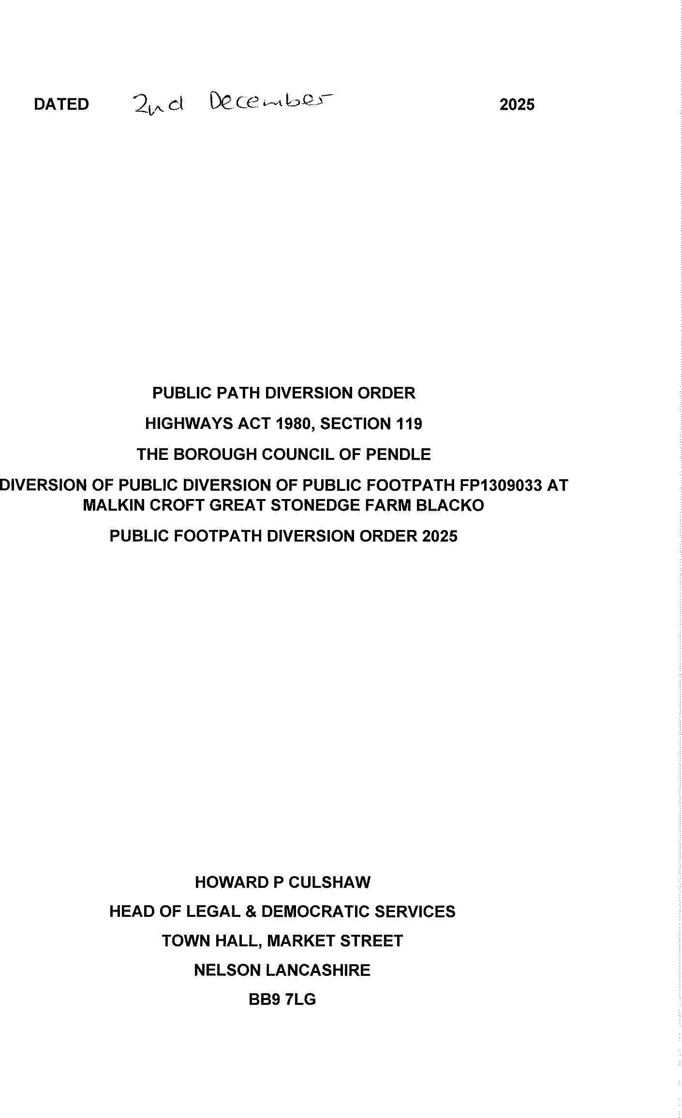
01a


