NOTICE OF ORDER

Wildlife and Countryside Act 1981, 53
Telford and Wrekin Council

TELFORD & WREKIN (CRUDGINGTON LANE, PARISH OF WATERS UPTON) RESTRICTED BYWAY ADDITION DMMO 2023

Notice is hereby given that the above referenced Order has been submitted to the Secretary of State for Environment, Food and Rural Affairs for determination. An Inspector will be appointed by the Secretary of State to determine the Order.

The start date for the above Order is 17 August 2026

Consideration of the Order will take the form of exchanges of statements of case and comments on statements of case.

The effect of the Order, if confirmed without modifications, will be to modify the Definitive Map and Statement for the area by adding the byway from a point commencing at Ordnance Survey Grid Reference (OSGR) SJ 63028 17761 on the junction with the highway A442 running in a general north easterly direction for approximately 268 metres on a mixed tarmac and stone surface with a width of approximately 2.5 metres to OSGR SJ 63280 17862 where the route turns in a general east by south direction for approximately 1140 metres to OSGR SJ 64355 17584 where it then runs in a general north-east by north direction for approximately 350 metres to terminate at OSGR SJ 64634 17827 at the junction with Crudgington Moor Lane. The route is a total distance of approximately 1758 metres.
Any queries relating to this Order should be referred to Paul Scrivener by email: paul.scrivener@planninginspectorate.gov.uk quoting reference number ROW/3377581 on all correspondence. Alternatively, queries may be sent in writing to The Planning Inspectorate, Rights of Way Section, c/o QUADIENT, 69 Buckingham Avenue, Slough, SL1 4PN. Telephone: 0303 444 5000.
Any person wishing to view the statements of case and other documents relating to this Order may do so by appointment at Telford & Wrekin Council, Darby House, Lawn Central, Telford Town Centre, TF3 4JA between 9am and 5pm Monday to Friday, by visiting Telford & Wrekin online planning portal and entering the DMMO reference DMMO/2002/0001 or by emailing PRW@telford.gov.uk

Timetable for sending in statements of case and comments

Within 2 weeks of the start date by 31 August 2026
The Order Making Authority, or where the Order Making Authority is taking a neutral stance and the applicant or other party are taking the case forward in support of the order, must ensure their statement of case is received by the Secretary of State. As soon as possible after the deadline, the Secretary of State will send a copy (excluding copies of any supporting documents - these will be available to view at the Authority’s
offices) to everyone who has made an objection or representation, the applicant and any other person who has written to us in respect of the Order.

Within 8 weeks of the start date by 12 October 2026
Everyone who has made an objection or representation or any other written representation or any other person wishing to make representations in writing must ensure their statement of case is received by the Secretary of State. As soon as possible after the deadline, the Secretary of State will send full copies to the Authority. Copies (excluding copies of any supporting documents - these will be available to view at the Authority’s offices) will also be sent to the applicant, every person who has made an objection or representation and any other person who has written to us in respect of the Order.
Within the same period the applicant (if applicable) must ensure their statement of case is received by the Secretary of State. As soon as possible after the deadline, Secretary of State will send a full copy to the Authority. Copies will also be sent to everyone who has made an objection or representation and any other person who has written to us in respect of the Order (excluding copies of any supporting documents - these will be available to view at the Authority’s offices).

Within 14 weeks of the start date by 23 November 2026.
Everyone who has made an objection or representation, the Authority, the applicant (if applicable) and anyone who has written to us in respect of the Order must ensure that their comments on any or every other statement of case is received by the Secretary of State. As soon as possible after the deadline, the Secretary of State will send copies of these comments to everyone else.
In fairness to the other parties everyone should keep to the timetable to ensure that statements of case and comments are received on time. Late documents will be returned.

We cannot accept any inflammatory, discriminatory or abusive comments. Any documents containing such comments will be returned.
If you use Artificial Intelligence (AI) to create or alter any part of your documents, information or data, you should tell us that you have done this when you provide the material to us. See the detailed guidance for further information.

Notice of order for w/r
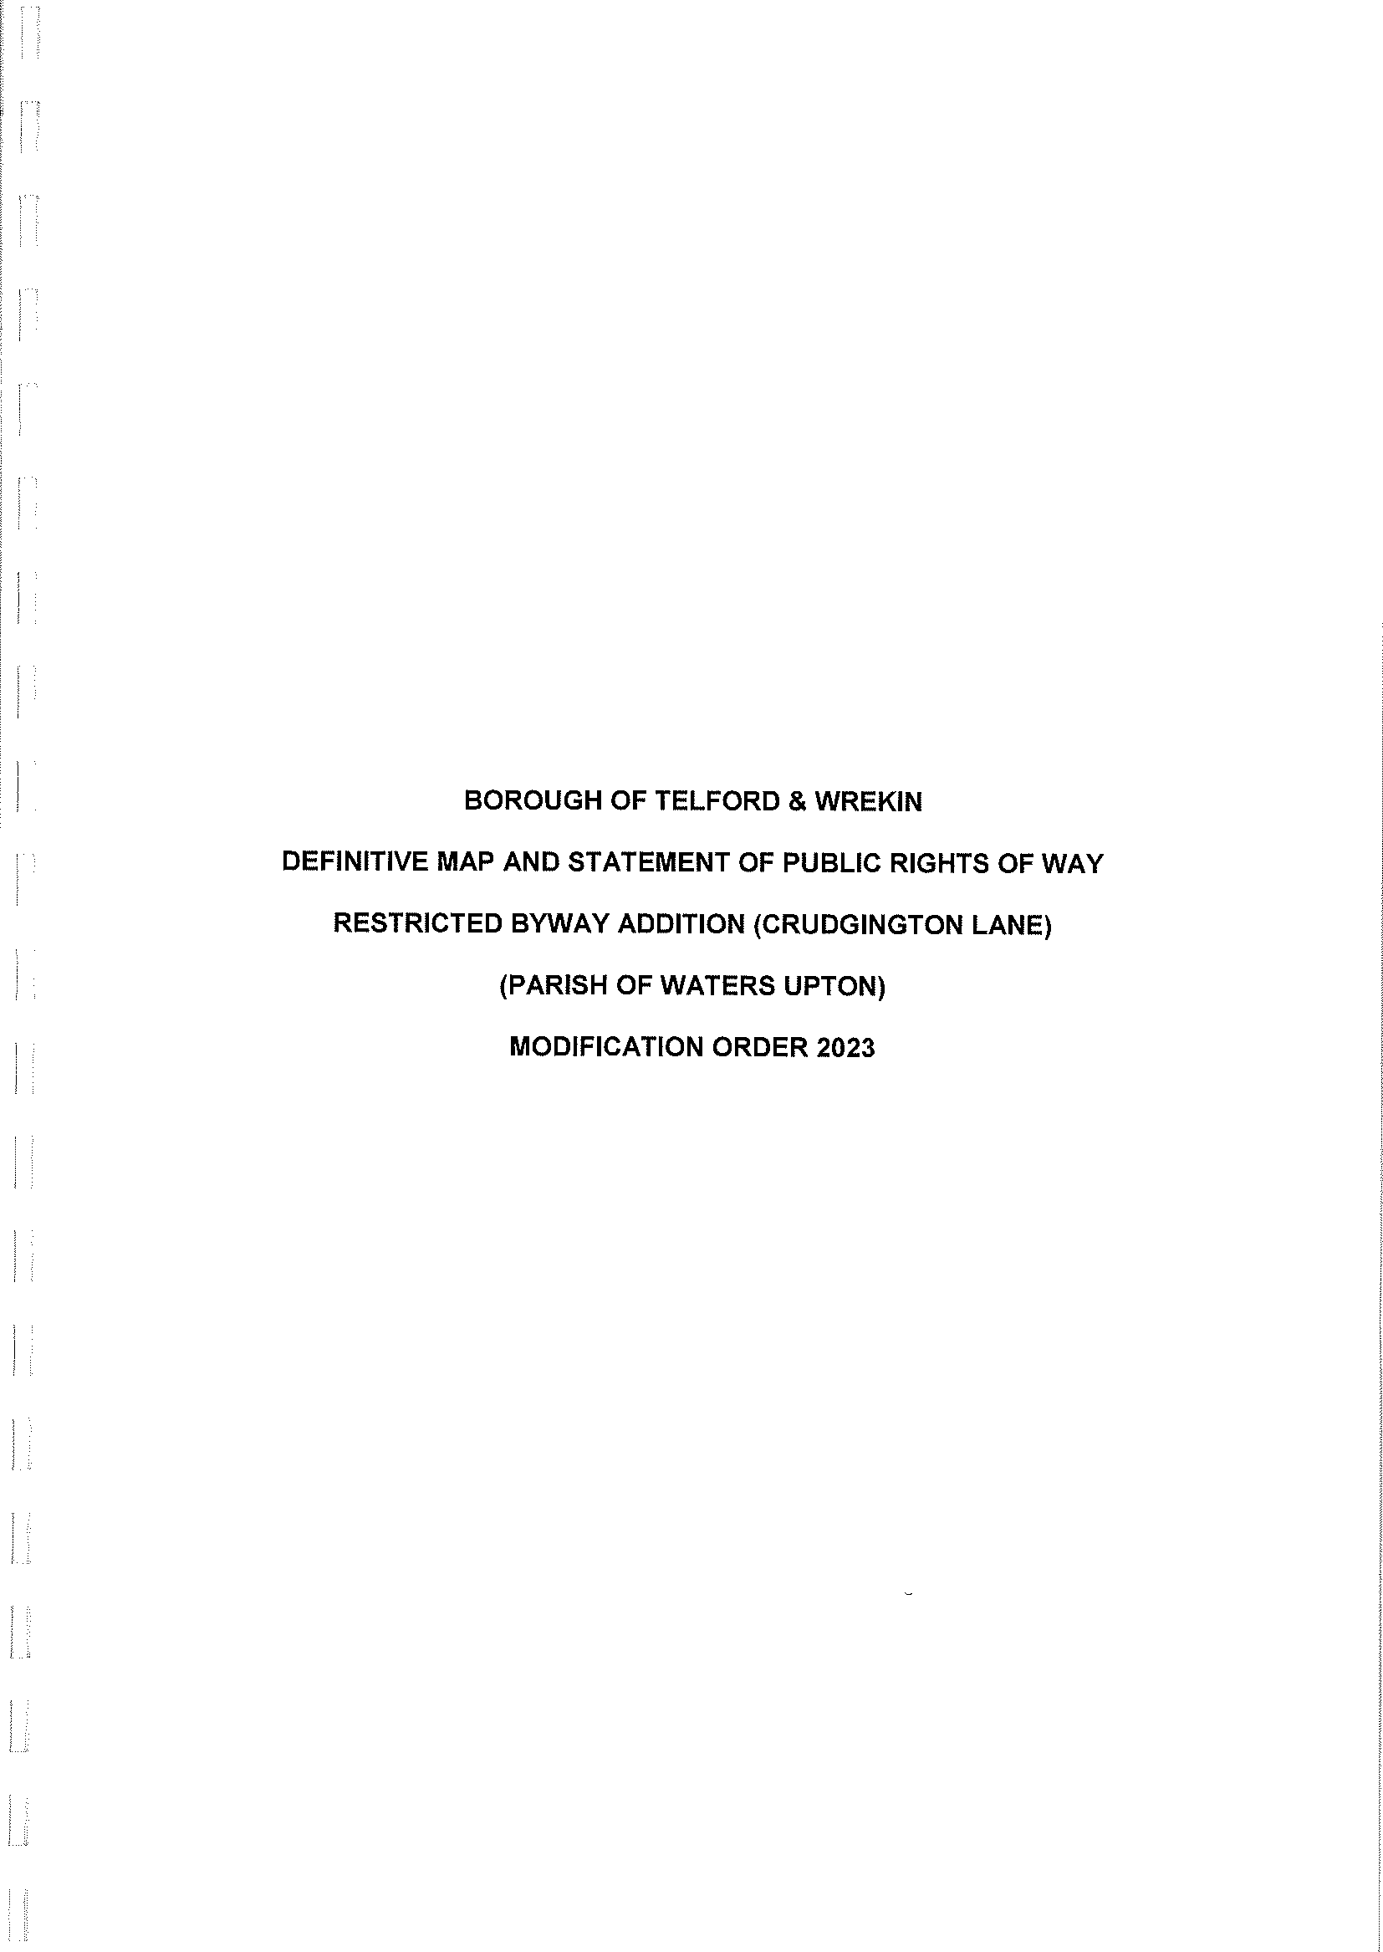
Document Ref 1 A&B


