What NOTICE OF ORDER

Wildlife and Countryside Act 1981 – Section 53
London Borough of Harrow
Definitive Map Modification Order 2024 Alleyway linking Lawrence Crescent and De Havilland Road

Notice is hereby given that the above referenced Order has been submitted to the Secretary of State for Environment, Food and Rural Affairs for determination. An Inspector will be appointed by the Secretary of State to determine the Order.

The start date for the above Order is 24 February 2026

Consideration of the Order will take the form of a public local inquiry.

The Inquiry will be held at 265 The Ridgeway, Harrow HA2 7DA on 28 July 2026 at 10.00am.

The effect of the Order, if confirmed without modifications, will be to modify the Definitive Map and Statement for the area by adding to them: -

UF175 A Footpath commencing side of nos82 De Havilland Road (Point A),
proceeding northwest and ending between nos21 & 23 Lawrence Crescent (Point B); with a width varying from 2.8m – 3.2m as shown on the map and with a centre line length of approximately 41m.

Any queries relating to this Order should be referred to Joanne Reid by email: rightsofway2@planninginspectorate.gov.uk quoting reference number ROW/3364457 on all correspondence. Alternatively, queries may be sent in writing to The Planning Inspectorate, Rights of Way Section, c/o QUADIENT, 69 Buckingham Avenue, Slough SL1 4PN Telephone: 0303 444 5136.

Any person wishing to view the statements of case and other documents relating to this Order may do so online at Definitive Map Modification Orders (DMMO) – London Borough of Harrow. Alternatively, please contact Tony Donetti tony.donetti@harrow.gov.uk Tel: 07927 548339 or Mitesh Joaly Mitesh.Joaly@harrow.gov.uk

Timetable for sending in statements of case and proofs of evidence

Within 8 weeks of the start date by [by 21 April 2026]

The Order Making Authority, or where the Order Making Authority is taking a neutral stance and the applicant or other party are taking the case forward in support of the order, must ensure their statement of case is received by the Secretary of State. As soon as possible after the deadline, the Secretary of State will send a copy (excluding copies of any supporting documents - these will be available to view at the Authority’s offices) to everyone who has made an objection or representation and the applicant and any other person who has written to us in respect of the Order.

Within 14 weeks of the start date [by 2 June 2026]

Everyone who has made an objection or representation and anyone who wishes to give evidence at the Inquiry must ensure their statement of case is received by the Secretary of State. As soon as possible after the deadline, the Secretary of State will send full copies to the Authority. Copies will also be sent to the applicant, every person who has made an objection or representation and any other person who has written to us in respect of the Order (excluding copies of any supporting documents - these will be available to view at the Authority’s offices).

Within the same period the applicant (if applicable) must ensure their statement of case is received by the Secretary of State. As soon as possible after the deadline, the Secretary of State will send a full copy to the Authority. Copies will also be sent to everyone who has made an objection or representation and any other person who has written to us in respect of the Order (excluding copies of any supporting documents - these will be available to view at the Authority’s offices).

4 weeks before the date of the inquiry [by 30 June 2026]

The Authority, everyone who has made an objection or representation, the applicant (if applicable) and anyone who wishes to give evidence at the Inquiry must ensure their proof of evidence (together with any summary) is received by the Secretary of State. As soon as possible after the deadline, the Secretary of State will send copies of:

- the Authority’s proof of evidence to everyone who has made an objection or representation, the applicant and anyone who has submitted a statement of case (including copies of any supporting documents – although none should be submitted with a proof of evidence);

- the applicant’s proof of evidence to the Authority, everyone who has made an objection or representation and anyone else who has submitted a statement of case (including copies of any supporting documents – although none should be submitted with a proof of evidence); and

- all other proofs of evidence to the Authority, the applicant, everyone who has made an objection or representation and anyone else who has submitted a statement of case (including copies of any supporting documents – although none should not be submitted with a proof of evidence).

All parties must keep to the timetable set out above and ensure that statements of case and proofs of evidence are received by the Secretary of State on time. Late documents will be returned.

We cannot accept any inflammatory, discriminatory or abusive comments. Any documents containing such comments will be returned.

If you use Artificial Intelligence (AI) to create or alter any part of your documents, information or data, you should tell us that you have done this when you provide the material to us. See the detailed guidance for further information.

If you would like to make any representations in respect of the Order after the event (whether orally or in writing), please contact the Planning Inspectorate using the details set out below. Any further representations must be made on or before Friday 21st August 2026 or they will not be accepted.

Any queries relating to this Order should be referred to Joanne Reid by email: rightsofway2@planninginspectorate.gov.uk quoting reference number ROW/3364457 on all correspondence. Alternatively, queries may be sent in writing to The Planning Inspectorate, Rights of Way Section, c/o QUADIENT, 69 Buckingham Avenue, Slough SL1 4PN Telephone: 0303 444 5136.

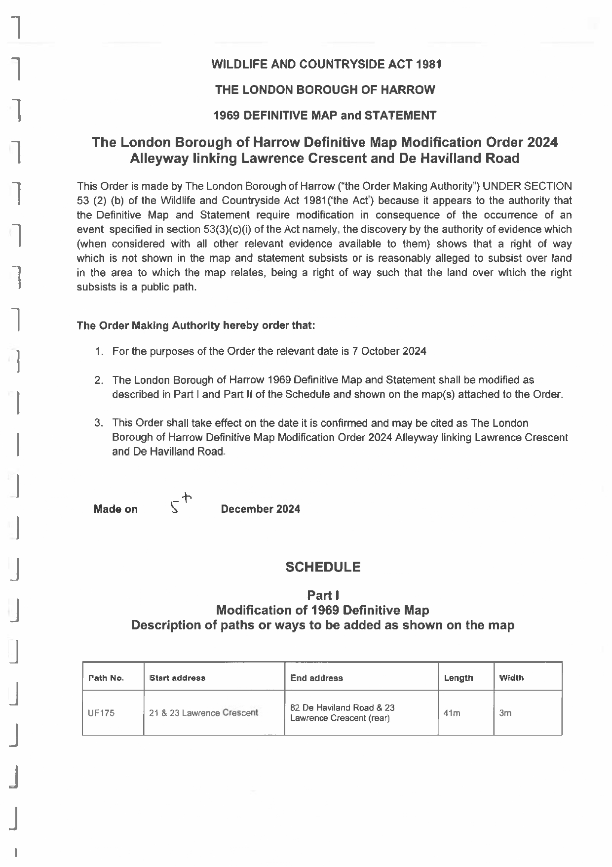

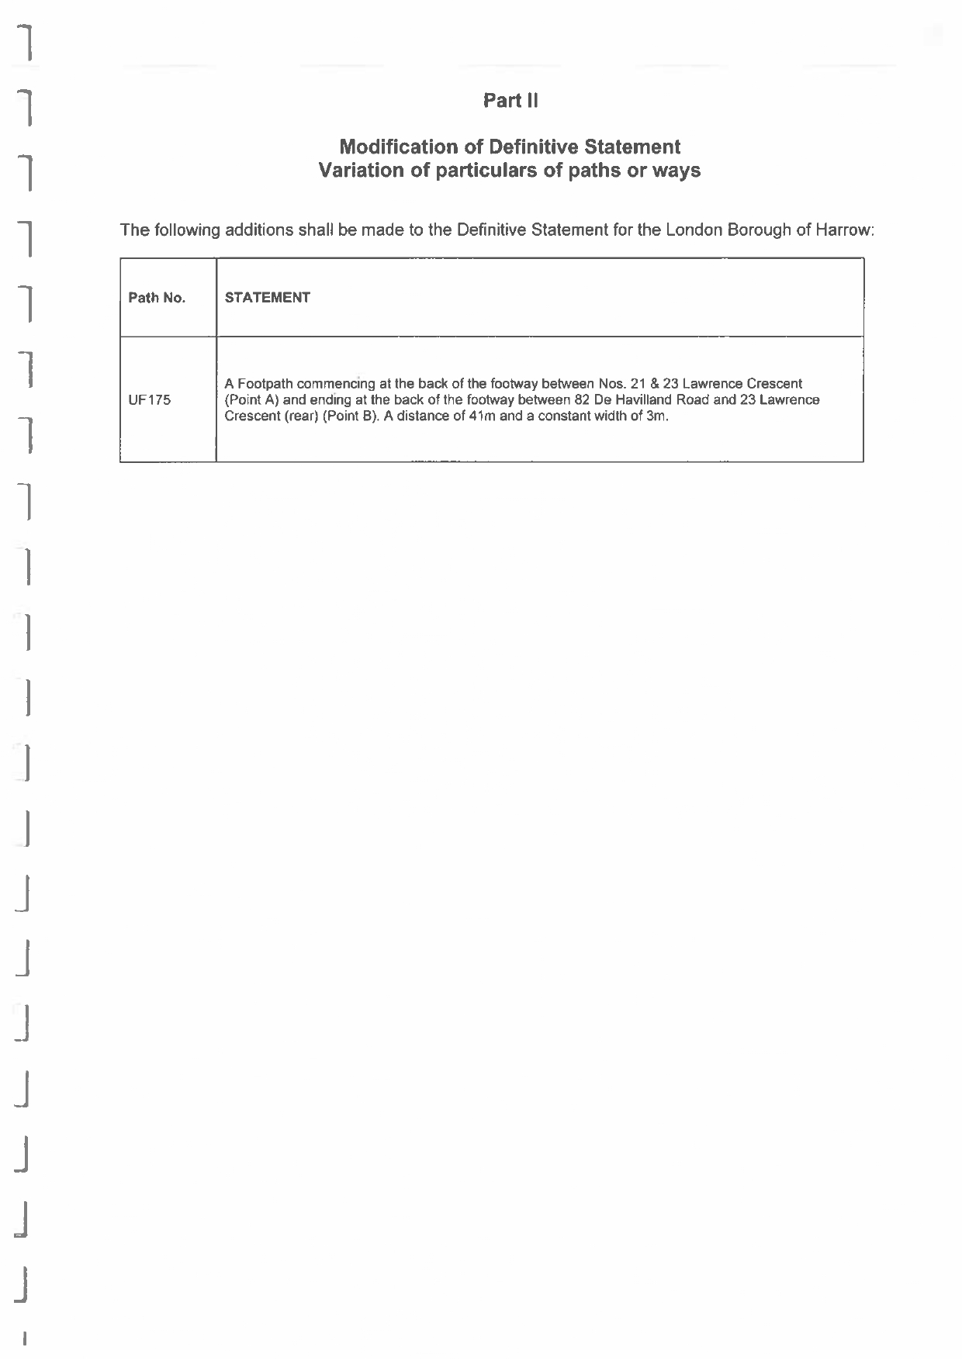

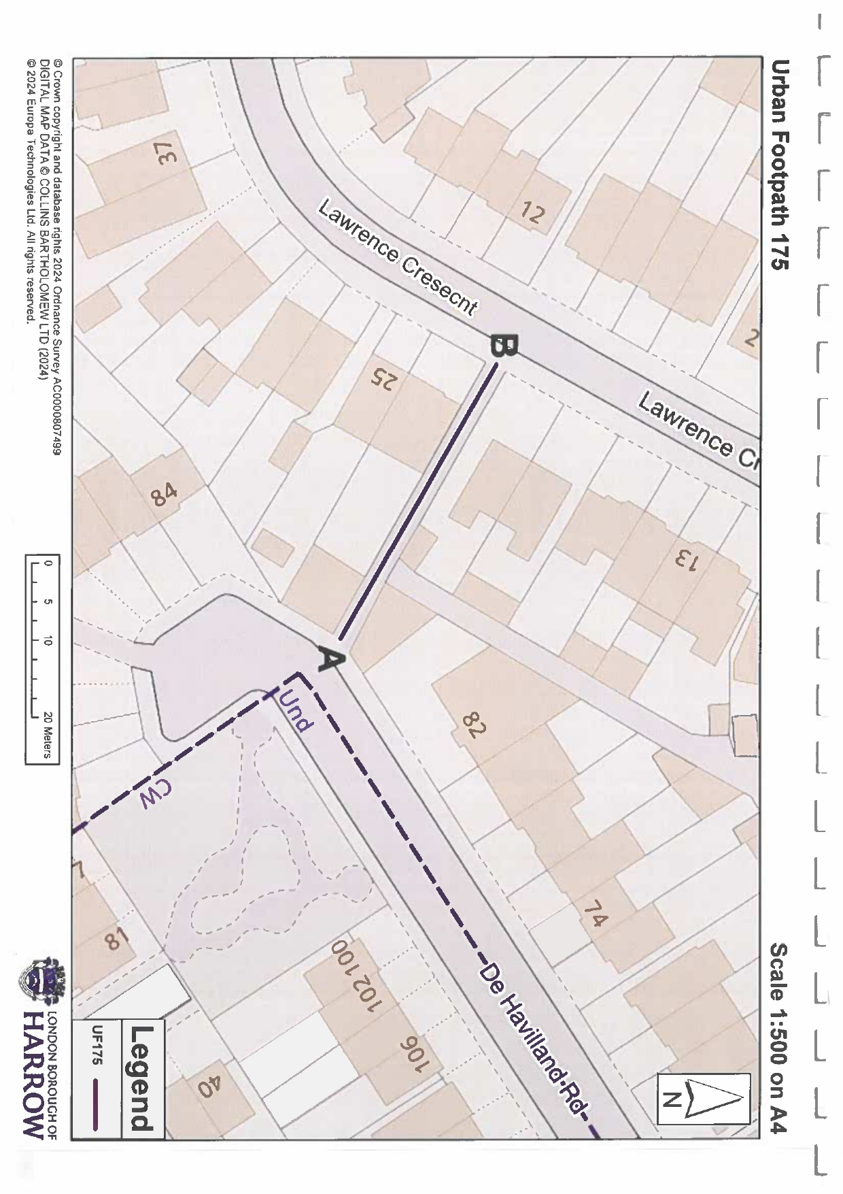

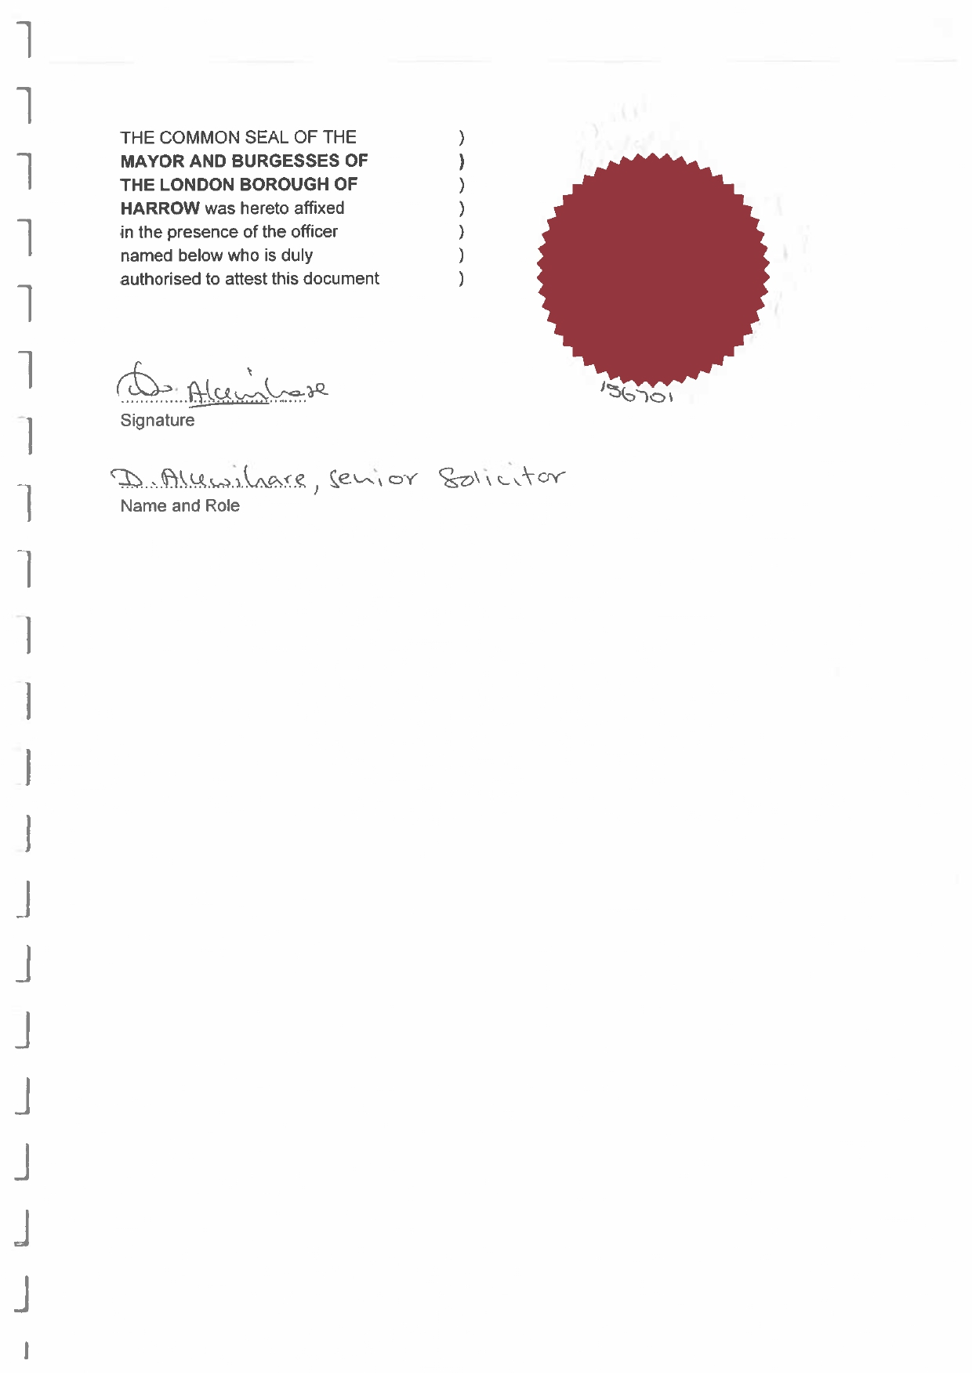

If you wish to make a legal submission, this should be submitted at the same time as your statement of case. Otherwise legal submissions will have to be submitted in writing on the day of the inquiry.

