
Order Decision
Site visit made on 2 June 2026
By Harry Wood BA (Hons) MA PhD MIPROW
an Inspector appointed by the Secretary of State for Environment, Food and Rural Affairs
Decision date: 23 June 2026

Order Reference: ROW/3363834

- This Order is made under Section 53(2)(b) of the Wildlife and Countryside Act 1981 and is known as the Borough of Telford & Wrekin Definitive Map and Statement of Public Rights of Way Footpath 6 Deletion (Parish of Chetwynd Aston and Woodcote) Modification Order 2024.
- The Order is dated 6 June 2024 and proposes to modify the Definitive Map and Statement for the area by deleting a public footpath, as shown on the Order Plan and described in the Order Schedule.
- There were three objections outstanding when Telford & Wrekin Council submitted the Order to the Secretary of State for Environment, Food and Rural Affairs for confirmation.

Summary of Decision: The Order is not confirmed.

Procedural Matters
- I have found it convenient to refer to points marked on the Order Plan and have attached a copy of it to this decision, for reference.
- The Applicant has raised concerns regarding the exact alignment of the Order Route. They have submitted an annotated map described as “Definitive map extract handed to applicant 12.11.2009”. This map shows the Order Route (which is recorded as footpaths 6 and 7) running directly north-east between points A1 and A3, to the west of Pave Lane Storage. The Order Plan, by contrast, records a kink at point A2 and shows the Order Route (now Footpath 6) running through two buildings at Pave Lane Storage. The Order Making Authority (OMA) assert that the Order Plan is an accurate reflection of Footpath 6 as recorded on the Definitive Map, adding that they have previously utilised Ordnance Survey maps at 1:2500 scale “to provide an accurate line” due to the small scale of the 1965 Definitive Map. I have visited the site and there is no clear trace of this section of the Order Route on the ground. While I am satisfied that the Order Plan is broadly accurate, I note that the OMA may wish to engage in further research concerning the exact alignment between point A1 and A3.
- The OMA have taken a neutral stance regarding the confirmation (or otherwise) of the made Order. As this case has been dealt with via written representations, this has had limited bearing on the process.
Main Issues
- The Order has been made under section 53(2)(b) of the Wildlife and Countryside Act 1981 (the 1981 Act) in consequence of the occurrence of an event specified in section 53(3)(c)(iii), namely that there is no public right of way over land shown in the map and statement as a highway of any description. The legal test I am required to deploy is the balance of probability test. This is a stronger test than the reasonably alleged to subsist test to determine if an order should be made.
- When considering cases where the removal of rights from the definitive map and statement (DMS) is proposed by an order, paragraph 4.33 of Defra’s Circular 1.09 advises that “The evidence needed to remove what is shown as a public right from such an authoritative record as the definitive map and statement … will need to fulfil certain stringent requirements." These requirements are:
● the evidence must be new. An order to remove a right of way cannot be founded simply on a re-examination of evidence known at the time the definitive map was surveyed and made;
● the evidence must be of sufficient substance to displace the presumption that the definitive map is correct;
● the evidence must be cogent.
- My decision must also have regard to the judgment in Trevelyan v Secretary of State for the Environment, Transport, and the Regions [2001]. In this judgment Lord Phillips stated as follows:

Where the Secretary of State or an inspector appointed by him has to consider whether a right of way that is marked on a definitive map in fact exists, he must start with an initial presumption that it does. If there were no evidence which made it reasonably arguable that such a right of way existed, it should not have been marked on the map. In the absence of evidence to the contrary, it should be assumed that the proper procedures were followed and thus that such evidence existed. At the end of the day, when all the evidence has been considered, the standard of proof required to justify a finding that no right of way exists is no more than the balance of probabilities. But evidence of some substance must be put into the balance, if it is to outweigh the initial presumption that the right of way exists.
- The DMS is regarded as the conclusive record of the existence of the public rights of way it shows. The deletion of a right of way from this record, therefore, requires sufficient evidence to show that no right of way existed as at the relevant date (meaning the date at which the evidence showed that the public right of way subsisted) of the definitive map on which the way was first shown.
- The OMA have not clarified when the Order Route was first recorded in the relevant DMS or specified a relevant date. They have provided evidence relating to the surveying process in 1954, in addition to the Draft Map (1954), the First Definitive Map (1958), and the review of the DMS in 1965. I have taken 1965 as the relevant date.
- Circular 1.09 also makes clear that it will be for those who contend that there is no right of way to prove that the DMS requires modification due to the discovery of evidence which, when considered with all other relevant evidence, shows that the right of way should be deleted. In other words, it is not for the objectors to prove that the DMS is correct.
- Section 32 of the Highways Act 1980 (the 1980 Act) requires that documentary evidence is taken into consideration “before determining whether a way has or has not been dedicated as a highway”, and that such weight is given to the evidence as “justified by the circumstances, including the antiquity of the tendered document, the status of the person by whom and the purpose for which it was made or compiled, and the custody in which it has been kept and from which it was produced.”

Reasons

Documentary Evidence

Definitive Map Preparation Records
- The OMA have provided various documents relating to the preparation of the DMS between 1954 and 1958 and the subsequent review in 1965.
- The Order Route now runs entirely within Chetwynd Aston and Woodcote Parish, but historically this was split into two separate parishes. The OMA have provided copies of maps prepared by both Chetwynd and Woodcote parishes in 1954, highlighting the routes they claimed as public rights of way. The Chetwynd Aston Map records the eastern section of the Order Route (from point B to south-west of point A2) and numbers it “7”. The Woodcote Map records the western section of the Order Route (from point A to south-west of point A2) and numbers it “6”.
- The OMA have also provided the list of objections to the 1954 Draft Map. Although several objections are logged against claimed routes within both parishes, no objections were received concerning either section of the Order Route.
- The Draft Map (1954) and the First Definitive Map (1958) depict the Order Route in a consistent manner, marked with purple ink and annotated “6” and “7”. The Review Map (1965) records the Order Route in black ink with a pecked line, though it retains the numerical annotations of the earlier maps.
- Based on the documents before me, I can see no evidence to suggest a mistake was made in recording the Order Route in the DMS. It is of some significance that two separate parishes claimed the Route as a public footpath. Though I have not seen detailed records of the surveys, they are likely to have been distinct parish-led processes. Both reached the same conclusion that the Order Route should be recorded as a public footpath.

Tithe Records
- Tithe maps officially recorded the boundaries of all tithe areas on which tithe rent-charge was apportioned. Their purpose was not to identify highways.
- The Applicant has provided a sketched copy of the 1842 Chetwynd Aston Tithe Map, dated November 1991. This Map appears to have been taken from a book entitled The History of Limestone Mining at Church Aston and Lilleshall by David Adams. The Map records part of the Donnington Wood Canal, which terminated at Pave Lane and along the historical line of which the Order Route is said to run. The sketch includes various annotations such as “Canal Wharf & Buildings”. The OMA emphasise that the Map “does not show the route as being public”.
- While I accept that the Order Route is not clearly shown on this Map, recording public rights of way was not the purpose of these documents. I also note that the Map is a relatively modern copy of the original tithe record, a fact that reduces its evidential value.

Ordnance Survey Maps
- The Applicant has submitted a scan of the OS Third Edition County Series 25 Inch Map. This also appears to have been taken from The History of Limestone Mining and, like the Tithe Map, includes various annotations.
- A way bearing close resemblance to the Order Route is recorded on the Map. The eastern section is represented by a single pecked line, which the OS mark as “F.P.” and “Footpath”. This changes at the point annotated “Stoplock” to parallel solid lines on the northern side of the canal and runs as far as the bridge on Pitchcroft Lane (point A).
- The Applicant contends that the footpath recorded on the Map terminates at the coal and limestone wharves (which were sited to the south of the “Old Limekilns”) in a manner “indicating they existed for trade purposes”. However, as suggested above, a route does appear to continue further westwards.
- While OS maps often provide useful evidence as to the physical characteristics of a route, they tend not to provide direct evidence of status. In this instance, the OS Map suggests that a way on the approximate alignment of the Order Route existed on the ground in 1926, and that the surveyor considered the eastern section to have the physical characteristics of a footpath.

Photographs
- The Applicant has submitted two black and white photographs. They are described as Plate 3 and Plate 4 in accompanying subtitles and appear to have been taken from The History of Limestone Mining.
- The first photograph is dated 1968 and shows a large spoil heap. The subtitle explains that “the canal basin was to the left and the remains of the kilns hidden in the bushes to the right”.
- The second photograph, also dated 1968, shows the site of the canal terminus at Pave Lane. Several buildings are identified, including the former weigh house, and it is explained that the area “now forms part of the Pave Lane Farm complex”.
- The OMA assert that “spoil and dilapidated buildings following the cessation of works and the closure of the canal” indicate that “the area would not have been available as [a] public right of way”. While this argument is not without foundation, I am not satisfied that these photographs offer evidence to this effect. The photographs were taken some years after the closure of the canal, and it is not clear whether either image include sections of the Order Route.

Guided Walk Map and Field Guide
- The Applicant has submitted a guided walk map entitled “Walk One” and accompanying “Field Guide”. This also appears to have been taken from The History of Limestone Mining. The author explains that the Field Guide was conceived to help orientate walkers around the “accessible industrial remains”.
- Walk One runs parallel to the Order Route along Pitchcroft Lane, meeting it at Point A (described in the Map as “1st Bridge”) before continuing to the north west. The Field Guide provides a detailed description of various features relating to the Donnington Wood Canal, including the terminal basin (near point B), the stop lock and stone wharfage. The Guide also draws attention to the garden of Meadowcroft (east of point A), explaining that “the canal passed under the ornamental wooden bridge which can be seen from the drive entrance”. I was unable to identify this feature on my site visit, but I was able to view a short section of the former canal and towpath (immediately east of point A).
- The Applicant highlights that the author of The History of Limestone Mining “had a profound insight into the area round Pave Lane” and “made no reference to a right of way to the Canal’s first bridge [point A]”. I accept that this absence suggests that the Order Route did not have a reputation locally as a public right of way at the point this book was published (1991). However, it does not seem to be in dispute that the Order Route has been unavailable to the public for many years, despite being recorded in the DMS. There would be little purpose in referring to an unavailable public right of way as part of a guided walk description.
- The Applicant argues that the towpath that ran adjacent to the canal “was for employees, horses, and handlers”, and that there “were no ‘rights’ in these times for public use”. Although public rights of way and rights of towage are distinct rights, a towpath is capable of being dedicated as a public right of way. The fact that all or part of the Order Route was once a towpath does not mean it cannot be a public footpath.

Conclusions on Documentary Evidence
- I am satisfied that the Applicant has provided new evidence (notably The History of Limestone Mining) that would not have been available during the DMS surveying and drafting process. I am also satisfied that the OMA and Applicant’s framing of this evidence is cogent, in as much as they have put forward reasonable arguments concerning the nature and physical characteristics of the location. I am not satisfied, however, that the evidence provided is of sufficient substance to show that the Order Route should be deleted. There is no evidence before me indicative of a mistake having been made during the DMS preparation process. I have also seen no evidence pointing to the Order Route being incapable of carrying public footpath rights.
- Having regard to these and all other matters raised in the written representations I have concluded that the Order should not be confirmed.

Other Matters
- The Applicant and the objectors have raised several arguments in their representations that I have not considered above, including the perceived convenience and efficiency (or lack thereof) of using the Order Route in comparison to Pitchcroft Lane, the length of the Order Route in the context of the canal’s full extent, as well as concerns regarding safety, business interests, and historical value. While these concerns are understandable, they cannot influence the issue of whether or not public footpath rights exist over the Order Route.

Formal Decision
- I do not confirm the Order.

Harry Wood

INSPECTOR

Order Plan (not to scale)

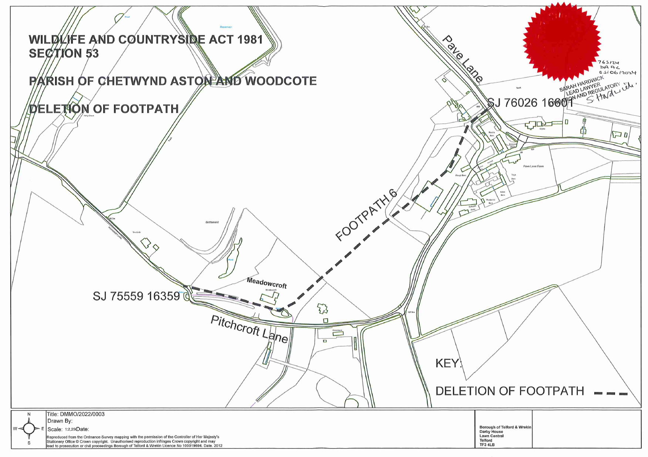
A3
A2
A1
B
A

