Annex A - Security and Research Security Questionnaire for Grant Recipients

Please answer as honestly as possible. Your responses will not affect your eligibility for the funding scheme you have applied for.

Your answers will be used to baseline the delivery of any assistance the UKSA can give you to grow your business securely and resiliently.

COMPANY NAME
CONTACT DETAILS
GRANT SCHEME

Governance
Please indicate
YES | NO | Evidence / Comment | QUESTION
 |  |  | Do you have an ongoing process in place to assess, document and understand your security risks in relation to this project?
 |  |  | Do you have a security policy in place which includes processes and procedures?
 |  |  | Do you have specifically assigned staff with security roles?
 |  |  | Do you have a policy which addresses security risks within your supply chain, 3rd party services such as Cloud and MSP’s, or any other organisations that has access to the company’s systems or data?
 |  |  | Do you have a policy in place to provide regular security related reporting to seniors within your organisation?
 |  |  | Is there board-level support and regular reviews of security in meetings with the board or senior leadership team?
 |  |  | Has a named individual been assigned responsibility for managing security and resilience risks associated with this project?

Foreign Ownership, Control and Influence (FOCI)
Please indicate
YES | NO | Evidence / Comment | QUESTION
 |  |  | Does your organisation have any foreign ownership, investment, controlling interests or parent company relationships outside the UK?
 |  |  | Does any individual, organisation or government outside the UK have the ability to direct, influence or veto decisions relating to this project?
 |  |  | Have you assessed the national security risks associated with foreign investment, overseas partnerships or international collaboration relating to this project?
 |  |  | Will any project information, intellectual property, data or technology be shared with overseas organisations or individuals?
 |  |  | Are you aware of any export control, sanctions, or technology transfer restrictions that may apply to this project?
 |  |  | Do you have a process for reporting and managing concerns regarding foreign influence, unwanted technology transfer or suspicious approaches?

Security culture and awareness
Please indicate
YES | NO | QUESTION
 |  | Do you have a policy for employees and contractors defining their responsibilities for information security?
 |  | Do all employees and contractors receive information security training?
 |  | Do you have an asset register that includes a list of all hardware devices and software that you use?
 |  | Do you undertake regular off-line back-up of systems?
 |  | Do you have response and recovery plans in place covering all of the security risks to your corporate and space activity/systems?

Insider Risk and Personnel Security
Please indicate
YES | NO | Evidence / Comment | QUESTION
 |  |  | Are staff, contractors and consultants provided with security briefings appropriate to their role and access level?
 |  |  | Are privileged users and administrators subject to additional oversight or monitoring?
 |  |  | Do you have a process for reporting suspicious behaviour, security concerns or insider threat indicators?
 |  |  | Are access rights reviewed regularly and removed promptly when staff leave the organisation or no longer require access?
 |  |  | Do you have a process in place to verify credentials for all staff prior to employment and security vetting for employees working on this project?
 |  |  | Do you have procedures to protect project information from accidental disclosure, insider misuse or unauthorised removal?
 |  |  | Have staff been made aware of the risks associated with social engineering, coercion, recruitment approaches and hostile state activity?

Cyber security
Please indicate
YES | NO | Evidence / Comment | QUESTION
 |  |  | Does your company currently hold any cyber security certification (e.g. Cyber Essentials, Cyber Essentials Plus, IASME or ISO 27001)?
 |  |  | Do you have a policy in place regarding the use of removable media, unauthorised and authorised software?
 |  |  | Do you have a policy and process in place covering the creation of new user and administrator accounts?
 |  |  | Do you have a policy in place regarding minimum requirements and confidentiality of passwords?
 |  |  | Is there a process in place for administration access over secure protocols, using multi-factor authentication?
 |  |  | Is a policy in place to control remote access to networks and systems?
 |  |  | Is a process in place to authenticate wireless connections?
 |  |  | Are application firewalls in place between corporate and space-related activity with processes in place to verify and validate traffic?
 |  |  | Is there a policy in place to monitor network behaviour and review computer security event logs for indications of potential incidents?
 |  |  | Is there a policy or process in place to undertake mitigation activity in response to an attempted cyber attack?
 |  |  | Is there a policy in place regarding the maintenance of patching and the ability to assess patching performance against this policy?

Physical security
Please indicate
YES | NO | Evidence / Comment | QUESTION
 |  |  | Are physical security measures in place to prevent unauthorised access to facilities, laboratories, control rooms or project areas?
 |  |  | Do you have controls in place to prevent unauthorised access to your facilities and assets?
 |  |  | Is access to sensitive areas controlled through keys, access cards or other access control measures?
 |  |  | Are visitors, contractors and delivery personnel managed and supervised when accessing sensitive areas?
 |  |  | Are physical security incidents reported, recorded and investigated?
 |  |  | Are critical assets, equipment and project materials protected against theft, damage or tampering?
 |  |  | Are facilities protected by appropriate detection, alarm or surveillance measures where justified by risk?

Research Security and High-Risk Projects
Please indicate
YES | NO | Evidence / Comment | QUESTION
 |  |  | Does this project involve technologies that could have military, dual-use, national security or strategic applications or critical national infrastructure applications?
 |  |  | Has the organisation assessed the risks of intellectual property theft, espionage or unauthorised technology transfer associated with this project?
 |  |  | Is a named individual responsible for managing security and research security risks associated with the project?

Annex B – Resilience Direct (RD)
Access to ResilienceDirect may be requested by UKSA for organisations participating in security and resilience information-sharing activities.
- To create an account on ResilienceDirect please navigate to https://www.resilience.gov.uk

- Choose the Collaborate icon from the services displayed which will take you to the registration page.

- Select “Register” and follow the on-screen instructions.
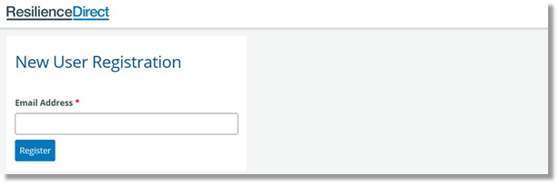
Please note: when registering for an RD account contact MUST be via an official company email address. Due to the sensitivity of content private/personal emails cannot be used.

4a. On the right-hand side of the page, you will notice the 'Select Group' field.
The Group is UK Space Agency RD Lite.

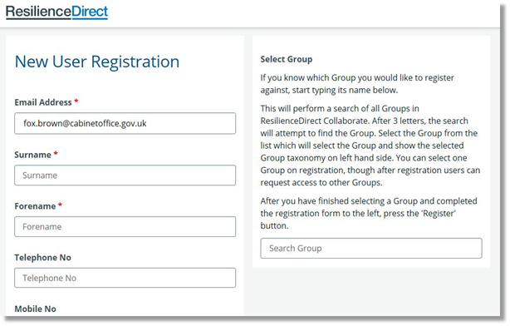

Complete your contact detail information, read the ‘End User Agreement’ and check the box to accept it.
Select ‘Register’.
Once you have created your account an email will be sent to your organisation Administrator asking them to confirm that you belong to that organisation. Once confirmed the RD Support Desk will finalise your profile, after which your login credentials will be generated and sent to you.

4b. If your organisation does not have an existing presence on RD, send a request to join the UK Space Agency RD Lite site to support@resilience.gov.uk. In these cases, the UK Space Agency will be asked to sponsor your membership of RD.

Once you have access to RD you will be able to:
- Login [note: details are Case Sensitive so ensure you enter the details as supplied to you]
- Click ‘collaborate’ on the dashboard
- Search for ‘UK Space Agency’ and request access (this is a one-off request which will come direct to the UKSA Space Security & Resilience Team). (You may not need to undertake this step if access has been granted via step 4b above)
- Edit your profile - Click on your name (top right) and on the dropdown list click edit your profile. Update this with as much info as possible. This will make it easier to find right people for the right things. Ensure you scroll to the bottom of the page to SAVE CHANGES.

