
Step by step guide to completing the DCO2 (non-fastrak) claim form
Claims for costs must be submitted on a DCO2 claim form for:
- Costs in excess of £2000 incurred in the Magistrates Court
- Costs incurred following a successful appeal to the Crown Court
- Costs incurred in the Crown Court

You should download the most up to date version of the claim form (DCO2) from the gov.uk website:
https://assets.publishing.service.gov.uk/media/66c356c7b75776507ecdf3f3/DCO2_-_Non_Fastrak_Claims_v2.53_Aug_2024.xlsx
Top tip
Always download a fresh form for each claim. Using an out of date form or overtyping may cause an error and result in your claim being rejected

Once downloaded, it is recommended that you name the file as using the following format:
- Defendant’s name followed by the case number
Please do not remove lines of information on the claim form. If work claimed has not been entered in date order then this can be rectified once the claim is received. If you do enter a row in error please highlight the relevant cells and use the ‘clear contents’ function to remove the data if you are copying and pasting into the form, please use the ‘paste values’ function.
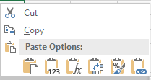

Your claim, and the Defendant’s Costs Order must be submitted via email to dco@justice.gov.uk.

CLAIM DETAILS
Step 1
Using the drop-down list choose the method used for the supplying of attendance notes.
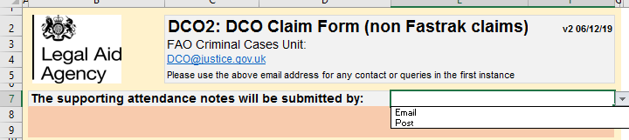
Your claim and papers should be submitted via email as separate attachments as follows:
- DCO2 claim form
- Defendant’s Costs Order
- Attendance notes, telephone notes and correspondence, invoices and receipts, expert reports, indictment/charge sheet, case summary, counsel’s fee note and work log (where appropriate)
If the total attachments exceed 10mb then please send attendance notes and any other supporting documents via a separate email.
Before sending supporting documents by post please submit your claim (DCO2) via e-mail and await further instructions.
Please note that documents are submitted electronically will not be returned. If a paper file is submitted it will be returned within 14 days of the determination.
Top tip
Please ensure that you provide both pages of the Defendant’s Cost Order including details of any offences to which it relates

Step 2
Enter you details of the instructed solicitor along with the case and defendant information. Select whether you are claiming London rates
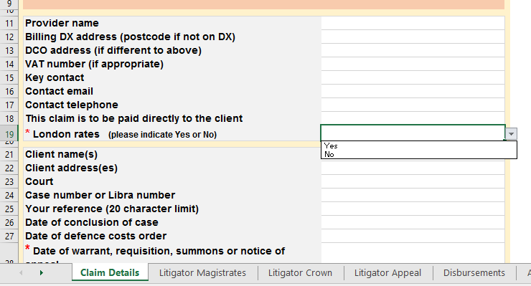

Step 3
Move onto the essential supporting documents section of the form.
You must state the reasons for not providing any of the essential documents.
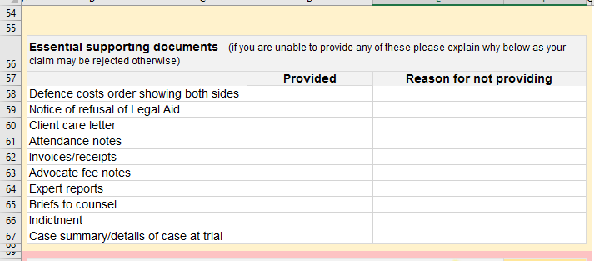
Step 4
You must ‘sign’ the declaration by selecting yes. Unsigned claims will be rejected and returned
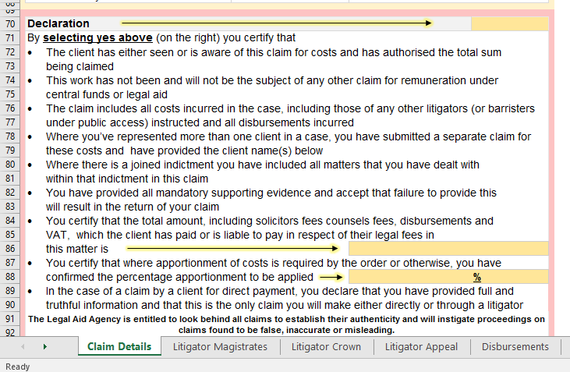

Step 5
You must declare the total costs that the defendant is liable to pay under the terms of the retainer.
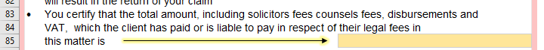

Step 6
Where a defendant has been convicted/pleaded guilty to any part of the charges the Criminal Cases Unit cannot determine any claim unless the court has indicated the percentage of costs to be allowed (partial acquittal). If the Court has ordered costs to be apportioned you must confirm the percentage of costs to be allowed.
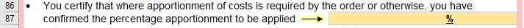
Top tip
Where the DCO does not confirm the percentage of costs to be allowed your claim will be returned and you will need to seek a further order from the Court.

Step 7
Complete the Fee Earners information including the full name, initials and grade of fee earner using the drop-down list.
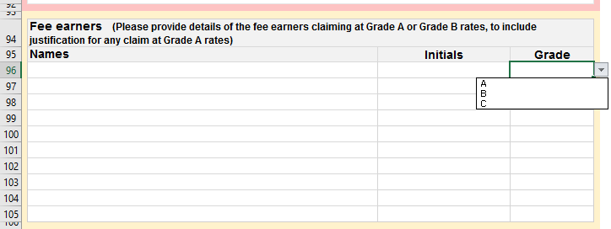
Top tip
If you are claiming a grade of fee earner based on previous experience you should provide supporting information, otherwise your claim may be allowed at a lower rate.

If you have instructed an advocate/counsel who is not an employee of your firm their costs must be claimed under advocate fees and a copy of their fee note and work log enclosed.
Step 7
You should provide details of the case and any relevant supporting information to assist the Case Manager in assessing your claim.
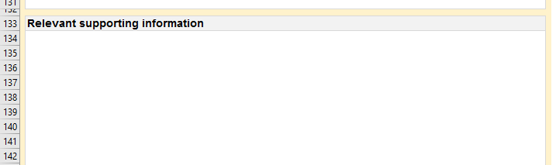
Top tip
Include any information that may not be apparent from the case papers that you wish to be considered on determination

Step 8
If you are claiming rates in excess of the prescribed rate you should provide supporting evidence/information either in an accompanying note for taxation or in the box provided
The prescribed rate may be exceeded in cases where:
- the work was done with exceptional competence, skill or expertise; or
- the work was done with exceptional dispatch; or
- the case involved exceptional circumstances or complexity.

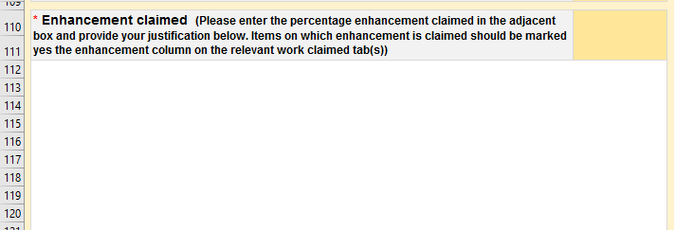
Top tip
If you are claiming enhanced rates and do not provide information in support your claim will be allowed at the prescribed rate only

Litigator Claim
Magistrates and Crown Court
Enter the details of the work claimed and fee earner using the drop-down box. Any additional clarification of the preparation undertaken should be provided in the supporting information box (see step 7 above).
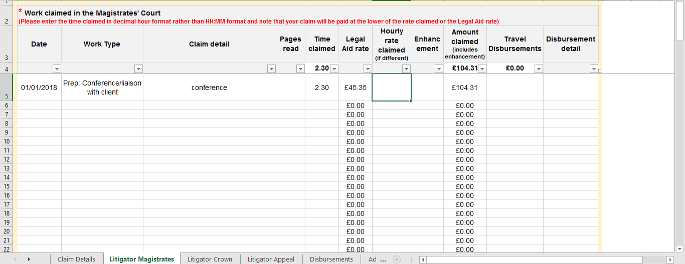

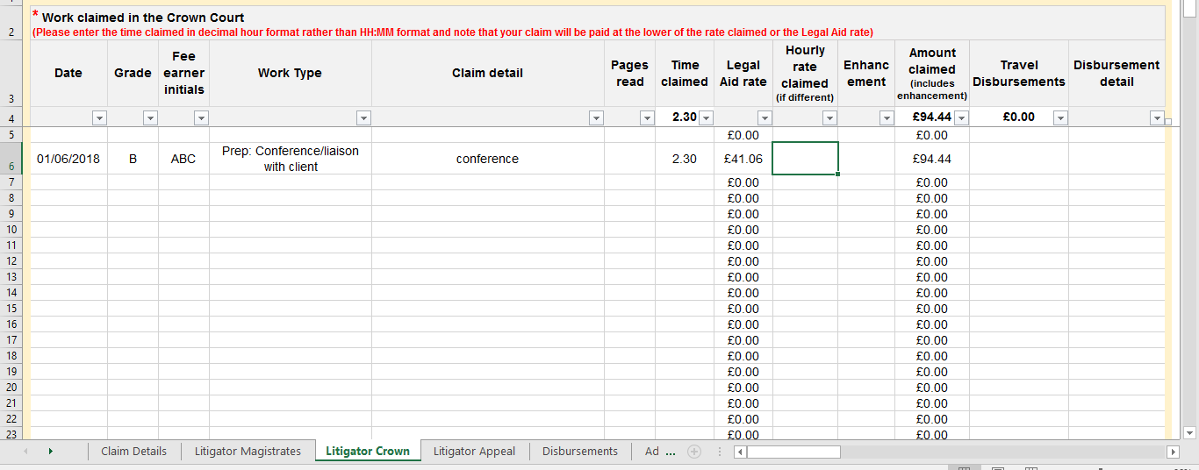
Top tip
Time must be entered as a digital, e.g.: 1hour 18m = 1.3. Entering time in the wrong format may result in your claim being underpaid.

NB: A decimal time converter can be found at the final tab on the claim form
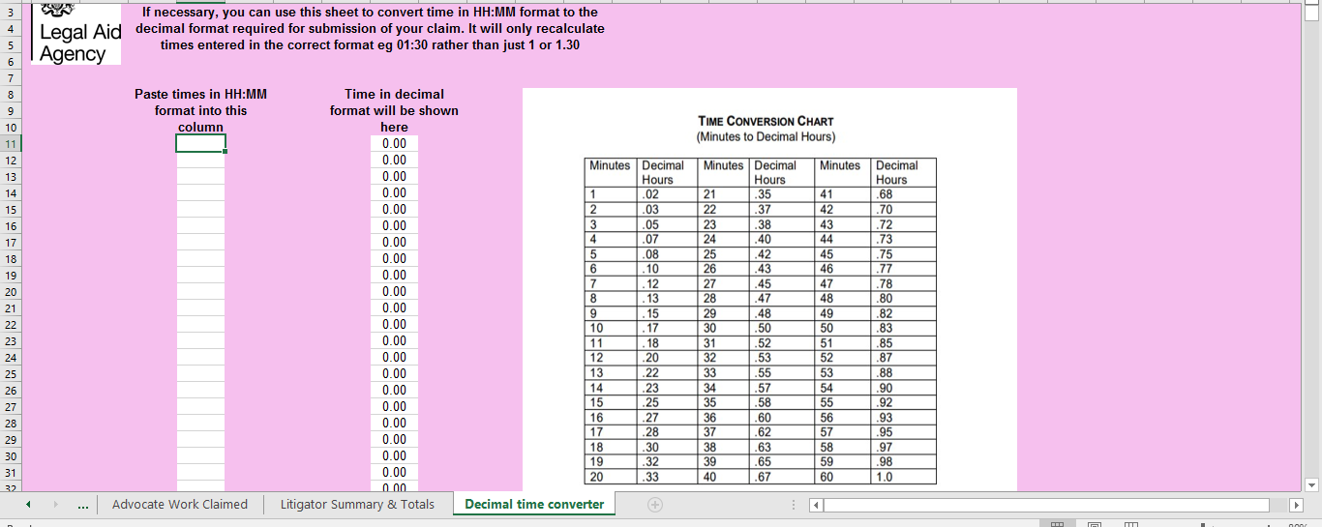
Appeal
Costs in relation to an Appeal to the Crown Court must be claimed separately
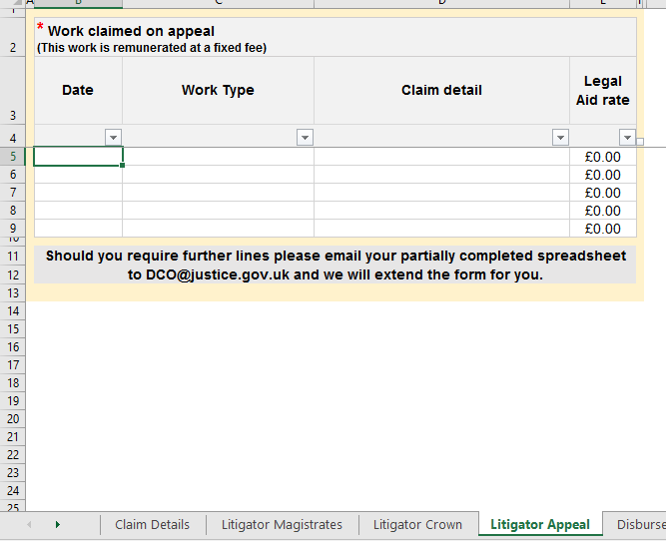
Top tip
There is no provision under the Regulations to exceed the fixed fee payable for litigators’ costs on Appeal

Disbursements:
Disbursements for travel expenses must be claimed as part of travel in “work claimed”.
Any disbursement in excess of £20 must be accompanied by an invoice or receipt.

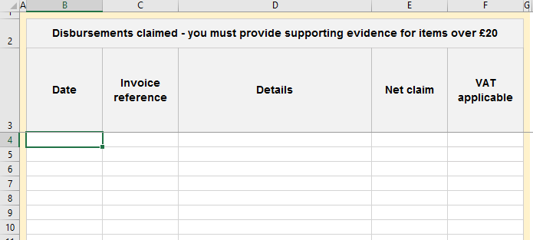
Advocate fees
Claims for advocate fees must be accompanied by a copy of the appropriate fee note and work log.
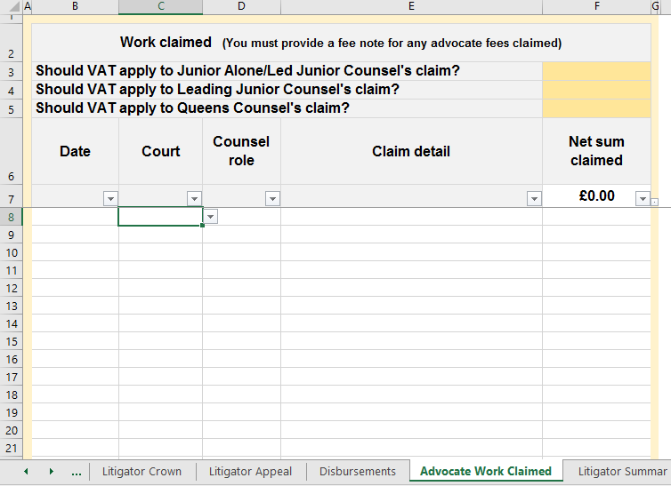
Top tip
Whilst there is provision under the Regulations to exceed the fixed fees payable to advocates you must provide evidence and/or information in support of your claim. If information is not provided your claim will be allowed at the prescribed rate only

Top tip
If you are claiming for costs of more than one advocate of the same status but they are not all VAT registered you should claim the non-VAT registered advocate under disbursements.

If the form does not contain sufficient lines for your claim, please contact the CCU and we will send you an appropriate form. In order for us to add additional lines please enclose your partially completed claim for with any request.
Routine Correspondence
Enter the number of routine items of correspondence claimed. This should include telephone calls made and received, emails and letters sent. Routine emails and letters received are not remunerated separately.
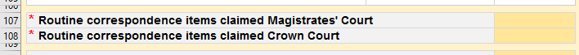

Please note that the ‘summary of claim’ does not populate until you have entered all of the claim details.
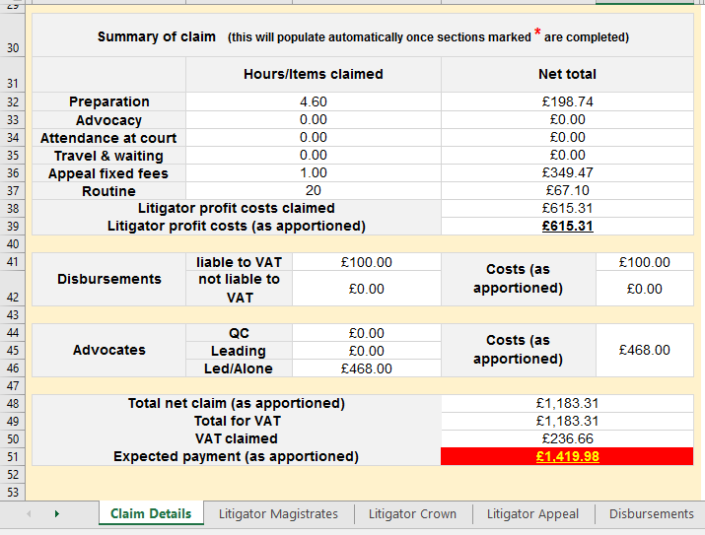
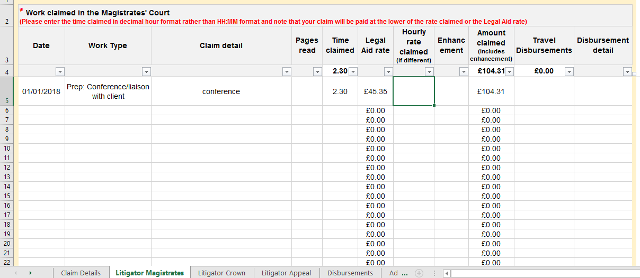
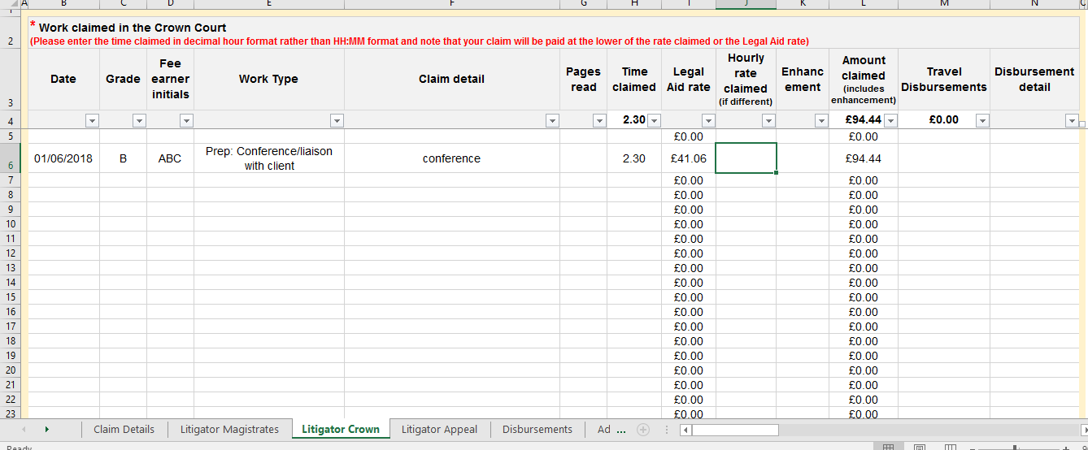
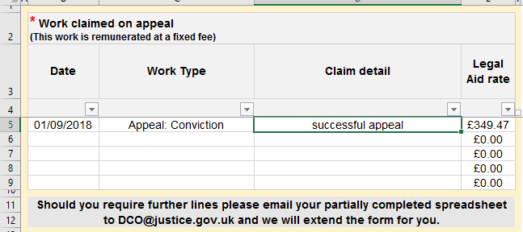
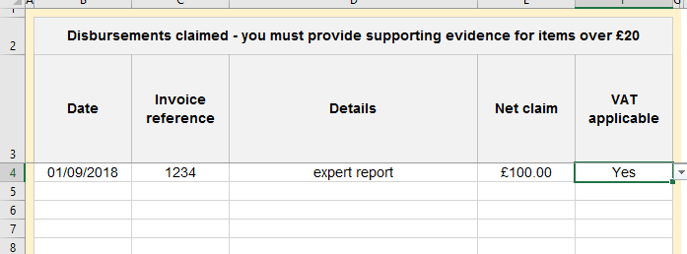
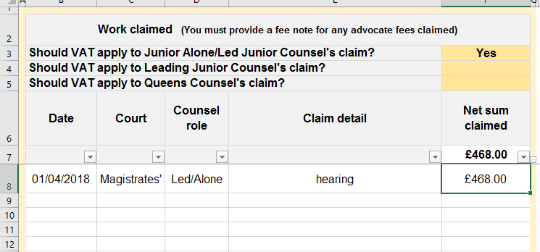
Top tip: Summary of claim does not populate correctly check –
- A fresh form has been downloaded;
- all the mandatory information (*) entered
- you have selected ‘London rates’ yes/no
- an hourly rate claimed for all work.
- Counsel’s vat details has been completed

Once you have completed your claim you must ensure that the declaration has been completed.
Your claim and accompanying documents should be emailed to dco@justice.gov.uk
If you are submitting your claim and documents in more than one email, please mark as such in the subject heading, i.e.: DCO2 claim John Smith 1 of 2
On receipt your claim will be allocated a unique reference number which should be quoted whenever you contact us.
We aim to determine all claims within 20 days of receipt.
Once your claim has been determined, if three or more reductions have been made on determination, a copy of your DCO2 will be sent to the email address provided on the claim form. Details of the determination can be found on the claim details page and/or under work claimed, disbursements and advocate fees (example below).
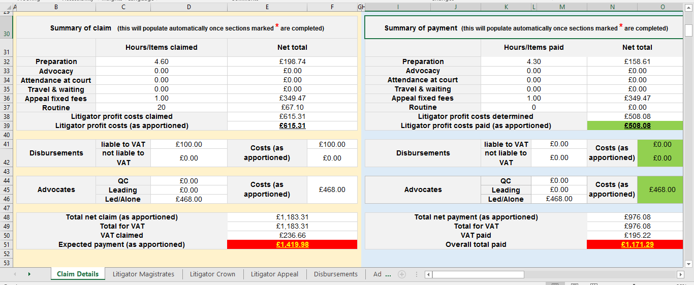
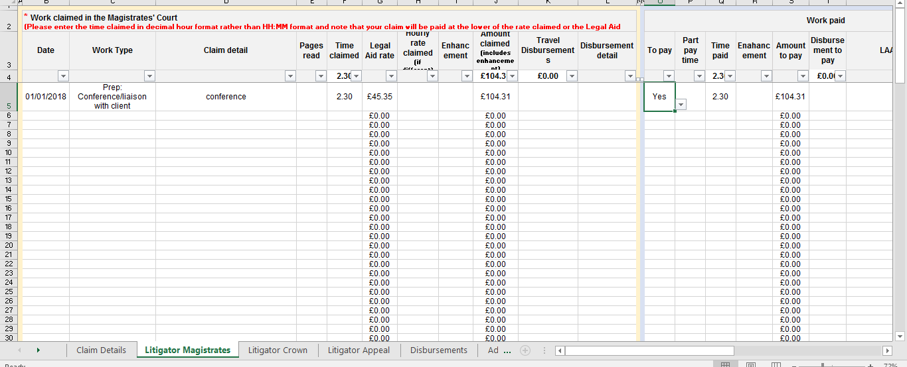

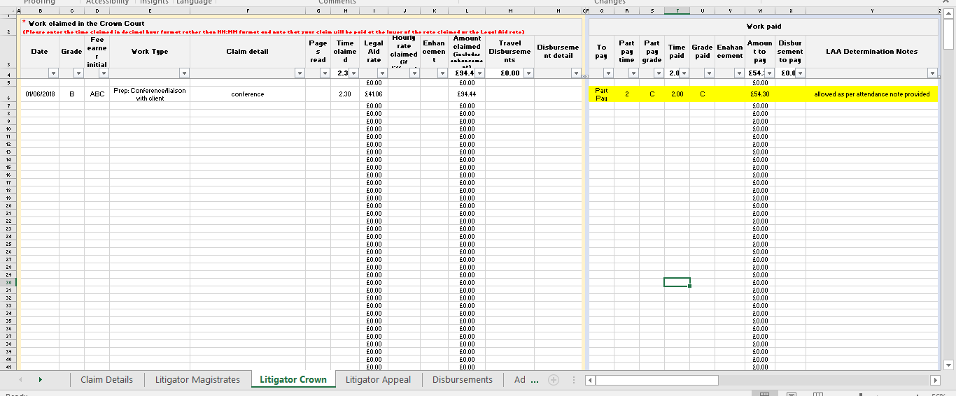
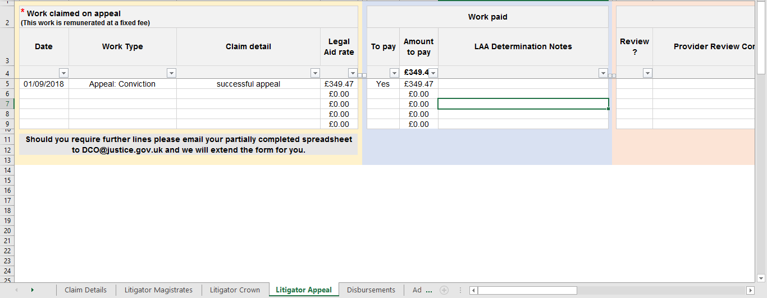
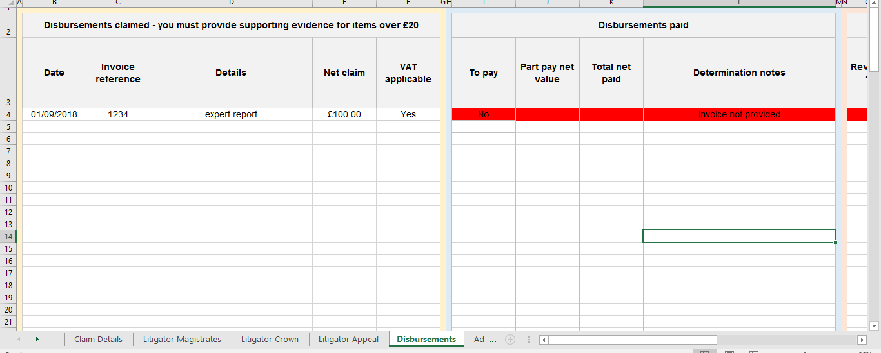
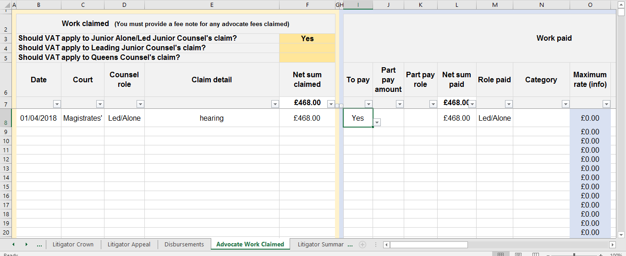
If you are dissatisfied with the determination you may request a review within 21 days of receipt of the notification of determination.
If you are dissatisfied with the costs allowed:
Requests for review should be sent to dco@justice.gov.uk quoting the unique reference number.
Any request for review must be made within 21 days of determination.

A request for review may be made using your original claim form or via email alone. You must set out on which items a review is requested, include any information you wish the case manager to consider and attach any relevant attendance notes or copies of correspondence.
Requesting a review using DCO2:
Using the drop-down list, indicate in column ‘AB’ which items you wish to be reviewed.
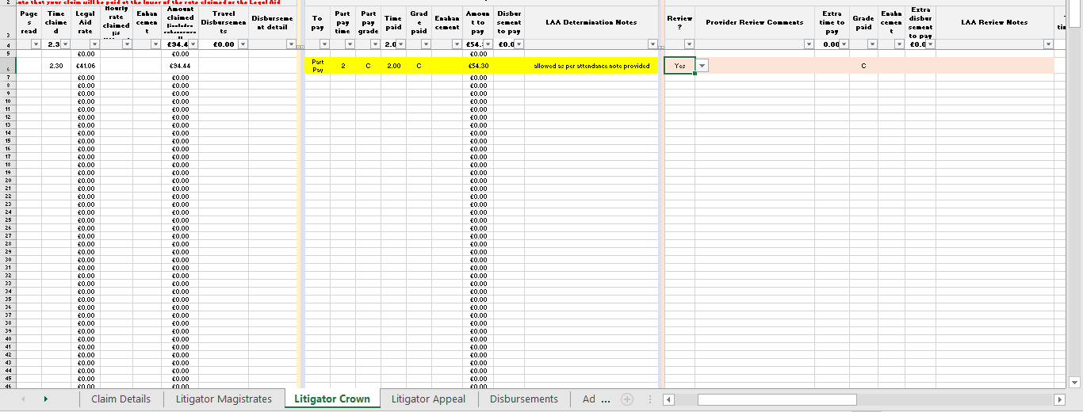
You should provide detailed submissions on each item you wish to be reviewed in your accompanying letter/email or on the claim form.
Once your claim has been reviewed a copy of your claim form will be returned detailing any additional amount to be paid. Further clarification setting out the reasons behind any decision will be sent either via letter/email or, if an additional payment is made via the payment notification.
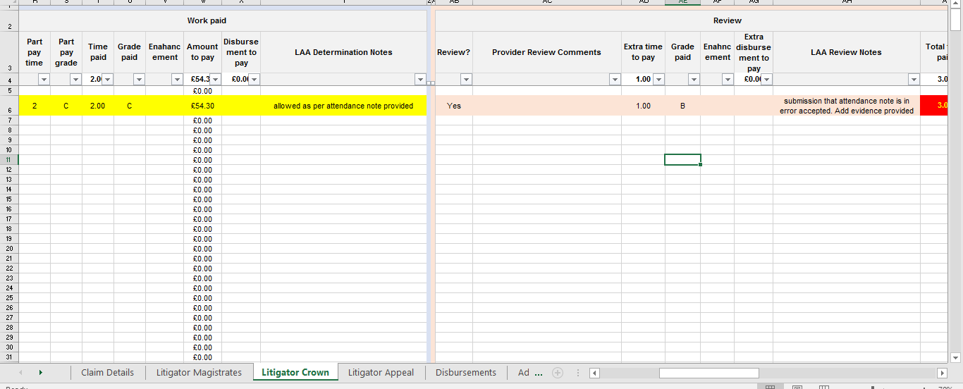
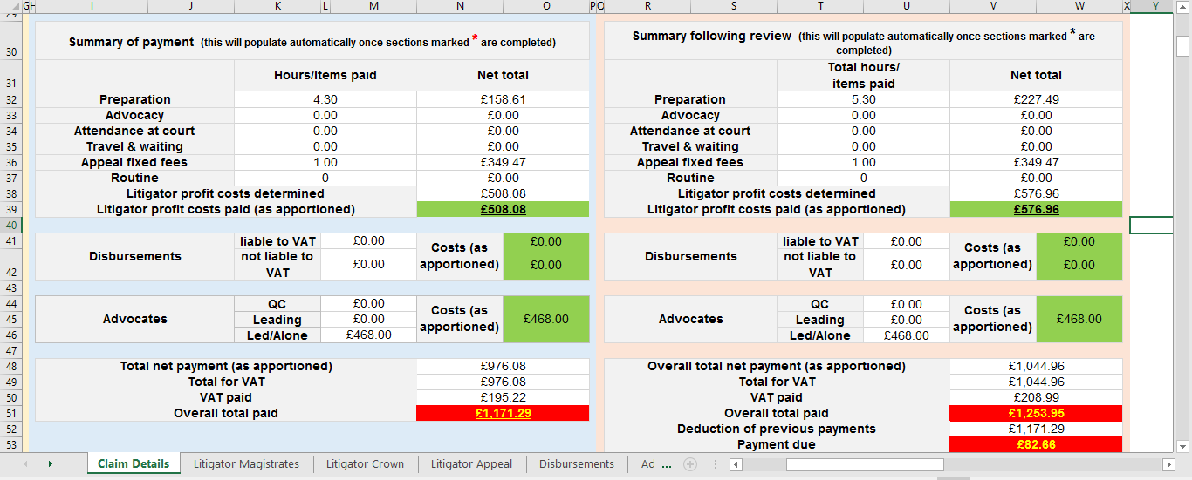
We aim to deal with requests for review within 20 working days of receipt
If you remain dissatisfied with the determination you may request formal written reasons within 21 days of receipt of the notification of the redetermination.
A request for written reasons must be sent via email to dco@justice.gov.uk

