

PROJECT PROPOSAL FORM
Proposals must be submitted in English, using Arial 11pt font and standard margins, and must clearly indicate the funding stream to which they are applying. Applicants must note late or incomplete submissions will not be considered.

The proposal form and all supporting annexes must be clearly named and submitted as separate email attachments. Annexes must not be embedded within the proposal form.

Applicants should ensure that all responses are tailored to the proposed project and reflect their own expertise, experience and analysis. Reliance on generic AI-generated content is unlikely to score well against the assessment criteria.

Questions on focus and eligibility
Implementing Agency’s Details
Your organisation’s name; address; telephone numbers; type of organisation; legal status contact name(s) and roles of the project team; You are invited to attach CVs (maximum 2 pages) or other relevant documents.
Please confirm that your organisation is run on a not-for-profit basis – that is, any surplus income or profits are reinvested in the organisation's objectives and are not distributed to members, shareholders or other private individuals. | Yes or No
Which Lot are you applying for funding for?
If Lot 4 for a UK-facing grant, are you applying for Official Development Assistance (ODA) or non-ODA funding?
If relevant, please explain how your proposal adheres to the requirements for ODA eligibility as set out by the OECD.
Maximum 100 words.
Project description
Project Title
Project purpose
Write one sentence that clearly sets out the aim of the project, reflecting the “change” it will help bring about. It is best formulated as “who is expected to do with differently”. The Outcome should be realistic in view of the project timeframe and resources.
Strategic fit (maximum 500 words)
Set out how your proposal aligns with the programme’s policy objectives and intended outcomes, as described in the Statement of Outcomes. Please also explain how your proposed outcomes, outputs and indicators will contribute to the Modern Slavery Fund Theory of Change (Annex A) and MSF Results Framework (Annex B).

Required attachments

Theory of Change
Results Framework

Technical delivery approach and methodology (maximum 500 words)

Describe how the proposed approach is evidence-based and realistic and addresses all relevant exploitation types. Set out how the outcomes will be achieved in practice and how the project will be designed to adapt to changing circumstances.
Organisation capability (maximum 400 words)
Describe your organisation's (or consortium's) experience in tackling human trafficking, and its expertise and capacity to deliver this Lot, including the proposed staffing, governance and management arrangements.
For Lots 1–3, explain your experience of delivering similar work in Albania and/or the Western Balkans and how the consortium partners (where applicable) bring together the expertise, reach, relationships and local knowledge required to deliver the Lot.
For Lot 4, explain your experience of delivering similar work in the UK context.
Please also describe the proposed project team, including the Team Leader, key personnel, roles, responsibilities and management arrangements.

Where a consortium or sub-partner arrangement is proposed, the Lead Organisation must:
• act as the sole signatory to the funding arrangement;
• take full accountability for programme delivery, financial management and reporting;
• ensure appropriate oversight of any implementing partners.
• consortium arrangements should be proportionate and clearly justified, demonstrating how they add value to programme delivery.
Monitoring, evaluation and learning (MEL) (250 words)
Outline the processes that will be in place to monitor, evaluate and learn (MEL) within and from the project, including who will be responsible for MEL activities, when these activities will take place, how monitoring findings and lessons learned will inform project delivery through feedback loops, and how transferable lessons will be shared across the wider MSF.

Risk management and safeguarding (maximum 300 words)

Describe the main risks to successful delivery of the project, including safeguarding risks and any risks arising from dependence on external factors. Explain the measures you will put in place to manage these risks and ensure the project can be delivered as planned on time and within budget.
Required attachment
Risk register
Sustainability and local ownership (maximum 250 words)
Describe how the benefits and results of the project will be sustained beyond March 2029, in line with the definition of sustainability set out in the Statement of Outcomes.

For Lots 1–3, explain how skills, systems and ownership will be transferred to Albanian institutions and civil society over time, and how local Albanian organisations will be meaningfully involved in project delivery and long-term sustainability.
Required attachment
Sustainability Plan
People with lived experience (maximum 200 words)

Describe how will People with Lived Experience (PLE) be meaningfully engaged throughout the design, delivery, monitoring, evaluation and governance of the project?

Applicants may find the Engaging People with Lived Experience Across the Programme Life Cycle handbook useful when developing their response which can be found as part of the documentation.

Project financial information
Value for money (maximum 300 words)  Please complete an actual based budget template to outline all spend. You are required to outline within your toolkit if the total costs of the project are more than the amount you are applying for from the MSF. If so, please provide details of this resource and if it has been secured.  (Note: No organisation can financially profit from receiving grant funding - proposals from for-profit organisations for grant funding can only be considered if an officially registered non-profit making arm or division of the for-profit organisation will deliver the project)  Attachment required: Activity-Based Budget | Total cost:
Compliance Questions (Finance)

Please attach a copy of your audited accounts or non-audited accounts (if exempt) for each of the most recent two years (including details of reserves held).
Has your organisation or any of the organisations in your application met the terms of its banking facilities and loan agreements (if any) during the past year?
Has your organisation or any of the organisations in your bid met all its obligations to pay its creditors within 30 days during the past year?
Grant funding is (to be ring-fenced) for use only to support delivery of the purpose; applicants must operate effective monitoring and financial management systems.

The applicant is to describe their proposed systems and processes and how this enables them to meet the required accounting standards. If an electronic system is utilised please specify.

Please do not upload financial procedure or other controls manuals, as these will not be evaluated at this stage.

Maximum 300 words.
Will the organisation be using a separate bank account / cost centre to manage the Grant Agreement funds?
Please briefly outline / describe your own procurement procedures. Are sub-grant arrangements with consortium partners clearly defined, with appropriate controls and reporting? (maximum 250 words)

Do not upload procurement manuals in response to this question, they will not be evaluated. Higher marks will be awarded for processes that demonstrate compliance with the spirit of the treaty principles:

(i) Transparency
(ii) Mutual recognition
(iii) Equality and non-discrimination
(iv) Proportionality

Other factors include:
Separation of Duties
Competition protocols
Clear delegations
Single tender approaches
The Authority has a target that no more than 7% of the award value should be used to fund indirect costs. You are required to confirm what percentage (%) of your overall budget for the whole cost of delivery is for indirect costs; this should be presented as
- total funding requested;
- total indirect costs;
- Percentage
If the Indirect Costs proposed exceeds the 7% target, please explain why this is not achievable.
An indirect cost is defined as: costs that cannot be directly attributed to the project, but are a necessary part of the costs of undertaking the project, for example, stationery, office cleaning, staff training etc. They must be additional, which means over and above your ‘business as usual’ costs.
Maximum 300 words.
Compliance Questions (Commercial)

Have you bid for funding from the UK Government in the past three years?
If yes, please provide details of bids made (successful and unsuccessful bids) and projects implemented.
Have you had a grant agreement or a contract terminated for default under the terms of the grant agreement/contract in the last three years?
Have you or any of the organisations included within your application, or (any of) the director(s) / partners / principal(s), been convicted of a criminal offence relating to the conduct of your/their business or profession?
Have you or any of the organisations included within your application, or (any of) the director(s) / partners / principal(s), committed an act of grave misconduct in the course of your/their business or profession?

Required attachment
In addition, please complete the Modern Slavery Fund Non-Collusion Certificate and Bid Form
Signature
Authorise signatory for the Implementing Organisation
Print name

Date

Annex A – Modern Slavery Fund Theory of Change

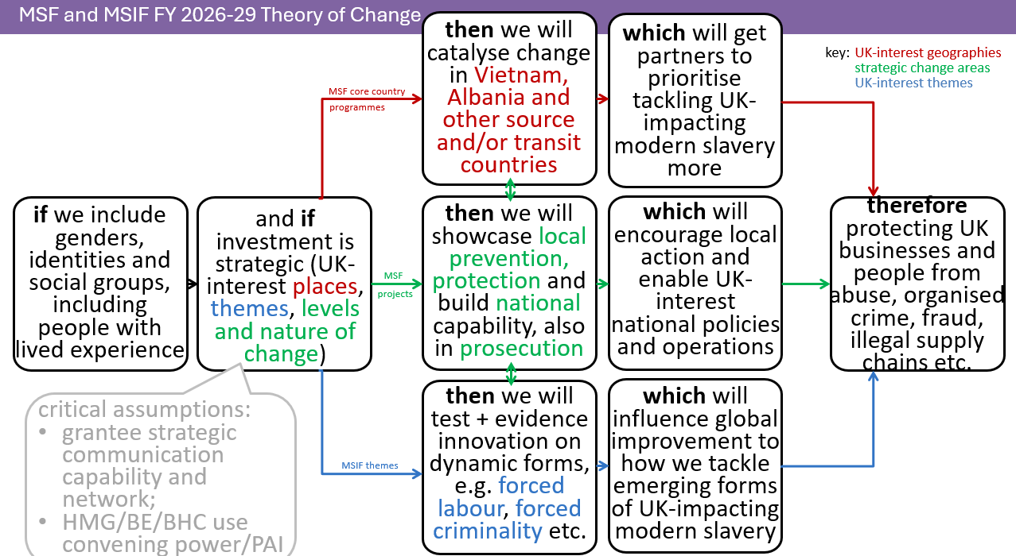

Annex B – Modern Slavery Fund Results Framework

Financial Years 2026/27 to 2028/29 Modern Slavery Fund (Fund-level) Results Framework

MODERN SLAVERY FUND-LEVEL IMPACT | Impact Indicator 1 (qualitative, global standards)
There is less negative impact from modern slavery on the UK. | Year-on-year, there is a perception of improved responses internationally on MSHT issues of concern to the UK, including trafficking and such as on forced criminality in cyber-scam centres and forced adult/child labour in global supply chains.
 | Impact Indicator 2 (quantitative, fraud)
 | % change in cyber-enabled fraud cases in the UK with an overseas element.
MODERN SLAVERY FUND-LEVEL OUTCOME 1 | Outcome 1 Indicator 1 (quantitative, prevention - before, early, harms)
By 31 March 2029: There is less local individual, family community and structural risk of being trafficked and/or re-trafficked. | # individuals at risk of MSHT identified who access services provided by the MSF and/or other local actors thanks to intervention by the MSF.
 | Outcome 1 Indicator 2 (qualitative, prevention - before, early, harms)
 | Individuals at risk of MSHT, their families and/or their communities have changed behaviour regarding vulnerability/risk drivers (e.g. less tolerance of MSHT, less enablement of MSHT, changed norms in ways adding friction against MSHT, choosing safer alternatives when/if these alternatives exist, survivor stability etc.).
 | Outcome 1 Indicator 3 (quantitative, protection - preventing re-trafficking)
 | # individual potential survivors of MSHT identified and referred to support, possibly including grievance mechanisms.
Outcome weighting towards the impact: 33% | Outcome 1 Indicator 4 (qualitative, protection -preventing re-trafficking)
 | Survivors of MSHT demonstrate overall progress in recovery and reintegration or grievances successfully resolved from the worker’s perspective
Primary theme: demonstrating prevention and protection.
MODERN SLAVERY FUND-LEVEL OUTCOME 2 | Outcome 2 Indicator 1 (quantitative, capabilities)
By 31 March 2029: National government and civil society responses to counter modern slavery are stronger. | # individual national government and/or civil society non-government personnel/people built up by the MSF in terms of capability (e.g. via training, workshops, advice, mentoring, policies, guidelines etc.) and/or capacity (e.g. via equipment, technology, premises, staff numbers, finance etc.) in prevention, protection, investigation and/or prosecution of MSHT. This metric can include # participants at national-level events, briefs, workshops and other mechanisms to share lessons and advice with key stakeholders in national governments (powerful and influential), with British Embassies / British High Commissions at a high level.
 | Outcome 2 Indicator 2 (quantitative, investigation, prosecution)
 | # alleged perpetrators of MSHT charged and/or prosecuted (no double counting, same alleged perpetrator counted once) using the capabilities/capacities built by the MSF at a national-level.
Outcome weighting towards the impact: 33% | Outcome 2 Indicator 3 (quantitative and qualitative, behaviour change on policy)
Primary theme: prevention, protection and prosecution capability (i.e. skills, competencies, experience etc.) and capacity (i.e. size, e.g. # staff, equipment, money etc.). | # and scope of local and/or national legislative, policy or strategy changes attributable to MSF input.
MODERN SLAVERY FUND-LEVEL OUTCOME 3 | Outcome 3 Indicator 1 (quantitative, evidence)
By 31 March 2029: Global efforts to counter modern slavery are more sustainable due to effective advocacy and innovation. | # events, briefs, workshops and other mechanisms to share evidence-informed innovation successes and failures with key stakeholders in regional and/or international governments and, importantly for supply chains, the private sector etc. (powerful and influential), with British Embassies / British High Commissions at a high level, as well as with the global counter MSHT community of practice in order to encourage more efficient, effective and sustainable approaches to tackling MSHT, including human trafficking and themes of UK interest such as forced criminality in cyber-scam centres, forced adult/child labour, at national and international levels.
Outcome weighting towards the impact: 33% | Outcome 3 Indicator 2 (qualitative, influence)
 | Key state and non-state actors (i.e. high power and high influence) in the international community of MSHT practice and/or regional and global decision-makers have been influenced by knowledge products, awareness raising and/or advocacy associated to all MSF investments and, in the case of MSIF investments, also by innovation, and these key stakeholders are, at least, thinking about doing something differently due to this influence.
Primary theme: partnership, ownership and sustainability.

Please note fund-level impact and outcomes are fixed, across all MSF and MSIF investments irrespective of country and grant. Grantees may add/edit outcomes 1, 2 and 3 by: replacing the words “In countries selected due to their modern slavery impact on the UK and feasibility of the implementing partner and HMG influencing system change there,” with the country/countries invested in; and/or by adding the specific form of modern slavery tackled in their grant in the relevant outcome statement if they wish. Other changes to outcomes 1, 2 and 3 are not permitted.

