NOTICE OF ORDER

Wildlife and Countryside Act 1981, 53
Lancashire County Council

THE LANCASHIRE COUNTY COUNCIL (ORMEROD STREET TO GAMBLE ROAD, THORNTON CLEVELEYS) DEFINITIVE MAP MODIFICATION ORDER 2015

Notice is hereby given that the above referenced Order has been submitted to the Secretary of State for Environment, Food and Rural Affairs for determination. An Inspector will be appointed by the Secretary of State to determine the Order.

The start date for the above Order is 23 JUNE 2026

Consideration of the Order will take the form of exchanges of statements of case and comments on statements of case.

The effect of the Order, if confirmed without modifications, will be to add a public footpath from a point on the corner of Ormerod Street (Point A grid reference SD 3392 4349) running in a north westerly direction for 75 metres through stone gateposts to Point B (SD 3386 4353) then in a northerly direction east of two ponds to Point C (SD 3384 4369), the route then passes through gateposts at Point C and then runs in a north north westerly direction for 255 metres to Point D (SD3381 4379), then across the playing fields to a fence at Point E (SD 3378 4391) and then across rough grass to exit onto Gamble Road Point F (SD3378 4349) for a total distance of approximately 500 metres.

Any queries relating to this Order should be referred to Paul Scrivener by email: paul.scrivener@planninginspectorate.gov.uk quoting reference number ROW/3374428 on all correspondence. Alternatively, queries may be sent in writing to The Planning Inspectorate, Rights of Way Section, c/o QUADIENT, 69 Buckingham Avenue, Slough, SL1 4PN. Telephone: 0303 444 5000.

Any person wishing to view the statements of case and other documents relating to this Order may do so by appointment at County Hall, Fishergate, Preston, PR1 0LD, for further information please contact Simon Moore at simon.moore@lancashire.gov.uk or on 01772 531280. Documents have also been made available online. To access the documents, please use the following URL address: https://www.lancashire.gov.uk/council/transparency/dmmos/ormerod-street-2015

Timetable for sending in statements of case and comments
Within 2 weeks of the start date by 7 JULY 2026
The Order Making Authority, or where the Order Making Authority is taking a neutral stance and the applicant or other party are taking the case forward in support of the order, must ensure their statement of case is received by the Secretary of State. As soon as possible after the deadline, the Secretary of State will send a copy (excluding copies of any supporting documents - these will be available to view at the Authority’s
offices) to everyone who has made an objection or representation, the applicant and any other person who has written to us in respect of the Order.

Within 8 weeks of the start date by 18 AUGUST 2026
Everyone who has made an objection or representation or any other written representation or any other person wishing to make representations in writing must ensure their statement of case is received by the Secretary of State. As soon as possible after the deadline, the Secretary of State will send full copies to the Authority. Copies (excluding copies of any supporting documents - these will be available to view at the Authority’s offices) will also be sent to the applicant, every person who has made an objection or representation and any other person who has written to us in respect of the Order.
Within the same period the applicant (if applicable) must ensure their statement of case is received by the Secretary of State. As soon as possible after the deadline, Secretary of State will send a full copy to the Authority. Copies will also be sent to everyone who has made an objection or representation and any other person who has written to us in respect of the Order (excluding copies of any supporting documents - these will be available to view at the Authority’s offices).

Within 14 weeks of the start date by 29 SEPTEMBER 2026
Everyone who has made an objection or representation, the Authority, the applicant (if applicable) and anyone who has written to us in respect of the Order must ensure that their comments on any or every other statement of case is received by the Secretary of State. As soon as possible after the deadline, the Secretary of State will send copies of these comments to everyone else.
In fairness to the other parties everyone should keep to the timetable to ensure that statements of case and comments are received on time. Late documents will be returned.

We cannot accept any inflammatory, discriminatory or abusive comments. Any documents containing such comments will be returned.
If you use Artificial Intelligence (AI) to create or alter any part of your documents, information or data, you should tell us that you have done this when you provide the material to us. See the detailed guidance for further information.

Notice of order for w/r

-WILDLIFE AND COUNTRYSIDE ACT 1981
THE DEFl�ITIVE M�Pr)AND STATEMENT-OF PUBLIC'RIGHTS OF WAY FQR THE COUNT.Y. OF LANCASHIRE

THE LANCASHIRE COUNTYlGJ:)�l!JNGlt. (OBMEROD STREET TO GAMBLE ROAD, THORNTON CLEVELEVS) DEFINITIVE MAP MODIFICAiflON ORDER 2015
This-Order is made by!Lancashire County Co(Jncil ("the Authority") under Section 53(2)(b) of the Wildlife and Countryside Act, 1981 ("the Act") because it appears to that Authority that The Definitive Map and Statement of Public Rights,of Way for the County of Lancashire require modificl:ltion 1in conseqyence of the occyrrence of an event specified in Section 53(3)(b) and 53(3)(c)(I) nBJT1ely the expiration of any period such that the enjoyment by the public of the way during that period raises a presumption that t_he w�y has been dedicated as a public path and the discovery 1by the Sl}rveying Authority of evidence which (when consideretj with all other relevant evidence available to them) shows that a fight of' way which is ,not shown in the mijp and statement subsists or is reasonably alleged to subsist over land in the area to which the map relates, namely a public footpath.
The Authority have consulteg with every local authority whose area includes tfle ·land to which the Order relates. Lancashire County Council hereby order that:
- For the purposes of this Order, the "relevant date" is the 21st October 2015.
- The Definitive Map and Statement of Public Rights of Way for the County of Lancashire shall be modified as described in Part I �nd Part II of the Schedule and shown on the map attached to the Order.
- This Order shall take effect on the date it is confirmed and may 1be,cited as The Lancashire Coynty Council (Ormerod Street to Gamble Road, Thornton Cleveleys) Definitive Map Modification Order 2015.
Dated this 21st day of October 2015. THE COMMON SEAi. of the )
Lancashire County Council ) was hereunto affixed In the presence of )

A_uthorised Signatory � ,
§Qtl_E_Q_U_LE
PABTJ
MODIFclCATION OF THE DEFINITIYE�MAP

DESCRIP.TJION OF PATH.OR WAY TO BEADDEE>
Py�lic Footpath�from a-point on tt@comer of Qrmerod Street (point A on the Oraer Map), running in a north westerly direction for a distance of 75 metres to pass through stone gateposts (point B on the Order Map) then in a northerly qirection east of two ponds for 170 metres to point C.� route passes through gateposts at point C and then runs in a north north westerly direction for 255 metres-passing through E! gEjp in the hedge at point1D, across playing fielqs to�fence at point E and across rough grass-to exit onto Gamble Road at point F; a total distance of 500 metres. All Lengths and compijss directions given are approximate
PABff"II
M00IF.1€Affil0N 0F IDEF-INITIVE STATEMENT
VABIATION OF PA@ffil®ULABS@F eAffilrl08 WAY
Entry to be added to read as follows:

"Public Footpath 27, from�point on the comer of Ormerod Street at SD 3392 4349, running ih a n.9rth westerly direction for a distance of 75 metres to pass through stone gateposts at
$�3386)4353 and running in a northerly direction for a distance of ,170 metres to the east of two ponds to a gateway at SD 3384 4369 from where it runs in a north north westerly direction for 255 metres t.t,roygh a gap in the hedge at SD 3381 4379, across playing fields ito a fence atlSIDJ3378 4391 and across rough grass�exit onto Gamble Road at SD 3378 4394. All lengths and compass directions given are approximate
Wldth:1.5 metres

Length:
0.50 km
Other Particulars: Limitations:
SD 3386 4353 - Field G,_ate
SD 3384 4369 - Field Gate
SD 3381 4379 - Field Gate11

,
.
- J'
14 •
I
I
\ I
333700 333800 333900 :0 334000
'
'•''•.
''
.:•�UI
..

',,,I " .
;..· ..:1-��-·
.••":=-----
,rI...-M..---!-':.'..,..-.-�---:·.a-:u..-R---N._...-N..A-Z·�E�. I
-- :�:.>
--------- --;":-"'•·
' ,' _. '----- ' ......
.
�·. . "-� ;�-,:.:-.-..-;----
�\ "
·--
't._,-·.... ........-: ...
':,,,..
• . , . I �! ,:,:-·i<:•. \'t. � 11-
111
�

':a
•
I.
I
:! ••

............
� ,.".. '"'
!�
ffJJJJ.I111H
�� t '\I
•• ,�•.-_u.w,,;,;-..-;•.;,1 -"• :'

.r'G�o• r�
g ---� -��':. [IIf1fIif�
•-•..O
•

.....
ll�--U--!--J-..�!-J--f�t
·.��:�·;·j·;,·
.
'... ,,
Y.:
- .-----� I
,,
•,',
��-r·-t"19
l"t

3
-
•
I I r•. ' .. •' •• 1-
,·,wl�··.,1����\ .hj - , . ,•:;:-.,_-

:::1...l!,11;\_._.,.
i

l"t

3
...I .I,•.• •,'.
� I� '• ,t--
I
",.
"
- I
••

I - \
i
I ••••I•-

Lancashii·e

Andrew Mull.in•)'

Wildlife and Countryside Act 1981
00 334000 0000
_.,
COun1V • Co,,a,ca1
Haad ol Planning and Environment
Addition of a public footpath from Ormerod Street to Gamble Road, Thornton Cleveleys, Wyre
1:2,500
•
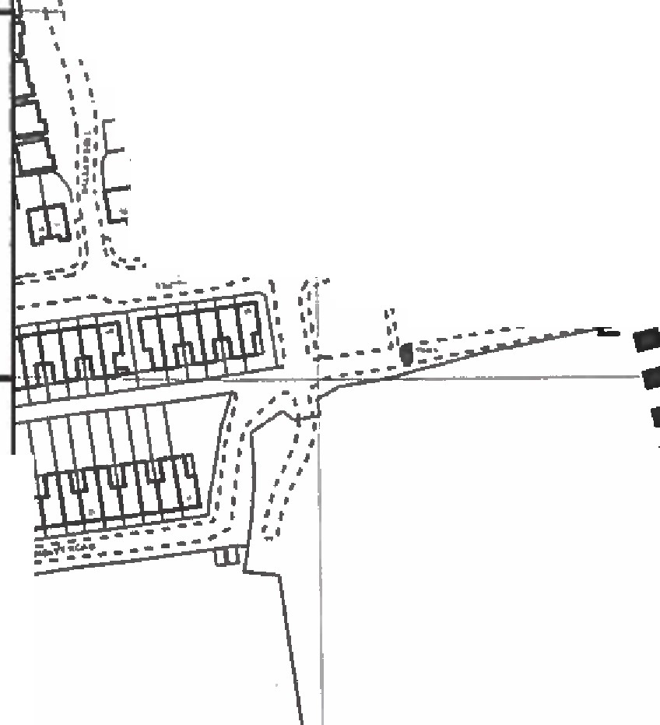
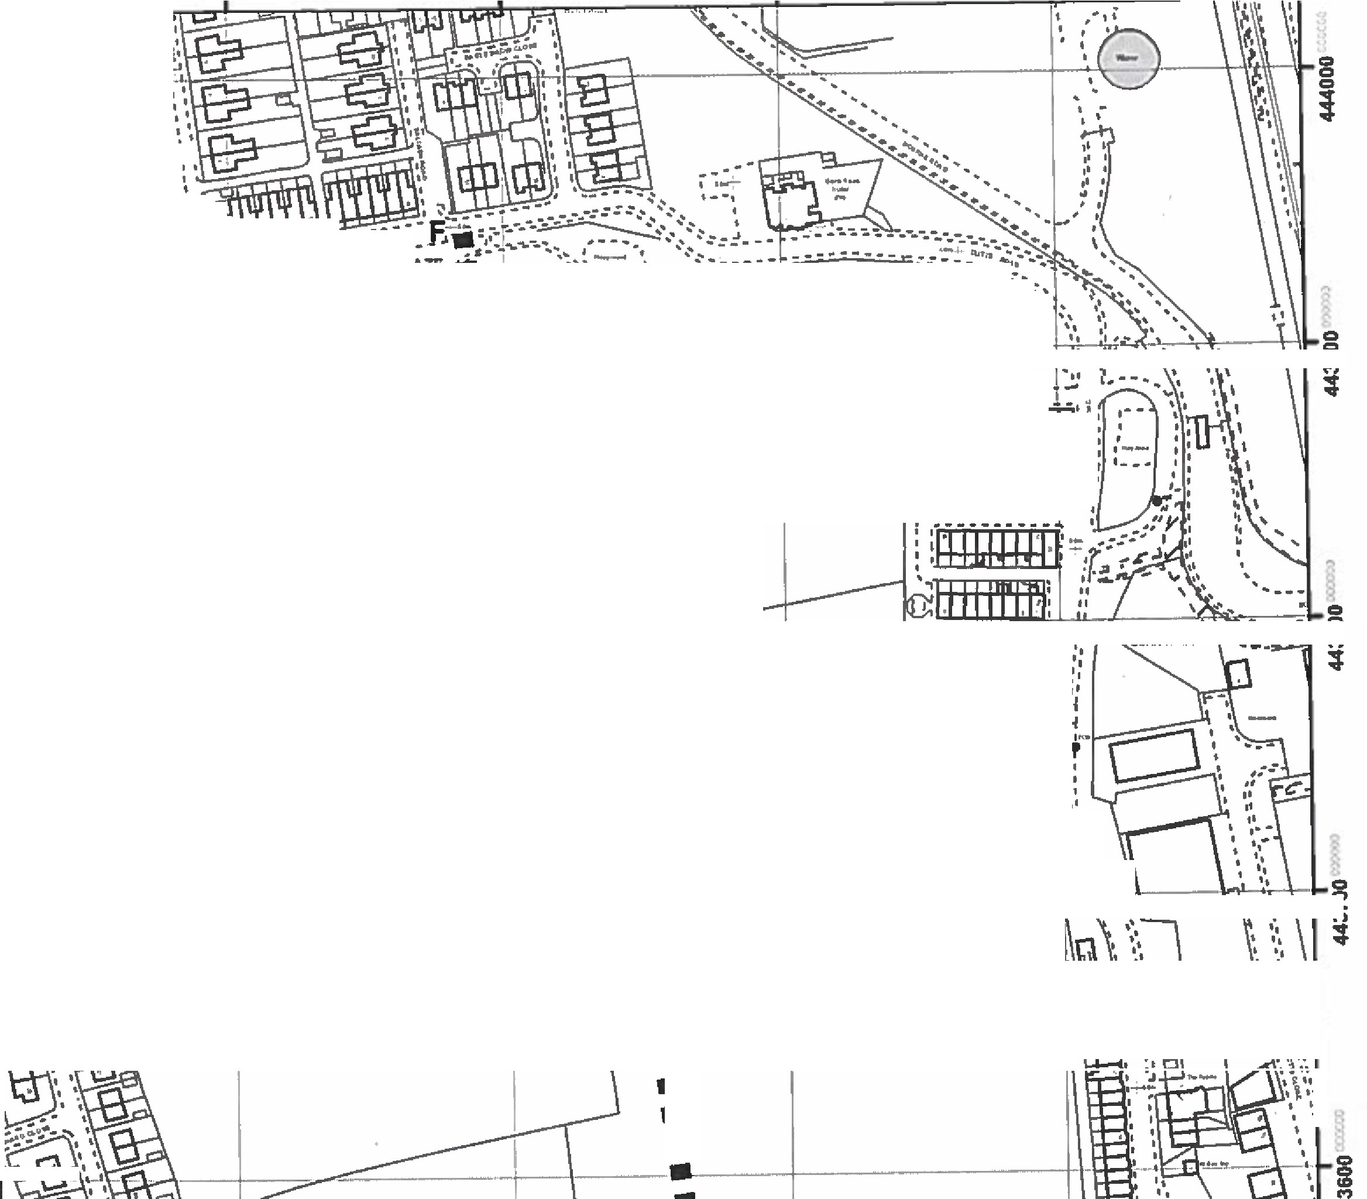

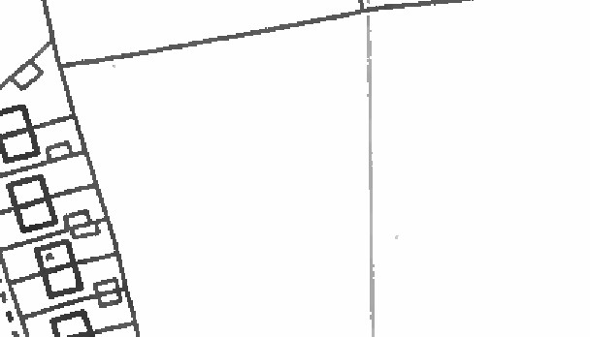

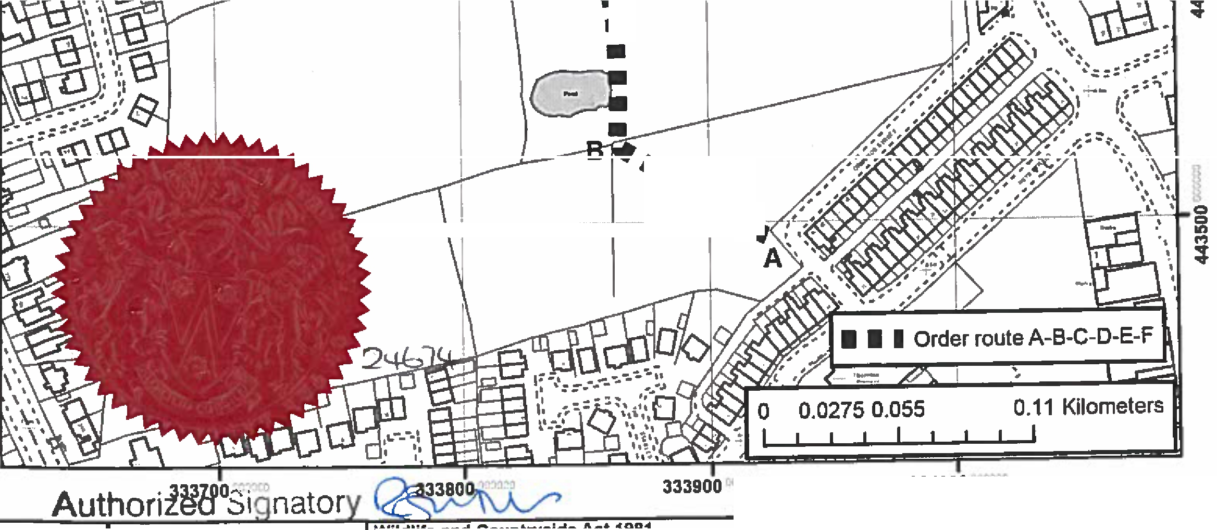
Th, dlgltlHd Rights of W6f lnlormalkm lhould be used for guldanca only H 1111ccmacy CHPOt i. g1manleed.Rlgln of Way lnlannallon must i. nrlfftd on the CUITIIII OeHnltlvo Map bdore bmg euwlied a, used lor any purpon.
Thi• Map11repnxlua<I from Ordnana Suivr, in,leri1I wtlh the ptrml11lon o!Ordn111ce Sumy onbehalf al lhe cantralllr ol Her Majesly'1 Staijonery 0lllat (Cl Crown Copyrlghl
Unal.(bori1td teprod1Jctloll lnfringn Crown Cop,.tght and_,lead b:) ProHcutloA or clvllp,oaedfngs. t..nc.hlre Counlj, Co1111dl Uetnce Na. 10002l320

