

Appeal Decision
by Harry Wood BA (Hons) MA PhD MIPROW
an Inspector on direction of the Secretary of State for Environment, Food and Rural Affairs
Decision date: 01 June 2026

Appeal Reference: ROW/3358371
- This appeal is made under Section 53(5) and Paragraph 4(1) of Schedule 14 of the Wildlife and Countryside Act 1981 against the decision of Hampshire County Council (the Council) not to make an Order under Section 53(2) of that Act.
- By application dated 27 November 2008, Christina Harris and Nicola Hine claimed that four routes over land to the south of Lower Road in South Wonston, should be added to the definitive map and statement for the area as public footpaths.
- The application was refused by the Council and the applicant was formally notified on 12 December 2024.
Summary of Decision: The appeal is allowed.

Preliminary Matters
- I have been directed by the Secretary of State for Environment, Food and Rural Affairs to determine this appeal on the basis of the papers submitted. I have not visited the site, but I am satisfied that I can make my decision without the need to do so.
- The appellants refer to the routes as paths A, B, C, and D. The paths are also associated with names, notably the west to east route which is often referred to as Racehorse Cottage Track. The Council have instead referred to the routes by number, presumably so that letters can be used as annotating points.
- I have found it convenient to refer to points on the Council’s Plan and have attached a copy of it to this decision, for reference. I have also labelled the routes as paths 1, 2, 3, and 4, and will refer to them as such throughout this decision.

Main Issues
- The application was made under Section 53(2) of the Wildlife and Countryside Act (the 1981 Act) which requires the surveying authority (in this case Hampshire County Council) to keep their Definitive Map and Statement (DMS) under continuous review, and to modify them upon the occurrence of specific events cited in section 53(3).
- Where it is proposed that an unrecorded way should be added to the DMS as a footpath, section 53(3)(c)(i) of the 1981 Act specifies that an Order should be made following the discovery of evidence which, when considered with all other relevant evidence, shows that “a right of way which is not shown in the map and statement subsists or is reasonably alleged to subsist over land in the area to which the map relates”.
- The issue was addressed in the High Court case of R v Secretary of State for the Environment ex parte Mrs J Norton and Mr R Bagshaw [1995] JPL 1019 and later clarified in R v Secretary of State for Wales ex parte Emery [1998] 4 All ER 367. When considering whether a right of way subsists (test A), clear evidence in favour of the appellant is required and no credible evidence to the contrary. However, when considering whether a right of way has been reasonably alleged to subsist (test B), if there is a conflict of credible evidence but no incontrovertible evidence that a way cannot be reasonably alleged to subsist, then the answer must be a public right of way has been reasonably alleged.
- For the purposes of this appeal, if the evidence is sufficient to satisfy the lesser test (B), then an order should be made, although the higher test (A) would be applicable if the matter fell exclusively under sub-section 53(3)(b).
- The application was based predominantly on user evidence. I will consider this appeal against the tests laid down in Section 31 of the Highways Act 1980 (the 1980 Act). I must establish the date when the public’s right to use the appeal route was brought into question. The evidence can then be examined to determine whether use by the public has been as of right and without interruption for a period of not less than 20 years. It is also necessary to consider whether there is sufficient evidence that there was no intention on the part of the landowners to dedicate public footpath rights during the relevant 20-year period.
- Under common law, an inference that a way has been dedicated for public use may be drawn when the actions of the landowners (or lack of action) indicate that they intended a way to be dedicated as a highway and where the public have accepted that dedication. Use by the public can be evidence of the intention to dedicate; this use should be as of right without force, secrecy, or permission. There is no fixed period of use at common law and use may range from a few years to several decades, based on the facts of the case. The more intensive and open the use, the shorter the period required to raise the inference of dedication. The burden of proof lies with the claimant to demonstrate that the evidence is sufficient to indicate an intention of dedication.
- Section 32 of the 1980 Act requires that documentary evidence is taken into consideration “before determining whether a way has or has not been dedicated as a highway”, and that such weight is given to the evidence as “justified by the circumstances, including the antiquity of the tendered document, the status of the person by whom and the purpose for which it was made or compiled, and the custody in which it has been kept and from which it was produced.”

Reasoning

Documentary Evidence
- The Council have submitted a range of documentary evidence. While these documents are generally silent as to the legal status of the appeal routes, they offer useful background regarding the land over which the paths run. Ordnance Survey (OS) maps from 1910 to 1933 indicate that this was the former site of Winchester Racecourse, and the land is marked in later maps as “Aerodrome”. Representations made by South Wonston Parish Council suggest that Path 4, in addition to the track heading south from point C, “formed part of the Perimeter Track of the former Worthy Down Airfield”. OS National Grid maps between 1962 and 1973 consistently record paths 2 and 4 between parallel lines (either solid or pecked). Aerial photographs taken between 1947 and 2005 indicate that paths 2 and 4 have existed on the ground since at least 1947, and Path 1 since at least 1984. Scans of a 1998 OS Explorer Map submitted by the appellants show all four paths: Path 1 with a single pecked line, paths 2 and 3 with parallel pecked lines, and Path 4 with one pecked line and one solid line. Path 3 appears to follow a different route to that applied for by the appellants, beginning at point H but curving to the north-east and joining Lower Road east of point G. The Council have also submitted copies of correspondence and internal memoranda from their own records, including a 1962 proposal from the Ministry of Defence (MoD) to divert what is now bridleway 517 (south of point I).

User Evidence
- The land over which the appeal routes run is in the ownership of the MoD, meaning that it has the status of Crown land. The provisions of the 1980 Act only apply to Crown land, as set out in section 327(2), where the “appropriate authority in relation to any land and a highway authority may agree that any provisions of this Act specified in the agreement shall apply to that land”. There is no evidence of an agreement between the MoD and the Council concerning the land in question. This means that dedication under section 31 of the 1980 Act cannot have occurred. However, dedication of the paths can still be established under common law principles.

Nature of Use
- The application was supported by 22 user evidence forms (UEFs) showing use between 1957 and 2010. All 22 respondents refer to using the appeal paths on foot. Several UEFs also detail use by bicycle and on horseback, though the volumes are low in comparison to use on foot.
- The claimed use includes walking for leisure, blackberry picking, accessing various facilities in Worthy Down or South Wonston, and a large proportion of dog walkers. Several users refer to using the paths while walking their children to South Wonston Primary School (north-east of point G) from Worthy Down. Users describe walking various different combinations of the four appeal routes. One user describes utilising Path 1 to visit “friends who live in Worthy Down”, presumably walking south from point C on the perimeter track. Others describe using paths 2 and 4 to access the Recreation Ground (north of point I).
- The frequency of use varied and included daily, weekly, and monthly use. Of the 22 people who submitted UEFs, 12 referred to daily use, five to weekly use, and five to monthly or less regular use. The timeframe of use also varied, with use gradually building from the 1960s onwards. The most intensive period of use was 1986 to 2008. During this period eight users claim daily use, three weekly use, and two monthly use.
- All of the UEFs refer to seeing other users on the appeal paths, including walkers, horse riders, and cyclists. The appellants have also provided details of an informal survey conducted in March 2025, where during a two-hour period 17 walkers and three horse riders were observed “using the path from Lower Road to the triangle [Path 1]”. Such evidence suggests that the appeal paths have been well-used historically and continue to be utilised by the public. Some users refer to seeing vehicles on site, but no one claims to have driven any of the appeal paths. It seems likely that the vehicles spotted belonged to either the tenant farmer or the MoD.
- Numerous users refer to the construction of a fence in 2008, an action that appears to have triggered the appellants’ definitive map modification order (DMMO) application. The extent of this fence is not clear. One user refers to “rabbit-proof fencing recently put up on field side of Lower Road”, while another states that the fence blocked “2 access points from Lower Rd”. The appellants contends that the fence did not block the access at point E, which in turn suggests that the two blocked access points were A and G. The majority of use recorded in the UEFs predates the construction of this fence. There is no evidence of other access controls that prevented use of the appeal routes. Several users refer to signage appearing in 2006 “outlining rights of way”, but it is not clear where these were located or what they aimed to communicate.
- None of the users recall being challenged while using the appeal routes. I have also seen no evidence that indicates use of the appeal routes prior to 2008 was by force. There is also no suggestion that the use was by stealth, or that there was any period of interruption.

Intention to Dedicate
- The land is farmed via a tenancy agreement with the MoD, and has been farmed by the same family since the 1940s. The current tenant responded to the consultation process run by the Council during their investigation of the DMMO application. They asserted that “for a long period an army patrol vehicle” drove the perimeter track “at least 4 times a day” which had “a reducing effect on those using parts of Worthy Down that were not rights of way”. The tenant adds that this regime is no longer in place, which has “led to further increased access ever since”. No dates are provided as to when such patrols ceased to take place. It is difficult to speculate on the purpose of these patrols without further details. I note that various users refer to seeing vehicles on the appeal routes, which is likely to have been an Army patrol vehicle, but that no one reports being challenged by military personnel.
- The tenant additionally states that they “have attempted to keep the public to made up paths, even if they are not rights of way”, and that they fenced off two “illicit paths” in 2008. Although location details are not included, it seems probable that these were paths 1 and 3 at points A and G respectively. While these actions were taken by the tenant rather than the landowner, it may be that the tenant was acting on behalf of the MoD when attempting to secure the boundary of the land. As such, this action could be seen to demonstrate a lack of intention to dedicate public footpath rights over paths 1 and 3.
- The Council received a deposit made under section 31(6) of the 1980 Act in November 1995. This provision allows landowners to acknowledge any public rights of way already recorded over their land, and then via a subsequent statutory declaration, confirm that no additional ways had been dedicated. The deposit includes a plan which shaded the boundary of the relevant land in red, encompassing the full Worthy Down site and including all of the appeal paths. Given that the land in question is Crown land (as discussed above), the deposit in question is likely to have been invalid. I also note, as highlighted by the Council, that no accompanying declaration was ever received. Nonetheless, I accept the Council’s reasoning that this action “is considered to indicate the intentions of the landowner at that time”, and I agree that the deposit demonstrates a lack of intention to dedicate public rights over the appeal routes.
- The Council have provided copies of correspondence with the Parish Council and the MoD which relate to the appeal routes. Writing on 11 April 1991 and enclosing a map that highlighted several routes including paths 1, 2, and 4, the Parish Council referred to rumours that the MoD were planning to sell the land in question and stated: “There are several footpaths and a substantial track in the area which have been used for many years by residents of South Wonston and Worthy Down”. The Council followed this letter up by writing to the MoD on 29 April 1991, asserting that “the Parish Council will wish to claim some or all of the paths as public rights of way (if sold)” and asking the MoD to confirm “whether this area of land is being retained or sold” and “whether any provision has been made for continued use of the paths/tracks by the general public”. Replying on 8 August 1991, the MoD acknowledged “that the local Parish Council are likely to claim that the tracks and paths […] as public rights of way should the land over which these access ways run be sold”. The letter points out that the perimeter track continues southwards towards Worthy Down and states that “no public right of way will be permitted through the adjacent service Married Quarter Estate”.
- This exchange is of some significance. Presented with an opportunity to clarify the extent of public rights over the land in question (and by extension, to demonstrate a lack of intention to dedicate further public rights), the MoD clarified that the section of the perimeter track over Worthy Down Camp (south of point C) was not a public right of way, but offered no view as to the status of the other highlighted paths.

Conclusions on User Evidence
- There is evidence of actions by the landowner in 1995 that demonstrate a lack of intention to dedicate footpath rights over the appeal paths. There is no evidence of equivalent actions during the period 1957 to 1995. This period saw gradually increasing use by members of the public, peaking between 1986 and 1995.
- While there may not have been an overt acknowledgment of dedication, the correspondence considered above suggests that the landowners acquiesced in public use of the appeal paths. I consider the lack of action to challenge those walking the paths and the acquiescence of use demonstrated in the letter of 12 August 1991 is sufficient to reasonably allege an inference of dedication of the appeal paths as public footpaths under common law. The evidence of use is also sufficient to show acceptance of rights of way by the public on foot.
- The making of an Order will give the opportunity for public consultation and any further evidence in support of footpath or higher rights may be discovered. In addition, if objections are made there would be an opportunity for the conflicting evidence to be tested more thoroughly and the issues determined at an inquiry.

Other Matters
- The Council have raised concerns about the alignment of Path 3, pointing out that “the route highlighted in this location by the Parish Council in 1991 is different from that which has been applied for”. While this discrepancy is recognised (and discussed at paragraph 11), I note that the UEFs recording use of Path 3 all refer to the alignment as depicted in the application.
- The appellants raised concerns in their appeal regarding the length of time it has taken the Council to consider their application and the degree of support they received. Although I can understand their frustration, such matters are not relevant to my decision. My task solely concerns assessing the statutory and common law tests set out above.
- The appellants highlight that use of the appeal paths has significantly increased in recent years and question why this was not taken into account when their application was considered. The Council explain that the application was “considered on the basis of the available user evidence” and add that the applicants were invited to submit further user evidence when investigation of the application was begun in 2023 but that no further user evidence was submitted. I note the concerns raised by the appellants, but stress that my decision has been based on the evidence put before me.

Overall Conclusion
- Having regard to these and all other matters raised in the written representations I conclude that the appeal should be allowed.

Formal Decision
- In accordance with paragraph 4(2) of Schedule 14 to the 1981 Act, Hampshire County Council is directed to make an Order under section 53(2) and Schedule 15 of the 1981 Act within three months of the date of this decision, to modify the definitive map and statement for the area by adding public footpaths over the application routes.
- This decision is made without prejudice to any decisions that may be given by the Secretary of State in accordance with her powers under Schedule 15 of the 1981 Act.

Harry Wood

Inspector

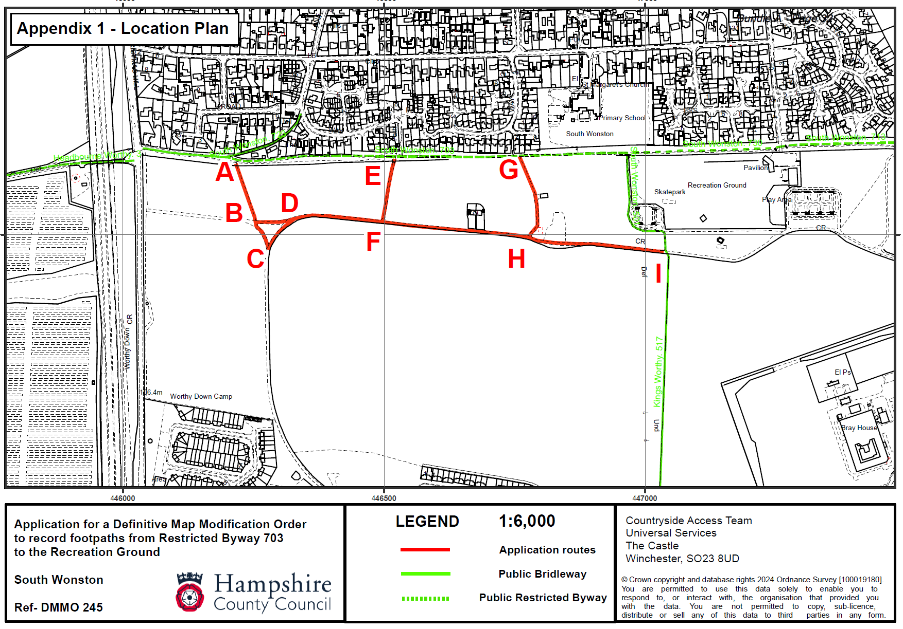
Path 4
Path 3
Path 2
Path 1

