

Order Decision
Site visit 17 March 2026
by Nigel Farthing LLB
an Inspector appointed by the Secretary of State for Environment, Food and Rural Affairs
Decision date: 30 March 2026

Order Ref: ROW/3355768 and ROW/3370002
- This decision concerns two Orders together referred to as “the Orders”.
- The first Order is made under Section 118 of the Highways Act 1980 (‘the 1980 Act’) and is known as the Norfolk County Council (Shipdham Footpath No.19) Extinguishment Order 2023 (“the Extinguishment Order”).
- The second Order is made under Section 26 of the 1980 Act and is known as the Norfolk County Council (Shipdham Footpath No.19a) Creation Order 2023 (“the Creation Order”).
- The Orders are both dated 22 November 2023. The Extinguishment Order proposes to extinguish the public right of way known as Shipdham Footpath No.19 (“FP19”) as shown on the Extinguishment Order Map and described in the Order Schedule. The Creation Order proposes to create the public right of way to be known as Shipdham Footpath No.19a (“FP19a”) as shown on the Creation Order map and described in the Order schedule.
- There was one objection outstanding when Norfolk County Council (‘the Council’) submitted the Orders to the Secretary of State for Environment, Food and Rural Affairs for confirmation.
Summary of Decision: The Orders are confirmed

Procedural Matters
- I undertook an unaccompanied site inspection during the afternoon of Tuesday 17 March 2026.
- In writing this decision I have before me the written statements of case of the Applicant and the Objector. I also have the Applicant’s Consultation Report and Determination Report and the Council’s Statement of Grounds.
- I have found it convenient in this decision to refer to the points marked on the Order Maps. I therefore attach copies of these maps.
- The Extinguishment Order was made by the Council under Section 118 of the 1980 Act. It proposes to extinguish the entirety of FP19 as shown on the Extinguishment Order map with a solid black line between points A and E (“the existing route”).
- The Creation Order was made by the Council under Section 26 of the 1980 Act and proposes to create FP19a as a public footpath as shown on the Creation Order map with a broken black line between points A and D (”the proposed route”).
- The Extinguishment and Creation Orders are to take effect concurrently and are contingent thereon.

The Legal Framework
- Section 118 of the 1980 Act permits an order to be made where it appears to a council that it is expedient for a path or way to be stopped up on the ground that it is not needed for public use.
- Section 118(2) provides that an order shall not be confirmed unless the Secretary of State, or the Council, are satisfied “that it is expedient so to do having regard to the extent (if any) to which it appears [ ] that the path or way would, apart from the order, be likely to be used by the public, and having regard to the effect which the extinguishment of the right of way would have as respects land served by the path or way, account being taken of the provisions as to compensation contained in section 28”.
- Section 118(5) provides that “Where, in accordance with regulations made under paragraph 3 of the said Schedule 6, proceedings preliminary to the confirmation of the public path extinguishment order are taken concurrently with proceedings preliminary to the confirmation of a public path creation order then, in considering –
- under subsection (1) above whether the path or way to which the public path extinguishment order relates is needed for public use, or
- under subsection (2) above, to what extent (if any) that path or way would apart from the order be likely to be used by the public,

the Secretary of State may have regard to the extent to which the public path creation order would provide an alternative path or way”
- Section 118(6) provides that when assessing likely use of the path or way by the public any temporary circumstances preventing or diminishing the use of the path or way shall be disregarded.
- Section 26 of the 1980 Act provides that an order may be made where it appears to a local authority that there is a need for a footpath over land in their area and “they are satisfied that, having regard to -
- the extent to which the path or way would add to the convenience or enjoyment of a substantial section of the public, or the convenience of the persons resident in the area; and
- the effect which the creation of the path or way would have on the rights of persons interested in the land, account being taken of the provisions as to compensation contained in section 28 below,

it is expedient that the path or way should be created”.
- Before exercising the power to make an order under section 26 the local authority is required to consult with any other local authority or authorities in whose area the land concerned is situated.
- In considering whether to confirm an order under section 26 the Secretary of State is required to have regard to any material provision of a rights of way improvement plan (“ROWIP”) for the area.
- Government guidance on diversion or extinguishment of public rights of way through private dwellings, their curtilages and gardens was published in August 2023 (“the guidance”). The guidance applies, inter alia, where a public right of way passes through a garden or curtilage of a residential dwelling.
- Paragraph 9 of the guidance states “In all cases where the guidance applies, the order-making and confirming authority should weigh the interests of the owner and/or occupier against the overall impact of the proposal on the public as a whole. They should note that reducing or eliminating the impact of the current route of the right of way on the owner and/or occupier, in terms of privacy, security and safety, are important considerations to which due weight should be given.”
- Paragraph 10 of the guidance states “The order-making authority should therefore be predisposed to make, and the confirming authority will be similarly predisposed to confirm, an order if it satisfies the respective relevant legislative tests.”
- Paragraph 11 of the guidance states “In such circumstances, it is in the public interest that any change to remove or reduce the impacts on the property owner or occupier of the existing public right of way should, wherever possible, involve diversion or replacement of the way rather than extinguishment alone. Before making an order, authorities should consider all the options available to them and/or to the landowner, and should be open to using the combination of powers, agreements and management arrangements that best suit the circumstances, whether mentioned below or not”. One of the options then set out in the guidance is concurrent extinguishment of the right of way and creation of an alternative route under s118 and s26 of the 1980 Act respectively.

Main Issues
- To confirm the Orders, I must be satisfied that they meet the criteria set out in the legal framework above, specifically.
- That the existing route is not needed for public use and that it is expedient for the Extinguishment Order to be confirmed having regard to likely public use of it and the impact of extinguishment upon the public rights of way network.

- That it is expedient to confirm the Creation Order on the ground that there is a need for the proposed route and having regard to the benefit it would bring to the convenience or enjoyment of the public or the convenience of local residents and also having regard to any ROWIP.

Site visit
- The purpose of both the existing and proposed routes is to provide a link from the cul-de-sac end of Parklands Avenue to Shipdham Bridleway 15 (“BR15”) and Shipdham Footpath 13 (“FP13”). The distance involved is very short, the proposed route having a length of approximately 50 metres.
- There is no evidence of the existing route on the ground. The recorded route commences mid-way across the end of the adopted road known as Parklands Avenue (point A on the Extinguishment Order map). It then runs in a broadly south-easterly direction initially across what appears to be a gravelled private driveway giving access to a residential property and continuing through the garden to point B where it turns due south exiting the garden and crossing BR15 to point C. From this point the existing route continues in a broadly easterly direction to point E with a slight kink to the north at point D. Between points C and D the route crosses a stream but with no bridge or other means of crossing at that location. From the point where the existing route crosses BR15 it is located to the south of BR15. It passes through an area of rough grass and trees and is not represented by any feature on the ground.
- The proposed route exists as a surfaced path with a width consistent with the description in Part 1 of the Creation Order. It commences at the northern corner of the end of Parklands Avenue and follows the boundary fence of the residential property, initially in a south-east direction from point A to B where it turns almost due south to C and then returns to a south-easterly alignment to connect with the public rights of way network at the junction of BR15 and FP13. Both BR15 and FP13 are well established and clearly defined routes on the ground.

Reasons

The extinguishment Order
- The existing route, as plotted on the Extinguishment Order map, bears no relation to any physical features and makes little sense. If, however the entirety of the recorded route is shifted north, it would closely fit the alignment of the proposed route. It is therefore a reasonable inference that the recording of the existing route demonstrates an error in its plotting, or transposition from one form of mapping to another. This hypothesis is supported by the Definitive Statement for the existing route which states that the route terminates at a junction with BR15 and FP13, which is not the case on the ground, and which could only be achieved at point D on the Creation Order map.

Is the route needed for public use?
- The existing route does, in theory, provide a connection to BR15 between points B and C although on the ground this would involve passing through the garden of a private residence, a fence and hedge and possibly a garden shed. For the purposes of the exercise of assessing likely use it is necessary to disregard any temporary circumstance, which would include the fence, hedge and shed. For the remainder of the route, from the crossing of BR15 to point E, there is no reason why anyone would use the route; it serves no purpose particularly with the requirement to ford the stream between points C and D and the fact that point E is not connected to any public right of way.
- Section 118(5) of the 1980 Act permits account to be taken of the alternative path that will be available on confirmation of the Creation Order. Having regard to this it can be confidently asserted that the availability of the Creation Order route would render the existing route completely otiose, and it is inconceivable that a member of the public would choose to use it.

The effect of extinguishment on land served by the path.
- As explained, part of the existing route provides a link between Parklands Avenue and BR15 and if extinguished the link would be lost. However, the Extinguishment Order is contingent upon the Creation Order being confirmed concurrently and this would ensure that the link is maintained and in consequence there would be no detrimental effect on the land served by the path.
- The section of the existing route between the crossing of BR15 and point E serves no purpose and thus no land benefits from it and no detriment will be caused by its extinguishment.

Whether it is expedient for the existing route to be stopped up
- In considering whether it is expedient to confirm the Extinguishment Order it is necessary for me to have regard to all relevant circumstances, including the concurrent Creation Order and the guidance. Accordingly, I shall deal with the question of expediency after considering the Creation Order.

The Creation Order

The need for the proposed route
- Section 26 requires the Council to have found there to be a need for the proposed route. In theory, whilst the existing route subsists, there is no need for the proposed route as a link between Parklands Avenue and BR15 and FP13 is available. However, if the existing route were to be extinguished there would be a need for the proposed route to maintain the link. In practice the existing route is not available for use because of the obstructions of the fence, hedge and probably the shed. The confirmation of the Creation Order is contingent upon the concurrent confirmation of the Extinguishment Order and in that event there would be a need for the proposed route.

The convenience or enjoyment of the public or the convenience of residents in the area
- As explained previously, the proposed route creates a public right of way linking Parklands Avenue to BR15 and FP13. In the absence of this link, the nearest access between Parklands Avenue and BR15 would be by way of Shipdham Footpath 16, some distance to the west of the proposed route. For the residents of properties at the eastern end of Parklands Avenue and in Gibson Road, the preservation of this link by way of the proposed route will be of significant convenience.

ROWIP
- The Norfolk Access Improvement Plan 2019 to 2029 (“the Plan”) requires the Council to take a ‘collaborative and pragmatic approach to responsibilities and resources.’ It further requires the Council, where discrepancies exist in the DMS, to address these as and when resources allow.
- The plotting of the existing route on the Definitive Map is, for the reasons explained, manifestly incorrect and results in a discrepancy which these Orders address. The use of concurrent extinguishment and creation orders represents a pragmatic approach to resolving the issue.

The effect creation of the proposed route will have on the rights of persons interested in the land.
- No objection has been made by the owners of any affected land.
- There was one duly made objection to confirmation of the Orders which has not been withdrawn. There are three elements to this objection. First, it is asserted that insufficient consideration has been given to the extent to which the existing route is used by the public, and specifically by the Objector. Second, the Objector asserts that he has the benefit of a private right of way over the proposed route, or some part of it, which will be adversely affected by confirmation of proposed route as it will restrict his ability to exercise his private easement. Third, he refers to the existence of a gas pipeline under the land over which the proposed route passes.
- The issue as to the extent to which the existing route is used by the public is addressed earlier. Use of the route by the Objector pursuant to a private right of way is not relevant to the right of the public to use the way.
- On the basis that the Objector has the benefit of a private right of way over some part of the affected land I accept that he has an interest in the land. However, confirmation of the Creation Order would serve only to establishes a right for the public to pass on foot over the surface of the proposed route. It would not restrict or limit the exercise by the Objector of any pre-existing private easement.
- I note from the Consultation Report that British Gas were a statutory consultee to this process and had no objection to either the Extinguishment or Creation Orders.

Whether it is expedient to confirm the Orders
- In determining whether it is expedient to confirm the Orders I must have regard to all relevant factors, including the guidance. The section of the existing route A to B and part-way to C passes within the garden and curtilage of a residential property such that the guidance is engaged. The alignment of the existing route, if used by the public, would impact the privacy and security of the occupiers of the property. Thus, following the guidance, I should be predisposed to confirm the Orders so as to diminish or remove that impact if the relevant legislative tests are satisfied.
- I have concluded, on the basis that the Orders are to be made concurrently, that the existing route is not needed for public use and its extinguishment will not have any detrimental effect on land served by it. I have further concluded that the proposed route is needed and will add to the convenience of local people and that its creation will not have any detrimental effect on persons with an interest in the land. Accordingly, I am satisfied that it is expedient to confirm the Orders.

Conclusions
- Having regard to these and all other matters I conclude that the Orders should be confirmed.

Formal Decision
- I confirm the Orders.

Nigel Farthing

Inspector

APPEARANCES

Order Making Authority

Mrs Baker

Applicant

Mrs S Whipps Holmes and Hills Solicitors

Objectors

Mr P Zollinger-Read Representing numerous objectors

Cllr. G Southgate Representing Castle Hedingham Parish Council

Mrs K Evans Representing The Ramblers

DOCUMENTS
- Notes prepared by Mr Jason Lindsay
- Mr Whipps – opening statement
- Mr Gandy ‘The removal of the protective fence and gate’
- Mr Gandy ‘Fencing in the existing footpath’
- Castle Hedingham PC - Statement of Gary Southgate
- Mr R van Dulken – statement
- Mrs S. Parker – ‘Historical Factors and use of the footpath’

Norfolk County Council (Shipdham Footpath No.19) Extinguishment Order 2023 Order Plan
- 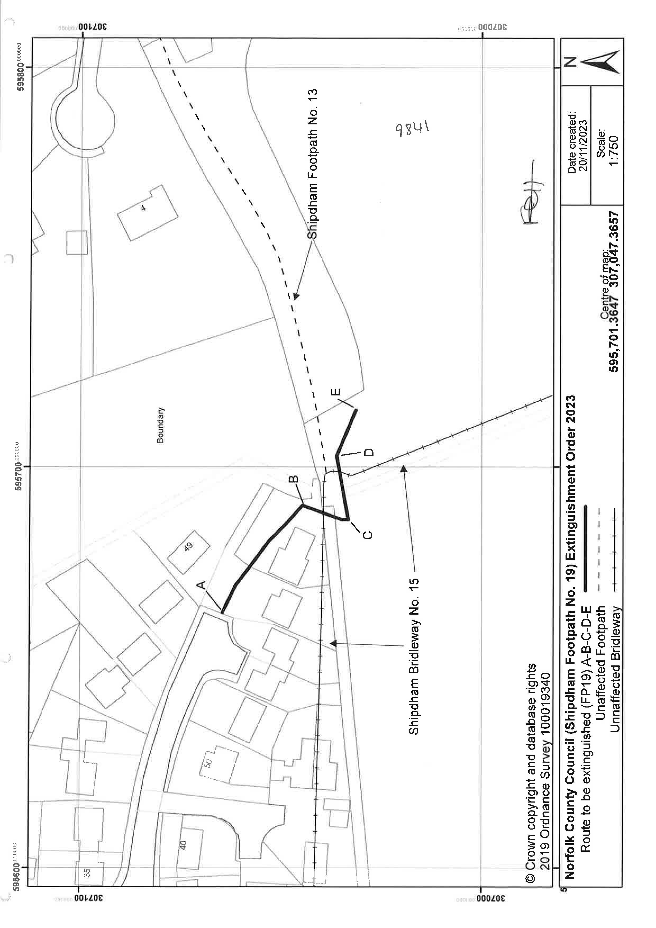

Norfolk County Council (Shipdham Footpath No.19a) Creation Order 2023 Order Plan
- 