

Order Decision
Inquiry held on 21 April 2026
by James Blackwell LLB (Hons) PGDip, Solicitor
An Inspector appointed by the Secretary of State for Environment, Food and Rural Affairs
Decision date: 20 May 2026

Order Ref: ROW/3360619
- The Order is made under Section 118 of the Highways Act 1980 and is known as the Essex County Council Public Path Extinguishment Order 2024, Footpath 70 Wimbish in the District of Uttlesford.
- The Order is dated 18 July 2024 and proposes to extinguish part of a footpath within Wimbish, as shown on the Order Plan and described in the Order Schedule.
- There was one objection outstanding when Essex County Council submitted the Order to the Secretary of State for Environment, Food and Rural Affairs for confirmation.
Summary of Decision: The Order is not confirmed.

Background
- The Order route is located in Wimbish, which is a rural village in the district of Uttlesford. On the plan attached to the Order, the route is shown to pass through land associated with three residential properties: Midfield; Stocks Cottage; and Flora Cottage.
- In terms of Flora Cottage, it is not entirely clear whether the alignment of the footpath which is shown on the Council’s Definitive Map and Statement does actually pass through land associated with this property. Whilst I have assessed the evidence on the assumption that it does (reflecting the Order plan), my overall conclusion would have been the same, even if I had assessed the route as running outside of this property.
- The applicant for the Order is the owner of Midfield, and Essex County Council, as Order Making Authority (OMA), also supports the Order. Conversely, the Parish Council objects to the Order on the basis that the footpath is still used, and would continue to be used in future. The Open Spaces Society (OSS) objects to the Order on similar grounds.

Main Issues
- The Order was made on the grounds that the footpath is no longer needed for public use. Under Section 118(2) of the Highways Act 1980 (HA 1980), if I am to confirm the Order, I must be satisfied that it is expedient to extinguish the path, having regard to:
- the extent to which it appears that the footpath would, apart from the Order, be likely to be used by the public; and
- the effect that the extinguishment of the footpath would have as respects land served by the footpath, account being taken of the provisions as to compensation.
- I have had regard to the judgments of R v SSE ex parte Stewart [1980] KPL 537 and R v SSE ex parte Cheshire County Council [1991] JPL 537 which clarified the relevant tests to be applied. Whilst the Order Making Authority must consider the need for the path when making an Order, I must consider its likely future use.
- In accordance with section 118(6) HA 1980, any temporary circumstances preventing or diminishing the use of the path by the public shall be disregarded. I must also have regard to any material provision of any rights of way improvement plan prepared by any local highway authority whose area includes land over which the order would extinguish a public right of way.

Reasons

The extent to which it appears that the footpath would, apart from the Order, be likely to be used by the public
- The route begins near to Midfield at point A, where it initially passes through a wooded area of land. The footpath then crosses a shallow ditch, and follows a route through an informal parcel of land associated with Stocks Cottage. The route continues on through an agricultural grazing field, before crossing the boundary into land associated with Flora Cottage, and then exits again towards point B, where it intersects with Footpath 67.
- The evidence suggests there have been several obstacles to usage of the footpath, which include dense and overgrown foliage in the wooded area around point A, and a lack of a footbridge over the ditch near to where the path exits the woodland. Whilst obstructed, usage of the path would invariably have been low.
- Nonetheless, records show that several enquiries have been made to the Council since 2018, highlighting these obstacles to use of the path. Whilst the number of enquiries is relatively low, they must be considered in the context of the path’s rural setting and expected levels of use. Indeed, Wimbish is a small rural community where levels of use would not be expected to be high - a position accepted by the OMA during the Inquiry. In turn, whilst limited in number, I consider these enquiries do suggest a reasonable level of usage (or attempted usage) of the footpath, particularly in the context of its location.
- I appreciate Byways 98 and 100 do provide an alternative route between points A and B, which means FP70 is not necessarily needed. However, this is not the correct test for confirmation of the Order: I need to assess likely future use of the footpath, whilst disregarding any obstacles to such use.
- In this instance, I can see why people would want to use FP70: as highlighted by the Objectors, it provides an attractive and pleasant walk through the countryside, and forms part of several circular routes within the area. If the footpath were unobstructed, there is no reason to think it would be used any less than other local recreational footpaths.
- Notably, whilst Byways 98 and 100 do provide an alternative route, these byways also form part of a short circular walk when combined with FP70. If unobstructed, it seems reasonable to conclude that FP70 would be used in addition to these byways, rather than users choosing one route over the other.
- The experience of walking FP70 is also different to the experience of walking along these byways. Whilst acknowledging the seasonal restriction along Byway 100, the byways can, at least for parts of the year, be used by vehicles. The byways also run alongside several residential properties and farm buildings. Conversely, much of FP70 passes through woodland and open fields, and therefore provides a more peaceful and rural experience. In turn, if users were choosing between the two options as part of a larger route, I consider a reasonable proportion would opt for FP70 in preference to the byways.
- If the Order were not confirmed, I therefore consider that the footpath (if reinstated), would likely be used at a level similar to other recreational footpaths in the local area.

The effect that extinguishment of the footpath would have as respects land served by the footpath, account being taken to the provisions as to compensation
- As mentioned, the Order route passes through land associated with three separate residential properties: Midfield; Stocks Cottage; and Flora Cottage. The owners of Midfield and Flora Cottage both contend that the path has rarely been used to date, and are concerned that any reinstatement could impact on their privacy and security. In particular, the owner of Midfield says their garden is used by young children to play in, and use of the path could pose a safety risk in this regard.
- Given the relationship between the Order route and these residential properties, the Government guidance on diversion or extinguishment of public rights of way that pass through private dwellings, their curtilages and gardens (DEFRA Presumptions Guidance) is relevant. Where applicable, the guidance says that confirming authorities should be predisposed to confirm an order where the relevant legislative tests under S118 of the HA 1980 are satisfied. This is to help ensure that the interests of landowners are adequately protected, particularly in terms of privacy and security.
- In this instance, the Order route runs through land towards the very edge of these residential properties. The footpath passes through woodland at the very end of Midfield’s paddock/garden, and continues on through an informal area of land which is separate from the main garden to Stocks Cottage. It then passes along the south-eastern boundary of Flora Cottage, just south of some stables, which again appears distinct from the house and its immediate garden area. Irrespective of whether the footpath falls within the curtilage to these properties, in each case, the route is therefore distant from the houses themselves. It also appears very separate from the immediate garden areas around each of these homes.
- Given the degree of separation, any interference on the privacy and security of the occupiers of these properties which may be attributed to use of the footpath is likely to be limited. This includes Midfield, where there appears to be ample space within the principal garden around the house for children to play in, without undue security concerns from the footpath.
- In turn, whilst extinguishment of the footpath may lead to some benefits to the owners and occupiers of the residential properties referred to, I consider such benefits would be minor in this instance.

Rights of Way Improvement Plan
- The OMA says there are no material provisions in its Rights of Way Improvement Plan (ROWIP) which are relevant to the Order, and none of the parties have made any representations to suggest otherwise.

Other Considerations
- Section 11 of the DEFRA Presumptions Guidance says: “it is in the public interest that any change to remove or reduce the impacts on the property owner or occupier of the existing public right of way should, wherever possible, involve diversion or replacement of the way rather than extinguishment alone”. Nonetheless, no diversion or replacement is proposed in this instance.
- To reinstate the footpath, the OMA says a new footbridge over the drainage ditch would be required, as well as a new access point through the boundaries of Flora Cottage. New way markers would also be needed. The OMA suggests the costs of these works would be low, which means they should not place undue burden on the public purse.
- The supporters of the Order question why the Parish Council has waited until now to seek reinstatement of the footpath. However, I must consider likely future use of the footpath, whilst disregarding any temporary obstacles to use. In turn, any previous maintenance of the footpath has limited bearing on my decision.
- The applicant suggests that new housing developments in the area will result in exponential increases to the local population using the local area amenities. Whilst there is limited information before me in respect of such developments, this argument amplifies the likelihood that the footpath would be used in future. As set out, this is one of the key factors that must be considered when determining whether the statutory tests under s118 HA 1980 have been met. In terms of security and privacy of the affected residential properties, for the reasons already set out, I am satisfied the footpath does not cause undue concerns in this regard.
- The applicant expressed concern that the reinstatement works would be carried out by prisoners out on day-release. However, it has since been confirmed that this was never intended to be the case, and there should be no associated security concerns during any such works.
- Whilst the supporters suggest that vegetation clearance works carried out by the Parish Council may have damaged flora and fauna within the wooded area near Point A, there is limited information available on this point. Going forwards, the OMA says the works required to reinstate the footpath would be fairly straightforward. In turn, there is little to suggest they would have any material impact on any flora, fauna or geological or physiographical features encompassed in the Order route. Similarly, there is little suggest such works would adversely affect the needs of agriculture or forestry.

Conclusion on whether it is expedient to confirm the Order
- If FP70 were reinstated, I consider levels of use would be comparable to usage of other recreational footpaths in the area. Whilst extinguishment would provide some privacy and security benefits to the landowners of residential properties along the route, such benefits would be relatively minor. There is also nothing before me to suggest retention of FP70 would conflict with any provision of the Council’s ROWIP.
- In turn, I do not consider that the proposed Order satisfies the legislative tests set out in S118 HA 1980, and it is therefore not expedient to confirm the Order. This conclusion is consistent with the DEFRA Presumptions Guidance, which says confirming authorities should only be predisposed to confirm an Order where the relevant legislative tests are met.

Overall Conclusion
- Having regard to the above and all other matters raised in the written representations and during the Inquiry, I conclude that the Order should not be confirmed.

Formal Decision
- I do not confirm the Order.

James Blackwell

Inspector

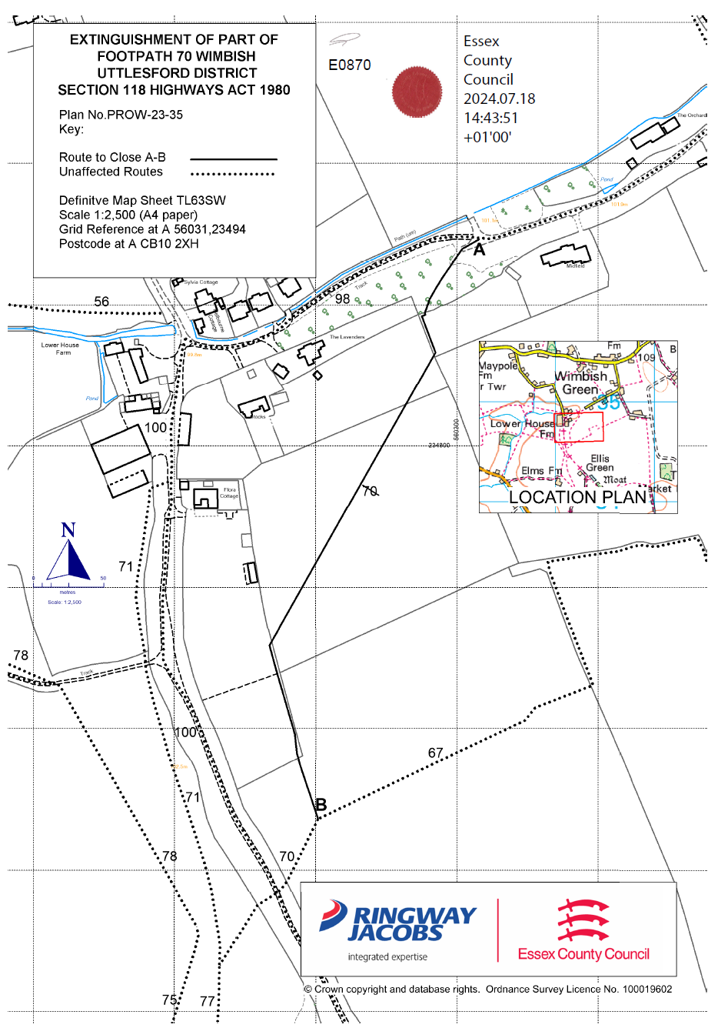

APPEARANCES

FOR THE ORDER MAKING AUTHORITY

Robert Lee
Ned Gemmill

FOR THE APPLICANT

Alex Hamilton

FOR THE PARISH COUNCIL

Edward Browne

FOR THE OPEN SPACES SOCIETY

Katherine Evans

INTERESTED PARTIES

Paul Evans

