

Order Decisions
Inquiry held on 21 April 2026
by K Taylor BSc (Hons) PGDip MRTPI
appointed by the Secretary of State for Environment, Food and Rural Affairs
Decision date: 12 June 2026

Order Ref: ROW/3357784
- This Order is made under Section 26 of the Highways Act 1980 and Section 53A(2) of the Wildlife and Countryside Act 1981 and is known as The Oxfordshire County Council, Beckley & Stowood Bridleway No.21, Noke Bridleway No.18 and Woodeaton Footpath No.12, Public Path Creation and Definitive Map and Statement Modification Order 2023.
- The Order is dated 10 July 2023 and proposes to create 2 bridleways and one footpath as shown on the Order Plan and described in the Order Schedule.
- There were 8 objections outstanding at the commencement of the Inquiry.
Summary of Decision: The Order is confirmed.
Order Ref: ROW/3357790
- This Order is made under Section 119 of the Highways Act 1980 and Section 53A(2) of the Wildlife and Countryside Act 1981 and is known as The Oxfordshire County Council, Noke Bridleway No.10 (part) and Woodeaton Bridleway No.11, Public Path Diversion and Definitive Map and Statement Modification Order 2023.
- The Order is dated 10 July 2023 and proposes to divert one bridleway and part of another bridleway as shown on the Order Plan and described in the Order Schedule.
- There were 8 objections outstanding at the commencement of the Inquiry.
Summary of Decision: The Order is confirmed.

Preliminary Matters
- I have referred to points shown on the Order Plans within my decision. For ease of reference, I have appended a copy of these plans to the end of this decision. Both Orders refer to several sections of bridleway which are named differently for administrative reasons as they extend across multiple parish boundaries. When referring to a whole route or section of a route I have generally refer to this in the singular, even when it relates to several named sections.
- I undertook an unaccompanied site visit on 20 April 2026 where I observed the existing bridleway, the Order routes, and other nearby routes including Woodeaton Footpath No. 7 and Woodeaton Bridleway No. 8 located on the south west side of the B4027. In addition, I walked along a section of the B4027 from close to point D to and beyond point J with a combination of walking along the metalled road and the highway verge.

Main Issues
- The Inquiry related to 2 separate Orders which were made concurrently.
- In respect of the Creation Order, Under Section 26 of the 1980 Act, if I am to confirm the Order, I need to be satisfied that there is a need for the bridleways and footpath and that it is expedient that they should be created, having regard to:
- the extent to which the paths would add to the convenience or enjoyment of a substantial section of the public, or the convenience of persons resident in the area; and
- the effect which the creation of the paths would have on the rights of the persons with an interest in the land, account being taken of the provisions for compensation.
- In respect of the Diversion Order, Section 119(6) of the Highways Act 1980 (the 1980 Act) involves three separate tests for an Order to be confirmed. These are:
TEST 1: whether it is expedient in the interests of the public for the paths to be diverted. This is subject to any altered point of termination of the path being substantially as convenient to the public.
TEST 2: whether the proposed diversions are substantially less convenient to the public.
TEST 3: whether it is expedient to confirm the Order having regard to the effect which— (a) the diversion would have on public enjoyment of the path as a whole, (b) the coming into operation of the Order would have as respects other land served by the existing public right of way, and (c) any new public right of way created by the Order would have as respects the land over which the right is so created and any land held with it.
- In determining whether to confirm the Order at Test 3 stage, (a)-(c) are mandatory factors. On (b) and (c) of Test 3, the statutory provisions for compensation for diminution in value or disturbance to enjoyment of the land affected by the new paths must be taken into account, where applicable.
- In respect of both Orders, regard must also be had to any material provision contained in a rights of way improvement plan (ROWIP) for the area under section 119(6A). Other relevant factors are not excluded from consideration and could, for instance, include those pointing in favour of confirmation.

Reasons

The Creation Order

The need for the proposed paths
- The B4027 is a busy road with fast moving traffic. I observed large vehicles such as busses and heavy goods lorries using this road. While it is possible to walk along the highway verge, rather than the metalled road, in places this is not possible for the full length of the route. There is a bend in the road close to point D which limits a driver’s visibility of any pedestrian, cyclist or horse rider travelling along or next to the road. Traveling along this section of road by foot, bicycle or on horse would feel unpleasant and unsafe.
- The creation of the new section of bridleway (N-M-L-K-E) would allow a link from Woodeaton Bridleway No. 8, onto the diverted route and then access to the bridleway network to the north of the B4027. This would require crossing the road on horse back to connect to the new bridleway. The road is relatively straight in this location with good visibility in either direction which would allow for riders to cross safely. The new bridleway would avoid the need for riders to travel along the main road. Considering the safety issues, it is likely that most riders would choose not to take this journey to connect with Noke Bridleway No. 10 and evidence to this effect was heard at the inquiry. The highway verge is very uneven underfoot and so it is not suitable for use by horse riders. Given the connections that would be created there is a need for the proposed bridleway.
- The creation of the new section of footpath (J-I-H) will provide a link from Woodeaton Footpath No. 7 to the diverted route and then to the wider public rights of way network on the northern side of the B4027. This would require crossing the road which can be achieved safely, and avoid walking along the road to meet with Noke Bridleway No. 10 near to point D. There is therefore a need for the proposed section of footpath.

The extent to which the path would add to the convenience or enjoyment of a substantial section of the public, or the convenience of persons resident in the area
- The proposed bridleway and footpath will provide links over the B4027 to the public rights of way network to the northern side of the road without the need to travel along the B4027. This would add significantly to the convenience and enjoyment of a substantial section of the public including those resident in the local area.
- The ground where the bridleway is proposed to be created is uneven and wet underfoot in places. Works to create the path could minimise this such that a bridleway which is convenient to use could be provided. The proposed section of footpath will include walking through a ditch adjacent to the highway. While this would require negotiating changes in gradient along the route, the ditch is not so deep that it would be an impediment to most users. It is also possible for the Order Making Authority (OMA) to explore options for providing a small footbridge at this location.

The effect which the creation of the footpath would have on the rights of persons interested in the land, taking account of the provisions as to compensation
- Both the proposed bridleway and footpath would be through areas of wooded land which does not appear to be used for productive agricultural purposes and as such the impact on the persons with an interest in the land would be limited. In this case the landowners have consented to the creation of the paths.

The Diversion Order

Whether it is expedient in the interests of the public that the paths in question should be diverted
- In isolation, the diversion of the bridleway would not result in any benefits to the public. The effect of the Diversion and Creation Orders together is considered below.

Whether any new termination point is substantially as convenient to the public
- The termination points at either end of the diverted route (points A and D) are located on the existing bridleway and as such these are substantially as convenient to the public.

Whether the new path will not be substantially less convenient to the public
- The OMA report that the diverted route would be 378 metres longer than the existing route. Given the location and nature of the route it is likely that most users on foot or bicycle would be using it for recreational, including exercise, purposes. This would also likely be as part of a longer journey where the additional length would be very modest in the context of the overall journey and only add a few minutes of extra time.
- There is evidence that some members of the public use the route as part of a commute on foot or bicycle. Any additional length and increase in journey time would be more inconvenient in this context. However, any commuting journey would necessarily include other paths and roads and the additional length is unlikely to add significant inconvenience for most commuters.
- Horse riders are highly likely to be solely using the route for recreational purposes, it would not be substantially less convenient in this context. Two 90 degree turns are included in the diverted route, but the width of the path would allow for this to be easily navigable on foot, cycle and horse. Overall, the route would be less convenient to the public, but not substantially so.

The effect of the diversion on public enjoyment of the path as a whole
- Part of section A-B crosses an open field without boundary vegetation on both sides. This provides an environment with an open feel, which adds variety when traveling along the whole of the bridleway. The diverted route does not contain a section with an open aspect on both sides and so there would be some loss of enjoyment, but the effect of this will be modest given the short length of this open section. There are also open longer views from this section of the existing route. This experience will be diminished but there would still be some opportunities to experience this view close to point A and when traveling north along part of section E-A. In these respects there would be a small loss of enjoyment as a result of the diversion.
- The remainder of section A-B passes by the boundary of Beckley Manor and is enclosed on one side with tall vegetation. This is similar to the experience of traveling along section A-E and so, for this section the effect on public enjoyment will be minimal.
- The definitive alignment for the bridleway is largely away from the road and as such it is experienced in an environment with limited road noise. The diverted alignment includes a section of route which, while set back significantly from the road, it is in a location where road noise will be audible. For this section there will be some diminished enjoyment for users, but other sections, including significant parts of A-E, will not be greatly affected by road noise. Given the degree of tree and hedge screening, vehicles using the road will not be readily visible for users on the diverted route and in this respect, there will not be any substantive effects on the enjoyment of users.
- Where the diverted route would be closer to the road, there is concern that it would not be as safe as the definitive alignment for those walking dogs particularly if dogs are allowed off the lead. The diverted route will be significantly set back from the road, however it is still possible that a dog off the lead could access the road. It is each owner’s responsibility to ensure their animal is under control and other sections of a longer walk, using the diverted route, would remain substantially distant from any road. While the diverted route would be less enjoyable for some dog walkers, this would not be significant.
- Evidence given at the Inquiry was that the current alignment of section A-B-C was as the result of an earlier diversion of Noke Bridleway No.10. Section C-D, and the route to the south east of point A, remain on the historic alignment. The diversion resulted in the bridleway being moved away from Beckley Manor and out of the garden. Notwithstanding that the full extent of Noke Bridleway No.10, and Woodeaton Bridleway No.11, are not on a historic alignment this is nevertheless close to it and some users enjoyment of the route will be associated with its close alignment to a historic route. There will be some loss of enjoyment through the further variance from this historic alignment.
- Overall, there will be a small reduction in the enjoyment that the majority of the public are likely to experience.

The effect of the diversion on other land served by the existing paths and the land over which the new paths would be created
- The diverted route is located on land within the same ownership as the definitive alignment and the landowner is supportive of the diversion. As such, there are no matters of concern in this respect.

Other considerations
- The Diversion Order and the Creation Order are interdependent on each other, in particular the majority of the benefits associated with the Creation Order would only accrue if the diverted route was also brought into being. Linking Woodeaton Footpath No. 7 and Woodeaton Bridleway No. 8 to the routes north of the B4027 without any substantive travel along the road is a very significant benefit. When this is considered against the relatively minor disbenefits associated with the convenience and enjoyment for users of the diverted paths, the benefits significantly outweigh these. Overall, this other consideration indicates that it is expedient that both the Diversion Order and the Creation Order should be confirmed.

Duty to consider the needs of agriculture, forestry, and conservation
- Under section 29 of the 1980 Act, there is a duty to have due regard to the needs of agriculture and forestry and the desirability of conserving flora, fauna and geological and physiographical features. The alignment of the diverted path is within agricultural land. Although overall a greater area of land would be affected by the route, a significant portion would be within a wooded area which is less likely to be used for productive agricultural use such as grazing. Similarly, the newly created paths would be through wooded areas which have limited productive agricultural use and tree removal is likely to be modest. Overall, the effect on agriculture would be minimal.
- The paths will pass through wooded areas, but there is no evidence that significant removal of trees would be required to create or maintain the paths. The effect on flora and fauna would be minimal and similar to the existing alignment. There is no evidence to indicate that the provision of the paths will result in undue ecological effects. There would be no effect on geological or physiographical features.

Rights of Way Improvement Plan
- When considered together, the Diversion and Creation Orders would align with Aims 1, 2 and 3 of the Oxfordshire Rights of Way Management Plan (the OMA’s ROWIP). These seek to improve public rights of way, balance the current and future needs of communities, farmers and the natural environment and secure a reasonably accessible public rights of way network including for those with limited mobility and vision.

Other Matters
- The benefits associated with the Creation Order could be provided if an alternative option to also create section E-F-G-H-D (and possibly also section E-A) but without diverting section A-B-C-D. The OMA report that the landowner did not wish to have this field surrounded on all sides by public rights of way and that, in its view, the 2 Orders as proposed is a suitable compromise position. While alternative options to secure the benefits that would arise with the Creation Order exist, this is not in the Orders as made and there is no evidence that this is likely to come forward. As such I do not give this matter any significant weight.
- It has been suggested that, based on historic documentary evidence, a public right of way may subsist on the track which is close to point M and heads north east where it meets with Noke Bridleway No. 10. If an Order were ultimately confirmed for this it would aid with connectivity with Woodeaton Bridleway No. 8. There is no guarantee that a public right of way subsists on this path and in any event, it would not aid with the connectivity of Woodeaton Footpath No. 7. This is not a substantive matter in considering whether the Orders should be confirmed.
- The diverted route would result in the definitive route being set further away from Beckley Manor than currently. It has been suggested that the Diversion Order should have been made in the interests of the landowner, rather than the public. The diverted route, when considered with the newly created routes, does result in benefits to the public and as such, the Order has been made appropriately. While there may also be some benefits for the landowner, this is not a significant factor and does not undermine the benefits that would result from both Orders. Similarly, any other reasons the landowner may have proposed the diversion or any future plans for their land are not matters of significance in considering whether these Orders should be confirmed.
- The Orders, as made, are different to earlier options upon which the Council carried out consultation. Any earlier options are not substantive matters in considering whether these Orders should be confirmed. The necessary consultation was carried out for these Orders where there was an opportunity to raise any objections.

Overall Conclusions
- Having regard to the above, and all other matters raised, I conclude that it is expedient that both Orders should be confirmed.

Formal Decisions

The Creation Order (ROW/3357784)
- I confirm the Order.

The Diversion Order (ROW/3357790)
- I confirm the Order.

K Taylor

INSPECTOR
APPEARANCES

For the Council
Ms Hazelwood, who called:
Mr Sylvester – Rights of Way Officer Oxfordshire County Council

In support of the Orders
Ms Flaxman
Mr Moon – Council for the Preservation of Rural England
Ms George – British Horse Society

Objecting to the Orders
Ms Camps-Walsh – Beckley and Stowood Parish Council
Mr Goad
Mr Smith
Mr Hall

DOCUMENTS
- Supplementary Statement of Case from Mr Moon, Council for the Preservation of Rural England
- Proof of Evidence from Ms Camps-Walsh – Beckley and Stowood Parish Council
- Proof of Evidence from Mr Hall
- Proof of Evidence from Mr Smith

Diversion Order Plan (not to scale)
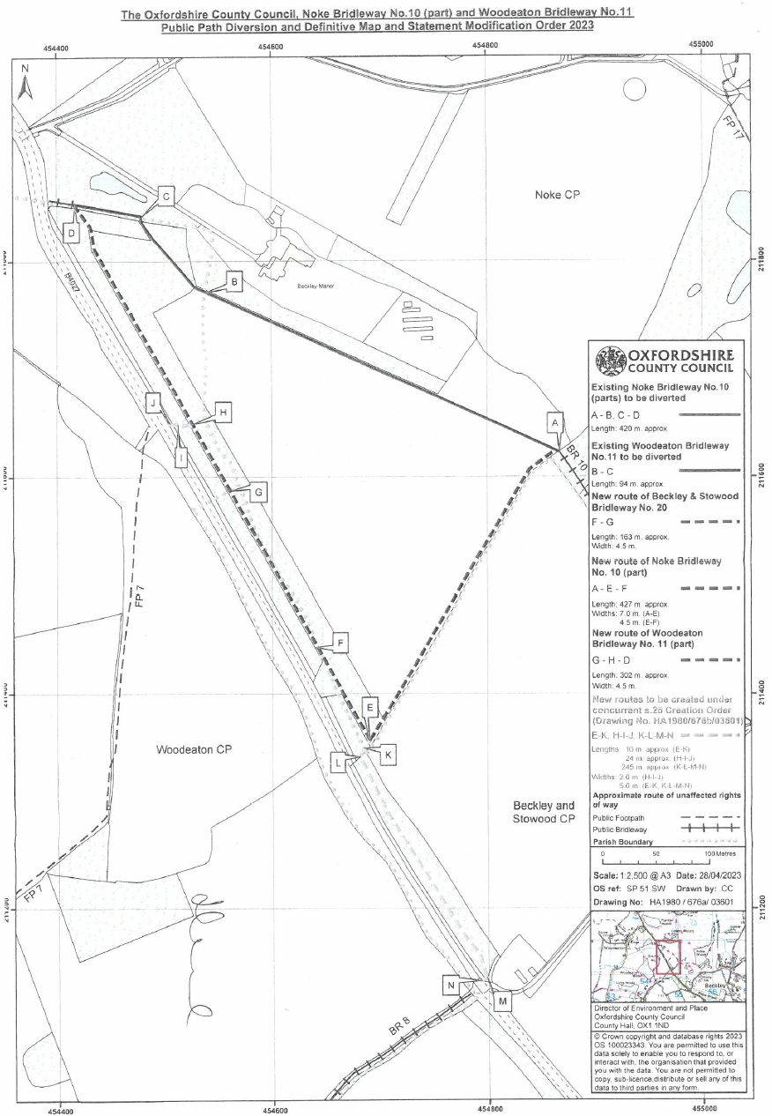
Creation Order Plan (not to scale)
