

Order Decision
Site visit made on 17 March 2026
by K Taylor BSc (Hons) PGDip MRTPI
An Inspector appointed by the Secretary of State for Environment, Food and Rural Affairs
Decision date: 20 May 2026

Order Ref: ROW/3356353
- This Order is made under Section 119 of the Highways Act 1980 and Section 53A(2) of the Wildlife and Countryside Act 1981. It is known as Devon County Council (Footpath No. 2, Bere Ferrers) Public Path Diversion and Definitive Map and Statement Modification Order 2024.
- The Order is dated 30 May 2024 and proposes to divert part of Footpath No. 2, as shown in the Order plan and described in the Order Schedule.
- There was 1 objection outstanding when Devon County Council submitted the Order to the Secretary of State for Environment, Food and Rural Affairs for confirmation.
Summary of Decision: The Order is confirmed.

Preliminary Matters and Background
- I conducted an accompanied site visit on Tuesday 17 March 2026, with representatives from the Order Making Authority (OMA), the objectors (and adjacent landowners), the landowners and applicants, and representatives from The Ramblers. For ease of reference, I have attached a copy of the Order plan and another plan (showing other relevant routes) to the end of this decision.
- In 1972 an Order (the 1972 Order) was made to divert the definitive line of Footpath No.2 from its original alignment. The evidence indicates that the intention was that the alignment of the eastern end of the 1972 Order route was located a little to the north meeting the access track through a field gate which was marked on the 1972 Order plan near point E. However, as drawn, the alignment passes through a barn and a hedge bank where it meets the access track. For a considerable period of time, from at least the 1990s but likely earlier, an unofficial alignment existed which is shown on the second plan appended to this decision (points F-G-H-I-E).
- Prior to 2017 Shutecombe Barn and its garden, the land to the north, and the field to the north of that, were all in the same ownership. In 2017 the owner sold Shutecombe Barn to the current owners and applicants for the diversion. In 2022 the remainder of the land was sold, with the plot to the immediate north sold to the new owners of Shutecombe Barn and the field to the north of that to the objectors. The unofficial diverted alignment was closed, an application was made to divert the footpath, and subsequently this Order was made.
- Most of the Order route is on land to the north of Shutecombe Barn and its garden (points A to D). Part of the diverted route (points D to E) is located on an access track, this is in separate ownership to Shutecombe Barn.

The Main Issues
- The relevant tests for public path diversion orders are set out in Section 119(6) of the 1980 Act. This involves three separate tests for an Order to be confirmed. These are:
- Test 1: whether it is expedient in the interests of the landowner, occupier, or the public for the path to be diverted. This is subject to any altered point of termination of the path being substantially as convenient to the public.
- Test 2: whether the proposed diversion is substantially less convenient to the public.
- Test 3: whether it is expedient to confirm the Order having regard to the effect which; (a) the diversion would have on public enjoyment of the path as a whole, (b) the coming into operation of the Order would have as respects other land served by the existing public rights of way, and (c) any new public rights of way created by the Order would have as respects the land over which the rights are so created and any land held with it.
- In determining whether to confirm the Order at the Test 3 stage, (a)-(c) are mandatory factors. On (b) and (c) of Test 3, the statutory provisions for compensation for diminution in value or disturbance to enjoyment of the land affected by the new paths must be taken into account, where applicable.
- I also need to have regard to any material provision of any rights of way improvement plan (ROWIP) prepared by any local highway authority whose area includes land over which the Order would divert public rights of way.

Reasons

Whether it is expedient in the interests of the landowner that the path should be diverted
- The objectors consider that part of the Order route, close to point D is within their ownership. Land registry information including the Title Registers for all of the relevant plots of land and the associated maps have been provided. Land Registry maps are not necessarily sufficiently accurate to precisely define the boundary line between properties. Nevertheless, these do show the shape and location of the boundaries which can be seen in the context of the situation on the ground.
- The diverted route between Point A to close to point D is located within land registry plot Title Number DN749443. The access track where the diverted route between point D to E is located is within the land registry plot with Title Number DN555070. The objectors’ land has Title Number DN752948. While the diverted route is located close to the objector’s land, the evidence shows it is only located within plots DN749443 and DN555070. The objectors prepared a plan indicating their boundary with the diverted route represented with a blue line. When the Order plan showing the diverted route is compared to the land registry plans and the situation on the ground, it is clear that the blue line on the objectors’ plan is not representative of the Order route. Rather the Order route extends further south east before entering the access track. Overall, the evidence indicates that the diverted route will not be located on the objectors’ land.
- The OMA made the Order in the interests of the landowner. Much of the definitive route sits on land above Shutecombe Barn and outside of the residential curtilage. The very eastern section of the definitive route (near point E) passes through the garden area. For significant sections of the definitive alignment there are clear views down and into the garden of Shutecombe Barn and towards windows of primary living accommodation and a bedroom. This does have significant effects on the privacy of these landowners. On the diverted alignment, due to the topography of the land, these views would be significantly reduced. The definitive route passes through a small portion of the garden and, on this alignment, this would cause privacy and security issues. Therefore, it is clearly expedient, in the interests of the owners of Shutecombe Barn, that the path be diverted.
- The diverted path would run adjacent to the boundary of the objectors’ land. For much of this route there would be clear views into this land. The definitive alignment to the west of point A, which would be unaffected by the proposed diversion, passes through a small area of land owned by the objectors. The privacy for this land is already compromised to a degree, but it would be affected further by the diversion. This land is agricultural land and it is not residential curtilage and as such any effect on the privacy of this land is of limited weight.
- The diverted path would be immediately adjacent to a building located on the objectors’ land. Some acts of maintenance may require a Temporary Traffic Regulation Order which would have some cost implications for the building’s owners. It is not uncommon that footpaths pass buildings and may require Temporary Traffic Work Orders on occasion. While the proximity of the path would have some impact on the adjoining owners, it is not a sufficient reason to not confirm the Order.

Whether any new termination point is substantially less convenient to the public
- The termination points (A and E on the Order plan) both link to the existing public rights of way network and so there would be no effect on the convenience of the public in this respect.

Whether the new path will be substantially less convenient to the public
- The definitive route in the 1972 Order is essentially a straight line from point J to point E. The diversion would introduce a number of turns in the route and would be approximately 15 metres longer. The increased length would be very modest in terms of the overall length of this section of Footpath No. 2, and it would not be noticeable to the majority of users. The increased turns would be marginally less convenient to the users of the path, but in the context of a journey which would include other turns this impact would be very modest.
- Both the definitive route and the diversion are primarily located through a wooded area and would be similar in terms of terrain. There are a small number of shallow steps on the diverted route, and none are present on the definitive alignment. These steps are not difficult to navigate, and they do not make the route significantly more difficult to walk along. Footpath No. 2, and the wider nearby footpath network, contain styles and so any user would need to navigate more significant features than these steps.
- The 1972 Order provides that the definitive route is 4 foot wide. The diverted route would be 2 metres wide between points A to D and then wider along the access track between points D – E. In this respect, the diverted route would be a moderate improvement over the definitive route. In a number of places the terrain and vegetation are such that works would be required to achieve the 2 metre width and the Order provides for the new site of the way to be brought into fit condition at the expense of the landowner.
- Given the nature of the route and the highway network it connects to, the vast majority of members of the public using the route would do so for recreational purposes. In this context, the increased length, additional turns and small number of steps would not be of any significance. Overall, the diverted path would not be substantially less convenient to the public.

The effect of the diversions on public enjoyment of the path as a whole
- The definitive route passes through a wooded area which, for much of its length, is away from any boundary providing a pleasant open feel while walking the route. The diversion would result in the majority of the route being immediately adjacent to a field boundary passing very close to 2 small barns, one on each side of the path. As such the diverted route would have a moderately less open feeling when walking along it. However, the diverted path would remain a pleasant route through a wooded area and it would not be significantly less enjoyable for the majority of the public.
- A greater section of the footpath would be located on the access track between points D to E than is the case on the definitive alignment. On this section there would be some interactions with vehicles accessing the land to the north. A journey along Footpath No. 2 would likely involve walking along the County Road (Shutecombe Lane) and Hensbury lane, where there could also be interactions with vehicles. As such, the modest additional section of the access track as part of the diverted route would not result in any substantive increased risk or inconvenience for users of the path.
- Overall, I consider that the diverted route would not be significantly less enjoyable to the public than the definitive route.

The effect of the diversions on other land served by the existing path and the land over which the new path would be created
- The definitive route, between points A and E, passes through land in 2 separate ownerships. This would not change with the diversion, although a greater portion of the access track would form part of the diversion than is affected by the definitive route. Given the access track is already affected by a public right of way, there would not be any significant effects in this regard.

Duty to consider the needs of agriculture, forestry, and conservation
- Under section 29 of the 1980 Act, there is a duty to have due regard to the needs of agriculture and forestry and the desirability of conserving flora, fauna and geological and physiographical features. There would be no effect on any geological or physiographical feature. There are trees within the land, and the land has previously been used for agricultural purposes. Any loss of trees to facilitate the diversion including future maintenance of the diverted route would be very modest. Given that the diverted path is within the same parcel of agricultural and treed land any effect of the path on agriculture, forestry and conservation would be similar on either alignment and very modest.

Rights of Way Improvement Plan
- The OMA’s ROWIP was published in 2005. Policy LP1B states that applications will be supported to divert paths away from residential buildings to improve privacy. Policy A8 notes that improving privacy to residential buildings is a reason to seek to make diversions in the interests of a landowner. In view of my findings above, the diversion would meet these policy objectives.
- The ROWIP also states that the sharing or defraying of costs will be considered where a diversion would be of benefit to the public. It appears that the costs of the diversion have been defrayed. The formal reasoning for making the Order was not in the interest of the public. Nevertheless, there are public benefits in dealing with the current alignment which passes through a field bank and building. While there may be alternative diverted alignments which would meet this goal, the Order route would also do so. I have had regard to this element of the ROWIP and consider that the OMA’s decision to defray the costs is not a substantive issue in concluding whether it is expedient to confirm the Order.

Conclusion on whether it is expedient to confirm the Order
- I consider that the diversion would be in the interests of the landowners. It would not be substantially less convenient or less enjoyable to the public. I therefore consider that it is expedient to confirm the Order.

Other Matters
- The objectors consider that the application to seek a public path diversion order was not properly made as it did not have the consent of Mr Harrison, the registered owner of the access track. The application form notes that Mr Harrison and Mrs Harrison (Mr Harrison’s sister) had given their consent. The access track is shown with Mr Harrison being the registered owner. However, the transfer for the purchase includes both Mr and Mrs Harrison. There is correspondence from Mr Harrison noting that he does give consent to the proposal but wishes to remain neutral in any dispute. The evidence shows that the landowners of the track consented to the proposal and that the related processes were carried out correctly by the OMA.
- The OMA carried out a Global Navigation Satellite System (GNSS) survey to seek to confirm matters relating to the positioning of the diverted alignment. This was carried out after the OMA’s Public Rights of Way Committee’s resolution to submit the Order for confirmation. A representation from the objectors to the Committee was not reported to the meeting due to administrative matters in respect of the email. Concerns have therefore been raised that the resolution of the Committee was made without the Members being fully aware of all relevant matters. These concerns primarily relate to the administrative process of the OMA and ultimately the objectors have had the opportunity to make full representations at this confirmation stage.
- General concerns have been raised about the manner in which the OMA has sought to address the irregularities associated with the definitive alignment with suggestions that alternative means of addressing this would have been more appropriate than through this diversion. Possible alternative approaches are not relevant to whether this Order should be confirmed. Similarly, matters relating to the permissive path agreement are also not relevant to the confirmation of the Order.
- The objectors have suggested alternative alignments for the diversion which they consider would resolve the primary concerns of the landowners and avoid their own concerns particularly the proximity of the route to their barn and minimising the use of the access track. These alternative alignments are not part of the Order before me, and I must make a determination on the submitted Order.

Conclusion
- I consider that the diversion would be in the interests of the landowners and it would not be substantially less convenient for the public. The enjoyment of the path would not be negatively affected to any significant degree. Having regard to all matters raised in the written representations, I conclude that the Order should be confirmed.

Formal Decision
- The Order is confirmed.

K Taylor

INSPECTOR

Order Plan (not to scale)

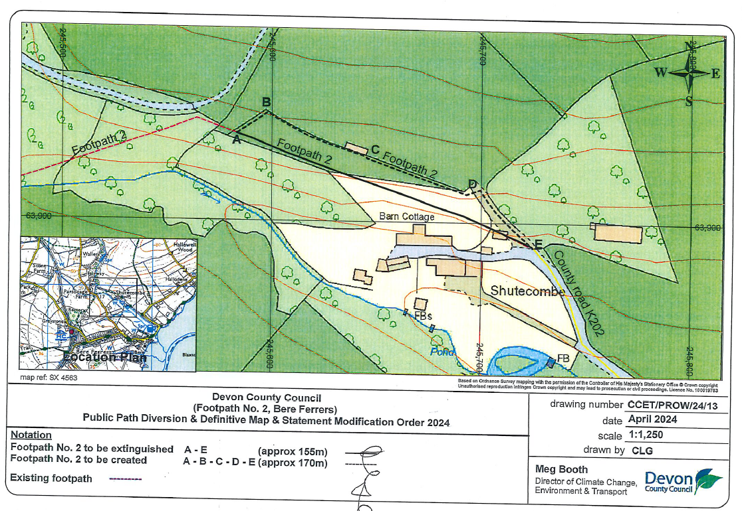

Various Alignments Plan (not to scale)

