

Application Decision
by Dominic Dobbs
Appointed by the Secretary of State for Environment, Food and Rural Affairs
Decision date: 16 June 2026

Application Ref: COM 3367575
Eastside Common and Westside Common
Register Unit Number: CL16 & CL15
Commons Registration Authority: Cambridgeshire County Council

- The application, dated 11 June 2025, is made under Section 38 of the Commons Act 2006 (the 2006 Act) for consent to carry out restricted works on common land.
- The application is made by Anglian Water Services Limited
- The works comprise:
- The excavation of trenches for archaeological investigations totalling approximately 1050m at multiple sites across the common.
- The laying of public sewer pipeline across an approximate 7.4km pipe route
- Temporary fencing for exclusion from the working areas.

Decision
- Consent is granted for the works in accordance with the application dated 11 June 2025 and the plans submitted with it subject to the following condition:
- the works shall begin no later than three years from the date of this decision;
REASON: To provide certainty to users of Eastside Common and Westside Common.
- the land shall be fully reinstated within one month from the completion of the works and the restoration of the affected trees and hedgerows will be initiated (note that this does not apply to any physical changes or permanent features introduced as part of the works for which consent is granted);

REASON: To retain access for commoners, public and livestock across Eastside Common and Westside Common
- Any temporary fencing shall be removed within one month of completion of the works.
REASON: To retain access for commoners, public and livestock over Eastside Common and Westside Common.
- For the purposes of identification only the location of the works is shown on the attached plans.

Preliminary Matters
- I have had regard to Defra’s Common Land Consents Policy Guidance (November 2015) in determining this application under section 38, which has been published for the guidance of both the Planning Inspectorate and applicants. However, every application will be considered on its merits and a determination will depart from the guidance if it appears appropriate to do so. In such cases, the decision will explain why it has departed from the guidance.

- This application has been determined solely on the basis of written evidence. I have taken account of the representations made by the Open Spaces Society (OSS), Natural England (NE) and Historic England (HE)

- I am required by section 39 of the 2006 Act to have regard to the following in determining this application:
- the interests of persons having rights in relation to, or occupying, the land (and in particular persons exercising rights of common over it);
- the interests of the neighbourhood;
- the public interest; Section 39(2) of the 2006 Act provides that the public interest includes the public interest in; nature conservation; the conservation of the landscape; the protection of public rights of access to any area of land; and the protection of archaeological remains and features of historic interest;
- any other matter considered to be relevant.

Reasons
- The applicant outlines that the proposed excavations are required in order to lay a new sewer pipeline to provide and maintain services in the area. They are also using the opportunity to conduct archaeological investigations along the pipeline.

The interests of those occupying or having rights over the land
Anglian Water Services Limited Plc are the applicant and the works are in their interest. The common land register records multiple rights to graze animals over the whole of the land on the Commons.
- I am satisfied that the applicant has carried out the required consultation and no further comments were received, and the planned works would not interfere with the interest of those occupying or having rights over the land.

The interests of the neighbourhood and public access
- The interests of the neighbourhood relate to whether the works will unacceptably interfere with the way the common land is used by local people and is closely linked with interests of public access.

- This application covers land over two Commons, namely Eastside Common and Westside Common, with the trench route covering a large section of the Commons green and natural spaces.

- The digging of the trenches both to lay the pipeline and to allow the archaeological investigations would create an impediment to access on the Commons where they are located. However, the trenches will be temporary in nature and the applicant has outlined the works will be completed in sections where the back filling of each section will mitigate the impact of the scale of the works.

- The sewer pipeline would be a permanent feature however is located below the surface of the Commons and therefore will not impact access to and across the Commons.

- The temporary fencing would impact access, blocking access to the areas of the Commons where the works are taking place. However, the impact will be minimal when considering the overall size of the Commons, which will also remain accessible via other routes. The fencing is also planned to be temporary in nature. I am satisfied that such fencing is appropriate on health and safety grounds and that it will be removed on completion of the works, which can be secured by attaching a suitable condition to the consent.

- Overall, I do not believe the works as planned would create any unacceptable barrier to people’s access to and across the Commons.

- I am of the view that this area of land has recreational value as an open area of green space for walking and for open air activities. The aim of these works is to maintain and continue the services to those living and working in the area and to allow for the archaeological investigation to take place which in the long run will not impact on these values. Additionally, the maintenance works is in the public interest of those living in the area.
- NE have been consulted on the application and stated that whilst the works may cause temporary disruption to users of the Commons however, based on the information available, they do not anticipate that the works will have any significant adverse effects on accessibility for the public.

- I am of the opinion that the works will have a minimal impact on people’s ability to access the Commons or to the recreational value of the Commons for the duration of the works. Furthermore, the works will likely be in the interest of individuals living in the area by improving and maintaining of the services provided.

The public interest
- As well as the public interest in the protection of public rights of access, the Guidance (November 2015) outlines the public interest in nature conservation, the conservation of the landscape and the protection of archaeological remains and features of historic interest.

Nature conservation and conservation of the landscape

- NE has highlighted that areas of the works will impact on the Portholme Special Area of Conservation (SAC) flood meadow lies which lies 3km upstream of the proposed works and the Ouse Washes SSSI, SAC and Ramsar wetland site lies 16km downstream and is supplied by water from the River Great Ouse.

- They outline that there should be no significant effects on SSSIs if the assessment carried out by the applicant are complied with and good practice CEMP measures are followed, including monitoring and reactive measures for Eastside Common. NE outline that reducing the flooding risk to the existing sewer network in Huntingdon is vital, and the effect of these proposals will reduce water pollution impacts on the River Great Ouse, the ecological status of which is currently rated by the EA as moderate outlining less pollution in the river will benefit the Protected Sites that lie in the floodplain and receive floodwaters from the river.

- NE have stated that they have been in direct contact with the applicant and were sent a draft Habitat Regulations Assessment (HRA) for the pipeline scheme. They agreed with their overall HRA screening decision and we have provided further comments to inform the ongoing development of that document with the applicant.

- The proposed works will have an impact on the visual qualities of the Commons as they involve the digging of trenches for the laying of the sewer pipeline, however this impact will be temporary in nature and the impacts can be mitigated by attaching the appropriate condition for the restoration of the Commons once the works are complete.
- NE have also asked that the loss to hedgerow crossings should be minimised by: using existing gaps; ensuring works take place in accordance with the Management of Hedgerows (England) Regulations 2024; and using a specification (including species, numbers, sizes and establishment / maintenance / replacement for a 5 year period) drawn up to support mitigation works as set out in the applicant’s Landscape and Visual impact Appraisal.

- In addition, they would wish to see existing gaps replanted (where this does not impact access to and across the Commons) to provide for enhancement to the existing hedgerow condition.

- Overall, I am of the view that the works will temporally negatively impact on nature conservation interests of the Commons and impact the landscape interests of the Commons. However, these will be temporary in nature, and with the planned restoration and guidance from NE I do not believe the impact on the Common would be significant or permanent to where the planned works could not proceed. Once the works are complete the reduction of flooding will lead to environmental benefits.

- I have attached the appropriate condition to this decision for the restoration of the land and for the planned restoration of the natural features of the land to be initiated to mitigate the impact of the works to the Commons.

Protection of archaeological remains and features of historic interest.
- HE has been consulted on the application and stated that they note the Common land in these areas is dominated by ridge and furrow and therefore has a strong landscape character, which provides evidence of the former medieval settlement and agriculture of the area. The land affect by the scheme also has a high archaeological potential.

- HE continues that the applicant has sought to pick a route which seeks to minimise the impact on the Common land. Given the historic character, they have however asked the applicant to give due consideration to recreating the ridge and furrow and restoring the character during the re-instatement of the land.

- HE has also stated they would defer to the local planning authority and their archaeological advisors with regards to the archaeological potential and the need for a programme of archaeological woks.

- They would ask the ExA to confirm they are satisfied that the proposal includes sufficient measures to reinstate and retore the historic landscape and recommend the ExA take into consideration the views of Cambridge County Council Historic Environment Team to ensure the programme of archaeological works is sufficient.

- There is no evidence before me to suggest that these interests will be harmed by the proposed works if the above conditions and applied by the applicant.
Conclusion

- In this case I conclude that the works will not prevent prolonged public access to the Commons and the works will not harm the other interests set out in paragraph 5 above. Consent for the works is therefore granted subject to the conditions set out at paragraph 1 above.

Dominic Dobbs

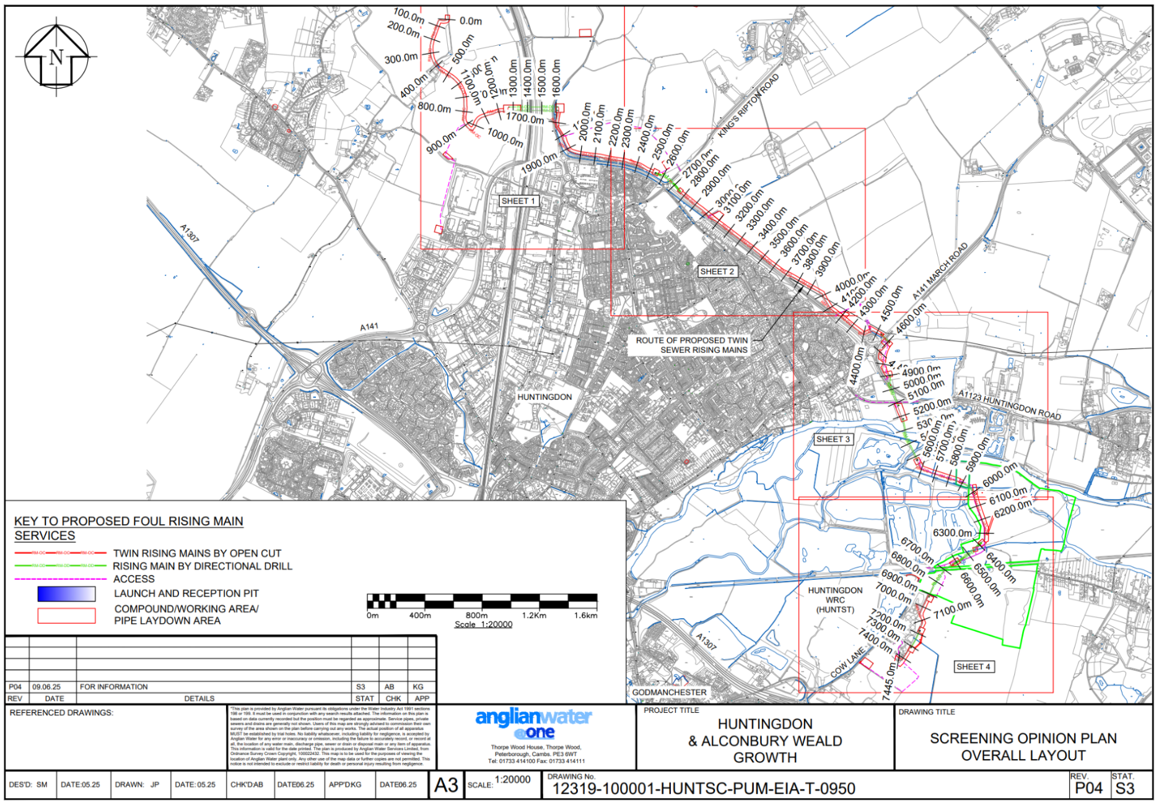
Figure 1 – Location of works on the Common

