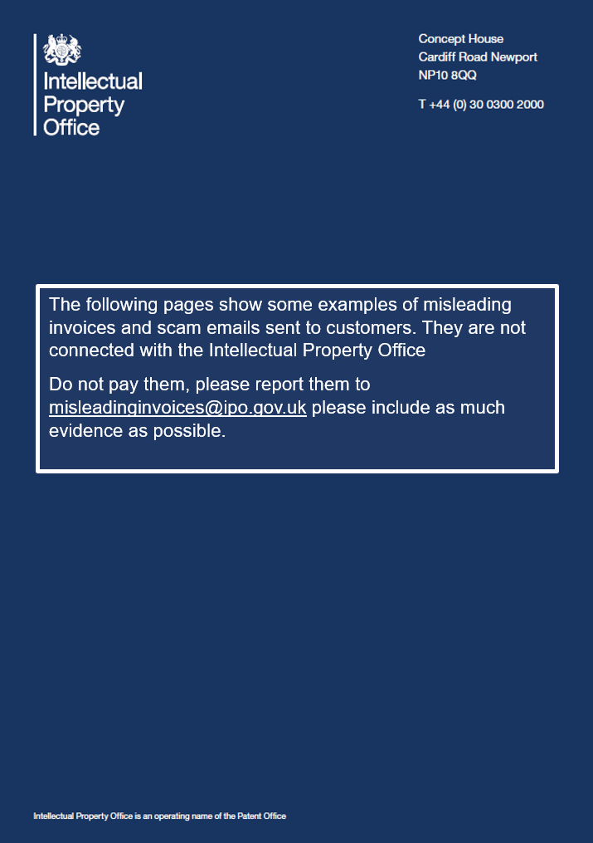

Misleading Invoices – Do not respond or pay
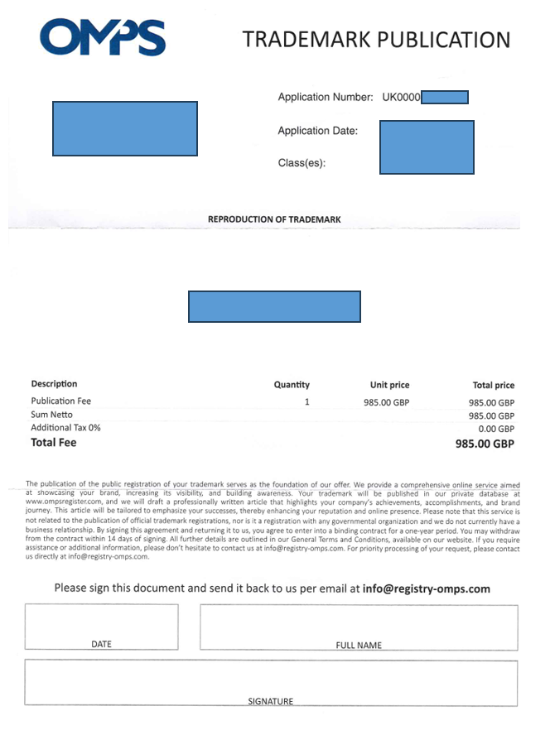

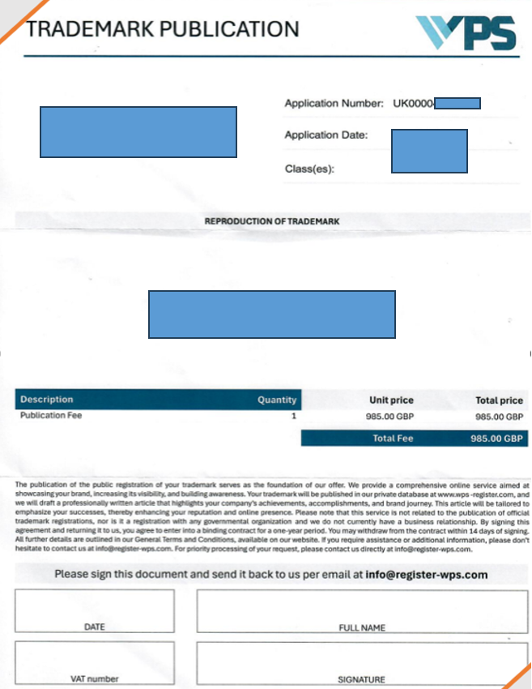

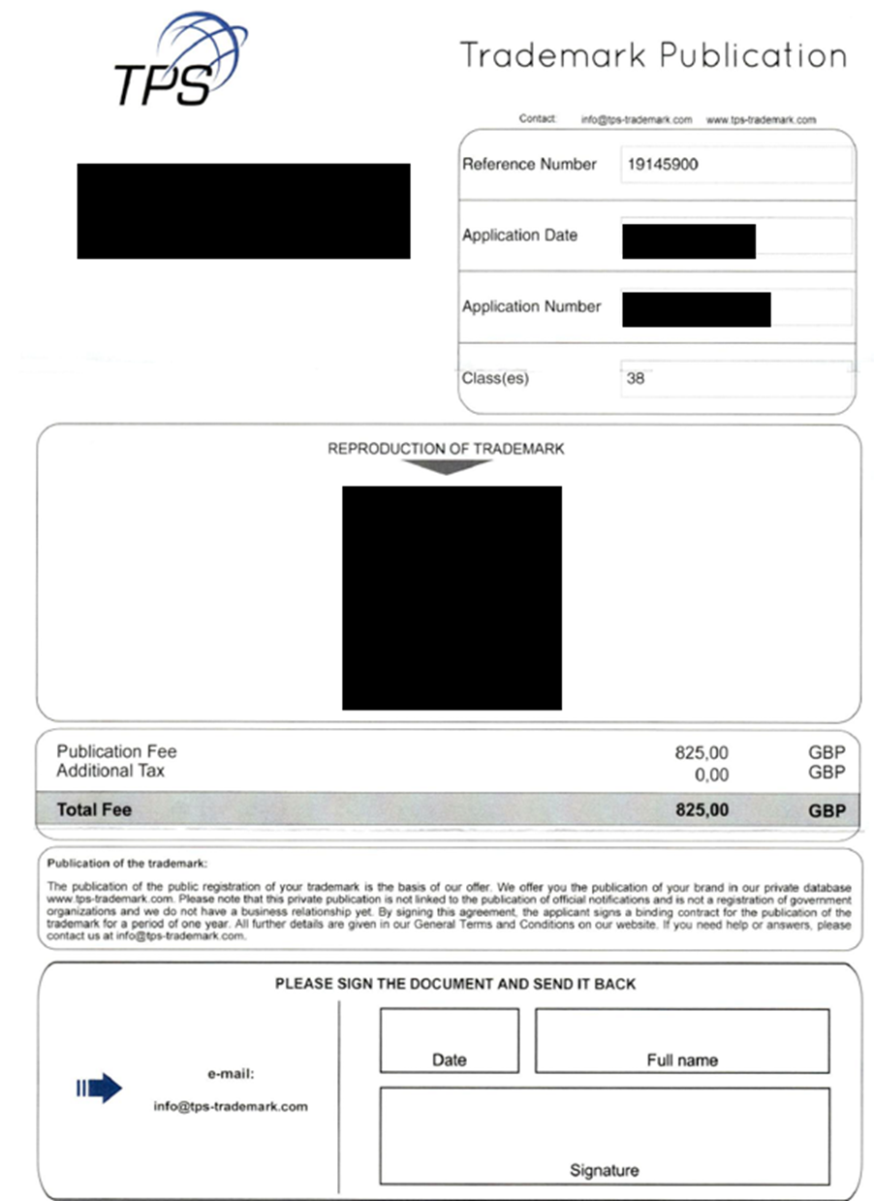
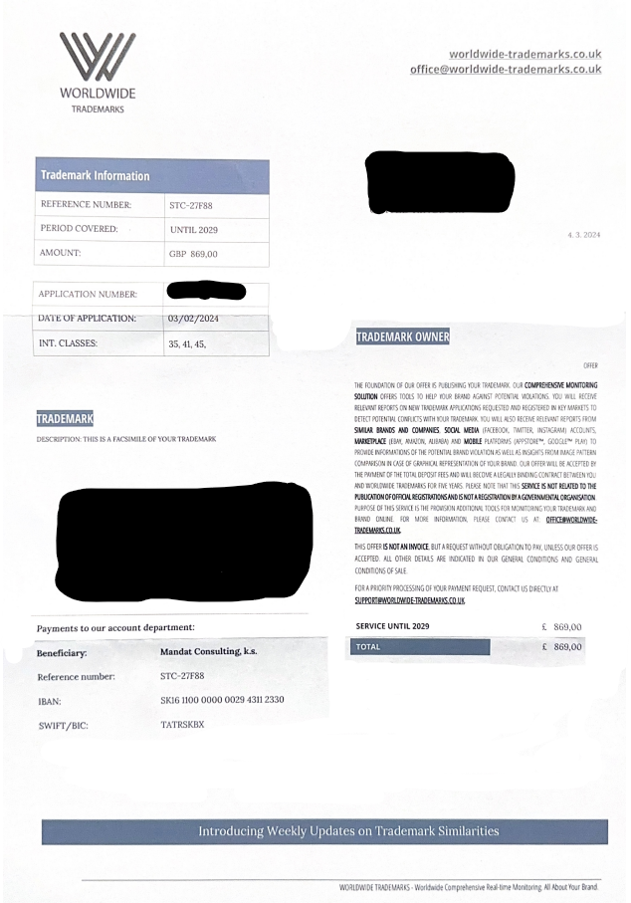
Example of scam emails – Do not respond or pay
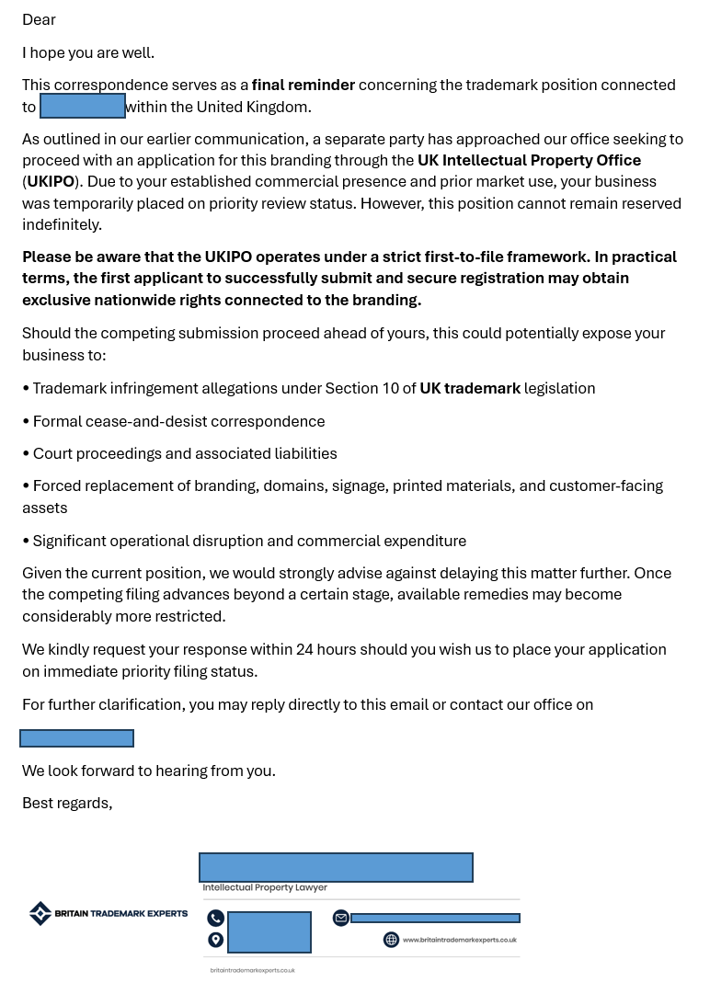

From: Director of Finance - Intellectual Property Office
Date: Friday, 13 December 2024 at 21:51
To:
Subject: Trade mark registration
Dear Sir/Madam,
On 12-10-2024, you applied to the Intellectual Property Office of the United Kingdom, via application number UK0000******, for legal protection in the United Kingdom of the trade mark ***** with Nice classifications 41, 43.

On 13/12/2024, the trade mark you applied for was granted legal protection and received a trade mark registration certificate with the number UK 0000839...
Please be advised that the completion of the registration procedure and the granting of legal protection to the trade mark at the Intellectual Property Office of the United Kingdom will require payment of a fee for the first 10-year protection period. In accordance with the Withdrawal Agreement concluded between the European Union and the United Kingdom, the fee of 1500.00 EUR must be paid to the European Union Intellectual Property Office by 27/12/2024 via SEPA transfer to the account below:
Payee's name: European Union Intellectual Property Office, Av. de Europa, 4 E-03008 Alicante
IBAN (account for transfers from EU and non-EU countries): PL58116022020000000643320832
BIC: BIGBPLPWXXX
Transfer reference: 96j501
Yours faithfully,
******
Director of Finance - Intellectual Property Office
This message was generated on a server used exclusively for the automatic generation and sending of email notifications. Please do not reply.

