www.agulhas.co.uk

www.agulhas.co.uk
Annexes
Evaluation of sustainable growth and investment partnerships between the UK and Tanzania

December 2025

Annexes

Annex 1: Terms of reference 3
Annex 2: Inception Report 4
Annex 3: Documents consulted 5
Annex 4: Evaluation matrix including questions and methods 11
Annex 5: Suggested revisions to the theory of change 13
Annex 6: Influence and communication plan 14
Annex 7: How to evaluate partnership and whole of government approaches to development: Guidance note 16

Annex 1: Terms of reference
[Please see separate document]

Annex 2: Inception Report
[Please see separate document]

Annex 3: Documents consulted
Aceli Africa. (2021, July 20). Preliminary Case Study: Effect of Aceli financial incentives on lending by SME Impact Fund in Tanzania. https://aceliafrica.org/preliminary-case-study-effect-of-aceli-financial-incentives-on-lending-by-sme-impact-fund-in-tanzania/
Aceli Africa. (2022, September 6). Both / And: Facilitating women's economic empowerment in agriculture. https://aceliafrica.org/gender-inclusive-lending-for-agricultural-enterprises/
Aceli Africa. (2023). Aggregate Impact Snapshot – October 2023. https://aceliafrica.org/aggregate-impact-snapshot-october-2023/
Aceli Africa. (2024, May 16). Aceli Africa Reaches $93M in International Donor Commitments. https://aceliafrica.org/aceli-africa-reaches-93m-in-international-donor-commitments-to-unlock-private-sector-lending-to-agri-smes-in-east-africa/
Aceli Africa. (2024). Year 3 Learning Report. https://globaldevincubator.org/aceli-africa-year-3-learning-report/
Aceli Africa. (2025, April 2). 2025 Financial Benchmarking Report. https://aceliafrica.org/2025-financial-benchmarking-report/
African Business. (2023). £373 million support to put United Kingdom exporters at heart of Zanzibar infrastructure upgrades. https://african.business/2023/07/apo-newsfeed/373-million-support-to-put-united-kingdom-exporters-at-heart-of-zanzibar-infrastructure-upgrades?
Bachwa, J. (2024). The Tanzania Tax Reforms Commission Begins Work by Seeking Public Recommendations. https://www.linkedin.com/pulse/tanzania-tax-reforms-commission-begins-work-seeking-public-bachwa-wj82f/
Bertelsmann Stiftung. (2022). BTI 2022 Country Report, Tanzania. https://bti-project.org/en/reports/country-dashboard-TZA.html
British High Commission Tanzania. (2021). Investment and Business Environment. [Internal]
British High Commission Tanzania. (2021). Joint Action Plan. [Internal]
British High Commission Tanzania. (2021). Predictable Policy and Law Formulation. [Internal]
British High Commission Tanzania. (2021). Predictable Policy and Law Formulation Discussion Paper. [Internal]
British High Commission Tanzania. (2021). Taxation. [Internal]
British High Commission Tanzania. (2022). Tanzania Inclusive Growth Diagnostic. [Internal]
British High Commission Tanzania. (2023). Business & Country Planning (BCP): Strategy and Delivery Overview Template. [Internal]
British High Commission Tanzania. (2023). Business and Country Planning (BCP) 6-Monthly Progress Tracker, April 2023-September 2023. [Internal]
British High Commission Tanzania. (2023). Country Plan Progress Report, April 2023-September 2023. [Internal]
British High Commission Tanzania. (2024). Business and Country Planning (BCP) 6-Monthly Progress Tracker. [Internal]
British High Commission Tanzania. (2024). Business and Country Planning (BCP) 6-Monthly Progress Tracker, April 2024-September 2024. [Internal]
British High Commission Tanzania. (2024). Business and Country Planning (BCP) 6-Monthly Progress Tracker, October 2023-March 2024. [Internal]
British High Commission Tanzania. (2024). Country Plan Progress Report, April 2024. [Internal]
British High Commission Tanzania. (2024). Country Plan Progress Report, April 2024-September 2024. [Internal]
British High Commission Tanzania. (2024). UK-Tanzania Mutual Prosperity Partnership. [Internal]
British High Commission Tanzania. (n.d.). Investment and Business Environment Discussion Paper. [Internal]
British High Commission Tanzania. (n.d.). JAP Workstream Planner. [Internal]
British High Commission Tanzania. (n.d.). Prosperity Workplan. [Internal]
British High Commission Tanzania. (n.d.). Taxation Discussion Paper. [Internal]
Conroy, K. (2023). DRAFT Evaluability Assessment for Tanzania British Investment Partnerships Strategy, October 2023. [Internal]
Department for Business and Trade. (n.d.). DBT Tanzania Strategy 2025/2026. [Internal]
Foreign, Commonwealth & Development Office (FCDO). (2016). Corridors for Growth, Business Case. https://iati.fcdo.gov.uk/iati_documents/3934481.odt
Foreign, Commonwealth & Development Office (FCDO). (2017). Financial Sector Deepening Africa Platform, Business Case and Summary. https://iati.fcdo.gov.uk/iati_documents/5723842.odt
Foreign, Commonwealth & Development Office (FCDO). (2018). Strengthening Public Finance Management in Tanzania, Business Case and Summary. https://iati.fcdo.gov.uk/iati_documents/24053414.odt
Foreign, Commonwealth & Development Office (FCDO). (2018). Trademark Tanzania Country Programme, Business Case. https://iati.fcdo.gov.uk/iati_documents/25513241.odt
Foreign, Commonwealth & Development Office (FCDO). (2019). International Growth Centre – Phase 3, Business Case and Summary. https://iati.fcdo.gov.uk/iati_documents/50304890.odt
Foreign, Commonwealth & Development Office (FCDO). (2019). Trademark Tanzania Country Programme, Logical Framework. https://iati.fcdo.gov.uk/iati_documents/45377497.xlsx
Foreign, Commonwealth & Development Office (FCDO). (2021). FUNGUO Program and Facility: Unlocking Innovation, Investment, Impact. https://undpngddlsprod01.blob.core.windows.net/pdc/00134027-PPMSigned%20FUNGUO%20ProDoc_final%20(3).pdf
Foreign, Commonwealth & Development Office (FCDO). (2021). FUNGUO Programme: Proposed 2022 Activity Workplan and Budget. https://undpngddlsprod01.blob.core.windows.net/pdc/00134027-PPMFUNGUO%20AWP%202022.pdf
Foreign, Commonwealth & Development Office (FCDO). (2021). Productivity for Prosperity, Business Case. https://iati.fcdo.gov.uk/iati_documents/D0003376.odt
Foreign, Commonwealth & Development Office (FCDO). (2022). Financial Sector Deepening Africa Platform, Business Case and Summary. https://iati.fcdo.gov.uk/iati_documents/D0000930.xlsx
Foreign, Commonwealth & Development Office (FCDO). (2022). FUNGUO Programme: 2022 Annual Implementation Progress Report. https://undpngddlsprod01.blob.core.windows.net/pdc/00134027-PPMFUNGUO%20Annual%20Progress%20Report%202022.pdf
Foreign, Commonwealth & Development Office (FCDO). (2022). FUNGUO Programme: Proposed 2023 Activity Workplan and Budget. https://undpngddlsprod01.blob.core.windows.net/pdc/00134027-PPMFUNGUO%20AWP%202023.pdf
Foreign, Commonwealth & Development Office (FCDO). (2022). International Growth Centre – Phase 3, Logical Framework. https://iati.fcdo.gov.uk/iati_documents/D0000890.xlsx
Foreign, Commonwealth & Development Office (FCDO). (2022). Productivity for Prosperity, Logical Framework. https://iati.fcdo.gov.uk/iati_documents/D0001047.xlsx
Foreign, Commonwealth & Development Office (FCDO). (2023). Financial Sector Deepening Africa Platform, Annual Review. https://iati.fcdo.gov.uk/iati_documents/D0003814.odt
Foreign, Commonwealth & Development Office. (2023). International Development in a Contested World: Ending Extreme Poverty and Tackling Climate Change. https://assets.publishing.service.gov.uk/media/6576f37e48d7b7001357ca5b/international-development-in-a-contested-world-ending-extreme-poverty-and-tackling-climate-change.pdf
Foreign, Commonwealth & Development Office (FCDO). (2023). The Centre for Tax Analysis in Developing Countries – Phase III, Business Case and Summary. https://iati.fcdo.gov.uk/iati_documents/D0003619.odt
Foreign, Commonwealth & Development Office (FCDO). (2023). Trademark Tanzania Country Programme, Annual Review. https://iati.fcdo.gov.uk/iati_documents/D0003991.odt
Foreign, Commonwealth & Development Office (FCDO). (2023). UK Infrastructure Investment Strategy: Country Portfolios and Guarantees Overview. [Internal]
Foreign, Commonwealth & Development Office (FCDO). (2024). Annual Review 2023/24: Tanzania Country Programme (strategy two). [Internal]
Foreign, Commonwealth & Development Office (FCDO). (2024). BIP Strategy Outcomes April 2024. [Internal]
Foreign, Commonwealth & Development Office (FCDO). (2024). Corridors for Growth, Annual Review. https://iati.fcdo.gov.uk/iati_documents/D0006098.odt
Foreign, Commonwealth & Development Office (FCDO). (2024). Corridors for Growth, Logical Framework. https://iati.fcdo.gov.uk/iati_documents/D0005669.xlsx
Foreign, Commonwealth & Development Office. (2024). Economic Diplomacy Review Letter: Tanzania Post. [Internal]
Foreign, Commonwealth & Development Office (FCDO). (2024). International Growth Centre – Phase 3, Annual review. https://iati.fcdo.gov.uk/iati_documents/D0004308.odt
Foreign, Commonwealth & Development Office (FCDO). (2024). ‘Meeting on Tanzania Mutual Prosperity Partnership’. First 6 monthly Technical Update, October 2024. [Internal]
Foreign, Commonwealth & Development Office (FCDO). (2024). Productivity for Prosperity, Annual Review 2024. https://iati.fcdo.gov.uk/iati_documents/D0006219.odt
Foreign, Commonwealth & Development Office (FCDO). (2024). Statistics on International Development 2023: UK Bilateral Aid Allocations. https://www.gov.uk/government/statistics/statistics-on-international-development-final-uk-aid-spend-2023
Foreign, Commonwealth & Development Office (FCDO). (2024). Strengthening Public Finance Management in Tanzania, Annual Review. https://iati.fcdo.gov.uk/iati_documents/D0005267.odt
Foreign, Commonwealth & Development Office (FCDO). (2024). Strengthening Public Finance Management in Tanzania, Logical Framework. https://iati.fcdo.gov.uk/iati_documents/D0006456.xlsx
Foreign, Commonwealth & Development Office (FCDO). (2024). The Centre for Tax Analysis in Developing Countries – Phase III, Annual review. https://iati.fcdo.gov.uk/iati_documents/D0005644.odt
Foreign, Commonwealth & Development Office (FCDO). (2024). The Centre for Tax Analysis in Developing Countries – Phase III, Logical Framework. https://iati.fcdo.gov.uk/iati_documents/D0006102.xlsx
Foreign, Commonwealth & Development Office (FCDO). (2025). Organogram. [Internal]
Foreign, Commonwealth & Development Office. (2025). Work and Opportunities for Women (WOW) programme: Strengthening Gender in Investment Policy Reforms in Tanzania. https://www.gov.uk/government/publications/work-and-opportunities-for-women-wow-programme-strengthening-gender-in-investment-policy-reforms-in-tanzania
Foreign, Commonwealth & Development Office (FCDO). (n.d.). British Investment Partnerships Country Strategy. [Internal]
Foreign, Commonwealth & Development Office (FCDO). (n.d.). British Investment Partnerships, Slides for Development Directors. [Internal]
Foreign, Commonwealth & Development Office. (n.d.). Tax Modernisation Programme Grant – Corporate Plan 4. https://devtracker.fcdo.gov.uk/programme/GB-1-204334/summary
KPMG. (2021). Emerging Issues in Tanzania’s Taz and Business Environment, Draft Final Report. [Internal]
KPMG. (2022). Policy Options for Improving Tanzania’s Tax and Business Environment. [Internal]
R. Kyomo and J. Buhimila (2025). Keeping the Revenue Performance Ship Afloat: A Case of Tanzania Revenue Authority, African Journal of Empirical Research https://ajernet.net/ojs/index.php/ajernet/article/view/890/643
ODI Global. (n.d.). Supporting Economic Transformation (SET). https://odi.org/en/about/our-work/supporting-economic-transformation-set/
Owere, P. (2024). Why Two Companies Won bank of Tanzania banknote Reprint Tender. https://www.thecitizen.co.tz/tanzania/news/national/why-two-companies-won-bank-of-tanzania-banknote-reprint-tender--4637740
Policy Forum. (2025). Addressing Tanzania’s Tax Challenges: A Call for Reform to Foster Sustainable Growth. https://www.policyforum-tz.org/news/2025-01-31/addressing-tanzanias-tax-challenges-call-reform-foster-sustainable-growth
PWC. (2025). Broadening Tanzania’s Tax Base: Strategies for Sustainable Growth. https://www.pwc.co.tz/press-room/broadening-tanzanias-tax-base.html
Rand, J., et al. (2022). Analysis of Determinants and Constraints of Foreign Investments to Tanzania. [Internal]
The Chanzo Reporter. (2024). After Traders’ Strike, Envoys Call for Dialogue Citing Unfair Tax Practices to Investors and Arbitrary Freezing of bank Accounts in Tanzania. https://thechanzo.com/2024/07/01/after-traders-strike-envoys-calls-for-dialogue-citing-unfair-tax-practices-to-investors-and-arbitrary-freezing-of-bank-accounts-in-tanzania/
Thomson, M. (2025). When Will Tanzania Stop Relying on Foreign Aid for Development?. https://www.linkedin.com/posts/mpoki-thomson-4482514a_when-will-tanzania-achieve-economic-independence-activity-7298273429735022592-9mLe/?utm_source=chatgpt.com. [Interview]
UK Department for Business and Trade. (2023). UK-Tanzania Business Forum 2022 Summary. https://www.gov.uk/government/news/uk-tanzania-business-forum-outcomes
UK Department for Business and Trade. (2023). UK-Tanzania Business Forum: Investment Briefing Document. https://www.gov.uk/government/news/uk-tanzania-business-forum-outcomes
UK Trade Envoy. (2024). UK-Tanzania Trade Envoy Update. [Internal]
UNDP. (n.d.). Funguo Unlocking innovation investment Impact. https://open.undp.org/projects/00134027
United Nations Capital Development Fund (UNCDF). (2022). Leaving no one behind in the digital era: Tanzania country diagnostic. https://www.uncdf.org/article/7476/digital-finance-tanzania-country-diagnostic
United Republic of Tanzania. (2017) Agricultural Sector Development Programme II (ASDP II). https://asdp.pmo.go.tz/uploads/ASDP_II_-ENGLISH_VERSION_.pdf
United Republic of Tanzania. (2021). Third Five-Year Development Plan (FYDP III): Realising Competitiveness and Industrialisation for Human Development. https://mof.go.tz
United Republic of Tanzania. (2023). ‘The Public Private Partnership (Amendment) Act, 2023’, Gazette of The United Republic of Tanzania, 104(28).
United Republic of Tanzania. (2024). Draft Tanzania Development Vision 2050. https://www.planning.go.tz/uploads/documents/en-1734088094-DRAFT%20TANZANIA%20DEVELOPMENT%20VISION%202050_.pdf
World Bank (n.d.) Tanzania PPP Program, Pipeline and Opportunities. [Internal]
World Bank. (2021). Tanzania Economic Update: Addressing the Impact of COVID-19 on Productive Sectors. https://documents.worldbank.org/en/publication/documents-reports/documentdetail/622771635160703809/tanzania-economic-update
World Bank. (2022). Enabling the Business of Agriculture 2022: Tanzania Country Profile. https://eba.worldbank.org
World Bank. (2022). Tanzania Economic Update: Transforming Infrastructure and Logistics for Growth. https://documents.worldbank.org/en/publication/documents-reports/documentdetail/322571654537263180
Young, M. (2024). H.E. Marianne Young, British High Commissioner to Tanzania, to Hermione, 29 September. [Letter]. [Internal]

Annex 4: Evaluation matrix including questions and methods
Evaluation criteria | Evaluation questions and sub-questions | Evaluation design | Data collection | Data analysis
Effectiveness | - What are the main lessons from UK support to sustainable growth and investment in Tanzania over the past 5 years, including on cross-cutting HMG objectives (e.g. gender, social inclusion, environment, conflict) and how well does the current strategy for growth and investment build on these lessons? | Outcome harvesting | Desk review  KIIs  Trade and investment statistics | Outcome harvesting  Theory of change  Descriptive statistics
Effectiveness | - What factors have enabled or hindered UK interventions in promoting sustainable growth and investment? | Outcome harvesting | Desk review  KIIs | Outcome harvesting  Theory of change
Effectiveness | - How have different UK levers (diplomatic, expertise, commercial, programme delivery, financing) been used and contributed to these results? Which combinations of levers have been most effective, and how does this differ by type of partner? | Outcome harvesting | Desk review  KIIs | Outcome harvesting  Theory of change  Matrix based thematic analysis
Effectiveness | - How accurate were the assumptions about how interventions would lead to results? | Outcome harvesting | Desk review  KIIs  Trade and investment statistics | Outcome harvesting  Theory of change  Descriptive statistics
Effectiveness | - How did contextual factors in Tanzania influence outcomes? | Outcome harvesting | Desk review  KIIs  Trade and investment statistics | Outcome harvesting  Theory of change
Effectiveness | - How well does the current strategy and workplan address cross cutting HMG objectives such as gender, social inclusion, environment and conflict? | Outcome harvesting | Desk review  KIIs | Outcome harvesting  Theory of change  Descriptive statistics
Coherence | - How well does the BHC sustainable growth and investment strategy operationalise the ‘whole of government’ approach, and support strong partnerships within Tanzania and UK? | Outcome harvesting | Desk review  KIIs | Outcome harvesting
Coherence |  | Process evaluation | KIIs | Theory of change  Process evaluation
Coherence | - How effective and efficient are the planning, coordination and delivery mechanisms in helping BHC Tanzania utilise a whole of Government approach and strong external partnerships? | Outcome harvesting | Desk review  KIIs | Outcome harvesting
Coherence |  | Process evaluation | KIIs | Theory of change  Process evaluation
Coherence | - Are there any gaps or areas for improvement? | Outcome harvesting | Desk review  KIIs | Outcome harvesting
Coherence | - Are there any gaps or areas for improvement? | Process evaluation | KIIs | Theory of change  Process evaluation
Coherence | - What risks and unexpected challenges have emerged as a result of whole-of-government? | Outcome harvesting | Desk review  KIIs | Outcome harvesting
Coherence |  | Process evaluation | KIIs | Theory of change  Process evaluation

Annex 5: Suggested revisions to the theory of change
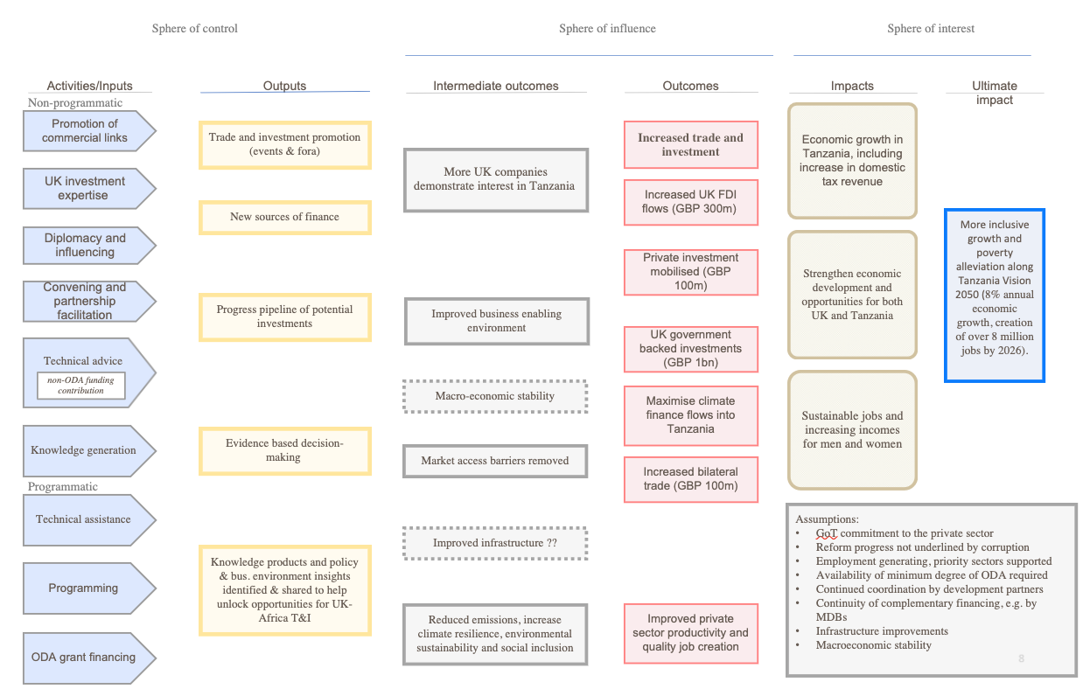

Annex 6: Influence and communication plan
The evaluation was designed and implemented to maximise usefulness while minimising the time burden on stakeholders. To ensure the evaluation questions and findings are relevant and impactful, a simple use and influence plan was designed and updated through the course of the evaluation (see table below). This plan identified key stakeholders and outlined tailored evaluation communication products to meet their specific needs.
The overall aim of the use and influence plan contributed to the purpose of the evaluation itself, notably on generating valuable internal learning for the review of the growth and investment goals of the next BHC Tanzania Country Plan, as well as establishing potential best-practice in evaluating new ways of working in partnership externally with government, the private sector and development partners and internally through the ‘whole of government’ approach across HMG. The timeline for the review of the Country Plan largely determined the timing for the completion of the evaluation by end of May 2025, though additional communications continued into late 2025. Beyond the BHC sustainable growth team, the internal audience included DBT and HMRC, as well as a number of UK agencies serving as suppliers for specific programmes. The external learning audience included other BHC and HQ teams interested in Tanzania growth work or evaluating partnerships and x-HMG working.
During the inception phase, we fundamentally reworked the evaluation questions with the BHC team to ensure their alignment with the overall learning purpose, information needs of the Country Plan revision, as well as the interest in new ways of working with different external and internal partnerships. We also conducted a quick participatory stakeholder analysis, which informed our understanding of different governmental, private sector, development partner and implementing partner stakeholders, especially their degree of interest and influence in the sustainable growth and investment work of the BHC.
These insights were factored in the dissemination channels and products generated by the evaluation. Further efforts will be required by the BHC to ensure the implementation of the evaluation recommendations beyond these efforts outlined in the table below. The UK government also holds the ultimate copyright on the evaluation report and its findings, as well as recommendations.
Communications products included conventional inception and evaluation reports, but also dedicated communications material, were summarised in a power point slide pack. This included extensive work on the visualisation of outcomes and related levers of change to support in the identification of UK priorities. The main findings on each of the five outcome areas were summarised in accessible text boxes, with conclusions, lessons and recommendations summarised in the main report.
The evaluation team will tailor information for sharing with different audiences through workshops and events (e.g., with the BHC Tanzania – already conducted; wider HMG staff – in late November 2025; and the evaluation cadre – dates to be confirmed). For audiences beyond UK government, we recommend the BHC share evaluation findings, conclusions, lessons and recommendations using the summarised material from the presentations.

Evaluation product/ audience | BHC Tanzania sustainable growth team | Other BHC Teams | FCDO HQ | DBT regional | Other posts | Government of Tanzania | Private Sector Tanzania | Development partners
Inception workshop | X
Inception report | X
Preliminary findings workshop | X
Draft evaluation report | X
Final evaluation report | X |  | X | X
Evaluation summary/briefing note/ppt |  | X |  | X | X | X | X | X
Dissemination workshop on the implications of the findings for the Country Plan | X | X | X | X
HMG wide workshop focused on x-HMG and partnerships evaluation methods and findings | X | X | X | X | X

Annex 7: How to evaluate partnership and whole of government approaches to development: Guidance note
[Please see separate document]

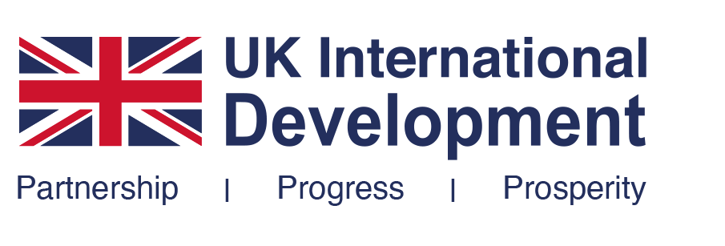
www.agulhas.co.uk

www.agulhas.co.uk
www.agulhas.co.uk

www.agulhas.co.uk
Agulhas
Applied Knowledge

Agulhas
Applied Knowledge

