

Application Decision
Site visit made on 20 August 2024
by D M Young JP BSc (Hons) MA MRTPI MIHE
An Inspector appointed by the Secretary of State for Environment Food and Rural Affairs
Decision date: 3 June 2026

Application Ref: COM/3338001 Land near Holy Well
Register Unit: CL709 (Original provisional registration number)
Registration Authority: Cornwall Council
- The application, dated 31 December 2020 is made under Schedule 2 paragraph 4 of
the Commons Act 2006.
- The application is made by the Open Spaces Society.
- The application is to register waste land of a manor as common land in the register of common land.

Decision
- The application is approved, and the land shown edged in red on the plan appended to this decision, save the public highway, shall be added to the commons register.

Preliminary Matters
- There were two objections from the Bolitho Estate (landowner) and the Commons Registration Authority (CRA) in respect of the highway land only.

The Application Land
- The application land is known as ‘land near Holy Well’ is in the parish of Madron to the west and south of Boswarthen. It comprises two parcels which extend to some 2.355 hectares. The larger western parcel is known as the ‘Old Gravel Pit’. The smaller parcel is unnamed.

Main Issues
- The main issue is whether the land was waste land of a manor, at the date of the application on 31 December 2020, and whether before 1 October 2008:
- the land was provisionally registered as common land under section 4 of the Commons Act 1965 (the 1965 Act);
- an objection was made in relation to the provisional registration; and
- the provisional registration was cancelled in the circumstances specified in sub-paragraphs (3), (4) or (5) of the Commons Act 2006 (the 2006 Act).
- Sub-paragraph (5), on which the applicant relies, requires the person who made the application for the provisional registration to request or agree to its cancellation (whether before or after its referral to a Commons Commissioner).

Reasons

The requirements of paragraph 4 of Schedule 2
- The application land was provisionally registered as common land under the 1965 Act pursuant to application ref: 1891 made by the West Cornwall Footpaths Preservation Society on 17 December 1969.
- The only objection to the provisional register was made by J E G Scobie Esq on behalf of the Bolitho Trust (Objection No. X1101). The objection was dated 4 July 1972. The grounds of objection were that part of the land was not common land at the date of registration.
- The application was withdrawn prior to a Commons Commissioner hearing. The applicant requested withdrawal of the provisional registration by a letter to the CRA dated 3 October 1972 (Ref: WV/51/X1101). The CRA subsequently cancelled the registration on 30 January 1973.
- Considering the circumstances set out above, I am satisfied that the application land is eligible for re-registration under Paragraph 4(5) of Schedule 2 of the 2006 Act.

Whether the land is waste land of a manor
- There were six manors in the parish of Madron (Alverton, Boswednan, Lanyon, Mulfra, Treganebris and Trengwainton). The applicant has carried out research into all the manors and through a process of elimination concluded, on the balance of probabilities, that the application land was situated in the Manor of Trengwainton.
- The manor house was situated relatively close to the application land, a mile and a half south. This manor was listed as being a ‘sub-manor’ of the manor of Roseworthy by Pool, P.S.A and F.S.A (1994) and Cadell & Davies (1814)4. The manor was held by the ancient Cowling family until it was sold in 1668 to the Arundell family and soon after owned by the Praed family and inhabited by the Price family.
- The tithe survey for the parish of Madron records that the unnamed parcel of the application land was included within Plot No. 719 and was described as turbary. The Old Gravel Pit formed part of Plot Nos. 603 and 732 and described as rocks and turbary respectively.
- There is no dispute from either of the objectors that the land lies in an area which is recognised to have been, or still be, manorial. On that basis, I am satisfied that the application land can be said to be waste land of a manor.

Whether the land fulfils the character of waste land of the manor
- The definition of waste land of a manor arising from the case of Attorney General v Hanmer [1858] (2 LJ Ch 837) is “the open, uncultivated and unoccupied lands parcel of the manor other than the demesne lands of the manor”. The question as to whether land is waste land of the manor is one which must be satisfied at the date of the application on 31 December 2020.
- The landowner’s objection letter states that the unnamed eastern parcel of land is enclosed by way of old granite walls and vegetation with the exception of the public right of way that runs through the middle of it.
- The applicant responded to the objection by pointing out that the walls abutting the application land serve to enclose the adjacent fields and not the application land. That is consistent with my own observations on my site visit when I saw that the land is open and accessible from the public footpath.
- The wall referred to by the objector is dilapidated to the extent that it cannot reasonably be considered to constitute an effective means of enclosure. Moreover, it is limited to the north-eastern boundary of the site (see photographs 2-5) and does not therefore enclose the majority of the application land. I therefore consider it more likely than not that the wall was built to enclose the neighbouring agricultural fields rather than the application land. There is no suggestion from the objector that the Old Gravel Pit is enclosed, and I see no reason to take a contrary view. I therefore conclude that the land is ‘open’.
- The landowner’s objection letter states that both parcels of land are subject to agricultural tenancies and the land is therefore occupied and has been for many decades by tenant farmers. However, it was clear from my own observations and the photographs supplied by the applicant that there is little or no evidence of any activity which required the soil to be broken for productive purposes. Consequently, the application land can be described as ‘uncultivated’.
- The applicant highlights the Department for Environment, Food & Rural Affairs guidance which in relation to occupation states that “land does not cease to be unoccupied (and therefore cease to be waste) merely because it is subject to a tenancy, lease or licence whose sole or principal purpose is to enable the land to be extensively grazed”. The letting out of land is not therefore sufficient to demonstrate occupation. There must be some persuasive evidence of practical occupation and improvement of the land. No such evidence has been provided by the objector. I therefore conclude that the land is ‘unoccupied’.

Other Matters
- The CRA objects on the basis that the application land includes an unclassified metalled road. The CRA argues that roads were exempt from the definition of common land under the 1965 Act and are therefore exempt from registration as common land. As the land was illegible for registration under the 1965 Act, the CRA considers that if the metalled carriageway is registered as common land, a new category of mistaken registration is being created. The CRA’s objection relates solely to the extent of the metalled carriageway in the western parcel of land.
- The applicant responded by pointing out that the 2006 Act does not need a definition of common land because it is concerned with whatever land is registered as common land. The exemption in the 1965 Act is therefore still operative. The sole relevant criterion to determining the application is therefore whether the application land is ‘waste land of a manor’.
- Having sought legal advice from DEFRA on the matter, it is considered that Schedule 2 to the 2006 Act only allows for the registration of land which could, in principle, have been registered under the 1965 Act. This did not expressly allow for the registration of highways when registering common land. I therefore concur with the CRA that it would not be appropriate to register a highway as common land. Therefore, I consider the highway crossing the land shown in the plan at Appendix 2 should be removed from the application and should not be registered as common.
- While I have noted concerns from the applicant and landowner, there is no substantial evidence before me to doubt the accuracy of the plans supplied by the Highway Authority. Even if there was, it would not be for a decision under Schedule 2 paragraph 4 of the 2006 Act to adjudicate on what is, or is not, public highway. Accordingly, the land shown on the plans at Appendix 2 should be excluded from the common register.

Conclusion
- Having regard to these and all other matters raised in the written representations, I conclude that the application land, save for the metalled highway, fulfils the necessary criteria for registration. Consequently, I approve the application and the land shown edged in red on the plan appended to this decision, minus the full width of the highways, should be added to the commons register.

D M Young

INSPECTOR

Appendix 1 - Application Plan

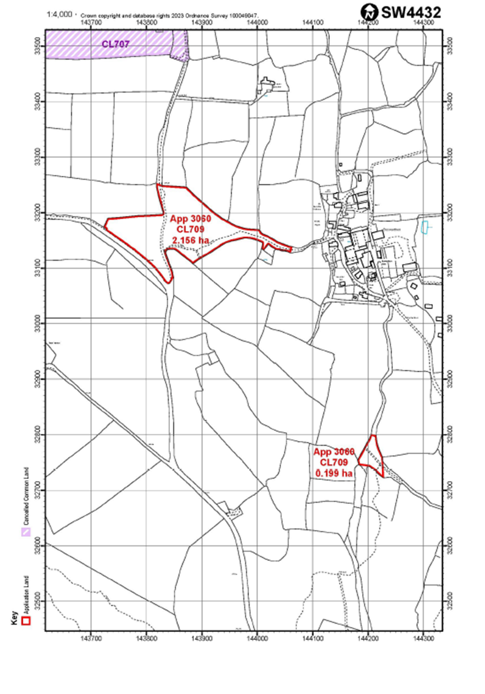

Appendix 2 - Extent of public highway to be excluded

