

Application Decision
Site visit on 28 April 2026
by Claire Tregembo BA (Hons) MIPROW
an Inspector appointed by the Secretary of State for Environment, Food and Rural Affairs
Decision date: 21 May 2026

Application Ref: COM/3374693
Boxmoor and Dew Green Commons
Register Unit No.: CL24
Registration Authority: Hertfordshire County Council
- The application dated 15 October 2025, is made under section 16 of the Commons Act 2006 to deregister and exchange land registered as Boxmoor and Dew Green Common, Hemel Hempstead.
- The application is made by the Box Moor Trust
- The release land comprises 7,130m² of land on the south side of London Road, Hemel Hempstead.
- The replacement land comprises 18,402m² of land between London Road and the A41, Hemel Hempstead.

Decision
- Consent is granted and an Order of Exchange is given in accordance with the application dated 15 October 2025 to deregister and exchange common land at Boxmoor Common, Box Hill, London Road. As part of the Order of Exchange a copy of the application plan showing the area for deregistration and exchange is attached to this decision.

Procedural Matters
- I carried out an accompanied site visit on 28 April 2026 with representatives of the applicant, the Box Moor Trust (the Trust).
- Some of the plans submitted with the application were not compliant with the Commons Registration (England) Regulations 2014. The Trust has since submitted plans at the required scale.
- The British Horse Society (the BHS) were not consulted when the application was made. As the affected land is subject to section 193 of the Law of Property Act 1925, they should have been consulted even though an Order and by-laws prevent horse riding on the Common. The Trust has confirmed that they have since consulted with the BHS.
- One of the parties queried why the release land does not directly abut London Road or the drive to the west. The release land is as shown on the Register of Commons map. There is a roadside verge, vehicular access, and layby alongside London Road and the western boundary is contiguous with a fence.

The Main Issues
- Section 16(1) of the Commons Act 2006 (the 2006 Act) provides that the owner of any land registered as common land may apply for the land (the release land) to cease to be so registered. Section 16(2) and (3) of the 2006 Act provide that if the release land is more than 200m² the application must include a proposal to replace it with other land to be registered as Common Land (the replacement land).
- I am required by section 16(6) of the 2006 Act to have regard to the following in determining the application:
- the interests of persons having rights in relation to, or occupying, the release land (and in particular persons exercising rights of common over it);
- the interests of the neighbourhood;
- the public interest, which includes the interest in nature conservation, conservation of the landscape, protection of public rights of access, and the protection of archaeological remains and features of historic interest;
- any other matters considered to be relevant.
- I have had regard to Defra’s Common Land Consents Policy Guidance (November 2015) (the 2015 Policy) in determining this application, which has been published for the guidance of both the Planning Inspectorate and applicants. However, every application will be considered on its own merits, and a determination will depart from the guidance if it appears appropriate to do so. In such cases, the decision will explain why it has departed from this guidance.

The Application
- The application is to exchange part of Boxmoor Common on the south side of London Road with land on the north side. The Trust own all the land.

The Release Land
- The release land is part of Gee’s Meadow, Box Hill, on the south side of London Road. It has an area of 7,130m² and comprises agricultural buildings and a mown or grazed field. Gee’s Meadow was acquired by the Highways Authority as part of the A41 construction and two livestock barns and an agricultural dwelling were built on it. Once the road was completed, the Highway Authority handed Gee’s Meadow, the agricultural dwelling, and barns to the Trust to reimburse them for land and buildings lost to the A41. The land and buildings were also registered as common to replace common lost to the A41.

The Replacement Land
- The release land is part of Snooks Moor, between London Road and the A41 comprising 18,402m² of meadow split into two enclosures. There is a permissive footpath across it.

Reasons

Background on the Trust
- The Trust originated in 1594 to protect an area of water meadows in Boxmoor for the benefit of local people. The extent of the land held by the Trust increased to 240 acres by the time of an Act of Parliament in 1809 which gave lasting protection of the land and access rights to the people of Hemel Hempstead and Bovingdon. The 1809 Act was superseded by the Charity Commission Scheme in 2000 (the 2000 Scheme). At this point, the extent of the Trust’s land was only 219 acres due to the construction of a canal, railway, and roads. The Trust’s prime responsibility is to protect and maintain the land and administer the Charity. The Trust can spend surplus income on environmental education, sport and recreation, and welfare of the sick, poor, and elderly. The Trust has acquired more land since 2000 and now owns 493 acres just over a quarter of which is common land.
- The 2000 Scheme states the Trust’s land shall ‘continue to be appropriated and used for the provision, in the interests of social welfare, of facilities for the recreation and other leisure time occupation of the residents of the area of benefit; subject to this use, the land shall be available for access for recreation by the public at large’.

The interests of those occupying or having rights over the release land
- Two properties in Hemel Hempstead each have a right to graze one cow on the Common. I am advised that these rights have not been exercised since 1999. The properties were notified of the application and have not made any comments. The release land has never been grazed by the Trusts beneficiaries and there are no tenants.
- There is a tied agricultural dwelling and two barns on the release land and the Trust use the land to graze their livestock and for educational purposes. The proposed exchange would allow the Trust to provide additional opportunities for educational purposes and provide a secure area for storing essential equipment. They would be able to upgrade livestock accommodation to meet regulatory standards, qualify for government grants and subsidies, address immediate threats and future-proof the farm to ensure long-term sustainability and productivity. The Trust would also be able to centralise their agricultural activities. Therefore, the proposed exchange would improve animal welfare, biosecurity, agricultural efficiency, productivity, environmental control, and reduce their carbon footprint.
- I consider the deregistration would be in the interests of the Trust. As the replacement land is larger than the release land and does not contain any buildings that limit the grazing area, I consider it would not have any impact on those with grazing rights.

The interests of the neighbourhood and the public interest for the protection of public rights of access
- The public have a right of access for air and exercise on the release land under section 193 of the Law of Property Act 1925 under a Ministerial Order dated 17 September 1969. There are by-laws imposing limitations and conditions on the land. These are largely to prevent horse riding, the discharge of firearms, removal of earth, trapping or chasing of animals, bathing, displaying notices, the erection of structures, selling goods, or holding fairs or exhibitions without permission.
- The release land was given in exchange for loss of common land for the A41 bypass and can only be accessed by one gate off London Road. Around a third of the release land is covered by an agricultural dwelling, two barns, and hardstanding which prevent access to the public. It is not clear why this area was included in the Common as land covered by a building or its curtilage would not normally be eligible for registration as common land. As these buildings existed prior to the land being registered as common I consider them to be lawful.
- The Trust installed a counter on the gate that provides access to the release land. The counter indicated that the gate was only opened a couple of times over a three year period. The Trust also states the release land is currently visited by one person a week except during their lambing weekend when around 1,500 people visit. Therefore, there is limited use of the release land by the neighbourhood and public.
- The permissive footpath across the replacement land was visible as a clear worn line during my site visit so appeared to be well used. However, the replacement land is subject to closures for lambing and other management activities for as much as eight months of the year. When closed it is not available for use by the neighbourhood or the public. The Trust would not be permitted to close the land if the proposed exchange is granted. The release land is contiguous to other parts of the Common along London Road which connect to the Grand Union Canal and towpath.
- The Trust would provide a permissive footpath across the release land to retain access to the rest of the Common at Gee’s Meadow. It would also provide a permissive path across Gee’s Meadow and two permissive paths across their land to the south to link into Public Footpath Nos. 145 and 3012. These footpaths connect to a large network of paths to the south. The land to the south is also part of the new Westbrook Hay Suitable Alternative Natural Greenspace, an area of approximately 75 acres. The permissive paths would provide two access points into Gee’s Meadow with routes to public highways in three different directions. The Trust intend to dedicate the existing permissive footpath across the replacement land and a link from the existing public Footpath 096 across Snoxall’s Moor to London Road opposite the proposed permissive footpath as public rights of way. These paths would form a direct link between the unaffected part of Gee’s Meadow and the replacement land. Hertfordshire County Council Rights of Way Team consider the new paths would improve connectivity to the Commons. The Trust confirm the new access gates would be compliant with British Standard BS 5709:2018.
- The Trust states the proposed exchange would allow them to improve the existing lambing events, run more educational events and activities, and allow additional opportunities for the local community to engage with agriculture. The Trust consider this would benefit the wellbeing of the neighbourhood.
- Natural England (NE) does not support the proposed exchange as they believe it contravenes the 2015 Policy objective to preserve common land for recreational use and public enjoyment. The Secretary of State would not normally grant consent where replacement land is subject to public access, either by right or informally because this could diminish the total land available to the public.
- The replacement land already has a permissive path across it and is subject to public access rights under the 2000 Scheme which means it is expressly dedicated to serving the recreational and social needs of residents and the public at large.
- However, access to the replacement land is currently limited for most of the year. If the exchange were granted, the public would have access to a much larger area of land all year round. This land appears to be more widely used by the public when it is available than the release land. There would also be new links to other publicly available land and the wider rights of way network. This would increase access for the neighbourhood and public to existing common land, other public access land, and the wider public rights of way network. The Trust would also remove the existing fence across the replacement land.
- Therefore, I do not consider the proposed exchange would diminish the total land available for the neighbourhood and public access and they would be no worse off as a consequence of the exchange. In addition to a larger area being available all year round, the proposed exchange would provide additional access points to existing common land which would benefit the neighbourhood and public access. Furthermore, there would be additional benefits to the neighbourhood if the Trust were able to increase and improve their educational activities.

The public interest

Nature conservation
- Neither the release land or the replacement land is subject to any statutory or local designations for nature conservation. The nearest Site of Special Scientific Interest; Roughdown Common is over a kilometre from the release land. NE do not consider the proposed exchange would have any adverse impact on any statutorily protected nature conservation sites.
- Much of the Common including the release and replacement lands are subject to a Higher Level Stewardship Agreement (HLSA) which is due to end on 31 August 2028. The Common is managed in line with the HLSA prescriptions for HK15 land. This means the grassland is maintained to protect target features or support biodiversity. The Trust state the proposed exchange would support their aims for conservation and biodiversity, but no details were provided to assess the benefit.
- As the land would still be subject to the HLSA and managed in accordance with the Trust’s 2000 Scheme, I consider there would be no adverse impact on nature conservation as a result of the proposed exchange.

Conservation of the landscape
- The release and replacement land are not in a National Park or National Landscape.
- The Trust state that conservation of the landscape is a prime concern of the Trust, and they are committed to maintain the moors as a unique rural landscape.
- NE consider that if the exchange were granted, the release land could have additional agricultural buildings placed on it. This could result in a reduction of grassland and views of the common land to the south would be impeded. However, NE do not consider these potential changes would significantly damage the area overall. Any proposed buildings would be subject to planning permission.
- There are hedges and trees along most of the northern boundary of the release land and there are existing buildings where there is no hedge. Therefore, views of the Common from the north are already limited. The unaffected Common to the south of the release land rises steeply, therefore any new buildings would have limited impact on the wider views of the Common. Taking this into account, I consider there would be limited impact on the landscape as a result of the proposed exchange.

Archaeological remains and features of historic interest
- The Trust states no archaeological remains would be affected by the proposed exchange. There are no Scheduled Ancient Monuments (SMA) or Listed Buildings in the release or replacement land. Historic England (HE) advises there are several designated heritage assets within 1km of the Common. They consider there would be no detrimental impact on any Conservation Area or settings of Listed Buildings or SAM.
- HE considers there may be some archaeological sensitivity and recommend consulting Hertfordshire County Council’s Archaeological Officer regarding any impact. The Archaeological Officer was consulted but did not reply.
- I consider there are unlikely to be any adverse effects to archaeological remains or features of historic interest.

Conclusions on the public interest
- Taking into account the above, I consider the proposed exchange would have limited, if any, adverse effect on the public interest.

Conclusion
- Having regard to my findings, the relevant guidance, written representations, and the merits of the proposed exchange referred to above, I conclude that the application should be granted, and an Order of Exchange should be made.

Formal Decision
- The application to deregister and exchange land is granted in accordance with the terms of the application (Ref: COM/3374693) dated 15 October 2025 and the accompanying plan and that an Order of Exchange should be made.

Claire Tregembo

INSPECTOR

Order

On behalf of the Secretary of State for Environment, Food and Rural Affairs and pursuant to section 17 (1), (2), (6), (7) and (8) of the Commons Act 2006, I HEREBY ORDER Hertfordshire County Council, as Commons Registration Authority for the area in which the release land and the replacement land are situated:
- to remove the release land from its register of common land, by amending register unit CL24 to exclude the release land;

First Schedule – the release land
Colour On Plan | Description | Extent
Outlined Red | Land and buildings on the south side of London Road, Hemel Hempstead | 7,130m²
- to register the replacement land as common land by amending the register unit CL24 to include the replacement land;

Second Schedule – the replacement land
Colour On Plan | Description | Extent
Outlined Light Green | Land between London Road and the A41 Hemel Hempstead | 18,402m²

Supplementary Provisions
- to register as exercisable over the replacement land (in addition to remaining exercisable over the remainder of the land comprised in register unit CL24) any rights of common which, immediately before the date on which the release land is removed from the register, are registered as exercisable over the release land and the remainder of the land comprised in register unit CL24;
- Section 193 of the Law of Property Act 1925 (public right of access for air and exercise) shall apply irrevocably to the replacement land, and the Commons Registration Authority shall enter a note of the irrevocable application of the right to the replacement land in the land section of the register.
- The Box Trust shall provide access gates and waymarking for the proposed footpaths conforming to BS 5709:2018 within 4 months of the date of this Consent Order. The Box Trust shall also seek to enter into permissive path and dedication agreements with Hertfordshire County Council at the earliest opportunity.
- The Box Trust shall remove the fence in the release land marked with red crosses within 4 months of the date of this Consent Order.

Claire Tregembo

INSPECTOR

Order Plan showing the release and replacement land

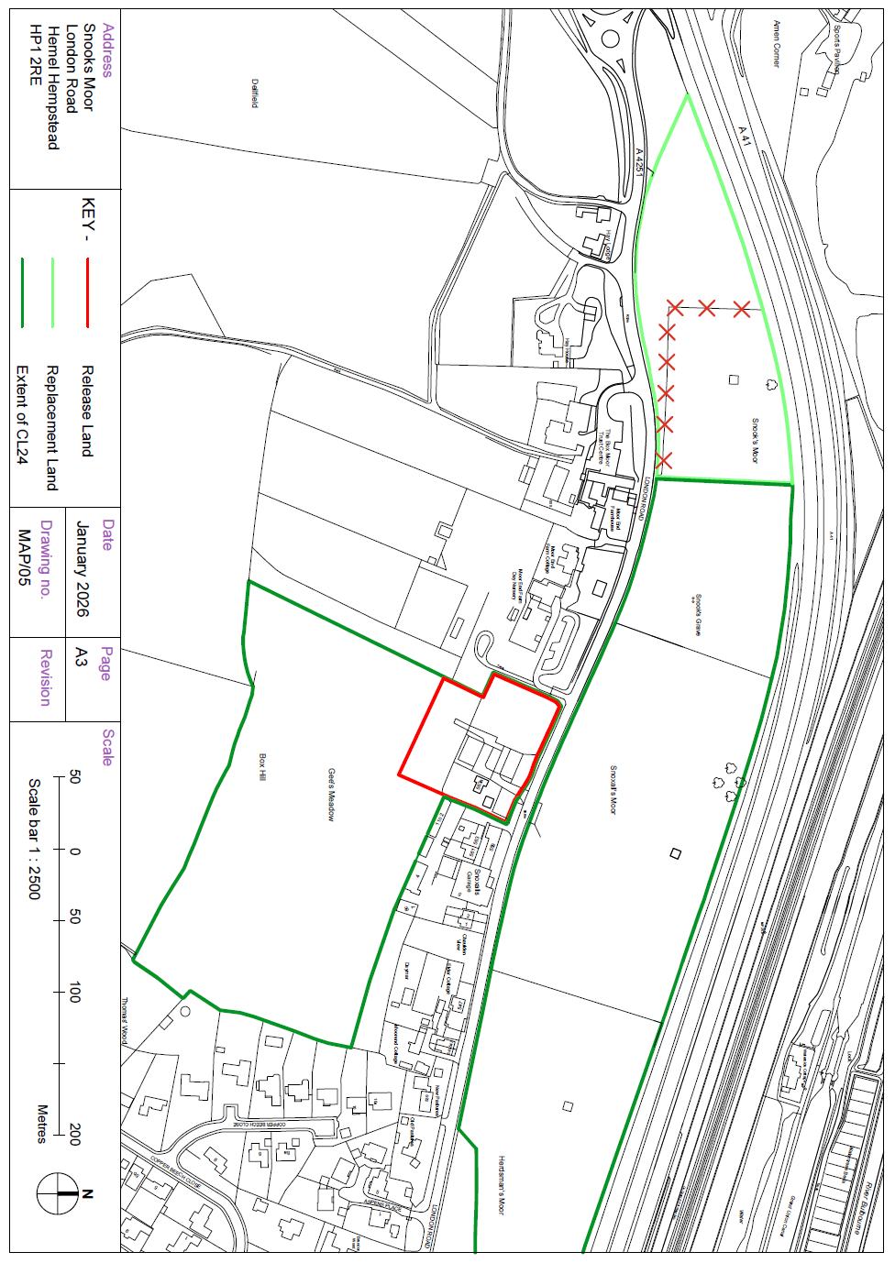

Maps of Proposed Footpaths and Gates

