NOTICE OF ORDER

Wildlife and Countryside Act 1981
Lancashire County Council
THE LANCASHIRE COUNTY COUNCIL UPGRADING OF WRIGHTINGTON FOOTPATH 21 TO BRIDLEWAY BETWEEN MOSS LANE AND MOSSY LEA ROAD, WRIGHTINGTON, WEST LANCASHIRE BOROUGH DEFINITIVE
MAP MODIFICATION ORDER 2016

Notice is hereby given that the above referenced Order has been submitted to the Secretary of State for Environment, Food and Rural Affairs for determination. An Inspector will be appointed by the Secretary of State to determine the Order.

The start date for the above Order is 12th March 2026.
Consideration of the Order will take the form of a public local inquiry.

The Inquiry will be held at Tanhouse Community Centre, Ennerdale, Skelmersdale, WN8 6AN on 9th September 2026 at 10.00am.
The effect of the Order, if confirmed without modifications, will be to modify the Definitive Map and Statement of Public Rights of Way for the area, by upgrading Public Footpath 21 Wrightington to public bridleway from SD 5358 1094 (point A on the Order map) on Moss Lane, Wrightington south of Wrightington Hotel and Country Club, running in a north easterly direction along an enclosed track at a width varying between 5 metres and
1.5 metres to SD 5396 1120 (point F) where it passes 6 and 8 Mossy Lea Fold and continues along Mossy Lea Fold at a width of 4 metres to meet Mossy Lea Road at SD 5406 1124 (point G); a total distance of approximately 585 metres as shown between points A-B-C-D-E-F-G on the Order Map.

Any queries relating to this Order should be referred to Paul Scrivener by email: paul.scrivener@planninginspectorate.gov.uk quoting reference number ROW/3355097 on all correspondence. Alternatively, queries may be sent in writing to The Planning Inspectorate, Rights of Way Section, c/o QUADIENT, 69 Buckingham Avenue, Slough, SL1 4PN. Telephone: 0303 444 5000.
Any person wishing to view the statements of case and other documents relating to this Order may do so by appointment at Documentation pertaining to this Order is held on deposit for public inspection at County Hall, Preston, PR1 0LD, for further information please contact Sarah Brooks-Silcock at Sarah.Brooks-Silcock@lancashire.gov.uk or on 01772530820
Documents have also been made available online. To access the documents, please use the following URL address: https://www.lancashire.gov.uk/council/transparency/dmmos/upgrade-FP21-wrightington-2016/

Timetable for sending in statements of case and proofs of evidence Within 8 weeks of the start date by 7 April 2026.
The Order Making Authority, or where the Order Making Authority is taking a neutral stance and the applicant or other party are taking the case forward in support of the order, must ensure their statement of case is received by the Secretary of State. As soon as possible after the deadline, the Secretary of State will send a copy (excluding copies of any supporting documents - these will be available to view at the Authority’s offices) to everyone who has made an objection or representation and the applicant and any other person who has written to us in respect of the Order.

Within 14 weeks of the start date by 18 June 2026.
Everyone who has made an objection or representation and anyone who wishes to give evidence at the Inquiry must ensure their statement of case1 is received by the Secretary of State. As soon as possible after the deadline, the Secretary of State will send full copies to the Authority. Copies will also be sent to the applicant, every person who has made an objection or representation and any other person who has written to us in respect of the Order (excluding copies of any supporting documents - these will be available to view at the Authority’s offices).
Within the same period the applicant (if applicable) must ensure their statement of case is received by the Secretary of State. As soon as possible after the deadline, the Secretary of State will send a full copy to the Authority. Copies will also be sent to everyone who has made an objection or representation and any other person who has written to us in respect of the Order (excluding copies of any supporting documents - these will be available to view at the Authority’s offices).

4 weeks before the date of the inquiry by 12 August 2026.
The Authority, everyone who has made an objection or representation, the applicant (if applicable) and anyone who wishes to give evidence at the Inquiry must ensure their proof of evidence (together with any summary) is received by the Secretary of State. As soon as possible after the deadline, the Secretary of State will send copies of:

- the Authority’s proof of evidence to everyone who has made an objection or representation, the applicant and anyone who has

1 If you wish to make a legal submission, this should be submitted at the same time as your statement of case. Otherwise legal submissions will have to be submitted in writing on the day of the inquiry.
submitted a statement of case (including copies of any supporting documents – although none should be submitted with a proof of evidence);
- the applicant’s proof of evidence to the Authority, everyone who has made an objection or representation and anyone else who has submitted a statement of case (including copies of any supporting documents – although none should be submitted with a proof of evidence); and

- all other proofs of evidence to the Authority, the applicant, everyone who has made an objection or representation and anyone else who has submitted a statement of case (including copies of any supporting documents – although none should not be submitted with a proof of evidence).

All parties must keep to the timetable set out above and ensure that statements of case and proofs of evidence are received by the Secretary of State on time. Late documents will be returned.
We cannot accept any inflammatory, discriminatory or abusive comments. Any documents containing such comments will be returned.
If you use Artificial Intelligence (AI) to create or alter any part of your documents, information or data, you should tell us that you have done this when you provide the material to us. See the detailed guidance for further information.

Notice of order for inquiry
Lancashire County Council
was hereunto affixed in th
Authorised Signatory+
e pre
-�
)
sence of )
·

WILDLIFE AND COUNTRYSIDE ACT 1981
THE DEFINITIVE MAP AND STATEMENT OF PUBLIC RIGHTS OF WAY FOR THE COUNTY OF LANCASHIRE

THE LANCASHIRE COUNTY COUNCIL UPGRADING OF WRIGHTINGTON FOOTPATH 21 TO BRIDLEWAY BETWEEN MOSS LANE AND MOSSY LEA ROAD, WRIGHTINGTON, WEST LANCASHIRE BOROUGH
DEFINITIVE MAP MODIFICATION ORDER 2016

This Order is made by Lancashire County Council ("the Authority") under Section 53(2)(b) and 53(3)(b) of the Wildlife and Countryside Act, 1981 ("the Act") because it appears to that Authority that the Definitive Map and Statement of Public Rights of Way for the County of Lancashire require modification in consequence of the occurrence of an event specified in Section 53(3)(c)(ii) namely the discovery by the Authority of evidence which (when considered with all other relevant evidence available to them) shows that a highway shown in the map and statement as a highway of a particular description, namely a footpath, ought to be there shown as a highway of a different description, namely a bridleway.

The Authority have consulted with every local authority whose area includes the land to which the Order relates. Lancashire County Council hereby order that:
- For the purposes of this Order, the "relevant date" is the 7th September 2016.
- The Definitive Map and Statement of Public Rights of Way for the County of Lancashire shall be modified as described in Part I and Part II of the Schedule and shown on the map attached to the Order.
- This Order shall take effect on the date it is confirmed and may be cited as The Lancashire County Council Upgrading of Wrightington Footpath 21 to Bridleway between Moss Lane and Mossy Lea Road, West Lancashire Borough Definitive Map Modification Order 2016.

Dated this 7th day of September 2016

THE COMMON SEAL of the )
SCHEDULE
PART I
MODIFICATION OF THE DEFINITIVE MAP

DESCRIPTION OF PATH OR WAY TO BE UPGRADED

Public bridleway from a point on Moss Lane, Wrightington south of Wrightington Hotel and Country Club (Point A on the Order Plan), running in a north easterly direction along an enclosed track at a width of 5 metres tapering to a width of 2.6 metres at Point B on the Order plan. It then continues as an enclosed track at a width of 2.5 metres to Point C and then varies between 2.5 metres and 1.5 metres continuing in a north easterly and then east north easterly direction to Point F where it passes 6 and 8 Mossy Lea Fold and continues along Mossy Lea Fold at a width of 4 metres to meet Mossy Lea Road at Point F; a total distance of approximately 585 metres. the path is shown between Points A-B-C-D-E-F on the Order Plan.

PART II
MODIFICATION OF DEFINITIVE STATEMENT
VARIATION OF PARTICULARS OF PATH OR WAY

Amend the entry for Wrightington 21 as follows:
Kind of Path:
"Bridleway"

Position:
"From a point on Moss Lane, Wrightington, south of Wrightington Hotel and Country Club at SD 5358 1094, running in a generally north easterly direction and then generally east north easterly direction along an enclosed track to SD 5396 1120 where it continues along surfaced area adjacent to 6 and 8 Mossy Lea Fold and then along Mossy Lea Fold to meet Mossy Lea Road at SD 5406 1124."

Width:
"SD 5358 1094 to SD 5359 1096 5 metres tapering to 2.6 metres
SD 5359 1124 to SD 5365 1103 2.5 metres
SD 5365 1103 to SD 5396 1120 Varying between 1.5 and 2.5 metres
SD 5396 1120 to SD 5406 1124 4 metres"

Length:
"0.59 km"

Other Particulars: "Limitations: None"
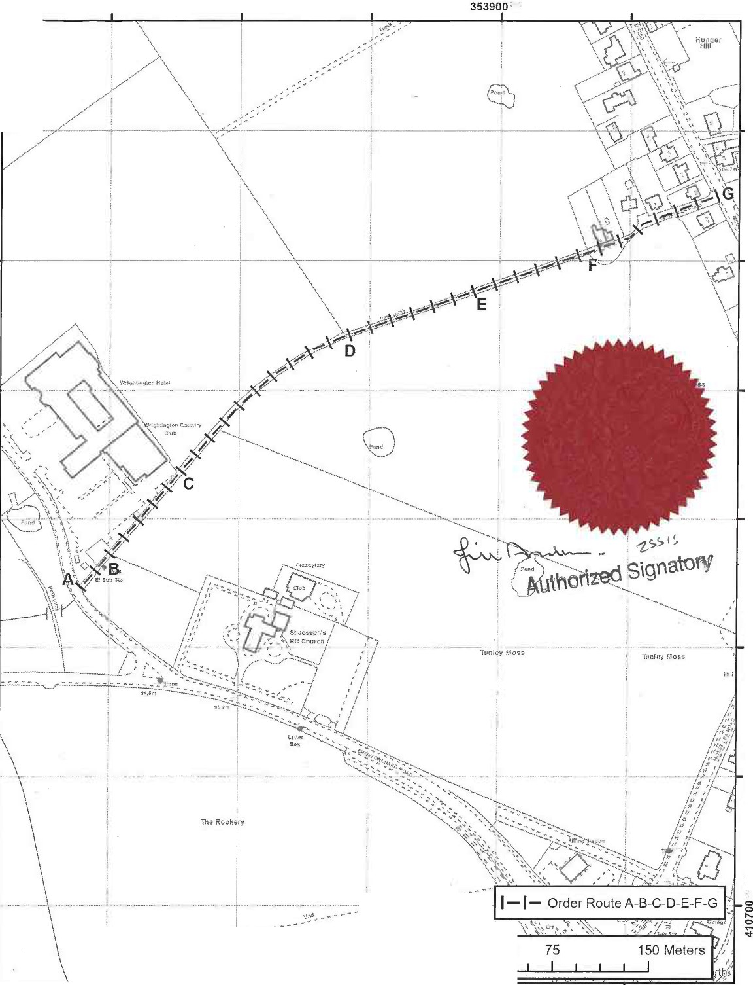
353600 353700'· 353800 354000·
"

0
0.."...'
<t

:::,
0
..N....
<t

::,
::,
...
...
<t

::,
::,
.::.,.
<t

::,
::,
...
1:1)
0
<t

::,
::,
...
:x)
::,
0
.("..)..
0
'<t

0
0
N
....
'<t

0
........
0
....
'<t

0
0
0
....
'<t

0
0
en
0....
'<t

0
0
CX)
0....
<t '<t

::,
::,
r-
0...
<t

,,

- •••.. •.. ·-··--••<'"- -:..::-•:• •.•••••••••••••.•••_ ........

0 37.5
---
353600 ,., "·• 353700'" 353800 ',." · • 353900 : •• ,, 354000 ,",c''.'

The digitised Righ_tsof Way information should be used for guidance only as its accuracy cannot be guaranteed. Rights of Way information must be verified on the current Definitive Map before being supplied or used for any purpose.

This Map is reproduced from Ordnance Survey material with the permission of Ordnance Survey on behalf of the controller of Her Majesty's Stationery Office (C) Crown Copyright Unauthorised reproduction infringes Crown Copyright and may lead to Prosecution or civil proceedings. Lancashire County Council Licence No. 100023320
1:3,000
Wildlife and Countryside Act 1981
Upgrade of Public Footpath 21 Wrightington, West Lancashire District to ublic bridlewa
Andrew Mullaney
Head of Planning and Environment
-i�l-
.-.
County -
Councll �V:i,'}
Lancashire

