2026 national curriculum tests
Key stage 2
Mathematics
Paper 3: reasoning
48pt Modified large print

Note to markers
This paper should be marked using the standard mark schemes for KS2 Mathematics: Paper 3.
There is additional guidance on marking some questions in this paper in the Key stage 2 Mathematics amendments to mark schemes –
MLP document.
First name
Middle name
Last name
Date of birth
Day Month Year
School name
DfE number

Instructions
You must not use a calculator to answer any questions in this test.
Questions and answers
You have 40 minutes, plus your additional time allowance, to complete this test.
Follow the instructions for each question.
Work as quickly and as carefully as you can.
If you need to do working out, you can use any space on the page.
Method questions
Some questions say: ‘Show your method.’
For these questions, you may get a mark for showing your method.
If you cannot do a question, go on to the next one. You can come back to it later, if you have time. If you finish before the end, go back and check your work.
[BLANK PAGE]

The test continues on the next page.

- Look at the five numbers below.

Tick or mark all the numbers that are
greater than 1 • 05

[Go to the next page]

1 • 03

1 • 2

0 • 95

1 • 51

0 • 15
- The table below shows the times that some children wake up one morning.

Name | Time
Ken | 7:08
Jacob | 7:45
Stefan | 7:37
Marie | 7:23
Lara | 6:30
How much later does Jacob wake up than Lara?

- Below are some temperatures recorded in New Zealand in July.

Auckland 11°C
Wellington 7°C
Christchurch 5°C
Queenstown −2°C
- What is the difference between the temperatures in Auckland and Queenstown?

°C
- The temperature in Christchurch falls by
6 degrees.

What is the new temperature?

°C

- Write the missing digits to make this
subtraction correct.

 | 7 |  | 8
– | 1 | 6
 | 5 | 4 | 6

- Adam buys 6 apples and 7 peaches.

Apples cost 28p each.
Peaches cost 32p each.

How much does he pay?

Show your method.

£
- Look at the four numbers below.
5
8

1
9
8

3
8

1
15
8

Write these numbers in order, starting with the least.

least

- Dev chooses a one–digit number.

He multiplies his number by 6

The tens digit of his answer is 5

What was the one–digit number he chose?

- Look at the graph on the opposite page.
It shows the height of a growing plant.

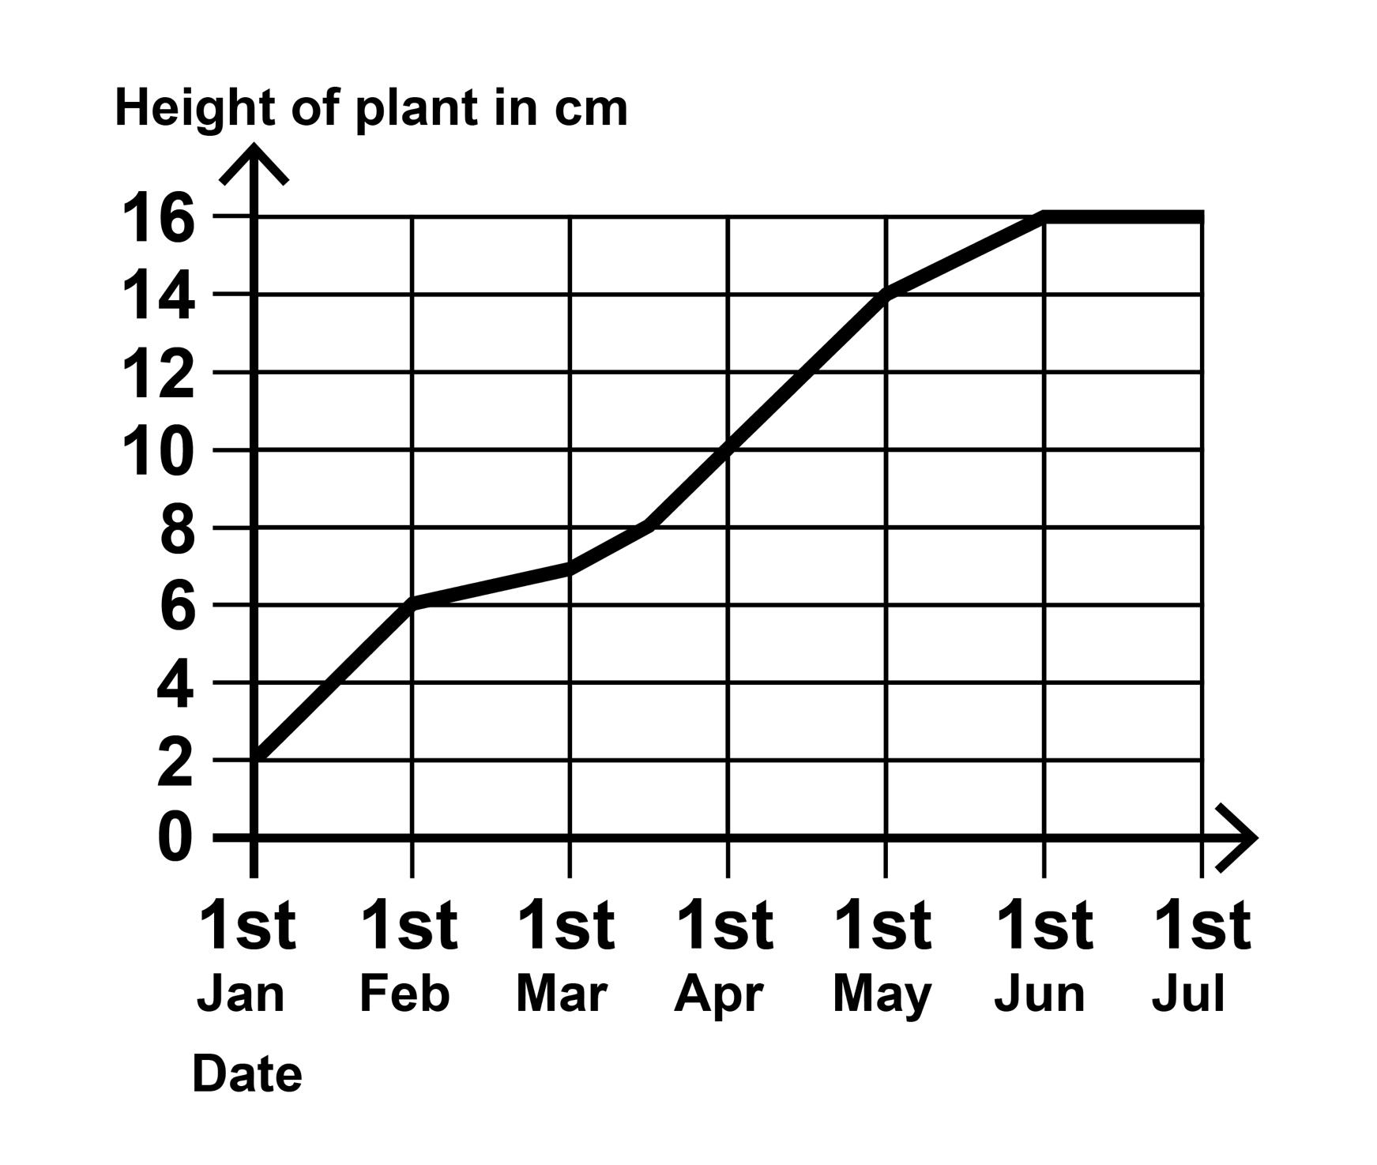
(a) How much did the plant grow between 1st January and 1st May?

cm

(b) During which month did the plant reach half of its final height?

- Olivia says 3 • 7 rounded to the nearest whole number is 3

Explain why Olivia is not correct.

- Tick or mark the two numbers below
that have the total nearest to 40

- 17 25 28

- John packs boxes of toys to sell in his
shop.
He packs 46 large boxes,
62 medium boxes and 70 small boxes.

A large box has 14 toys.

A medium box has 10 toys.

A small box has 6 toys.
How many toys does John pack altogether?

Show your method.

- Look at the graph on the following page.
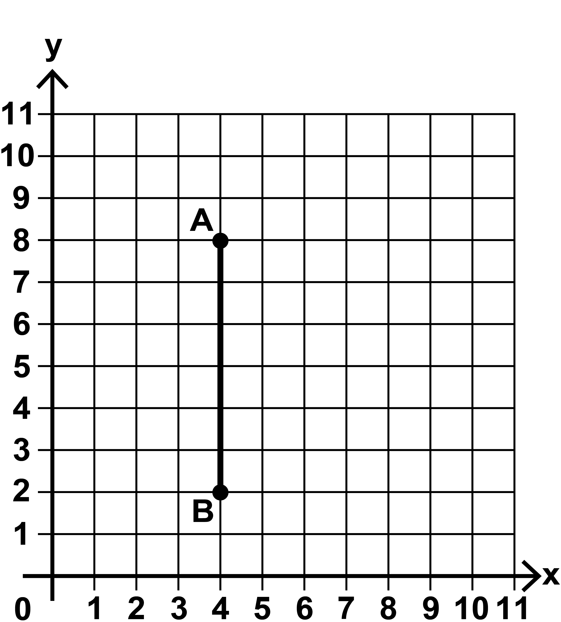
- Write the coordinates of point B.

( , )

- Triangle ABC is a right–angled triangle.

Point C is not shown.

Two sides of the triangle are equal in length.

Mark on the grid one point where
point C could be.
- Ally has two boxes.

Box B is three times heavier than Box A.

The total mass of the boxes is
600 grams.

What is the mass of each box?

Box A = g
Box B = g
- The number sentence below can be
completed in different ways.

Show one way to complete it.

Write a different whole number in each box.
×
126 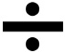 = 7

[BLANK PAGE]

The test continues on the next page.

- A machine in a bakery makes
1 250 loaves of bread in one hour.

The machine runs for 8 hours in one day.

The loaves of bread are packed into boxes of 40

How many boxes are filled in one day?
Show your method.

boxes
- Look at the three digit cards below.

6
3
2

You can use each card more than once.

Use the cards to make:

a prime number

a square number

a multiple of 7

- Look at the list of five number sentences
below and on the following page.
Tick or mark the number sentences that are correct.

= 0 • 5
1
2

2
5

= 0 • 2
7
10

= 0 • 07

9
20

= 0 • 45

27
100

= 0 • 27

- Layla is saving to buy a game.
It costs £60

For every £4 that Layla saves, her mum gives her £1

How much must Layla save to reach her target?

Show your method.

£
- Look at the five cards below.

A and B stand for two different whole numbers.

B
B
A
A
A

The sum of all of the cards is 35

(a) Give one pair of possible values
for A and B.

A = B =

(b) Now write a different pair of values for A and B.

A = B =

[BLANK PAGE]

The test continues on the next page.

- The triangle in the diagram below is
isosceles.

Not to scale

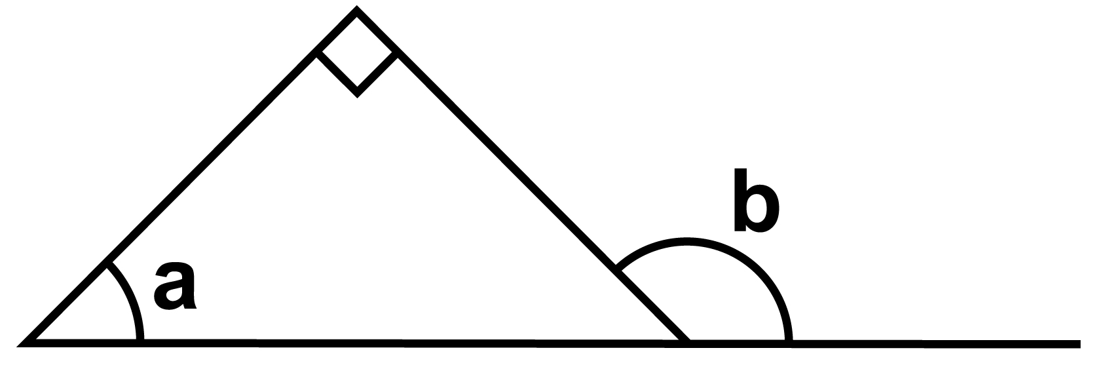

What are the sizes of angles a and b?

a is °

b is °
- The diagram below shows a triangle
inside a rectangle.

Not actual size
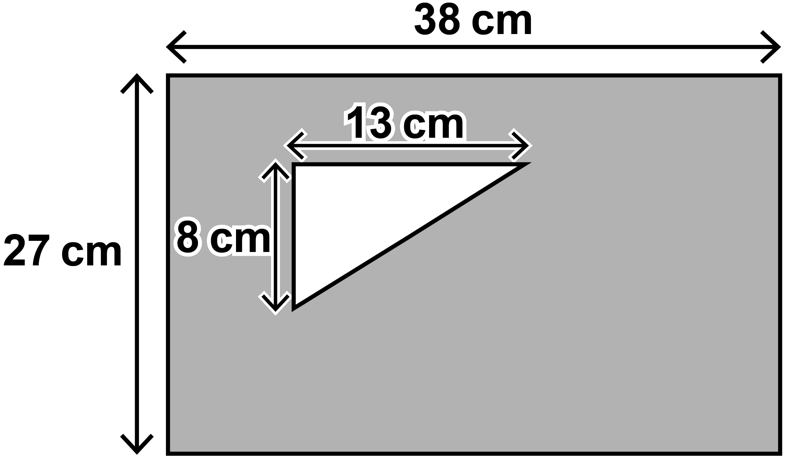

The triangle has a height of 8 cm
and a width of 13 cm.
The rectangle has a height of 27 cm
and a width of 38 cm.

What is the area of the shaded section?

Show your method.

cm2

End of test
[BLANK PAGE]

Key stage 2 mathematics
48 point A3 modified large print Paper 3: reasoning
Electronic product code: STA/26/9019/MLe_48pt ISBN: 978-1-83507-895-2
For more copies
Additional copies of this modified large print test paper can be ordered by contacting the national curriculum assessments helpline on 0300 303 3013. After the test window, it can be downloaded from www.gov.uk/government/collections/national-curriculum-assessments-past-test-materials.
© Crown copyright
The materials in this booklet are Crown copyright. You may re-use them (not including logos) free of charge in any format or medium in accordance with the terms of the Open Government Licence v3.0, which can be found on the National Archives website and accessed via the following link: www.nationalarchives.gov.uk/doc/open-government-licence.
If you have any queries regarding these test materials, please contact the national curriculum assessments helpline on
0300 303 3013 or email assessments@education.gov.uk.

