2026 national curriculum tests
Key stage 2
Mathematics
Paper 2: reasoning
48pt Modified large print

Note to markers
This paper should be marked using the standard mark schemes for KS2 Mathematics: Paper 2.
There is additional guidance on marking some questions in this paper in the Key stage 2 Mathematics amendments to mark schemes –
MLP document.
First name
Middle name
Last name
Date of birth
Day Month Year
School name
DfE number

Instructions
You must not use a calculator to answer any questions in this test.
Questions and answers
You have 40 minutes, plus your additional time allowance, to complete this test.
Follow the instructions for each question.
Work as quickly and as carefully as you can.
If you need to do working out, you can use any space on the page.
Method questions
Some questions say: ‘Show your method.’
For these questions, you may get a mark for showing your method.
If you cannot do a question, go on to the next one. You can come back to it later, if you have time. If you finish before the end, go back and check your work.
- Look at the four numbers below.
Write the numbers in order.
Start with the least.

1 505 1 050 1 005 1 500

least

- Look at the graph on the opposite page.

30 pupils were asked how they travelled to school.

Complete the graph to show how many children walk to school.

Use a ruler.

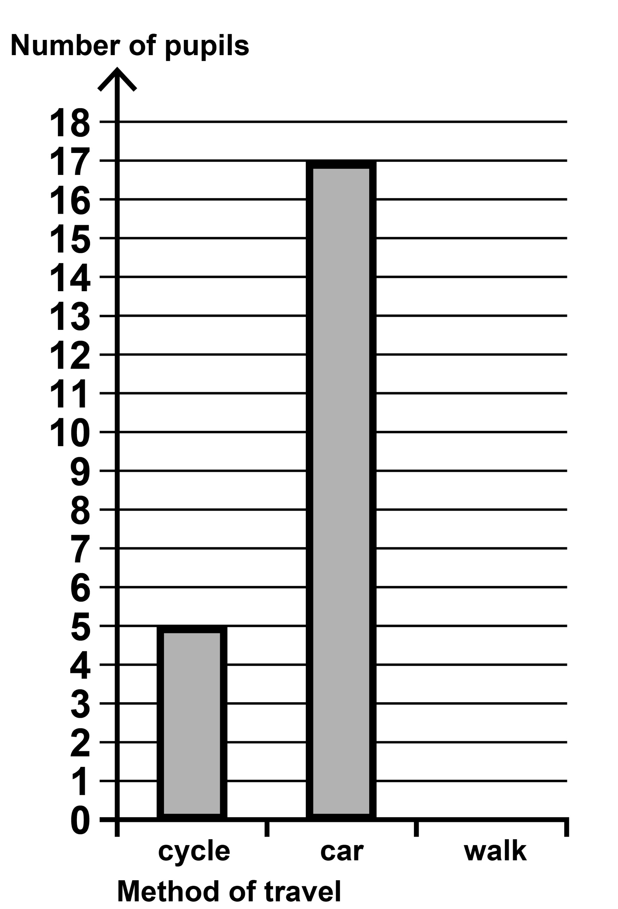
3. You have three models for this question labelled P, Q and R

Write the letter of each model next to its shape name on the following page.

triangular prism

triangle–based pyramid

cone

4. The table below shows the numbers of children in each year in a school.

One number is missing.

 | Year 3 | Year 4 | Year 5 | Year 6
Children | 119 |  | 118 | 117

[Go to the next page]
There are 468 children in the
school altogether.
How many children are in Year 4?

5. Jack buys a book for £11 • 79

He pays for the book with a
£10 note and a £5 note.

[Go to the next page]

How much change does he get?

£
6. Ken has 14 comics.

Maria has one more comic than Ken.

Stefan has 3 times as many comics
as Maria.

How many comics do Ken, Maria and Stefan have altogether?
[Go to the next page]
Show your method.

comics
7. You have a cut–out shape for this
question.

Look at the grid on the opposite page.
It shows Shape A and four transformations of the shape.

Tick or mark the transformation that is not a reflection of Shape A.

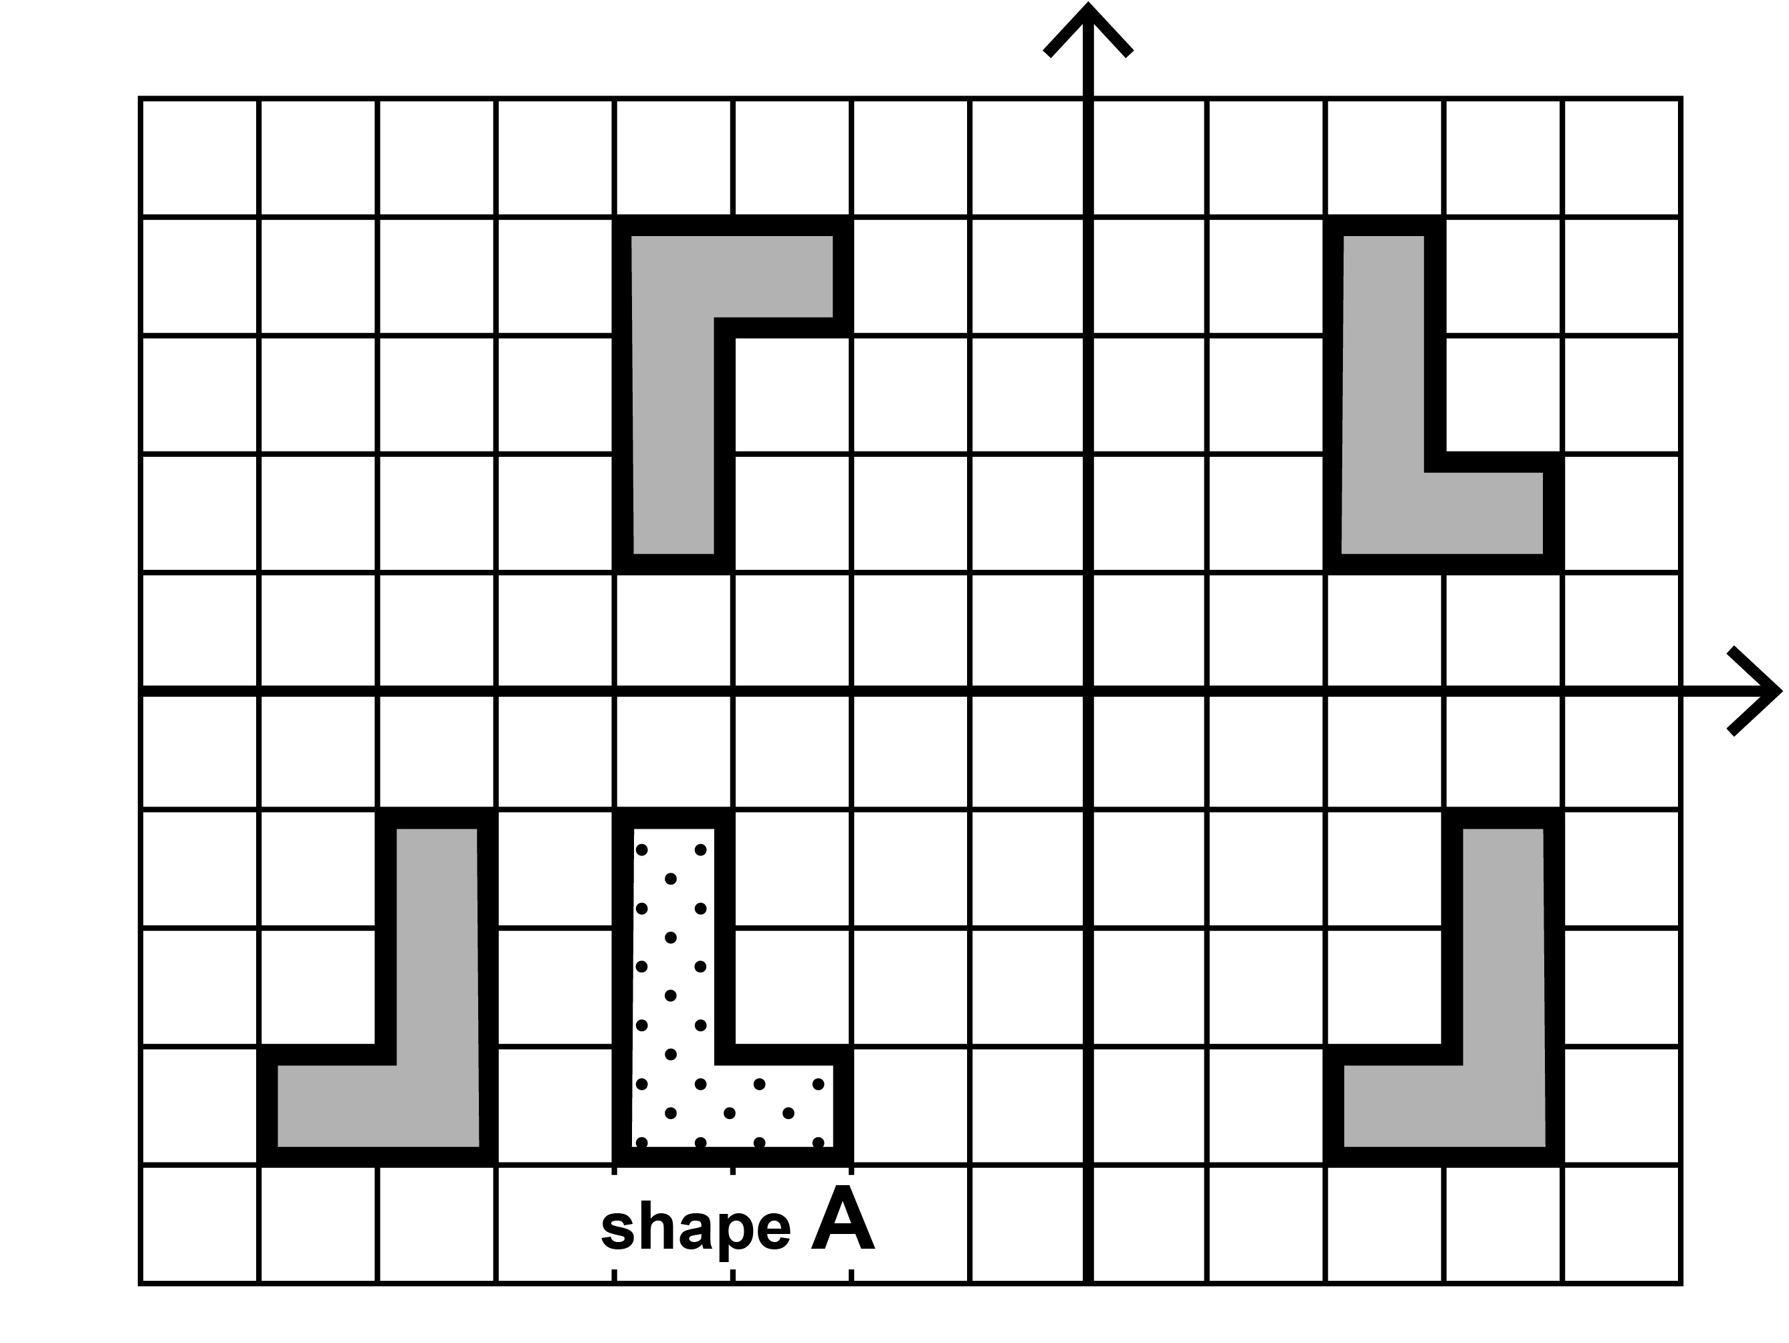
Shape A
x
y
8. Look at the diagram on the opposite page.
It shows a shaded parallelogram on a square grid.

Draw a rectangle on the grid that has the same area as the parallelogram.

Use a ruler.

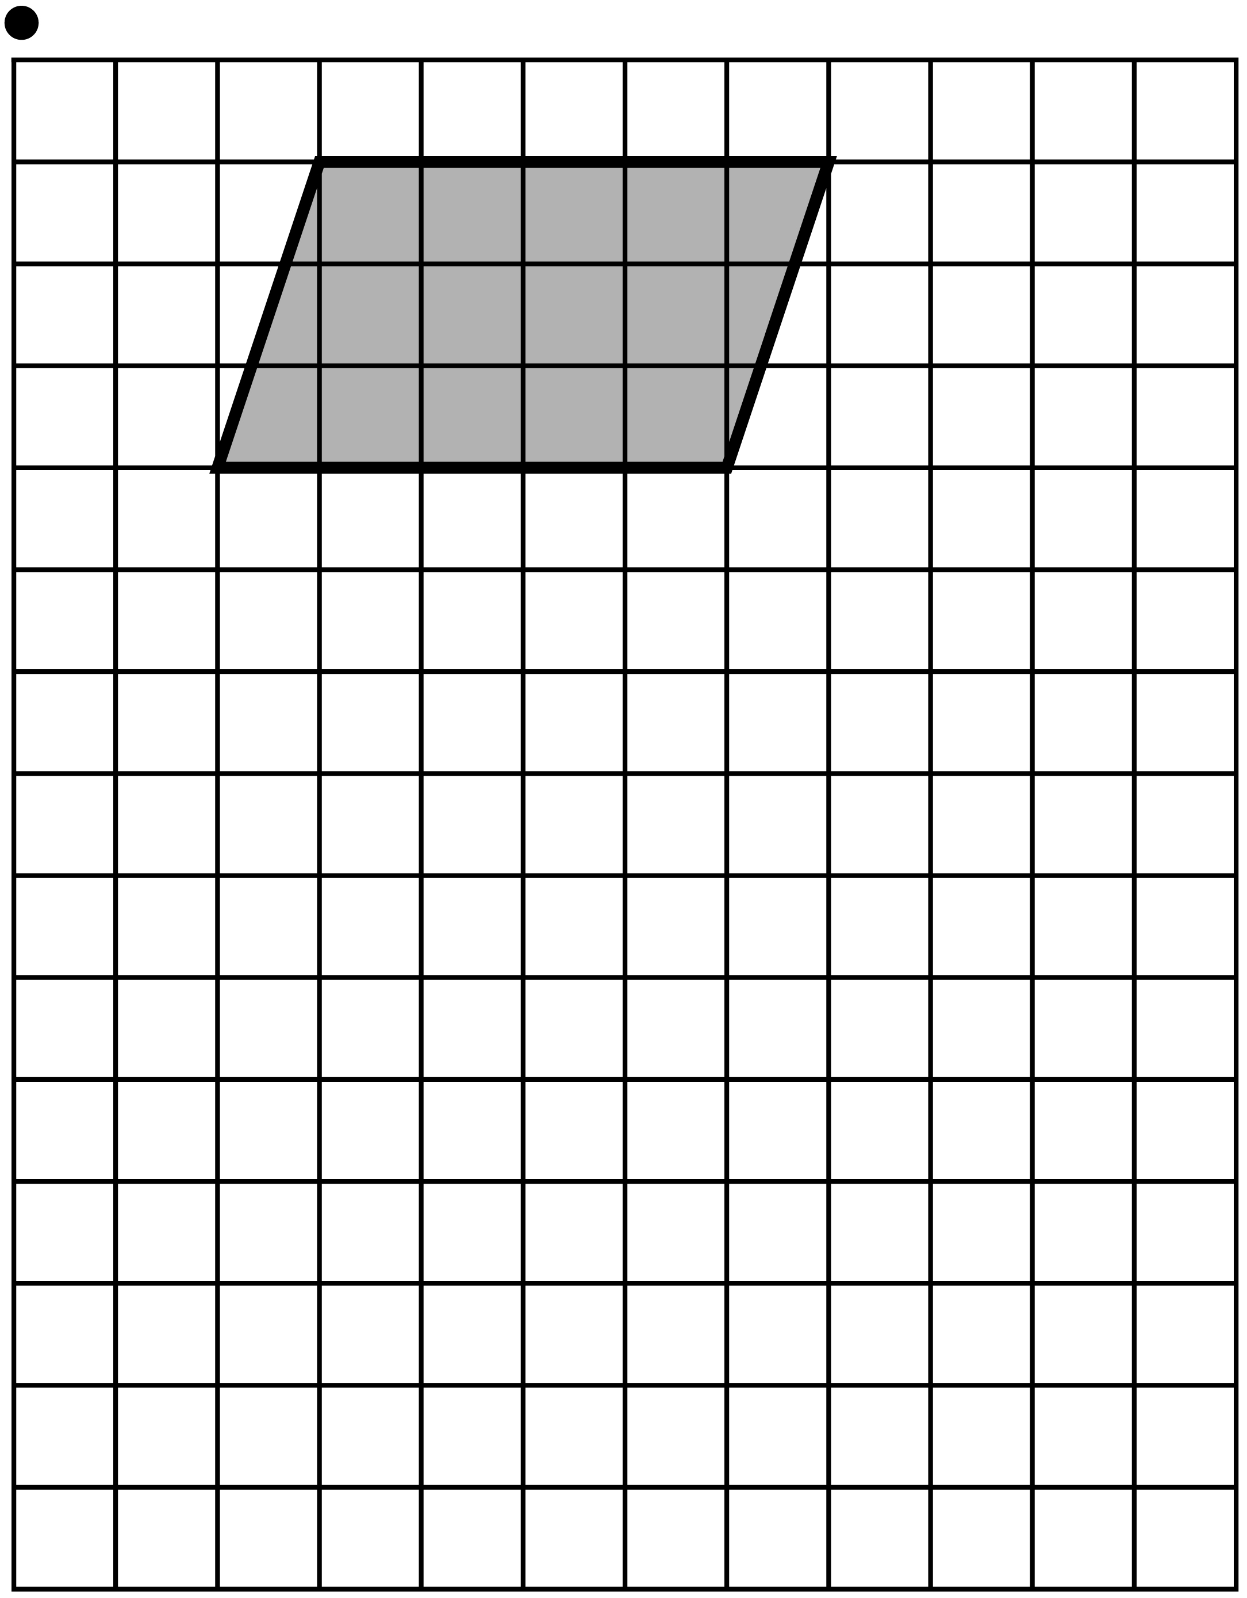

9. On the following page are four statements about multiples.

Tick or mark the statements that are true.

All multiples of 9 are multiples of 6

All multiples of 20 are multiples of 10

All multiples of 5 are multiples of 10

All multiples of 10 are multiples of 5

10. Amir makes a necklace with blue and red beads.

For every 5 blue beads there are
3 red beads.

There are 30 blue beads in the
necklace.

What is the total number of beads in
the necklace?
Show your method.

11. The rectangle below has a length of
16 centimetres.
The perimeter of the rectangle is 50 centimetres.
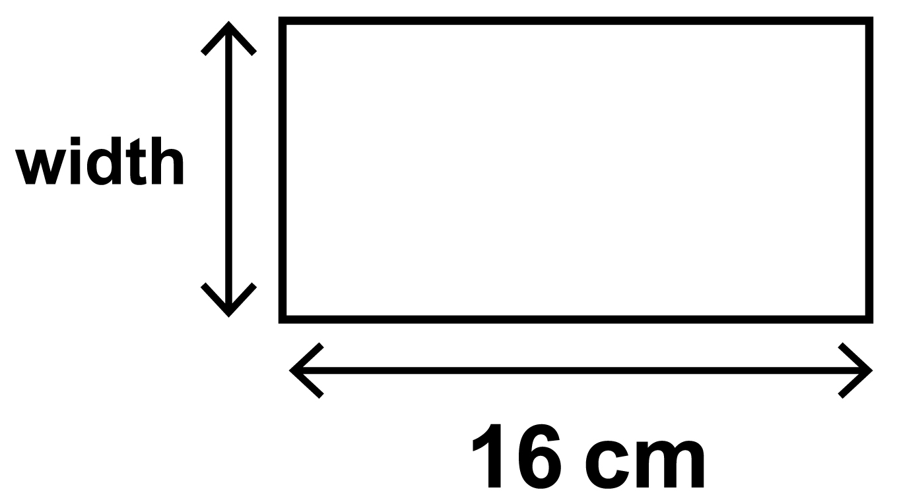
Not actual size

What is the width of the rectangle?

cm
12. Round 349 909

[Go to the next page]

to the nearest 10

to the nearest 100

to the nearest 1 000

13. Look at the 4 circles on the following page.
Each circle has a proportion shaded.

Match each circle to the correct
proportion to show how much is
shaded.

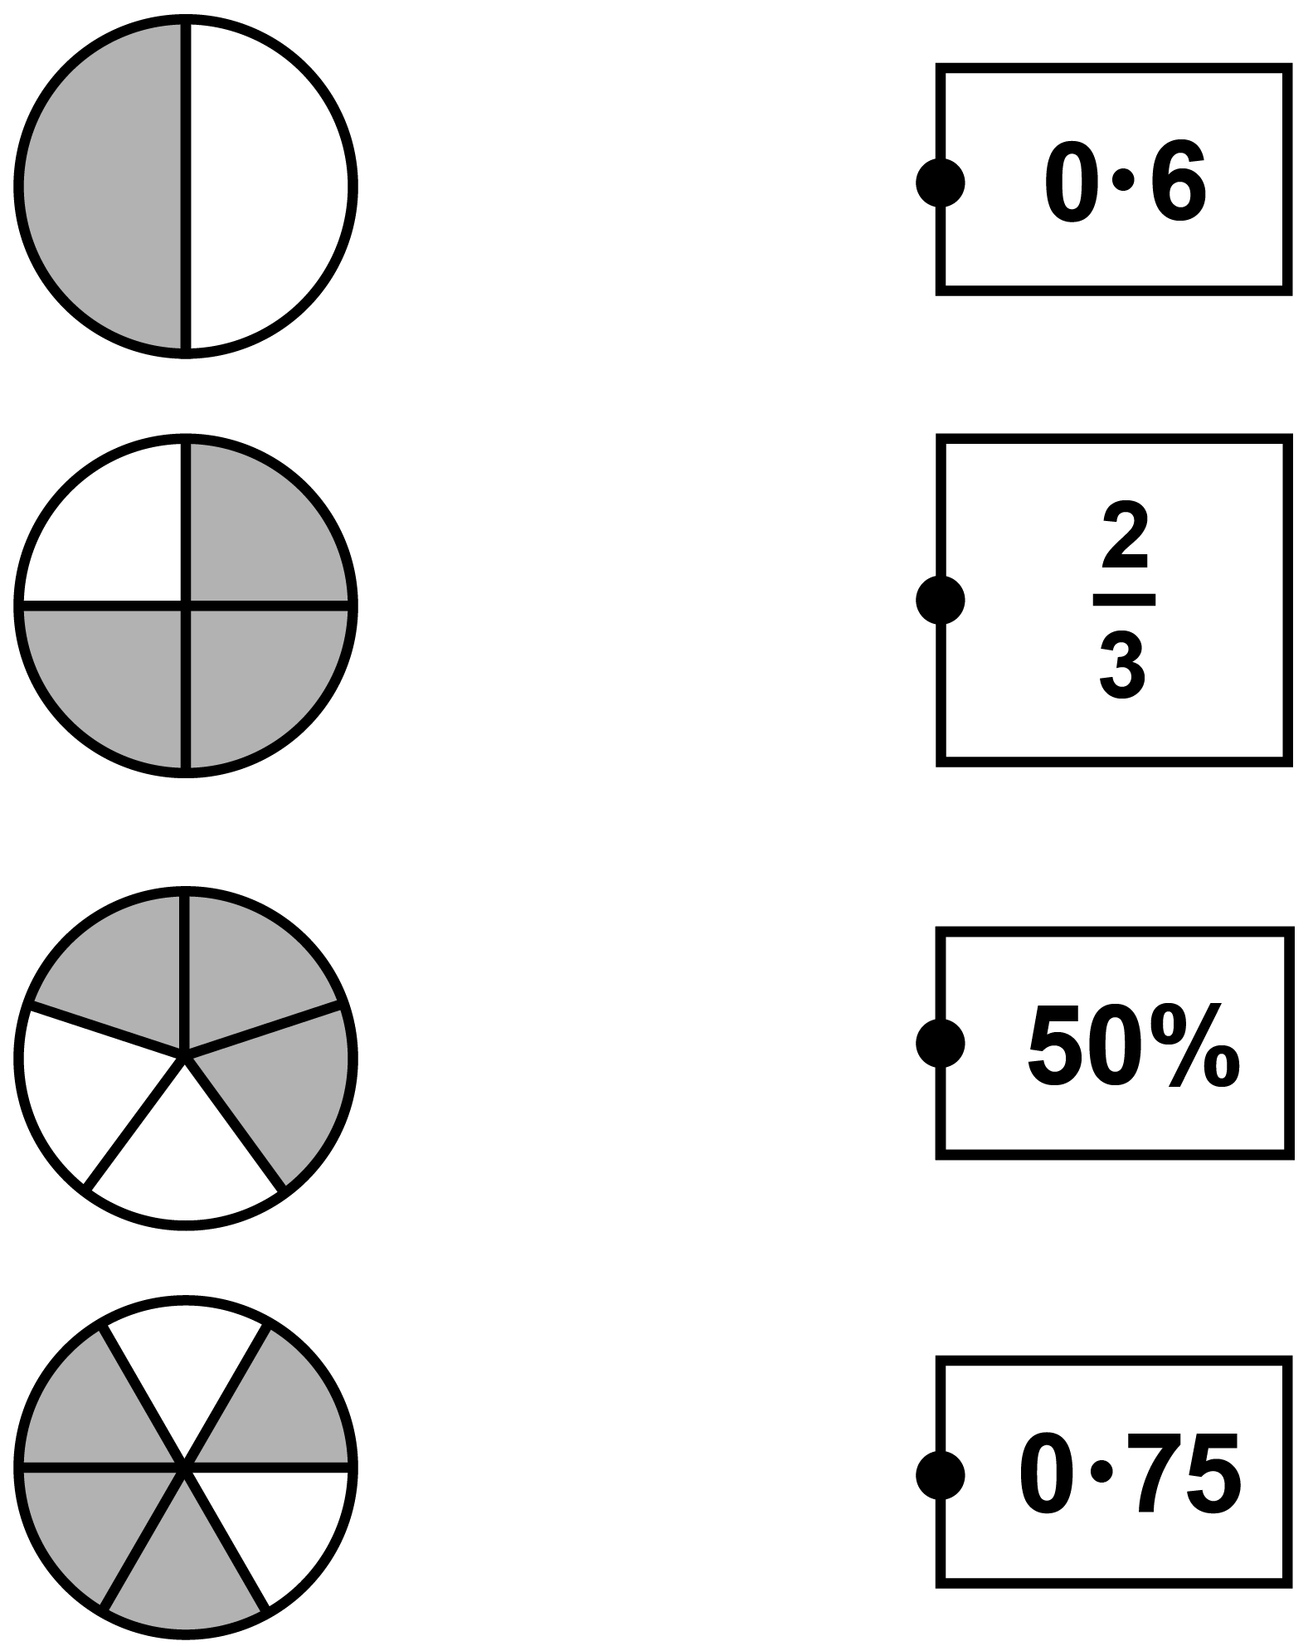
14. 3 oranges and 2 pineapples cost
£4 • 06 altogether.

Oranges cost 36p each.

What is the cost of one pineapple?

Show your method.
[Go to the next page]

£
15. Write the missing number in each box to make these divisions correct.

[Go to the next page]

24 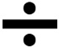 = 2 • 4

24 = 1 • 2

2 • 4 = 1 • 2

16. (a) Tick or mark the fractions below
2
3

that are less than

3
9

8
9

7
9

4
9

5
9

(b) Tick or mark the fractions below
2
5

that are greater than

3
8

2
8

6
8

4
8

5
8

17. Amina is on holiday in France.

A road sign says: PARIS 320 km

How many miles does Amina need to travel to get to Paris?

Use the conversion:
5 miles = 8 kilometres
[Go to the next page]

miles
18. Look at the diagram on the following page.
A line makes an angle with the x–axis.
Not to scale

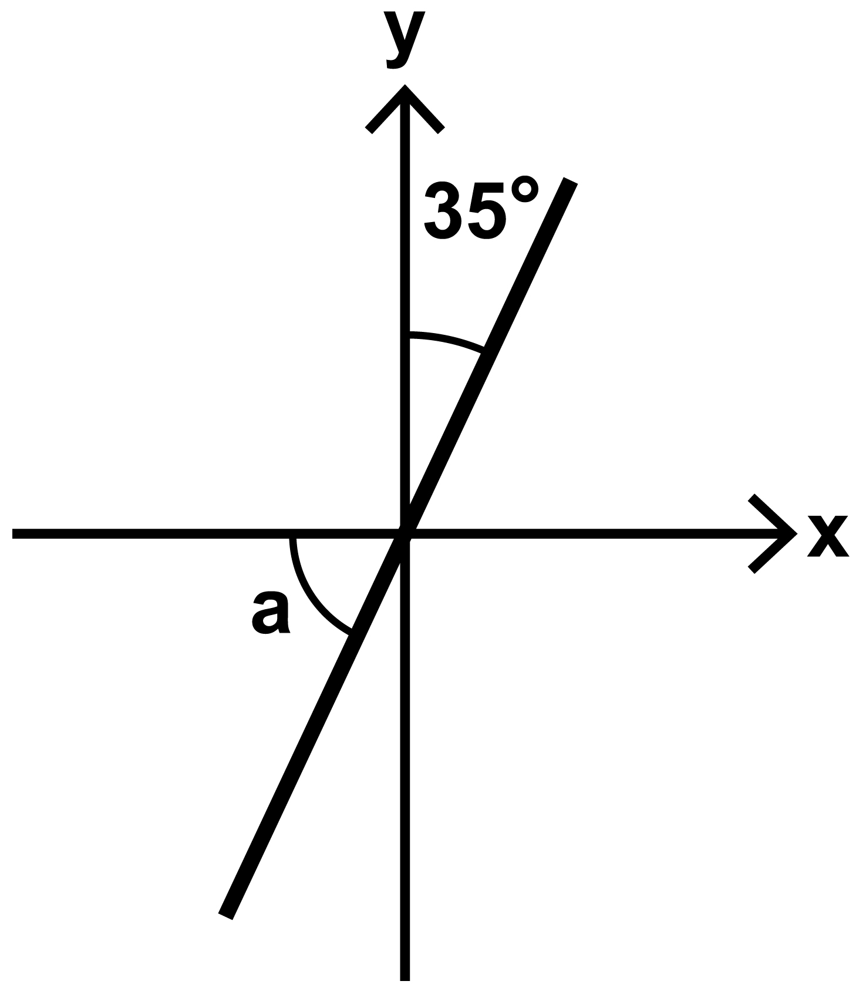
Calculate the size of angle a

a is °
[BLANK PAGE]

The test continues on the next page.

19. Megan buys 6 cans of beans.

The total mass of the cans is
2 • 49 kilograms.

What is the mass of one can, in grams?

Show your method.
[Go to the next page]

g
20. Mabel has some 5p and 2p coins.

She has a total of 41p.

Complete the table on the following page to show how many of each type of coin she could have.

One row has been done for you.
5p | 2p
1 | 18

21. Kirsty mixes blue paint and yellow paint.
2
5

of her mixture is blue paint.

She uses 3 • 5 litres of blue paint.

How many litres of yellow paint does Kirsty use?
Show your method.
[Go to the next page]

litres
22. (a) Look at the number line on the
following page.

On this number line, 3 is halfway between the missing number and 10

Write the missing number.

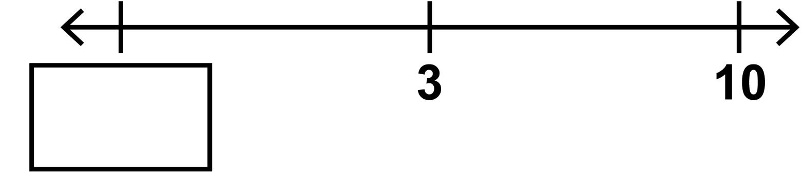
(b) Look at the number line on the
following page.

What number is halfway
between 20 and −100?

Write the missing number.

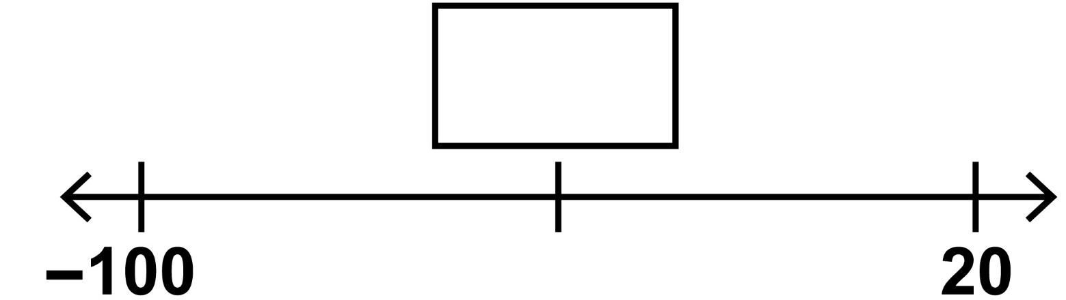
23. William asked some children to choose their favourite club.

The pie chart on the following page shows
the results.

Clubs
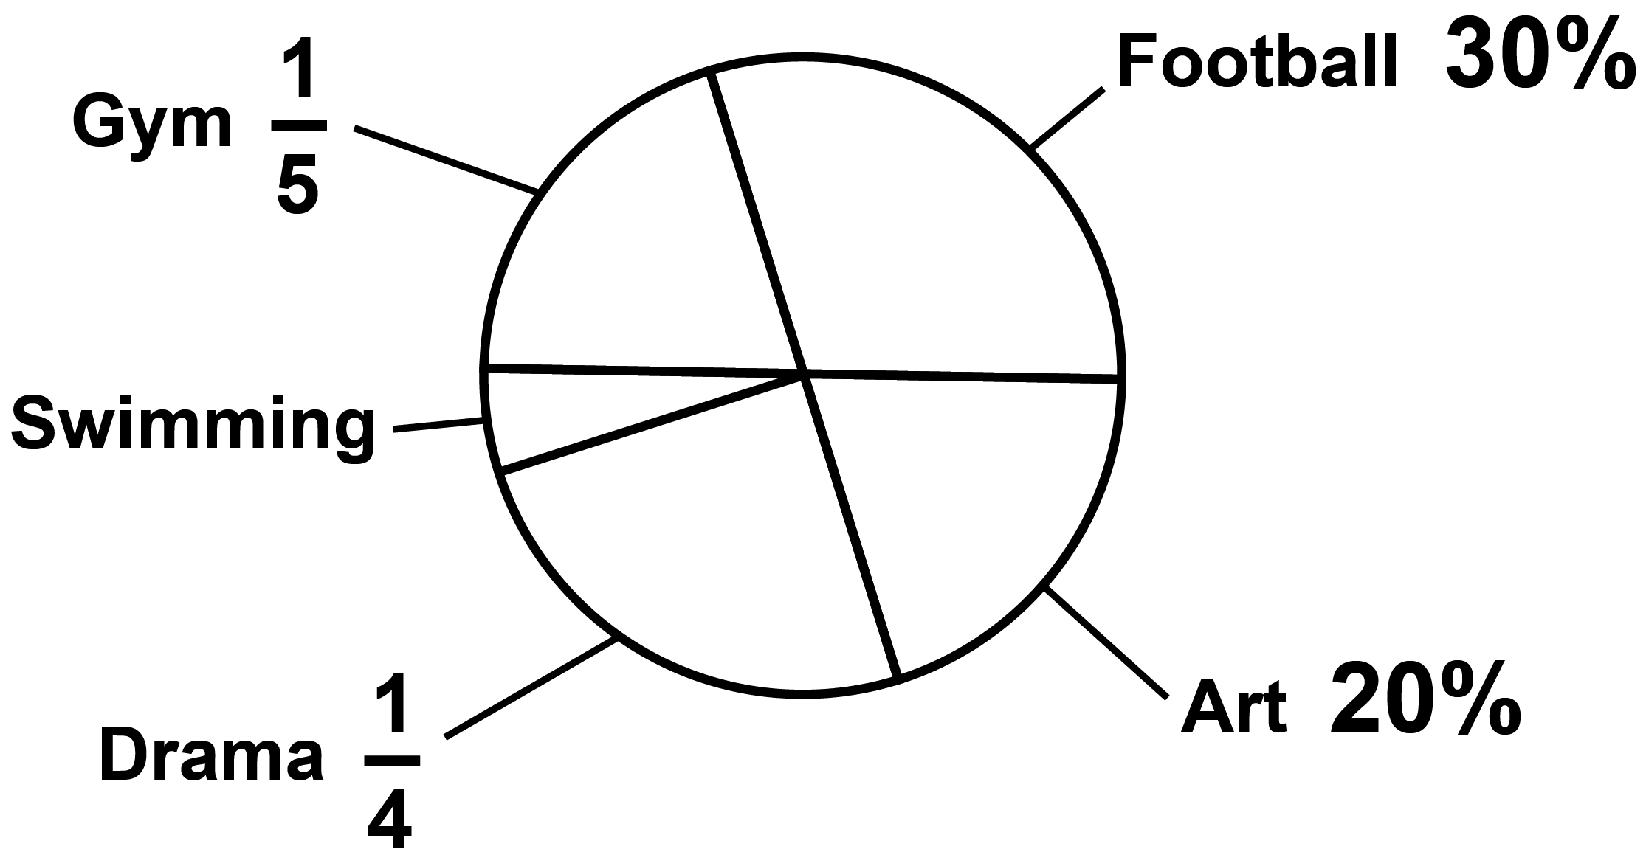
Three children chose swimming.

How many children did William
ask altogether?

Show your method.
[Go to the next page]

children

End of test

[BLANK PAGE]

Key stage 2 mathematics
48 point A3 modified large print Paper 2: reasoning
Electronic product code: STA/26/9048/MLe_48pt ISBN: 978-1-83507-894-5
For more copies
Additional copies of this modified large print test paper can be ordered by contacting the national curriculum assessments helpline on 0300 303 3013. After the test window, it can be downloaded from www.gov.uk/government/collections/national-curriculum-assessments-past-test-materials.
© Crown copyright
The materials in this booklet are Crown copyright. You may re-use them (not including logos) free of charge in any format or medium in accordance with the terms of the Open Government Licence v3.0, which can be found on the National Archives website and accessed via the following link: www.nationalarchives.gov.uk/doc/open-government-licence.
If you have any queries regarding these test materials, please contact the national curriculum assessments helpline on
0300 303 3013 or email assessments@education.gov.uk.

