NOTICE OF ORDER

Wildlife and Countryside Act 1981, 53
Lancashire County Council

THE LANCASHIRE COUNTY COUNCIL BRIDLEWAY ON LORD'S LOT ROAD, OVER KELLET DEFINITIVE MAP MODIFICATION ORDER 2021

Notice is hereby given that the above referenced Order has been submitted to the Secretary of State for Environment, Food and Rural Affairs for determination. An Inspector will be appointed by the Secretary of State to determine the Order.

The start date for the above Order is 5 May 2026.

Consideration of the Order will take the form of exchanges of statements of case and comments on statements of case.

The effect of the Order, if confirmed without modifications, will be to modify the Definitive Map and Statement of Public Rights of Way for the area, by adding the Bridleway known as Lord's Lot Road from a junction with Kirby Lonsdale Road along a bounded track in a generally northerly and then north north easterly direction before turning to continue in a more easterly direction to pass through Lord's Lot Wood along an unbounded track before leaving the track to continue north east for 30 metres through the woodland to the junction with Borwick Road.
The total length of the route is 1.95 km and the width varies between 3m and 10m.

Any queries relating to this Order should be referred to Paul Scrivener by email: paul.scrivener@planninginspectorate.gov.uk quoting reference number ROW/3357193 on all correspondence. Alternatively, queries may be sent in writing to The Planning Inspectorate, Rights of Way Section, c/o QUADIENT, 69 Buckingham Avenue, Slough, SL1 4PN. Telephone: 0303 444 5000.
Any person wishing to view the statements of case and other documents relating to this Order may do so by appointment at County Hall, Fishergate, Preston, PR1 0LD, for further information please contact Sarah Brooks-Silcock at Sarah.Brooks-Silcock@lancashire.gov.uk or on 01772530820.

Documents have also been made available online. To access the documents, please use the following URL address: https://www.lancashire.gov.uk/council/transparency/dmmos/lords-lot-road-2021/

Timetable for sending in statements of case and comments
Within 2 weeks of the start date by 19 May 2026.
The Order Making Authority, or where the Order Making Authority is taking a neutral stance and the applicant or other party are taking the case forward in support of the order, must ensure their statement of case is received by the Secretary of State. As soon as possible after the deadline, the Secretary of State will send a copy (excluding
copies of any supporting documents - these will be available to view at the Authority’s offices) to everyone who has made an objection or representation, the applicant and any other person who has written to us in respect of the Order.

Within 8 weeks of the start date by 30 June 2026.
Everyone who has made an objection or representation or any other written representation or any other person wishing to make representations in writing must ensure their statement of case is received by the Secretary of State. As soon as possible after the deadline, the Secretary of State will send full copies to the Authority. Copies (excluding copies of any supporting documents - these will be available to view at the Authority’s offices) will also be sent to the applicant, every person who has made an objection or representation and any other person who has written to us in respect of the Order.

Within the same period the applicant (if applicable) must ensure their statement of case is received by the Secretary of State. As soon as possible after the deadline, Secretary of State will send a full copy to the Authority. Copies will also be sent to everyone who has made an objection or representation and any other person who has written to us in respect of the Order (excluding copies of any supporting documents - these will be available to view at the Authority’s offices).
Within 14 weeks of the start date by 11 August 2026.
Everyone who has made an objection or representation, the Authority, the applicant (if applicable) and anyone who has written to us in respect of the Order must ensure that their comments on any or every other statement of case is received by the Secretary of State. As soon as possible after the deadline, the Secretary of State will send copies of these comments to everyone else.

In fairness to the other parties everyone should keep to the timetable to ensure that statements of case and comments are received on time. Late documents will be returned.
We cannot accept any inflammatory, discriminatory or abusive comments. Any documents containing such comments will be returned.
If you use Artificial Intelligence (AI) to create or alter any part of your documents, information or data, you should tell us that you have done this when you provide the material to us. See the detailed guidance for further information.

Notice of order for w/r
WILDLIFE AND COUNTRYSIDE ACT 1981

THE DEFINITIVE MAP AND STATEMENT OF PUBLIC RIGHTS OF WAY FOR THE COUNTY OF LANCASHIRE

THE LANCASHIRE COUNTY COUNCIL BRIDLEWAY ON LORD'S LOT ROAD, OVER KELLET
DEFINITIVE MAP MODIFICATION ORDER 2021

This Order is made by Lancashire County Council ("the authorityu) under Section 53(2}(b) of the Wildlife and Countryside Act, 1981 ("the Act") because it appears to that authority that The Definitive Map and Statement of Public Rights of Way for the County of Lancashire require modification in consequence of the occurrence of an event specified in Section 53(3)(b) and 53{3)(c){i) namely the discovery by the surveying authority of evidence which (when considered with all other relevant evidence available to them) shows that a right of way which is not shown in the map and statement subsists or is reasonably alleged to subsist over land in the area to which the map relates, namely a bridleway.
The authority have consulted with every local authority whose area includes the land to which the Order relates. Lancashire County Council hereby order that:
- For the purposes of this Order, the "relevant date" is 18th August 2021.

- The Definitive Map and Statement of Public Rights of Way for the County of Lancashire shall be modified as described in Part I and Part II of the Schedule and shown on the map attached to the Order.

- This Order shall take effect on the date it is confirmed and may be cited as The Lancashire County Council Bridleway on Lord's Lot Road, Over Kellet Definitive Map Modification Order 2021.

Dated this 18th day of August 2021.

THE COMMON SEAL of the )
Lancashire County Council ) was hereunto affixed in the presence of )

�
Authorised Signatory
SCHEDULE

PARTI

MODIFICATION OF THE DEFINITIVE MAP

DESCRIPTION OF PATH OR WAY TQ BE ADDEO

Bridleway known as Lord's Lot Road from a junction with Kirby Lonsdale Road (point A on the Order Map) along a bounded track in a generally northerly and then north north easterly direction before turning to continue in a more easterly direction to pass through Lord's Lot Wood along an unbounded track before leaving the track (point G) to continue north east for 30 metres through the woodland to the junction with Barwick Road (point H).

The route is shown on Order Maps 1-3 between points A-8-C-D-E-F-G-H as a broken black line with cross bars in the intervals.

The total length of the route is 1.95 km and the width varies between 3m and 1Om

PART II

MODIFICATION OF DEFINITIVE STATEMENT

VARIATION OF PARTJCULARS OF PATH OR WAY

The Statement to be added for Over Kellet 26 to read as follows:

Over Kellet 26:

No. of path: "26"

Kind of path: "Bridleway"

Position: "Bridleway known as Lord's Lot Road commencing at junction with Kirby Lonsdale Road at SD 5340 6978 along a bounded stone surfaced track in a generally northerly and then north north easterly direction to SD 5368 7053 and then continuing in a more north easterly and then easterly direction passing through Lord's Lot Road as an unbounded track to a junction with Barwick Road at SD 5476 7078. All compass directions given are approximate. 11

Length: "1.95 km"

Other particulars: "Width varies between 3 and 10 metres as shown on the Ordnance Survey 25 inch Sheets XXV.5 and XXV.6 surveyed 1890 and published 1891.

Limitations: None"
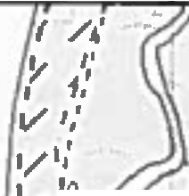
I � .. 0
,,::':;
,I /�I.o:.:: ,'
1
:: .
,,
,,,1
.
.. ...
,
:: \�
t./2
.-r.:
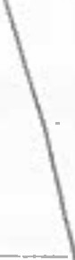

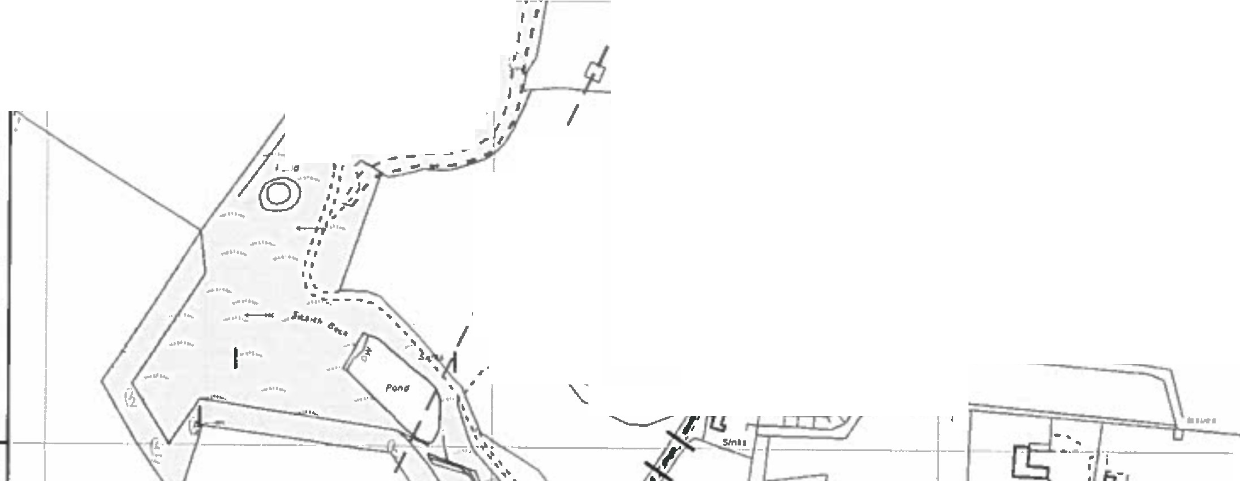
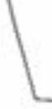
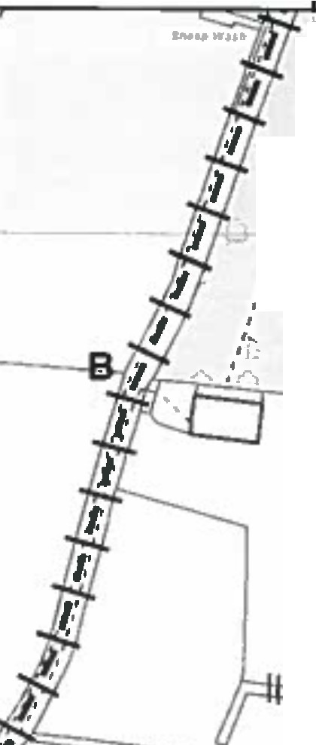
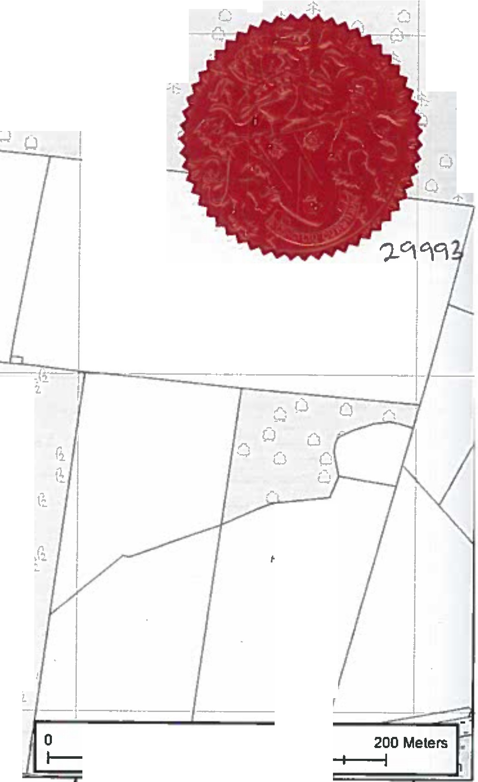
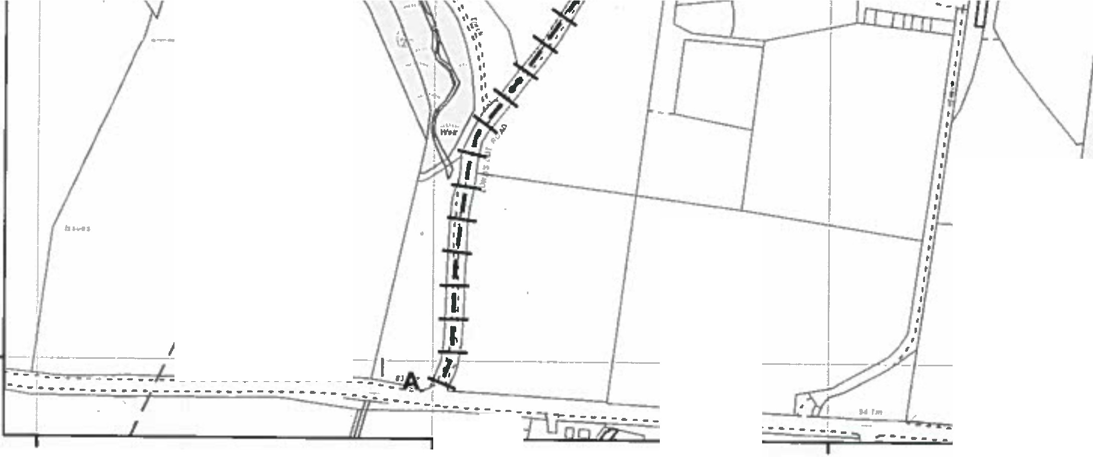
Q
-� ,..,
\L'J•• CJ • ·1:: _:t:_ 0 t: -t:
a
I I Q 0
I ��/ �
G_/h *- -

CJ
.-..
CJ 0 .. O
;}._ t;:

,...
0
,,
•..J
1-1-1 Order Route 1-- r '
(.',.;
�:
��
I •'
..+,
..-"'.....

,1•, LJ
-!
....� A
0 � .•. � 0 CJ
8◄ \
N
I
r'I'.I l '; cl,I
11--.-�•,
1
tJ /1,' .:.�-·fl•
I - r-.
. ' 4 .: • '
,L -�
I l - -�
1,.J
�-= � '-
-·
--.
.,,.
""i:":
.r,
:,,..,t.
;.�
I
0
� ,' i/ ,.�· '� � -- ,.,·:
,,,
, �•...
;�IC
.-,
...:_
0
,.
)� '"'$:
. ;
---
:!!. .,.•::-;�

;f::.
....
;(,, ,' ,','
�- ·:•,'·• .,,,1
�'/ ;r .,.I' �- I I I I ti

,. i!';:
·,·-, :i'_,
.,...
.,�
C.·
;�"
;�
,r -1:
1,.J
;!- ... I b ,'3
•·!:'·
C:
.i".t.
�:
..�. .
,- , -� ........!..,.!, #
.. �-...'
0 0 �
� , --�--� I
I
I
,1
l
/

r,

Htsley J)aclr
bl,:... <tz=r= ii b;;
- .�...
0
0
0
0
� I
I
I

I
I

I
I

I
I
I
t
--'-l-!

G.

'i rl

(1

�
.�
(�

,...:.. ,."...

G.

ii,
·-
(�
I;_

(1.

�
A��gnatory

H.. 1erWood
�

g
Ill GI U)
�

I

I ---=-=-- -----·----

..-..
,, (�
,l
•1.
,,�... a_ G.

50 100
353200°00000 353400 °00000 353600 OOOOO'l 353800 000000 354000 000000
Leao.n.,1ycale  Coundi | Public Rights of Way PROW@lancashlre.gov.uk  01772 530317 | Wildlife and Countryside Acl1981  Addition of bridleway along Lord's Lot Road, Over Kelle! | 1:3,000 | •♦• •  •
. The dlgillaed Rights ol Way lnformatton •hould1M used !Of' guldani:e only as Its accuracy cannot be guaranleed. Rights of Way lnlon111llon musl be vertned on lh■ curnftl D■flnltlv■ Map before being supplied or used for eny purpose.
Thi• Map Is ,-produced from Ordnance Survey material wllh die permission of Ordnance Survey on behaH of Iha controller of Her Maje•ty's Stallon•ry Office IC) Crown Copyright Unauthorised reproduction Infringes Crown CDpl'rlght Pian 1 of 3
and may lead lo Proucullon or clvll procHdlngs. Lancashire County Council Ucence No. 100023320

Cl
:z: tr
Cl

I / .1 il, �*• -:-:, +·1:�"-

�,,. .,.....,. �

1
I r')Oj_. J
' '-- I -*- • ·r.: ·-., 11·!:is ,A, '• - -' "'!';'-•
,,H
r-::,. , ·1-----t l � ·-*-, *- - •·.--�>- "'- • I ..,
.:1;- �r: A:: .. ,�,·..:t::-".' •. .._t.:.Jt-z/ -------�---- -.�-·:·-:h -�
/ ,'i, ,' -11,:. -'!:t �1t�rd's�P- {-Wo•_ �• 1 ,_-.•,-- --.-.._.._._.. _-.-�-
,
1. , -·"' .••::- � ,, ..�- -1•r1.. - -1" .. - -::: •.,. ....,,. _... - .._
/ •I - .' -f.:� '··r:·: ·-'Js' -it ;� 1• ·-t-r:/ .;•:::·Q -t: �, --� ,... kV\'i , .:f: .,.

·•:,,
I ., �t�. ,,· *- . I::::••- uui \J\,.:,Nv \t"'l V. � *-
.��. t �,s._-1---t: ;1: -'!Jr. ;r: :t· .-•�.:.··:{· 0 oAuthorized Simn ory
•, 1

·11 1,
-'f:. ,� _� ;;;-.... 1 . . . 11 .._._ ._ , �' rfl
',•, /
•·'#,, l2.•,' ,1: - .:t�*- ,_. ·I. �-E ,'
. r:;_sr -t Q
t -1: U
.:t_
:t: (-,I
,,, • ., ,:t• �- i. •• '' ,Sr --t. A u u
,J•I

/ ' -�·�::*.: ,isl::.. +-�:-'!:: J
. s-

t_ A
,,_,
-t- .t� r, -t- t: � -t-
.,:.•,
_,,---=-
I .f,j,

•-• ••
+ --r-
r.�.. �D
...+ • sl ,sf.
'r..J •J� ; w
...., "T....; 0-
'C ...
•-r:"' .. ;:
"' t')',..,,1 . _,.:-:,
T: :-- ' • ... �:
.r-;,... A . .,"""�,• ��'"'•.,_.,.
•1:
-
( j -
,f..., -1� ...._ ,-_
I C ,·"/ (1
,,,._..,,
----=;------- -".!:?-t:--.. • :-11- : - -.1
"' .•-.·· 4-,:-
t- --.t:-

--rt-.
-·�r:
�-,� --rt.-::
-is .�-ts
, I ! • � li w O - - - - i ...............-- - *- 0 - I *- (.J - .... I0
I -....,.;::s.,,...c..� / o -t� .-i:, ;;� w G..'....;_.. 0 .1, -t; _f u-t� 11': -f2 Q :t -'t: -1: 0 0 -1:
I '° ·o •• aI :: ..
...:
. I �. I·;.) w u
Q .O. u. • o -w
. ;...; a so 11JO
CJ
11 / i· +--�
_+ Q
.·..".'. CJ .;l

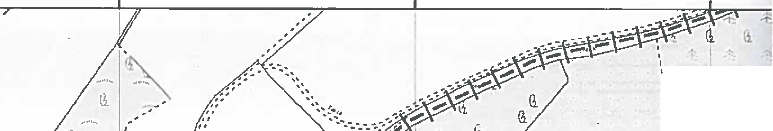
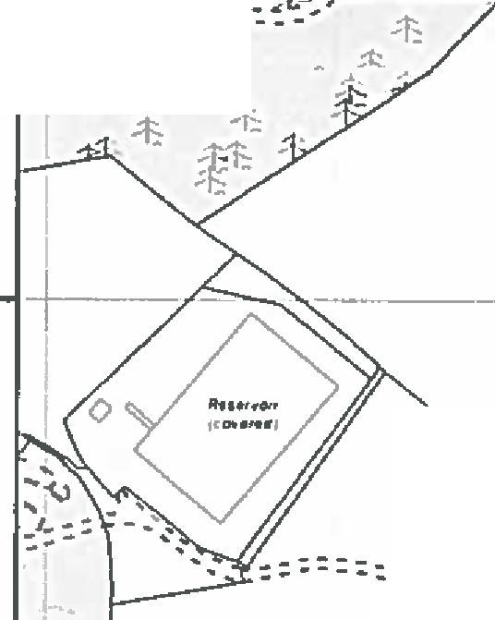
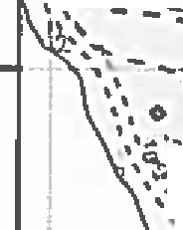
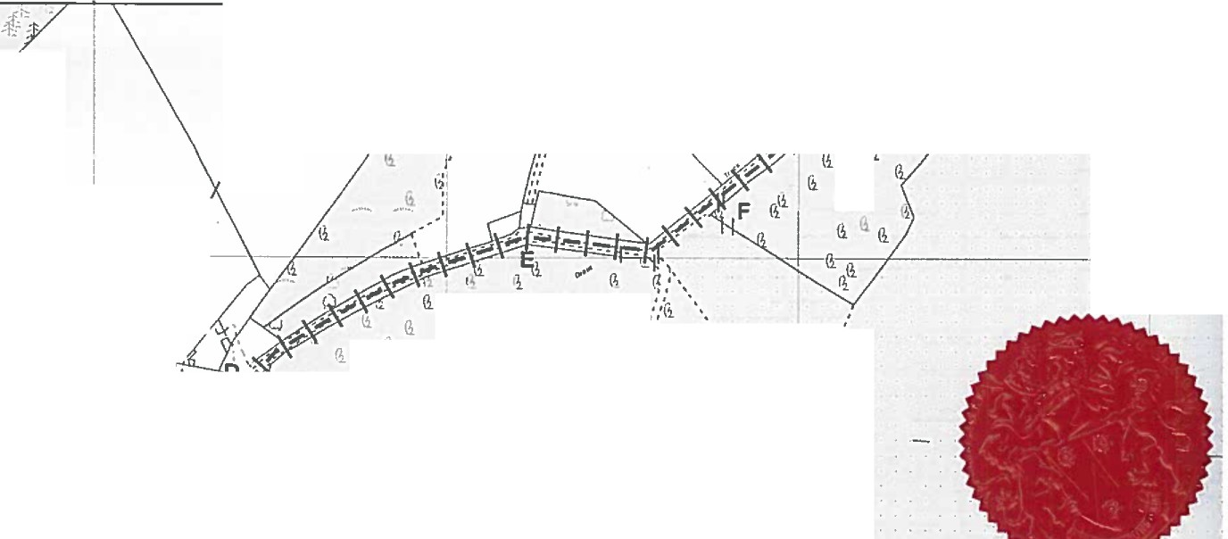



353400 353600 000000 353800 oooooo 354000 354200 .
-
I
' l
',
��
I
,..
l. J
I
.,;,,
�
I
I
.,,...I
G.
• .. _.•:--'!---·-·--
..... I ���·

f/
I
I
I
7
I
'l
\i\i
\i
li
(1P�"
(i
\l
" ..
�:":(i
•.
.
•
--::.:..- .. -
....: : ..-..
�
/
·-.:· . l"'"/-· •: ::--···
--·....-
••
,'·.
, ,
l.i
�,
'
•-
,.
_ .
tiG.
·.-...
''
l ', .
,•J -t I.
� ....
G.
ri_'J. .�· 1i
, ,.,
Q ' '
I,
.
,
:
'
'..
I
'
' ),
/I
I
- - -= - =: == f ..- •
I
,,.,
?1
n , ,.•
\.,,.
.....:f: :;,:. ,. r4 · •
.._ -t•,t
... ...
- . ........ • ◄: ,
·-
," --0._ ll (i
I
I-
,
-'b --t•• II·1'-:. •1:·t:•
• • - • ......
-
'
,�..,,...�':.t-,.£:
,
•*-= i& .:t�f: •t,
\:1,-l• '1·-
,·r.:- _,. ..
11.;'
I
.ll..
'>f,; t
,�•'-'•
,-
• • • • ' \'L• -
. :
�-
•
..1,,.........��,,'..:. ..-- ...·-•-'...�.....
- ✓- "
1,\
\/'
ff.,.
I
/
, ..7:...i .. ..-r-,
.+
,_.,_,,,: .."?::,•'
�2. ,. ........
,. ;ff
Jt.:1-3::
/
•�"T.;�r-·r.:r.:
r.+;t- ;t-"t
,to
.±
,l'
�:--¾,,
:
•
.-•
;.·..•, ,t.•• + ..,. ':".
=,·'.lf-}°h--�-
+-
*--� ;f3:,�· -
,....�,7,
.'
p . . • • • .
,
.,
I
•
�
:,c
.s• ....ct •
I,·
•,,',,,.'
�-'-
-·,•+-···
•"•'' ..I
��
--'f
Cl
Cl
�._
'It
:·\
'1
•.
�_.,�_$. 'i', 'I; ,;,
Ii .:t
,7
·I 1-1-1 Order Route
I
IJf
I
I
-··"'=- -�::._
�
I
La�fJhire  Caurol | Public Rights of Way PROW@lancashlre.gov.uk  01TT2 530317 | Wildlife and Countryside Act 1981  Addi6on of bridleway along Lord's Lot Road, over Kelle! | 1:3,000 | ·♦.
The dlgltlHd Rights ol Way lnlonnatlon should be used for guidance only H Us accuracy cannot be guaranteed. Rights of Way lnlonnadon must be veitned on the currant Dellnfllve Map before being supplied or used for any purpose.
' This Map Is reprod<lced f,om Ordnance Survey maletlal with the permission of Ordnance Sun,ey an behalf of the contraller of Har Majesty's Stationery Offk:e CCJ Crawn Copyright Unauthorised repn>cluctlon lnlrlngn Crown Copyright Plan 2 of 3
and may lead to Prunc:utlon or clril proceeding&. Lanc.. hlre County Council Ucence Na. 100023320

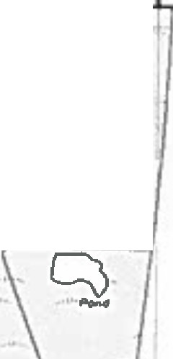
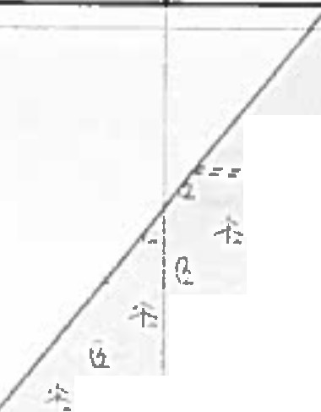
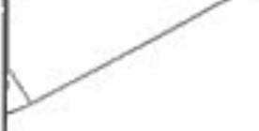
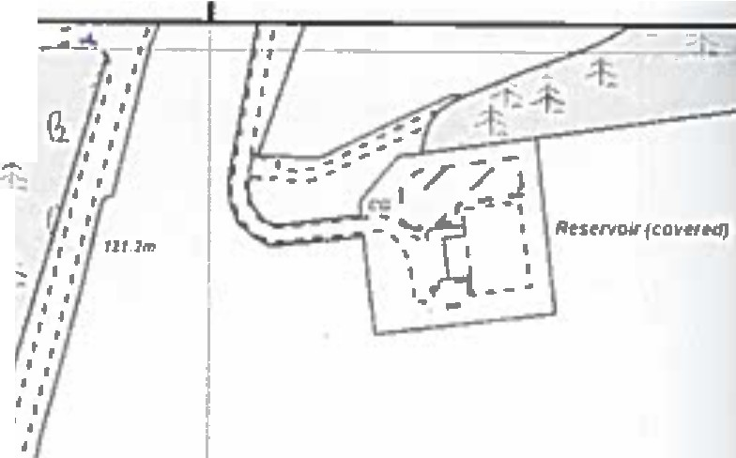
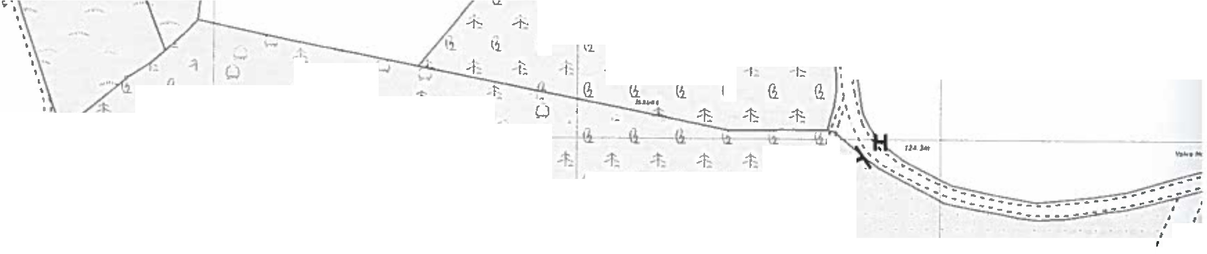

:Csl
,.
,',•
.,,,
:'..,)
,..::=-:
1-,--,--1-0-�-e-·r-Ro-u-��t;.J�
1:.•�=;�G.
c-..:::�· -1:
:�-
--�==CJ==-..�-
:::··.,.....
(i
(i
(i
-b•I;;-b
�
•t:,
G.
(.,.

�l }
•I
��
+.
_;'�
-+�
�
�
-+.
-i::
(1_
-·
/"
.'.\
\
I
/.a
.
G.G.G.
;I�.:t::_
=::::
·t
_;.k
��
!i
(i
-+-
G.li
G.
li
�
. 11\f'.f
I.
l1
•t::
,_
+•t--
·I';: II
h
\i
(i
\1
(l � �
..
-t•
-1:
i.
, ,
'I
.:=· � ...:i·*-t:t
, ,
,;.•·
..
_· �
·I
-
r,
\l
;f.: �::·
' •
I _;j•
�
��
•t• ••
+-t,,''
��
G.
-t-
...- .::==:r:1::-'r::i/:,tJ�G.G.�
'..:t-1::
-t=
-
-t;
'11
••
\1G.G.
·- --� ·-• .•.
..:t
>':,.
14:.-.t>_:'\,_;t'·l's+.·f.:
tr.•.....�
·t::
�
+--I'�
\l
....!>,.
t
;t
�
G.
t
-t-�
i2G-1(1b -�
(i,(ili
G.(i
(i
-1=I .:r:.•'�-���,-1-1•
·I::
tt
.•.
;;;;
(i
-t:-,�,+-�t"� �-)..\"'\(- G
�
tl�
l� --¥
...- �---•
11 �\�\�\��r ,•
.t,
w
-r-
..h ''
·t�-
.
:•
...
.,..._,

g
ID
0
�
h. ll. li ,' •  ', . • 1-· :I •  I I  ', l2 I \1 \2 ft,,'  � �I �,_ . r�.. '•..! ...',.,; ,  tl l} li tl/  '., ...:t:- !�--- .,.-- Lord's l..ot Wood  ::- ....  _.-•::::::::::::=1··���-------' • ..•...  ---·· --- ·t- (.) ,, - �  , , -.--· •---;: -• ·.r..:..: 'I�-�0 ,,,, ·1: |  | ·-. !:: ½Ii t- -t: ; -t. ·,�-_.-b .I ..,  I  t  Q -t- -.J .... I ..•  ') tj .-,t- ·r� r, r ' 7 '-\•, =:·--- _... •, ,  I-' ·i= - •• -..---•-·-r•--/  (.) .......- : : : -r - - - - ·4_ I.;: � I  (i G. G. f' ,' '4  ... ... :f": ,' .� .... '  -;. I �2_ I  � � I / J�•  ,, • , l1 •  ,._ r,----·-.:�: ' _a.-·. - - -,-1•, ,': 0 G' i;.  -t- ,' .,..  ....r:: � ':-j t--.:, , ,w "l '  - :f:., I -1:� ,' - t : I h I i:.  , ) d .. : -,· .' a o .•  ,, �;: ' •.. 1 , ' � � I.  <,...) 1 I r -,.._, 0,,.. •·  I: , •...) ! t I "'b 1..,;_YlhoH n4-,.,1 I I  .,-1 I  • ...,•: 12.,'  ,j ,• ti 1,Or1  �ut � driz� Si�riatory ��-q�:�2 ° G.��  � 0 t ••  -· ;{ , ;.."JI ' I • ' '1 •  t .4 � :�: ,r 0 50 100 200 Meters  : -1- ·'- ' •-1-,  ..., .-... �' ,t _ •  l
- • ----- | . - --�,;,1�i'  - ,, I·

g
co

.�.,

354200 354400 354600 354800
Lanca-·e  e°o"'.-.".c'tov, | Public Rights of Way PROW@lancashlre.gov.uk  01n2 530311 | Wildlife and Countryside Act 1981  Addition or bridleway along Lord's Lot Road, Over Kellet | 1:3,000 | ·♦• ·  •
The dlglU•ed Rlgh19 of Way lnlormallOl'I sh0111d be used for gulda11C11 only as Its accuracy cannOC be guaranteed. Rights of Way lnform1U0n must ba vertlled on the currenl Dellnltlve M■p before being auppHed or used for any purpose,
This Map Is reproduced from Ordnance Survey material with the permlsalon of Ordnance Survey on behalf of the c011troll11r of Her Mafaaty'■Stat1011ery Office (Cl Crown Copyrtghl Unauthortsed reproducUon Infringe• Crown Copyright P)an 3 Of 3
and may lead to Proaecullon or clvll proceedings. Lancashire County Council Lk:ence No. 100023320

..

