NOTICE OF ORDER

Wildlife and Countryside Act 1981
Lancashire County Council

THE LANCASHIRE COUNTY COUNCIL DELETION OF PART OF FOOTPATH NO. 3 BROUGHTON AND ADDITION OF A FOOTPATH FROM SANDYFORTH LANE
TO LIGHTFOOT LANE (DEFINITIVE MAP MODIFICATION) ORDER 2014

Notice is hereby given that the above referenced Order has been submitted to the Secretary of State for Environment, Food and Rural Affairs for determination. An Inspector will be appointed by the Secretary of State to determine the Order.

The start date for the above Order is 30th June 2026.

Consideration of the Order will take the form of exchanges of statements of case and comments on statements of case.

The effect of the Order, if confirmed without modifications, will be to modify the Definitive Map and Statement of Public Rights of Way for the area, by: Deleting part of Public Footpath No. 3 Broughton from the south side of the stile at point A (SD 5144 3368) running in a south easterly direction across the rugby pitches to a boundary hedge at point B (SD 5153 3360) and continuing across the north east corner of a field to eastern boundary hedge of that field (SD 5154 3360) to continue along boundary hedge to parish boundary at point D (SD 5161 3348) for a total distance of 265 metres.

Adding a Public Footpath from a point on Public Footpath No. 3 Broughton from the south side of the stile by Sandyforth Lane at Point A (SD 5144 3368) running generally in a south easterly direction across the rugby pitches to Point E (SD 5154 3361) and then continuing in a south south easterly direction along the east side of the boundary hedge through the parish boundary at Point F (SD 5162 3348) to continue as Public Footpath No. 47 Fulwood in a south south easterly direction to the south west corner of the field turning west to terminate at Point G (SD 5164 3344) where it meets the footway of Lightfoot Lane, a total distance of 320 metres.
Any queries relating to this Order should be referred to Paul Scrivener by email: paul.scrivener@planninginspectorate.gov.uk quoting reference number ROW/3359820 on all correspondence. Alternatively, queries may be sent in writing to The Planning Inspectorate, Rights of Way Section, c/o QUADIENT, 69 Buckingham Avenue, Slough, SL1 4PN. Telephone: 0303 444 5000.

Any person wishing to view the statements of case and other documents relating to this Order may do so by appointment at County Hall, Fishergate, Preston, PR1 0LD, for further information please contact Sarah Brooks-Silcock at Sarah.Brooks-Silcock@lancashire.gov.uk or on 01772530820.

Documents have also been made available online. To access the documents, please use the following URL address:
https://www.lancashire.gov.uk/council/transparency/dmmos/sandyforth-lane-lightfoot-lane-2014/

Timetable for sending in statements of case and comments
Within 2 weeks of the start date by 14th July 2026.
The Order Making Authority, or where the Order Making Authority is taking a neutral stance and the applicant or other party are taking the case forward in support of the order, must ensure their statement of case is received by the Secretary of State. As soon as possible after the deadline, the Secretary of State will send a copy (excluding copies of any supporting documents - these will be available to view at the Authority’s offices) to everyone who has made an objection or representation, the applicant and any other person who has written to us in respect of the Order.

Within 8 weeks of the start date by 25th August 2026.
Everyone who has made an objection or representation or any other written representation or any other person wishing to make representations in writing must ensure their statement of case is received by the Secretary of State. As soon as possible after the deadline, the Secretary of State will send full copies to the Authority. Copies (excluding copies of any supporting documents - these will be available to view at the Authority’s offices) will also be sent to the applicant, every person who has made an objection or representation and any other person who has written to us in respect of the Order.
Within the same period the applicant (if applicable) must ensure their statement of case is received by the Secretary of State. As soon as possible after the deadline, Secretary of State will send a full copy to the Authority. Copies will also be sent to everyone who has made an objection or representation and any other person who has written to us in respect of the Order (excluding copies of any supporting documents - these will be available to view at the Authority’s offices).

Within 14 weeks of the start date by 6th October 2026.
Everyone who has made an objection or representation, the Authority, the applicant (if applicable) and anyone who has written to us in respect of the Order must ensure that their comments on any or every other statement of case is received by the Secretary of State. As soon as possible after the deadline, the Secretary of State will send copies of these comments to everyone else.
In fairness to the other parties everyone should keep to the timetable to ensure that statements of case and comments are received on time. Late documents will be returned.

We cannot accept any inflammatory, discriminatory or abusive comments. Any documents containing such comments will be returned.

If you use Artificial Intelligence (AI) to create or alter any part of your documents, information or data, you should tell us that you have done this when you provide the material to us. See the detailed guidance for further information.

Notice of order for w/r

WILDLIFE AND COUNTRYSIDE ACT 1981

THE DEFINITIVE MAP AND STATEMENT OF PUBLIC RIGHTS OF WAY FOR THE COUNTY OF LANCASHIRE

THE LANCASHIRE COUNTY COUNCIL DEFINITIVE MAP AND STATEMENT OF PUBLIC RIGHTS OF WAY
DELETION OF PART OF FOOTPATH NO. 3 BROUGHTON AND ADDITION OF A FOOTPATH FROM SANDYFORTH LANE TO LIGHTFOOT LANE
(DEFINITIVE MAP MODIFICATION) ORDER 2014

This Order is made by Lancashire County Council ("the Authority") under Section 53(2)(b) of the Wildlife and Countryside Act, 1981 ("the Act") because it appears to that Authority that The Definitive Map and Statement of Public Rights of Way for the County of Lancashire require modification in consequence of the occurrence of events specified in Sections 53(3)(c)(iii) and 53(3)(c)(i) namely the discovery by the Authority of evidence which (when considered with all other relevant evidence available to them) shows that there is no public right of way over land shown in the map and statement as a public footpath and that a right of way which is not shown in the map and statement subsists or is reasonably alleged to subsist over land in the area to which the map relates, namely a public footpath.
The Authority has consulted with every local authority whose area includes the land to which the Order relates. Lancashire County Council hereby order that:
- For the purposes of this Order, the "relevant date" is the 30th December 2014.
- The Definitive Map and Statement of Public Rights of Way for the County of Lancashire shall be modified as described in Part I and Part II of the Schedule and shown on the map attached to the Order.
- This Order shall take effect on the date it is confirmed and may be cited as The Lancashire County Council Definitive Map and Statement of Public Rights of Way Deletion of Part of Footpath No. 3 Broughton and Addition of Footpath from Sandyforth Lane to Lightfoot Lane (Definitive Map Modification) Order 2015.

Dated this 30th day of December 2014. THE COMMON SEAL of the )
Lancashire County Council ) was hereunto affixed in the presence of )

Authorised Signatory
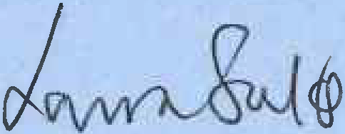

SCHEDULE

PARTI

MODIFICATION OF THE DEFINITIVE MAP

DESCRIPTION OF PATH OR WAY TO BE DELETED

The full unrecorded width of part of Public Footpath no. 3 Broughton from south side of stile at SD 5144 3368 running in a south easterly direction across rugby pitches to a boundary hedge at SD 5153 3360 and continuing across the north east corner of a field to eastern boundary hedge of that field at SD 5154 3360 to continue along boundary hedge to the parish boundary at SD 5161 3348; a total distance of 265 metres.

DESCRIPTION OF PATH OR WAY TO BE ADDED

Public Footpath no. 3 Broughton from the south side of stile by Sandyforth Lane at SD 5144 3368 running in a generally south easterly direction across rugby pitches to a boundary hedge at SD 5154 3361 and continuing in a generally south south easterly direction along the east side of a boundary hedge through the parish boundary at SD 5162 3348 to continue as Public Footpath no.47 Fulwood in a south south easterly direction east of the boundary with Lightfoot House Cottage and The Cottage to the south west corner of the field turning west to terminate at SD 5164 3344 where it meets the footway of Lightfoot Lane.

PARTII
MODIFICATION OF DEFINITIVE STATEMENT
VARIATION OF PARTICULARS OF PATH OR WAY

Modify the Statement for Public Footpath no. 3 Broughton to read as follows:

"Public footpath from a junction with Sandyforth Lane at SD 5144 3368, over stile and continuing in a south easterly direction to SD 5154 3361 through field boundary to continue in a south south easterly direction on the east side of a boundary hedge to parish boundary at SD 5162 3348 from where it continues to Lightfoot Lane as Public Footpath no. 47 Fulwood. Compass directions given are approximate.
Width: 2 metres

Limitations and Conditions: Stile at SD 5144 3368, Stile at SD 5154 3361

Length: 0.27 km"

Modify the Statement for Public Footpath No. 47 Fulwood to read as follows:
"A continuation of Public Footpath no. 3 Broughton from the parish boundary at SD 5162 3348 in a south south easterly direction on the east side of a field boundary to the

south west corner of the field turning west via a stile to terminate at SD 5164 3344 where it meets Lightfoot Lane. Compass directions given are approximate.

Width: 2 metres

Limitations and Conditions: Stile at SD 5164 3344 Length: 0.06 km"
351500 ccoooo 351600 000000
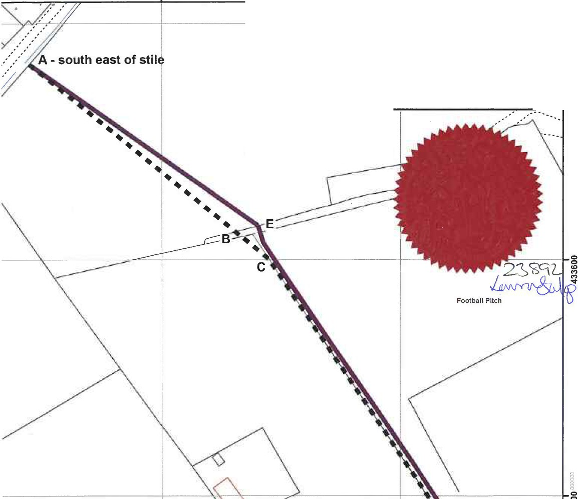

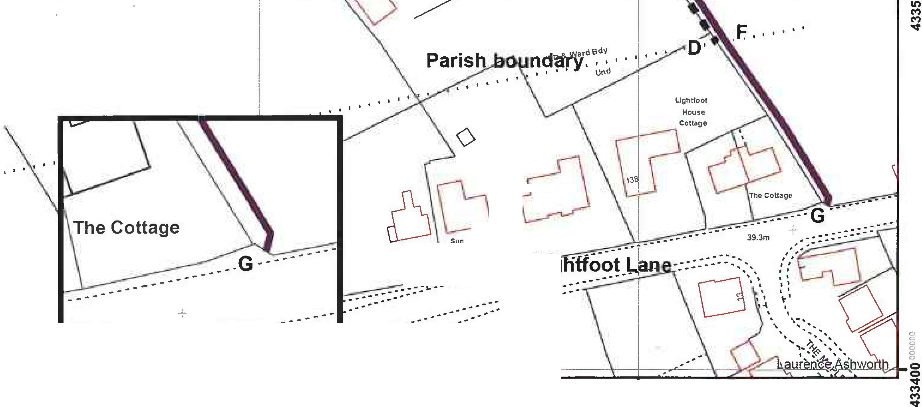
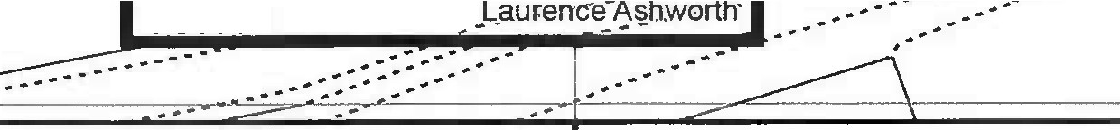
iRugby Football Ground
I
11 • • Footpath to be deleted A-B-C-D
•

01.... ._s1... . .3.1..0_., .... , ,6,o Meter.s L...
Footpath to be added A-E-F-G
-

Authorized Signatory

0
0
C, 0 C, 0

.. ...
I I I I

d --�--

The

n bank

1 ...---.-.-.- ::

39.3m

351500 000000 351600000000

LaCnoucntay•-s.h.ire  Councll | steve Browne  Interim Executive Director  for the Environment | Wildlife and Countryside Act 1981  Deletion of part of Public Footpath No. 3 Boroughton, and addition of public footpath from Sandvforth Lane to LiQhtfoot Lane Preston Citv | 1:1,250 | ♦N •  w  s
The digitised Rights of Way infonnation shoold be used for guidance only as its accuracy cannot be guaranteed.Rights of Way information must be verified on the current Definttive Map before being suppliedor used for any purpose.
This Map is reproduced from Ordnance Survey material with the permission of Ordnance Survey on behalf of the controller of HerMajesty's Stationery Office (C) Crown Copyright Unauthorised reproduction infringes Crown Copyright and may lead to Prosecution or civil proceedings. Lancashire Coonty Council Licence No. 100023320

